Mojtaba Hafezi

N0771021  
Report for the android application  
Name: Space Shooter 2D

Report

Mobile Interactive Systems

Contents

Introduction and Background 2

Design: 3

Implementation: 6

Testing: 8

Critique: 9

References 10

Demo Sheet: 11

# Introduction and Background

Space Shooter 2D is a simple game implemented using the IDE Android Studio and the programming language Java. Nowadays the popularity of games in the google play store is undeniable as the top paid applications consist mainly of games (Google LLC, 2018). Thus, this coursework aims to create a video game for android from scratch. The idea is to build a simple two-dimensional game like space invader with a simple menu to navigate through the different screens. There is no win situation in the game, the player will lose the game when his shields are reduced to zero and the scores will be saved. The player has unlimited “bullets” to shoot at the enemies and there are unlimited enemies being spawned, but only six at a time are going to be visible to keep the balance of the game.

Native android game programming is uncommon compared to the creation of applications using popular game engines. Nonetheless, the android features are perfect for any developer to start learning game and android application development. Google provides many benefits like API’s, virtual machines for testing, graphic libraries and media support (Zechner, 2016). Another key factor is that, mobile gaming has become popular due to the mobile devices being everywhere and their prices being so cheap (Zechner, 2016). This seems to be the perfect situation to learn how to write game object classes, detect and handle collision, draw graphics and to make a complete game respond to the player’s input (Cho, 2014).

Additionally, another important aspect this coursework aims to cover is to make use of android specific features and learn more about the native development process. Key features as Bluetooth controller handling and the use of accelerometer can be adopted for any other application as well. The simple game development framework created at the end of this work needs be altered and can then be reused as well. As Cho (2014, pp. 96-107) states, reusability is an important matter in software development, but it was neglected for this game framework to make the work feasible.

Android is provided on many different devices and hence many different screen resolutions need to be covered (Steele & To, 2010). If not handled, this issue will lead to different gameplay experiences on different devices. Horton (2015, pp. 89-97) explains that this issue can be solved by drawing the game objects at the same coordinates and scale appropriately regardless to the resolution. This solution would have gone beyond the scope of a simple game framework and was therefor omitted.

# Design:

The application aims to create a fully working simple two-dimensional game for android. The essential features of a simple game would consist of audio and graphics. To produce a better software, a game engine can be added which includes a better code structure and reusability.

The key features of the application are:

* Graphics: Using bitmaps the graphics are drawn on the screen and animated.
* Audio: To produce sound effects and the looping background music.
* Simple game engine: A game engine with reusable classes for handling the game loop.

The following are optional features:

* Persistence:
  + Shared preferences: Save the Boolean values for options like enabling sound or accelerometer.
  + Database: Connection to and population of a database is included for the high-scores.
* Sensor Input: The accelerometer can be enabled in the options for gameplay. Additionally, vibration is used to represent the damage when being hit by an enemy ship.
* Wireless Connectivity: Gamepads and joysticks to play the game
* Handling audio and video: In the options menu a tutorial button is available which opens a video player that shows the tutorial for the game.

Special code/technical features:

The application will need a single Audio manager instance to take care of specific events. For this matter, the singleton design pattern seems to be a good approach and the disadvantages of it are acceptable for this small project. The Audio manager will have one instance across all activities and handle the sound output and the ambient music. As Horton (2015, pp. 423-427) mentions, for creating an instance of a class that is available throughout the whole application, the singleton design pattern is useful and straightforward.

For drawing the graphics onto the screen there are some viable options. For simplicity, the standard “View” can be used to draw bitmaps on the canvas. In case more animation and graphics are going to be used further views are available. In this project the “SurfaceView” is going to be implemented, since the drawing can be affected by the desired number of objects. Although the “SurfaceView” is more complicated, the draw method will be done in a dedicated thread and therefor leads to better gameplay experience for the users (Derek, 2013).

Most of the game engine relevant functions are in the “GameView” class. This is bad programming style but had to be done, since the focus of this project was android application development. All game objects inherit from the “GameObject” class with all the essential attributes and methods included. The collisions between objects will be calculated by creating a rectangle around the game graphic and then checking for intersection between the rectangles.

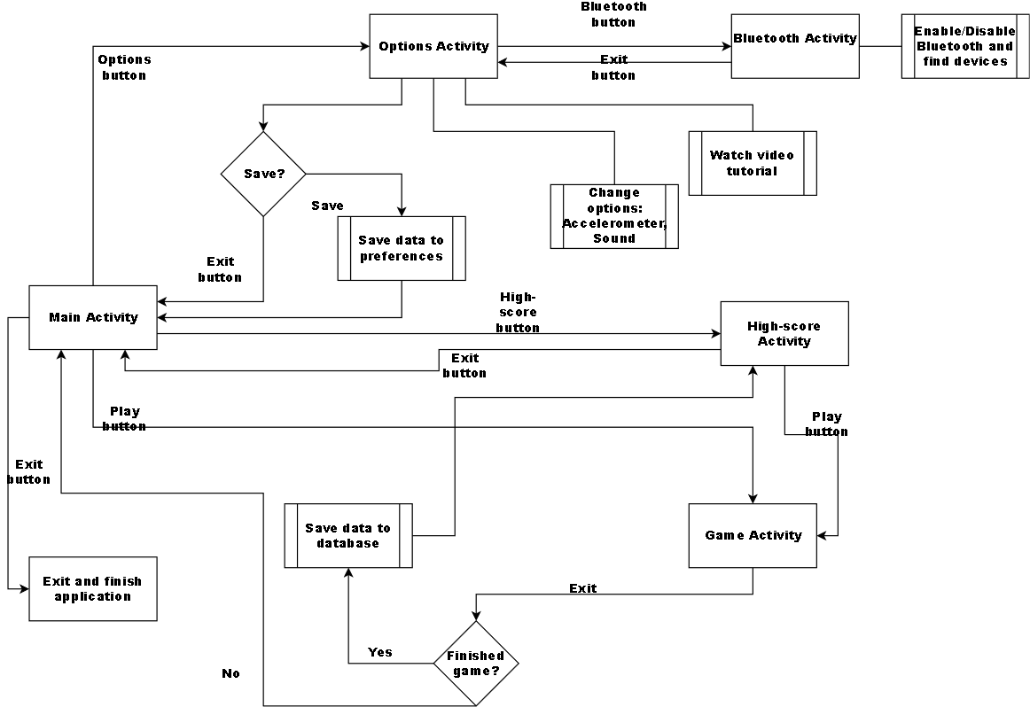

Figure 1: Chart representing the flow

Testing

The testing will be done on different android devices per user testing. Unit, integration and functional tests are recommended for any software but due to the size of this project that kind of tests were left out. The layout and the content scaling were tested on different screen resolutions using the emulators provided by the android studio IDE.

* Menu testing: The transition from one activity to another should work. The buttons should change their colour and if the sound is enabled the menu sound should be played before starting the next activity.
* Gameplay testing: A balanced gameplay. The user should not die immediately, and the instance needs to be instantiated without issues and graphic errors. Sound and music should be playing correspondingly. The player’s ship has to move according to the input.
* Input: The game needs to be able to accept any Bluetooth controller, joystick or D-Pad. The touch and accelerometer motions have to work accordingly to the input.
* Bluetooth: The Bluetooth enabling/disabling and search for devices need to be tested.
* Tutorial video: The imbedded video player is required to open and play the desired tutorial video. It should be closed upon user request and the application needs to continue.
* Persistence tests: Need to check if the shared preferences and the database work correctly in different situations.
* For detailed tests see the testing section.

# Implementation:

# Testing:

# Critique:

# References

Cho, J. (2014) *'The Beginner’s Guide to Android Game Development',* 1 edition, Dublin: Glasnevin Publishing.

Derek, J. (2013) *'Android Game Programming for Dummies',* 1st edition, New Jersey: John Wiley & Sons.

Google LLC, (2018) *Top paid in category apps,*   
https://play.google.com/store/apps/collection/topselling_paid  
(accessed 07 03 2018).

Horton, J. (2015) *'Android game programming by example',* 1st edition, Birmingham: Packt Publishing.

Horton, J. (2015) *'Android Programming for Beginners',* 1st edition, Birmingham: Packt Publishing.

Steele, J. & To, N. (2010) *'The Android Developer's Cookbook',* 1st edition, s.l.:Addison-Wesley Professional.

Zechner, M. (2016) *'Beginning Android Games',* 1st edition, Portland: Appress.

Table of figures:

Figure 1: Chart representing the flow 4

# Demo Sheet:

Mobile Interactive Systems Demo Sheet

Name: Mojtaba Hafezi N-Number: 0771021

App Title: SpaceShooter2D

App Description:

The application is a simple two-dimensional space shooting game. The user can play the game indefinitely and create high-scores which will be saved in the shared preferences.

Gameplay: Use your fingers and touch the upper or lower part of the screen’s left half to move the ship. Shoot by pressing anywhere on the right half of the screen. Destroy as many enemy ships as possible and survive long enough to beat the high-score. Initially, the player starts off with two lives and after getting hit the first time has a two second time frame in which the ship is immune to hits.

Key Features:

* Graphics
* Audio
* Simple game engine incl. physics

Other Features

* Persistence: Database and shared preferences
* Sensor Input: Vibration and Accelerometer
* Wireless Connectivity: Any gamepad, joystick or D-Pad via Bluetooth
* Handling audio and video

What have you done which addresses the following:

* Design: After prototyping how the individual menus should look like they were created having simplicity in mind. Many users become confused if there are too many options to choose from.
* User testing: I asked friends and neighbours to test the application. The game was tested on three different devices with success and no issues.
* Adapting to different devices: The layouts have got a “weight” attribute to determine how much of the screen space they will cover. Through this method the layout looks approximately the same on different resolutions.

Did you use any external resources such as code, multimedia, text…etc?

Yes, all multimedia used in the project are from the public domain.

List of external multimedia:

* The ships and laser sprites along with the sound effects were from the following website: <https://kenney.nl/assets/space-shooter-redux>
* All title images were created using the “spaced out” theme from the following website: <https://de.cooltext.com/Logo-Design-Spaced-Out>
* Background images were found on: <https://pixabay.com/de/>
* The application icon was created using the application “Iconion”
* Ambient music by frankum: <https://freesound.org/people/frankum/>
* Font: <https://www.1001freefonts.com/>
* Chart: <https://www.draw.io>

Is your application creative? Why and how?

Most of the games created nowadays, make use of available game engines. This application provides everything from scratch and only accesses the android utilities. Furthermore, providing support for Bluetooth game controllers improved the playability and usability of the application. Although the main concept is not new, some game features are creative e.g. the rapid fire of lasers when many ships are close to the player ship.