The picture of one sample in the Georgia-tech dataset is as following.

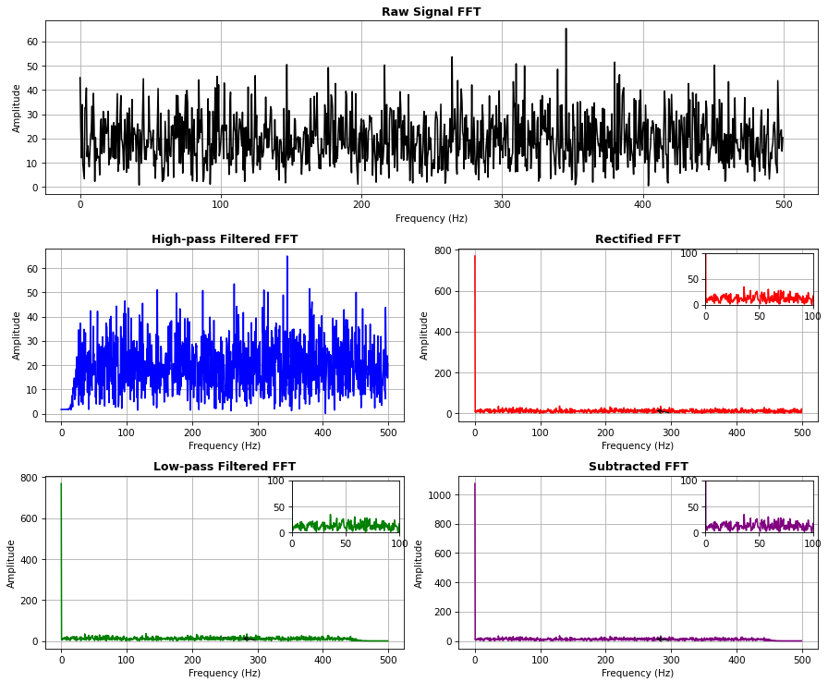

After rectification, The red plot indicates that the signal's energy is concentrated below the 100HZ and after the low-pass filter at 20 HZ, the above frequencies will be removed.