Abstract

Personal Health Monitoring System (PHMS) is a full-stack web application developed to support continuous and structured health tracking for users, along with medication adherence, notifications, report generation, and smartwatch-based data integration. The platform is designed with a modular architecture using Flask, SQLAlchemy, and service-repository layering to keep business logic maintainable and testable.
The system allows users to record key health metrics such as heart rate, temperature, steps, sleep hours, blood pressure, and glucose levels. It computes health scores and integrates machine learning assessments to provide risk-oriented insights. In addition to manual entry, PHMS supports smartwatch synchronization through Google Fit OAuth integration. To ensure reliability in real-world wearable ecosystems where data may be partial or delayed, PHMS includes adaptive fetch windows, diagnostic logging, incremental sync boundaries, and scheduler-driven background sync.
The medication module supports prescription management, intake logs, reminder notifications, and missed-dose handling through scheduled background tasks. Reports are generated through a dedicated reporting flow. Security features include authentication, CSRF protection, secure session handling, and configurable rate limiting.
PHMS demonstrates an end-to-end digital health workflow that combines usability, modular engineering practices, background automation, and practical wearable integration constraints.

Keywords: health monitoring, smartwatch integration, medication adherence, Flask, machine learning, scheduler automation, real-time notifications, Google Fit.

Contents
1 Chapter 1: Introduction 8
1.1 Background 8
1.2 Motivation 8
1.3 Project Overview 8
2 Chapter 2: Problem Statement and Objectives 9
2.1 Problem Statement 9
2.2 Objectives 9
2.3 Scope 9
3 Chapter 3: Literature Survey 11
3.1 Existing Approaches 11
3.2 Identified Gaps 11
3.3 Proposed Positioning of PHMS 11
4 Chapter 4: Requirement Analysis 12
4.1 Functional Requirements 12
4.2 Non-Functional Requirements 13
4.2.1 Security requirements 13
4.2.2 Reliability requirements 13
4.2.3 Maintainability requirements 13
4.2.4 Performance requirements 14
4.2.5 Usability requirements 14
5 Chapter 5: System Design 15
5.1 High-Level Architecture 15
5.2 Major Modules 16
5.2.1 Authentication module 16
5.2.2 Health module 16
5.2.3 Medication module 16
5.2.4 Notifications module 16
5.2.5 Reports module 16
5.2.6 Smartwatch module 16
5.2.7 Scheduler module 16
5.3 Database Design Summary 17
5.3.1 Core entity categories 17
5.4 Smartwatch Sync Design 18
5.5 Scheduler Design 19
6 Chapter 6: System Implementation 20
6.1 Technology Implementation 20
6.2 Health Ingestion Pipeline 20
6.3 Smartwatch Adapter Implementation 22
6.3.1 Google Fit adapter behavior includes 22
6.3.2 Data extraction rules 22
6.3.3 Additional sync reliability behavior 22
6.4 Smartwatch Sync Error Recovery Flow 24
6.5 Medication Log Lifecycle Flow 25
6.6 Notification Generation Flow 26
6.7 Report Generation Flow 27
6.8 Reliability and Error Handling 28
6.9 Use Interface Screenshots 28
6.9.1 Authentication Interface 28
6.9.2 Dashboard Overview 30
6.9.3 Health Module Interface 32
6.9.4 Medication Management 35
6.9.5 Medicines in Medication Page 37
6.9.6 Notification Center 38
6.9.7 Medication Logs Management 40
6.9.8 Report Page 42
6.9.9 SmartWatch Sync Page 46
6.9.10 Profile Page 48
6.10 Email Notification Features 50
6.10.1 User Registration Successful Email 50
6.10.2 Forgot Password – Reset Password OTP Email 50
6.10.3 Password Reset Successful Email 51
6.10.4 Password Reset Failure Email 51
6.10.5 Critical Medication Reminder Email 52
6.10.6 Critical Medication Missed Email 53
6.10.7 Consecutive Missed Medication Email 54
6.10.8 High Risk Health Indicator Detected Email 55
7 Chapter 7: Testing and Validation 56
7.1 Behavioral Validation with Sequence and State Models 56
7.1.1 Sequence: Smartwatch OAuth and Manual Sync 56
7.1.2 Sequence: Health Ingestion and Risk Assessment 57
7.1.3 Sequence: Medication Log Status Transitions 58
7.1.4 Sequence: Authentication (Register, Login, Password Reset) 59
7.1.5 Sequence: Scheduler Periodic Smartwatch Sync 60
7.1.6 States: Medication Log States 61
7.1.7 States: Smartwatch Account Status States 61
7.1.8 States: Smartwatch Sync State Progression 62
7.1.9 States: Notification Lifecycle States 63
7.2 Testing Strategy 64
7.3 Validation Areas 64
7.3.1 Functional validation covers 64
7.3.2 Sync correctness validation covers 64
7.3.3 Scheduler validation covers 64
7.4 Observed Behavior Summary 65
7.5 Testing Output Screenshots 65
7.5.1 Pytest summary – Output 65
8 Chapter 8: Results and Discussion 71
8.1 Achievements 71
8.2 Practical Insights from Wearable Integration 71
8.3 Limitations 71
9 Chapter 9: Conclusion and Future Scope 72
9.1 Conclusion 72
9.2 Future Scope 72
10 Chapter 10: References 73
10.1 Flask / Backend 73
10.2 Testing 73
10.3 Scheduler / Background Jobs 73
10.4 Smartwatch APIs / Fitness Sync 73
10.5 Architecture / Design 73
10.6 Programming Language and Database 74
10.7 Web Standards and API Specification 74
10.8 Diagram and Modeling Tools 74
10.9 Dataset Sources 74
11 Chapter 11: Appendices 75
11.1 Appendix A: Key Environment Variables 75

Figures
Figure 4.1 PHMS Use-Case Diagram 13
Figure 5.1 PHMS High Level Architecture Diagram 15
Figure 5.2 PHMS Class Diagram 17
Figure 5.3 PHMS ER Diagram 18
Figure 5.4 Context DFD for PHMS 19
Figure 5.5 Level-1 DFD for PHMS Core Modules 19
Figure 6.1 Health Ingestion Canonical Pipeline 21
Figure 6.2 Scheduler Periodic Sync Flow 23
Figure 6.3 Smartwatch Sync Error-Recovery Flow 24
Figure 6.4 Medication Log Lifecycle Flow 25
Figure 6.5 Notification Generation Flow 26
Figure 6.6 Report Generation Flow 27
Figure 6.7 Login page 28
Figure 6.8 Registration Page - validation 29
Figure 6.9 Forgot Password Page - Using OTP verificcation 29
Figure 6.10 Dashboard Summary View 31
Figure 6.11 Health entry page 34
Figure 6.12 Medication management 36
Figure 6.13 Medicines - In Medication Page 37
Figure 6.14 Notification Center 39
Figure 6.15 Medication Logs - Scheduled/Pending + Taken/Missed/Skipped 41
Figure 6.16 Report Page 44
Figure 6.17 Report PDF - Genrated 45
Figure 6.18 Profile Management Page 49
Figure 6.19 User Registration Successful Email 50
Figure 6.20 Reset Password - OTP Email 50
Figure 6.21 Password Reset Successful Email 51
Figure 6.22 Password Reset Failure Email 51
Figure 6.23 Critical Medication Remider Emial 52
Figure 6.24 Critical Medication Missed Email 53
Figure 6.25 Consecutive Medication Missed Email 54
Figure 6.26 High Risk Health Indicator Detected Email 55
Figure 7.1 Smartwatch OAuth and Manual Sync Sequence 56
Figure 7.2 Health Ingestion and Risk Assessment Sequence 57
Figure 7.3 Medication Log Transition Sequence 58
Figure 7.4 Authentication Sequence 59
Figure 7.5 Scheduler Periodic Smartwatch Sync Sequence 60
Figure 7.6 Medication Log States 61
Figure 7.7 Smartwatch Account Status States 62
Figure 7.8 Sync State Progression 62
Figure 7.9 Notification Lifecycle States 63
Figure 7.10 pytest summary - Run all tests 70
Figure 7.11 SmartWatch Diagnostics 70

Chapter 1: Introduction

Background
With increasing lifestyle-related health risks and irregular medication adherence, users need a centralized and practical system for routine health observation. Consumer wearables generate large volumes of useful activity and physiological data, but this data is often fragmented across vendor applications. A health platform that unifies manual logging, medication workflows, and wearable sync can improve awareness, discipline, and preventive care.

Motivation
The motivation behind PHMS is to:
provide users with one dashboard for health and medication routines
bridge manual records and smartwatch data
automate repetitive monitoring tasks through scheduled jobs
offer risk interpretation using rule-based and machine learning assessment

Project Overview
PHMS is a modular Flask web application containing:
user authentication and profile management
health data ingestion and risk scoring
medication scheduling and intake logging
alert and notification management
smartwatch OAuth and sync orchestration
reporting and analytics views

Chapter 2: Problem Statement and Objectives

Problem Statement
Many users face the following practical issues:
health metrics are not recorded consistently
medication reminders and follow-up are unreliable
smartwatch data integration is incomplete and vendor-dependent
there is no unified view combining health trends and medication adherence

Objectives
Primary objectives of PHMS are:
build a secure web system for user-specific health record management
provide medication planning, reminders, and missed-dose tracking
integrate smartwatch data via Google Fit OAuth
maintain robust sync behavior under partial-data conditions
generate meaningful health insights through score and ML-based assessment
support scheduled background automation for recurring operational tasks

Scope
In-scope areas are:
personal user accounts and health records
medication, notification, and report workflows
Google Fit-based smartwatch synchronization
background scheduler for periodic and daily jobs
Out-of-scope areas are:
clinical diagnosis replacement
direct hospital EMR integration
multi-provider smartwatch ecosystem beyond configured adapters

Chapter 3: Literature Survey

Existing Approaches
Existing solutions broadly fall into three categories:
generic health tracking apps focused on manual entry
smartwatch vendor apps focused on device-specific data
clinical systems focused on institutional workflows

Identified Gaps
Common gaps observed:
limited interoperability between manual and wearable data
weak medication adherence workflows
poor transparency when wearable APIs return partial datasets
insufficient scheduler-level reliability in low-resource deployments

Proposed Positioning of PHMS
PHMS addresses these gaps through:
unified user-centric health and medication modules
explicit smartwatch sync diagnostics and adaptive retry windows
structured background job orchestration
modular architecture for maintainable extension

Chapter 4: Requirement Analysis
The PHMS requirement model is represented through actor-driven use cases covering authentication, health record management, medication adherence, notifications, report generation, and smartwatch synchronization. The use-case view helps map each functional requirement to user-visible actions and backend workflows.

Functional Requirements
user registration, login, and secure session management
profile management
manual health record ingestion
risk score and ML assessment generation
medication CRUD and scheduling support
medication log lifecycle: pending, taken, missed, skipped
notification generation and display
smartwatch account connect, disconnect, status, diagnostics, and sync
report generation and summary visualization
scheduler-driven automation for recurring tasks
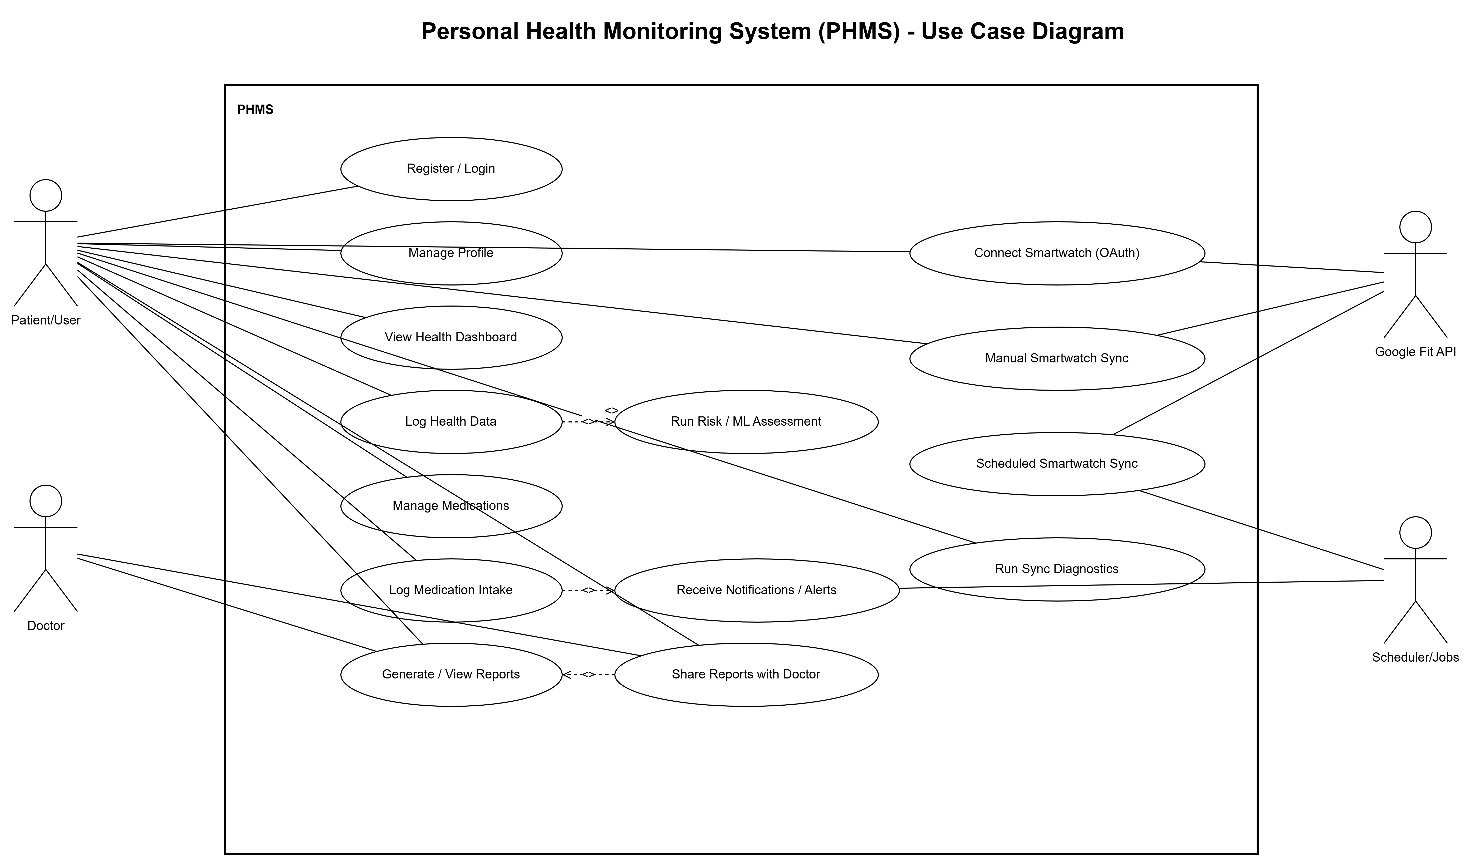
Figure 4.1 PHMS Use-Case Diagram

Non-Functional Requirements

Security requirements
CSRF protection
configurable rate limiting
environment-based secret management

Reliability requirements
retry and recovery in sync flow
failure-isolation during batch smartwatch sync jobs

Maintainability requirements
layered architecture with feature route groups
test coverage for smartwatch and scheduler workflows

Performance requirements
incremental sync boundaries
deduplication logic to avoid duplicate ingestion

Usability requirements
clear page-level status indicators
diagnostic summaries for pre-sync visibility

Chapter 5: System Design
To ensure maintainability and clear separation of concerns, PHMS follows a layered architecture with explicit boundaries between transport, business logic, and persistence layers. Structural and behavioral design views are included to document both static relationships and runtime interactions.

High-Level Architecture
PHMS follows an MVC-inspired and layered service architecture:
presentation layer: HTML templates and static assets
route/controller layer: request transport and endpoint handling
service layer: business rules and orchestration
repository layer: persistence abstraction
data layer: SQLAlchemy models and migrations
jobs layer: scheduler callbacks for automated workflows
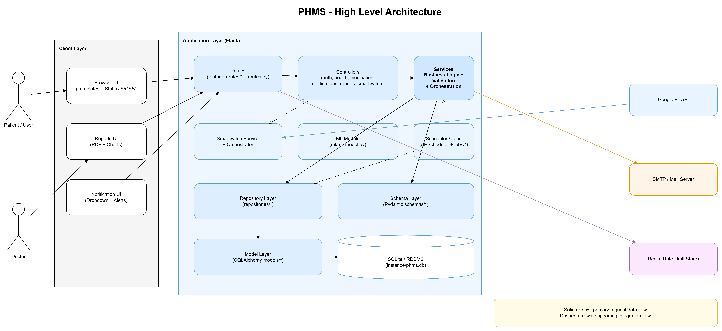
Figure 5.1 PHMS High Level Architecture Diagram

Major Modules

Authentication module
login, registration, password-reset support

Health module
manual ingestion and score computation
ML prediction integration

Medication module
medication records, schedules, and lifecycle actions

Notifications module
alert creation and reminder interfaces

Reports module
user-facing summaries and printable output support

Smartwatch module
OAuth authorization
sync now and status endpoints
pre-sync diagnostics
adaptive fetch and merge in provider adapter

Scheduler module
daily and interval jobs
smartwatch periodic sync for connected accounts

Database Design Summary

Core entity categories
users and authentication support
health records and alert records
medication, medicine catalog, and medication logs
smartwatch account state and sync boundary state
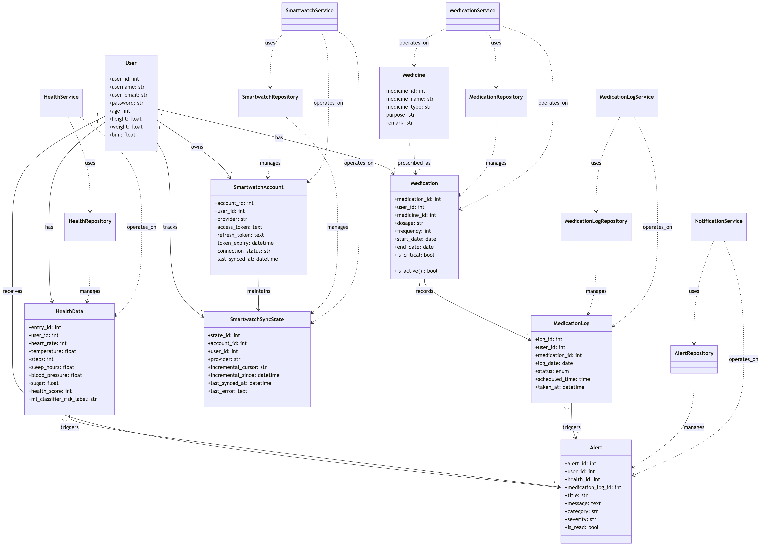
Figure 5.2 PHMS Class Diagram

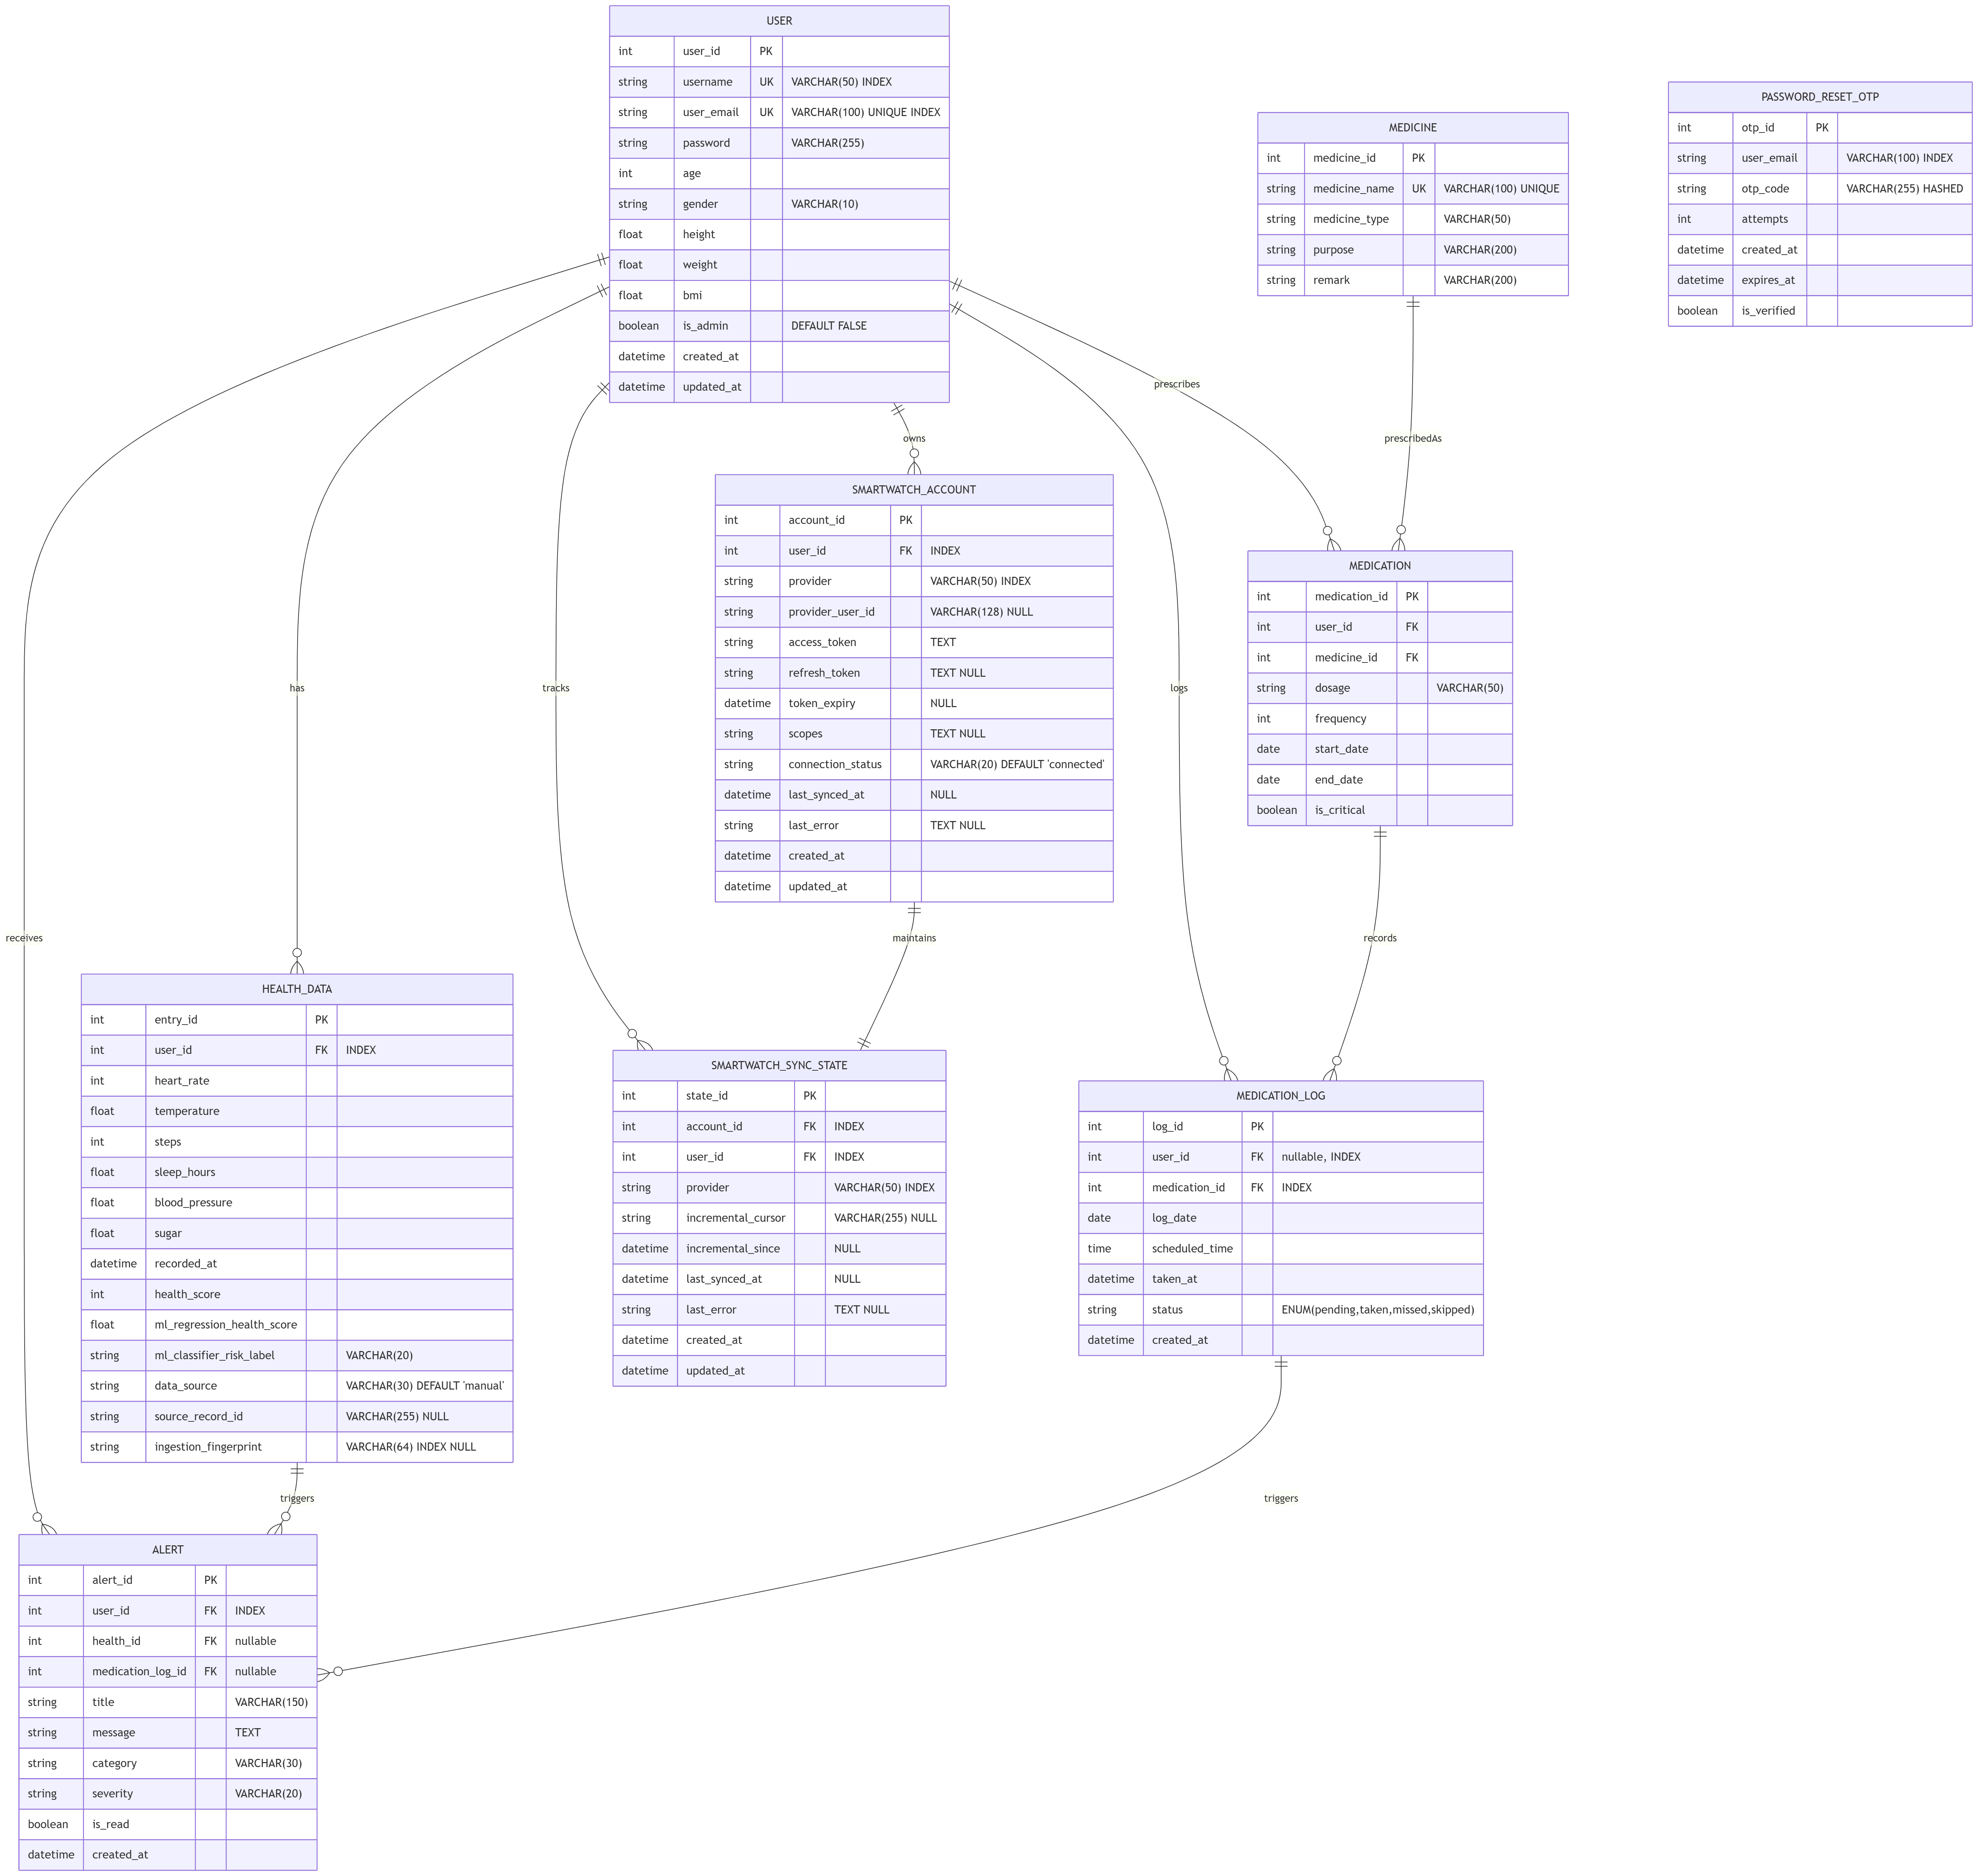
Figure 5.3 PHMS ER Diagram

Smartwatch Sync Design
Smartwatch flow includes
OAuth token acquisition and refresh
fetch context with optional cursor/since boundaries
adaptive lookback windows for missing metric families
merge of available metrics without value fabrication
partial payload forwarding to canonical ingestion pipeline
sync-state updates for next incremental boundary

Scheduler Design
Scheduler setup registers recurring jobs with configurable interval and safety controls:
max_instances, misfire_grace_time, coalesce
The smartwatch periodic job syncs only connected accounts and isolates failures per account.

The context DFD shows high-level system boundaries and external interactions:
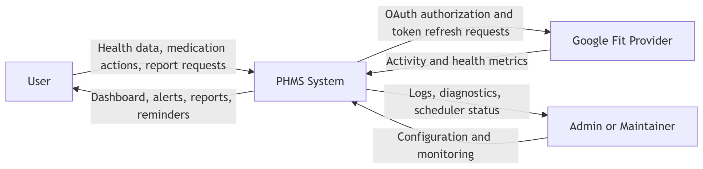
Figure 5.4 Context DFD for PHMS

The Level-1 DFD decomposes PHMS into six core processes with their persistent stores:
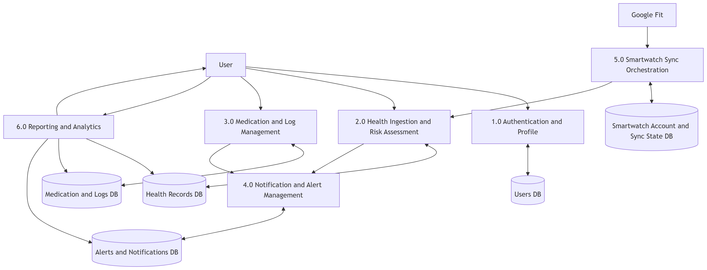
Figure 5.5 Level-1 DFD for PHMS Core Modules

Chapter 6: System Implementation
Implementation behavior in PHMS is validated through runtime flow diagrams covering canonical health ingestion, medication log updates, notification generation, smartwatch synchronization, and report generation. These flows explain internal orchestration from route entry to persistence and user feedback.

Technology Implementation
Backend implementation uses Flask and SQLAlchemy with feature route registration and explicit service orchestration. Smartwatch integration is implemented using provider adapters and a shared sync orchestrator. Health ingestion follows a canonical pipeline to preserve validation and risk-scoring behavior across manual and smartwatch sources.

Health Ingestion Pipeline
The pipeline accepts health payloads and performs:
schema validation
deduplication checks
score and ML assessment
health record persistence
alert creation and optional notification behavior
For smartwatch source, strict completeness policy is enforced for required metrics before final insertion.

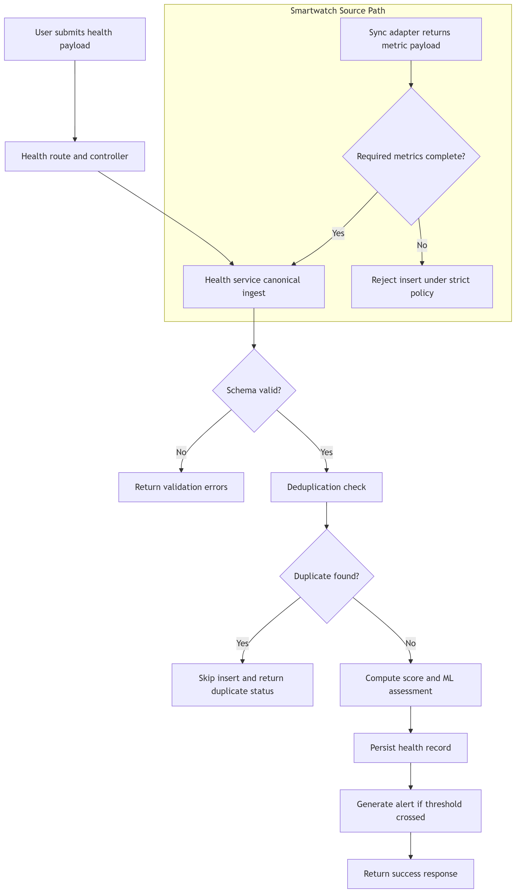
Figure 6.1 Health Ingestion Canonical Pipeline

Smartwatch Adapter Implementation

Google Fit adapter behavior includes
OAuth authorization URL generation
token exchange and refresh support
aggregate API requests for metric families

Data extraction rules
steps are summed
heart rate is averaged
sleep segments are converted and aggregated to hours
blood pressure extraction prioritizes systolic values

Additional sync reliability behavior
adaptive windows and missing-metric-only retry requests
final diagnostics logging before payload return

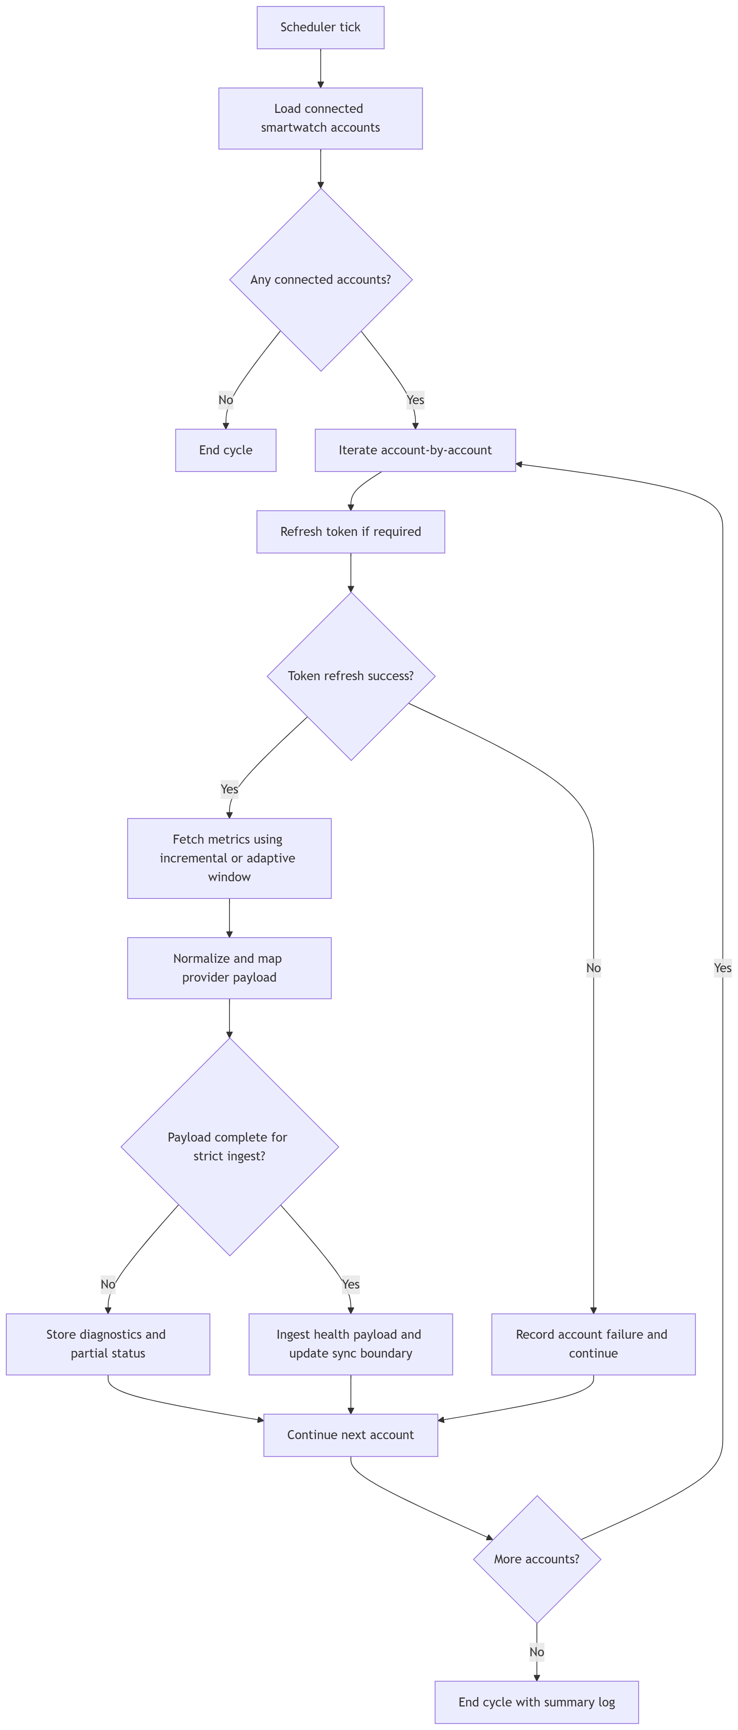
Figure 6.2 Scheduler Periodic Sync Flow

Smartwatch Sync Error Recovery Flow
The smartwatch synchronization recovery flow begins with provider-side data retrieval for a connected account. Following retrieval, the system evaluates the response for operational errors. If no error is detected, normalized data is persisted and the synchronization cycle is marked successful. If an error is present, it is classified as transient or permanent. Transient failures are scheduled for controlled retry using backoff policy, whereas permanent failures produce actionable user-facing guidance for corrective intervention. This recovery strategy increases synchronization robustness and reduces the risk of silent data staleness across subsequent sync cycles.
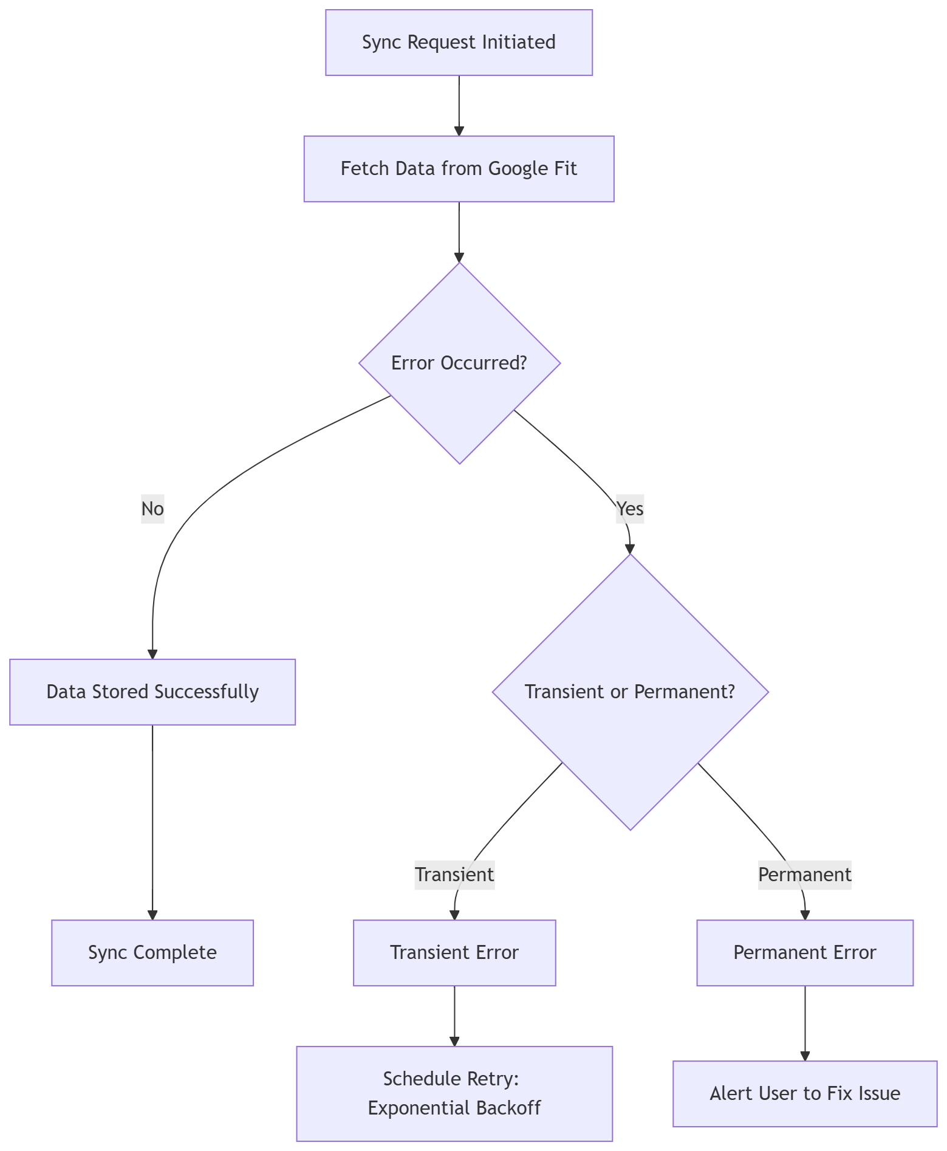
Figure 6.3 Smartwatch Sync Error-Recovery Flow

Medication Log Lifecycle Flow
The medication log lifecycle is initiated when a scheduled log entry is created and assigned a pending status. At the scheduled administration time, the system verifies whether a medication action has been recorded. In the absence of a recorded action, the entry remains pending and is subsequently governed by grace-window evaluation logic. During the grace period, explicit user action may transition the log to either taken or skipped. If no intake action is captured before grace-window expiry, the status is updated to missed. This state model provides a consistent and auditable basis for adherence monitoring, reminder generation, and longitudinal reporting.
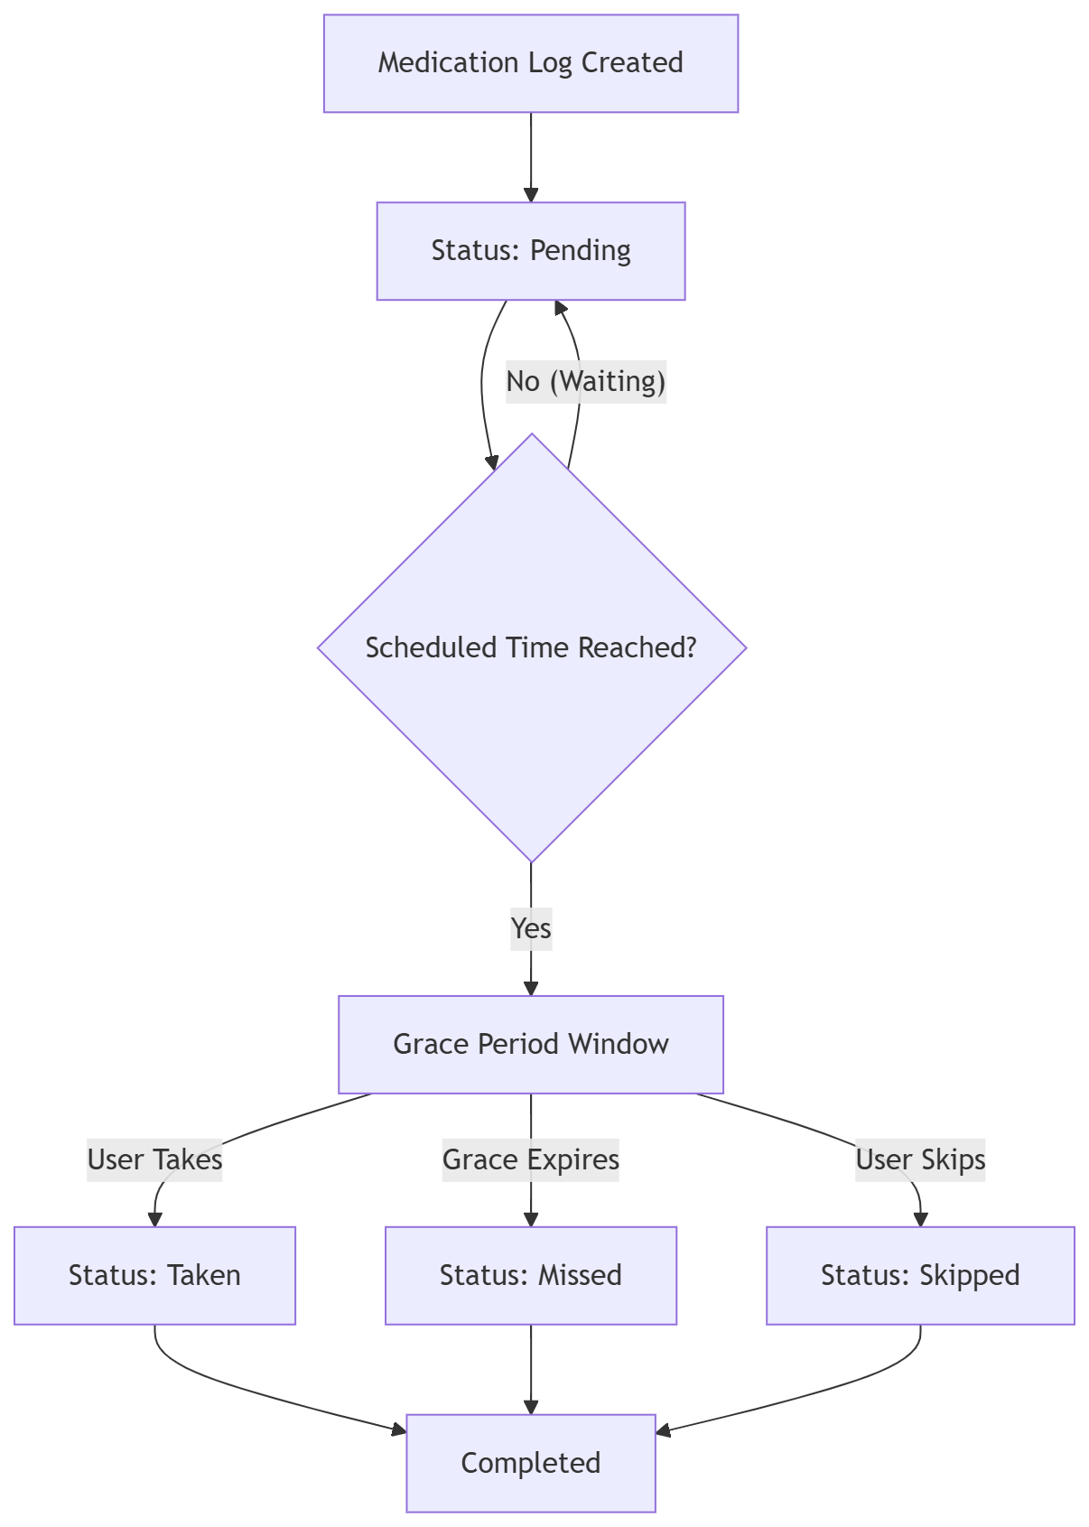
Figure 6.4 Medication Log Lifecycle Flow

Notification Generation Flow
The notification generation flow is triggered by either a health-related event or a medication-related event. The system first classifies the event type and routes execution to the corresponding rule pathway. For health events, notification eligibility is determined through risk-severity evaluation. For medication events, adherence status is assessed to identify missed or delayed doses. Notifications are dispatched only when rule conditions are satisfied, using configured channels such as push or email. This selective policy minimizes non-essential alerts and improves the clinical relevance of user-facing notifications.
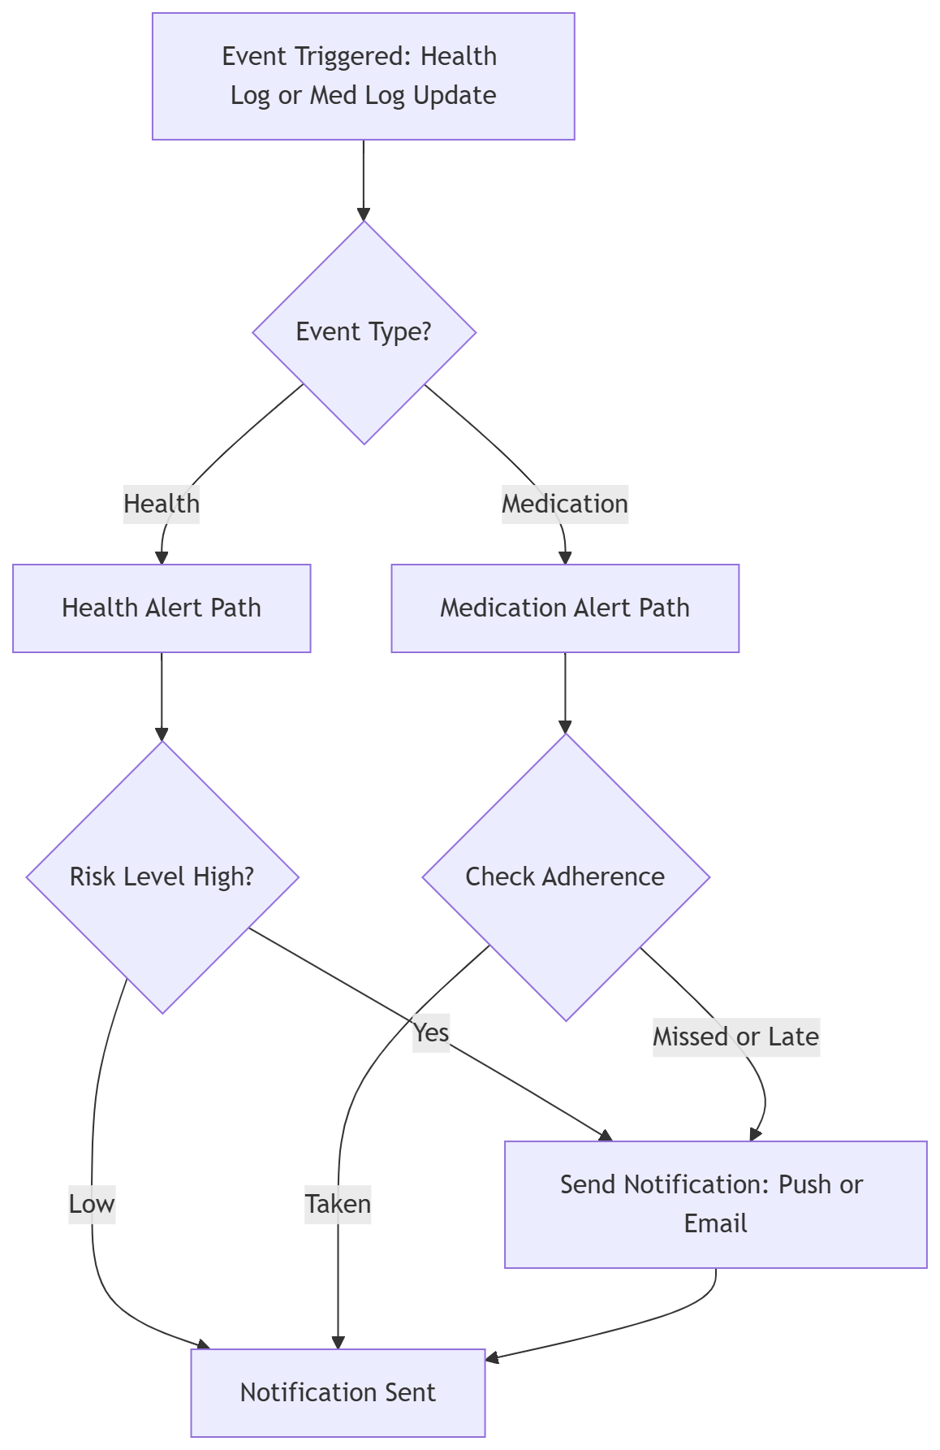
Figure 6.5 Notification Generation Flow

Report Generation Flow
The report generation flow is initiated when a user submits a report request for a specified date interval. Prior to data access, the system validates temporal consistency of the selected range. Invalid intervals are rejected with explanatory feedback, and the user is prompted to resubmit corrected input. For valid intervals, the system aggregates health records, medication logs, and adherence indicators from the relevant data stores. A structured PDF report is then generated, including summary sections and graphical representations where applicable. The generated artifact is persisted and exposed to the user through a controlled download mechanism.
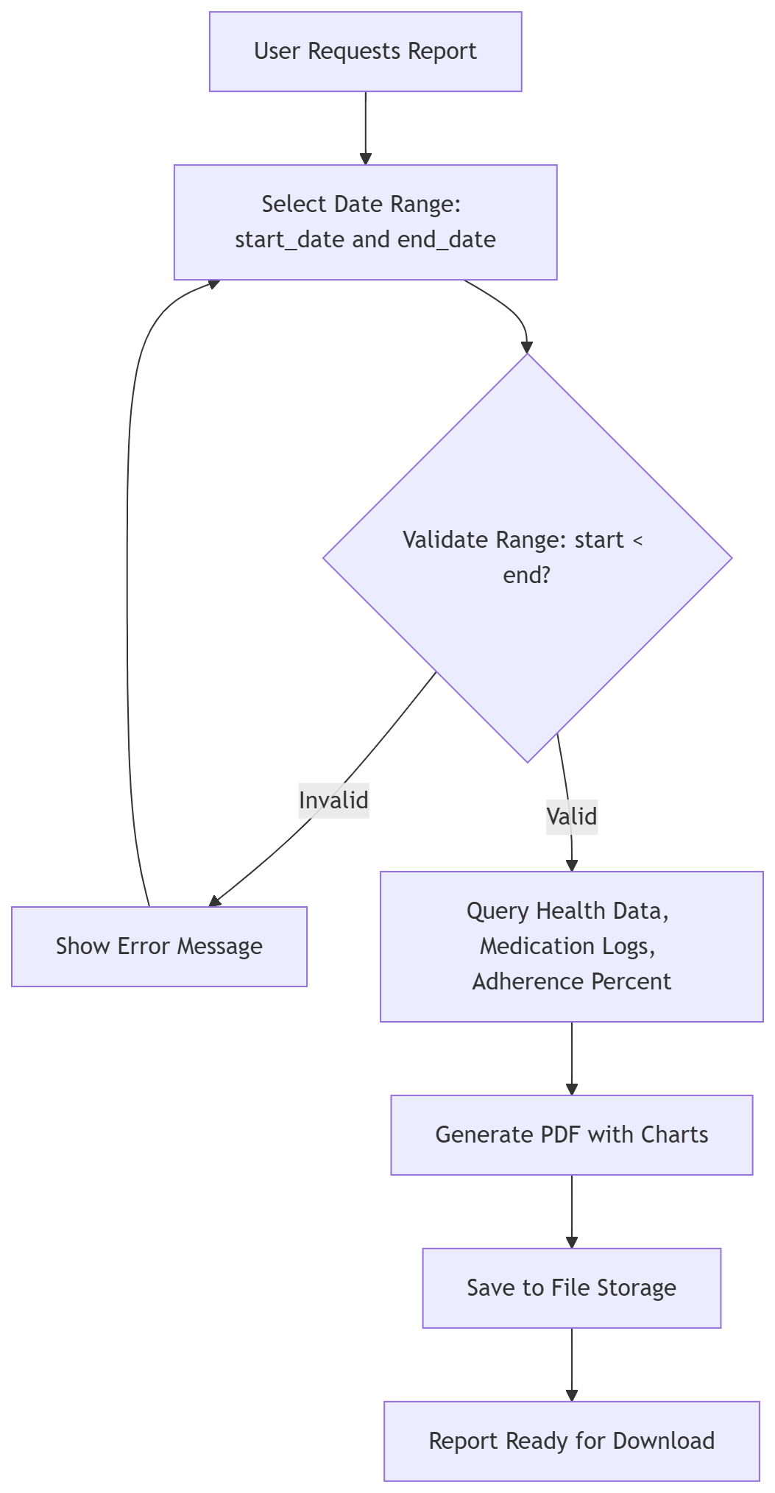
Figure 6.6 Report Generation Flow

Reliability and Error Handling
Implemented strategies:
explicit exception handling with actionable messages
retry with backoff for transient failures
per-account sync failure isolation
state-preserving fallback when incremental windows return empty results

Use Interface Screenshots

Authentication Interface
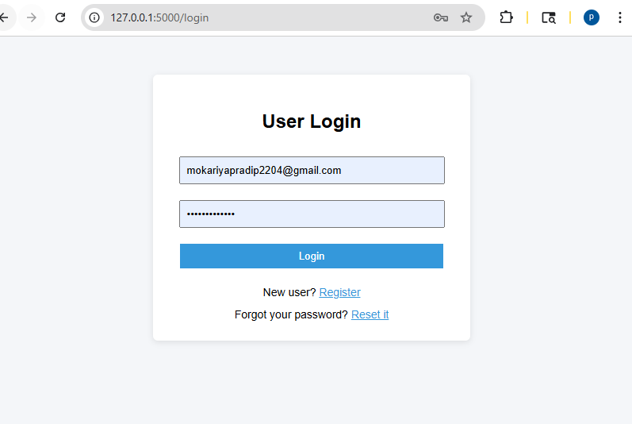
Figure 6.7 Login page
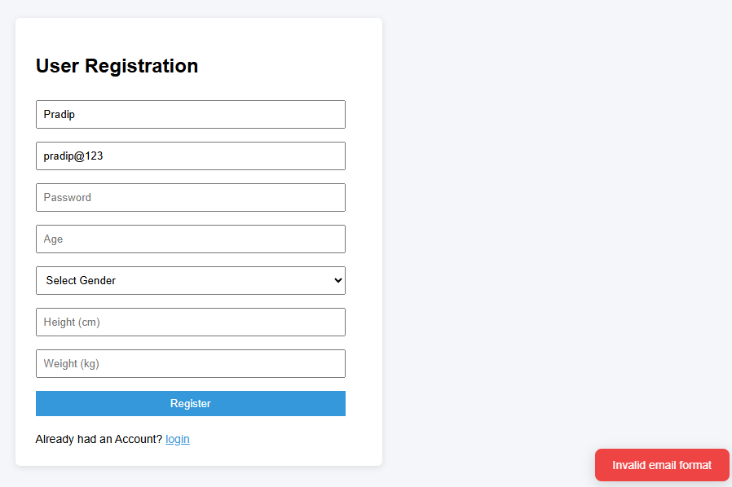
Figure 6.8 Registration Page - validation
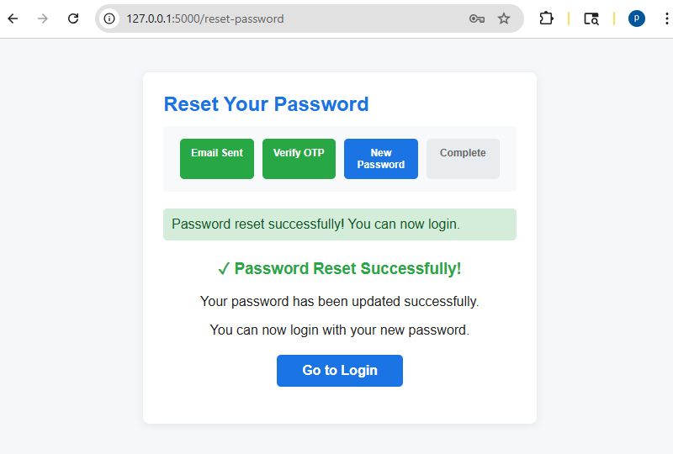
Figure 6.9 Forgot Password Page - Using OTP verificcation

Dashboard Overview
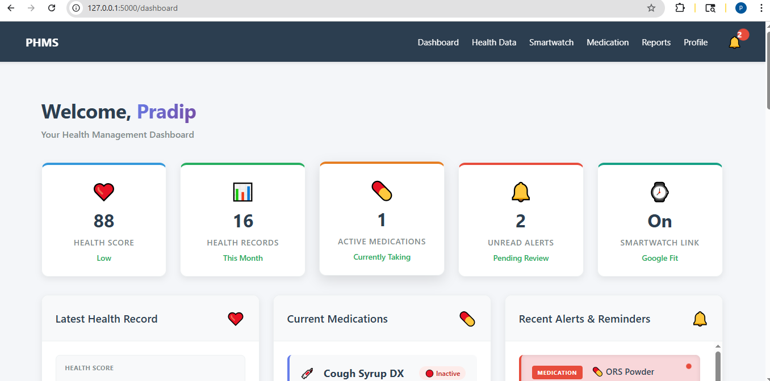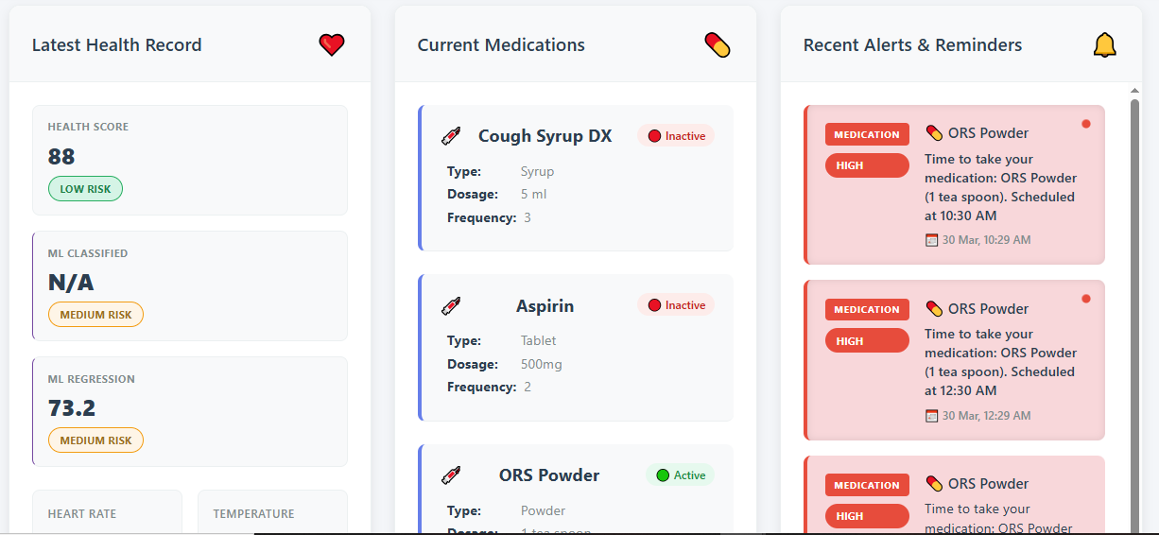
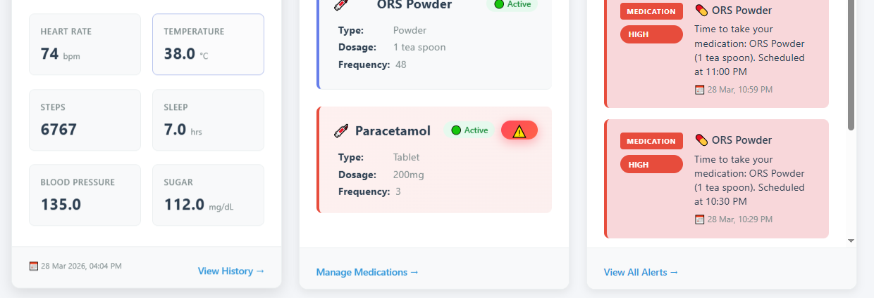

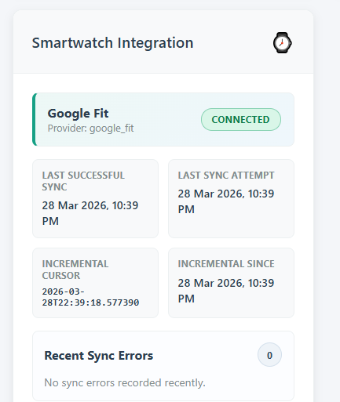

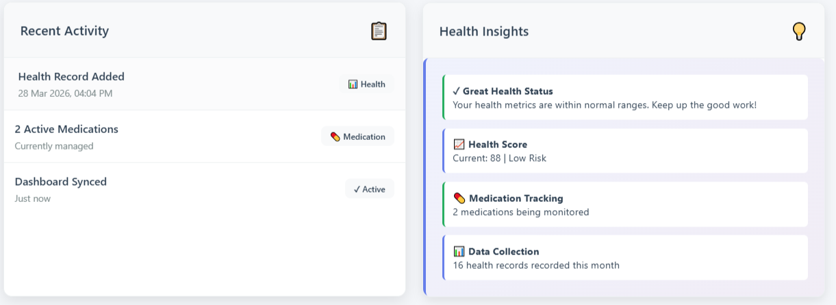
Figure 6.10 Dashboard Summary View

Health Module Interface
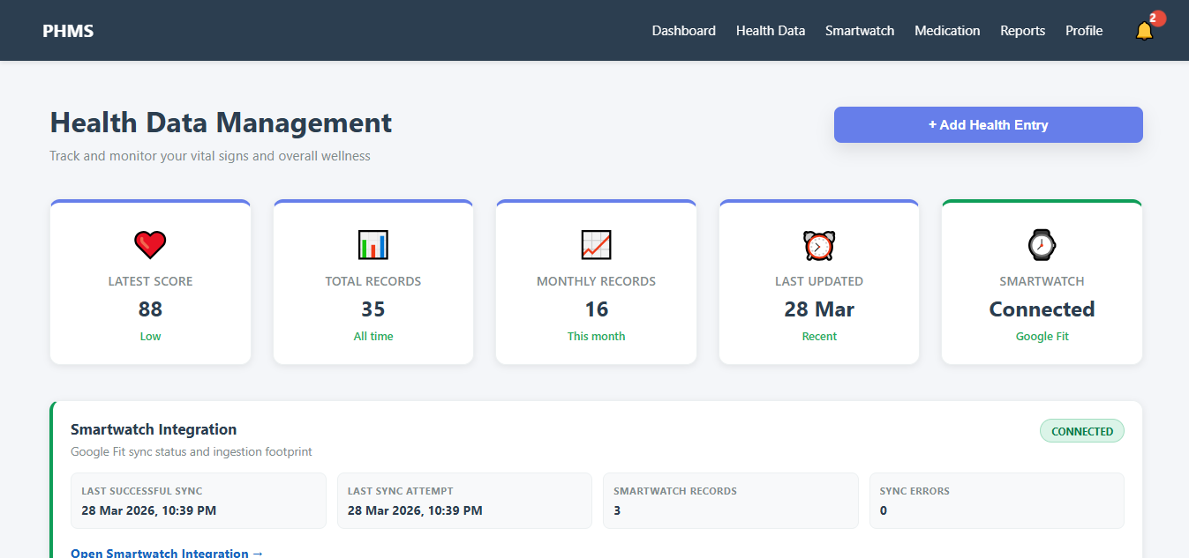
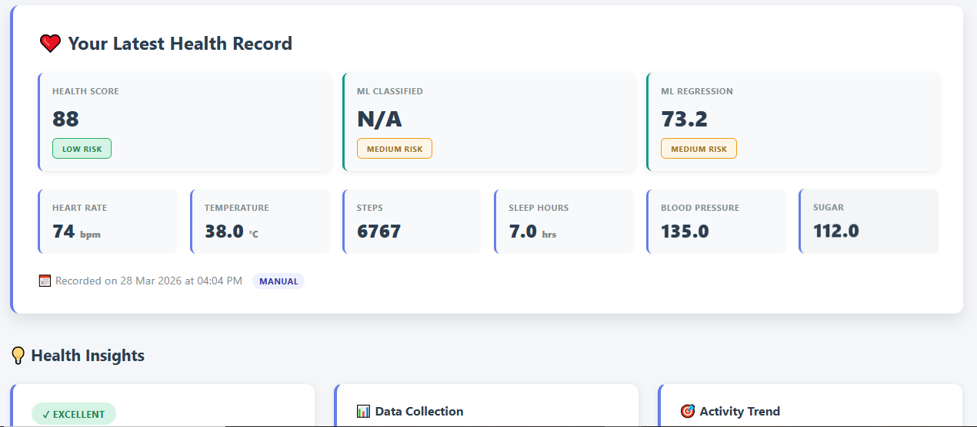
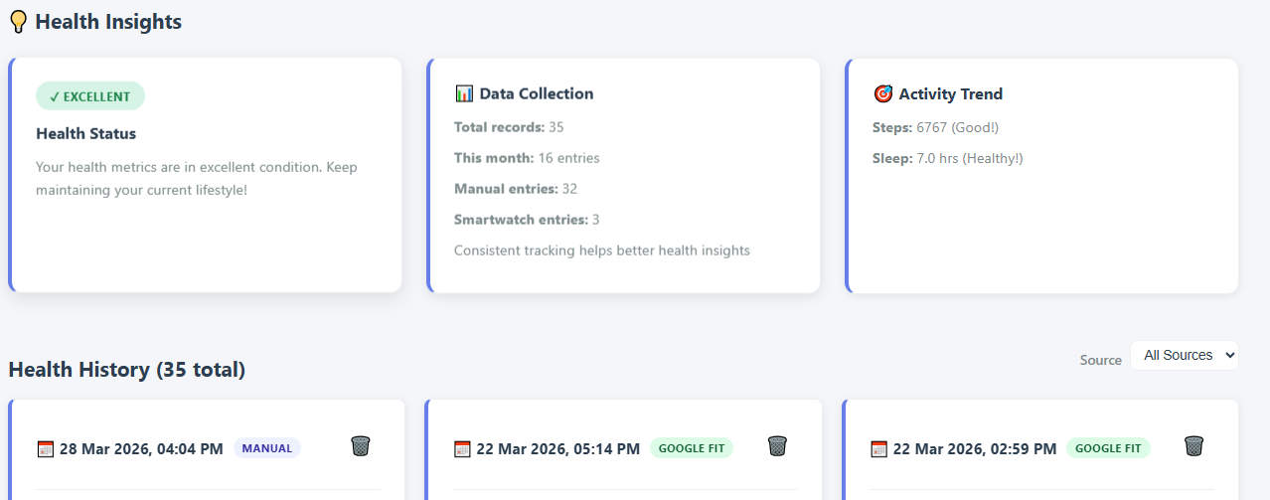
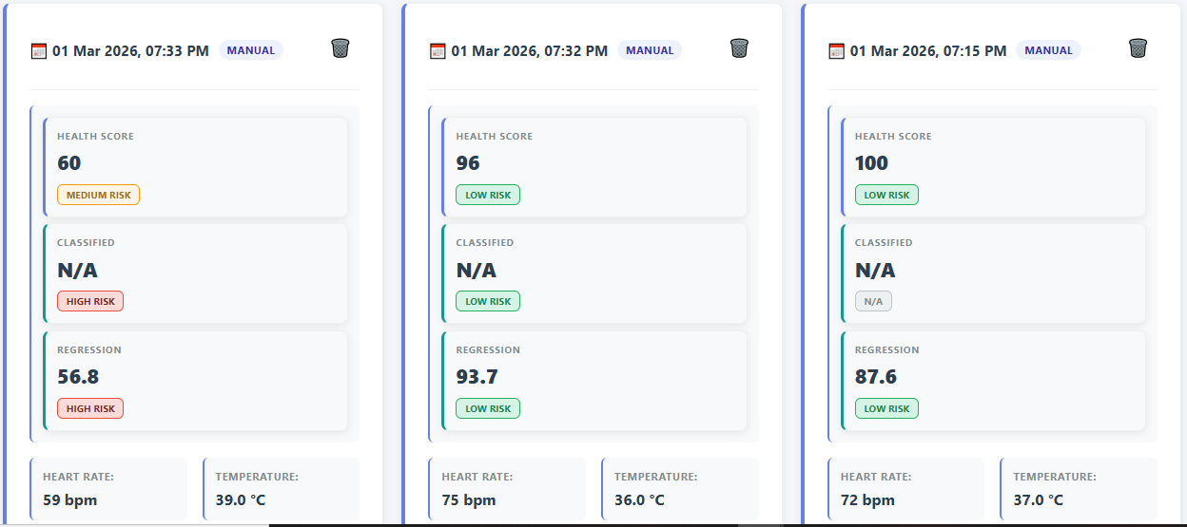
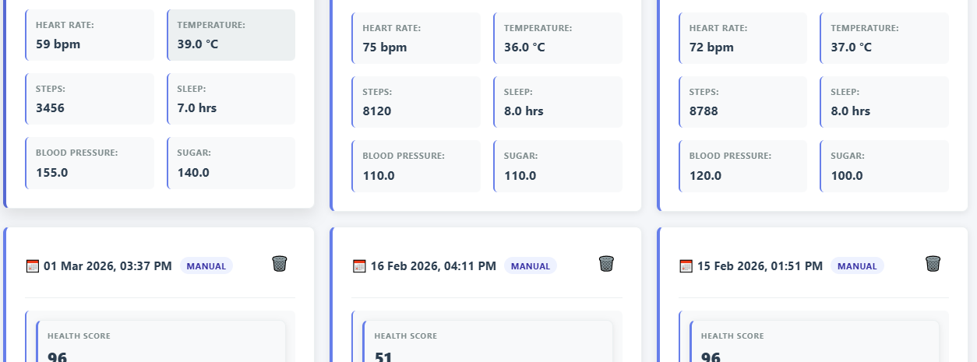

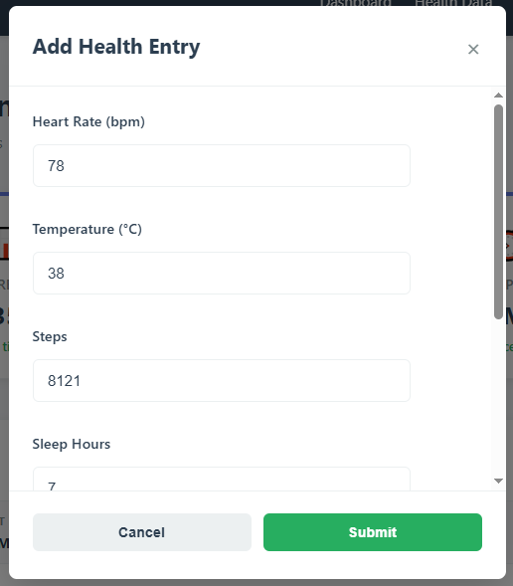
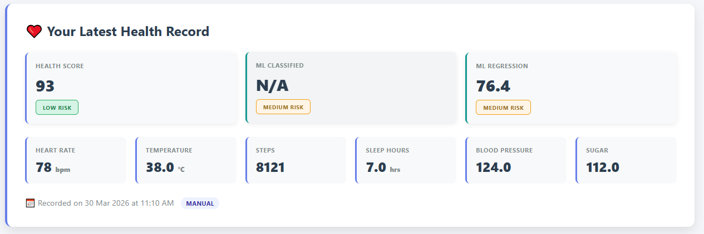
Figure 6.11 Health entry page

Medication Management
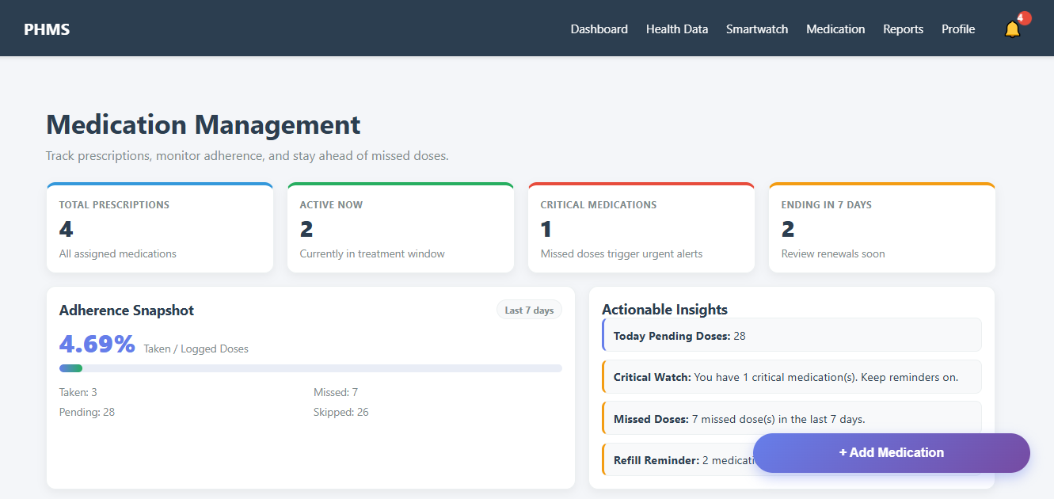
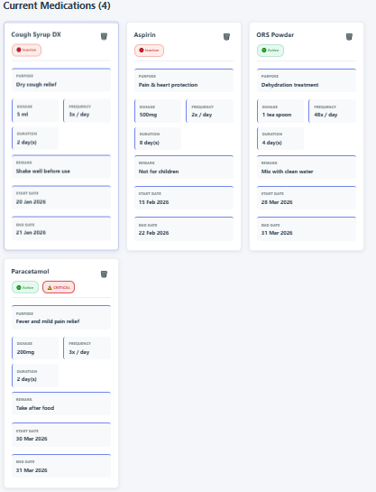

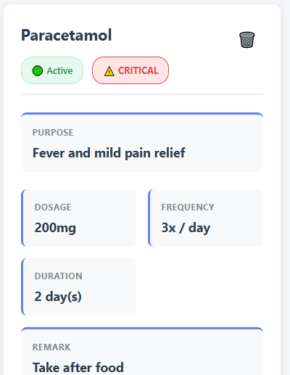 | 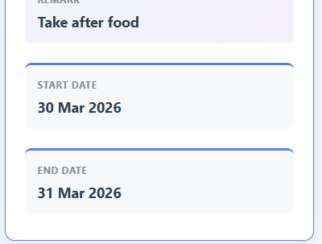
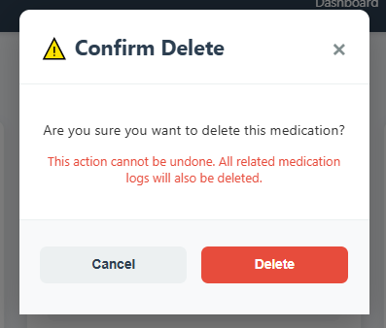 | 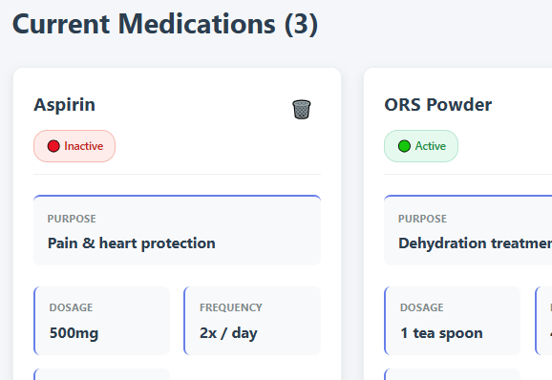
Figure 6.12 Medication management

Medicines in Medication Page
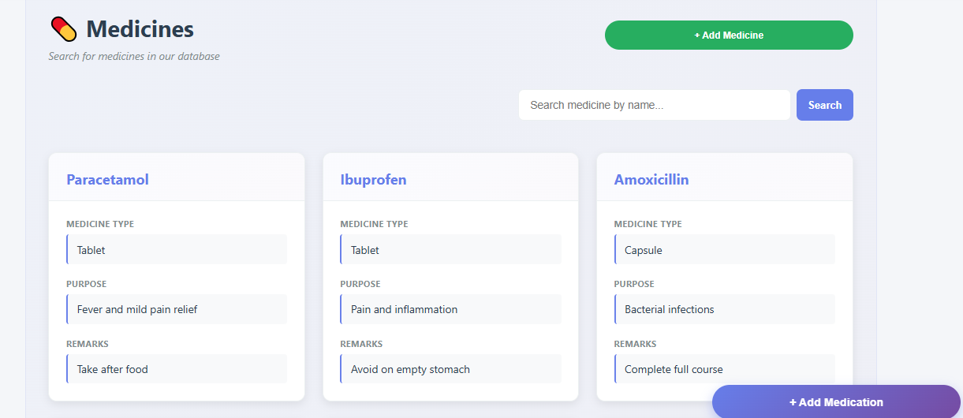
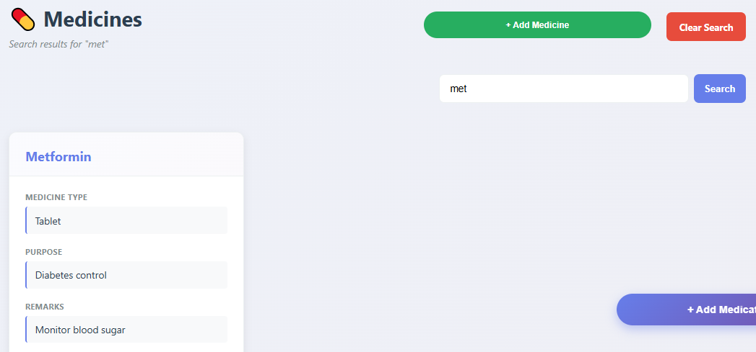
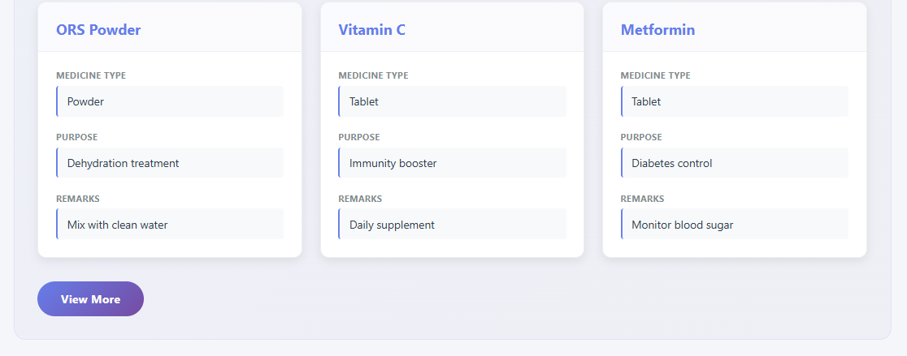
Figure 6.13 Medicines - In Medication Page

Notification Center
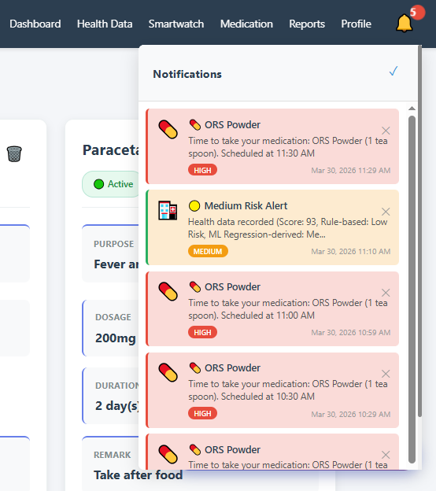
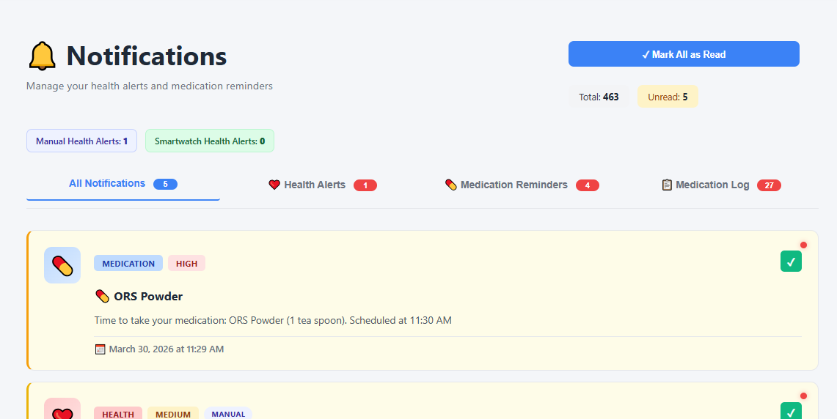

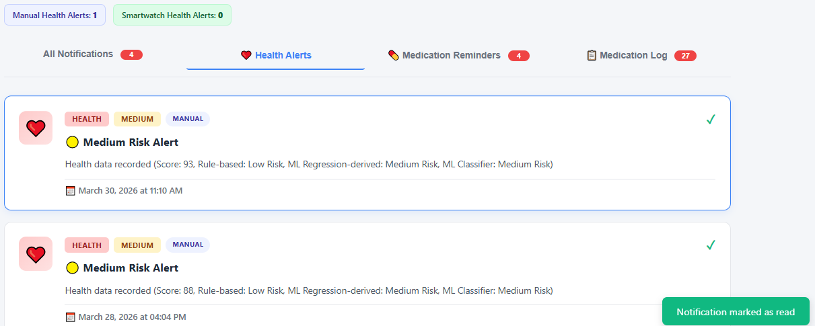
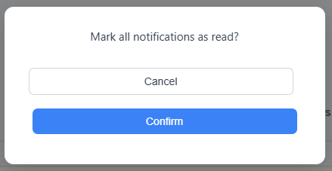
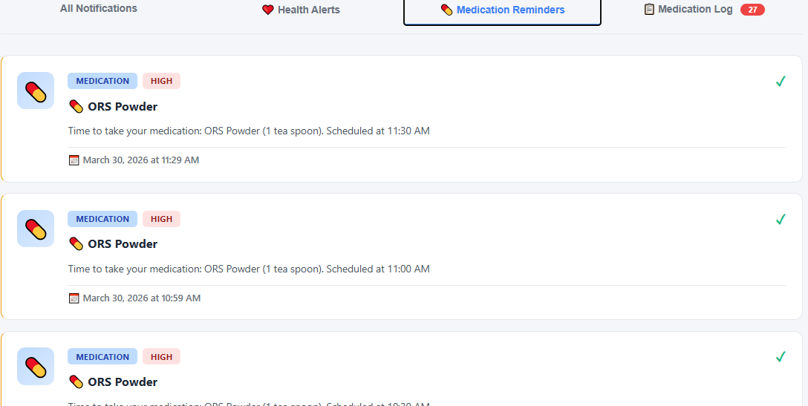
Figure 6.14 Notification Center

Medication Logs Management
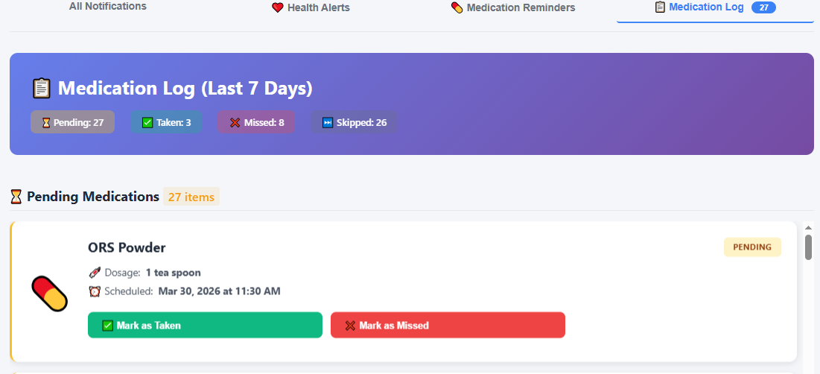
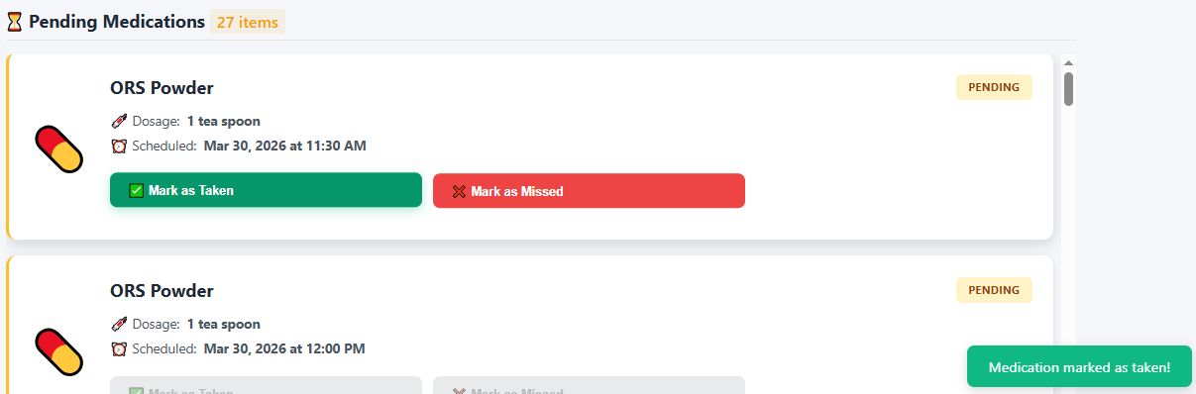
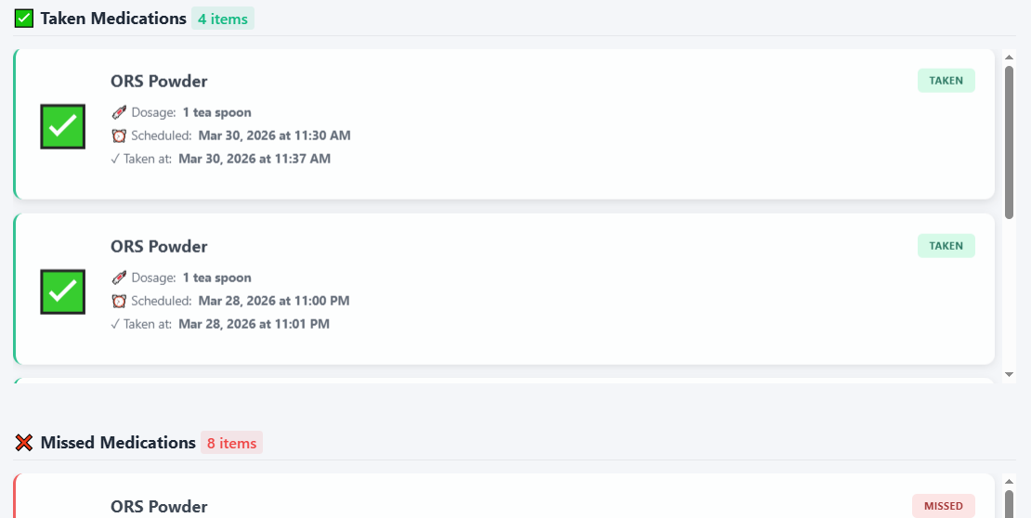
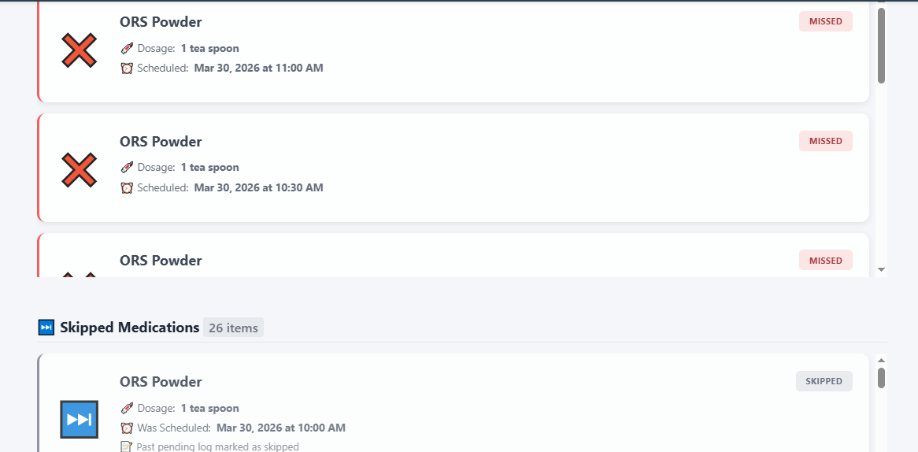
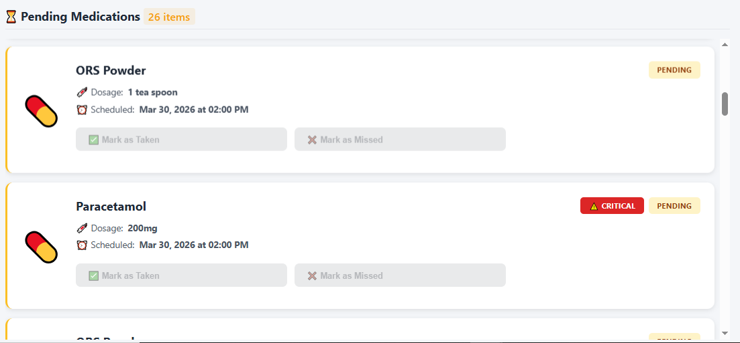
Figure 6.15 Medication Logs - Scheduled/Pending + Taken/Missed/Skipped

Report Page
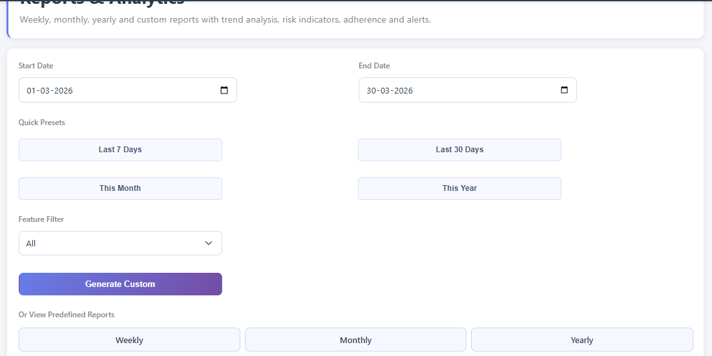
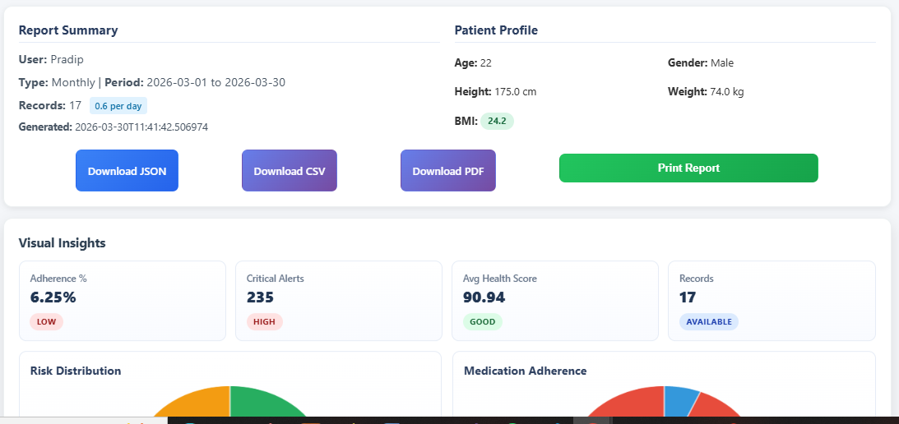
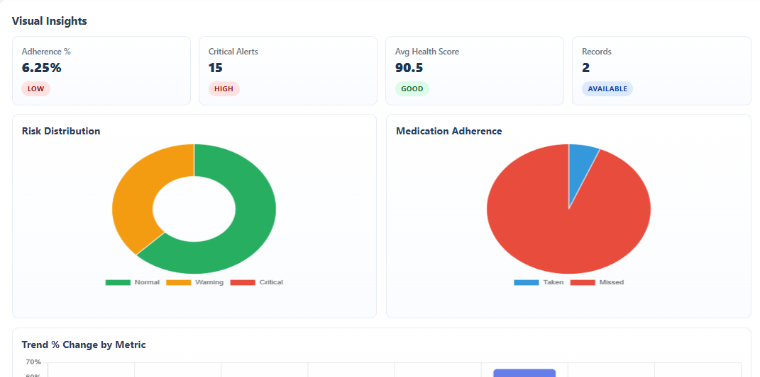
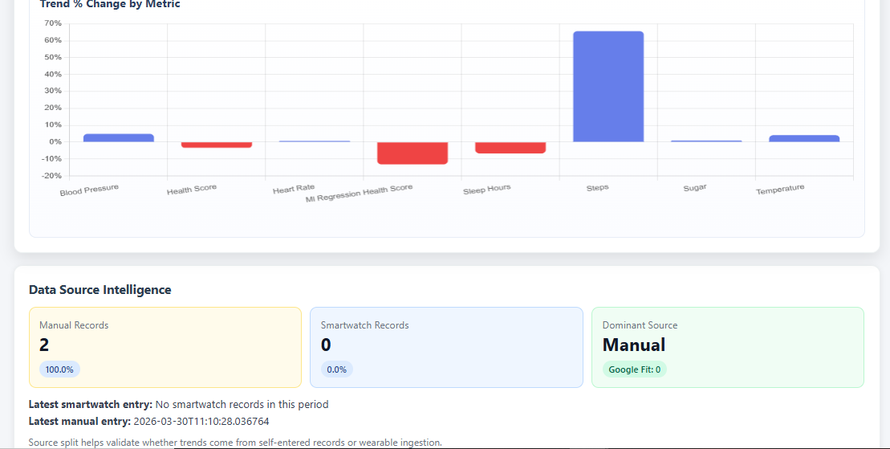
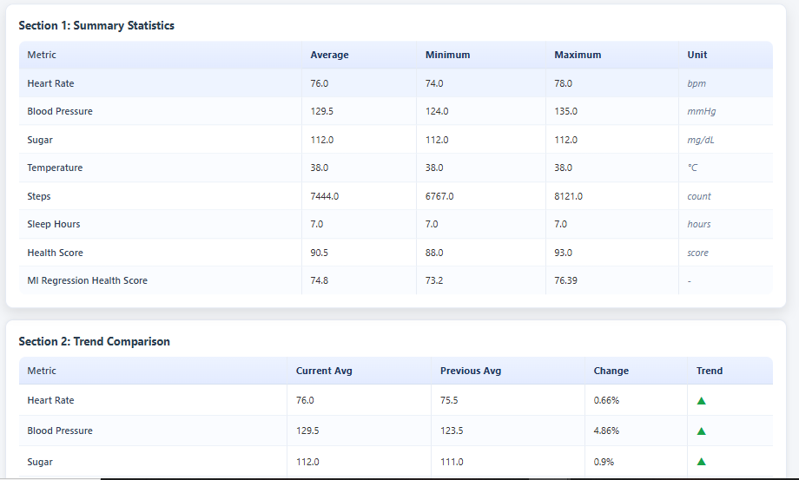

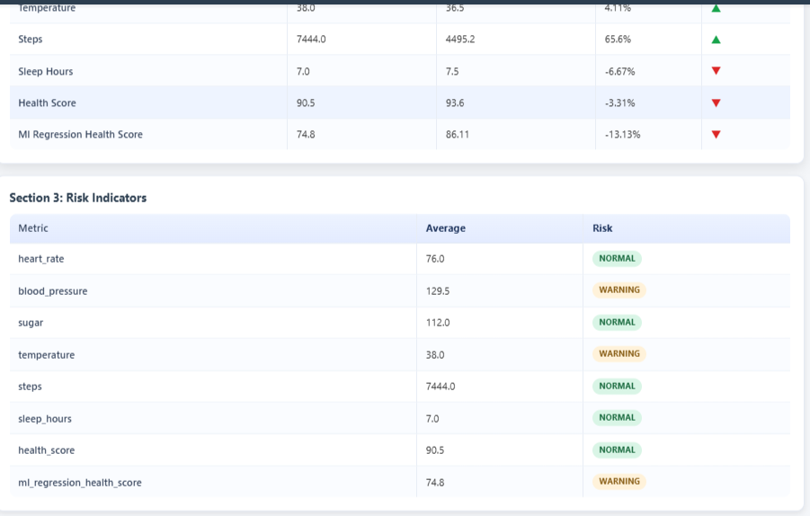
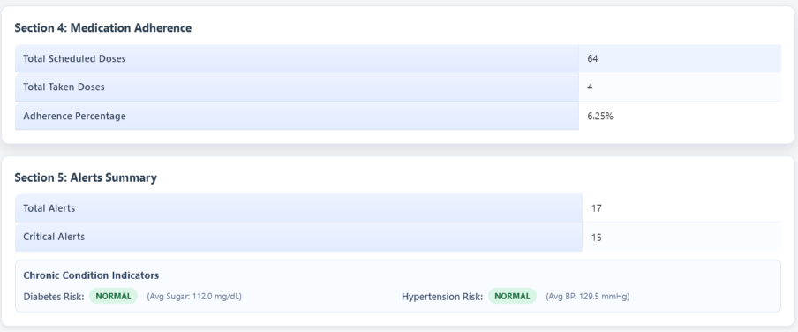
Figure 6.16 Report Page
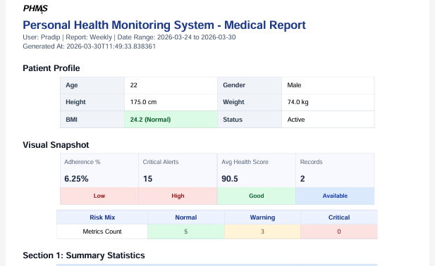
Figure 6.17 Report PDF - Genrated

SmartWatch Sync Page
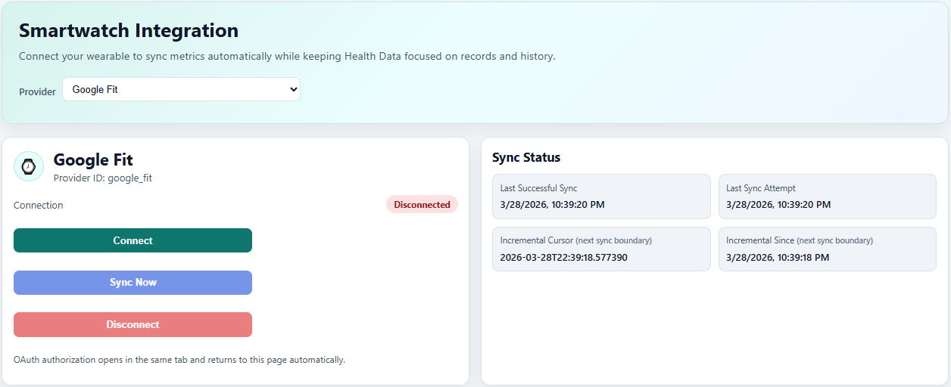
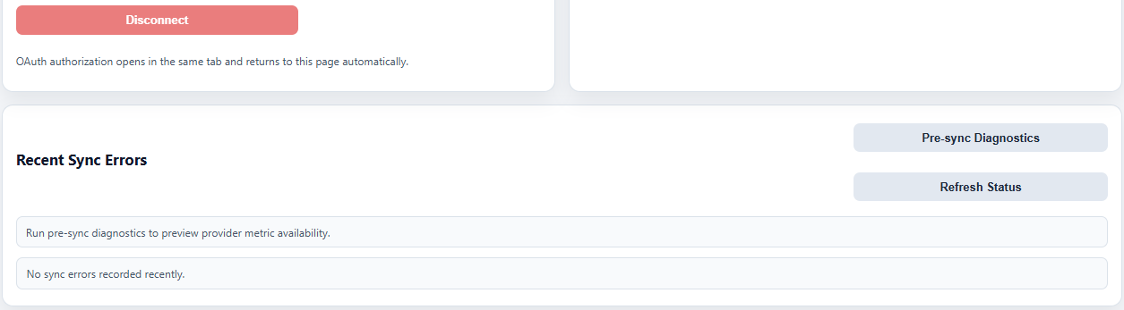
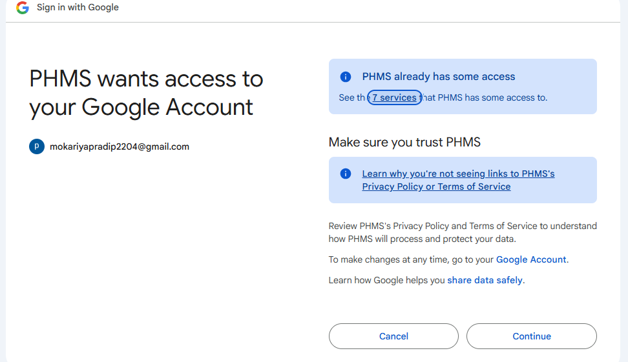

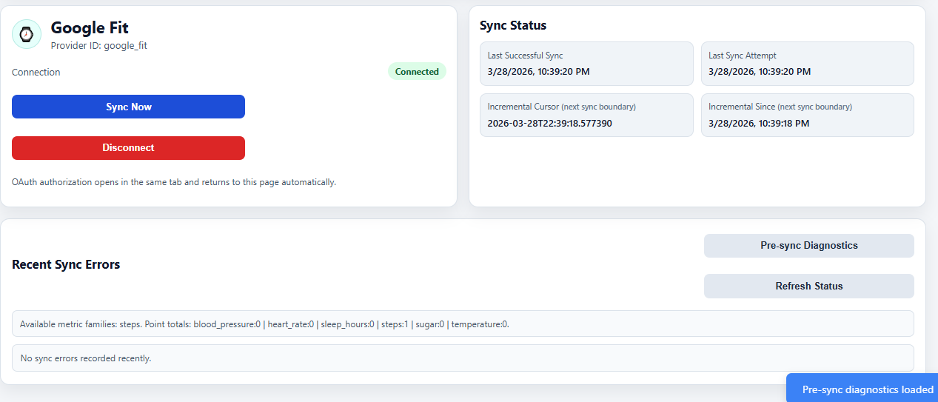
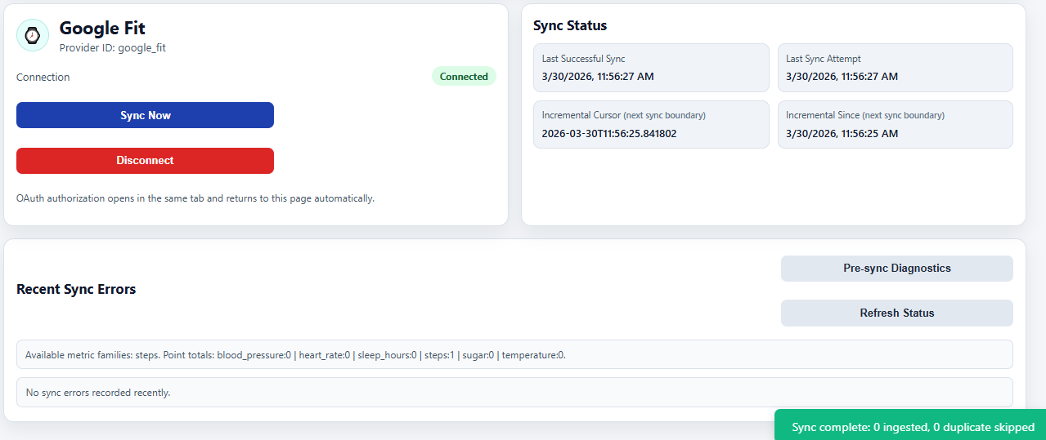

Profile Page
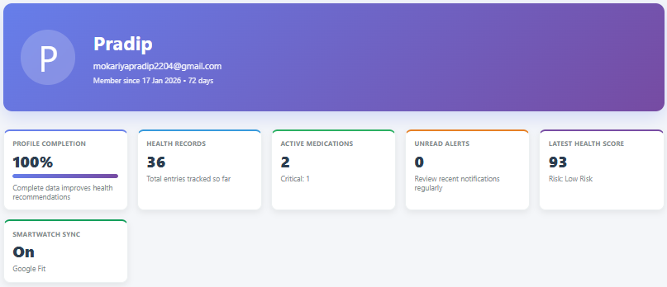
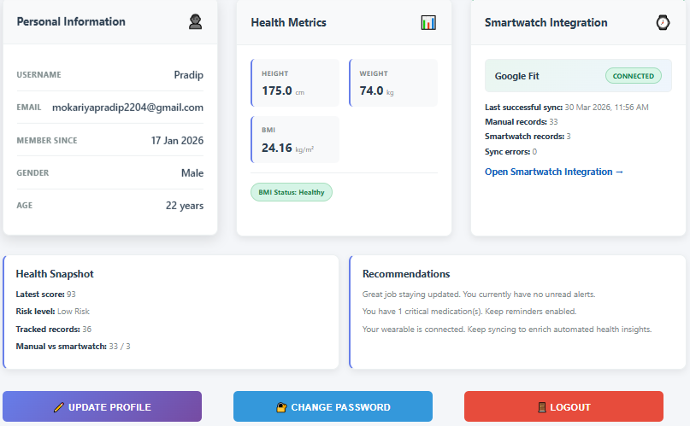
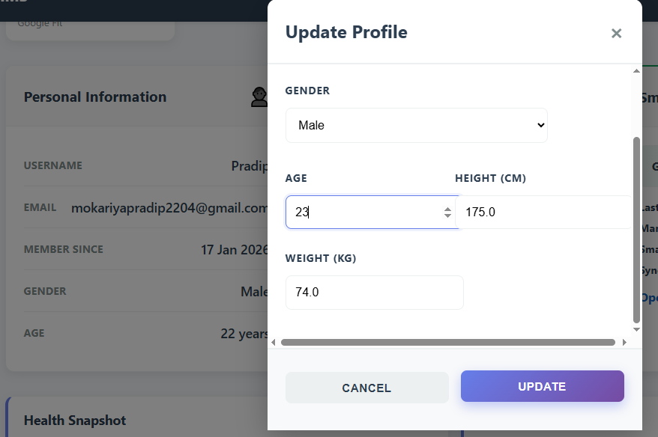
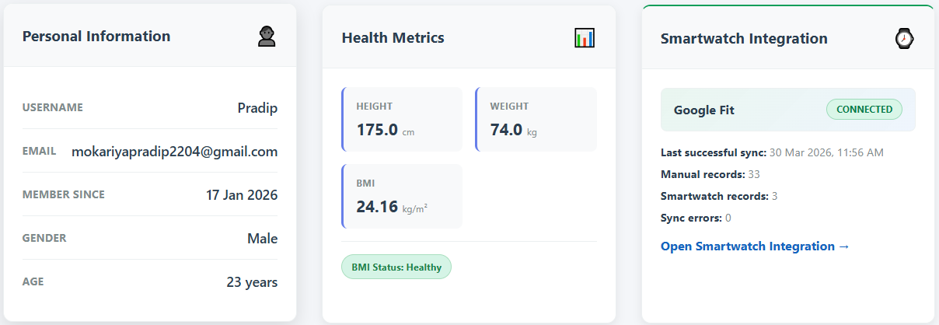
Figure 6.18 Profile Management Page

Email Notification Features

User Registration Successful Email
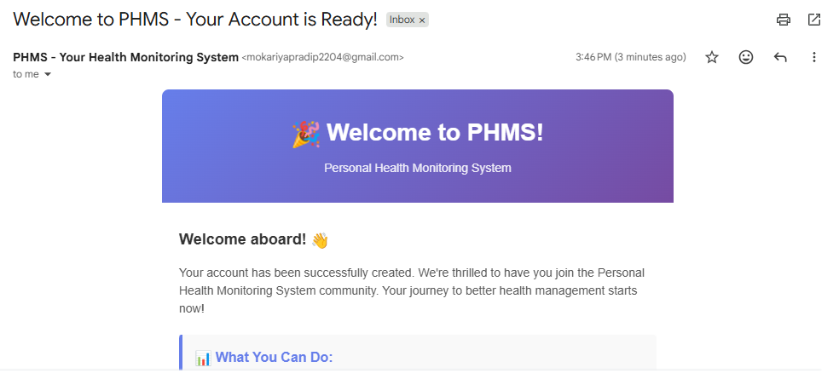
Figure 6.19 User Registration Successful Email

Forgot Password – Reset Password OTP Email
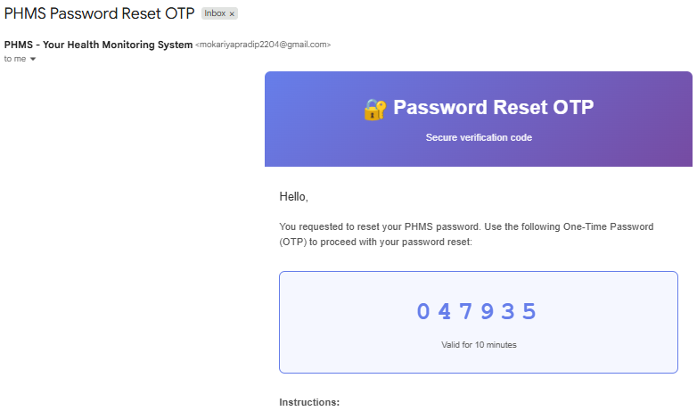
Figure 6.20 Reset Password - OTP Email

Password Reset Successful Email
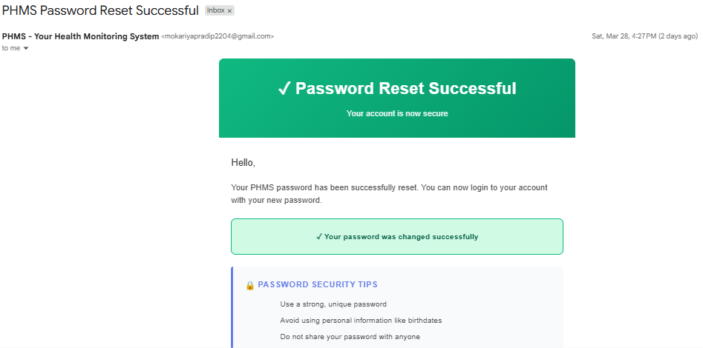
Figure 6.21 Password Reset Successful Email

Password Reset Failure Email
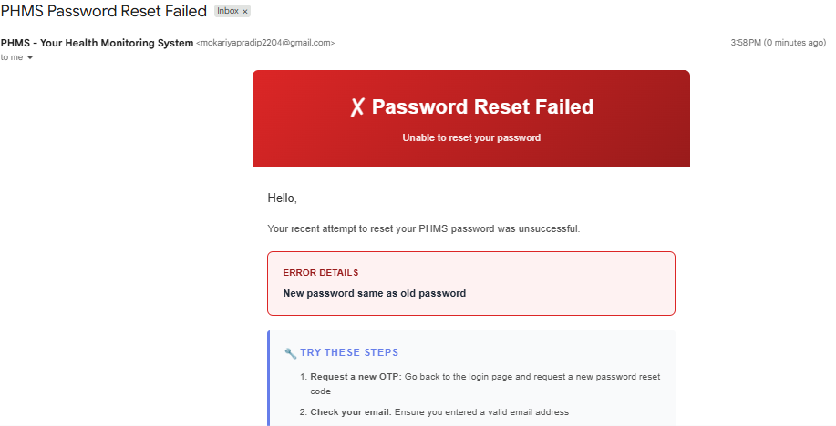
Figure 6.22 Password Reset Failure Email

Critical Medication Reminder Email
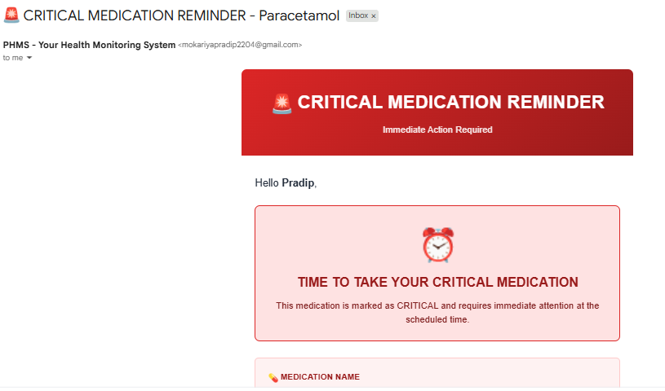
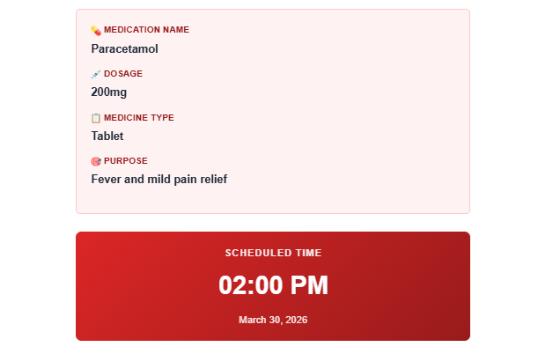
Figure 6.23 Critical Medication Remider Emial

Critical Medication Missed Email
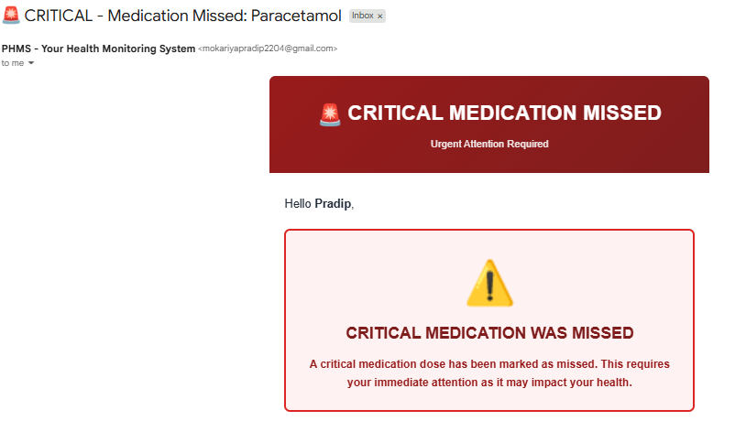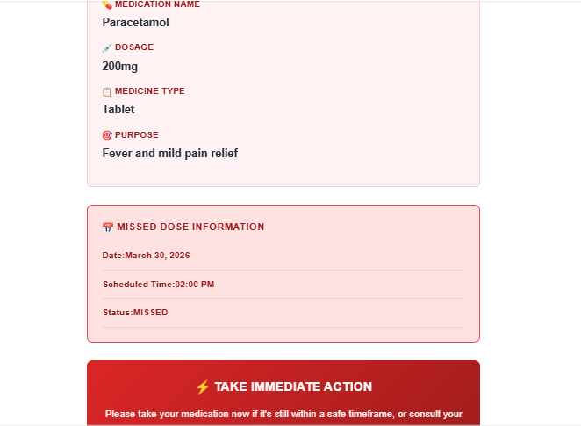
Figure 6.24 Critical Medication Missed Email

Consecutive Missed Medication Email
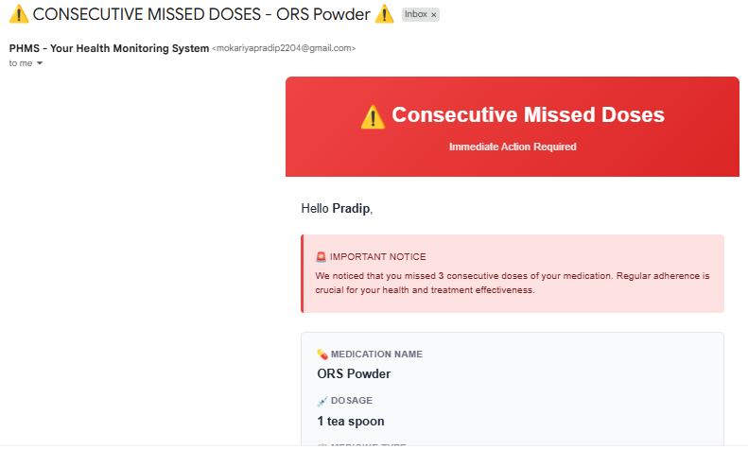
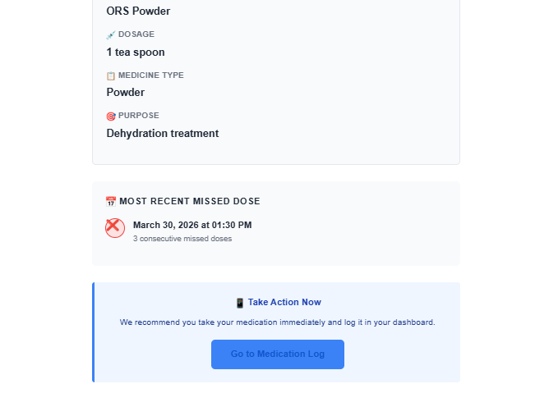
Figure 6.25 Consecutive Medication Missed Email

High Risk Health Indicator Detected Email
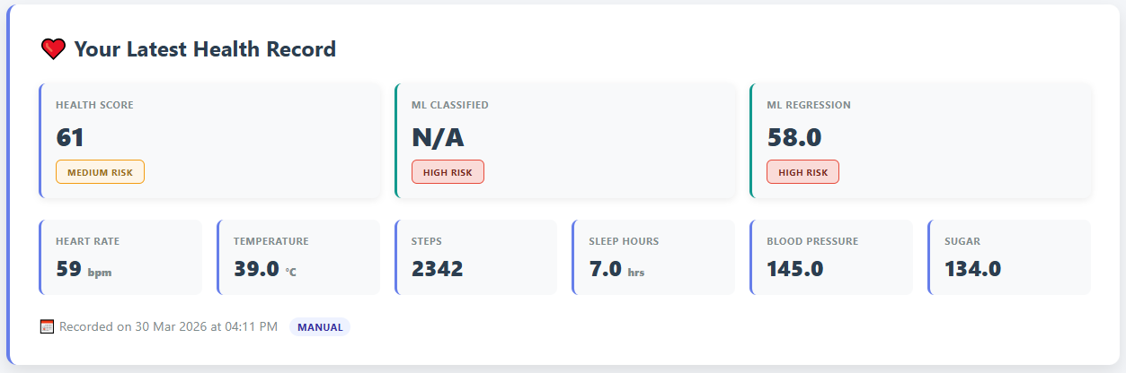
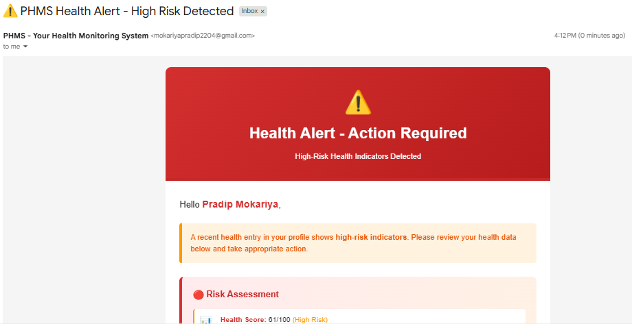
Figure 6.26 High Risk Health Indicator Detected Email

Chapter 7: Testing and Validation

Behavioral Validation with Sequence and State Models
Behavioral validation is supported using sequence and state-machine models to confirm event ordering, transition correctness, and fault-resilient behavior in asynchronous workflows.

Sequence: Smartwatch OAuth and Manual Sync
The smartwatch integration supports OAuth2-based authorization with Google Fit followed by manual data synchronization. The sequence traces the complete flow from user-initiated connection request through token exchange and manual sync invocation. The system generates an OAuth authorization URL, redirects the browser to Google Fit for user consent, processes the returned authorization code, exchanges it for an access token, and persists the smartwatch account state. Upon subsequent user request, the system fetches provider data and ingests it through the canonical health pipeline. This design ensures secure token management and clear audit trails for third-party integrations.

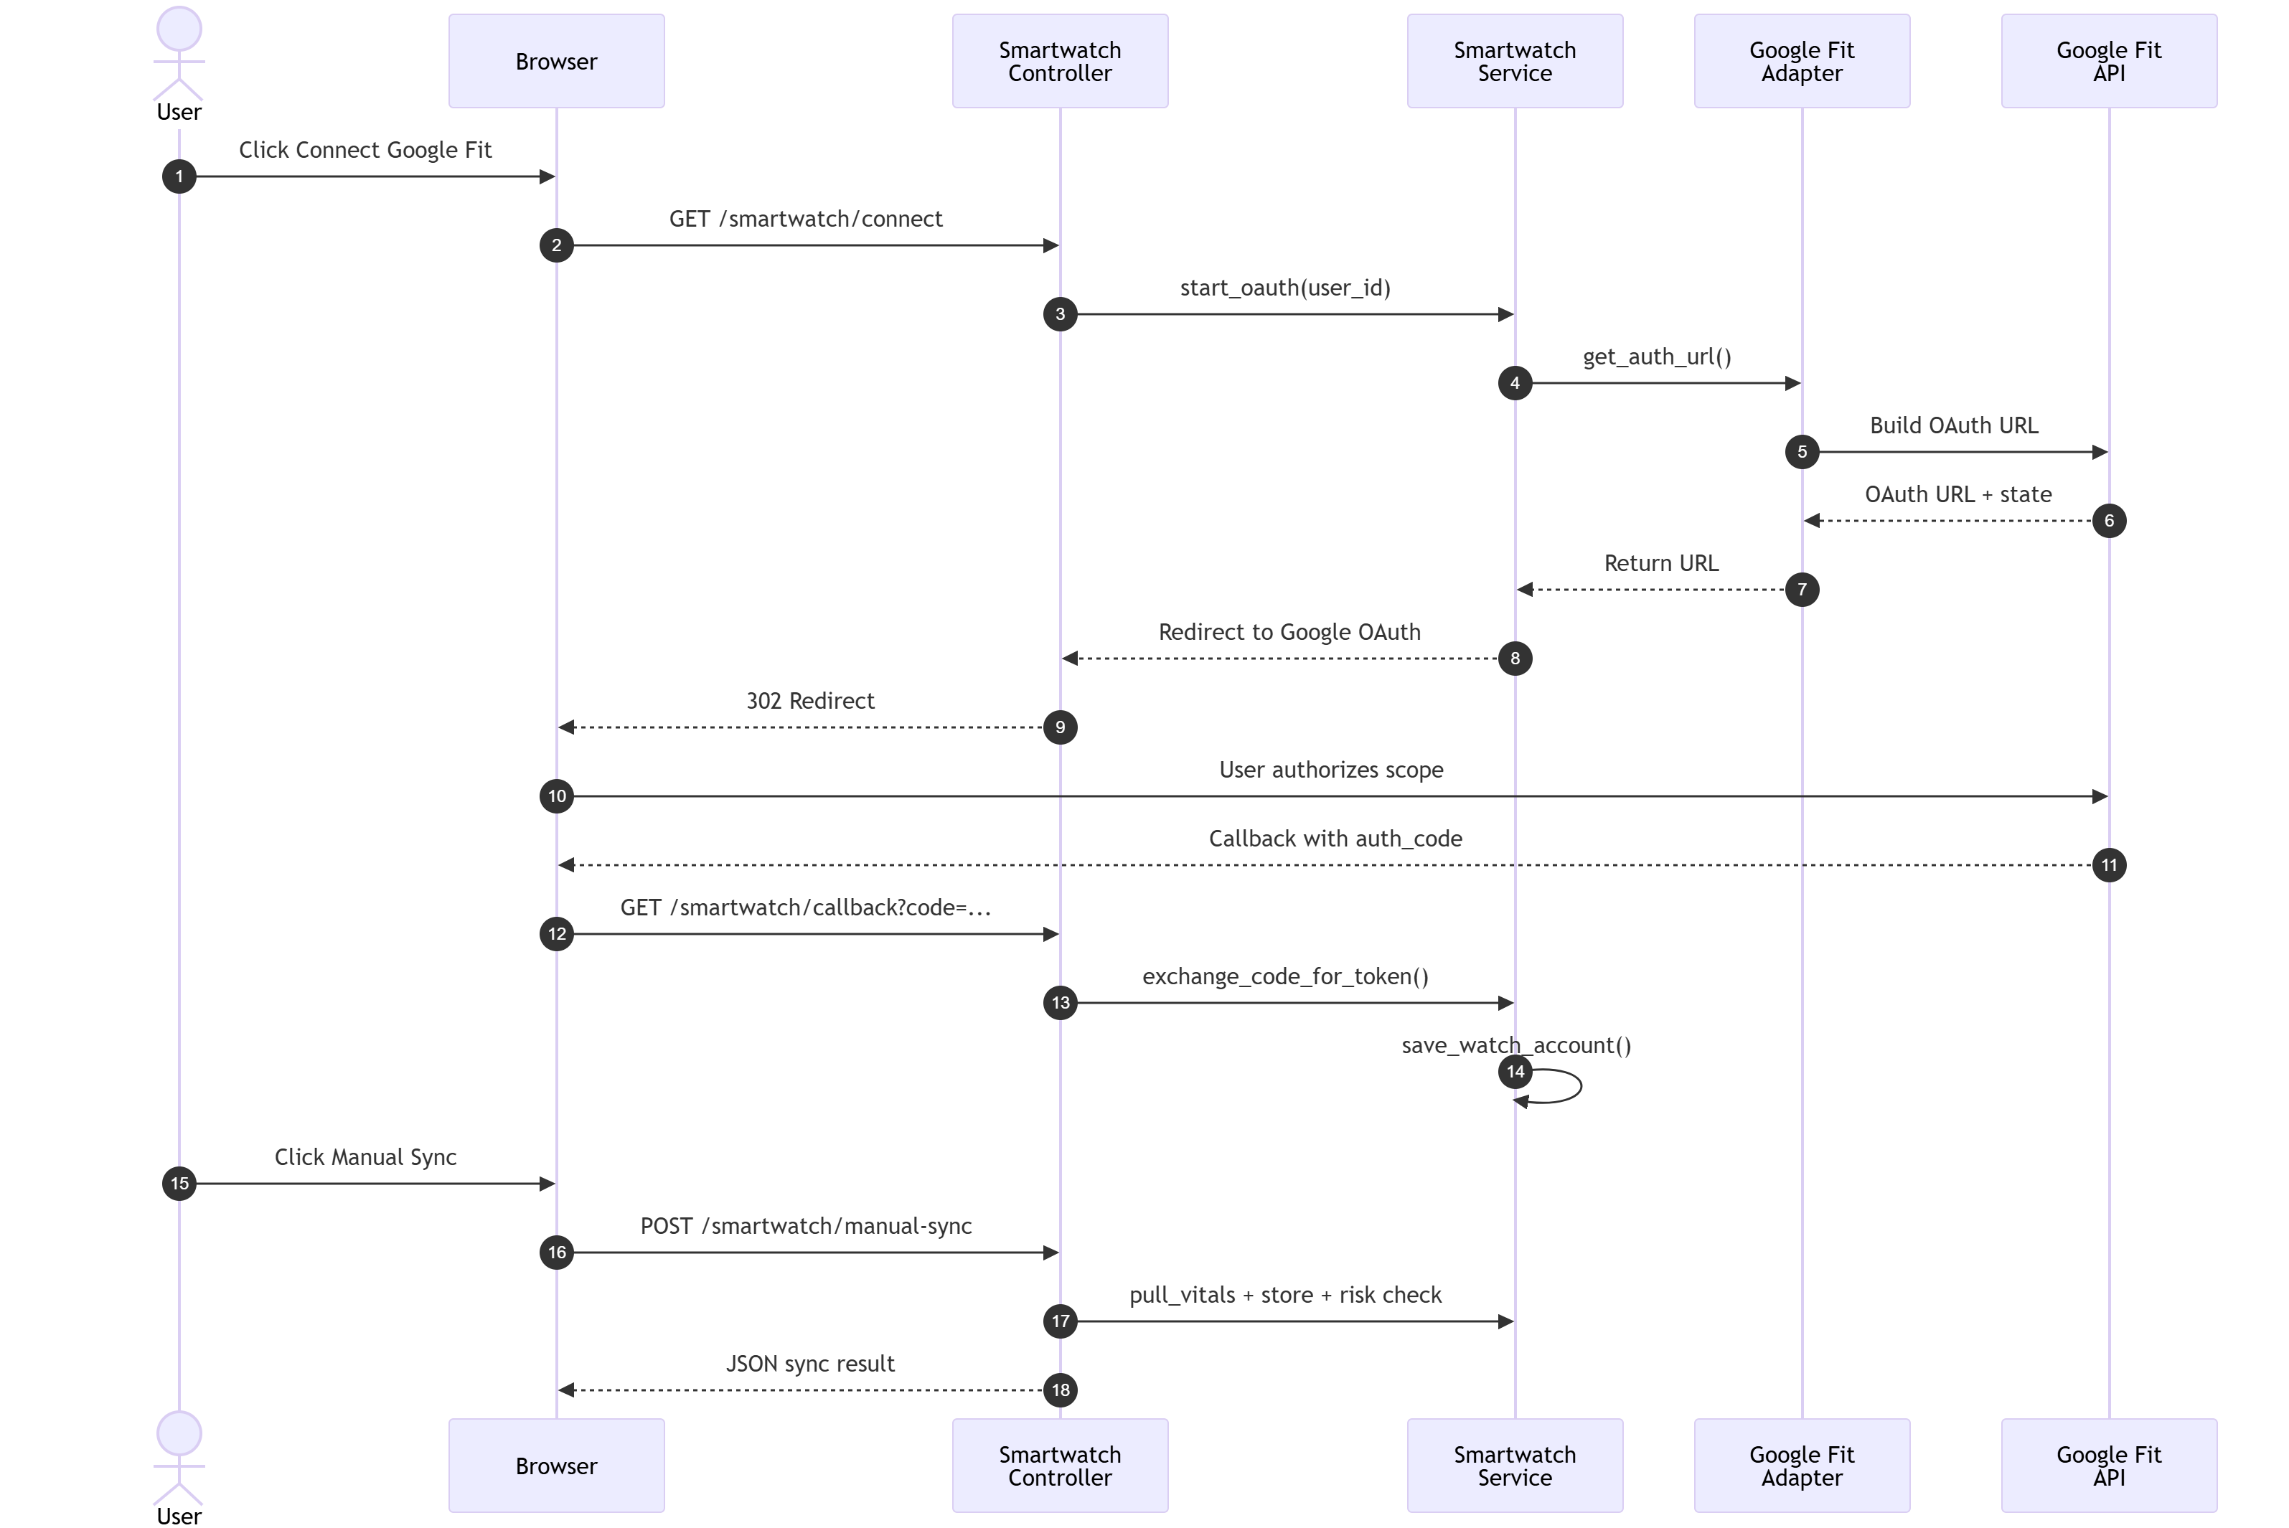
Figure 7.1 Smartwatch OAuth and Manual Sync Sequence

Sequence: Health Ingestion and Risk Assessment
Health data ingestion follows a structured pipeline from API request through persistence and ML-based risk evaluation. The sequence depicts payload validation, data normalization, database insertion, ML model scoring, conditional alert generation, and response transmission. After initial record insertion, the system invokes the ML module to compute risk scores and risk labels based on normalized vital signs. If high-risk conditions are detected, the system creates alert records and enqueues notifications. This end-to-end flow ensures that every health record is assessed for risk before being exposed to the user or clinical personnel.
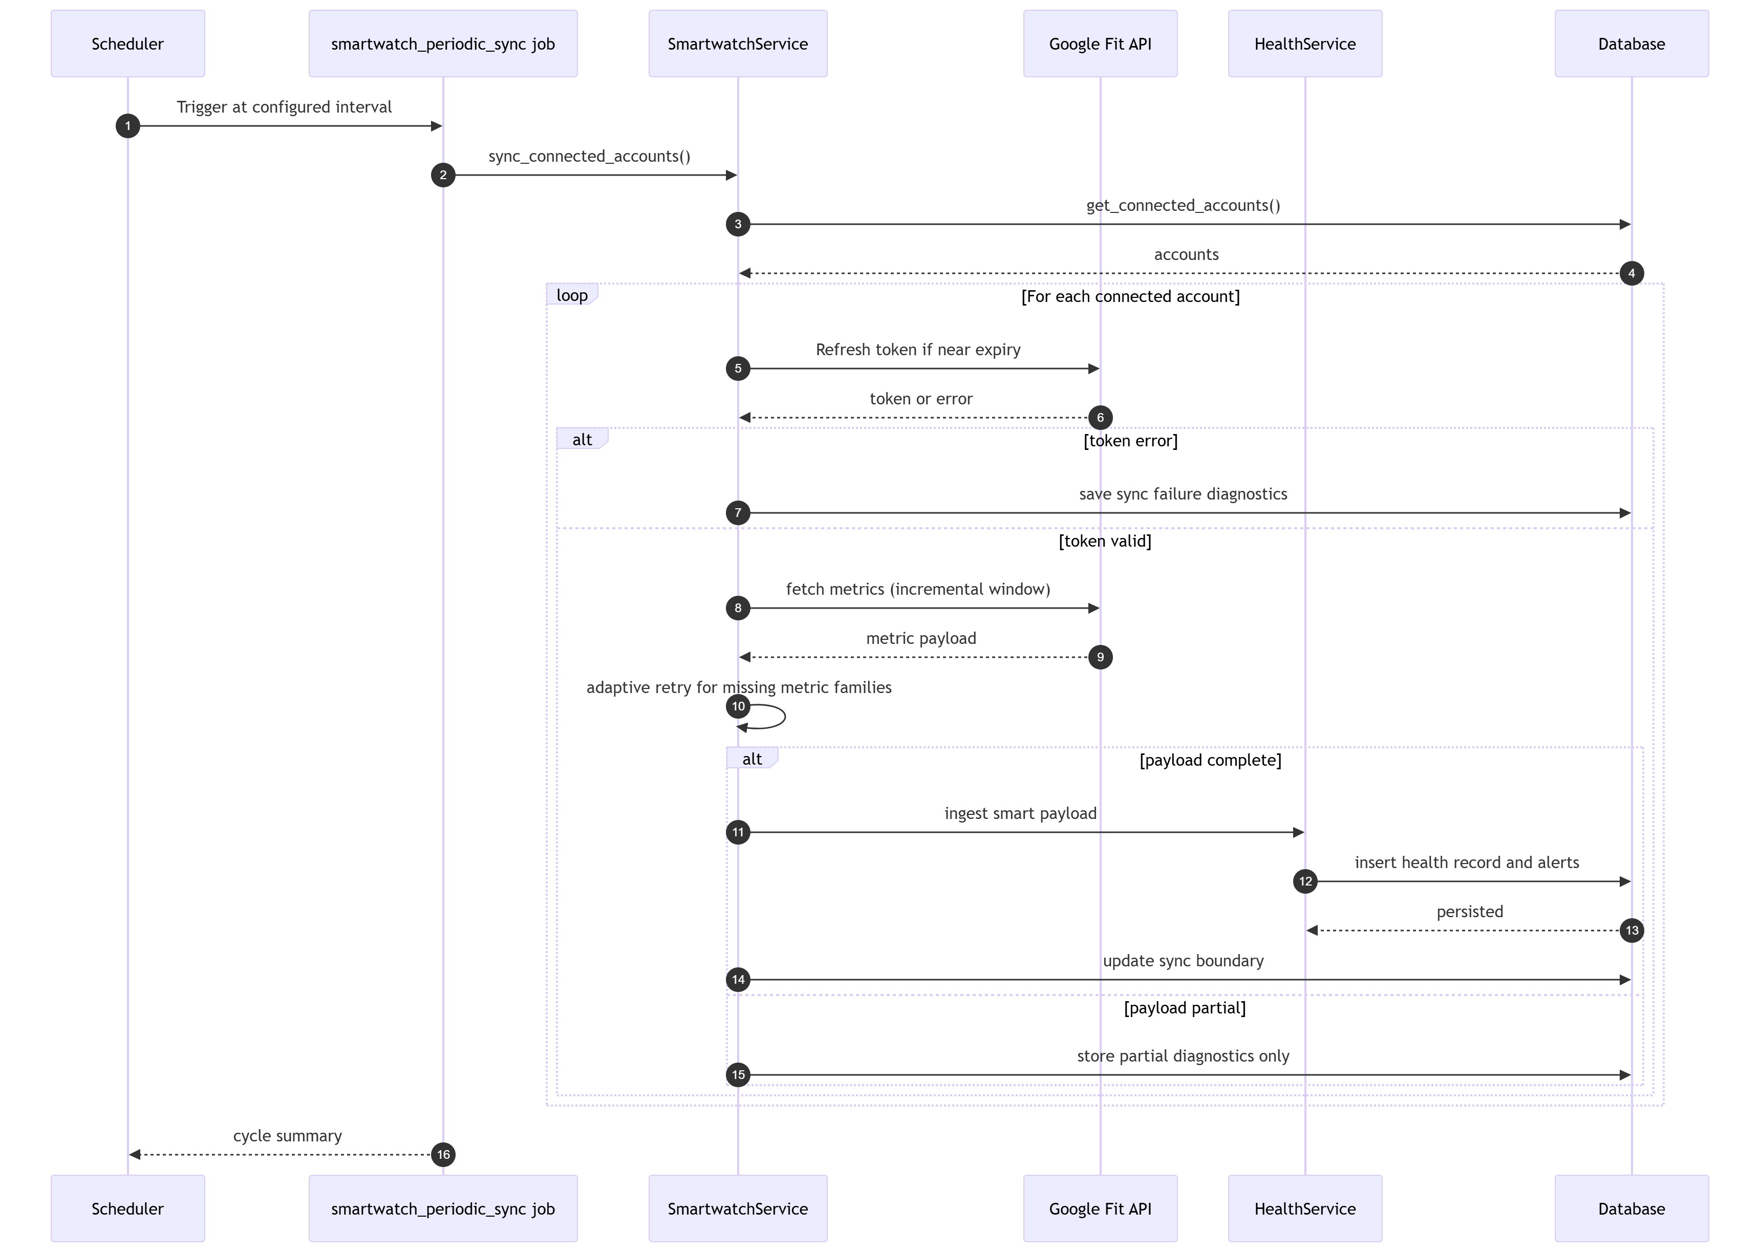
Figure 7.2 Health Ingestion and Risk Assessment Sequence

Sequence: Medication Log Status Transitions
Medication log transitions from pending to terminal states (taken, missed, skipped) are state-aware and trigger corresponding notifications. The sequence shows the controller receiving a status-change request, the service validating the transition, the database fetch of the scheduled window and prior state, status computation, database update, and conditional notification dispatch. Each terminal state activates different notification pathways: TAKEN logs positive adherence, MISSED generates alert for user correction, and SKIPPED creates warning for clinical review. This transition-aware design ensures that adherence tracking is granular and consistently linked to user expectations and clinical workflows.
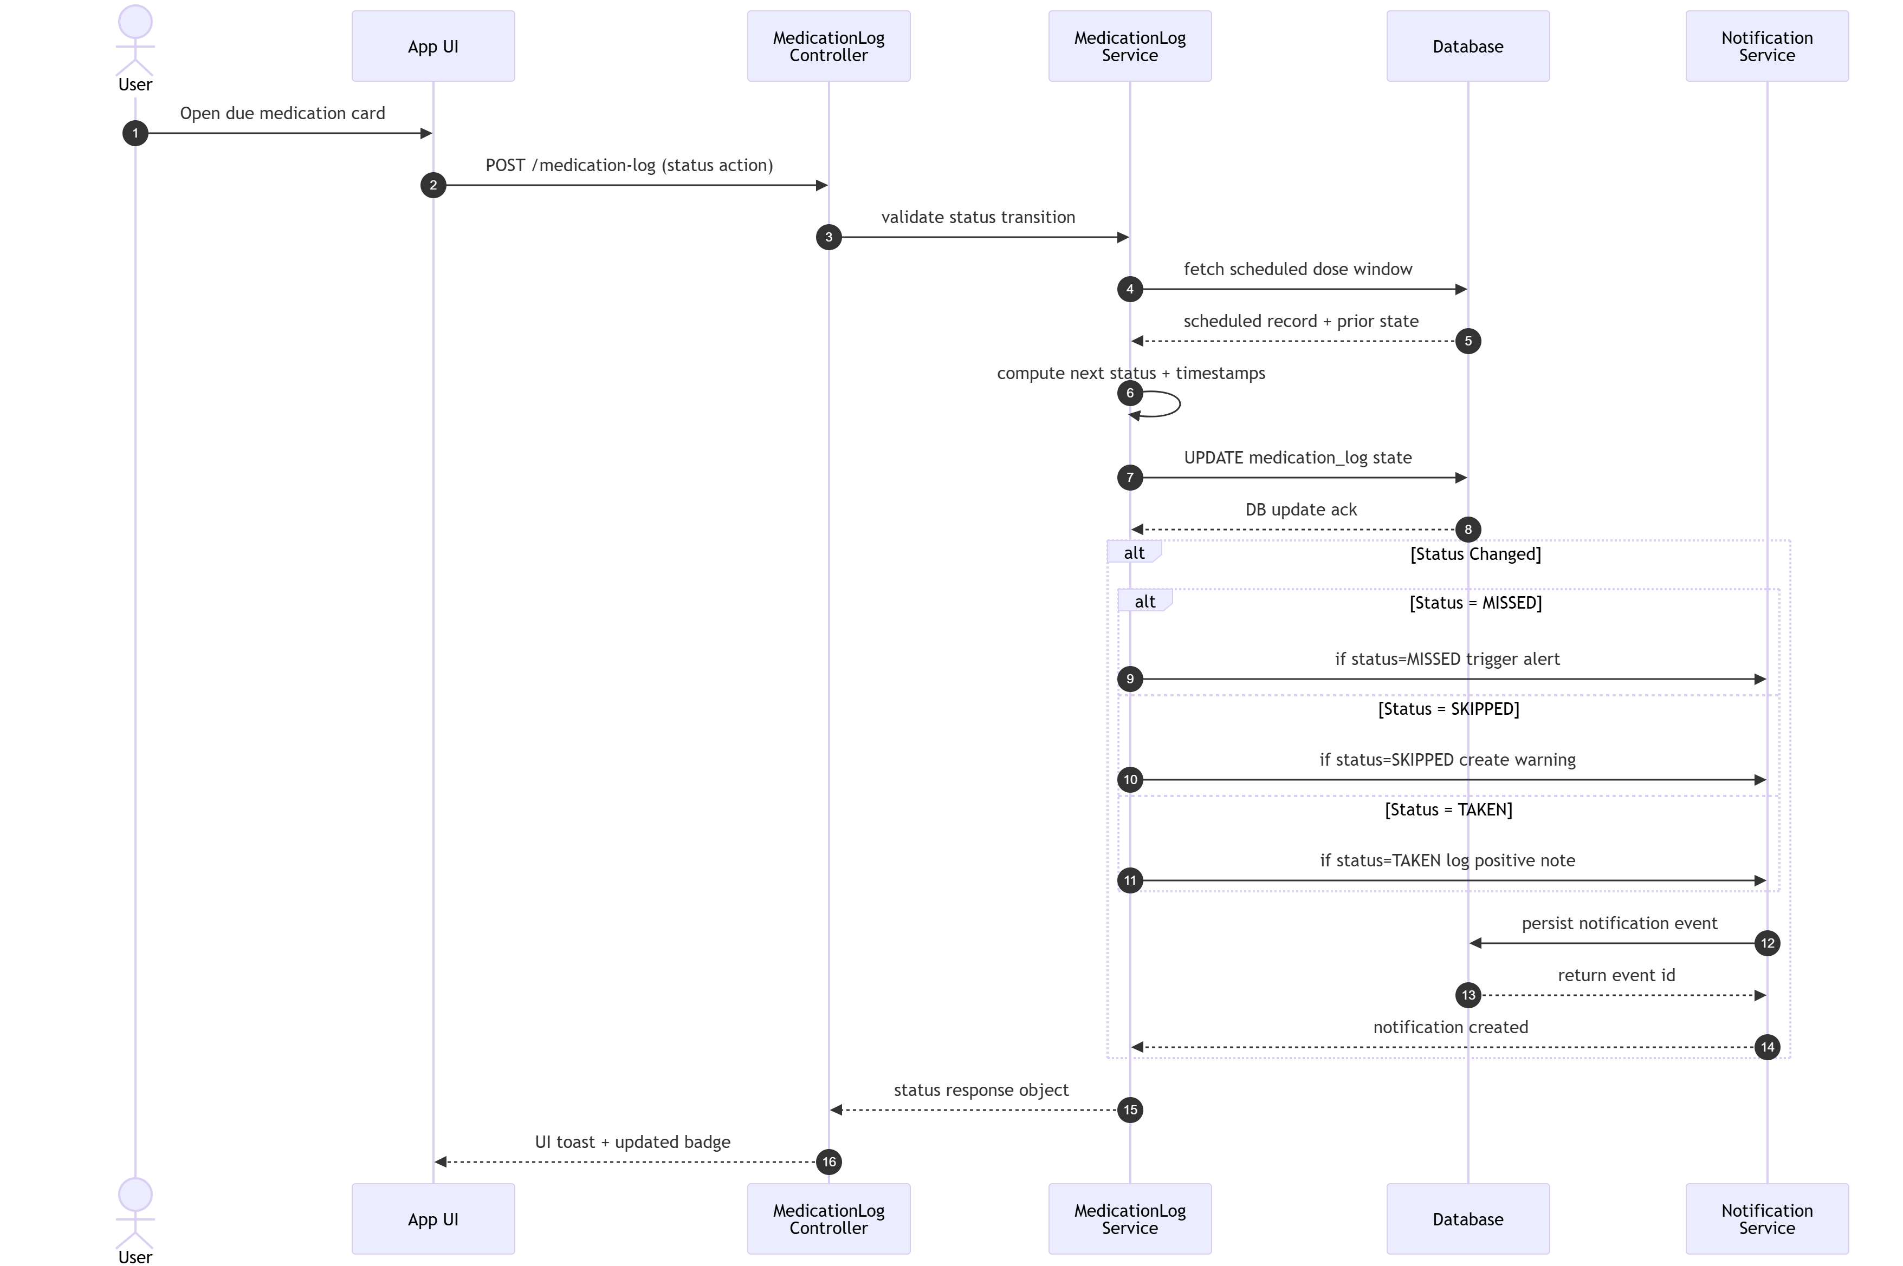
Figure 7.3 Medication Log Transition Sequence

Sequence: Authentication (Register, Login, Password Reset)
Authentication flows for registration, login, and password reset are depicted in unified sequence showing payload validation, credential verification, token generation, and secure OTP-based recovery. For registration, the system validates email uniqueness, hashes passwords using security best practices, creates an OTP record, and dispatches verification email. For login, credentials are verified and JWT tokens (access and refresh) are generated. For password reset, the system issues OTP and sends reset instructions via email. This multi-mode authentication design balances security, usability, and recovery scenarios.
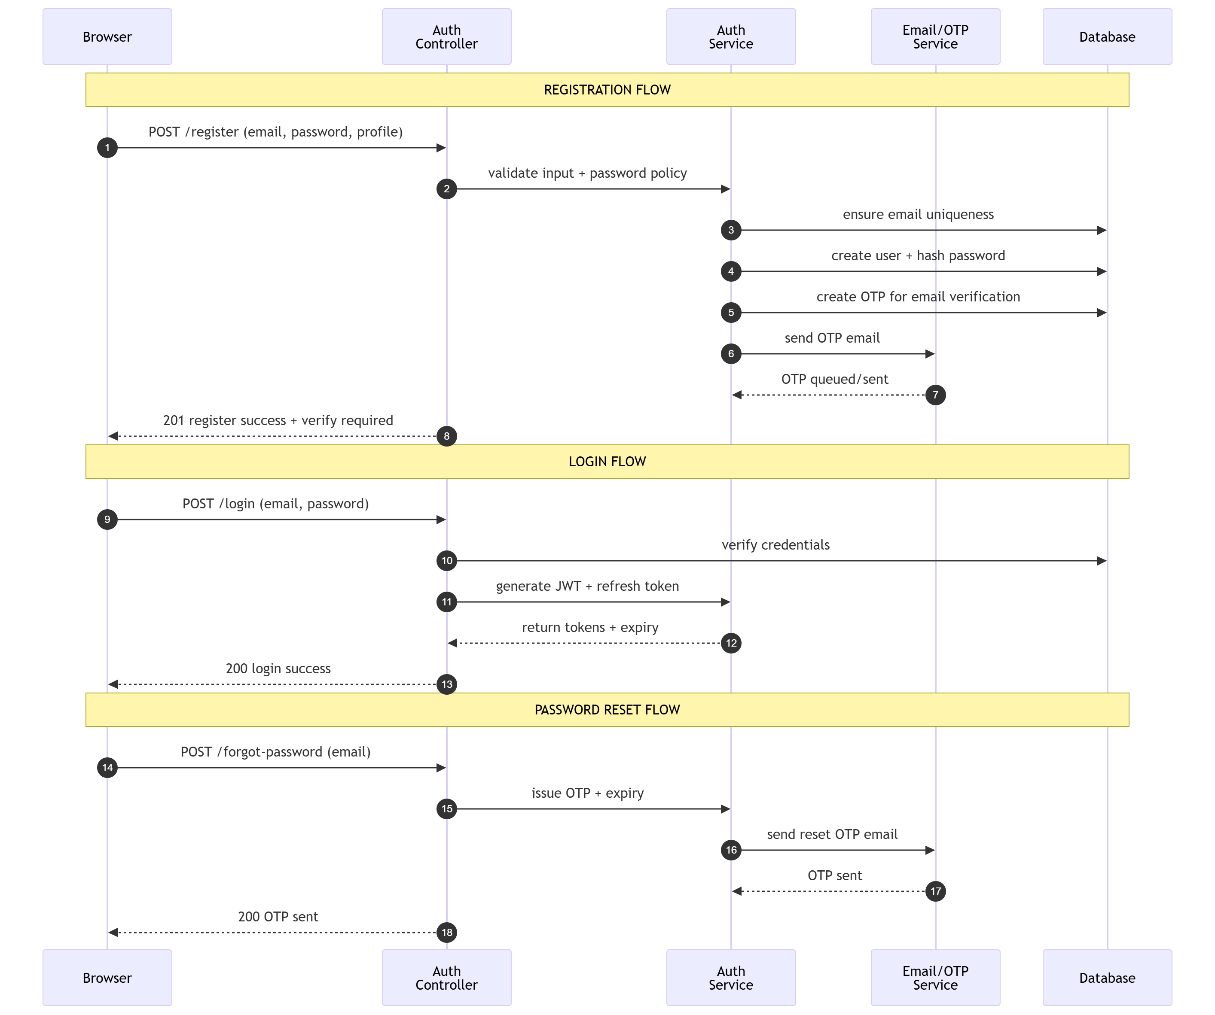
Figure 7.4 Authentication Sequence

Sequence: Scheduler Periodic Smartwatch Sync
The scheduler-driven background sync cycle manages periodic synchronization for all connected smartwatch accounts without operator intervention. The sequence traces scheduler invocation, connected-account enumeration, per-account token refresh, provider-side data fetching, adaptive retry for missing metric families, ingestion into health records with strict completeness policy, sync-boundary updates, and per-account failure isolation. This background orchestration ensures continuous data freshness while preventing sync failures in one account from disrupting others.

Figure 7.5 Scheduler Periodic Smartwatch Sync Sequence

States: Medication Log States
The medication log state machine models the lifecycle of a single dose entry from creation through completion. States include pending (awaiting scheduled time), grace-period (in user-action window), and terminal states (taken, missed, skipped). Transitions are driven by time expiry and explicit user actions. Pending remains active until scheduled time is reached. Once in the grace window, immediate user action transitions to taken or skipped; if grace expires without action, state automatically becomes missed. Each terminal state locks the record and triggers downstream notification logic. This formalization ensures consistent interpretation of adherence status across modules.
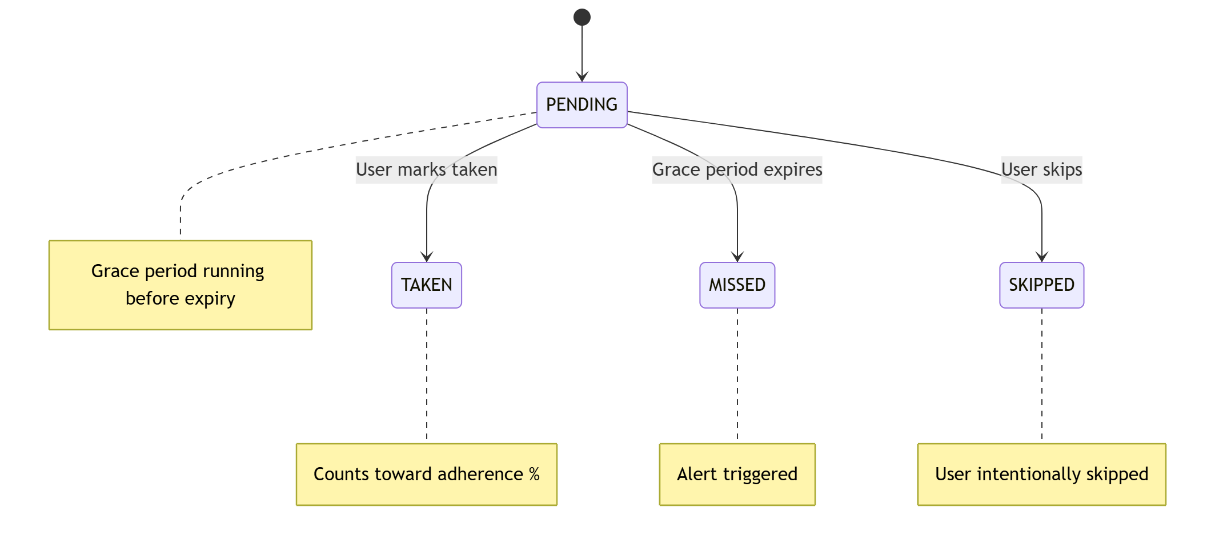
Figure 7.6 Medication Log States

States: Smartwatch Account Status States
The smartwatch account state machine represents the lifecycle of a provider connection. States include disconnected (initial), authorized (OAuth token acquired), syncing (active data fetch), and error (recoverable or fatal). Transitions occur when the user initiates OAuth, the system acquires and refreshes tokens, begins periodic syncs, or encounters sync failures. From authorized, the account enters syncing during fetch operations and returns to authorized on success. Recoverable errors may transition back to authorized after retry; permanent errors move to error state requiring user re-authorization. This state model provides visibility into integration health and enables per-account isolation of fault conditions.
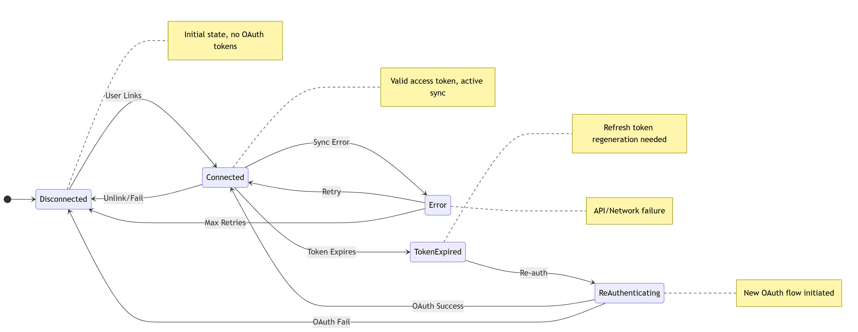
Figure 7.7 Smartwatch Account Status States

States: Smartwatch Sync State Progression
The sync state machine tracks incremental synchronization boundaries across multiple fetch cycles. States include initial (first sync), incremental (using stored cursor), empty-window (provider returned no data), and rollback (fallback due to empty window). From initial, the first sync establishes a base cursor. Subsequent cycles transition to incremental using the stored cursor and advance it after successful ingestion. If a cycle returns empty and no data was found, the system transitions to empty-window and may revert to a wider lookback window. On next successful data arrival, the cycle returns to incremental with updated cursor. This design prevents data loss and handles real-world scenarios where provider APIs return sparse or delayed results.
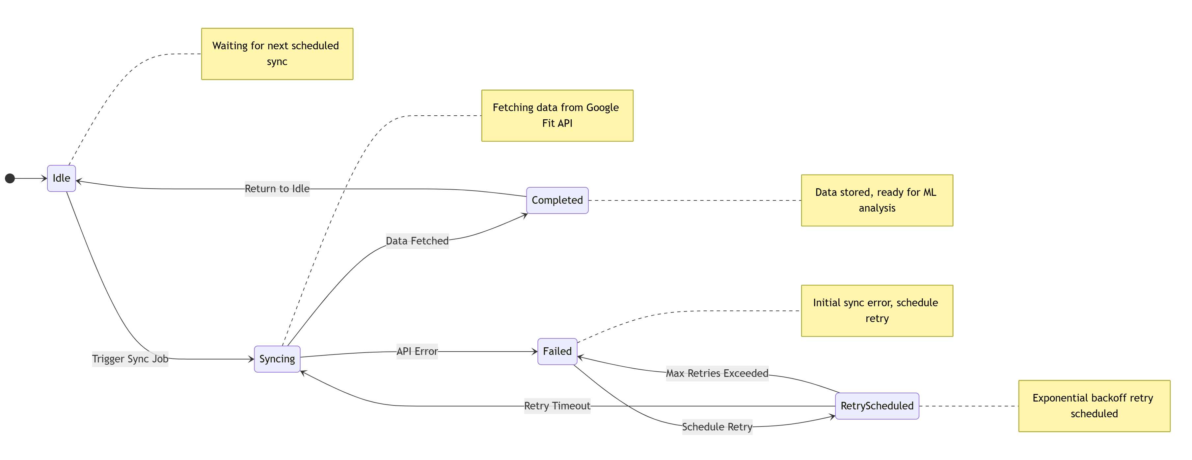
Figure 7.8 Sync State Progression

States: Notification Lifecycle States
The notification state machine captures the lifecycle of alert and reminder events from generation through archival. States include created (new event), queued (dispatch pending), sent (message delivered to channel), read (user opened notification), expired (validity window closed), failed (dispatch error), and archived (final cleanup). From created, the notification enters queued for processing. Queued transitions to sent on successful dispatch or to failed on error. Sent notifications are read by user or expire after validity period. Failed or expired notifications may undergo retry; ultimately all non-active notifications transition to archived. This state model ensures consistent notification handling across synchronous and asynchronous dispatch pathways.
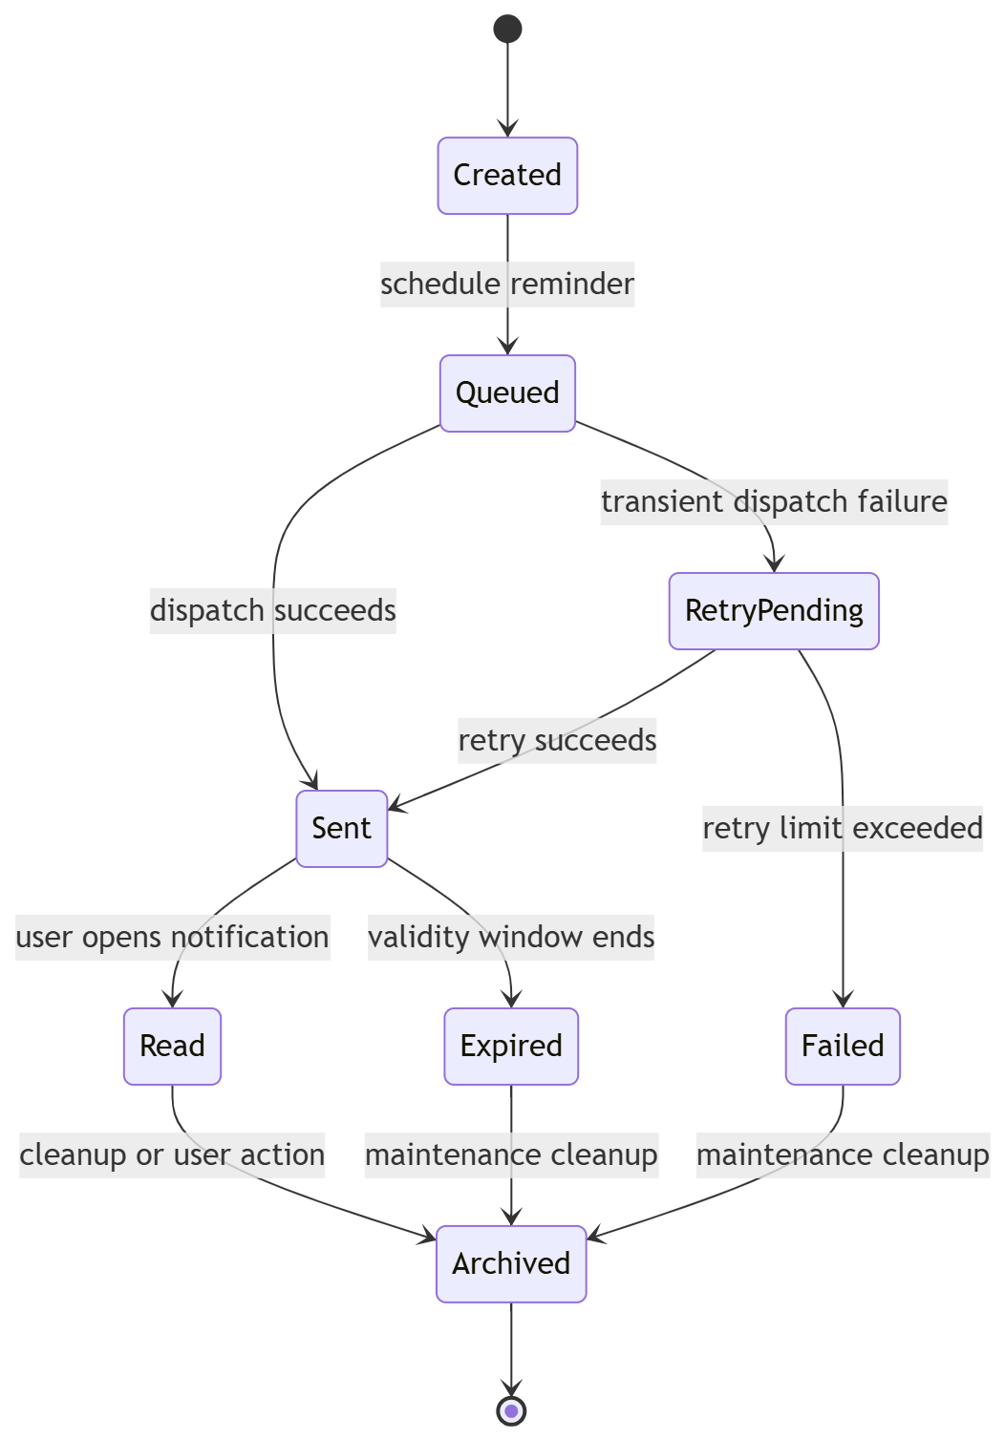
Figure 7.9 Notification Lifecycle States

Testing Strategy
The project applies unit and integration-oriented pytest suites with emphasis on:
smartwatch adapter mapping and edge cases
sync state progression behavior
partial metric handling in strict ingestion mode
scheduler task behavior and startup guards
route transport validation

Validation Areas

Functional validation covers
authentication and route behavior
health and medication workflows
smartwatch OAuth and sync endpoints

Sync correctness validation covers
adaptive fetch windows
missing-metric retries
diagnostics payload consistency

Scheduler validation covers
periodic job registration
connected-account filtering
failure resilience

Observed Behavior Summary
From executed smartwatch-focused tests and runtime diagnostics:
adapter and sync logic correctly fetch available provider data
partial provider exports are handled without fabricated values
downstream policy correctly rejects incomplete smartwatch payloads
scheduler and startup gating behavior are consistent with configuration intent

Testing Output Screenshots

Pytest summary – Output
PS C:\Users\Admin\Desktop\Sem-06\2_SDP\project> python -m pytest -vv
===================================== test session starts =====================================
platform win32 -- Python 3.12.5, pytest-8.3.5, pluggy-1.6.0 -- C:\Users\Admin\AppData\Local\Programs\Python\Python312\python.exe
cachedir: .pytest_cache
rootdir: C:\Users\Admin\Desktop\Sem-06\2_SDP\project
configfile: pytest.ini
testpaths: PHMS/tests
collected 74 items

PHMS/tests/smartwatch/test_google_fit_adapter.py::test_google_fit_build_authorization_url_contains_expected_params PASSED [ 1%]
PHMS/tests/smartwatch/test_google_fit_adapter.py::test_google_fit_exchange_and_refresh_return_token_bundle PASSED [ 2%]
PHMS/tests/smartwatch/test_google_fit_adapter.py::test_google_fit_fetch_health_payloads_maps_to_canonical_fields PASSED [ 4%]
PHMS/tests/smartwatch/test_google_fit_adapter.py::test_to_token_bundle_requires_access_token PASSED [ 5%]
PHMS/tests/smartwatch/test_google_fit_adapter.py::test_fetch_health_payloads_returns_empty_when_no_supported_metrics PASSED [ 6%]
PHMS/tests/smartwatch/test_google_fit_adapter.py::test_fetch_health_payloads_ignores_invalid_cursor_and_still_maps_data PASSED [ 8%]
PHMS/tests/smartwatch/test_google_fit_adapter.py::test_extract_metrics_combines_multiple_points_and_buckets PASSED [ 9%]
PHMS/tests/smartwatch/test_google_fit_adapter.py::test_fetch_health_payloads_retries_only_missing_metrics_across_windows PASSED [ 10%]
PHMS/tests/smartwatch/test_health_ingestion_canonical.py::test_manual_and_smartwatch_ingestion_share_same_pipeline_outputs PASSED [ 12%]
PHMS/tests/smartwatch/test_health_ingestion_canonical.py::test_manual_and_smartwatch_ingestion_share_same_validation_behavior PASSED [ 13%]
PHMS/tests/smartwatch/test_health_ingestion_canonical.py::test_smartwatch_ingestion_integrity_race_returns_deduplicated_response PASSED [ 14%]
PHMS/tests/smartwatch/test_health_ingestion_canonical.py::test_high_risk_manual_and_smartwatch_paths_keep_alert_and_email_behavior_consistent PASSED [ 16%]
PHMS/tests/smartwatch/test_incremental_sync_state_progression.py::test_trigger_sync_persists_provider_progress_markers PASSED [ 17%]
PHMS/tests/smartwatch/test_incremental_sync_state_progression.py::test_sync_failure_records_last_attempt_timestamp PASSED [ 18%]
PHMS/tests/smartwatch/test_partial_metrics.py::test_sync_with_steps_only_should_be_rejected PASSED [ 20%]
PHMS/tests/smartwatch/test_partial_metrics.py::test_sync_with_three_metrics_should_be_rejected PASSED [ 21%]
PHMS/tests/smartwatch/test_partial_metrics.py::test_sync_with_full_metrics_should_succeed PASSED [ 22%]
PHMS/tests/smartwatch/test_partial_metrics.py::test_sync_with_partial_metrics_logs_rejection PASSED [ 24%]
PHMS/tests/smartwatch/test_partial_metrics.py::test_sync_fails_fast_on_permanent_token_refresh_error PASSED [ 25%]
PHMS/tests/smartwatch/test_route_transport_validation.py::test_smartwatch_endpoints_registered PASSED [ 27%]
PHMS/tests/smartwatch/test_route_transport_validation.py::test_smartwatch_routes_have_expected_methods PASSED [ 28%]
PHMS/tests/smartwatch/test_route_transport_validation.py::test_integration_page_context_uses_requested_supported_provider PASSED [ 29%]
PHMS/tests/smartwatch/test_route_transport_validation.py::test_integration_page_context_falls_back_to_first_supported_provider PASSED [ 31%]
PHMS/tests/smartwatch/test_route_transport_validation.py::test_parse_json_object_payload_rejects_non_json PASSED [ 32%]
PHMS/tests/smartwatch/test_route_transport_validation.py::test_parse_json_object_payload_rejects_invalid_json PASSED [ 33%]
PHMS/tests/smartwatch/test_route_transport_validation.py::test_parse_json_object_payload_rejects_json_array PASSED [ 35%]
PHMS/tests/smartwatch/test_route_transport_validation.py::test_sync_now_transports_cursor_and_since_to_service PASSED [ 36%]
PHMS/tests/smartwatch/test_route_transport_validation.py::test_sync_now_rejects_non_json_payload_when_body_present PASSED [ 37%]
PHMS/tests/smartwatch/test_route_transport_validation.py::test_sync_now_rejects_malformed_json_when_body_present PASSED [ 39%]
PHMS/tests/smartwatch/test_route_transport_validation.py::test_callback_redirects_to_error_when_code_missing PASSED [ 40%]
PHMS/tests/smartwatch/test_route_transport_validation.py::test_authorize_stores_oauth_state_in_session PASSED [ 41%]
PHMS/tests/smartwatch/test_route_transport_validation.py::test_callback_rejects_mismatched_oauth_state PASSED [ 43%]
PHMS/tests/smartwatch/test_route_transport_validation.py::test_callback_accepts_matching_oauth_state_and_calls_service PASSED [ 44%]
PHMS/tests/smartwatch/test_route_transport_validation.py::test_callback_rejects_when_provider_cannot_be_resolved PASSED [ 45%]
PHMS/tests/smartwatch/test_route_transport_validation.py::test_pre_sync_diagnostics_transports_query_params_to_service PASSED [ 47%]
PHMS/tests/smartwatch/test_scheduler_sync_behavior.py::test_sync_scheduler_job_continues_when_one_account_fails PASSED [ 48%]
PHMS/tests/smartwatch/test_scheduler_sync_behavior.py::test_sync_scheduler_job_no_accounts_returns_success PASSED [ 50%]
PHMS/tests/smartwatch/test_smartwatch_dedup_integration.py::test_repeated_sync_with_source_record_id_is_idempotent PASSED [ 51%]
PHMS/tests/smartwatch/test_smartwatch_dedup_integration.py::test_repeated_sync_without_source_record_id_uses_hash_idempotency PASSED [ 52%]
PHMS/tests/test_architecture_reuse_patterns.py::test_scheduler_config_uses_jobs_layer_callbacks PASSED [ 54%]
PHMS/tests/test_architecture_reuse_patterns.py::test_medication_tasks_remain_thin_service_delegates PASSED [ 55%]
PHMS/tests/test_architecture_reuse_patterns.py::test_reports_routes_delegate_to_reports_controller PASSED [ 56%]
PHMS/tests/test_architecture_reuse_patterns.py::test_reports_controller_delegate_to_services_layer PASSED [ 58%]
PHMS/tests/test_architecture_reuse_patterns.py::test_report_service_uses_report_repository_for_queries PASSED [ 59%]
PHMS/tests/test_architecture_reuse_patterns.py::test_medication_log_service_keeps_compatibility_facade_exports PASSED [ 60%]
PHMS/tests/test_architecture_reuse_patterns.py::test_medication_log_status_endpoints_use_repository_queries PASSED [ 62%]
PHMS/tests/test_architecture_reuse_patterns.py::test_profile_service_uses_repositories_for_cross_domain_queries PASSED [ 63%]
PHMS/tests/test_controller_transport.py::test_health_add_rejects_non_json_payload PASSED [ 64%]
PHMS/tests/test_controller_transport.py::test_medication_add_coerces_is_critical_flag PASSED [ 66%]
PHMS/tests/test_controller_transport.py::test_notifications_api_limit_is_clamped PASSED [ 67%]
PHMS/tests/test_medication_scheduler_integration.py::test_add_medication_and_daily_scheduler_deduplicate_logs PASSED [ 68%]
PHMS/tests/test_medication_scheduler_integration.py::test_create_daily_logs_tracks_created_skipped_and_failed_counts PASSED [ 70%]
PHMS/tests/test_medication_scheduler_integration.py::test_mark_medication_taken_updates_log_state PASSED [ 71%]
PHMS/tests/test_medication_scheduler_integration.py::test_scheduler_marks_expired_pending_log_as_missed PASSED [ 72%]
PHMS/tests/test_medication_scheduler_integration.py::test_scheduler_notification_deduplicates_alerts_for_same_log PASSED [ 74%]
PHMS/tests/test_medication_scheduler_integration.py::test_schedule_notifications_tracks_failed_send_attempts PASSED [ 75%]
PHMS/tests/test_medication_scheduler_integration.py::test_add_medication_rolls_back_when_initial_schedule_creation_fails PASSED [ 77%]
PHMS/tests/test_medication_scheduler_integration.py::test_mark_medication_taken_rejects_when_scheduled_time_not_reached PASSED [ 78%]
PHMS/tests/test_medication_scheduler_integration.py::test_mark_medication_missed_critical_returns_email_failure_flag PASSED [ 79%]
PHMS/tests/test_medication_scheduler_integration.py::test_initialize_medication_logs_creates_future_and_skips_overdue_pending PASSED [ 81%]
PHMS/tests/test_route_registration.py::test_core_feature_endpoints_registered PASSED [ 82%]
PHMS/tests/test_route_registration.py::test_reports_blueprint_registered PASSED [ 83%]
PHMS/tests/test_schema_validation_services.py::test_health_service_rejects_non_numeric_heart_rate PASSED [ 85%]
PHMS/tests/test_schema_validation_services.py::test_medication_service_rejects_invalid_date_format PASSED [ 86%]
PHMS/tests/test_schema_validation_services.py::test_auth_service_register_validates_email_format PASSED
[ 87%]
PHMS/tests/test_schema_validation_services.py::test_auth_service_reset_password_requires_email PASSED [ 89%]
PHMS/tests/test_secondary_integration_flows.py::test_reports_build_range_integration_returns_consistent_aggregates PASSED [ 90%]
PHMS/tests/test_secondary_integration_flows.py::test_auth_password_reset_otp_flow_integration PASSED [ 91%]
PHMS/tests/test_secondary_integration_flows.py::test_ml_predict_health_assessment_classifier_only_fallback PASSED [ 93%]
PHMS/tests/test_secondary_integration_flows.py::test_ml_predict_health_assessment_raises_when_no_models PASSED [ 94%]
PHMS/tests/test_secondary_integration_flows.py::test_reports_invalid_feature_filter_falls_back_to_all_metrics PASSED [ 95%]
PHMS/tests/test_secondary_integration_flows.py::test_auth_password_reset_locks_after_too_many_invalid_otp_attempts PASSED [ 97%]
PHMS/tests/test_startup_behavior.py::test_app_import_does_not_start_scheduler PASSED [ 98%]
PHMS/tests/test_startup_behavior.py::test_bootstrap_function_exists_for_explicit_startup PASSED [100%]
==================================== warnings summary =====================================
PHMS/tests/smartwatch/test_health_ingestion_canonical.py::test_manual_and_smartwatch_ingestion_share_same_pipeline_outputs
PHMS/tests/test_startup_behavior.py::test_app_import_does_not_start_scheduler
C:\Users\Admin\AppData\Local\Programs\Python\Python312\Lib\site-packages\flask_limiter\extension.py:336: UserWarning: Using the in-memory storage for tracking rate limits as no storage was explicitly specified. This is not recommended for production use. See: https://flask-limiter.readthedocs.io#configuring-a-storage-backend for documentation about configuring the storage backend.
warnings.warn(

-- Docs: https://docs.pytest.org/en/stable/how-to/capture-warnings.html
============================== 74 passed, 2 warnings in 23.32s ================================
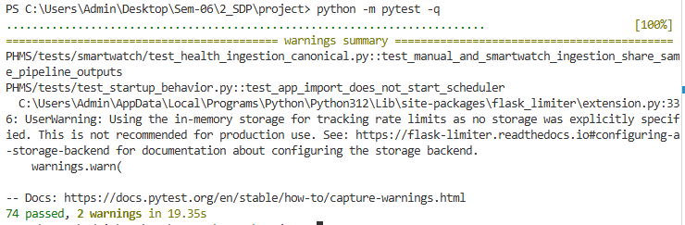
Figure 7.10 pytest summary - Run all tests

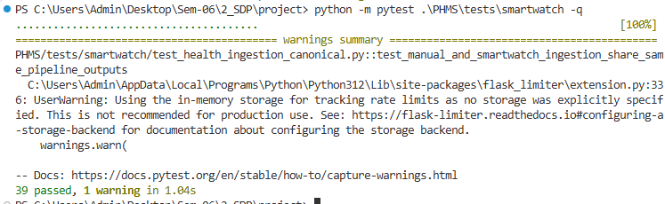
Figure 7.11 SmartWatch Diagnostics

Chapter 8: Results and Discussion

Achievements
PHMS successfully delivers:
end-to-end user health and medication workflows
modular and maintainable architecture
secure request processing and rate limiting support
smartwatch sync with practical diagnostics under real-world API constraints
scheduler-based background automation

Practical Insights from Wearable Integration
In real device ecosystems, non-step metric availability may vary by watch brand and companion app sync policy. PHMS intentionally keeps this transparent through diagnostics and does not fabricate missing metrics. This preserves data integrity.

Limitations
smartwatch metric completeness depends on upstream provider data availability
some watch ecosystems expose only a subset of required health families
production hardening still requires infrastructure controls such as dedicated scheduler process and managed secret storage

Chapter 9: Conclusion and Future Scope

Conclusion
PHMS demonstrates a complete and practical personal health monitoring solution integrating manual records, medication adherence, risk scoring, and smartwatch sync. The architecture and testing approach support maintainability and iterative enhancement. The smartwatch pipeline is robust to partial datasets and preserves strict downstream validation behavior.

Future Scope
multi-provider wearable adapters beyond current integration
enhanced user-level analytics and trend dashboards
fine-grained per-metric policy configuration for smartwatch ingestion
notification channel expansion such as SMS and push
role-based admin observability dashboards
containerized deployment and CI pipeline hardening
AI health predictions
wearable multi-device support
mobile app version
cloud deployment

Chapter 10: References

Flask / Backend
[1] Pallets Projects. Flask Documentation. Available: https://flask.palletsprojects.com/
Accessed: March 2026.
[2] Flask-RESTful Authors. Flask RESTful APIs Documentation. Available: https://flask-restful.readthedocs.io/
Accessed: March 2026.

Testing
[3] Pytest Development Team. Pytest Documentation. Available: https://docs.pytest.org/
Accessed: March 2026.

Scheduler / Background Jobs
[4] APScheduler Authors. APScheduler Documentation. Available: https://apscheduler.readthedocs.io/
Accessed: March 2026.

Smartwatch APIs / Fitness Sync
[5] Google Developers. Health Connect API Guide. Available:
https://developer.android.com/health-and-fitness/guides/health-connect
Accessed: March 2026.
[6] Google Developers. Google Fit REST API. Available:
https://developers.google.com/fit
Accessed: March 2026.

Architecture / Design
[7] RESTfulAPI.net. REST API Design Best Practices. Available:
https://restfulapi.net/
Accessed: March 2026.
[8] UML Diagrams Organization. UML Diagram Reference. Available:
https://www.uml-diagrams.org/
Accessed: March 2026.

Programming Language and Database
[9] Python Software Foundation. Python Documentation. Available:
https://docs.python.org/3/
Accessed: March 2026.
[10] SQLite Consortium. SQLite Documentation. Available:
https://www.sqlite.org/docs.html
Accessed: March 2026.

Web Standards and API Specification
[11] Mozilla Developer Network. HTTP Status Codes. Available:
https://developer.mozilla.org/en-US/docs/Web/HTTP/Status
Accessed: March 2026.
[12] OpenAPI Initiative. OpenAPI Specification. Available:
https://swagger.io/specification/
Accessed: March 2026.

Diagram and Modeling Tools
[13] Draw.io. Diagrams.net Documentation. Available:
https://www.diagrams.net/doc/
Accessed: March 2026.
[14] Mermaid Team. Mermaid Live Editor. Available:
https://mermaid.live/
Accessed: March 2026.

Dataset Sources
[15] Kaggle Inc. Kaggle Dataset Repository. Available:
https://www.kaggle.com/datasets
Accessed: March 2026.

Chapter 11: Appendices

Appendix A: Key Environment Variables
Flask / Core Application
FLASK_ENV - Flask environment (development, production, testing)
FLASK_DEBUG - Enable Flask debug mode (disable in production!)
SECRET_KEY - Secret key for session encryption
SECURITY_PASSWORD_SALT - Additional password hashing salt
ENVIRONMENT_NAME - Application environment identifier.
LOG_LEVEL - Logging verbosity level.
Database Configuration
DATABASE_URL - Database URL (SQLite is default for development)
Smartwatch OAuth Configuration
PHMS_BASE_URL - Base public URL used to build OAuth callback redirects.
SMARTWATCH_OAUTH_CALLBACK_PATH - OAuth callback path registered with
provider console.
GOOGLE_FIT_CLIENT_ID - Google Fit OAuth credentials (required for smartwatch
connect flow).
GOOGLE_FIT_CLIENT_SECRET - Google Fit OAuth credentials.
Smartwatch Scheduler Configuration
ENABLE_SCHEDULER - Start scheduler in dedicated process/worker when using multi-worker servers.
SMARTWATCH_SYNC_INTERVAL_HOURS - Periodic smartwatch sync interval.
SMARTWATCH_SYNC_MAX_INSTANCES - Maximum concurrent sync job instances.
SMARTWATCH_SYNC_MISFIRE_GRACE_SECONDS - Allowed delay before skipping missed jobs.
SMARTWATCH_SYNC_COALESCE - Merge pending scheduler runs into one execution.

Email / Notification Configuration
MAIL_SERVER - SMTP server hostname for sending notification emails.
MAIL_PORT - SMTP server port.
MAIL_USERNAME - SMTP authentication username.
MAIL_PASSWORD - SMTP authentication password.
MAIL_DEFAULT_SENDER - Default sender email address.
MAIL_USE_TLS - Enable TLS encryption for SMTP connection.

Session Security Configuration
SESSION_COOKIE_SAMESITE - Cookie SameSite policy.
SESSION_COOKIE_SECURE - Enable secure cookies over HTTPS only.

