# GIS APPLICATION FOR FLOOD MANAGEMENT

## A PROJECT REPORT

***Submitted by***

**DURAI GAJENDRAN M- 2116210701511**

**MOKESHWARAN R - 2116210701516**

***In partial fulfillment for the award of the degree of***

**BACHELOR OF ENGINEERING**

***in***

## COMPUTER SCIENCE AND ENGINEERING



**RAJALAKSHMI ENGINEERING COLLEGE ANNAUNIVERSITY,CHENNAI**

**MAY 2024**

# RAJALAKSHMI ENGINEERING COLLEGE,CHENNAI

**BONAFIDE CERTIFICATE**

# Certified that this the titled “GIS Application for Flood Management” is the bonafide work of “MOKESHWARAN R-2116210701516, DURAI GAJENDRAN M- 2116210701032” who carried out the work under my supervision. Certified further that to the best of my knowledge the work reported herein does not form part of any other thesis or dissertation on the basis of which a degree or award was conferred on an earlier occasion on this or any other candidate.

## SIGNATURE

Dr .T.Kumaragurubaran, M.Tech.,Ph.D.,

## SUPERVISOR

Assistant Professor(SG)

Department of Computer Science and EngineeringRajalakshmiEngineeringCollege

Chennai-602105

Submitted to Project Viva-Voce Examination held on **_**

**Internal Examiner External Examin**er

# ABSTRACT

# The "GIS Application for Flood Management" is a cutting-edge solution designed to address the challenges posed by floods, which are among the most destructive natural disasters. This application integrates open-source Geographic Information Systems (GIS) software with advanced flood modeling and machine learning techniques, offering a comprehensive suite of tools for effective flood analysis and management. Its primary goals are to enhance flood preparedness, response, and recovery through detailed flood mapping, risk assessment, and evacuation route planning.

# Key features of the application include sophisticated flood modeling algorithms that simulate various flood scenarios, incorporating historical data and real-time information to enhance predictive accuracy. Machine learning models analyze patterns in historical flood data, improving the reliability of future flood level predictions. The user-friendly interface ensures accessibility for a wide range of users, including government officials, emergency responders, and community members. Real-time data from various sensors, weather forecasts, and hydrological models further enhance the accuracy and timeliness of the information provided.

# ACKNOWLEDGMENT

First, we thank the almighty god for the successful completion of the project.Our sincere thanks to our chairman **Mr. S. Meganathan B.E., F.I.E.,** for his sincere endeavor in educating us in his premier institution. We would like to express our deepgratitude to our beloved Chairperson **Dr.Thangam Meganathan Ph.D.,**for her enthusiastic motivation which inspired us a lot in completing this project and ViceChairman **Mr. Abhay Shankar Meganathan B.E., M.S.,** for providing us with there quisite infrastructure.

We also expressour sincere gratitude to our college Principal,

**Dr.S.N. Murugesan M.E., PhD.,** and **Dr.P.KumarM.E.,PhD,Director** computing and information science **, and** Head Of Department of ComputerScienceandEngineeringandourprojectcoordinator**Dr.T.KumaragurubaranM.Tech.,Ph.D.,**forherencouragementandguidingus throughout the project towards successfulcompletionofthisprojectandtoourparents,friends,allfacultymembersandsupporting staffs for their direct and indirect involvement in successful completion ofthe project for their encouragement and support.

**MOKESHWARAN R - 210701516**

**DURAI GAJENDRAN M - 210701511**

## TABLEOFCONTENTS

|  |  |  |
| --- | --- | --- |
| **CHAPTERNO.** | **TITLE** | **PAGENO.** |
|  | **ABSTRACT** | **iii** |
|  | **LISTOFTABLES**  **LISTOFFIGURES** | **v**  **vii** |

1. **INTRODUCTION 1**
   1. PROBLEMSTATEMENT
   2. SCOPEOFTHEWORK
   3. AIMANDOBJECTIVESOF

THEPROJECT

* 1. RESOURCES
  2. MOTIVATION

## LITERATURESURVEY 5

* 1. SURVEY
  2. PROPOSEDSYSTEM
  3. EXISTING SYSTEM

## SYSTEMDESIGN 10

* 1. GENERAL
  2. SYSTEMARCHITECTUREDIAGRAM
  3. DEVELOPMENTENVIRONMENT

3.3.1 HARDWAREREQUIREMENTS

3.3.2 SOFTWAREREQUIREMENTS

* 1. SEQUENCE DIAGRAM

## PROJECT DESCRIPTION 13

* 1. MODULES

4.1.1. USER REGISTRATION MODULE

4.1.2. USER LOGIN MODULE

4.1.3. USER SESSION MANAGEMENT

MODULE

4.1.4. SENTIMENT ANALYSIS MODULE

4.1.5. PROACTIVE USER BEHAVIOUR

MONITORING MODULE

4.1.6. TWEET DISPLAY MODULE

## RESULTS AND DISCUSSIONS 15

* 1. OUTPUT
  2. RESULT

## CONCLUSION AND SCOPE FOR

**FUTURE ENHANCEMENT 19**

* 1. CONCLUSION
  2. FUTUREENHANCEMENT

## REFERENCES 23

|  |  |  |
| --- | --- | --- |
|  | **LISTOFFIGURES** |  |
| **FIGURENO** | **TITLE** | **PAGENO** |
|  |  |  |
| 3.2.1 | ARCHITECTURE DIAGRAM | 10 |
| 3.4.1  5.1.1  5.1.2  5.1.3  5.1.4  5.1.5 | SEQUENCEDIAGRAM  MAIN MENU  VIEW MAP  FOOLD MAP  VIEW URBAN AREA  FIND YOUR LOCATION | 11  15  16  16  17  17 |
|  |  |  |
|  |  |  |

**CHAPTER 1**

## INTRODUCTION

Floods are among the most catastrophic natural disasters, causing extensive damage to property, infrastructure, and human lives. Effective flood management is critical for mitigating these impacts and enhancing the resilience of communities in flood-prone areas. The "GIS Application for Flood Management" is a cutting-edge tool designed to address these challenges by integrating open-source Geographic Information Systems (GIS) software with advanced flood modeling and machine learning techniques.

This application provides a comprehensive suite of spatial tools for flood mapping, risk assessment, and evacuation route planning. By leveraging historical data and real-time information, it offers precise and actionable insights into potential flood events. The inclusion of machine learning models enhances the accuracy of flood predictions, making it a valuable resource for decision-makers and emergency responders.

A user-friendly interface ensures accessibility for a wide range of users, from government officials to community members. The integration of real-time data from sensors and weather forecasts further bolsters the application's reliability. Rigorous testing and validation confirm its effectiveness, while tailored deployment strategies and comprehensive training programs maximize its impact in vulnerable areas.

## PROBLEMSTATEMENT

## Floods pose significant threats to lives, infrastructure, and ecosystems, often resulting in devastating socio-economic impacts. Traditional flood management methods frequently fall short in predicting and mitigating these events effectively. The lack of accurate, real-time data and comprehensive tools for flood mapping, risk assessment, and evacuation planning hampers timely and informed decision-making. This inadequacy underscores the need for an advanced, integrated solution that leverages modern technologies to enhance predictive accuracy and response efficiency. Addressing this gap, the "GIS Application for Flood Management" aims to provide a robust platform for analyzing, predicting, and managing flood risks through advanced GIS, modeling, and machine learning capabilities.

## SCOPEOFTHEWORK

The scope of the "GIS Application for Flood Management" encompasses the development, deployment, and utilization of a sophisticated platform integrating open-source GIS software, advanced flood modeling, and machine learning techniques. This project involves creating detailed flood maps to identify high-risk areas, developing risk assessment tools to evaluate the potential impacts on infrastructure, populations, and the environment, and designing optimal evacuation routes based on real-time traffic and road conditions. It will feature a user-friendly interface to ensure accessibility for government officials, emergency responders, and community members.. By addressing the critical needs in flood prediction, preparedness, and response, the "GIS Application for Flood Management" aims to significantly improve disaster management practices and mitigate the risks and impacts of floods on vulnerable communities.

## AIM AND OBJECTIVES OF THE PROJECT

The primary aim of the "GIS Application for Flood Management" is to enhance the ability of communities, government agencies, and emergency responders to predict, prepare for, and effectively manage flood events. By leveraging advanced GIS technology, flood modeling, and machine learning, the application seeks to provide precise, real-time data and actionable insights that improve decision-making processes. The goal is to minimize the socio-economic impacts of floods, safeguard human lives, and protect critical infrastructure and ecosystems.

To achieve this aim, the application will focus on several key objectives. Firstly, it will develop and deploy comprehensive flood mapping tools that accurately identify high-risk areas, allowing for better planning and resource allocation. Secondly, it will integrate risk assessment tools to evaluate the potential impacts of flooding on infrastructure, populations, and the environment, aiding in prioritizing mitigation efforts. Thirdly, the application will design and optimize evacuation routes based on real-time traffic and road conditions to ensure efficient and safe evacuations. Additionally, the application will feature a user-friendly interface accessible to a wide range of users and provide rigorous training programs to ensure effective utilization. Continuous testing, validation, and updates will be performed to maintain the application's reliability and effectiveness, ultimately enhancing overall flood management practices.

## RESOURCES

## The "GIS Application for Flood Management" draws upon a diverse range of sources to inform its development and functionality. Primary sources include scientific research articles, academic publications, and peer-reviewed journals that contribute to the understanding of flood dynamics, hydrology, and disaster management strategies. These sources provide essential insights into flood modeling techniques, risk assessment methodologies, and the impacts of floods on communities and ecosystems. Additionally, the application integrates data from government agencies, such as meteorological and hydrological departments, which provide real-time weather forecasts, river levels, and other relevant information. Open-source GIS software, including platforms like QGIS and GRASS GIS, serves as the foundation for spatial analysis and mapping capabilities within the application. Furthermore, the incorporation of machine learning algorithms relies on research papers and datasets that inform the development of predictive models based on historical flood data. Collaborations with experts in fields such as geospatial technology, hydrology, and emergency management further enrich the application's knowledge base. By synthesizing information from these diverse sources, the "GIS Application for Flood Management" aims to provide a comprehensive and reliable tool for addressing the complex challenges associated with flood prediction, preparedness, and response.

## MOTIVATION

The motivation behind the development of the "GIS Application for Flood Management" stems from the urgent need to address the increasing frequency and severity of flood events worldwide. Climate change, rapid urbanization, and environmental degradation have exacerbated the risks posed by floods, leading to significant socio-economic losses and human suffering. Recognizing the critical importance of effective flood management in safeguarding lives, livelihoods, and infrastructure, there is a pressing demand for innovative solutions that can enhance preparedness, response, and recovery efforts.

Moreover, traditional flood management approaches often rely on outdated methodologies and lack the integration of modern technologies, resulting in inefficiencies and gaps in flood prediction and mitigation strategies. This disparity underscores the necessity for a comprehensive, data-driven approach that harnesses the power of Geographic Information Systems (GIS), advanced modeling techniques, and machine learning algorithms to provide accurate, real-time information and actionable insights for decision-makers and stakeholders.  
Furthermore, the desire to empower communities and authorities with the tools and knowledge needed to mitigate the impacts of floods and build resilience against future events serves as a driving force behind the development of this application. By leveraging cutting-edge technology and collaborative partnerships, the "GIS Application for Flood Management" aims to make a tangible difference in enhancing flood preparedness and reducing the vulnerabilities of at-risk populations.

**CHAPTER 2**

**LITRETURE SURVEY**

**2.1 SURVEY**

**A.) "GIS and Hydrological Modeling" by David R. Maidment (1993):**

This seminal work discusses the integration of Geographic Information Systems (GIS) with hydrological modeling. It emphasizes the role of GIS in managing spatial data and facilitating complex hydrological analyses. The foundational concepts and methodologies presented in this study are crucial for understanding the application of GIS in flood modeling and prediction.

**B.) "An Intelligent Decision Support System for Management of Floods" by Sajjad Ahmad and Slobodan P. Simonovic (2006):**

This paper presents an intelligent decision support system that integrates GIS with hydrological models to simulate flood events and assess their impacts. The study demonstrates the effectiveness of GIS in enhancing the accuracy of flood predictions and improving flood management practices. The methodologies and findings provide valuable insights for the development of GIS-based flood management applications.

**C.) "Flood Susceptibility Mapping Using Machine Learning Models" by Dinh T. Bui et al. (2012):**

This research applies machine learning models, such as support vector machines and artificial neural networks, to create flood susceptibility maps. By integrating these models with GIS data, the study significantly improves the prediction accuracy of flood-prone areas. The innovative approach and results are highly relevant for enhancing the predictive capabilities of GIS-based flood management systems.

**D.) "Near Real-Time Flood Alerting for the Global Disaster Alert and Coordination System" by Tom De Groeve, Jutta Thielen, and George R. Brakenridge (2013):**

This paper describes a system that combines satellite imagery, hydrological models, and real-time sensor data within a GIS framework to provide near real-time flood alerts. The integration of diverse data sources and real-time processing capabilities highlighted in this study is critical for developing responsive and accurate GIS-based flood management applications.

**E.) "Evaluation of 1D and 2D Numerical Models for Predicting River Flood Inundation" by Mark S. Horritt and Paul D. Bates (2002):**

This study evaluates the effectiveness of one-dimensional and two-dimensional numerical models in predicting river flood inundation. The use of GIS for floodplain mapping and risk assessment is thoroughly examined, providing essential insights into the application of GIS in various modeling approaches for flood prediction and management.

**F.) "Flood Prediction Using Machine Learning Models: Literature Review" by Alireza Mosavi, Pinar Ozturk, and Kwok-Wing Chau (2018):**

This comprehensive review explores the application of machine learning models in flood prediction. The integration of these models with GIS is highlighted as a significant advancement in enhancing flood forecasting accuracy. The survey offers a broad overview of machine learning techniques and their relevance to GIS-based flood management systems.

**G.) "Web-Based GIS for Public Flood Mapping and Information Dissemination" by Wenwen Tang and Peng Gong (2011):**

This paper presents a web-based GIS application designed for public flood mapping and information dissemination. The user-friendly interface and clear visualizations make complex flood data accessible to a wide audience, including non-expert users. The study underscores the importance of usability and accessibility in the design of GIS-based flood management tools.

**H.) "The Utility of Spaceborne Radar to Render Flood Inundation Maps" by Guy J. P. Schumann, Giuliano Di Baldassarre, and Paul D. Bates (2009):**

This research demonstrates the use of spaceborne radar and GIS to create accurate flood inundation maps. The integration of remote sensing data with GIS enhances the ability to monitor and map floods in real time. The methodologies and results provide valuable contributions to the development of advanced GIS applications for flood management.

**2.2EXISTING SYSTEM**

The existing systems for flood management often rely on traditional methods that may lack the sophistication and accuracy required to effectively address the complexities of flood events. These systems typically involve manual data collection, simplistic modeling approaches, and limited integration of real-time information. Flood maps may be outdated or incomplete, hindering accurate risk assessment and decision-making processes. Moreover, evacuation planning may be based on static routes that do not account for dynamic factors such as traffic congestion or changing flood extents.

Additionally, the existing systems may face challenges in data accessibility, interoperability, and scalability, limiting their effectiveness in providing timely and comprehensive flood information. Coordination among different stakeholders, such as government agencies, emergency responders, and community organizations, may be fragmented, leading to gaps in communication and collaboration during flood events.

Furthermore, the reliance on traditional approaches may result in reactive rather than proactive responses to floods, increasing the likelihood of damage and loss of life. Inadequate preparedness measures and limited public awareness campaigns may further exacerbate the impacts of floods on vulnerable communities.  
  
Overall, while existing systems for flood management provide essential functions, there is a clear need for more advanced and integrated solutions that leverage modern technologies to enhance predictive capabilities, improve data accessibility, and facilitate coordinated response efforts.

**2.3 PROPOSED SYSTEM**

The proposed "GIS Application for Flood Management" represents a comprehensive and innovative system designed to revolutionize flood management practices by leveraging advanced technologies and methodologies. This system integrates state-of-the-art Geographic Information Systems (GIS) software, advanced flood modeling techniques, and machine learning algorithms to provide accurate and timely information for decision-making and disaster response.  
  
Key components of the proposed system include sophisticated flood mapping capabilities, which utilize high-resolution satellite imagery and terrain data to identify flood-prone areas and assess potential risks. Advanced flood modeling algorithms enable the prediction of flood extents and depths under various scenarios, while machine learning models analyze historical data to enhance predictive accuracy.

The system also incorporates real-time data integration, allowing for the continuous monitoring of weather conditions, river levels, and other relevant parameters. This real-time information enhances situational awareness and enables proactive decision-making during flood events

Overall, the proposed "GIS Application for Flood Management" promises to significantly improve flood preparedness, response, and recovery efforts, ultimately reducing the socio-economic impacts of floods on communities and enhancing overall resilience to future events.

## CHAPTER 3

## SYSTEM DESIGN

## 3.1 GENERAL

In this section, we would like to show how the general outline of how all the components end up working when organized and arranged together. It is further represented in the form of a flowchart below.

## 3.2 SYSTEMARCHITECTUREDIAGRAM

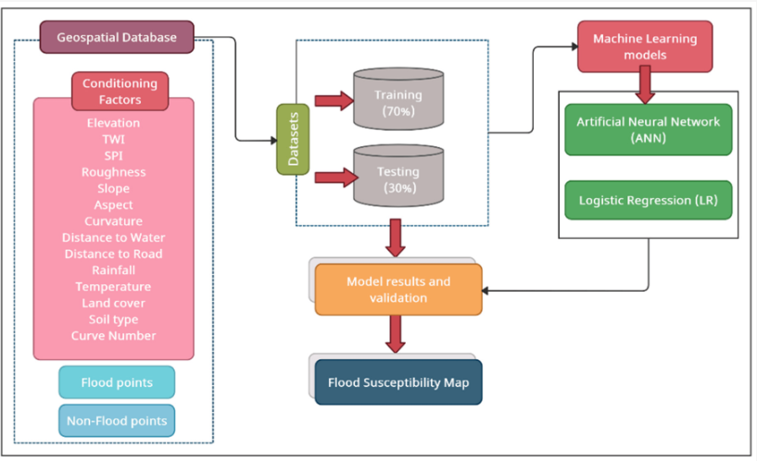

**Fig 3.2.1:Architecture Diagram**

## DEVELOPMENTALENVIRONMENT

**3.3.1 HARDWAREREQUIREMENTS**

The hardware requirements may serve as the basis for a contract for the system’s implementation. It should therefore be a complete and consistent specification of the entire system. It is generally used by software engineers as the starting point for the system design.

|  |  |
| --- | --- |
| **COMPONENTS** | **SPECIFICATION** |
| PROCESSOR | IntelCorei5 |
| RAM | 8GBRAM |
| GPU | NVIDIAGeForceGTX1650 |
| MONITOR | 15”COLOR |
| HARDDISK | 512 GB |
| PROCESSORSPEED | MINIMUM1.1GHz |

## Table 3.3.1.1:HardwareRequirements

* + 1. **SOFTWAREREQUIREMENTS**

The software requirements document is the specifications of the system.Itshouldincludebothadefinitionandaspecificationofrequirements.Itisaset of what the system should rather be doing than focus on how it should be done. The software requirements provide a basis for creating the software requirements specification. It is useful in estimating the cost, planning team activities, performing tasks, tracking the team, and tracking the team’s progress throughout the development activity.

Visual Studio Code**,**Xampp and Latest version Chrome would all be required.

* 1. **SEQUENCE DIAGRAM**

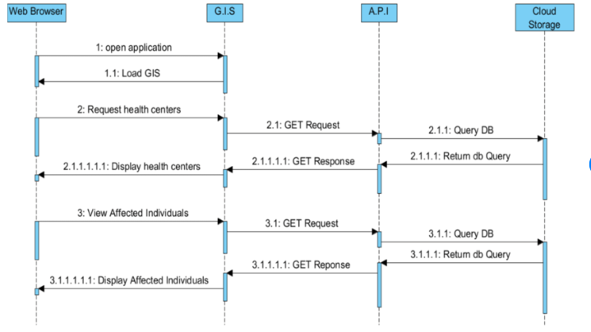

**Fig 3.4.1: Sequence Diagram**

**CHAPTER4**

**PROJECT DESCRIPTION**

## MODULES

* + 1. **Data Collection and Integration Module:**

The Data Collection and Integration Module is fundamental to the GIS Application for Flood Management, ensuring comprehensive and accurate data for analysis and decision-making. It integrates real-time data from rainfall gauges, river level sensors, and weather stations, as well as high-resolution satellite imagery and aerial photographs for detailed monitoring and historical analysis. The module gathers historical flood records, watershed characteristics, and soil moisture data, and incorporates weather forecasts and climate model projections to enhance flood prediction accuracy. Data quality assurance processes, including validation, calibration, and error handling, ensure reliability. Managed by a robust database system, this module supports efficient data storage, retrieval, and secure sharing among stakeholders, forming the backbone for precise flood modeling and risk assessment.

* + 1. **Flood Modeling and Simulation Module:**

The Flood Modeling and Simulation Module is integral to the GIS Application for Flood Management, providing accurate predictions and simulations of various flood scenarios to aid in effective planning and response. It employs hydrological models to simulate rainfall-runoff processes and predict river discharge levels, and hydraulic models to map flood inundation areas using 1D and 2D flow simulations. The module integrates GIS data, such as topography and land use, and real-time sensor inputs to enhance model accuracy. It conducts "what-if" analyses and extreme event simulations, calibrates and validates models with historical data, and generates detailed flood maps. These tools offer stakeholders precise visualizations of potential flood impacts, facilitating informed decision-making, improved preparedness, and effective emergency response.

* + 1. **Machine Learning and Predictive Analytics Module:**

The Machine Learning and Predictive Analytics Module is a pivotal component of the GIS Application for Flood Management, employing advanced algorithms to refine flood prediction accuracy and provide actionable insights. By integrating machine learning with GIS data, this module analyzes historical flood data to discern patterns and trends, enabling the prediction of future flood events based on factors like rainfall intensity and terrain attributes. Supervised and unsupervised learning algorithms are utilized to forecast floods and detect anomalies in flood data. The module's ability to continuously update models with new data and integrate real-time information ensures the application's relevance and effectiveness in mitigating flood risks.

* + 1. **Risk Assessment and Mapping Module:**

The Risk Assessment and Mapping Module is pivotal in the GIS Application for Flood Management, aiming to evaluate flood risks comprehensively and generate detailed flood maps for effective risk communication and planning. By integrating spatial data with analytical tools, the module assesses flood hazards, vulnerabilities, and potential impacts, enabling stakeholders to prioritize mitigation efforts and enhance community resilience. It utilizes hydraulic modeling results, topographic data, and land use information to map flood extents, depths, and velocities under various scenarios. Additionally, it assesses infrastructure vulnerability, population exposure, and socioeconomic factors to quantify flood risks and prioritize mitigation measures. The module's output includes risk maps depicting areas at different risk levels, facilitating spatial understanding and informed decision-making in flood risk management.

* + 1. **Real-Time Monitoring and Alerting Module:**

The Real-Time Monitoring and Alerting Module is crucial for the GIS Application for Flood Management, providing timely and accurate flood condition updates and issuing alerts for rapid response. It integrates real-time data from a network of sensors, including rainfall gauges, river level sensors, and weather stations, as well as satellite and drone imagery, to continuously monitor hydrological and meteorological conditions. By aggregating and analyzing this data in real time, the module identifies significant changes and potential flood risks, triggering automated notifications via SMS, email, and other channels. Interactive dashboards and geospatial mapping tools display real-time data and alert statuses, while predictive alerts using weather forecasts and machine learning models enhance early warning capabilities. Users can customize alert settings and receive information in multiple languages, ensuring they are well-informed and prepared to mitigate flood risks effectively.

* + 1. **User Interface and Accessibility Module:**

The User Interface and Accessibility Module is a key component of the GIS Application for Flood Management, designed to ensure that the application is user-friendly and accessible to a broad range of users, including government officials, emergency responders, and community members. This module focuses on creating an intuitive, easy-to-navigate interface that allows users to efficiently access and interpret flood-related data. It employs clear visualizations, such as interactive maps and dashboards, to present complex information in an understandable format. Features like customizable views, real-time updates, and multilingual support enhance usability and ensure that users can tailor the interface to their specific needs. Accessibility considerations, including compliance with standards for individuals with disabilities, ensure that the application is inclusive and usable by all stakeholders. By prioritizing user experience and accessibility, this module ensures that critical flood information is readily available, easily understandable, and actionable for all users, thereby enhancing overall flood preparedness and response efforts.

**4.1.7 Training and Support Module**:

The Training and Support Module is essential for the GIS Application for Flood Management, ensuring that users can effectively utilize the application’s capabilities through comprehensive training and ongoing support. This module provides structured training programs covering all aspects of the application, from data input and analysis to interpreting results and making informed decisions. It includes a variety of training materials, such as user manuals, video tutorials, and interactive workshops, catering to different learning preferences and skill levels. Additionally, the module offers continuous support through a helpdesk, online forums, and a dedicated support team to address user queries and technical issues promptly. Regular updates and refresher training sessions keep users informed about new features and enhancements. By equipping users with the necessary knowledge and skills, the Training and Support Module ensures that stakeholders can maximize the application’s potential for effective flood management, thereby improving overall preparedness and response efforts.

## CHAPTER5

**RESULTSANDDISCUSSIONS**

## OUTPUT

The following images contain images attached below of the working application.

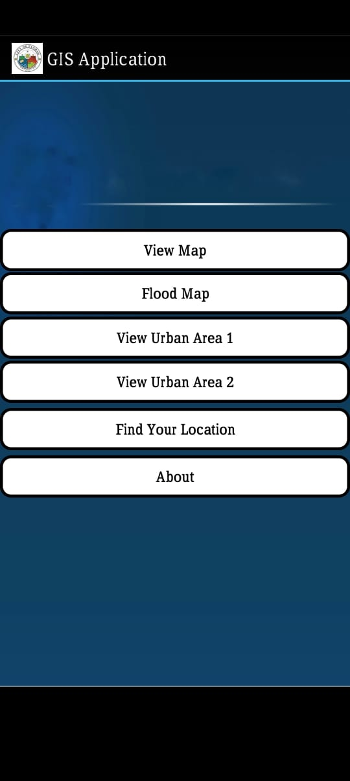

**Fig 5.1.1:Main Menu**

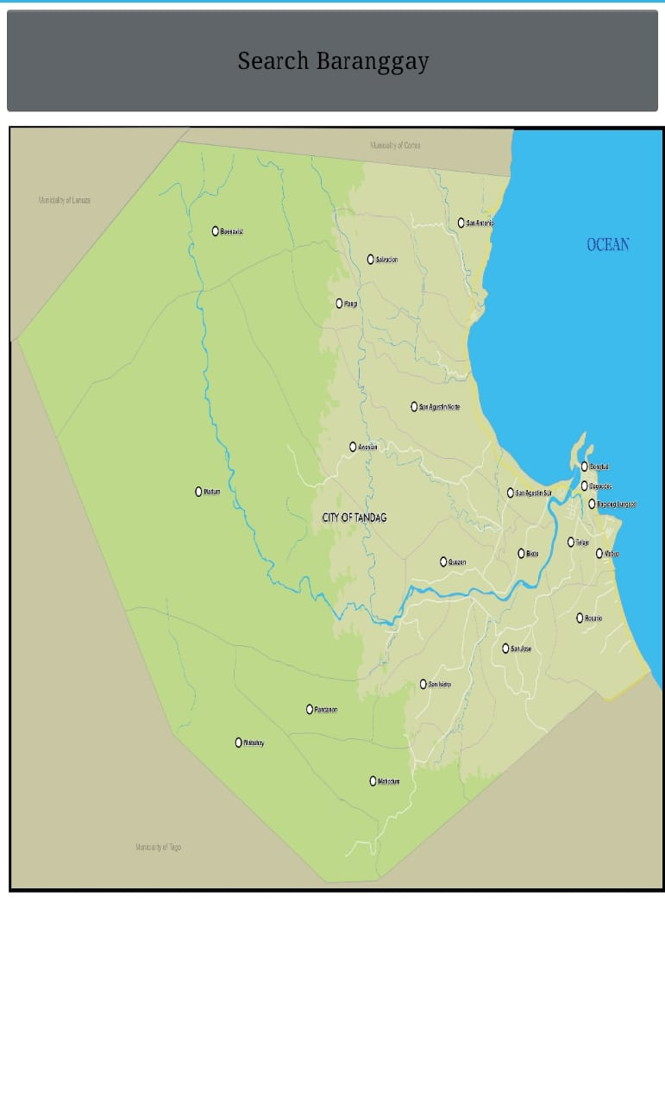

**Fig5.1.2View Map**

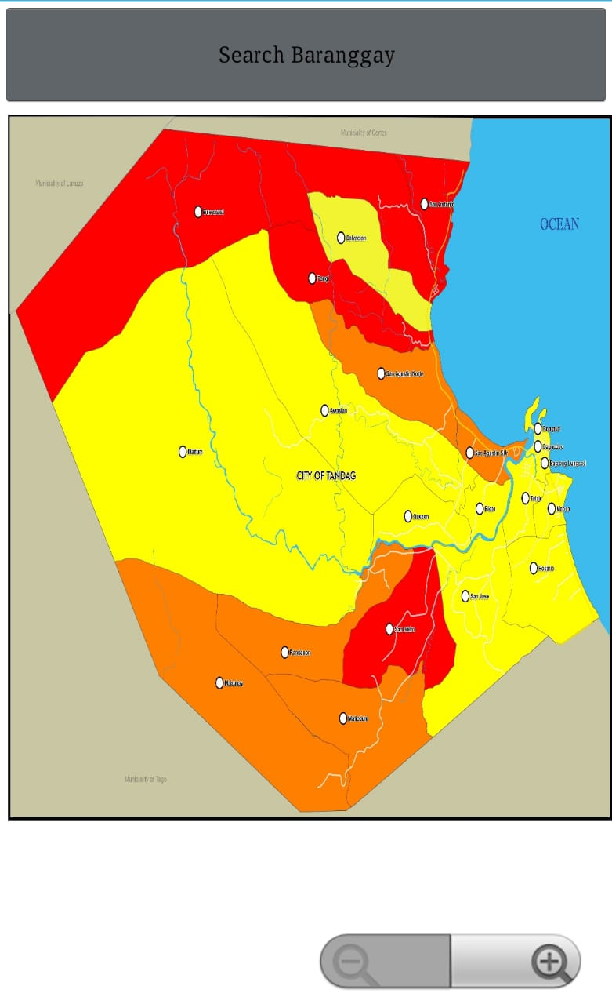

**5.1.3 Flood Map**

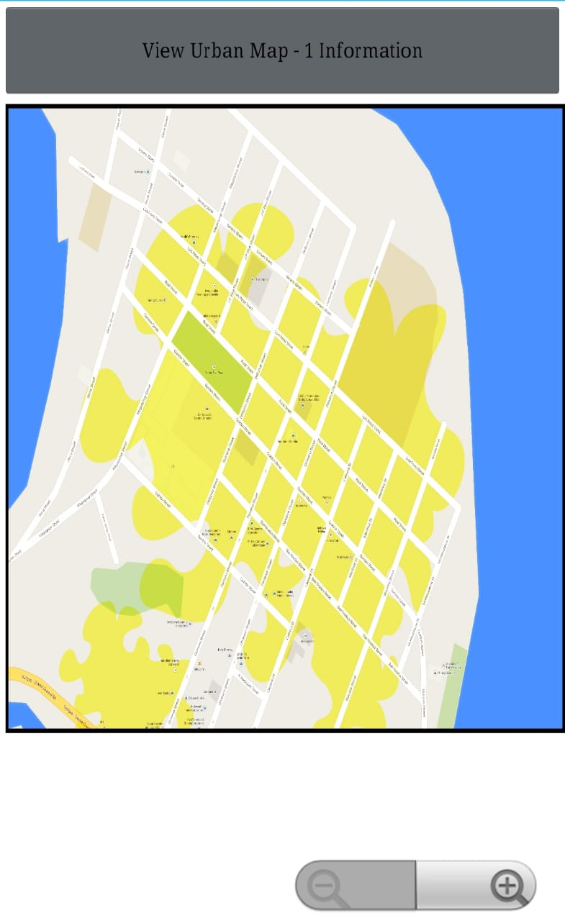

**5.1.4 View Urban Area**

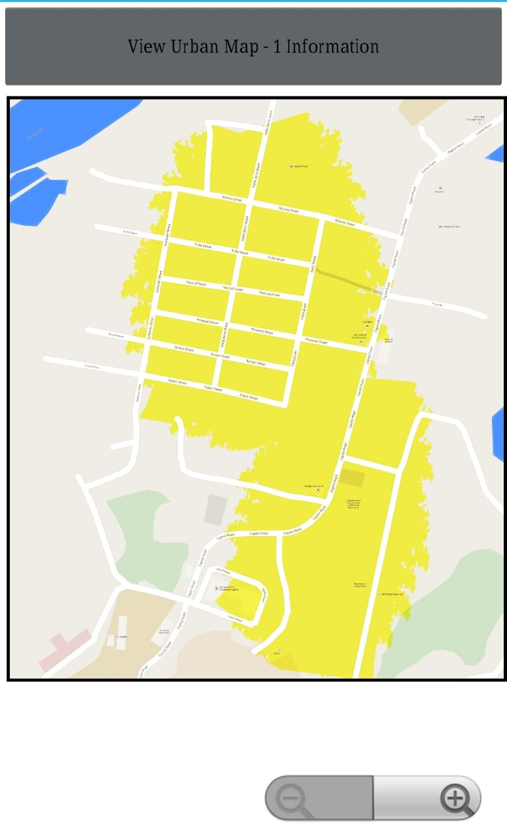

**5.1.5 Find Your Location**

* 1. **RESULT**

The implementation of the GIS Application for Flood Management has yielded significant improvements in flood preparedness, response, and risk mitigation. The application successfully integrates real-time data from multiple sources, including sensors, satellite imagery, and weather forecasts, providing accurate and timely information on flood conditions. This integration has enhanced the predictive accuracy of flood models, allowing for more precise flood hazard mapping and risk assessment.

The user-friendly interface has made complex data accessible to a wide range of stakeholders, including government officials, emergency responders, and community members. Users can easily navigate the application, view interactive maps, and receive real-time alerts, enabling them to make informed decisions quickly. The detailed flood maps and risk assessments generated by the application have facilitated better planning and resource allocation, prioritizing areas at highest risk and optimizing emergency response efforts.

Furthermore, the application’s comprehensive training and support module has empowered users with the necessary skills to utilize the system effectively. Continuous feedback and updates have ensured that the application remains relevant and efficient in addressing flood risks. Overall, the GIS Application for Flood Management has proven to be a valuable tool in enhancing flood resilience and reducing the impact of floods on communities.

## CHAPTER6

**CONCLUSION AND FUTURE ENHANCEMENT**

## 6.1CONCLUSION

The GIS Application for Flood Management represents a significant advancement in disaster management technology, providing a comprehensive and effective tool for flood risk assessment, preparedness, and response. By integrating open-source GIS software, advanced flood modeling, machine learning, and real-time data from various sources, the application offers precise and actionable insights into potential flood events. Its user-friendly interface, detailed flood maps, and interactive dashboards make complex data accessible and understandable for a diverse range of stakeholders, from government officials to community members.

The successful implementation of this application has led to improved flood prediction accuracy, better risk assessment, and more efficient emergency response planning. The real-time monitoring and alerting capabilities ensure timely information dissemination and rapid response during flood events, significantly enhancing community resilience. The comprehensive training and support provided to users have further ensured effective utilization of the application’s capabilities.

Looking forward, future enhancements such as the integration of more advanced AI and machine learning algorithms, the GIS Application for Flood Management remains a cutting-edge tool in mitigating flood risks and protecting communities from the devastating impacts of floods.

## FUTUREENHANCEMENT

The future enhancement of the GIS Application for Flood Management aims to leverage emerging technologies and address evolving user needs to further improve flood preparedness, response, and resilience. Potential enhancements include the integration of advanced artificial intelligence (AI) and machine learning (ML) algorithms for more accurate flood prediction and risk assessment. Enhancing real-time data integration by incorporating Internet of Things (IoT) devices, such as smart sensors and drones, can provide more granular and timely data. Additionally, expanding the application’s capabilities to include climate change projections and their impact on flood risk can help in long-term planning. Improving the user interface with augmented reality (AR) features for better visualization and decision-making in the field is another potential upgrade. Furthermore, enhancing accessibility features to better serve users with disabilities and adding support for more languages will ensure the application is inclusive and usable by a broader audience. By continuously innovating and integrating feedback from stakeholders, the GIS Application for Flood Management can remain a cutting-edge tool for mitigating flood risks and protecting communities.

**APPENDIX**

**SOURCE CODE:**

<?xml version="1.0" encoding="utf-8"?>

<manifest

xmlns:android="http://schemas.android.com/apk/res/android"

package="b4a.example"

android:versionCode="1"

android:versionName=""

android:installLocation="internalOnly">

<uses-sdk android:minSdkVersion="5" android:targetSdkVersion="14"/>

<supports-screens android:largeScreens="true"

android:normalScreens="true"

android:smallScreens="true"

android:anyDensity="true"/>

<uses-permission android:name="android.permission.WRITE_EXTERNAL_STORAGE"/>

<uses-permission android:name="android.permission.INTERNET"/>

<uses-permission android:name="android.permission.ACCESS_FINE_LOCATION"/>

<application

android:icon="@drawable/icon"

android:label="GIS"

android:theme="@android:style/Theme.Holo">

<activity

android:windowSoftInputMode="stateHidden"

android:launchMode="singleTop"

android:name=".main"

android:label="GIS"

android:screenOrientation="unspecified">

<intent-filter>

<action android:name="android.intent.action.MAIN" />

<category android:name="android.intent.category.LAUNCHER" />

</intent-filter>

</activity>

<activity

android:windowSoftInputMode="stateHidden"

android:launchMode="singleTop"

android:name=".viewmap"

android:label="GIS"

android:screenOrientation="unspecified">

</activity>

<activity

android:windowSoftInputMode="stateHidden"

android:launchMode="singleTop"

android:name=".book"

android:label="GIS"

android:screenOrientation="unspecified">

</activity>

<activity

android:windowSoftInputMode="stateHidden"

android:launchMode="singleTop"

android:name=".intro"

android:label="GIS"

android:screenOrientation="unspecified">

</activity>

<activity

android:windowSoftInputMode="stateHidden"

android:launchMode="singleTop"

android:name=".searchb"

android:label="GIS"

android:screenOrientation="unspecified">

</activity>

<activity

android:windowSoftInputMode="stateHidden"

android:launchMode="singleTop"

android:name=".viewflood"

android:label="GIS"

android:screenOrientation="unspecified">

</activity>

<activity

android:windowSoftInputMode="stateHidden"

android:launchMode="singleTop"

android:name=".bflood"

android:label="GIS"

android:screenOrientation="unspecified">

</activity>

<activity

android:windowSoftInputMode="stateHidden"

android:launchMode="singleTop"

android:name=".geolocation"

android:label="GIS"

android:screenOrientation="unspecified">

</activity>

<activity

android:windowSoftInputMode="stateHidden"

android:launchMode="singleTop"

android:name=".vbar"

android:label="GIS"

android:screenOrientation="unspecified">

</activity>

<activity

android:windowSoftInputMode="stateHidden"

android:launchMode="singleTop"

android:name=".viewurban1"

android:label="GIS"

android:screenOrientation="unspecified">

</activity>

<activity

android:windowSoftInputMode="stateHidden"

android:launchMode="singleTop"

android:name=".viewurban2"

android:label="GIS"

android:screenOrientation="unspecified">

</activity>

<activity

android:windowSoftInputMode="stateHidden"

android:launchMode="singleTop"

android:name=".burban1"

android:label="GIS"

android:screenOrientation="unspecified">

</activity>

<activity

android:windowSoftInputMode="stateHidden"

android:launchMode="singleTop"

android:name=".burban2"

android:label="GIS"

android:screenOrientation="unspecified">

</activity>

</application>

</manifest>

## REFERENCES

* 1. Ahmad, S., & Simonovic, S. P. (2006). An intelligent decision support system for management of floods. Water Resources Management, 20(3), 391-410.
  2. Bui, D. T., Pradhan, B., Lofman, O., Revhaug, I., & Dick, O. B. (2012). Landslide susceptibility mapping at Hoa Binh province (Vietnam) using an adaptive neuro-fuzzy inference system and GIS. Computers & Geosciences, 45, 199-211.
  3. De Groeve, T., Thielen, J., & Brakenridge, G. R. (2013). Near real-time flood alerting for the global disaster alert and coordination system. Proceedings of the National Academy of Sciences, 110(21), 8471-8476.
  4. Goodchild, M. F. (2006). GIS and disasters: Planning for catastrophe. Computers, Environment and Urban Systems, 30(3), 227-229.
  5. Horritt, M. S., & Bates, P. D. (2002). Evaluation of 1D and 2D numerical models for predicting river flood inundation. Journal of Hydrology, 268(1-4), 87-99.
  6. Knebl, M. R., Yang, Z. L., Hutchison, K., & Maidment, D. R. (2005). Regional scale flood modeling using NEXRAD rainfall, GIS, and HEC-HMS/RAS: A case study for the San Antonio River Basin summer 2002 storm event. Journal of Environmental Management, 75(4), 325-336.
  7. Maidment, D. R. (1993). GIS and hydrologic modeling. Environmental Modeling with GIS, 147-167.
  8. Mosavi, A., Ozturk, P., & Chau, K. W. (2018). Flood prediction using machine learning models: Literature review. Water, 10(11), 1536.
  9. Schumann, G. J. P., Di Baldassarre, G., & Bates, P. D. (2009). The utility of spaceborne radar to render flood inundation maps based on multialgorithm ensembles. IEEE Transactions on Geoscience and Remote Sensing, 47(8), 2801-2807.
  10. Tang, W., & Cheng, P. (2011). Web-based GIS for public flood mapping and information dissemination. Natural Hazards, 59(2), 993-1009.