Subtype- and Age-Dependent Transcriptional Remodeling of Hippocampal Neurons in APP23 Mice Reveals Early Dentate Gyrus Synaptic Dysfunction and Late CA1-Like Sterol Reprogramming
Manuscript draft
Mostafa Abdelaziz
Faculty of Pharmacy and Pharmaceutical Sciences, University of Alberta, Edmonton, Alberta, Canada

Abstract
Selective neuronal vulnerability is a defining feature of Alzheimer’s disease (AD), but the molecular programs that distinguish susceptible from relatively preserved neuronal populations remain incompletely understood. We reanalyzed the publicly available hippocampal single-nucleus RNA-sequencing dataset GSE141044 from 6- and 24-month-old wild-type (WT) and APP23 mice. The processed dataset contained 3,280 neuronal nuclei generated using a modified Smart-seq2 strategy. Following quality-control verification, normalization, variable-feature selection, principal-component analysis, graph-based clustering, and Uniform Manifold Approximation and Projection (UMAP), ten fine transcriptional clusters were resolved and consolidated into four broad neuronal populations: dentate gyrus (DG), CA1-like, CA3, and inhibitory neurons. APP23-versus-WT differential expression was assessed by biological-sample-level pseudobulk aggregation and edgeR separately within age and neuronal population. Ranked differential-expression statistics were analyzed using Gene Ontology Biological Process gene-set enrichment analysis (GSEA), transcription-factor activity was explored with DoRothEA/decoupleR, and CellChat was used to characterize inferred neuron-to-neuron communication at 24 months. Gene-level differential expression was sparse after multiple-testing correction, but pathway analysis revealed marked subtype- and age-specific remodeling. Six-month DG neurons showed depletion of synaptic transmission and synaptic-vesicle programs, while 24-month DG neurons showed broader depletion of synapse organization, neuronal projection, and morphogenesis programs. CA1-like neurons showed little FDR-significant pathway remodeling at 6 months but pronounced late enrichment of cholesterol/sterol biosynthetic programs at 24 months. CA3 and inhibitory neurons showed no FDR-significant GO pathway enrichment in the primary analysis. No transcription factor survived FDR correction; however, Srebf2 emerged as a biologically coherent exploratory candidate in 24-month CA1-like neurons. CellChat indicated broad network rewiring in aged APP23 neurons and higher inferred cholesterol- and desmosterol-associated communication probabilities. Together, these findings support temporally and molecularly distinct neuronal responses in APP23 hippocampus, characterized by early DG synaptic dysfunction and late CA1-like sterol-associated remodeling.
Keywords: Alzheimer’s disease; APP23; hippocampus; single-nucleus RNA sequencing; dentate gyrus; CA1; cholesterol; synaptic signaling; pseudobulk; CellChat

1. Introduction
Alzheimer’s disease (AD) is a progressive neurodegenerative disorder in which synaptic dysfunction, neuronal loss, amyloid-β pathology, tau pathology, and age-dependent molecular alterations converge to impair cognition. Importantly, neuronal populations are not affected uniformly. Distinct neuronal classes and anatomical regions show different degrees and temporal patterns of vulnerability, making cell-type-resolved analysis important for understanding disease progression.
The hippocampus is central to learning and memory and contains molecularly and functionally distinct neuronal populations, including dentate gyrus, CA1, CA3, and inhibitory neurons. Bulk-tissue transcriptomics can obscure population-specific responses, whereas single-cell and single-nucleus transcriptomic approaches can resolve disease-associated changes at cellular resolution.
Zhong et al. generated a hippocampal neuronal single-nucleus RNA-sequencing dataset from young and aged APP23 transgenic and control mice using a modified Smart-seq2 strategy. Their study analyzed 3,280 neuronal nuclei and identified four major neuronal subpopulations, demonstrating that APP23-associated transcriptional changes vary among neuronal subtypes [1]. The dataset is publicly available as GEO accession GSE141044.
The present reanalysis was designed around the question: Which hippocampal neuronal subtypes exhibit the strongest pathway-level transcriptional remodeling in APP23 mice, and which biological programs distinguish susceptible from relatively preserved neuronal populations? To address this question conservatively, the biological mouse rather than the individual nucleus was used as the experimental replicate for differential-expression inference. We integrated sample-level pseudobulk differential expression with ranked pathway enrichment, transcription-factor activity inference, and inferred neuronal communication. Particular attention was given to synaptic programs and sterol metabolism because cholesterol homeostasis is closely linked to neuronal membrane biology, vesicular trafficking, synaptic function, and AD-related processes [2–4].

2. Materials and Methods

2.1 Dataset and experimental design
Processed single-nucleus RNA-sequencing data were obtained from GEO accession GSE141044. The source study used a modified Smart-seq2 strategy to profile hippocampal neuronal nuclei from APP23 and WT mice [1]. The final processed dataset contained 3,280 neuronal nuclei from 11 biological samples: three 6-month WT mice, three 6-month APP23 mice, two 24-month WT mice, and three 24-month APP23 mice. The dataset contained 951 nuclei from 6-month WT, 841 from 6-month APP23, 655 from 24-month WT, and 833 from 24-month APP23 animals.

2.2 Expression-matrix processing and metadata reconstruction
Inspection of the downloaded processed expression file showed that, despite its .mtx filename, its content was a dense whitespace-delimited table. Cell identifiers were recovered from the first row, gene symbols from the first column, and expression values from the remaining entries. Sample identity, age, genotype, and lane information were reconstructed from nucleus identifiers. Lane suffixes were removed when defining biological sample identifiers so that downstream pseudobulk aggregation occurred at the mouse level. The imported matrix initially contained 28,693 features across 3,280 nuclei. A feature labeled “a” contained only eight counts across two nuclei and was removed as a non-biological parsing/annotation artifact, leaving 28,692 features.

2.3 Quality-control verification
The source study reported quality criteria including >500 detected genes, >4,000 transcripts, and mapping rate >20% [1]. Because the present reanalysis began from the authors’ processed expression matrix, mapping-rate filtering could not be independently repeated. We verified the expression-level thresholds nFeature_RNA >500 and nCount_RNA >4000. All 3,280 nuclei passed these criteria; the minimum detected-feature count was approximately 1,237 and the minimum total count was approximately 4,024. Mitochondrial percentage was not used because mitochondrial genes were absent from the processed matrix. No additional computational doublet removal was performed. The starting material was an already processed Smart-seq2 neuronal-nucleus dataset rather than a raw droplet matrix, and droplet-specific ambient-RNA or empty-droplet procedures were therefore not applicable.

2.4 Normalization, feature selection, and dimensionality reduction
The dataset was analyzed in Seurat. Expression was normalized with LogNormalize using a scale factor of 10,000. The top 2,000 highly variable genes were selected using the variance-stabilizing transformation method and scaled before principal-component analysis (PCA). Thirty principal components were calculated, and PCs 1–10 were used for graph construction, clustering, and UMAP. No Harmony or other batch-integration correction was applied because biological sample identity was nested within the age/genotype design and aggressive integration could attenuate genuine biological differences. UMAP was generated with a fixed random seed of 100. t-SNE was not used.

2.5 Graph-based clustering and neuronal annotation
A shared nearest-neighbor graph was constructed from PCs 1–10. A resolution grid was evaluated, and resolution 0.5 was selected because it yielded ten fine clusters. Positive cluster markers were identified using FindAllMarkers with the Wilcoxon rank-sum test, only.pos=TRUE, min.pct=0.25, and log-fold-change threshold=0.25. Cluster 0 showed strong Prox1/C1ql2 expression and was assigned as DG. Cluster 4 showed strong Mndal expression and was assigned as CA3. Clusters 6, 7, and 9 expressed Gad1/Gad2 and were grouped as inhibitory. The remaining excitatory clusters (1, 2, 3, 5, and 8) were operationally grouped as CA1-like for broad population-level inference. The final broad annotation contained 1,119 DG, 1,493 CA1-like, 328 CA3, and 340 inhibitory nuclei.

2.6 Pseudobulk differential-expression analysis
Raw RNA counts were aggregated for each biological mouse × broad neuronal subtype combination, yielding approximately 44 pseudobulk libraries. Differential expression was analyzed separately within each age and neuronal subtype using edgeR. Genes were filtered with filterByExpr, TMM normalization factors were calculated, robust dispersion was estimated, and quasi-likelihood generalized linear models were fitted. APP23-versus-WT contrasts were tested with glmQLFTest. Positive log2 fold change represented higher expression in APP23. A stringent DEG criterion of FDR <0.05 and |log2FC| >0.25 was used.

2.7 Gene-set enrichment analysis
Because relatively few individual genes survived multiple-testing correction, pathway remodeling was evaluated using complete ranked pseudobulk differential-expression results. Genes were ranked using a signed statistic based on log-fold-change direction and the edgeR F statistic. Gene symbols were mapped to Entrez identifiers and duplicate mappings were resolved by retaining the strongest absolute ranking statistic. GO Biological Process GSEA was performed with clusterProfiler gseGO using gene sets of 10–500 genes and Benjamini-Hochberg correction. Positive NES values indicate enrichment toward the APP23-upregulated end of the ranked list; negative NES values indicate enrichment toward the WT/up-in-WT end. For the primary pathway analysis, the exact uppercase APP feature and Thy1 were excluded to reduce domination by construct-associated features, whereas endogenous App was retained. A sensitivity analysis retaining these features was also performed.

2.8 Transcription-factor activity inference
Mouse DoRothEA transcription-factor–target interactions with confidence levels A, B, and C were used with decoupleR. Pseudobulk logCPM profiles served as input, and exact uppercase APP and Thy1 were excluded from the primary TF analysis. Activity was estimated using the univariate linear-model method. Differential TF activity between APP23 and WT was evaluated within each age × neuronal-subtype comparison using limma with Benjamini-Hochberg correction. Because no TF reached FDR <0.05, TF results were interpreted as exploratory.

2.9 CellChat analysis
CellChat was used to investigate inferred neuron-to-neuron communication in 24-month WT and APP23 animals, the age at which the strongest pathway-level phenotype was observed. Separate CellChat objects were generated using DG, CA1-like, CA3, and inhibitory populations. Normalized RNA expression was used; overexpressed signaling genes and interactions were identified, and communication probabilities were estimated using the trimean method with raw.use=TRUE. Interactions involving groups with fewer than 10 cells were filtered. WT and APP23 networks were compared for interaction number, aggregate strength, sender-receiver relationships, pathway composition, condition-specific pathways, and cholesterol/desmosterol-associated signaling. Because nuclei were pooled by genotype rather than modeled as independent mice, CellChat results were treated as descriptive network inference rather than replicated statistical evidence. Because GSE141044 contains neuronal nuclei only, the analysis cannot evaluate neuron–glia communication.

3. Results

3.1 The processed dataset retains 3,280 high-quality neuronal nuclei
The processed GSE141044 dataset contained 3,280 neuronal nuclei from 11 biological samples. Verification against the source study’s expression-level thresholds showed that every nucleus contained >500 detected genes and >4,000 total counts/transcripts. No additional nuclei were removed during QC, consistent with the dataset having already undergone substantial upstream quality selection before public release.

3.2 Fine clustering resolves ten neuronal states within four broad hippocampal populations
PCA followed by graph-based clustering at resolution 0.5 identified ten transcriptionally distinguishable neuronal clusters. Marker expression supported consolidation into four broad populations. Cluster 0 showed strong Prox1 and C1ql2 expression and was assigned as DG; cluster 4 showed strong Mndal expression and was assigned as CA3; clusters 6, 7, and 9 expressed Gad1/Gad2 and represented inhibitory neurons. Clusters 1, 2, 3, 5, and 8 were predominantly excitatory and were operationally grouped as CA1-like. Cluster 5 was distinguished by immediate-early/activity genes including Fos, Npas4, Arc, and Egr1, while cluster 8 showed a Rorb-associated signature. The broad populations contained 1,119 DG, 1,493 CA1-like, 328 CA3, and 340 inhibitory nuclei, and all four populations were represented in every mouse.
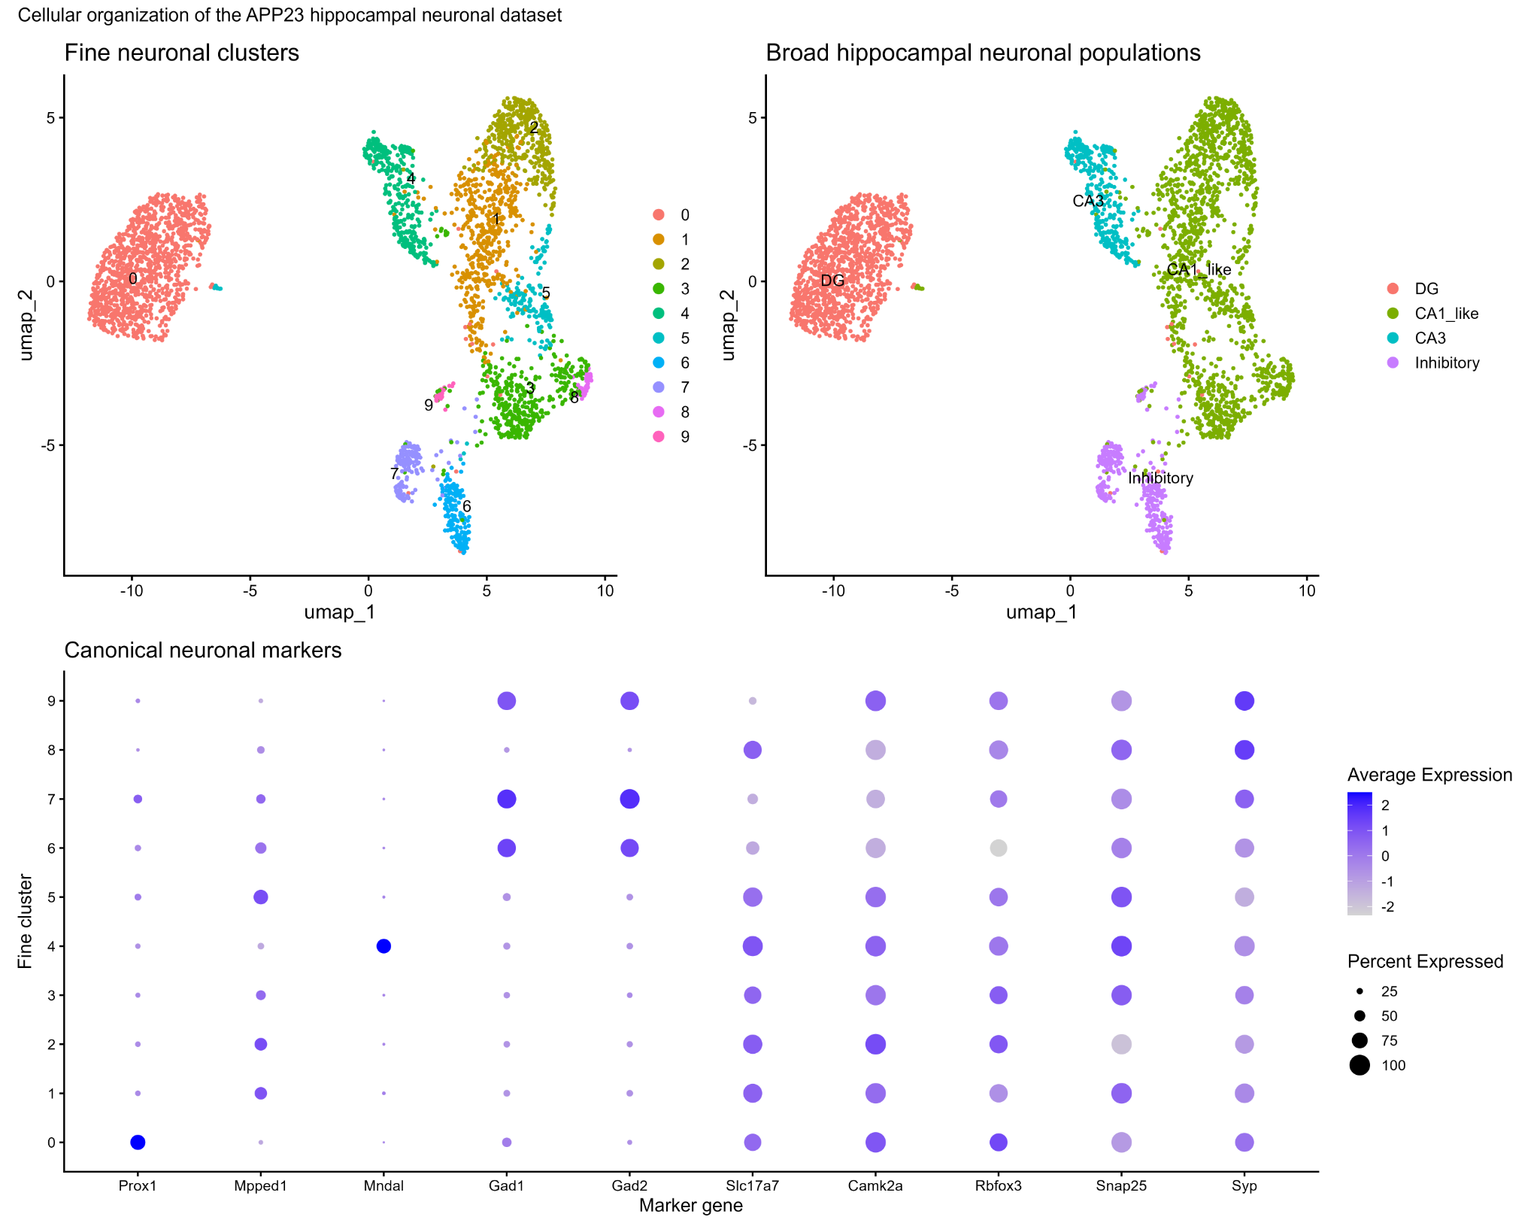
Figure 1. Cellular organization and annotation of the APP23 hippocampal neuronal dataset. Top left: UMAP of the ten fine neuronal clusters obtained at clustering resolution 0.5. Top right: the same UMAP after consolidation into DG, CA1-like, CA3, and inhibitory populations. Bottom: canonical-marker DotPlot across the ten fine clusters; dot size represents percent expressed and color represents average expression.

3.3 Sample-level pseudobulk analysis reveals sparse individually significant genes
Using the biological mouse as the experimental replicate, relatively few genes met the stringent criterion of FDR <0.05 and |log2FC| >0.25. At 6 months, 2, 2, 3, and 5 significant genes were identified in DG, CA1-like, CA3, and inhibitory populations, respectively. At 24 months, the corresponding numbers were 3, 2, 2, and 3. The uppercase APP feature displayed very large positive log-fold changes across all eight comparisons, whereas endogenous App showed small, nonsignificant changes. Thy1 was also significantly increased across comparisons. APP and Thy1 were therefore retained as model-associated observations but excluded from the primary pathway ranking. The scarcity of FDR-significant DEGs, together with hundreds of nominally ranked genes, motivated rank-based GSEA.

3.4 DG neurons show early synaptic suppression and later structural/synaptic remodeling
At 6 months, DG neurons showed four FDR-significant GO Biological Process terms, all negatively enriched in APP23: regulation of trans-synaptic signaling, modulation of chemical synaptic transmission, synaptic vesicle cycle, and vesicle-mediated transport in synapse. By 24 months, the DG phenotype broadened to eight significant pathways, dominated by negative enrichment of postsynapse organization, regulation of synapse structure or activity, regulation of synapse organization, synapse assembly, neuron projection development, and cell morphogenesis. This pattern is consistent with an age-dependent transition from early synaptic functional disruption toward broader synaptic and structural remodeling.

3.5 CA1-like neurons develop pronounced late cholesterol/sterol biosynthetic remodeling
CA1-like neurons showed no FDR-significant GO pathway enrichment at 6 months, but 20 significant pathways at 24 months. The clearest positively enriched program involved cholesterol and sterol biosynthesis, including cholesterol biosynthesis through lathosterol and desmosterol and zymosterol metabolic/biosynthetic processes. The strongest cholesterol term had an NES of approximately 2.50 with FDR <0.001. Several negatively enriched terms were also identified, but many were less neuron-specific or redundant. The sterol/cholesterol biosynthetic program therefore represented the most coherent positive signature of aged APP23 CA1-like neurons.

3.6 CA3 and inhibitory neurons show comparatively limited FDR-significant pathway remodeling
Neither CA3 nor inhibitory neurons showed FDR-significant GO Biological Process enrichment in the primary GSEA at either age. This does not imply an absence of molecular change: individual genes were altered, including significant Abca7 downregulation in 6-month CA3 and changes in Tnrc6b, Chrm3, and Gfod2 in 6-month inhibitory neurons. Rather, relative preservation here refers specifically to the absence of strong FDR-defined coordinated pathway remodeling under the present analysis.
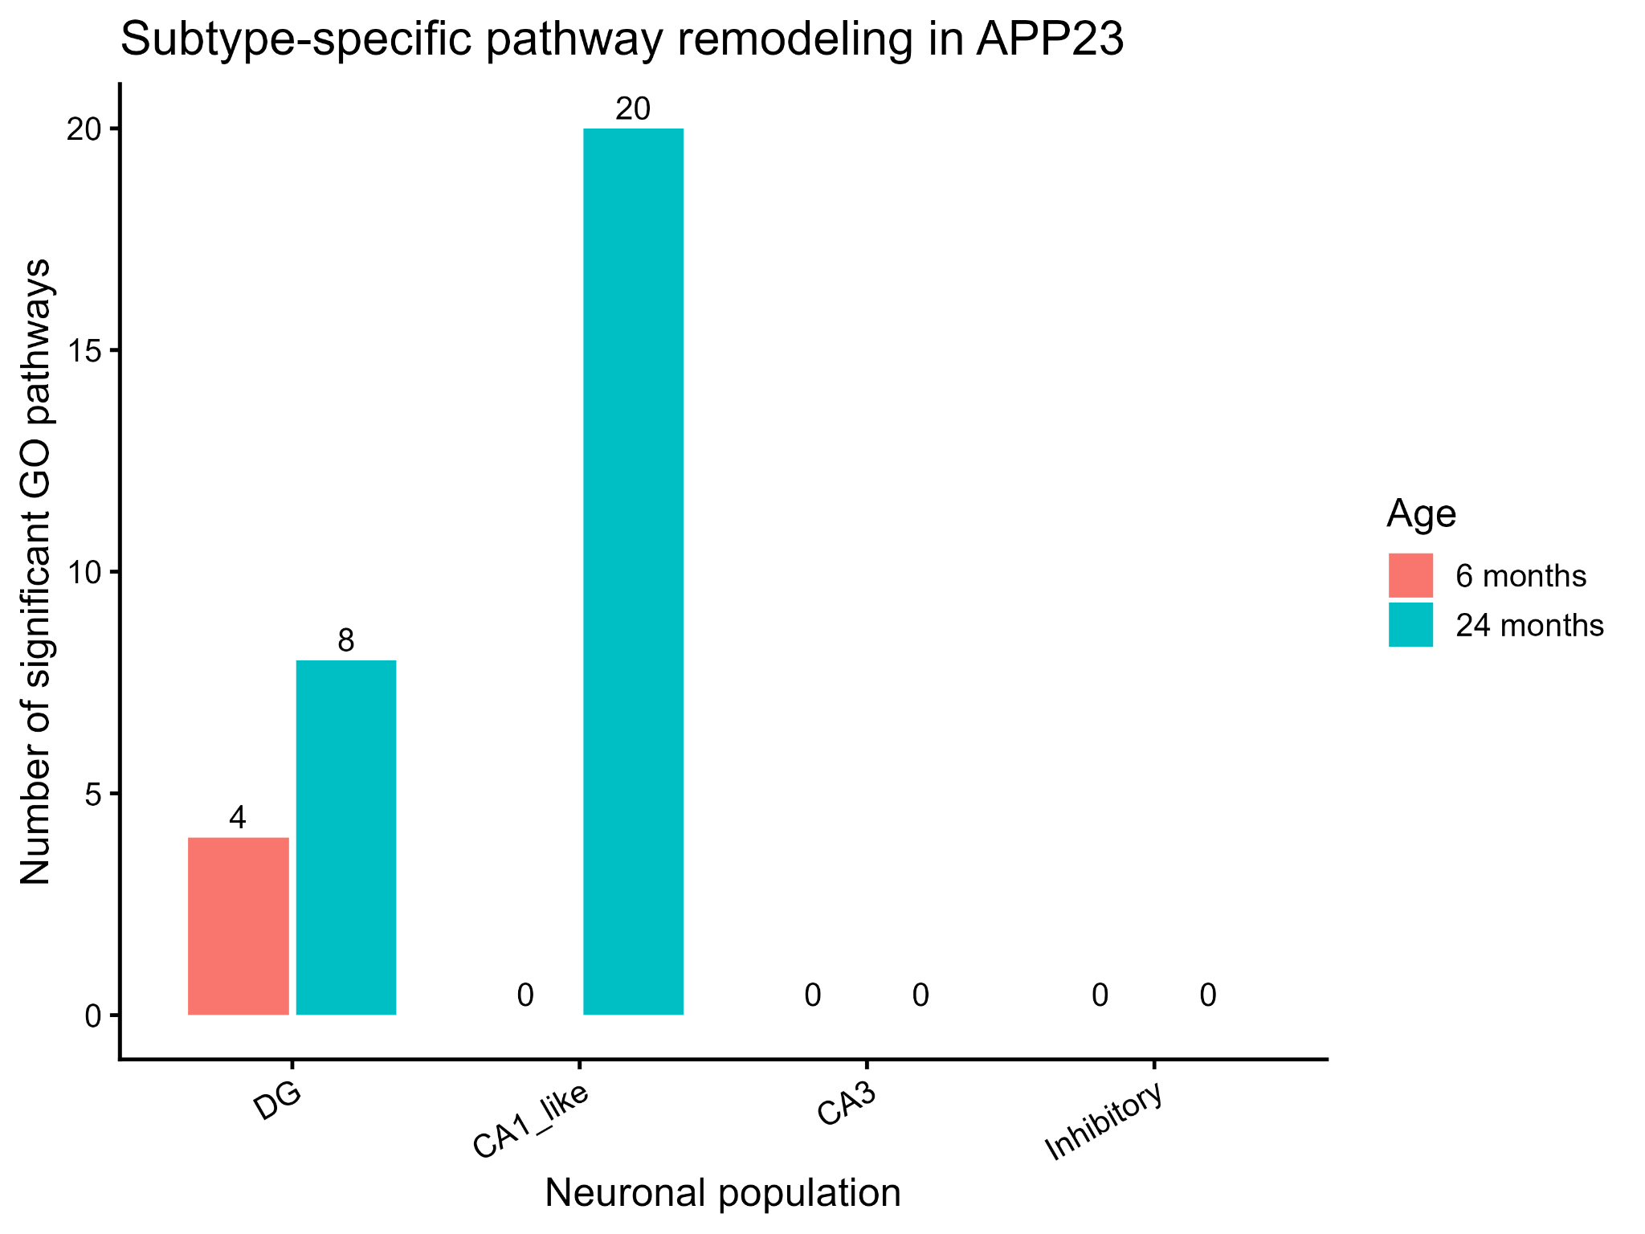
Figure 2. Subtype- and age-specific pathway remodeling in APP23. Number of FDR-significant GO Biological Process terms detected by ranked GSEA for APP23-versus-WT comparisons. DG showed four significant pathways at 6 months and eight at 24 months, while CA1-like neurons showed 20 significant pathways at 24 months. CA3 and inhibitory neurons showed no FDR-significant GO terms in the primary analysis.

3.7 TF activity analysis nominates biologically coherent but statistically exploratory regulators
DoRothEA/decoupleR inferred activity for 272 transcription factors across pseudobulk samples. No TF reached FDR <0.05 in any comparison. In 6-month DG, Neurod1, Jun, and Fos ranked toward lower activity while Nrf1 and Trp53 ranked toward higher activity. At 24 months, DG showed exploratory ranking of regulators including Rela, Zeb1, and Creb3l1. Of particular interest, Srebf2 ranked toward increased activity in 24-month CA1-like APP23 neurons. Because SREBF2 is a major regulator of cholesterol biosynthesis [3,4], this direction is biologically concordant with the independent GSEA sterol signature. However, Srebf2 did not survive multiple-testing correction and is therefore considered a candidate rather than a validated regulator.

3.8 APP23 is associated with broad reorganization of inferred neuronal communication at 24 months
The 24-month WT CellChat network contained 1,350 inferred interactions across 41 pathways, whereas the APP23 network contained 1,388 interactions across 42 pathways. Thirty-eight pathways were shared. WT-only inferred pathways included CypA, AGRN, and ncWNT; APP23-only pathways included SEMA6, TENASCIN, PDGF, and IGF. Aggregate strength differences showed that APP23 did not cause a uniform increase in communication. Instead, the network was rewired: DG→CA1-like strength increased by approximately 0.61, whereas several CA3- and inhibitory-associated relationships decreased. The largest aggregate reduction occurred for CA3→CA3 communication (approximately −2.52).
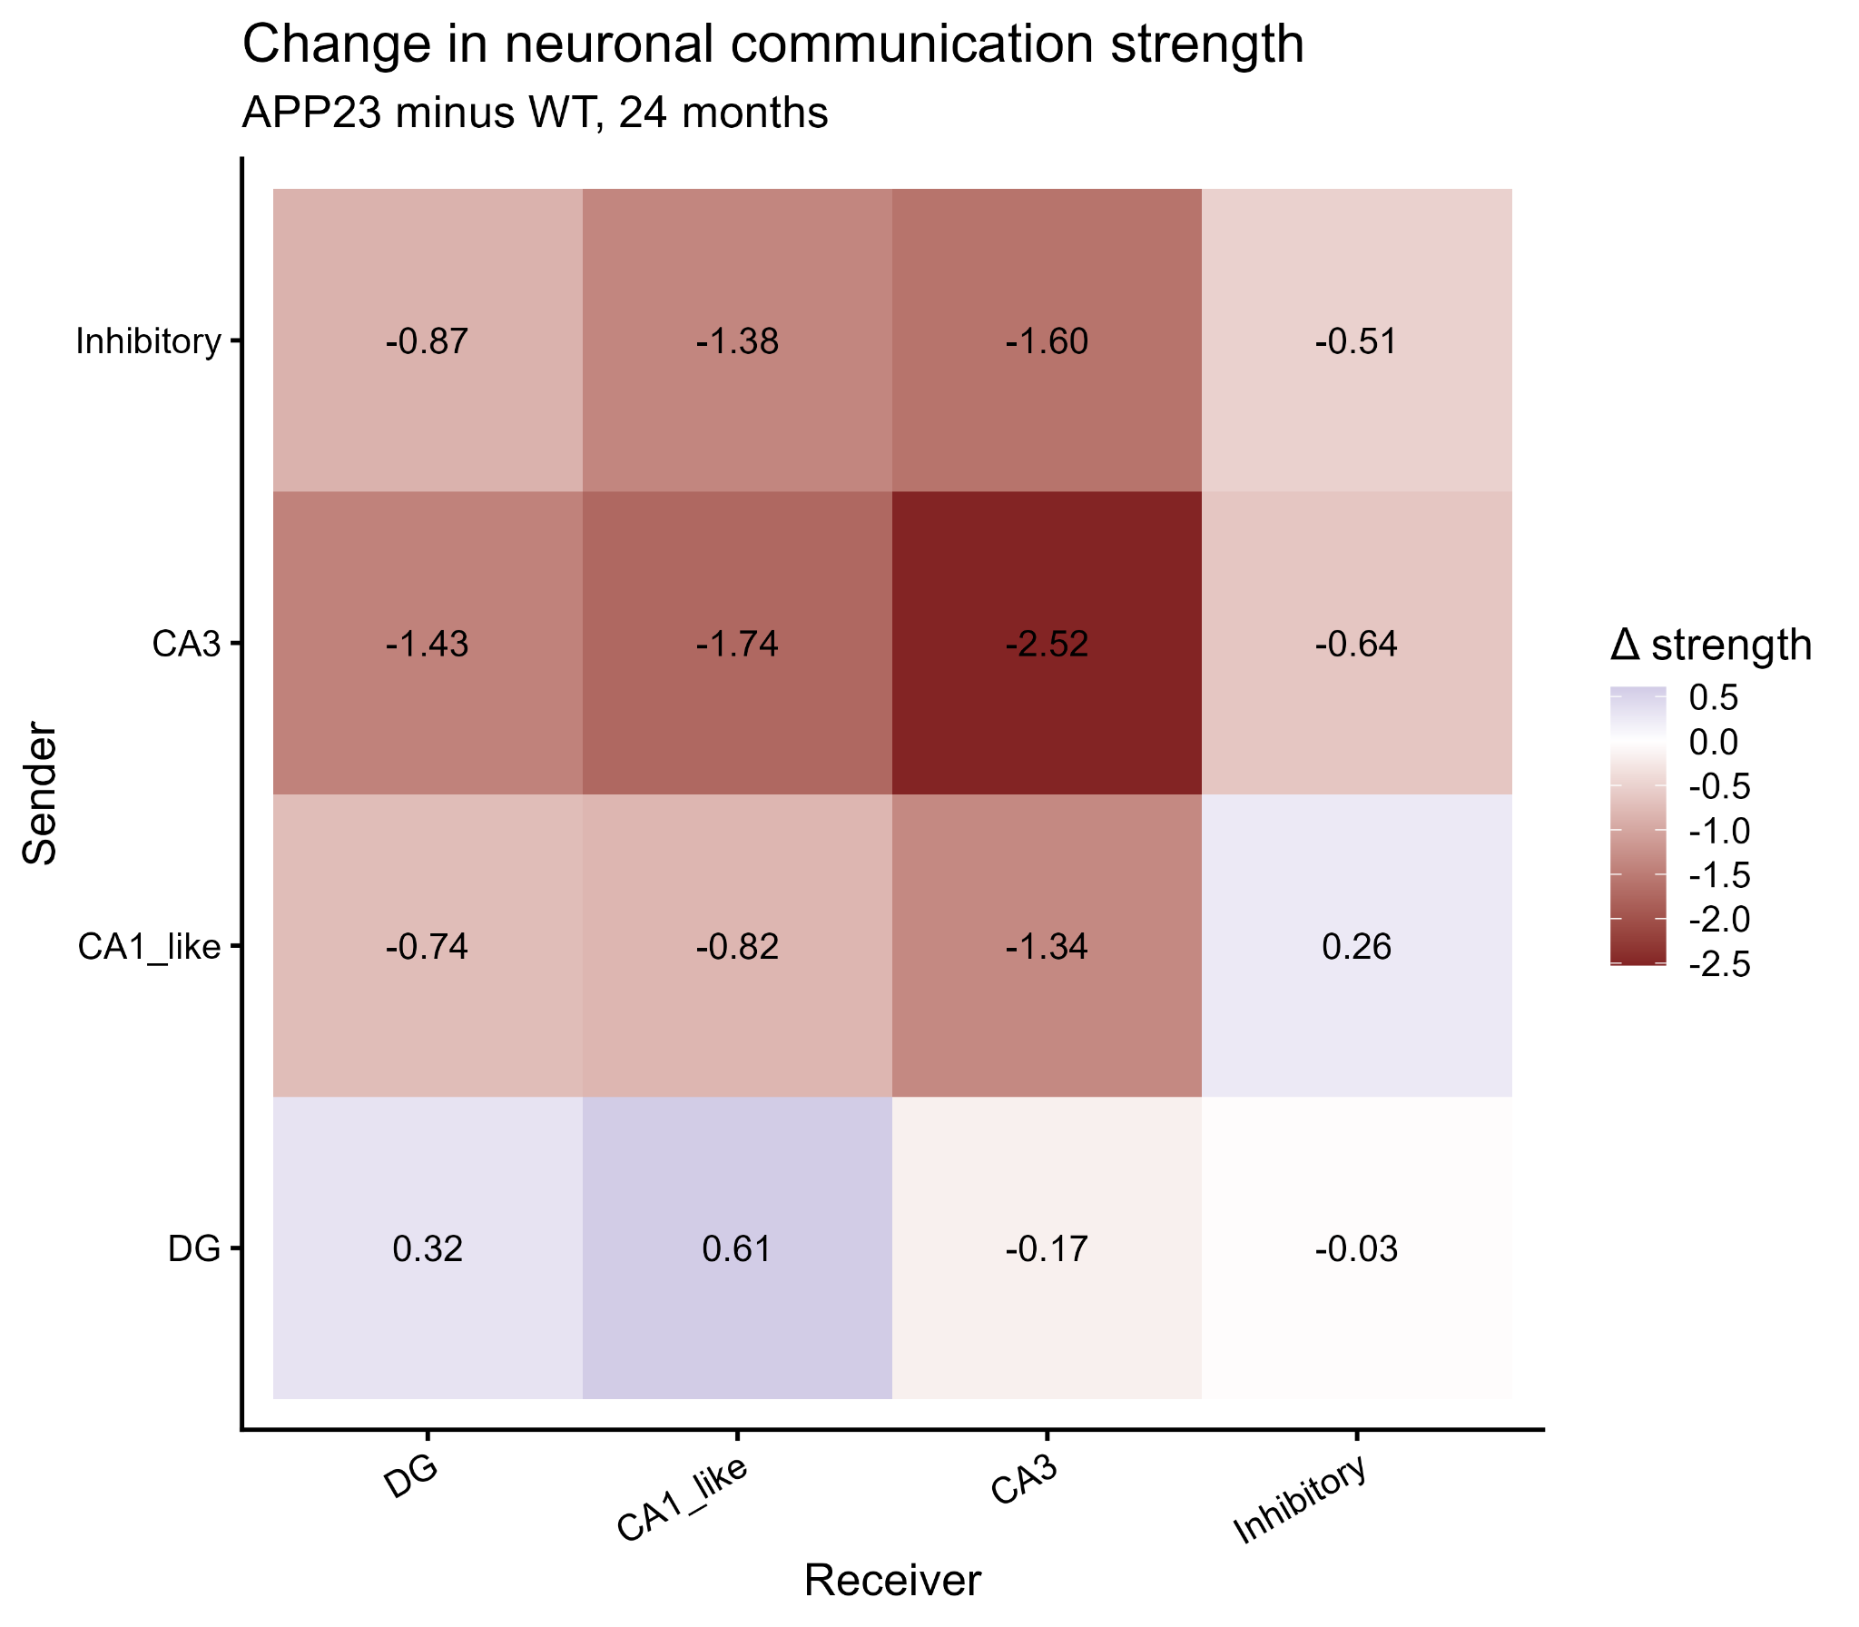
Figure 3. Change in inferred neuronal communication strength at 24 months. Heatmap shows APP23 minus WT aggregate CellChat communication strength. Positive values indicate stronger inferred communication in APP23 and negative values indicate weaker inferred communication. The pattern is consistent with network rewiring rather than a uniform global increase or decrease.

3.9 Sterol-associated inferred communication is higher in aged APP23 neurons
Both cholesterol and desmosterol signaling pathways were detected in the 24-month WT and APP23 CellChat networks. Summed inferred cholesterol communication probability increased from approximately 0.0109 in WT to 0.0137 in APP23, while desmosterol-associated communication increased from approximately 0.0051 to 0.0139. Sender-receiver analysis indicated that these signals were distributed across multiple neuronal populations rather than being restricted to CA1-like neurons. Therefore, the CellChat result does not demonstrate that the intracellular CA1-like cholesterol program directly causes altered sterol communication. Instead, the convergence of GSEA and communication inference identifies sterol-associated biology as a prominent feature of the aged APP23 neuronal transcriptome.
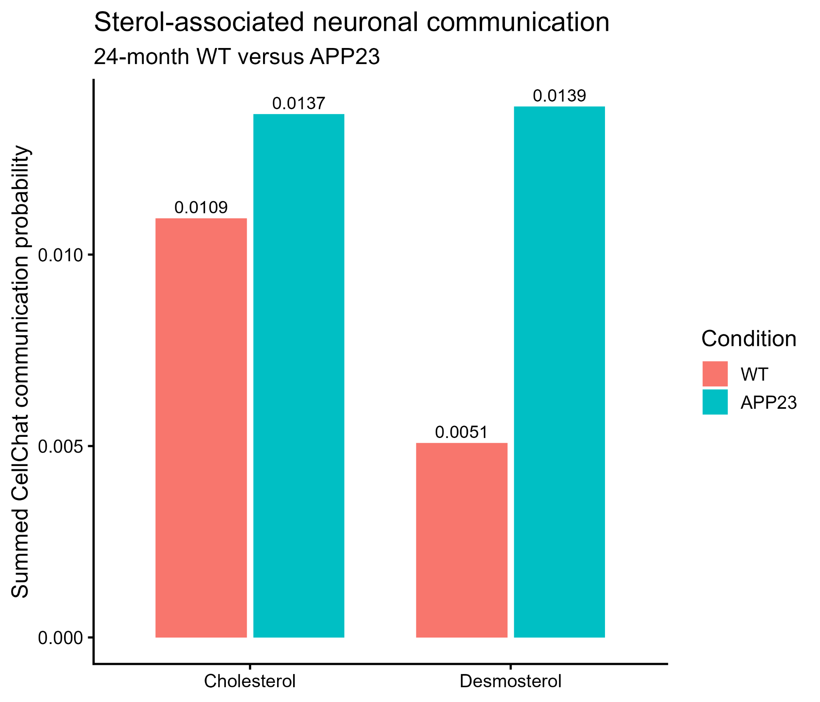
Figure 4. Sterol-associated neuronal communication in 24-month WT and APP23 networks. Summed CellChat communication probabilities for cholesterol and desmosterol pathways were higher in APP23. These values represent descriptive ligand-receptor network inference and are not mouse-level replicated statistical tests.

4. Discussion
This reanalysis reveals a clear interaction between neuronal identity and age in determining the transcriptional response associated with APP23. The principal finding is that APP23-associated remodeling is neither uniform across hippocampal neuronal populations nor static across age. DG neurons show an early synaptic phenotype, whereas CA1-like neurons show a pronounced late sterol/cholesterol phenotype.
At 6 months, DG neurons were characterized by coordinated depletion of synaptic transmission, trans-synaptic signaling, synaptic-vesicle cycling, and vesicle-mediated transport. By 24 months, the DG signature broadened to pathways involved in postsynaptic organization, synapse assembly, neuronal projections, and cell morphogenesis. This progression suggests that early disturbance of synaptic functional programs may be followed by broader remodeling of synaptic architecture and neuronal structure. Importantly, this interpretation arises from coordinated pathway-level shifts rather than from a large number of individually significant genes.
CA1-like neurons followed a different temporal pattern. They showed no FDR-significant GO pathway remodeling at 6 months but exhibited the largest pathway response at 24 months, dominated by cholesterol and sterol biosynthesis. Cholesterol is an essential component of neuronal membranes and participates in membrane trafficking, synaptic vesicle biology, and signaling. Brain cholesterol homeostasis is highly cell-type specific and has repeatedly been linked to aging and AD biology [2–4]. The current analysis cannot determine whether the increased cholesterol-biosynthetic transcriptional program is pathogenic, compensatory, or secondary to another process; however, its strength and coherence make sterol metabolism a compelling feature of the aged CA1-like APP23 state.
The exploratory TF analysis provided a mechanistically compatible observation: Srebf2 ranked toward increased activity in 24-month CA1-like APP23 neurons. SREBF2 is a central transcriptional regulator of cholesterol synthesis [3,4]. Nevertheless, no TF survived FDR correction, and the Srebf2 result should not be presented as statistically validated regulatory activation. Rather, it provides a candidate hypothesis that is consistent with the independently detected pathway phenotype and could be evaluated in additional datasets or experimental models.
CellChat added a distinct systems-level layer. The aged APP23 network did not simply show more or less communication globally; instead, sender-receiver strengths were redistributed. Several CA3- and inhibitory-associated relationships weakened, whereas some DG-derived relationships increased. The increased summed cholesterol and desmosterol communication probabilities provide additional evidence that sterol-associated biology is altered in aged APP23 neurons. However, GSEA and CellChat quantify different phenomena: GSEA reflects coordinated intracellular transcriptional ranking, whereas CellChat infers potential intercellular signaling from expression of ligand-receptor systems. Their convergence is hypothesis-generating rather than causal proof.
CA3 and inhibitory neurons were comparatively preserved according to the primary FDR-defined pathway criterion, despite individual gene-level changes and substantial participation in the CellChat network. Thus, “relative preservation” should be interpreted narrowly: these populations lacked the same magnitude of coordinated GO pathway remodeling observed in DG and aged CA1-like neurons. It does not mean that they are unaffected by APP23.
The present framework also differs methodologically from a purely cell-level analysis because the biological mouse was retained as the replicate for differential expression. This conservative pseudobulk strategy reduces pseudoreplication and produced sparse gene-level significance, particularly given the small number of animals. Rank-based pathway analysis was therefore critical for identifying coordinated biology that was not evident from DEG counts alone.
Taken together, the results support a model of temporally distinct selective neuronal responses: DG neurons display an early synaptic program that becomes structurally broader with age, whereas CA1-like neurons develop a strong late sterol-associated state. These patterns provide testable hypotheses for understanding why hippocampal neuronal populations respond differently during amyloid-associated neurodegeneration.

5. Limitations
• The number of biological replicates was small, particularly at 24 months (two WT versus three APP23 mice), limiting power for gene- and TF-level inference.
• The analysis used a processed public expression matrix rather than raw sequencing reads; read alignment and mapping-rate QC could not be independently reproduced.
• No additional computational doublet-removal procedure was applied. The dataset was processed Smart-seq2 neuronal nuclei rather than raw droplet data, but residual multiplets cannot be completely excluded.
• Mitochondrial transcripts were absent from the processed matrix, preventing mitochondrial percentage from being used as an independent QC metric.
• The CA1-like category is operational and combines five excitatory fine clusters; it should not be interpreted as proof that every nucleus belongs to an identical canonical CA1 subtype.
• Small fine clusters were not used as primary pseudobulk units because some mice contributed very few nuclei.
• No TF survived multiple-testing correction, so TF findings, including Srebf2, remain exploratory.
• CellChat pooled nuclei by condition and therefore provides descriptive network inference rather than mouse-level replicated statistical evidence.
• The dataset contains neuronal nuclei only and cannot evaluate interactions with astrocytes, microglia, oligodendrocytes, endothelial cells, or other non-neuronal populations.
• Y-chromosome-associated genes appeared among highly ranked genes in some older comparisons. Given the small number of aged animals, potential sex-related effects should be considered if complete sex metadata cannot be incorporated into the model.

6. Conclusion
Reanalysis of 3,280 hippocampal neuronal nuclei from APP23 mice demonstrates that APP23-associated transcriptional remodeling is strongly dependent on neuronal subtype and age. DG neurons exhibit an early phenotype characterized by reduced synaptic transmission and vesicle-associated programs, which broadens with aging toward synapse organization, neuronal projection development, and morphogenesis. CA1-like neurons follow a different trajectory, showing limited FDR-significant pathway remodeling at 6 months but pronounced cholesterol/sterol biosynthetic enrichment at 24 months. Srebf2 is a biologically coherent exploratory regulator of this late phenotype but was not statistically significant after multiple-testing correction. CA3 and inhibitory populations show comparatively limited FDR-significant pathway remodeling. Finally, CellChat indicates reorganization of the aged APP23 neuronal communication network and higher inferred cholesterol/desmosterol-associated communication. Together, these results support temporally distinct neuronal responses in APP23 hippocampus: early DG synaptic dysfunction followed by broader structural remodeling, and a pronounced late sterol-associated response in CA1-like neurons.

Data Availability
The single-nucleus RNA-sequencing dataset analyzed in this study is publicly available through the NCBI Gene Expression Omnibus under accession GSE141044.

Code Availability
The complete R analysis workflow will be organized into a dedicated GitHub repository after finalization of the manuscript and analysis documentation.

References
1. Zhong S, Wang M, Zhan Y, et al. Single-nucleus RNA sequencing reveals transcriptional changes of hippocampal neurons in APP23 mouse model of Alzheimer’s disease. Biosci Biotechnol Biochem. 2020;84(5):919–926. doi:10.1080/09168451.2020.1714420.
2. Puglielli L, Tanzi RE, Kovacs DM. Alzheimer’s disease: the cholesterol connection. Nat Neurosci. 2003;6:345–351. [Background reference; verify final bibliographic formatting before submission.]
3. Petrov AM, Pikuleva IA. Cholesterol and Alzheimer’s disease; from risk genes to pathological effects. Front Aging Neurosci. 2021;13:690372. doi:10.3389/fnagi.2021.690372.
4. Wang H, Kulas JA, Wang C, Holtzman DM, Ferris HA, Hansen SB. Regulation of beta-amyloid production in neurons by astrocyte-derived cholesterol. Proc Natl Acad Sci USA. 2021;118:e2102191118. [Verify final bibliographic details before submission.]

Supplementary Figure Panels
The following individual panels correspond to Figure 1 and are included for convenient editing and presentation use.
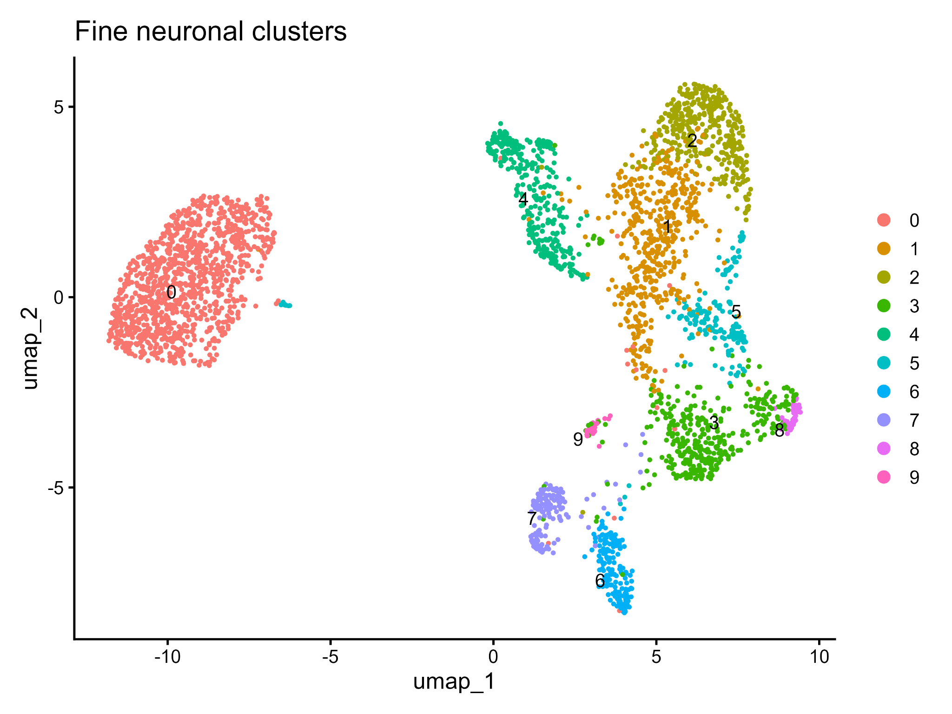
Supplementary panel S1A. Fine neuronal clusters.
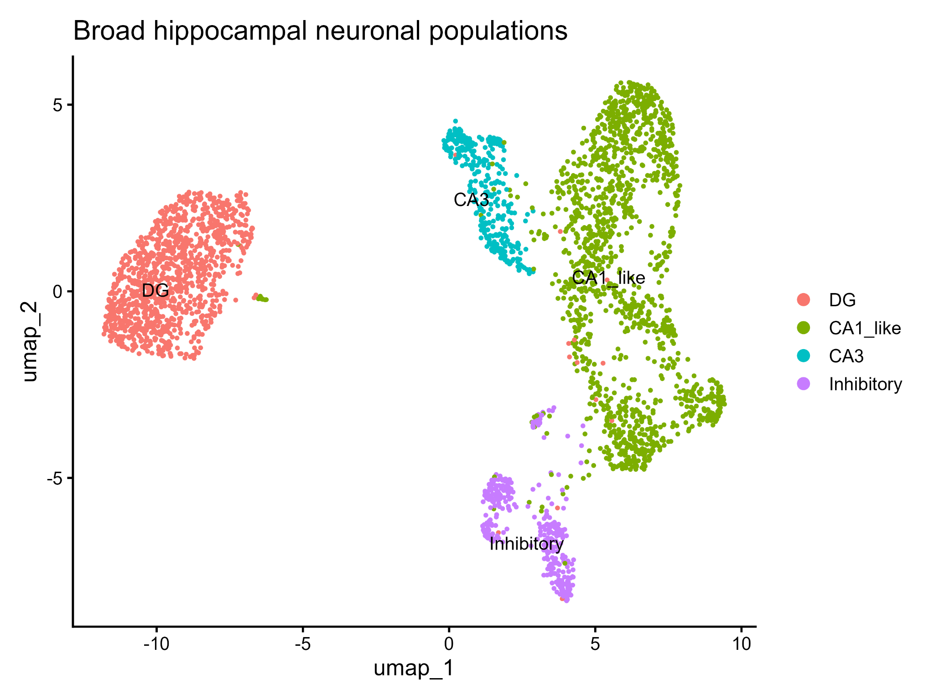
Supplementary panel S1B. Broad hippocampal neuronal populations.
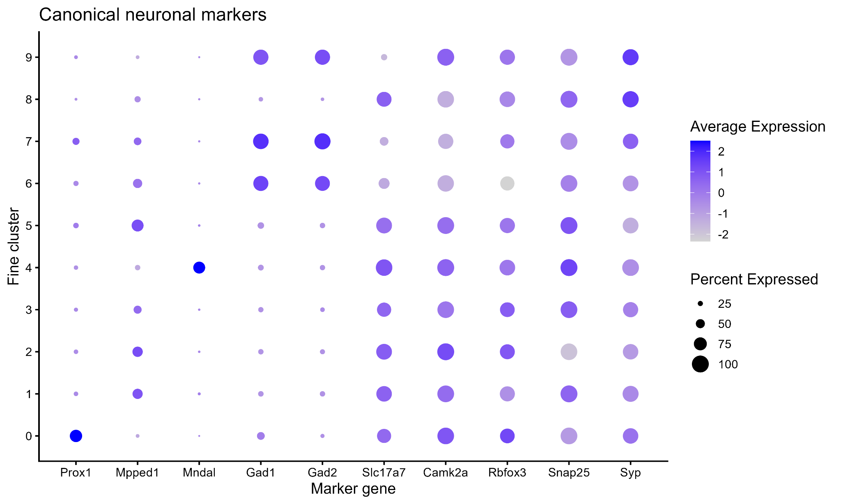
Supplementary panel S1C. Canonical neuronal marker DotPlot.

