1. **Design a Scratch application to empty coke bottle.**

**Solution -** The application will simulate an animated Coke bottle being emptied. It will use sprites and coding blocks in Scratch to create the illusion of the liquid pouring out of the bottle and the bottle becoming empty.

Code

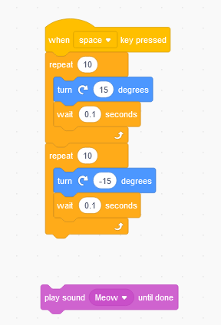

**Output-**

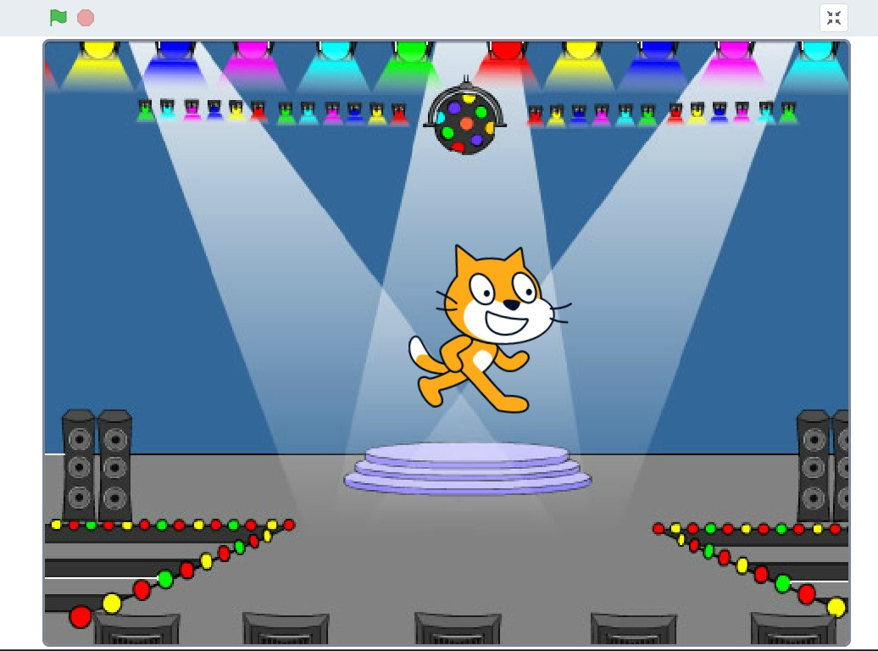

1. **Design a Scratch application to bounce a ball.**

**Solution -** The application will simulate a ball bouncing within a defined area. When the ball hits the edge of the screen or a specified object (like a paddle), it will bounce back at an appropriate angle.

Code

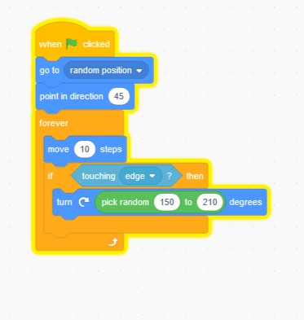

**Output-**

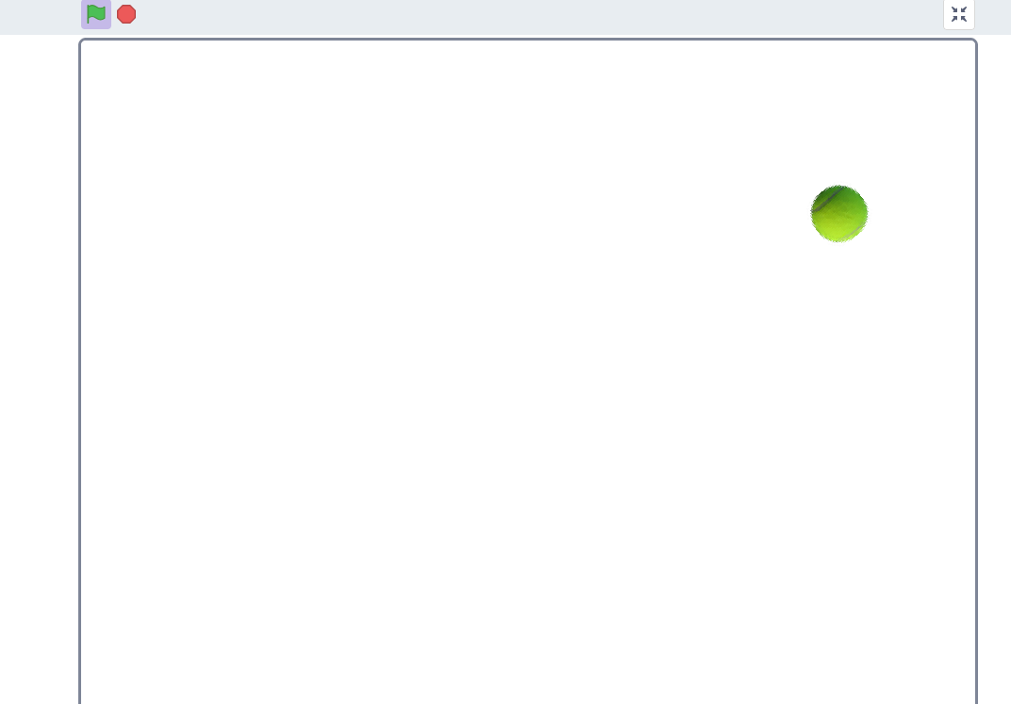

1. **Design a Scratch application to move the object from one location to another.**

**Solution -** The application will feature an object (sprite) that can be moved to a specific target location using keyboard inputs, mouse clicks, or automatic animations.

Code-

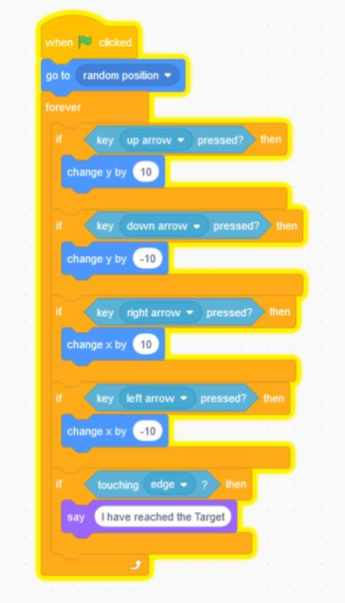

**Output-**

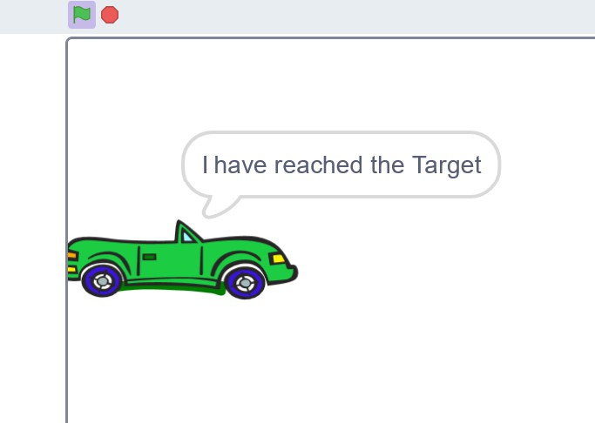

1. **Design a Scratch application to display fade-in and fade-out applications.**

**Solution -** The application will display a sprite that gradually appears (fade-in) and disappears (fade-out) using the "ghost" effect in Scratch.

Code - 1) Fade-In Effect:

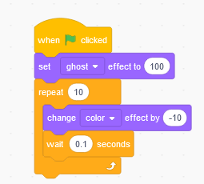

2) Fade-out Effect:

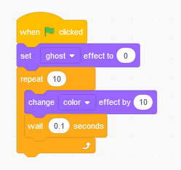

**Output-**

1. **Fade-In Effect:**

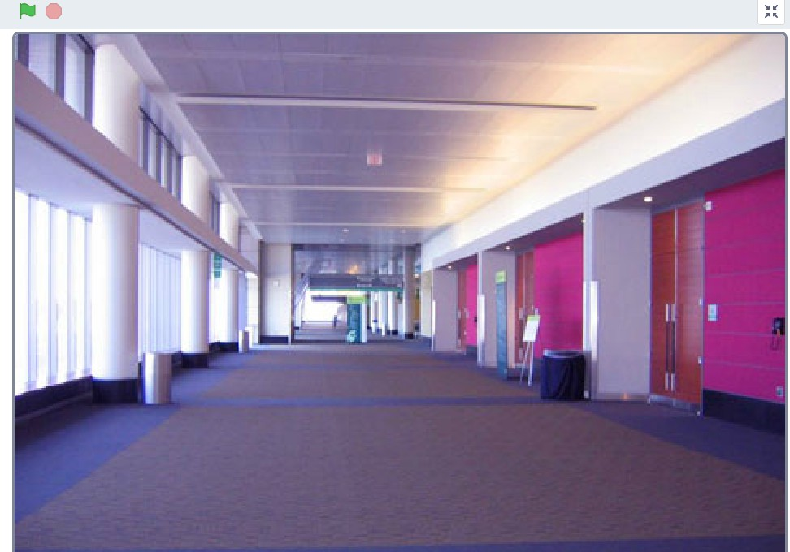

1. **Fade-out Effect:**

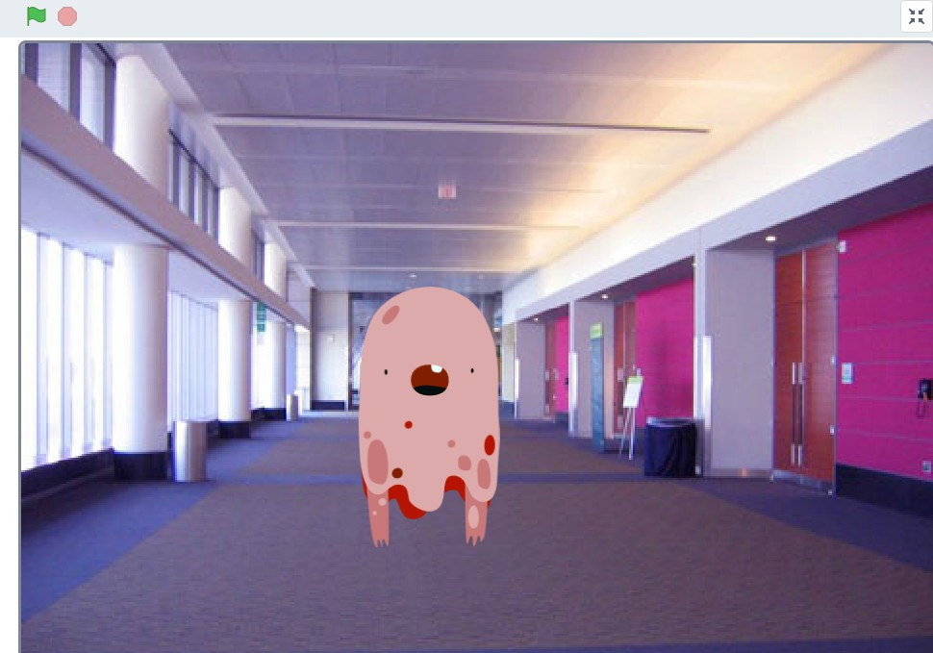

* 1. **. Design a Scratch application for Rainfall.**

**Solution -**

Code -

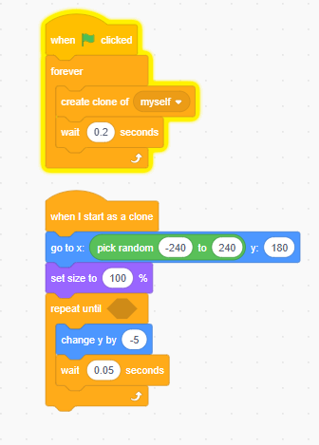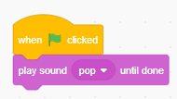

**Output-**

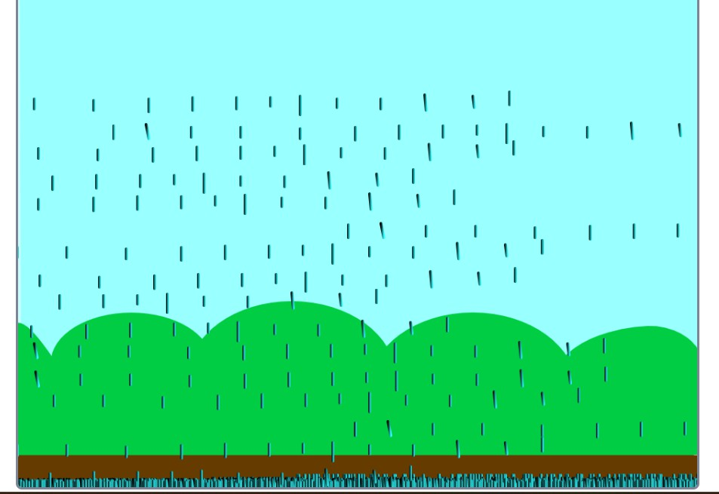

* 1. **Design a Scratch application for Smoke effect.**

**Solution -**

Code

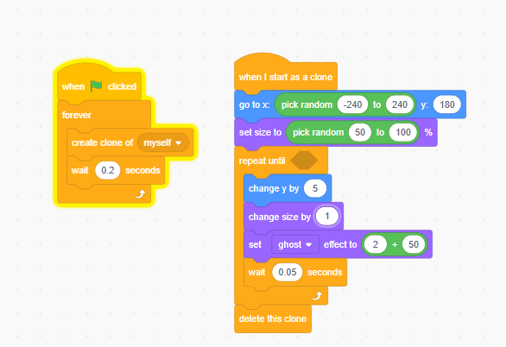

**Output-**

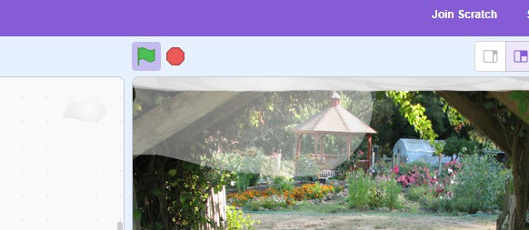

* 1. **Design a Scratch application for Bubble effect.**

**Solution -**

Code-

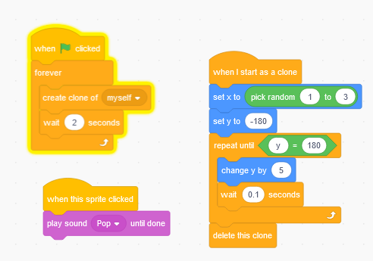

**Output-**

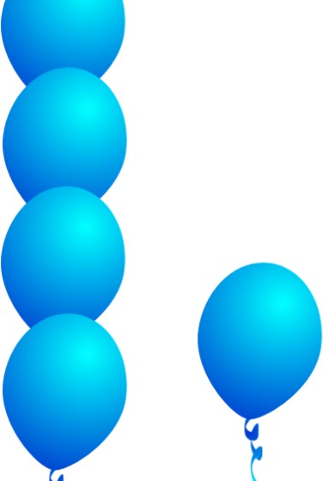

* 1. **Design a Scratch application on a dancing doll.**

**Solution - Code -** 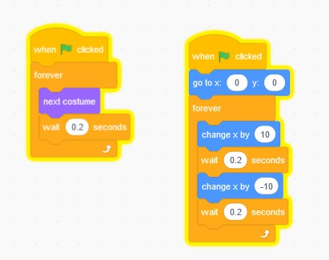

**Output-**

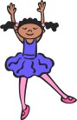

* 1. **Design a Scratch application on Sparrow Jumping Game.**

**Solution -**.

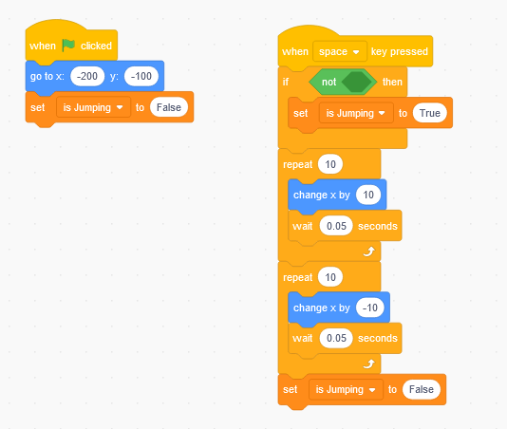

* 1. **Design a Scratch application on Catching Apple in a Bowl.**

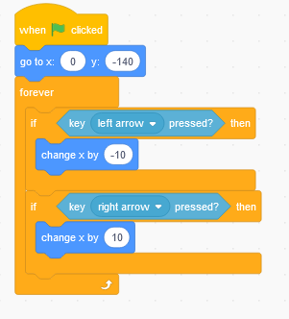

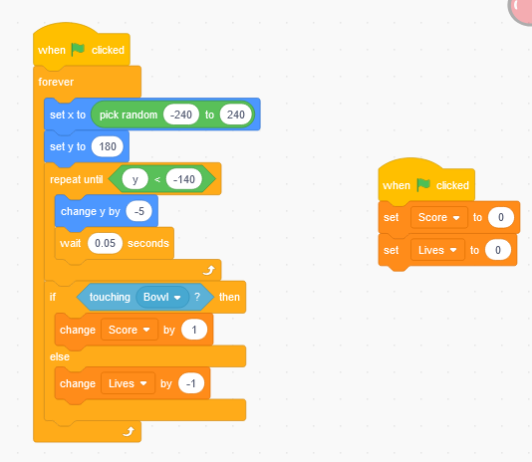

Output-

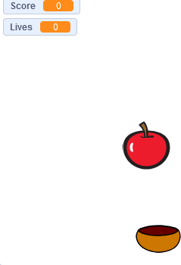

1. **Design a Scratch application to make a Mouse Trail.**

**Solution -**

Code -

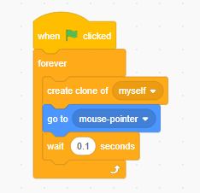

**Output-**

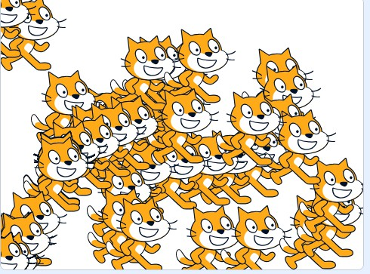

1. **Design a Scratch application to make a Virtual Town.**

**Solution -**

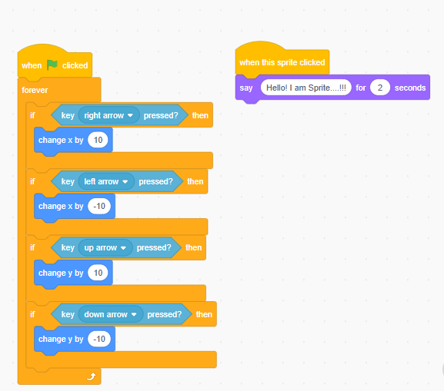

**Output-**

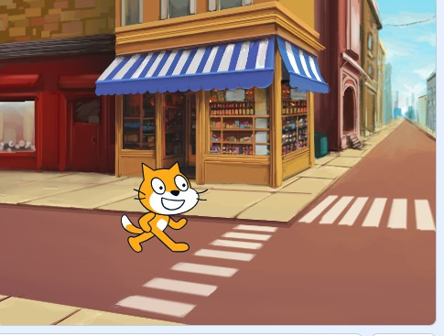

1. **Design a Scratch application to make a Virtual Pet.**

**Solution -**

Code-

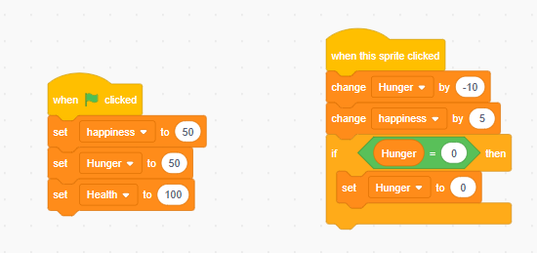

**Output-**

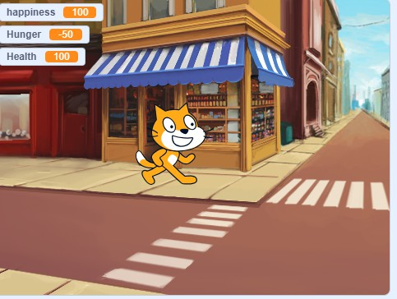

1. **Design a Scratch application to make Clicker Game.**

**Solution - Code -** 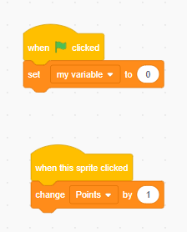

**Output-** 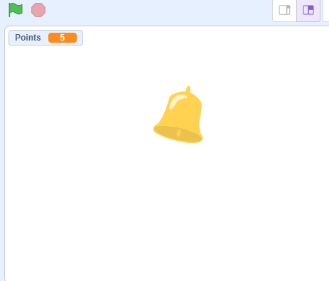

1. **Design a Scratch application to apply Day and Night mode.**

**Solution -**.

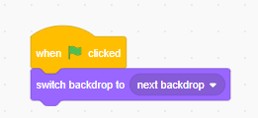

Output-

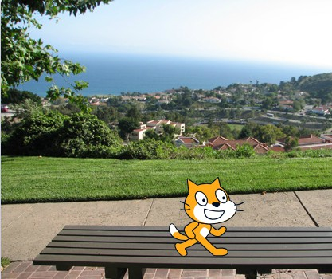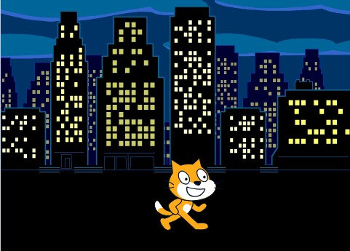

1. **Design a Scratch application to make a Dancing Girl and add background Music to it.**

**Solution -** Add music by yourself.

Code -



**Output-**



1. **Design a Scratch application to make a Story with two Sprites and two Backgrounds.**

**Solution -**

* + Add 2 characters from the sprite library.
  + Add 2 backdrops from the library.

**Code for sprite - 1**

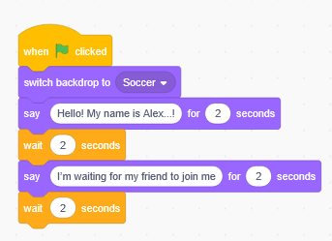

**Code for sprite - 2**

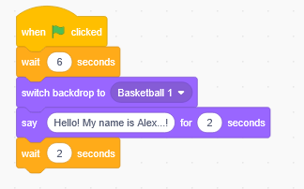

**Code for Backdrop - 2**

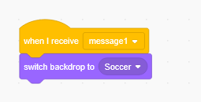

**Output-**

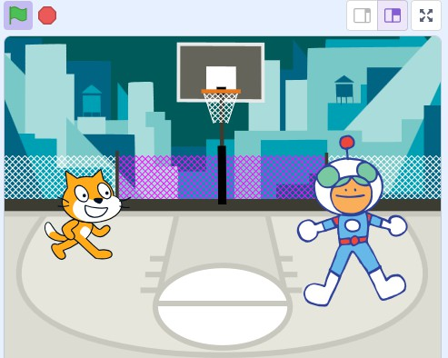

1. **Design a Scratch application to Moonrise after sunset.**

**Solution -**

Code-

* + Add 2 characters from the sprite library.(Sun & Moon)
  + Add 2 backdrops from the library (Sunny & Night with stars)

**Code for sun**

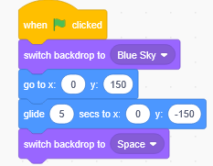

**Code for Moon**

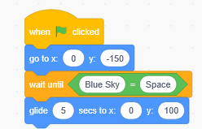

**Output-**

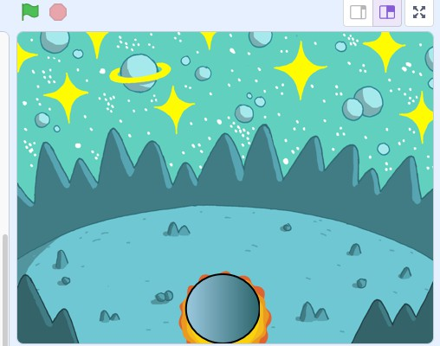

1. **Develop a Scratch application to Run a race.**

**Solution - Code -**

**Output-**

1. **Develop a Scratch application to make a Car Steering Simulation.**

**Solution -**. Code-

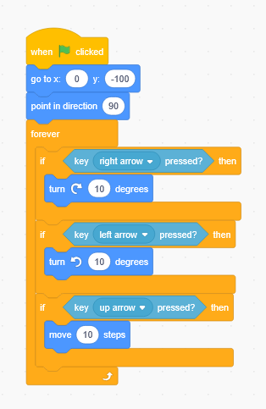

Output-

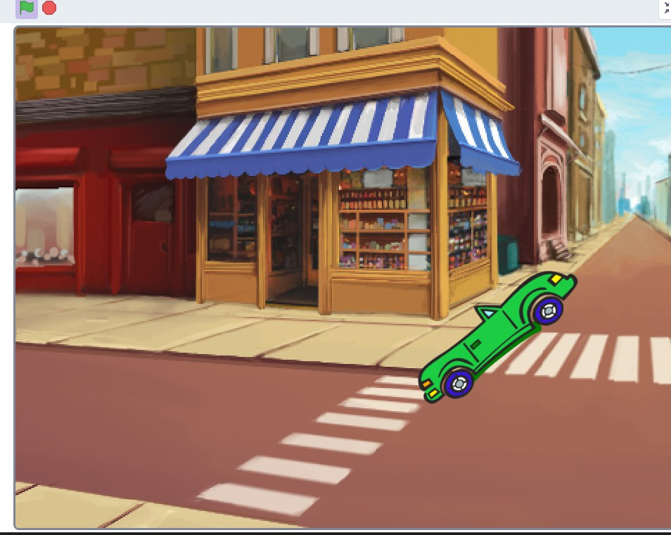

1. **Develop a Scratch application to make a Snake Game.**
2. **Develop a Scratch application to make Fish-Shark Game. Solution-**

Code for Fish-

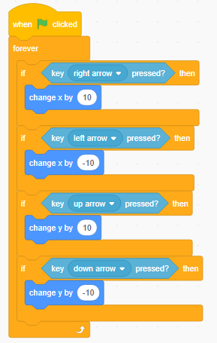

Code for Shark-

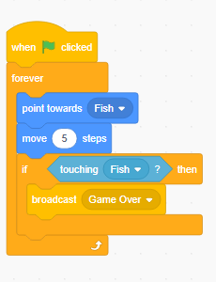

Code for Bubble-

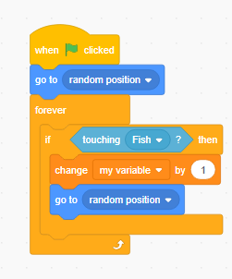

Code for Game Over/Backdrop-

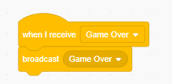

Output -

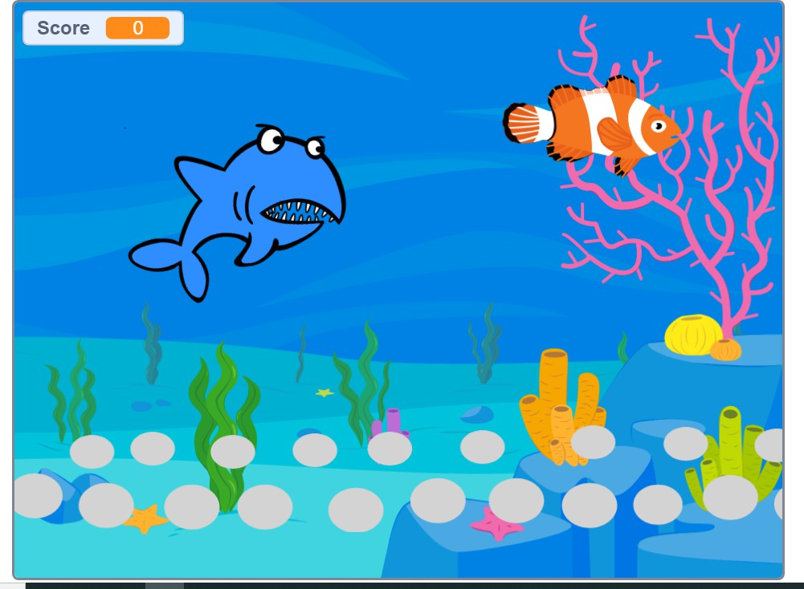

1. **Design a Scratch application to add Audio and Video. Solution -**

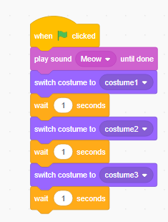

Output-

