Math Engine Project
Supervision: Dr. Nermeen Elkot

Contributors:
- ……………………………..

- ……………………………..

- ……………………………..

- ……………………………..

- ……………………………..

Project Aim:
This project aims to create a Desktop based software to solve Mathematical Equations related to Matrices and Complex Numbers.

Project working Scope:
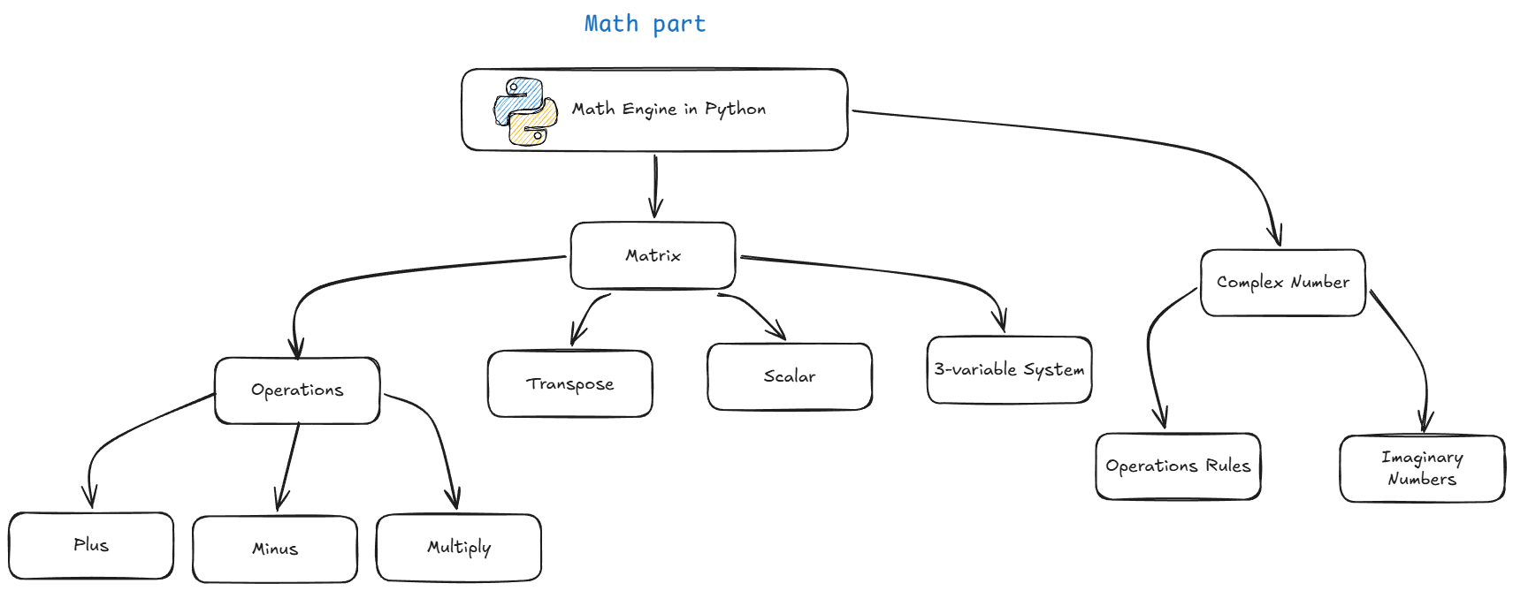
- Math constrains:

We needed to full understand the identity of the math operations done in each sector of the Desktop software operations like:
- Matrix addition / Subtraction rules
- Matrix multiplication rules
- Complex numbers conjugate rule etc….
Each of these sectors was needed to be understood clearly to start working on the project

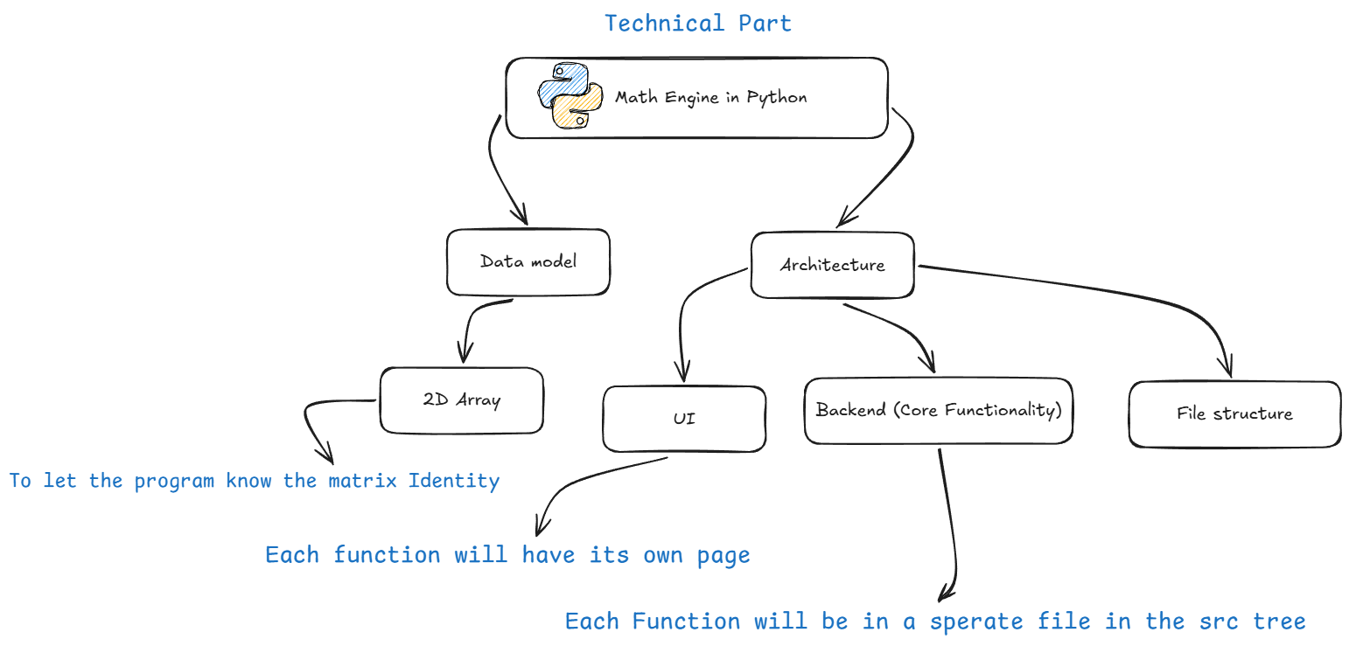
- Technical Constrains:

The Desktop based software will be built using python by (math, pyside6) libraries
For the mathematical operations and the GUI.

Code for the Mathematical Equations:
- Matrix:

@staticmethod
def binary_op(A: Matrix, B: Matrix, op: str) -> Result:
t0 = _t()
rA, cA = len(A), len(A[0])
rB, cB = len(B), len(B[0])

if op in ("add", "sub", "hadamard"):
if rA != rB or cA != cB:
return Result(ok=False, error=f"Dimension mismatch: [{rA}×{cA}] vs [{rB}×{cB}]")
elif op == "mul":
if cA != rB:
return Result(ok=False, error=f"Cannot multiply [{rA}×{cA}] · [{rB}×{cB}] — cols(A) must equal rows(B)")

if op == "add":
C = [[A[i][j] + B[i][j] for j in range(cA)] for i in range(rA)]
dims = f"{rA}×{cA}"
elif op == "sub":
C = [[A[i][j] - B[i][j] for j in range(cA)] for i in range(rA)]
dims = f"{rA}×{cA}"
elif op == "mul":
C = [[sum(A[i][k] * B[k][j] for k in range(cA)) for j in range(cB)] for i in range(rA)]
dims = f"{rA}×{cB}"
elif op == "hadamard":
C = [[A[i][j] * B[i][j] for j in range(cA)] for i in range(rA)]
dims = f"{rA}×{cA}"
else:
return Result(ok=False, error=f"Unknown operation: {op}")

return Result(ok=True, matrix=C, dims=dims, elapsed_ms=(_t() - t0) * 1000)

# ── Transpose ─────────────────────────────────────────────────────────────

@staticmethod
def transpose(A: Matrix) -> Result:
t0 = _t()
rows, cols = len(A), len(A[0])
T = [[A[i][j] for i in range(rows)] for j in range(cols)]
return Result(ok=True, matrix=T, dims=f"{cols}×{rows}", elapsed_ms=(_t() - t0) * 1000)

# ── 3-Variable Linear System ──────────────────────────────────────────────

@staticmethod
def solve_system3(A: Matrix, b: list[float]) -> Result:
t0 = _t()
n = 3
aug = [A[i][:] + [b[i]] for i in range(n)]
for col in range(n):
mx = max(range(col, n), key=lambda r: abs(aug[r][col]))
aug[col], aug[mx] = aug[mx], aug[col]
if abs(aug[col][col]) < 1e-12:
return Result(ok=False, error="Singular system — no unique solution exists")
for row in range(col + 1, n):
f = aug[row][col] / aug[col][col]
for j in range(col, n + 1):
aug[row][j] -= f * aug[col][j]
x = [0.0] * n
for i in range(n - 1, -1, -1):
x[i] = aug[i][n]
for j in range(i + 1, n):
x[i] -= aug[i][j] * x[j]
x[i] /= aug[i][i]
return Result(ok=True, vector=x, elapsed_ms=(_t() - t0) * 1000)

# ── Scalar Multiply ───────────────────────────────────────────────────────

@staticmethod
def scalar_multiply(k: float, A: Matrix) -> Result:
t0 = _t()
rows, cols = len(A), len(A[0])
C = [[k * A[i][j] for j in range(cols)] for i in range(rows)]
return Result(ok=True, matrix=C, dims=f"{rows}×{cols}", elapsed_ms=(_t() - t0) * 1000)

# ── Inverse ───────────────────────────────────────────────────────────────

@staticmethod
def inverse(A: Matrix) -> Result:
t0 = _t()
n = len(A)
aug = [A[i][:] + [1.0 if i == j else 0.0 for j in range(n)] for i in range(n)]
for col in range(n):
mx = max(range(col, n), key=lambda r: abs(aug[r][col]))
aug[col], aug[mx] = aug[mx], aug[col]
if abs(aug[col][col]) < 1e-12:
return Result(ok=False, error="Matrix is singular — inverse does not exist")
pv = aug[col][col]
aug[col] = [v / pv for v in aug[col]]
for row in range(n):
if row == col:
continue
f = aug[row][col]
aug[row] = [aug[row][j] - f * aug[col][j] for j in range(2 * n)]
inv = [row[n:] for row in aug]
return Result(ok=True, matrix=inv, dims=f"{n}×{n}", elapsed_ms=(_t() - t0) * 1000)

Complex:
class ComplexEngine:
"""Pure Python complex number operations engine."""

@staticmethod
def add(a: float, b: float, c: float, d: float) -> ComplexResult:
"""Add two complex numbers: (a+bi) + (c+di)"""
t0 = _t()
real = a + c
imag = b + d
return ComplexEngine._build_result(real, imag, "addition", t0)

@staticmethod
def subtract(a: float, b: float, c: float, d: float) -> ComplexResult:
"""Subtract two complex numbers: (a+bi) - (c+di)"""
t0 = _t()
real = a - c
imag = b - d
return ComplexEngine._build_result(real, imag, "subtraction", t0)

@staticmethod
def multiply(a: float, b: float, c: float, d: float) -> ComplexResult:
"""Multiply two complex numbers: (a+bi) × (c+di)"""
t0 = _t()
real = a * c - b * d
imag = a * d + b * c
return ComplexEngine._build_result(real, imag, "multiplication", t0)

@staticmethod
def divide(a: float, b: float, c: float, d: float) -> ComplexResult:
"""Divide two complex numbers: (a+bi) ÷ (c+di)"""
t0 = _t()
denominator = c * c + d * d
if denominator == 0:
return ComplexResult(
ok=False,
error="Division by zero — denominator cannot be 0+0i",
operation="division",
elapsed_ms=(_t() - t0) * 1000
)
real = (a * c + b * d) / denominator
imag = (b * c - a * d) / denominator
return ComplexEngine._build_result(real, imag, "division", t0)

@staticmethod
def conjugate(a: float, b: float) -> ComplexResult:
"""Compute conjugate: a - bi"""
t0 = _t()
real = a
imag = -b
return ComplexEngine._build_result(real, imag, "conjugate", t0)

@staticmethod
def modulus(a: float, b: float) -> ComplexResult:
"""Compute modulus: |z| = √(a² + b²)"""
t0 = _t()
mod = math.sqrt(a * a + b * b)
return ComplexEngine._build_result(mod, 0.0, "modulus", t0)

@staticmethod
def argument(a: float, b: float) -> ComplexResult:
"""Compute argument: θ = atan2(b, a)"""
t0 = _t()
arg = math.atan2(b, a)
return ComplexEngine._build_result(arg, 0.0, "argument", t0)

@staticmethod
def to_polar(a: float, b: float) -> ComplexResult:
"""Convert to polar form: r(cos θ + i sin θ)"""
t0 = _t()
r = math.sqrt(a * a + b * b)
theta = math.atan2(b, a)
return ComplexEngine._build_polar_result(a, b, r, theta, t0)

@staticmethod
def _build_result(real: float, imag: float, operation: str, t0: float) -> ComplexResult:
"""Build a ComplexResult with all computed properties."""
modulus = math.sqrt(real * real + imag * imag)
argument = math.atan2(imag, real)
conjugate_real = real
conjugate_imag = -imag

# For polar form of result
polar_r = modulus
polar_theta = argument

return ComplexResult(
ok=True,
result_real=real,
result_imag=imag,
modulus=modulus,
argument=argument,
conjugate_real=conjugate_real,
conjugate_imag=conjugate_imag,
polar_r=polar_r,
polar_theta=polar_theta,
operation=operation,
elapsed_ms=(_t() - t0) * 1000
)

@staticmethod
def _build_polar_result(a: float, b: float, r: float, theta: float, t0: float) -> ComplexResult:
"""Build a ComplexResult specifically for polar form conversion."""
modulus = r
argument = theta
conjugate_real = a
conjugate_imag = -b

return ComplexResult(
ok=True,
result_real=r,
result_imag=theta,
modulus=modulus,
argument=argument,
conjugate_real=conjugate_real,
conjugate_imag=conjugate_imag,
polar_r=r,
polar_theta=theta,
operation="polar_form",
elapsed_ms=(_t() - t0) * 1000
)

@staticmethod
def format_complex(real: float, imag: float) -> str:
"""Format a complex number as a string."""
if imag >= 0:
return f"{fmt(real)} + {fmt(imag)}i"
else:
return f"{fmt(real)} - {fmt(abs(imag))}i"

