SW2 – Project Evaluation Form
- Each team must submit the following Documentation that contains:
- Project Description in detail.
- Class Diagram. And Database Schema.
- Each team must submit the project via GitHub:
- Source Code.
- Video Demo for running ( 2 – 5 Minutes ).
- Documentation and Evaluation Form.
- The Evaluation will start with giving all teams 30 marks then check the following criteria:
Full violated –They violate the principle in all cases in the Code.
Medium Violated – They apply the principle in some cases and violate it in some cases (in total the student applies the principle on average).
Small violated – They Apply the principle in most cases except for a very few cases, no more than one or two.
Violation Level | Full | Medium | Small | Grade
Documentation | -5 | -2 | -1
Not Apply MVC (it does not Separate Business logic from GUI ).  Example of violation: write the implantation for a method such as an inset item into the database inside the Button Action method) | -6 | - 3 | -1
Violate clean code – Variables | -2 | -1 | -.05
Violate clean code – Functions | -2 | -1 | -.05
Violate Single-responsibility Principle | -2 | -1 | -.05
Violate Open-closed Principle | -2 | -1 | -.05
Violate the Liskov Substitution Principle | -2 | -1 | -.05
Violate Interface Segregation Principle | -2 | -1 | -.05
Violate Dependency Inversion Principle | -2 | -1 | -.05
Not Upload code to GitHub | -1
Only One Branch Without Merge (GitHub) | -2
Only One Contribution (GitHub) | -2
Total Minus from Grade
Design Pattern Bounce | +4
Bounce on Overall Work | +2
Total Team Grade / 30

Name (Arabic) | ID | Individual Bounce +2 | Grade
احمد عمرو ابراهيم عبد السلام ابراهيم | 201900071
محمد لبيب مرسي لبيب | 201900718
محمد احمد سيد عبد الرحيم | 201900623
محمد احمد مختار محمد | 201900628
حسام الدين علي سيد علي | 201900261

Database description
- ERD

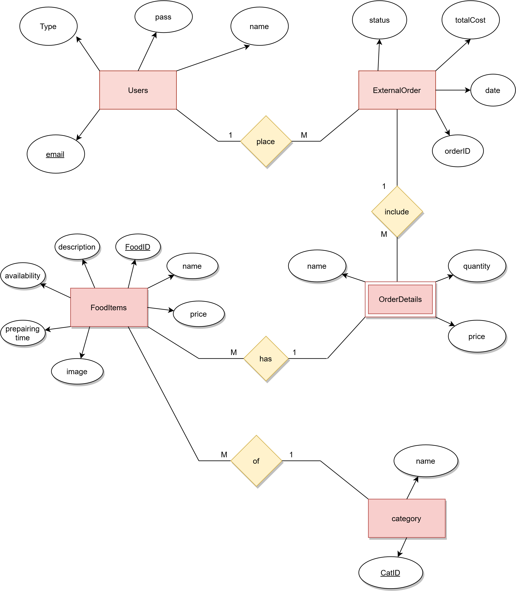

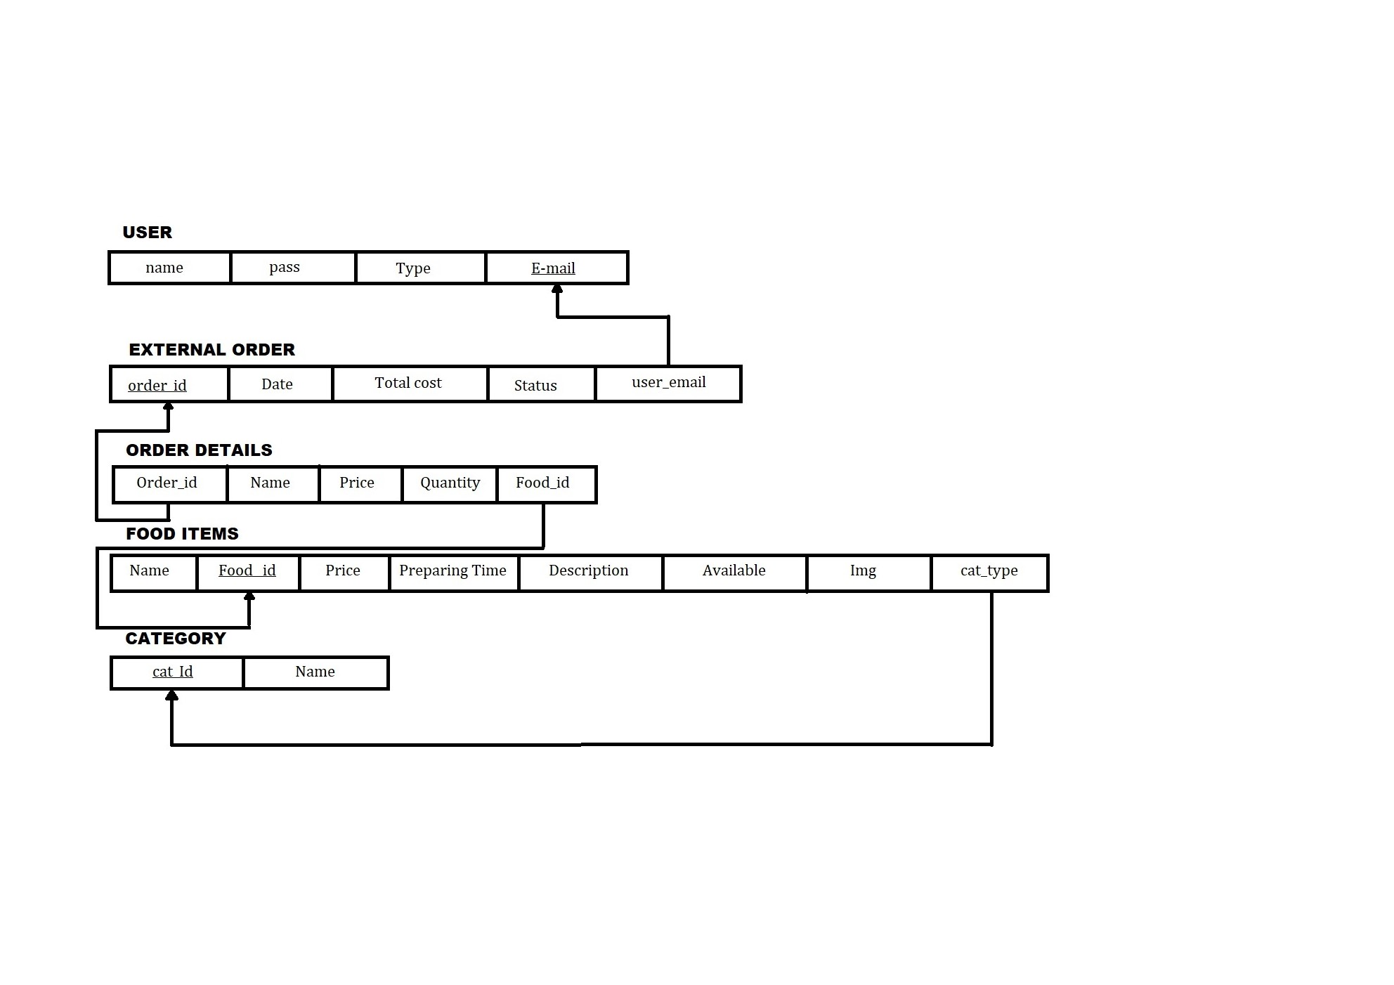
- Tables diagram

Class diagram

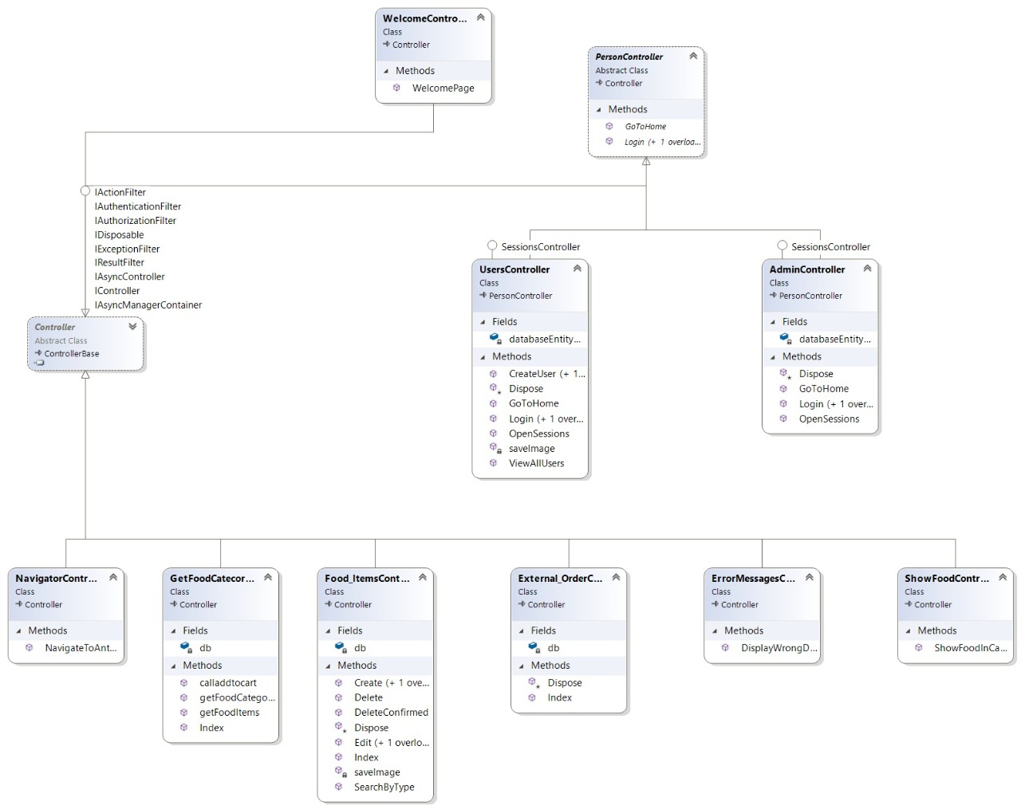

Description of project
In this software people will order different type of food using a simple site and delivery status, this system is based on relational database with its functions. Furthermore it, we deeply hope to provide simple, good and comfortable experience to user and client as much as possible. One of the most important purpose to provide better management Information about online food ordering and improve online treatment with food.
  - Functional requirements
    - Admin requirements
      - System shall add new food item with its name, photo, description, price, category and preparing Time.
      - System shall view all foods with its details.
      - System shall delete food items from database.
      - System shall modify food items and update price or status (disable or enable according to availability).
      - System should display previews order transaction after each order delivery.
      - System should view users’ details (which came from registration).
    - Customer requirements
      - Customer shall register with his personal details (name, password and email).
      - Customer shall login to access food ordering system with (email and password).
      - System shall display food category and items in cards.
      - Customer shall view items details and add product to carts.
      - Customer shall view his carts details and modify (delete or update quantity) food items inside it.

  - Non-Functional requirements
    - Look and feel
      - The site should use four colors (white, black, gray, deep yellow).
      - The site should a little bit of animation.

    - Usability & Humanity
      - System should be easy to use for everyone even without training.
      - User can order his food within 2 minutes.

    - Performance
      - System should be fast and bugs as few as possible.

    - Operational & Environmental
      - The system would save battery (because there is few action in one page).

    - Maintainability & Support
      - The system should be able to be edited after a long time easily.

    - Security
      - Only the admin has rights to access users’ details.
      - System should have a few of vulnerability.

