**Ekta resource centre for women**

**Internship report**

**(18.06.24 – 26.06.24)**

**Submitted by**

**Moksha G.N**

**B.sc CS (Data science and Analytics)**

**Manikam Ramaswami college of Arts and Science**

As computer science students embarking on our social internship at Ekta Resource Centre for Women, we are eager to understand and contribute to the operational dynamics of an NGO (non-governmental organization). NGOs typically operate with a mission-driven approach, focusing on social issues and community development rather than profit. At Ekta, we anticipate learning about the organizational structure and how various departments collaborate to achieve common goals. This includes understanding fundraising strategies, program development and implementation, advocacy efforts, and community outreach. We aim to contribute our technical skills to enhance data management systems, develop digital tools for outreach and education, and improve operational efficiency. By immersing ourselves in Ekta’s initiatives, we hope to gain insights into the challenges and successes of NGO work, while actively supporting their mission to empower marginalized women and promote gender equality.

Ekta Resource Centre for Women is a non-governmental organization based in India that focuses on empowering women and promoting gender equality. Here are some key points about Ekta Resource Centre for Women:

1. **Mission and Goals**: Ekta Resource Centre for Women aims to empower women from marginalized communities by providing them with education, skills training, legal support, and advocacy. The organization works towards creating a society where women have equal opportunities and rights.
2. **Services Offered**: The organization offers a range of services and programs tailored to the needs of women. This includes vocational training, literacy programs, health and nutrition workshops, legal aid, counselling services, and awareness campaigns on women's rights and gender-based violence.
3. **Community Engagement**: Ekta Resource Centre for Women actively engages with local communities to raise awareness about issues affecting women. They work towards fostering a supportive environment where women can access resources and support to improve their lives and challenge gender norms.
4. **Advocacy and Policy Influence**: The organization also engages in advocacy efforts to influence policies and laws that impact women's rights. They participate in campaigns and initiatives aimed at promoting gender equality at local, regional, and national levels.
5. **Impact and Reach**: Ekta Resource Centre for Women has made significant strides in empowering women and improving their socio-economic status. By providing education and skills training, the organization equips women with the tools they need to become financially independent and lead fulfilling lives.
6. **Collaborations and Partnerships**: The organization collaborates with other NGOs, government agencies, and international organizations to expand its reach and maximize its impact. Partnerships help Ekta Resource Centre for Women leverage resources and expertise to better serve the community.

**Day 1**

**Date:18.06.24**

**Day: Tuesday**

The orientation session hosted by Ekta was a pivotal event aimed at acquainting participants with the organization's multifaceted mission and impactful programs. Ekta, dedicated to empowering communities through initiatives spanning education, healthcare, and social welfare, presented a comprehensive overview of its endeavours during the session.

The session commenced with an introduction to Ekta, offering attendees a deep dive into its core values, mission, and vision. It underscored Ekta's commitment to fostering positive change and sustainable development within communities. Central to Ekta's approach are diverse programs such as skill development workshops, health camps, and educational scholarships, each designed to address specific needs and challenges faced by the community.

Moreover, the session illuminated Ekta's successes through compelling success stories that vividly demonstrated the organization's positive impact on local communities. These stories not only highlighted the tangible outcomes of Ekta's efforts but also underscored the transformative power of community-driven initiatives in uplifting lives.

Crucially, the orientation provided detailed guidance on avenues for individuals to contribute and participate actively in Ekta's initiatives. Participants were informed about volunteering opportunities and encouraged to play an active role in advancing Ekta's mission. By fostering a sense of community involvement and engagement, Ekta aims to harness collective efforts towards sustainable social change and development.

Furthermore, the session emphasized the importance of spreading awareness about Ekta and its initiatives. Attendees were encouraged to become ambassadors for Ekta's cause, amplifying its impact and reaching a wider audience to garner support and participation.

In conclusion, Ekta's orientation session served as a catalyst for community engagement and support for its noble endeavours. By providing comprehensive information, inspiring success stories, and avenues for active participation, the session underscored Ekta's commitment to empowering communities and fostering a brighter future through meaningful social initiatives.

Top of Form

Bottom of Form

**Day 2**

**Date: 19.06.24**

**Day: Wednesday**

The recent orientation on safety auditing conducted within our organization brought into sharp focus the significance of a special day in July dedicated to women and girl children. This day serves as a poignant reminder of the critical need for robust safety measures to safeguard these vulnerable groups within our communities. The orientation session was a pivotal moment where we collectively explored and deliberated upon various strategies aimed at enhancing safety protocols and ensuring a secure environment for women and girls.

Central to the discussion were comprehensive approaches to bolster safety measures, which included heightened surveillance, targeted awareness programs, and active community involvement. These strategies are essential not only in preventing potential threats but also in fostering a culture of vigilance and support within our organizational framework.

The session underscored the paramount importance of creating safe environments across all spheres of life, including homes, schools, and public spaces. Experts in the field shared invaluable insights on effectively addressing issues such as harassment and abuse through prompt reporting mechanisms and robust support systems. By emphasizing proactive measures and timely interventions, the orientation aimed to equip participants with the knowledge and tools needed to protect and advocate for the safety of women and girl children.

Furthermore, education emerged as a cornerstone in empowering women and girls to assert their rights and safety. By promoting education initiatives that emphasize awareness, resilience, and empowerment, we aim to cultivate a generation of individuals who are not only aware of their rights but also equipped to navigate and challenge unsafe situations.

Ultimately, the orientation session served as a powerful reminder of our collective responsibility to ensure the well-being and security of women and girl children in our communities. It highlighted the imperative for continuous vigilance, proactive measures, and community engagement to create a safer and more supportive environment for all. By reinforcing these principles and commitments, we strive to make meaningful strides towards a society where every woman and girl can thrive free from fear and insecurity.

In conclusion, the orientation on safety auditing was not just a gathering of minds but a call to action—a reaffirmation of our dedication to promoting safety, equality, and dignity for women and girl children everywhere. It underscored our commitment to driving positive change and standing as advocates for a safer and more inclusive world.

Top of Form

Bottom of Form

**Day 3**

**Date:20.06.24**

**Day: Thursday**

The field visit conducted to the Arapalayam bus stand for safety auditing revealed several significant concerns that warrant immediate attention to enhance the safety and security of its users. A detailed report was compiled based on thorough observations made during the audit.

One of the primary safety concerns identified was the insufficient lighting in certain areas of the bus stand, particularly at night. This deficiency not only creates dark and potentially unsafe zones but also increases the risk of accidents and criminal activities due to reduced visibility.

Another critical issue noted during the audit was the lack of clear signage and well-defined pedestrian pathways. This led to congestion and confusion among commuters, increasing the likelihood of accidents and hindering the smooth flow of pedestrian traffic within the bus stand premises.

Surveillance and security were found to be compromised due to the absence of CCTV cameras. This limitation reduces the ability to monitor and deter unlawful activities, posing a significant risk to the safety of both passengers and staff.

Furthermore, the audit highlighted the absence or inadequate accessibility of fire extinguishers throughout the bus stand, which raises concerns about the readiness to respond to fire emergencies effectively. Similarly, emergency exits were either blocked or poorly marked, potentially impeding swift evacuation during crises.

The condition of public toilets at the bus stand was also deemed substandard, with inadequate cleanliness and maintenance. This not only impacts user comfort but also raises hygiene and health concerns among visitors.

Based on these observations, several recommendations were put forth to address these critical safety deficiencies. They include enhancing lighting infrastructure to improve visibility and deter criminal activities, installing CCTV surveillance systems to monitor and enhance security, ensuring clear and accessible emergency exits with proper signage, and improving the cleanliness and maintenance of public toilets.

Additionally, the installation and regular maintenance of fire extinguishers at strategic locations within the bus stand were emphasized to mitigate fire risks effectively.

In conclusion, the safety audit of Arapalayam bus stand underscored the urgent need for improvements across various aspects to ensure the safety and security of its users. By addressing these recommendations promptly and comprehensively, authorities can create a safer and more secure environment for commuters, staff, and visitors alike, fostering a more efficient and pleasant experience at the bus stand.

Top of Form

Bottom of Form

**Day 4**

**Date:21.06.24**

**Day: Friday**

The teams prepared a comprehensive PowerPoint presentation detailing their recent field visit to the Arapalayam bus stand, focusing specifically on safety auditing. The presentation commenced with an outline of the objectives set for the field visit and an overview of the methodology employed to conduct the audit effectively.

Key observations from the visit highlighted several critical safety and security concerns within the bus stand premises. Inadequate lighting in certain areas was identified as a significant issue, particularly impacting visibility and safety during nighttime hours. Poor signage and congested pedestrian pathways were noted, contributing to confusion and potential hazards for commuters navigating the area.

A major security concern raised during the audit was the absence of CCTV cameras, which are crucial for surveillance and deterring criminal activities. Similarly, the lack of accessible fire extinguishers posed a risk in terms of fire safety preparedness within the bus stand. Blocked or inadequately marked emergency exits were also identified as potential obstacles to swift evacuation during emergencies, further compromising user safety.

Additionally, the condition and maintenance of public toilets at the bus stand were found to be substandard, impacting user comfort and hygiene.

In response to these findings, the presentation proposed several recommendations aimed at improving safety and security at the Arapalayam bus stand. These recommendations included:

1. Enhancing lighting infrastructure to improve visibility and deter criminal activities.
2. Installing CCTV surveillance systems to monitor and enhance security throughout the premises.
3. Ensuring clear and accessible emergency exits with proper signage to facilitate swift evacuation.
4. Implementing regular maintenance schedules for facilities, particularly focusing on improving the cleanliness and upkeep of public toilets.
5. Installing and maintaining accessible fire extinguishers at strategic locations to enhance fire safety preparedness.

The presentation concluded with a call to action for stakeholders and authorities to prioritize these safety improvements. By implementing these recommendations, the Arapalayam bus stand can significantly enhance user security and comfort, ensuring a safer and more efficient environment for commuters, staff, and visitors alike.

Top of Form

Bottom of Form

**Day 5**

**Date: 24.06.24**

**Day: Monday**

During the meeting, the teams delivered their PowerPoint presentations, each meticulously showcasing their findings and key points from the field visits to the Arapalayam bus stand. The presentations began with clear objectives and methodologies used for safety auditing, emphasizing critical observations such as inadequate lighting, signage issues, and concerns with security infrastructure like CCTV and fire safety measures. Each team outlined their recommendations for improvement, focusing on enhancing safety protocols and user experience at the bus stand.

Following the presentations, our head facilitated a thorough discussion on the content presented. They provided constructive feedback, acknowledging strengths and identifying areas for enhancement in each team's presentation. Specific suggestions were offered to improve the clarity and impact of the slides, ensuring that the information was effectively communicated to the audience. Pertinent questions were posed to deepen the analysis and encourage teams to delve further into their findings and recommendations.

The session was characterized by constructive criticism aimed at refining future presentations to be more impactful and informative. The exchange of ideas and insights among team members and leadership proved valuable in refining the strategies and recommendations put forward.

Ultimately, the meeting concluded on a productive note with actionable takeaways for each team. Action points were assigned based on the feedback received, emphasizing the importance of implementing suggested improvements to enhance the overall effectiveness of future presentations and, importantly, to drive tangible improvements at the Arapalayam bus stand.

**Day 6**

**Date:25.06.24**

**Day: Tuesday**

After receiving feedback from the head, the teams diligently revised their PowerPoint presentations to enhance clarity and effectiveness. Specific points were refined and adjusted to better convey key findings and recommendations regarding safety auditing at the Arapalayam bus stand. Additionally, our head contributed valuable insights by adding important points to the presentations, aiming to fill any gaps and further strengthen the overall content.

Following these updates, a detailed discussion centered on the Information, Education, and Communication (IEC) framework was conducted. The head underscored the significance of integrating IEC principles into the projects undertaken. This framework emphasizes improving information dissemination, enhancing educational content, and refining communication strategies to effectively engage stakeholders and the public.

Team members were encouraged to explore innovative ways to enhance the reach and impact of their messages, ensuring that safety recommendations and findings are communicated clearly and comprehensively. The discussion sparked new perspectives strategies for improvement, fostering a collaborative environment where ideas were shared and refined.

Ultimately, the session concluded with actionable outcomes focused on integrating IEC principles into future work plans. Action items were identified to implement the discussed strategies, ensuring that future presentations and projects incorporate robust IEC frameworks to maximize effectiveness and impact. By leveraging these principles, the teams aim to not only enhance safety measures at the Arapalayam bus stand but also to empower stakeholders with valuable information and promote community engagement in ongoing safety initiatives.

**Day 7**

**Date:26.06.24**

**Day: Wednesday**

On the final day of my internship at Ekta, we gathered to document a detailed report that encapsulated the essence of my journey and contributions during this enriching experience. The report highlighted the various projects I undertook, showcasing the practical skills I developed and the challenges I overcame. It also provided a comprehensive overview of the industry insights I gained and the valuable lessons learned from my mentors and colleagues. Writing this report was not just a culmination of my efforts over the internship period but also a testament to the growth and professional development I experienced during my time at Ekta. It was a reflection of the dedication, learning, and meaningful connections that defined my internship journey.

**Safety audit at Arapalayam bus stand**

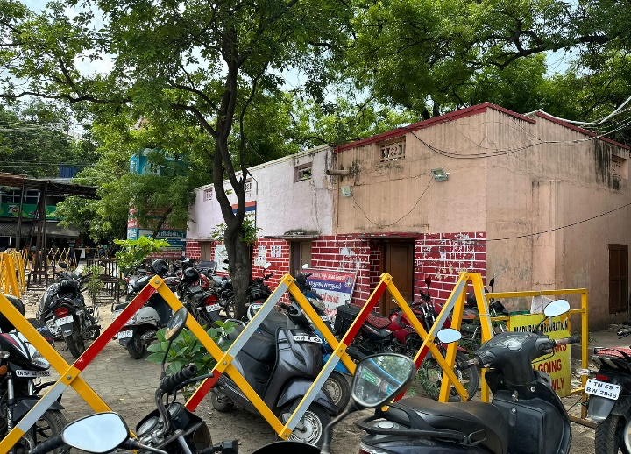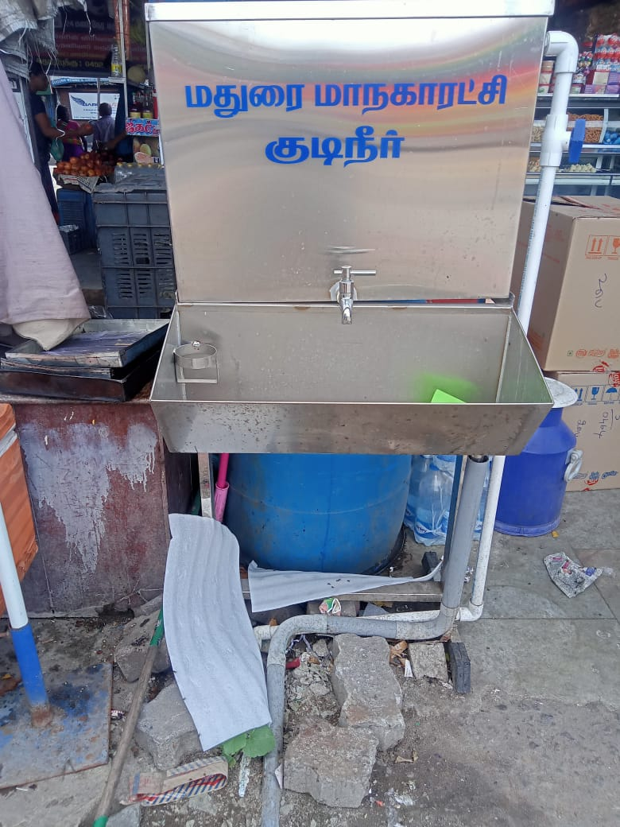

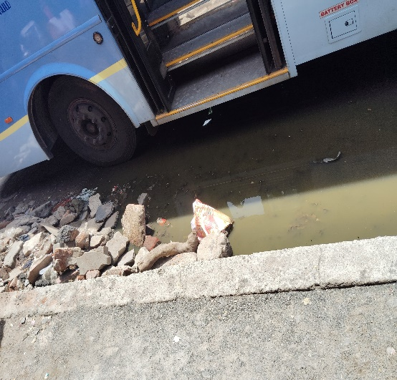

**Activities at Ekta**

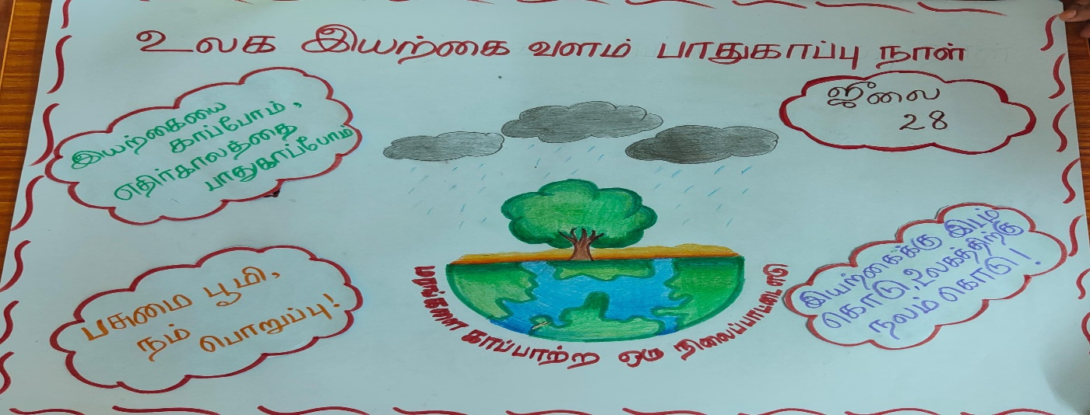

My internship experience at Ekta was incredibly valuable and enriching. It provided me with practical insights into the industry that I couldn't have gained through academic studies alone. Working alongside seasoned professionals at Ekta exposed me to real-world challenges and innovative solutions, allowing me to apply my theoretical knowledge in a practical setting. The mentorship I received was invaluable, helping me sharpen my skills in [specific area or field], and the hands-on projects I worked on not only enhanced my technical abilities but also taught me how to collaborate effectively within a team. Overall, my time at Ekta was instrumental in shaping my career path and preparing me for future challenges.