**All SQL Statements**

**Creating database tables:**

Admin Table

Announcement Table

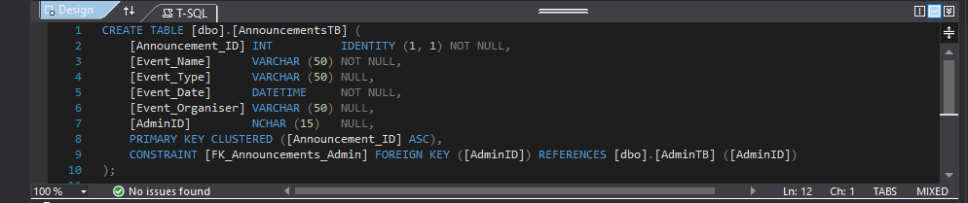

Teacher Table

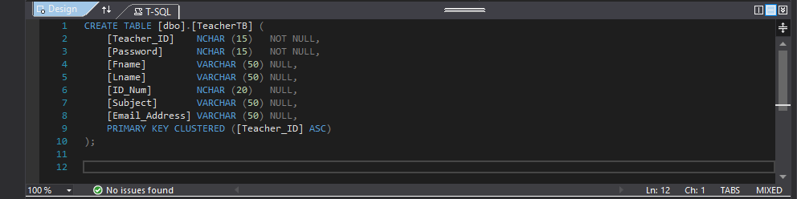

Learner Table

Maths Gradebook Table

Physics Gradebook Table

English Gradebook Table

**Maintaining All Tables in the Database**

**Adding records into the database:**

Registering learner, teacher and admin are more of the same.

Teacher

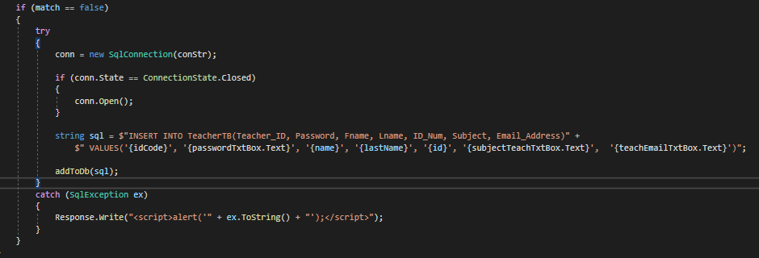

Learner

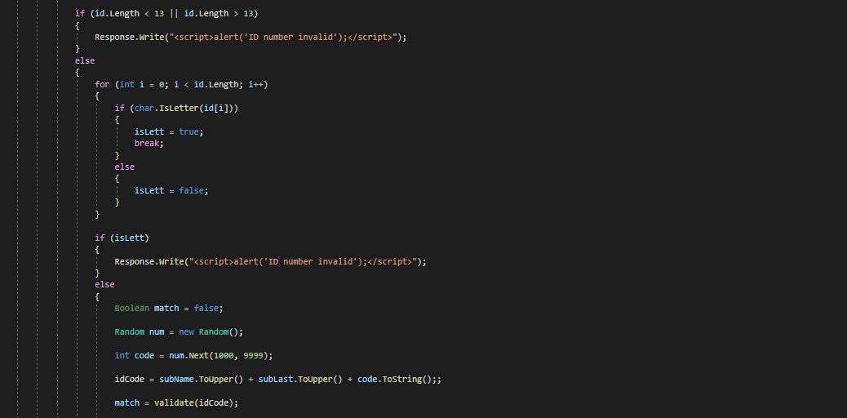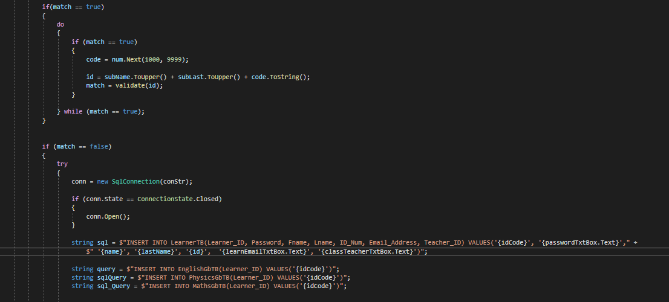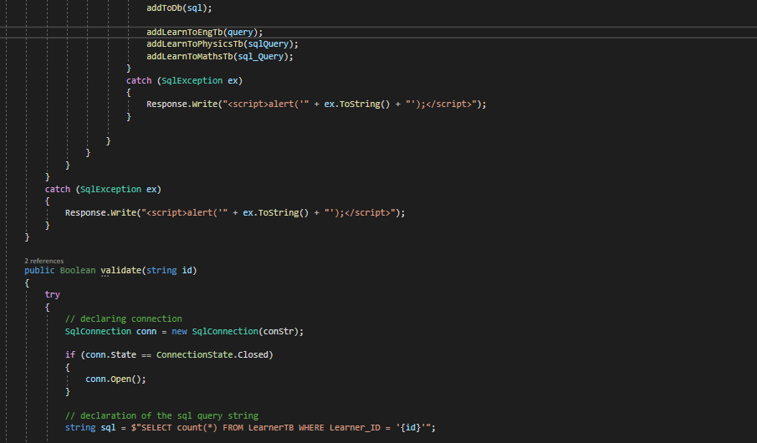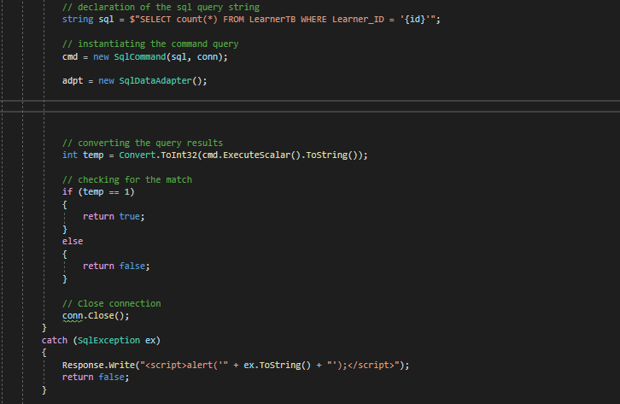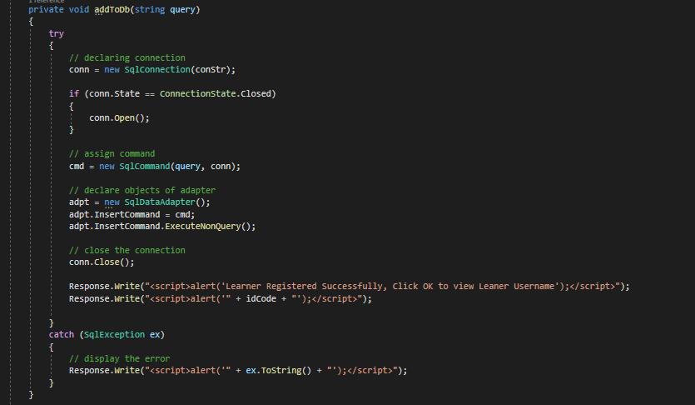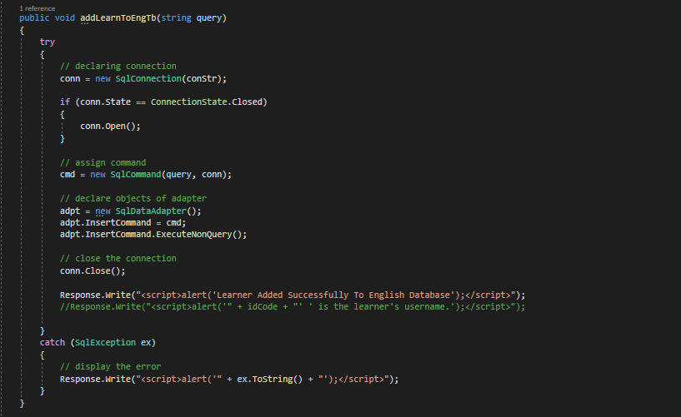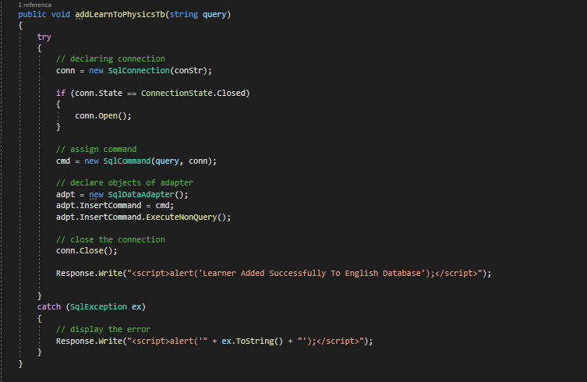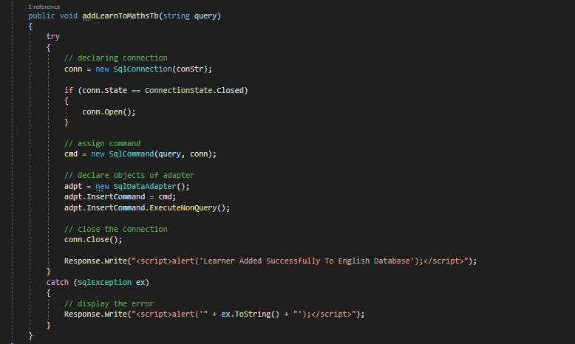

**Update Records in the database:**

Update Learner Records

**Deleting Records in the database:**

Learner

**Querying the Database:**

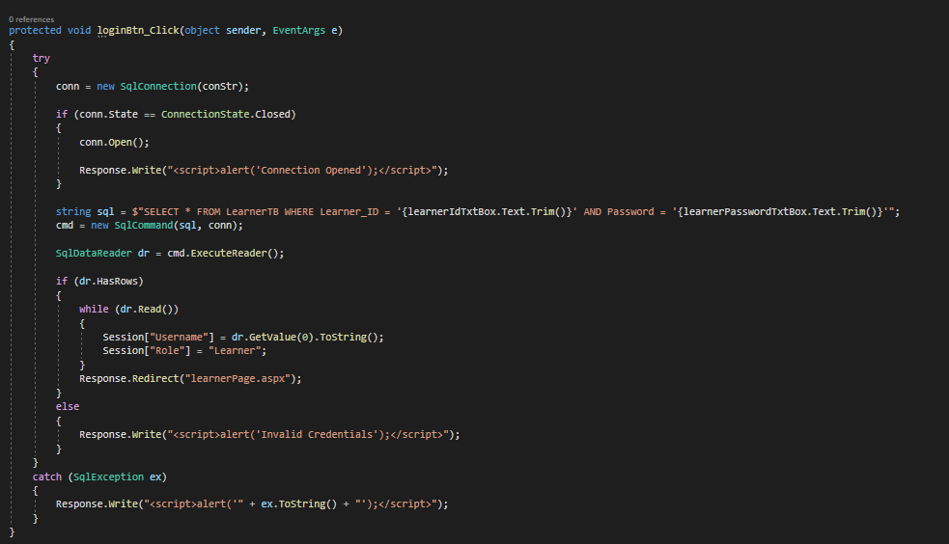

**Maintaining Child Entity of Data Model:**

Adding announcements

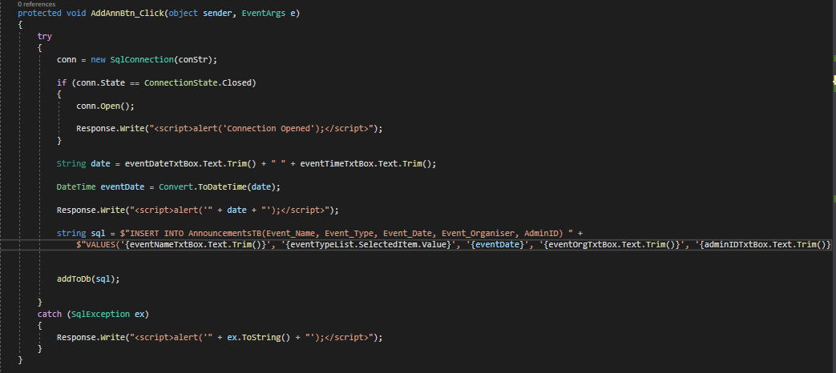

Update Announcements

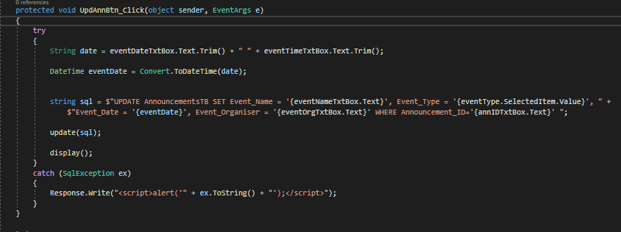

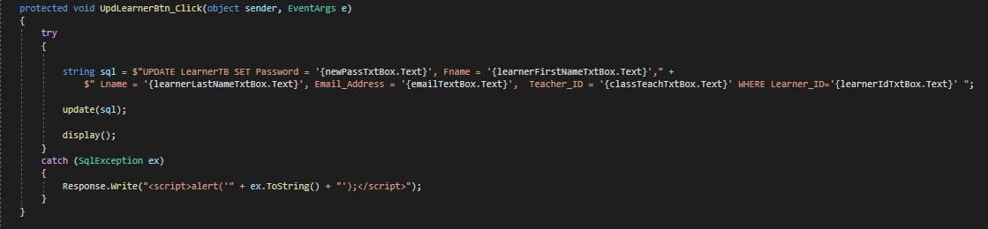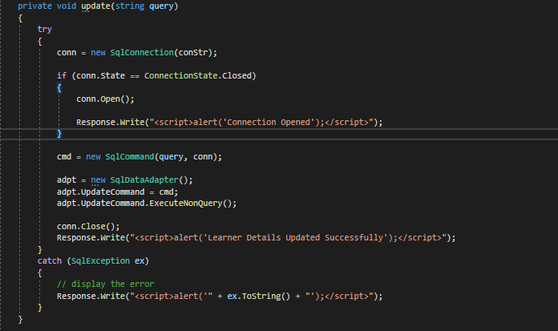

Deleting Announcements

