Digital Literacy Portfolio

Student’s Name – Moksh Berawala
Registration no. – 25BCE10120
Branch – Computer Science and Engineering
Year- 2025-2029
Course Code - CSE0001
Date-25.03.2026

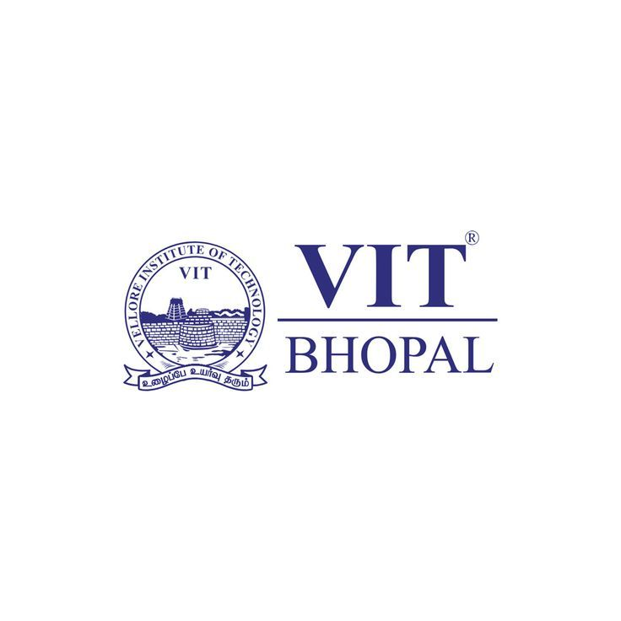
Introduction

In the modern digital era, digital literacy has become a vital competency for students to actively engage in academic, professional, and social settings. It involves the responsible, effective, and secure use of digital technologies for communication, learning, and managing information.
As a Student Digital Ambassador, my responsibility is to assist and motivate my peers to understand the value of digital awareness and ethical online conduct. This Digital Literacy Portfolio has been developed to showcase important dimensions of digital literacy such as internet safety, building a professional online identity, clear digital communication, and the practical use of essential digital tools.
Through this portfolio, I seek to share useful knowledge and guidance that can help students become more confident, aware, and responsible digital citizens. The activities included in this project represent real-life digital skills that contribute significantly to academic achievement and future career readiness.

Task - 1

For my Digital literacy awareness infographic task, I used canva an online design tool which helps create multiple design by providing ready made templates. My infographic explains the importance of digital literacy as a smart skill for students especially in this technology driven world. It includes 3 main sections : Useful Digital Tools for Students, Professional Online Presence, Safe Internet Practices. The design uses bullet points and some graphical design to catch the attention of readers.

Through this infographic, I intend to spread awareness among the readers how digital skills are not only helpful for academic work are killing time but also essential for personal safety and future career growth. One interesting challenge which I faced was selecting the right amount of information and the balance between information and the attractiveness of the infograph. Learning how to balance content with visual appeal helped me understand the importance of clarity and simplicity in digital communication.

Task-2

For my professional growth and project development, I have chosen GitHub, LinkedIn, and Stack Overflow as my primary platforms. Each of these platforms serves a unique and important purpose in my journey toward becoming a Backend Engineer.
GitHub will be used to host and manage my coding projects, track my progress, and build a strong portfolio that showcases my skills in backend technologies such as Java, Spring Boot, and SQL. It will also help me collaborate with other developers and understand real-world development workflows.
LinkedIn will serve as my professional networking platform where I will connect with industry professionals, follow technology trends, share my achievements, and explore internship and job opportunities. Over time, I plan to build a strong professional presence that reflects my learning and growth.
Stack Overflow will be my go-to platform for solving technical doubts and learning from the global developer community. I also aim to contribute by answering questions once I gain more experience.
Over the next four years, I plan to actively use these platforms to learn continuously, build impactful projects, and prepare myself for a successful career as a Backend Engineer.

Task – 3

For this project, I used HackerRank and Google Forms as my primary digital platforms.
On HackerRank, I completed Python introduction challenge that focused on basic concepts such as loops, conditional statements, functions, and logical thinking. Solving these coding challenges helped me improve my problem-solving ability, accuracy, and understanding of programming syntax. It also allowed me to build confidence in writing efficient code and debugging errors independently.
On Google Forms, I created a Digital Literacy Awareness Quiz for my batchmates. Through this activity, I learnt how to design structured questionnaires, use different question types such as multiple choice and short answer, and analyse responses effectively. This helped me understand how digital tools can be used for surveys, assessments, and data collection.
These platforms will support my academic growth by strengthening both my technical and communication skills. HackerRank will help me build a strong foundation in programming and logical reasoning, which is important for my goal of becoming a backend engineer. Google Forms will help me in future projects, presentations, and research activities by enabling efficient information gathering and collaboration.

Task – 4

Poor digital communication can sometimes lead to serious misunderstandings and practical problems. For example, imagine a college group project where one team member shares important instructions about the submission format in a class WhatsApp group late at night. Some students miss the message or misunderstand the requirements because the information is unclear and not highlighted properly. As a result, a few team members submit their parts in the wrong format, causing delays and affecting the overall project grade.
This situation could have been avoided through clearer and more responsible communication. The student could have shared the instructions in a structured way, such as using bullet points, proper timing, and confirmation from all members. Additionally, using a more formal platform like email or a shared document would ensure that everyone receives and understands the information correctly.

Task – 5
While researching UPI and online payment fraud, what surprised me the most was how simple psychological tricks like urgency, trust, or greed are enough for scammers to succeed. I learned that many victims are not careless or uneducated — they are often students or working professionals who make quick decisions under pressure. Another surprising fact was how instantly money can be transferred and how difficult recovery becomes if the fraud is not reported immediately.
As a result of this research, one habit I will personally change is being more cautious before approving any payment request or clicking on unknown links. I will always take a moment to verify the source, read notifications properly, and avoid sharing any sensitive details like OTPs or UPI PINs. Developing this pause-and-verify habit can significantly reduce the risk of becoming a cyber fraud victim.

Conclusion
This project enhanced my knowledge of digital tools, communication practices, and online security. It enabled me to build practical skills that are important for academic achievement and future professional development. In my role as a Digital Ambassador, I now feel more confident in supporting and guiding others to use digital technologies in a responsible and effective way.

References
- Canva – for infographic design
- GitHub – for project repository and version control
- LinkedIn – for professional profile creation
- HackerRank – for coding practice
- Google Forms and Google Sheets – for quiz creation and response analysis
- National Cyber Crime Portal (https://cybercrime.gov.in)
- Helpline: 1930

