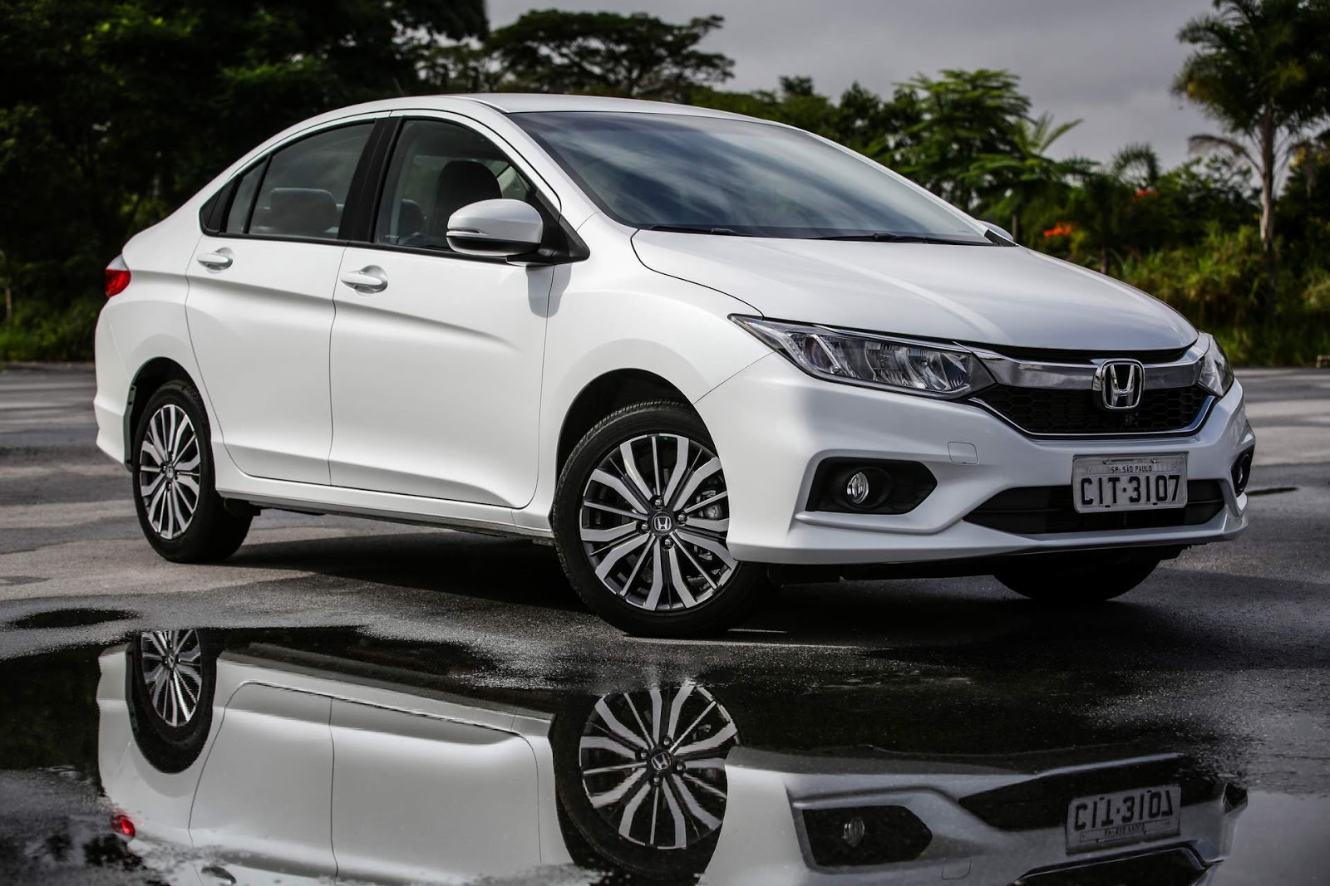

**Honda City – ₹3000 per Day**

The Honda City is a **5-seater** premium sedan known for its elegant design, powerful performance, and superior comfort. Equipped with a refined petrol or diesel engine, it delivers a smooth and fuel-efficient ride, making it perfect for both city drives and long-distance travel. The spacious cabin features plush leather seats, a touchscreen infotainment system, and advanced safety features, ensuring a luxurious and secure journey.

Ideal for **business trips, family outings, and comfortable city travel**, the Honda City offers a perfect blend of style, performance, and reliability. Whether you're heading to a corporate meeting or enjoying a weekend getaway, this sedan guarantees a premium driving experience. Rent the Honda City today and travel in style and comfort.