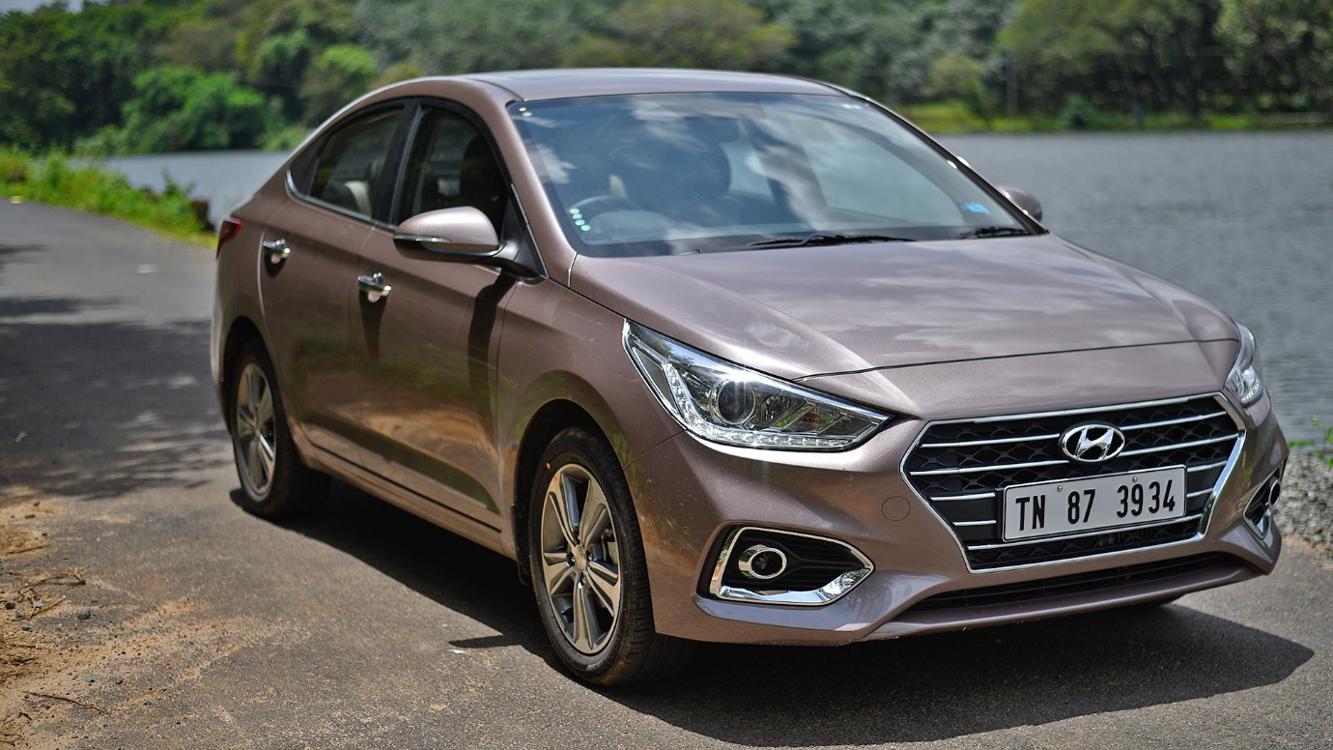

**Hyundai Verna – ₹2800 per Day**

The Hyundai Verna is a **5-seater** premium sedan that offers a perfect combination of style, comfort, and performance. With its sleek design, powerful yet fuel-efficient engine options, and smooth handling, it ensures an enjoyable driving experience on city roads and highways. The Verna features a spacious and well-appointed cabin with premium upholstery, a touchscreen infotainment system, and advanced safety features for a secure and comfortable ride.

Ideal for **business trips, family travel, and long drives**, the Hyundai Verna provides a luxurious and smooth journey with excellent fuel efficiency. Whether you need a stylish car for daily commutes or a comfortable sedan for road trips, the Verna is a smart and reliable choice. Rent the Hyundai Verna today and experience premium driving comfort.