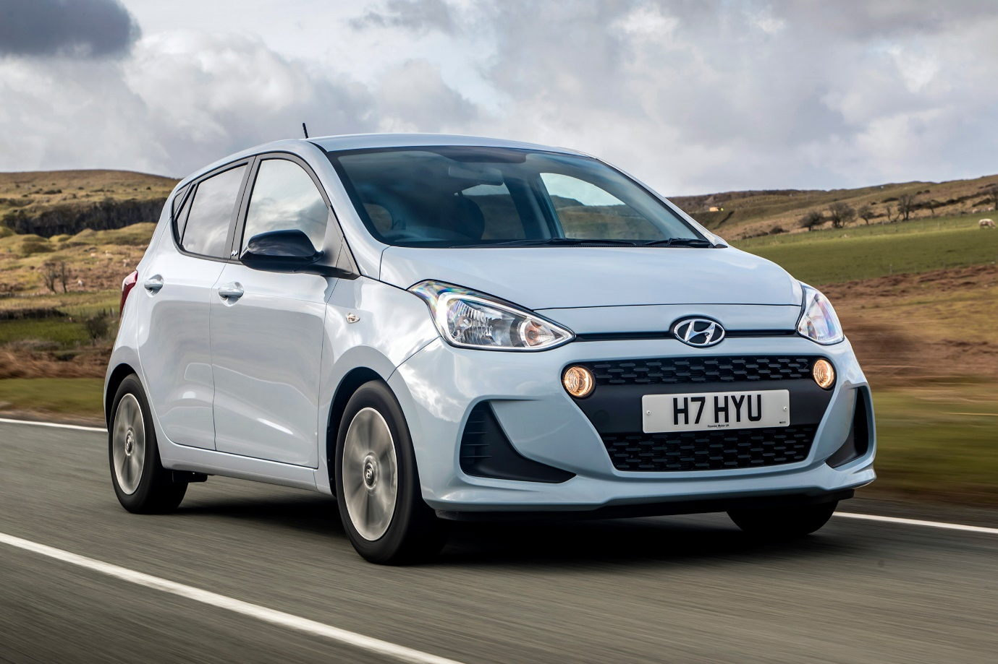

**Hyundai i10 – ₹1400 per Day**

The Hyundai i10 is a **5-seater** compact hatchback known for its stylish design, fuel efficiency, and easy maneuverability. Its compact size makes it perfect for city driving, while the smooth engine ensures a comfortable and economical ride. The i10 comes with a well-designed cabin, user-friendly infotainment system, and essential safety features, making every journey convenient and secure.

Ideal for **daily commutes, short trips, and budget-friendly travel**, the Hyundai i10 offers a great balance of affordability, reliability, and comfort. Whether you're navigating busy city streets or planning a quick getaway, this hatchback is a practical and efficient choice. Rent the Hyundai i10 today for a hassle-free and enjoyable ride.