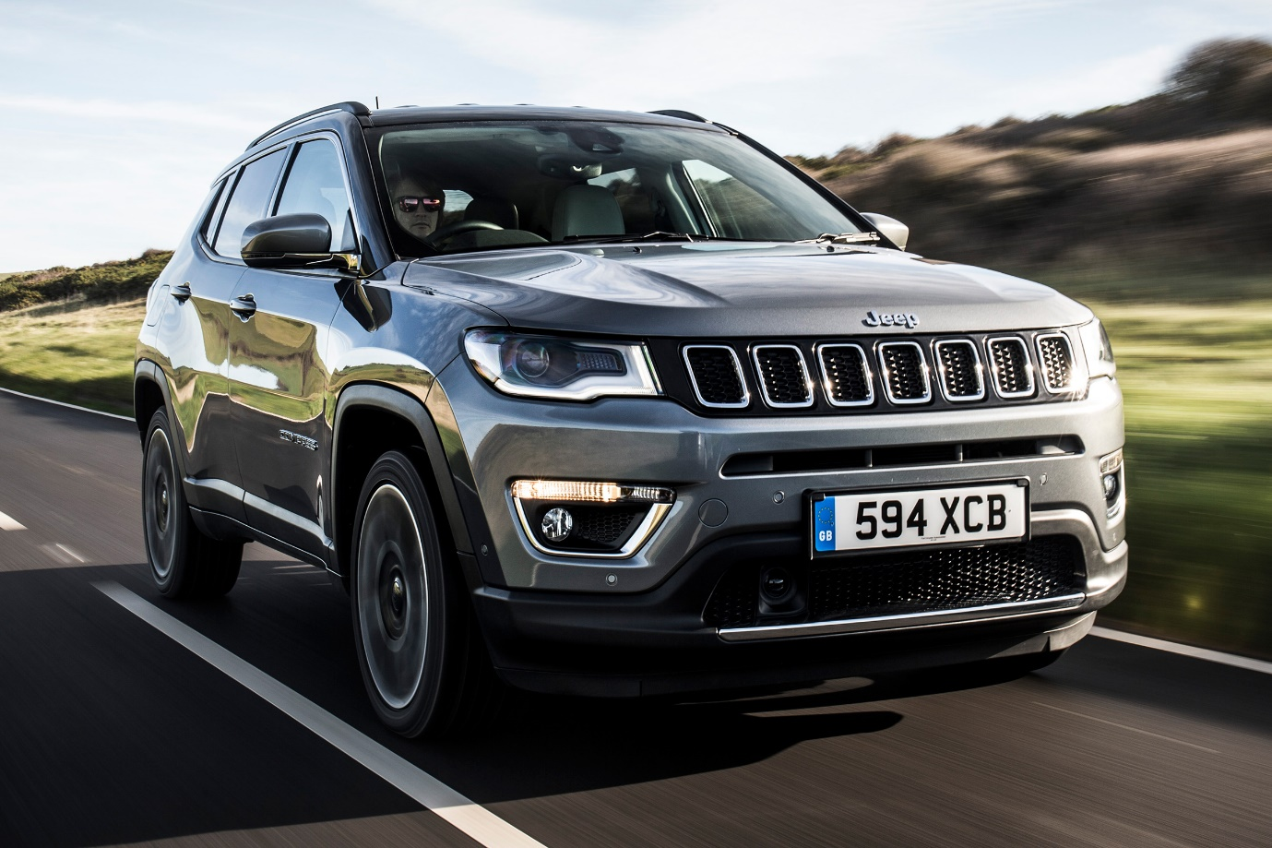

**Jeep Compass – ₹4500 per Day**

The Jeep Compass is a **5-seater** premium SUV designed for those who seek adventure and luxury in one package. With its rugged yet stylish design, powerful engine options, and smooth handling, it delivers an exceptional driving experience on highways and off-road terrains alike. The Compass features a well-appointed cabin with premium leather seats, a touchscreen infotainment system, and advanced safety features for maximum comfort and security.

Ideal for **city commutes, long road trips, and off-road adventures**, the Jeep Compass is perfect for those who demand performance, style, and reliability. Whether you're heading out for business or leisure, this SUV ensures a powerful and comfortable ride. Rent the Jeep Compass today and experience the thrill of driving an iconic SUV.