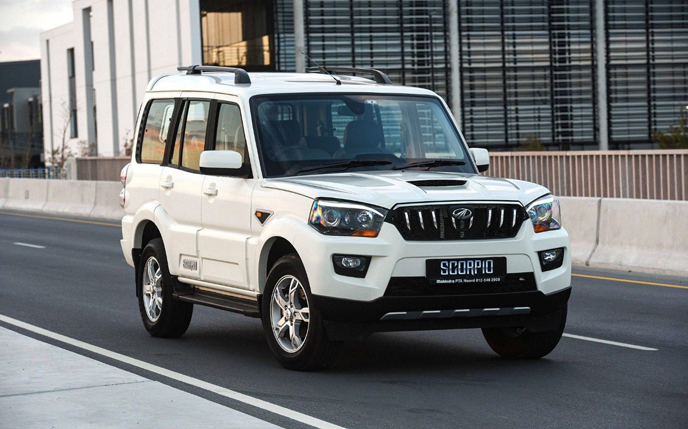

**Mahindra Scorpio – ₹3500 per Day**

The Mahindra Scorpio is a **7-seater** SUV built for power, durability, and comfort. With its muscular design and robust diesel engine, it delivers a smooth yet commanding performance on both city roads and off-road terrains. The Scorpio features a spacious cabin, modern infotainment system, and essential safety features, ensuring a comfortable and secure ride for passengers.

Ideal for **family outings, corporate travel, and adventure trips**, this SUV offers ample space for passengers and luggage, making it a great choice for long drives and rugged journeys. Whether navigating city streets or exploring rough terrains, the Scorpio provides unmatched reliability and versatility. Rent it today and experience the thrill of a true SUV.