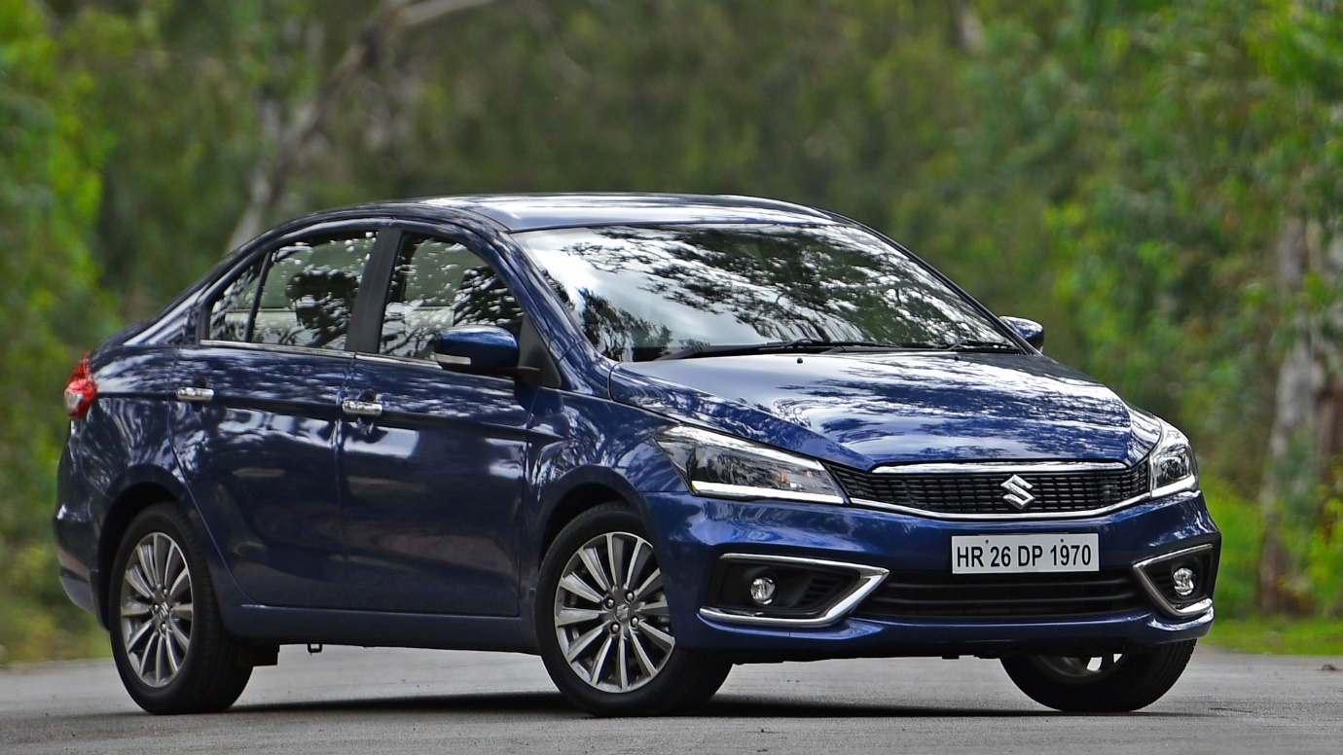

**Maruti Suzuki Ciaz – ₹2700 per Day**

The Maruti Suzuki Ciaz is a **5-seater** premium sedan known for its elegant design, spacious interiors, and fuel-efficient performance. With a refined petrol or diesel engine, it delivers a smooth and comfortable driving experience, making it perfect for both city commutes and long-distance travel. The Ciaz features a plush cabin with premium upholstery, a touchscreen infotainment system, and advanced safety features, ensuring a secure and enjoyable ride.

Ideal for **business trips, family outings, and comfortable long drives**, the Ciaz offers a perfect blend of style, luxury, and efficiency. Whether you need a sophisticated car for corporate travel or a spacious sedan for weekend getaways, this car is an excellent choice. Rent the Maruti Suzuki Ciaz today and travel with elegance and ease.