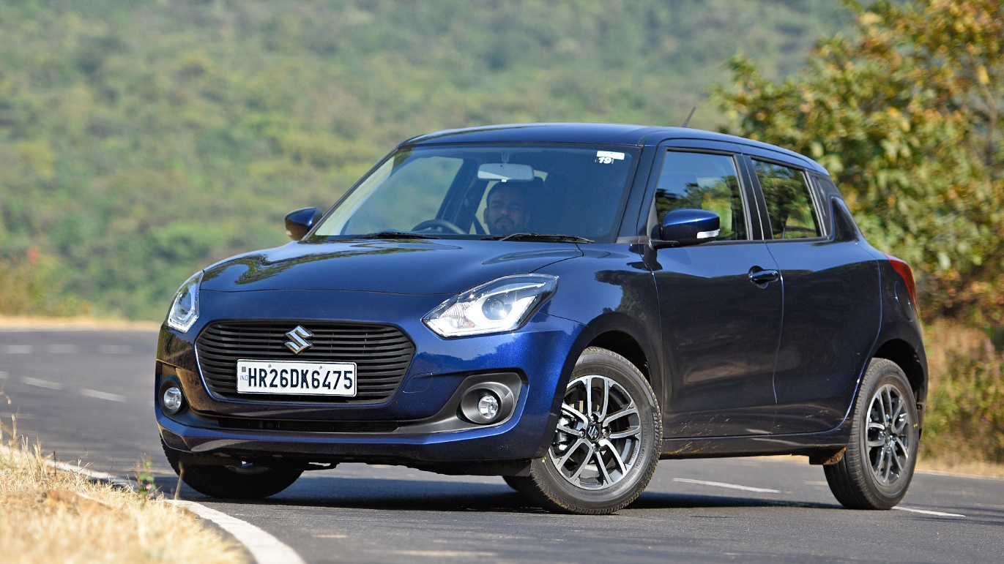

**Maruti Suzuki Swift – ₹1500 per Day**

The Maruti Suzuki Swift is a **5-seater** hatchback known for its sporty design, fuel efficiency, and smooth performance. With its compact size and responsive handling, it is perfect for navigating city streets and highways with ease. The Swift features a stylish and comfortable cabin, a touchscreen infotainment system, and essential safety features, ensuring a convenient and secure ride.

Ideal for **daily commutes, weekend getaways, and budget-friendly travel**, the Swift offers excellent mileage, reliability, and affordability. Whether you need a car for city driving or a short road trip, this hatchback is a smart and practical choice. Rent the Maruti Suzuki Swift today and enjoy a comfortable and economical journey.