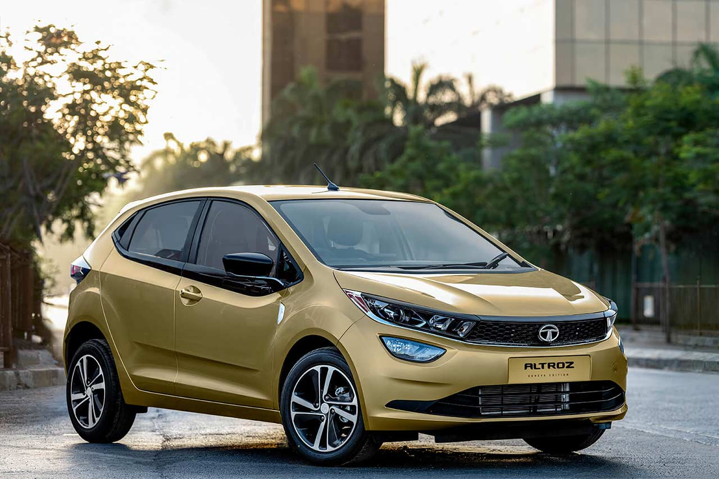

**Tata Altroz – ₹1600 per Day**

The Tata Altroz is a **5-seater** premium hatchback known for its bold design, spacious interiors, and high safety standards. Powered by fuel-efficient petrol and diesel engine options, it delivers a smooth and reliable performance on both city roads and highways. The Altroz features a modern cabin with comfortable seating, a touchscreen infotainment system, and advanced safety features, ensuring a secure and enjoyable ride.

Ideal for **daily commutes, long drives, and budget-friendly travel**, the Altroz offers a perfect blend of style, efficiency, and comfort. Whether you're looking for a car for city navigation or a weekend road trip, this hatchback ensures a premium driving experience. Rent the Tata Altroz today and enjoy a smart, safe, and stylish ride.