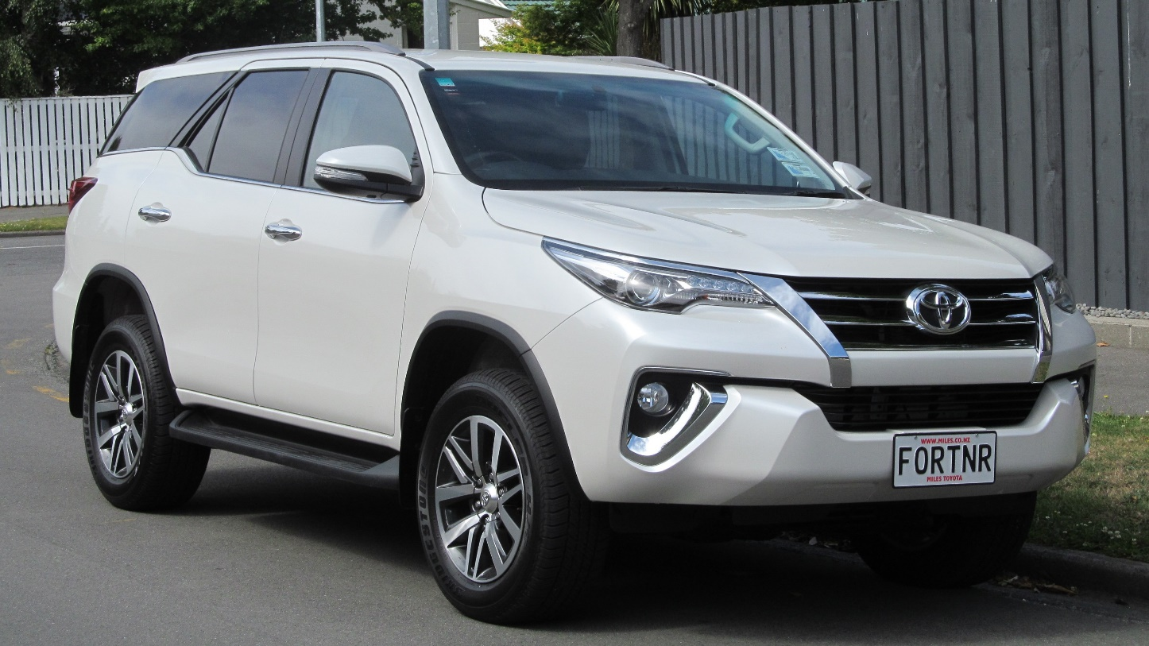

**Toyota Fortuner – ₹5000 per Day**

The Toyota Fortuner is a premium **7-seater** SUV known for its rugged design, powerful performance, and luxurious comfort. Equipped with a robust diesel engine and an advanced 4x4 drivetrain, it offers an exhilarating driving experience on both highways and off-road terrains. The spacious cabin features premium leather upholstery, a state-of-the-art infotainment system, and advanced safety features, ensuring a comfortable and secure journey.

Ideal for **family trips, corporate travel, and adventure tours**, the Fortuner provides ample space for passengers and luggage. Whether you're heading for a long road trip, a business tour, or exploring tough terrains, this SUV delivers unmatched reliability and dominance on the road. Rent this powerful SUV today and experience the perfect blend of strength and sophistication.