Game Design Document

Fill up the following document

1. Write the title of your project.

Spaceship game

1. What is the goal of the game?

To avoid the spaceships

1. Write a brief story of your game.

A person is trying to reach some other planet. Aliens on that planet do not want the person to enter their planet.

So the aliens are sending spaceships to kill the person.

1. Which are the playing characters of this game?

* Playing characters are the ones who respond to the user based on the input from the user.
* Cars, monkeys, dinos, wizards, etc., are the playing characters in the game.

|  |  |  |
| --- | --- | --- |
| Number | Character Name | What can this character do? |
| 1 | spaceship | Move and shoot bullets |
| 2 |  |  |
| 3 |  |  |
| 4 |  |  |
| 5 |  |  |
| 6 |  |  |
| 7 |  |  |
| 8 |  |  |

1. Which are the Non-Playing Characters of this game?

* Non-Playing characters are the ones that don't have an action or behavior when the user interacts with the game.
* Hurdles, stones, bananas, coins, etc., are non-playing characters in the game.

|  |  |  |
| --- | --- | --- |
| Number | Character Name | What can this character do? |
| 1 | Alien spaceships | Shoot bullets |
| 2 |  |  |
| 3 |  |  |
| 4 |  |  |
| 5 |  |  |
| 6 |  |  |
| 7 |  |  |
| 8 |  |  |

Draw your imagination of this game. What does this game look like?

* Draw the game either on your computer or on paper.
* Add images of the game scenes to show each of the playing and non-playing characters at least once.

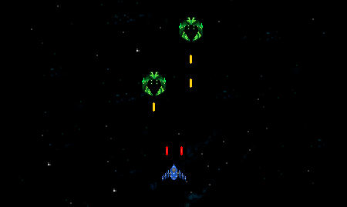

How do you plan to make your game engaging?

By increasing the rate of NPCs and balancing the game.