Day 04
Run and record output for at least 6 commands :
Process commands (ps, top, pgrep)
ps -aux | head -n 5 = It displays the top 5 lines (including the header) from the list of all running processes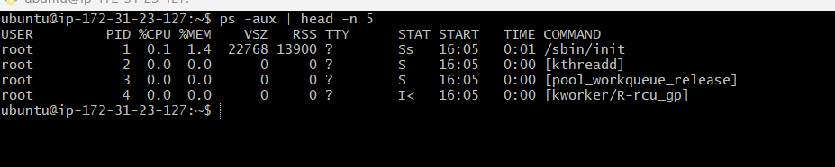
top | head -n 10 =It shows the first 10 lines of live system and process information from top
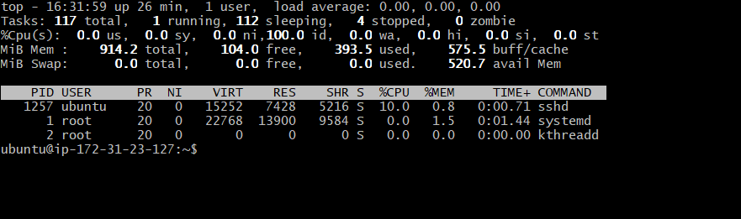
pgrep –l docker = Finds processes whose name matches nginx and shows the PID with process name.
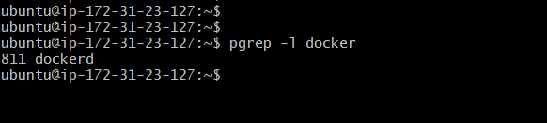

Service commands (systemctl status, systemctl list-units, etc)

systemctl status nginx = It shows the current status of the Nginx service

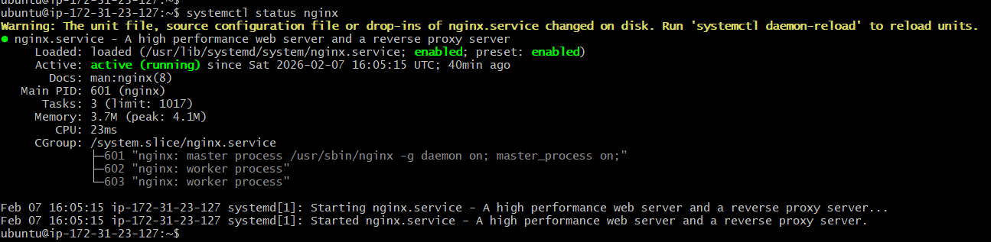
systemctl list-units --type=service --state=running | head= It shows the first few running services on the system.
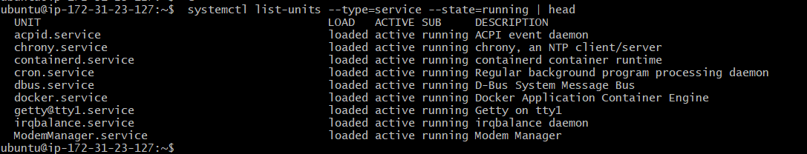
Log commands (journalctl -u <service>, tail -n 50, etc.)

journalctl -u docker | head -n 10 = It shows the first 10 log entries for the Docker service from the system logs.
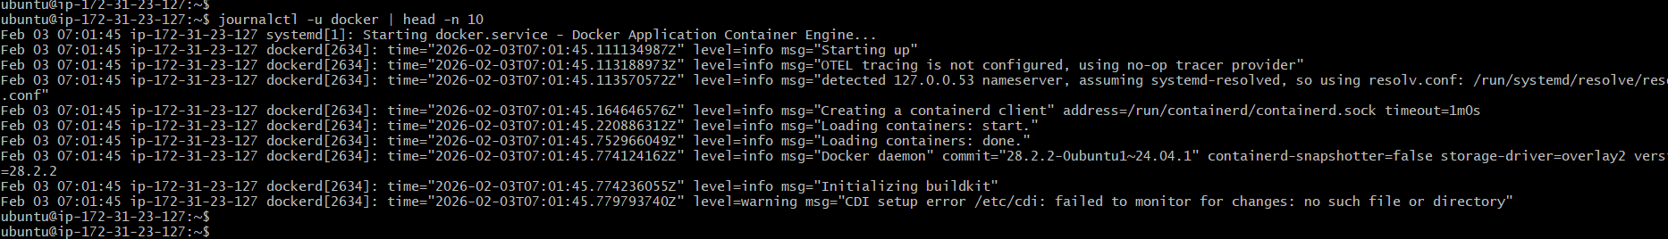

journalctl -u docker | grep -i error | head = Shows the first 10 Docker service log entries that contain the word “error”.

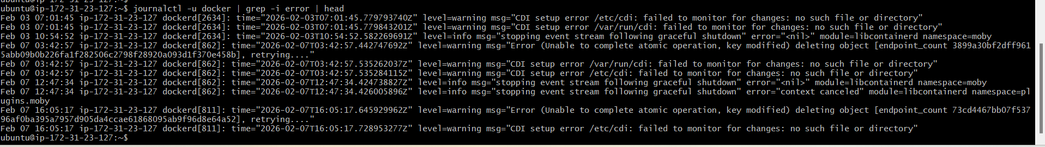

Service for Inspection commands (journalctl -u <service>, tail -n 50, etc.)
systemctl status nginx
sudo systemctl stop nginx
curl http://localhost
systemctl status nginx
journalctl -u nginx
sudo systemctl start nginx
systemctl status nginx
curl http://localhost

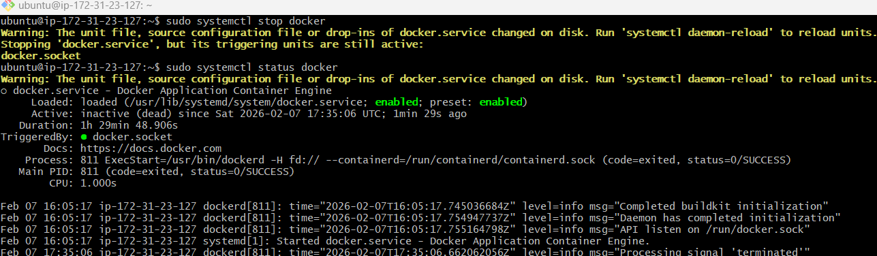
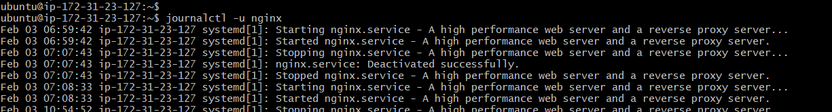

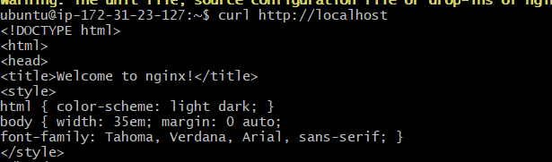

I first verified that the NGINX service was running, then intentionally stopped it to simulate a failure and confirmed the service outage.
After inspecting the service status and logs, I restarted NGINX and verified that the web service was restored successfully.

