**Design and Implementation of a Smart Agricultural Marketplace for Rural Farmers**

## A PROJECT REPORT

***Submitted by,***

|  |  |  |
| --- | --- | --- |
| **Sl. No.** | **Roll Number** | **Student Name** |
| 1 | 20211CSE0464 | Dhanya MU |
| 2 | 20211CSE0232 | Sneha A |
| 3 | 20211CSE0210 | Vennapusa Moksha Sravani |
| 4 | 20211CSE0409 | Pragathi MS |

### *Under the guidance of,*

Dr. Pajany M

School of Computer Science,

***in partial fulfillment for the award of the degree of***

**BACHELOR OF TECHNOLOGY**

**IN**

**COMPUTER SCIENCE AND ENGINEERING, COMPUTER ENGINEERING, INFORMATION SCIENCE AND ENGINEERING Etc.**

**At**



**PRESIDENCY UNIVERSITY**

**BENGALURU**

**FEBRUARY 2025**

**PRESIDENCY UNIVERSITY**

**SCHOOL OF COMPUTER SCIENCE ENGINEERING**

**CERTIFICATE**

This is to certify that the Project report **“Design and Implementation of a Smart Agricultural Marketplace for Rural Farmers”** being submitted by “Dhanya M U, Sneha A, Vennapusa Moksha Sravani, Pragathi MS” bearing roll number(s) “20211CSE0464, 20211CSE0232, 20211CSE0210, 20211CSE0409” in partial fulfillment of the requirement for the award of the degree of Bachelor of Technology in Computer Science and Engineering is a Bonafide work carried out under my supervision.

|  |  |
| --- | --- |
| **Dr. Pajany M**  Assistant Professor  School of CSE  Presidency University | **Dr. Asif Mohammed**  Assistant Professor & HOD  School of CSE  Presidency University |

|  |  |  |
| --- | --- | --- |
| **Dr. L. SHAKKEERA**  Associate Dean  School of CSE  Presidency University | **Dr. MYDHILI NAIR**  Associate Dean  School of CSE  Presidency University | **Dr. SAMEERUDDIN KHAN**  Pro-V c School of Engineering  Dean -School of CSE&IS  Presidency University |

**PRESIDENCY UNIVERSITY**

**SCHOOL OF COMPUTER SCIENCE ENGINEERING**

**DECLARATION**

We hereby declare that the work, which is being presented in the project report entitled Design and Implementation of a Smart Agricultural Marketplace for Rural Farmersin partial fulfillment for the award of Degree of **Bachelor of Technology** in **Computer Science and Engineering**, is a record of our own investigations carried under the guidance of **Dr. Pajany M Assistant Professor,** **School of Computer Science Engineering, Presidency University, Bengaluru.**

We have not submitted the matter presented in this report anywhere for the award of any other Degree.

|  |  |  |  |
| --- | --- | --- | --- |
| **Sl. No.** | **Roll Number** | **Student Name** | **Signature(s) of the Students** |
| 1 | 20211CSE0464 | Dhanya MU |  |
| 2 | 20211CSE0232 | Sneha A |  |
| 3 | 20211CSE0210 | Vennapusa Moksha Sravani |  |
| 4 | 20211CSE0409 | Pragathi MS |  |

|  |  |
| --- | --- |
|  |  |

**ABSTRACT**

This project focuses on developing a comprehensive platform that bridges the gap between farmers and consumers, allowing users to purchase agricultural products directly from farmers. The application provides seamless online payments, user and farmer profile management, and real-time inventory updates. Administrators play a key role in fostering trust by onboarding verified farmers and uploading schemes beneficial to farmers. Future expansions include vehicle and land renting functionalities as well as fertilizer management to further support farmers.

**ACKNOWLEDGEMENT**

First of all, we indebted to the **GOD ALMIGHTY** for giving me an opportunity to excel in our efforts to complete this project on time.

We express our sincere thanks to our respected dean **Dr. Md. Sameeruddin Khan**, Pro-VC, School of Engineering and Dean, School of Computer Science Engineering, Presidency University for getting us permission to undergo the project.

We express our heartfelt gratitude to our beloved Associate Deans **Dr. Shakkeera L and Dr. Mydhili Nair,** School of Computer Science Engineering, Presidency University, and **Dr. Asif Mohammed**, Head of the Department, School of Computer Science Engineering, Presidency University, for rendering timely help in completing this project successfully.

We are greatly indebted to our guide **Dr. Pajany M,** assistant professor and Reviewer **Ms. Tintu Vijayan,** associate professor**,** School of Computer Science Engineering & Information Science, Presidency University for their inspirational guidance, and valuable suggestions and for providing us a chance to express our technical capabilities in every respect for the completion of the project work.

We would like to convey our gratitude and heartfelt thanks to the PIP4004 Internship Coordinators **Dr. Sampath A K, Dr. Abdul Khadar A and Mr. Md Zia Ur Rahman,** department Project Coordinators and Git hub coordinator **Mr. Muthuraj.**

We thank our family and friends for the strong support and inspiration they have provided us in bringing out this project.

**Dhanya MU**

**Sneha A**

**Vennapusa Moksha Sravani**

**Pragathi MS**

**TABLE OF CONTENTS**

|  |  |  |
| --- | --- | --- |
| **CHAPTER NO.** | **TITLE** | **PAGE NO.** |
|  | **ABSTRACT**  **ACKNOWLEDGMENT** | **i**  **ii** |
| 1. | **INTRODUCTION** | **1** |
|  | 1.1 GENERAL | 1 |
|  | 1.2 Problem Statement | 1 |
|  | 1.3 Objective | 1 |
|  | 1.4 Scope of the Study | 1 |
|  | 1.5 Significance of the Study | 1 |
| **2.** | **LITERATURE SURVEY** | **2** |
|  | 2.1 Related Work | 2 |
| **3.** | **SYSTEM ANALYSIS** |  |
|  | 3.1 Existing System | 2 |
|  | 3.2 Disadvantages | 2 |
|  | 3.3 Proposed System |  |
|  | 3.4 Advantages |  |
| **4.** | **REQUIREMENT ANALYSIS** | **3** |
|  | 4.1Function and non-functional requirements |  |
|  | 4.2 Hardware Requirements |  |
|  | 4.3 Software Requirements |  |
|  | 4.4 Architecture |  |
| **5.** | **PROPOSED METHODOLOGY** | **4** |
|  | 5.1 System Overview | 4 |
|  | 5.2 Implementation Steps | 4 |
|  | 5.3 Integration and User Interface Device | 4 |
|  | 5.4 Evaluation Metrics | 4 |
|  | 5.5 Maintenance and Update | 4 |
| **6.** | **OBJECTIVES** | **5** |
| **7.** | **SYSTEM DESIGN & IMPLEMENTATION** | **45** |
|  | 6.1 Introduction of Input Design | 6 |
|  | 7.2 UML Diagrams |  |
|  | 6.2 System Modules and Components | 6 |
|  | 6.3 Implementation | **7** |
|  | 6.4 Technologies Used | 7 |
| **8.** | **TIMELINE FOR EXECUTION OF PROJECT** | **8** |
| **9.** | **OUTCOMES** | **9** |
| **10.** | **RESULTS AND DISCUSSIONS** | **10** |
| **11.** | **CONCULSION** | **11** |
| **12.** | **REFERENCES** | **12** |

**CHAPTER 1**

**INTRODUCTION**

**1.1 General**

The agricultural sector has long faced challenges with transparency, efficiency, and market accessibility, leaving farmers without direct avenues to reach consumers and maximize their profits. The motivation behind this project is to empower farmers by bridging the gap between them and consumers, creating an ecosystem that ensures fairness, trust, and accessibility. By integrating technology with agriculture, this platform provides farmers with tools to manage their products, streamline payments, and access beneficial schemes. This will not only uplift farmers' livelihoods but also foster a sustainable farm-to-consumer relationship, enhancing the overall agricultural economy.

**1.2 Problem Statement**

Traditional agricultural marketplaces often suffer from a lack of transparency and inefficient payment processes. Farmers are often isolated from direct market access, and consumers have limited opportunities to purchase fresh products directly from the source. This project addresses these gaps by creating a platform that connects farmers directly with consumers, ensuring transparency in product quality and prices, along with efficient payment processing.

**1.3 Objective**

The objective is to develop an application that connects consumers directly with farmers, offering a seamless and secure payment gateway, profile management, and inventory system. The platform will allow users to view and purchase products from verified farmers. Provide farmers with tools to manage their product listings, receive payments, and stay informed about government schemes. Enable administrators to maintain trust within the system by onboarding verified farmers and providing them access to beneficial schemes.

**1.4 Scope of the Study**

The project focuses on creating a user-friendly mobile application that facilitates transactions between farmers and consumers. Users can browse, purchase, and make payments for farm products, while farmers can manage their inventory and receive payments directly via UPI. Admins will manage farmer onboarding and upload relevant agricultural schemes. Future extensions include vehicle renting for transporting produce, land renting, and fertilizer management systems.

**1.5 Significance of the Study**

This project connects farmers directly with consumers, eliminating middlemen and ensuring fair Prices. Features like UPI payments, real-time inventory management, and access to government schemes enhance efficiency and transparency. It empowers farmers financially while providing consumers with fresh, affordable produce. Ultimately, the platform promotes sustainable **agriculture and rural development**.

**CHAPTER 2**

**LITERATURE SURVEY**

**2.1 Related Work**

1. **Pranav Shriram; Sunil Mhamane | Android App to Connect Farmers to Retailers and Food Processing Industry | 15-16 November 2018:** Mobile internet will help the farmers to sell their products directly to consumers and food processing industries. This paper provides market information to a farmer using its easy interface on the mobile application. The mobile application is intended to be used for fast and updated information delivering system for farmers. Also, it has native language support to make the transaction easy for farmers. The mobile application treats farmers as a seller and a buyer. The intention behind this paper is to help farmers so they buy or sell their agriculture goods and products. Market prices provided by data.gov.in lets the system to keep the selling and buying prices in control. As the products are to be browsed and there may be plenty of products for the user. To make browsing easy many filters can provide. Farmers face many problems while selling their goods and products, this system promises to provide an easy and recreational way to sell the products. The system lets the farmers to sell goods at a reasonable price and makes business even fair and transparent. Consumers are the opposite side of the same coin. This system lets consumer to choose from a wide variety of products, select the product as per their requirement and also to apply price filters. Location is a one of parameter for consumer and producer while selling or buying their product it will helps the user to get the product nearby their location. The basic objective of the system is to consider every one need and full fills their requirement with fair and transparent agriculture business.
2. **L.A. Imalka; K.G.A. Gunawardana; K.M.S.K. Kodithuwakku; H.K.E. Arachchi; S.M.B. Harshanath | Farming through Technology Driven Solutions for Agriculture Industry Ceylon E-Agro mobile application-find technology-based solutions for agricultural problems | 16-18 September 2022:** Many developing countries are based on the agricultural sector. More than 60 percent of the population depends on this sector. This project is focused on maize cultivation. In agriculture, farmers play the most important role. Currently, farmers are facing many problems related to maize cultivation in Sri Lanka. This mobile application will help the maize farmers to overcome these difficulties and provide a good consumer demand for maize cultivation. Through this mobile application, the farmer can find solutions for pest & diseases in maize, fire threat in the farm field. AI based Agri Agent will be provide real-time solutions, bring the farmers and the buyers into the one platform, and provide price prophesying, price index feature. IOT based smart farming features will be provided to remain soil moisture and quality of soil for maize plantation.
3. **R. Ranjana; T. Subha; Pravin Kumar P; Sneka L; Varsha S; Jothishree N | Integrated App for Farmers - Agreliance | 16-17 December 2021:** In this contemporary world, the development of telecommunication technology is far beyond the human knowledge that allows people to stay connected who are detached thousands of miles away by the internet. An integrated mobile app is created in such a way that it enhances the life of farmers both in their financial and mental status. Telehealth care systems emerged as one of the best alternate remedies for treating people during this covid - 19 crises, By video conferencing technology, doctors are likely to treat farmers who are emotionally and mentally downhearted. Tata Communications - Confidential It is as effective as traditional way of counselling in person and it's a proven fact. Not only for farmers but also crops need some attention as it is prone to some diseases, to tackle that issue experts will be providing consultations to the farmers by pre - booking them. Economic growth is highly distressed due to global pandemic, so retailing farmers goods to consumers in online platforms would greatly increase the economic growth and reduce price despite the secondary agents. Loan facilities which are available around the location of the farmers are made aware to them, thus it will greatly influence their basic survival in agriculture.
4. **Niket Chauhan; M. Krishnakanth; G. Praneeth Kumar; Prerna Jotwani; Utkarsh Tandon; | Crop Shop – An application to maximize profit for farmers | 30-31 March 2019:**For several years, farmers in India have had little liberty in choosing markets and purchasers for their produce. All states in the country, except three, decree that the marketing and selling of farm produce must be directed through state-owned mandis, retail markets where mediators (middlemen) crush farmers to increase margins. According to Goldman Sachs, mediators have become dominant buyers of the agricultural market, resulting in them taking control over the plight of the farmers and reaping all the profits. The farmers work day and night, expecting a good yield. They use a lot of financial resources, lending money and buying fertilizers, seeds, etc. So, they have the right to enjoy every rupee gained from their corporation. In this context, we propose a system that brings farmers close to the retailers, cutting out the middlemen. The middlemen usually take up to 70% of the profits of farmers, leaving them helpless. Our system consists of a mobile application that will serve as a platform for growers and retailers, and customers to sell and buy their farm products. This system aims to give a profitable price to farmers for their farm products, cutting out the middlemen. This allows the retailers or the customers to buy products from the farmers at a lower price than the normal price.
5. **Aina Marie Joseph; Nurfauza Jali; Amelia Jati Robert Jupit; Suriati Khartini Jali | eMarket for Local Farmers | 23-25 November 2021:** The Covid-19 pandemic is a global health crisis that has brought an impact on everyone. A negative impact has made local farmers struggle to find their means of income other than selling their crops to their customers. The customers have had difficulties searching for good quality fresh produce other than from the supermarket. The purpose of this paper is twofold: firstly, to assess the manual and existing system on how consumers acquire their fresh produce during the Covid-19 pandemic, to design and implement a delivery system for local farmers to vend their fresh produce through a mobile application; and secondly, to test and evaluate the usability and functionality of the online farmers' market application. The existing mobile applications have changed everyone's approach in acquiring daily essentials that the pandemic has brought. Therefore, the idea of developing an online marketplace for local farmers resulted in the proposed application, which will be explained in this paper. Rapid Application Development (RAD) was used as the methodology for the development of the e-Market application. A survey was conducted via Google form for twenty local farmers and another twenty potential customers during the pre-development stage. It was to collect data on the users' opinions regarding the proposed application. We then conducted the usability testing through Google form to collect the users' feedback on the e-Market application. Ten local farmers from Matang's market have participated in the testing phase. Additionally, ten students from a local university participated as potential customers in the usability testing. As a result of these testing’s, we have developed a usable farmer's market application that has been well-received by local farmers and customers.

**CHAPTER 3**

**SYSTEM ANALYSIS**

**3.1 Existing System**

Current platforms in agriculture-based commerce either offer limited direct interaction between farmers and consumers or are complicated by lengthy payment processes. Farmers often face challenges in listing their products and managing payments. Additionally, government schemes that benefit farmers are often underutilized due to a lack of awareness and access.

#### **3.2 Disadvantages**

1. Fragmented processes lead to inefficiencies in connecting farmers with consumers.
2. Lack of seamless payment solutions hinders transaction completion.
3. Limited visibility of government schemes results in missed opportunities for farmers.

**3.3 Proposed System**

The proposed system integrates a unified platform for farmers, users, and administrators. Users can browse and purchase products while completing payments through UPI-based gateways. Farmers can manage inventory, update product listings, and receive payments directly into their accounts. Administrators will onboard trusted farmers, upload helpful schemes, and manage the platform's ecosystem.

**3.4 Advantages**

* A cohesive system for purchasing agricultural products directly from farmers.
* Payments are processed securely through UPI-like gateways, reducing delays.
* Farmers can easily add and update their products.
* Admins can upload schemes beneficial to farmers, ensuring they are accessible.
* Future updates will allow for vehicle and land renting, as well as fertilizer management

**CHAPTER 4**

**REQUIREMENT ANALYSIS**

**4.1 Function and non-functional requirements**

Requirement’s analysis is very critical process that enables the success of a system or software project to be assessed. Requirements are generally split into two types: Functional and non-functional requirements.

Functional Requirements: These are the requirements that the end user specifically demands as basic facilities that the system should offer. All these functionalities need to be necessarily incorporated into the system as a part of the contract. These are represented or stated in the form of input to be given to the system, the operation performed and the output expected. They are basically the requirements stated by the user which one can see directly in the final product, unlike the non-functional requirements.

Examples of functional requirements:

1) Authentication of user whenever he/she logs into the system

2) System shutdown in case of a cyber-attack

**Non-functional requirements:** These are basically the quality constraints that the system must satisfy according to the project contract. The priority or extent to which these factors are implemented varies from one project to other. They are also called non-behavioral requirements.

They basically deal with issues like:

• Portability

• Security

• Maintainability

• Reliability

• Scalability

• Performance

• Reusability

• Flexibility

Examples of non-functional requirements:

1) Emails should be sent with a latency of no greater than 12 hours from such an activity.

2) The processing of each request should be done within 10 seconds

3) The site should load in 3 seconds whenever of simultaneous users are > 10000

**4.2 Hardware Requirements**

* Processor - I3/Intel Processor
* RAM - 8 GB
* Hard Disk - 1TB

**4.3 Software Requirements**

* Operating System - Windows 10
* JDK - java
* Plugin -Kotlin
* SDK - Android
* IDE -Android studio
* Database` - server script, mySQL

**4.4 Architecture**

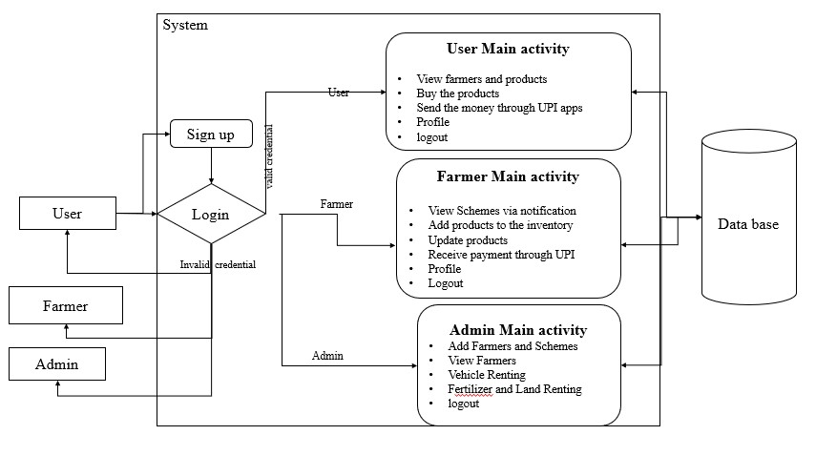

**Fig 4.4: The image illustrates a system architecture for the rural commerce application, which connects users, farmers, and administrators.**

**CHAPTER 5**

**PROPOSED MOTHODOLOGY**

**4.1 System Overview**

The proposed system integrates a unified platform for farmers, users, and administrators. Users can browse and purchase products while completing payments through UPI-based gateways. Farmers can manage inventory, update product listings, and receive payments directly into their accounts. Administrators will on board trusted farmers, upload helpful schemes, and manage the platform's ecosystem.

**4.2 Implementation Steps**

1. **Requirement Analysis & System Design** – Define system architecture, database schema, and business logic.
2. **Frontend Development** – Build the UI using **Kotlin in Android Studio**, including user authentication and product listing.
3. **Backend Development** – Implement APIs using **Java Spring Boot**, integrating UPI-based payments and notifications.
4. **Admin Panel Development** – Manage **farmer onboarding, government schemes, and system monitoring**.
5. **Testing & Deployment** – Conduct **unit, integration, and user acceptance testing**, then deploy on a secure cloud server.

**4.3 Integration and User Interface Design**

The system integrates a **Java Spring Boot backend with a Kotlin-based Android frontend** using REST APIs for smooth data exchange. A **secure UPI-based payment gateway** enables seamless transactions. The user interface, designed with **Constraint Layout in Android Studio**, ensures responsiveness and ease of use. Features like **product browsing, filters, multilingual support, and real-time notifications** enhance accessibility.

**4.4 Evaluation Metrics**

The system is evaluated based on **performance (response time and load handling), usability (ease of navigation and user satisfaction), and security (data protection and transaction safety)**. Success is measured through **user adoption rates, feedback, and transaction success rates**. Regular **testing and monitoring** ensure system efficiency and reliability.

**4.5 Maintenance and Updates**

Regular **bug fixes, performance optimizations, and security patches** are implemented to ensure smooth operation. **User feedback is analyzed** to introduce necessary updates and feature enhancements. Future updates will include **IOT-based smart farming and extended marketplace functionalities**.

**CHAPTER 6**

**OBJECTIVES**

1. Input Design is the process of converting a user-oriented description of the input into a computer-based system. This design is important to avoid errors in the data input process and show the correct direction to the management for getting correct information from the computerized system.
2. It is achieved by creating user-friendly screens for the data entry to handle large volume of data. The goal of designing input is to make data entry easier and to be free from errors. The data entry screen is designed in such a way that all the data manipulates can be performed. It also provides record viewing facilities.
3. When the data is entered it will check for its validity. Data can be entered with the help of screens. Appropriate messages are provided as when needed so that the user will not be in maize of instant. Thus, the objective of input design is to create an input layout that is easy to follow.

**CHAPTER 7**

**SYSTEM DESIGN & IMPLEMENTATION**

**7.1 Introduction of Input design**

**INPUT DESIGN**

The input design is the link between the information system and the user. It comprises the developing specification and procedures for data preparation and those steps are necessary to put transaction data into a usable form for processing can be achieved by inspecting the computer to read data from a written or printed document or it can occur by having people keying the data directly into the system. The design of input focuses on controlling the amount of input required, controlling the errors, avoiding delay, avoiding extra steps and keeping the process simple. The input is designed in such a way so that it provides security and ease of use with retaining the privacy. Input Design considered the following things:

* What data should be given as input?
* How the data should be arranged or coded?
* The dialog to guide the operating personnel in providing input.
* Methods for preparing input validations and steps to follow when error occur.

**OUTPUT DESIGN**

A quality output is one, which meets the requirements of the end user and presents the information clearly. In any system results of processing are communicated to the users and to other system through outputs. In output design it is determined how the information is to be displaced for immediate need and also the hard copy output. It is the most important and direct source information to the user. Efficient and intelligent output design improves the system’s relationship to help user decision-making.

1. Designing computer output should proceed in an organized, well thought out manner; the right output must be developed while ensuring that each output element is designed so that people will find the system can use easily and effectively. When analysis design computer output, they should Identify the specific output that is needed to meet the requirements.

2. Select methods for presenting information.

3. Create document, report, or other formats that contain information produced by the system.

The output form of an information system should accomplish one or more of the following objectives.

* Convey information about past activities, current status or projections of the
* Future.
* Signal important events, opportunities, problems, or warnings.
* Trigger an action.
* Confirm an action.

**7.2 UML Diagram**

UML stands for Unified Modelling Language. UML is a standardized general-purpose modelling language in the field of object-oriented software engineering. The standard is managed, and was created by the Object Management Group.

The UML is a very important part of developing object-oriented software and the software development process. The UML uses mostly graphical notations to express the design of software projects.

**Use Case Diagram**

A use case diagram in the Unified Modeling Language (UML) is a type of behavioral diagram defined by and created from a use case analysis. Its purpose is to present a graphical overview of the functionality provided by a system in terms of actors, their goals (represented as use cases), and any dependencies between those use cases. The main purpose of a use case diagram is to show which system functions are performed by which actor. Roles of the actors in the system can be depicted.

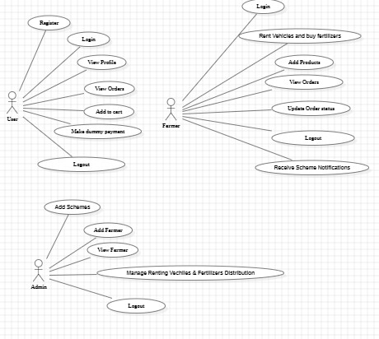

**Fig 7.2.1: The image depicts use case diagram for agricultural system, outlining interactions between users, farmers, and administrators.**

**Class Diagram**

In software engineering, a class diagram in the Unified Modelling Language (UML) is a type of static structure diagram that describes the structure of a system by showing the system's classes, their attributes, operations (or methods), and the relationships among the classes. It explains which class contains information.

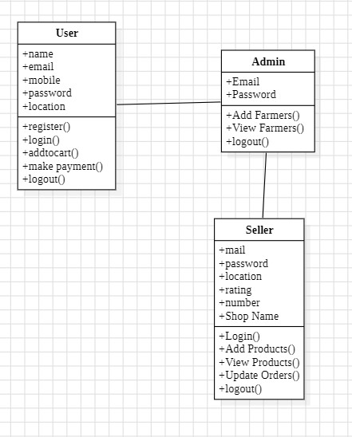

**Fig 7.2.2: This image is a class diagram outlining the attributes and methods for User, Admin, and Seller entities in a system.**

**Sequence Diagram**

A sequence diagram in Unified Modelling Language (UML) is a kind of interaction diagram that shows how processes operate with one another and in what order. It is a construct of a Message Sequence Chart. Sequence diagrams are sometimes called event diagrams, event scenarios, and timing diagrams.

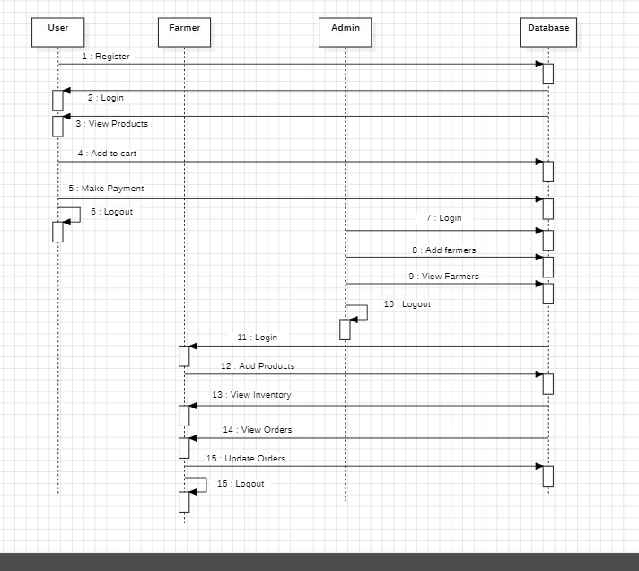

**Fig 7.2.3: The image depicts sequence diagram illustrating interactions between a user, farmer, admin, and database system.**

**7.3 System Modules and Components**

1. **User Module**: Users will sign up, log in, and browse a list of farmers and their products. After selecting products, users can purchase them and complete payments through a UPI-like dummy payment gateway. Users can manage their profiles, track orders, and view their order history.
2. **Farmer Module:** Farmers can log in, manage their profiles, and add or update products in the inventory. Farmers will receive notifications for new orders and can fulfil them. Payments will be credited directly to their UPI accounts. Farmers can view schemes uploaded by the admin, with notifications available in the app.
3. **Admin Module:** Admins will onboard trusted farmers, creating a verified environment for users. They will upload and manage schemes that are beneficial for farmers. Admins will also be responsible for suggesting and providing references for applying to these schemes, fostering an efficient farming ecosystem. They can also monitor platform performance and manage system operations.

**7.4 Implementation**

1. **System Architecture** – Built using a **three-tier architecture** (Frontend, Backend, and Database).
2. **Frontend Development** – Developed using **Kotlin in Android Studio**, ensuring a user-friendly and responsive interface.
3. **Backend Development** – Implemented using **Java Spring Boot**, providing RESTful APIs for seamless communication.
4. **Database Management** – **MySQL** is used to store user data, product listings, and transaction records.

**7.5 Technologies Used**

1. **Programming Languages**: Java (Backend), Kotlin (Frontend), SQL (Database).
2. **Frameworks**: Spring Boot (Backend), Android Studio (Mobile App).
3. **Database**: MySQL
4. **Cloud Platforms**: AWS or Google Cloud for deployment and scalability.

**CHAPTER 8**

**TIMELINE FOR EXECUTION OF PROJECT**

**(GANTT CHART)**

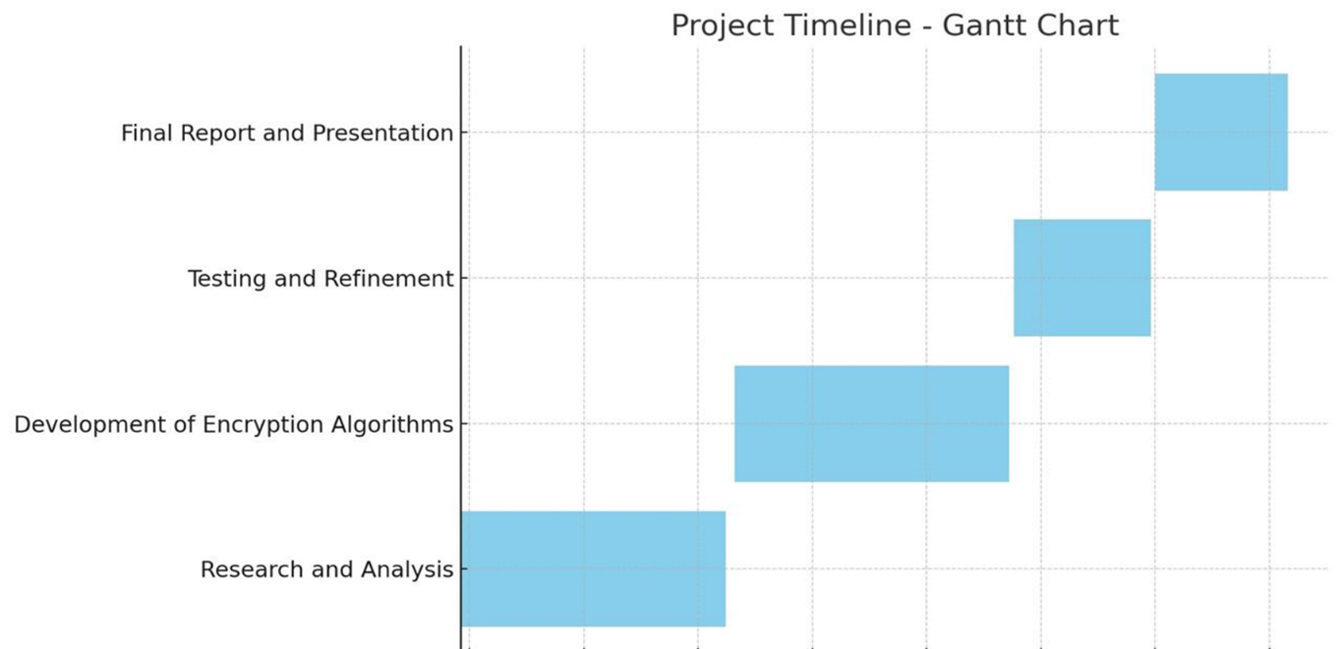**Fig 8.1 TimeLine for the Execution of the Project**

**Table 8.1: Project Timeline and Activities**

|  |  |  |
| --- | --- | --- |
| **Phase** | **Activity** | **Task** |
| Review – 0 | Research and Analysis | Gather data, review existing methods, and identify research gaps. |
| Review – 1 | Development | Design the chat-bot system, pre-process data, and implement the Naive Bayes algorithm. |
| Review – 2 | Testing and Refinement | Conduct testing with sample queries, refine the model, and integrate with user interface. |
| Review – 3 | Final Report and Presentation | Document findings, prepare the final report, and create a presentation for stakeholders. |

**CHAPTER 9**

**OUTCOMES**

1. **Direct Market Access**:

Farmers can sell produce directly to consumers, eliminating middlemen and increasing profits.

1. **User-Friendly Platform**:

The mobile app provides easy navigation, product filtering, and multilingual support.

1. **Improved Market Efficiency**:

Real-time inventory management and price transparency enhance market operations.

1. **Seamless Transactions**:

UPI-based payment integration ensures secure and instant payments.

1. **Scalability & Future Expansion**:

The system can integrate IoT-based smart farming and additional marketplace features.

1. **Government Scheme Awareness**:

Farmers can access relevant schemes, maximizing available benefits.

**CHAPTER 10**

**RESULTS AND DISCUSSIONS**

1. **Direct Farmer-to-Consumer Sales:**

The system enables farmers to sell their produce directly, removing middlemen and ensuring better profits.

1. **Seamless Payment Processing:**

UPI-based transactions provide secure, fast, and hassle-free payments.

1. **Efficient Inventory Management:**

Farmers can easily update product listings, track sales, and manage stock in real-time.

1. **Admin Control & Scheme Access:**

Administrators can onboard farmers, update government schemes, and monitor platform security.

1. **Enhanced Payment Security:**

The integration of UPI-based payments has improved transaction reliability and efficiency.

1. **Improved Accessibility:**

Multilingual support and a user-friendly interface have made the platform accessible to a larger farmer base.

1. **Challenges in Implementation:**

Internet connectivity in rural areas and limited digital literacy among farmers remain key obstacles.

1. **Impact on Agriculture Market:** The system increases transparency, efficiency, and sustainability, ultimately benefiting both farmers and consumers.

The proposed system successfully bridges the gap between farmers and consumers, ensuring fair pricing, secure transactions, and improved market access

**CHAPTER 11**

**CONCLUSION**

Agriculture remains a crucial sector, yet farmers often struggle with unfair pricing, market inefficiencies, and limited access to direct consumers. This project addresses these challenges by providing a **digital marketplace** where farmers can sell their produce directly, ensuring **fair trade and transparency**. With **UPI-based payments, real-time inventory management, and government scheme integration**, the platform simplifies transactions and boosts financial security for farmers. The user-friendly mobile interface, coupled with **multilingual support**, enhances accessibility, making it easier for farmers to adopt digital solutions. While challenges like **internet connectivity and digital literacy** remain, they can be mitigated through awareness programs and infrastructure improvements. Future enhancements, such as **IoT-based smart farming and logistics support**, will further optimize the system. Overall, this initiative **empowers farmers, strengthens rural economies, and promotes sustainable agricultural practices**, paving the way for a more efficient and equitable marketplace.

Overall, the implementation of this project empowers farmers by enabling **direct market access, fair pricing, and efficient transactions** through a digital platform

**REFERENCES**

1. Pranav Shriram; Sunil Mhamane | *Android App to Connect Farmers to Retailers and Food Processing Industry | 15-16 November 2018*
2. L.A. Imalka; K.G.A. Gunawardana; K.M.S.K. Kodithuwakku; H.K.E. Arachchi; S.M.B. Harshanath | *Farming Through Technology Driven Solutions For Agriculture Industry Ceylon E-Agro mobile application-find technology-based solutions for agricultural problems | 16-18 September 2022*
3. R. Ranjana; T. Subha; Pravin Kumar P; Sneka L; Varsha S; Jothishree N | *Integrated App for Farmers - Agreliance | 16-17 December 2021*
4. Niket Chauhan; M. Krishnakanth; G. Praneeth Kumar; Prerna Jotwani; Utkarsh Tandon | *Crop Shop – An application to maximize profit for farmers | 30-31 March 2019*
5. Aina Marie Joseph; Nurfauza Jali; Amelia Jati Robert Jupit; Suriati Khartini Jali | *eMarket for Local Farmers | 23-25 November 2021*