**EW1 - Project Report**

**Project:** Smart Street Lights

**Team Members:** Moksha Choksi

Dhanika Kothari

**TA:** Ananya Varma

**November 29, 2024**

**IIIT HYDERABAD**

**CONTENTS**

1. Problem Statement
2. Aim of the Project
3. Components Used
4. Circuit Schematics and Process Diagrams
5. Flowchart
6. Description of the Project
7. Results
8. Simulation and Short Video Demonstration
9. Photos
10. Bibliography
11. **Problem Statement :**

**Limitations of Traditional Solutions:**

1. **Energy Wastage**: Traditional systems do not adjust brightness based on traffic or movement, leading to continuous energy consumption regardless of road activity.
2. **No Environmental Monitoring**: These systems do not track important atmospheric parameters like temperature and humidity, which could help in making informed decisions about urban planning and environmental sustainability.
3. **Lack of Day/Night Detection**: Conventional lights are often left on during the day or in well-lit areas, leading to unnecessary power consumption.
4. **No Real-Time Data**: Traditional systems do not provide real-time data on vehicle velocity or pedestrian activity, which can be crucial for monitoring road safety and traffic patterns.
5. **High Maintenance Costs**: Conventional street lighting systems require frequent maintenance and manual intervention, leading to increased operational costs and inefficiency.
6. **Aim of the Project :**

The aim of the Smart Street Light project is to develop an

* Energy-efficient, adaptive lighting system that optimizes street light usage based on real-time environmental and traffic conditions.
* The system will leverage sensors to detect motion, measure vehicle velocity, which can be helpful in at times to detect overspeeding.
* To monitor atmospheric parameters like temperature and humidity.
* By incorporating these intelligent features, the project seeks to reduce energy consumption, enhance urban safety, and provide valuable data for smart city applications, ultimately contributing to sustainability and efficient urban management.

1. **Components Used :**

* Arduino UNO
* IR sensors
* LDR Module Sensor
* DHT22 Sensor
* OLED Display
* Connecting wires
* LEDs
* PCBs
* Solder wire
* Soldering equipment
* Arduino IDE Application

1. **Circuit Schematics and Process Diagrams :**

* Circuit schematics

**Components:**

1. Arduino Uno
2. **IR Sensors** - To detect nearby vehicles.
3. **LDR Module** - To detect ambient light levels.
4. **DHT22 Sensor** - To monitor temperature and humidity.
5. LEDs - To represent street lights.
6. **Resistors** - For LEDs
7. **Power Source** - 5V supply for Arduino.

* The circuit is designed as follows:
  + Connections to Arduino:
  + IR Sensor 1: **Digital Pin 8**
  + IR Sensor 2: **Digital Pin 9**
  + IR Sensor 3: **Digital Pin 10**
  + IR Sensor 4: **Digital Pin 13**
  + LDR: **Digital Pin 12**
  + DHT22 Sensor: **Digital Pin 4**
  + LED 1: **Digital Pin 3 (PWM)**
  + LED 2: **Digital Pin 5 (PWM)**
  + LED 3: **Digital Pin 6 (PWM)**

{PWM : Pulse width modulation}

1. Power and Ground:
   * All sensors are connected to common **GND**.
   * **VCC** pins of sensors are connected to the Arduino's 5V output.
2. Schematic details:
   * The **LDR module** outputs a voltage level to **12** based on ambient light intensity.
   * The **DHT22 sensor** provides temperature and humidity readings via its data pin.
   * The **IR sensors** trigger the lights when an object is detected by changing their output states.
   * Process design:

**Step 1: Detect Ambient Light Using LDR Sensor**

* 1. The LDR (Light-Dependent Resistor) measures the surrounding light intensity to determine whether it is day or night. If the LDR detects sufficient light (daytime), the streetlights remain off.
  2. If the LDR detects insufficient light (nighttime), the streetlights turn on **dimly** and proceed to the next step.

**Step 2: Detect Objects Using IR Sensors**

* + The system uses IR sensors to detect objects or vehicles near the streetlights. **If no object or vehicle is detected:** The lights continue to glow dimly.
  + If an object or vehicle is detected near an IR sensor: ▪ The lights gradually increase brightness to their **maximum intensity**.

**Step 3: Monitor Vehicles Passing Between Streetlights**

* 1. When a vehicle passes between two IR sensors: The system detects the time taken for the vehicle to move from one IR sensor to the next.
  2. The vehicle's **velocity** is calculated using the time difference and the known distance between the two sensors.

**Step 4: Display Environmental Data and Vehicle Velocity**

* The velocity of the vehicle is displayed on an OLED screen.
* The screen also shows the ambient **temperature and humidity** measured using the DHT22 sensor.

**Step 5: Dim Lights When Vehicle Exits Sensor Range**

* When the vehicle moves out of the IR sensor's range:
  1. The lights slowly decrease brightness and return to their **dim state**.

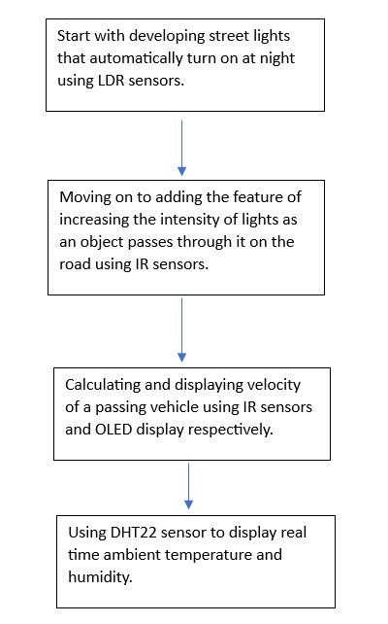

1. 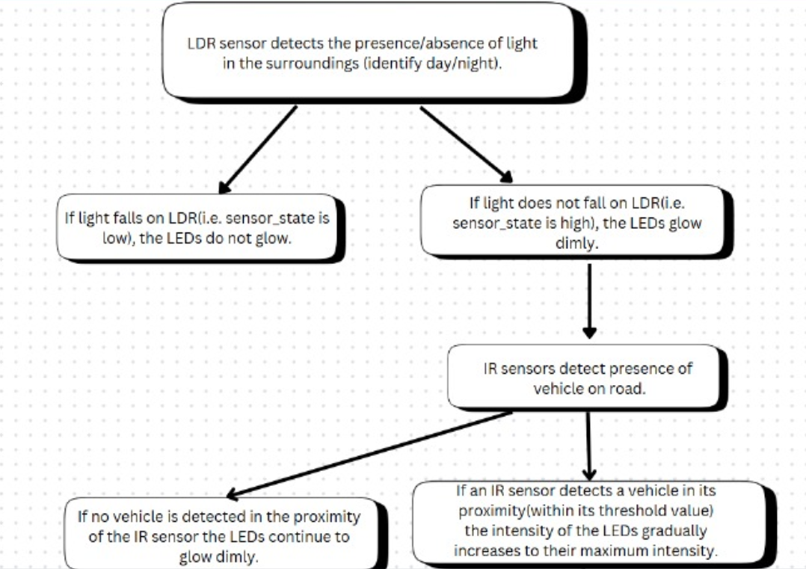**Flowchart :**

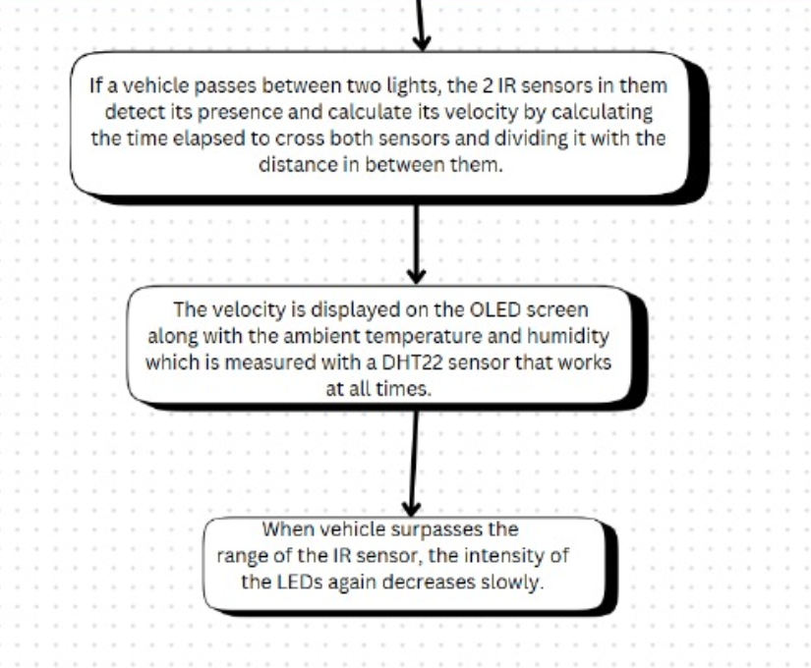



1. **Description of the Project :**

The Smart Street Light System is designed to improve energy efficiency, enhance urban safety, and provide real-time environmental data. By utilizing sensors and microcontrollers, the system dynamically adjusts street light brightness, monitors traffic velocity, and collects atmospheric parameters.

Below is a detailed explanation of the project and the components used:

**Components and Sensors Used:**

1. **LDR Sensor (Light Dependent Resistor)**:
   * **Purpose**: Detect ambient light levels to control when the street lights are turned on or off.
   * **Functionality**: The LDR sensor measures the intensity of ambient light. During the day or in bright conditions, the lights remain off to conserve energy. The system automatically switches the lights on only during low-light conditions or at night.
2. **IR Sensors**:
   * **Purpose**: Detect objects so that to make the brightness of street lights vary and measure vehicle velocity.
   * **Functionality**:

* One IR sensor is used to detect the presence of an object within a predefined range. If an object is detected, the street light transitions from dim to maximum brightness gradually . When the object leaves the range, the light dims back.
* Two IR sensors placed at a fixed distance calculate the velocity of a passing object. The time taken by the object to move from one sensor to the other is measured, and velocity is calculated using the formula: Velocity=Distance/Time .​ The calculated velocity is displayed in real-time on an OLED screen.

1. **DHT22 Sensor**:
   * **Purpose**: Measure atmospheric temperature and humidity.
   * **Functionality**: The DHT22 sensor captures real-time temperature and humidity data, which is then displayed on the OLED screen. This information is valuable for environmental monitoring and smart city data collection.
2. **OLED Display**:
   * **Purpose**: Display real-time data including object velocity, temperature, and humidity.
   * **Functionality**: Acts as the user interface for the system, providing visual feedback on the measured parameters.

**Working of the Project:**

1. **Day/Night Control**:  
   The LDR sensor monitors ambient light levels. During daylight or well-lit conditions, the system ensures that the street lights remain off. At night or in low-light conditions, the lights are activated as per the object detection system to further enhance energy efficiency.
2. **Object Detection and Adaptive Lighting**:  
   When an object enters the range of the IR sensor, the corresponding street light transitions from dim to maximum brightness. Once the object leaves the range, the light automatically dims back to conserve energy. This ensures that energy is used efficiently by only providing maximum brightness when needed.
3. **Velocity Measurement**:  
   Two IR sensors are strategically placed at a fixed distance along the road. When a vehicle or object passes the first sensor, the system starts a timer. The timer stops when the object passes the second sensor. Using the time recorded and the known distance between the sensors, the system calculates the velocity and displays it on the OLED screen.
4. **Environmental Monitoring**:  
   The DHT22 sensor continuously measures temperature and humidity in the surrounding environment. This data is displayed on the OLED, providing real-time insights into atmospheric conditions.

This Smart Street Light System integrates intelligent sensors and automation to create a sustainable, efficient, and technologically advanced solution for modern urban infrastructure.

1. **Results :**

The Smart Street Light System effectively addresses the limitations of traditional street lighting systems and demonstrates significant advantages in terms of energy efficiency, environmental monitoring, and adaptability.

**Traditional Solutions vs. Our Smart System**

1. **Traditional Solution: Constant Illumination**
   * **Drawbacks**:
     + Street lights remain fully illuminated regardless of traffic or environmental conditions, leading to significant energy wastage.
     + No mechanism to adjust brightness based on the presence of vehicles or pedestrians.
   * **Our Smart System Advantage**:
     + Uses IR sensors to detect objects and dynamically adjust brightness, transitioning from dim to maximum only when an object is detected. This reduces energy consumption significantly in low-traffic areas.
     + The automation ensures efficient use of energy without manual intervention.
2. **Traditional Solution: No Day/Night Detection**
   * **Drawbacks**:
     + Lights are often left on during the day due to human error or lack of automation, resulting in unnecessary power usage.
   * **Our Smart System Advantage**:
     + Employs an LDR sensor to automatically detect ambient light levels, ensuring the lights turn on only during darkness or at night, eliminating energy wastage during the day.
3. **Traditional Solution: Absence of Real-Time Traffic Monitoring**
   * **Drawbacks**:

Most of these systems are limited to specific points or stretches of the road and may not cover the entire area. Some methods rely on the physical presence of law enforcement, which can be costly and labor-intensive. Installation and maintenance of systems like inductive loops or piezoelectric sensors, LIDAR, VASCAR, Radar guns, speed cameras can be expensive and may require road closures.

* + **Our Smart System Advantage**:
    - Two IR sensors are used to measure the velocity of passing vehicles in real time, providing valuable data for urban traffic management and improving safety and helps in detecting overspeeding too.

1. **Traditional Solution: No Environmental Monitoring**
   * **Drawbacks**:
     + Conventional systems do not track atmospheric parameters like temperature or humidity, which could aid in environmental awareness and smart city initiatives.
   * **Our Smart System Advantage**:
     + Integrates a DHT22 sensor to measure temperature and humidity, providing real-time environmental data that can inform city planners and support sustainability efforts.

**Why Our Solution is Better**

* **Energy Savings**: By incorporating adaptive brightness and day/night detection, our system minimizes energy wastage compared to traditional lights that operate at full brightness continuously.
* **Automation**: Fully automated processes eliminate human error and the need for manual operation, ensuring efficient functioning in all conditions.
* **Cost-Effectiveness**: The use of affordable sensors like IR, LDR, and DHT22 provides a low-cost solution that is scalable and easy to implement.
* **Real-Time Data**: The system offers real-time insights into traffic velocity and environmental conditions, enabling better decision-making for urban infrastructure management.
* **Sustainability**: The system’s energy-efficient design and ability to monitor environmental parameters align with sustainable development goals.

The results of our project clearly show that our Smart Street Light System is a significant improvement over traditional solutions, offering enhanced efficiency, functionality, and environmental consciousness. This innovative approach supports smarter, greener, and more sustainable urban living.

1. **Simulation and Short Video Demonstration :**

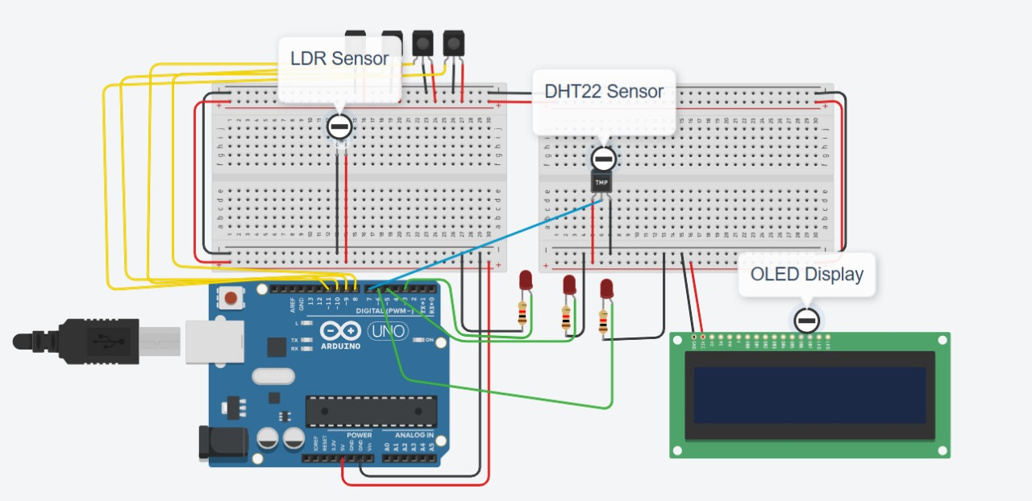

Simulation

**DEMO VIDEO LINK :** https://drive.google.com/file/d/1FF5M0IkyRN5rVpdPyWMpBaaGRxR-NNi9/view?usp=sharing

1. **Photos :**

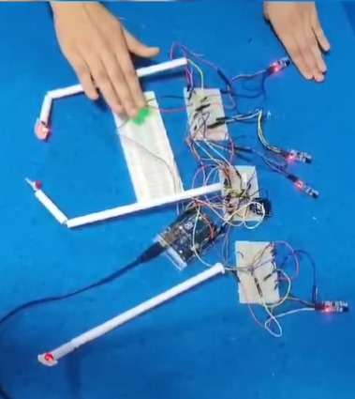

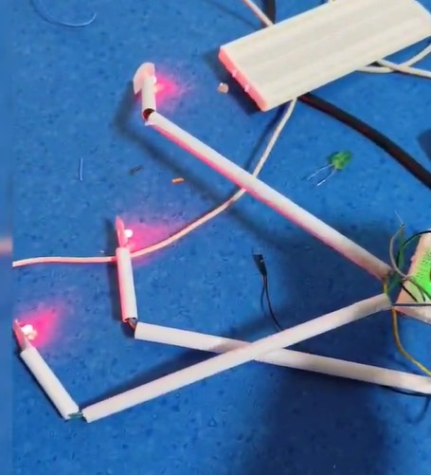

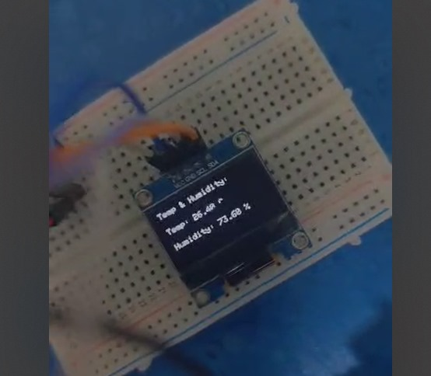

1. **BIBLIOGRAPHY**
   * [**https://youtu.be/xQfC72VeV7Y?si=dQpDRnbdeWiXfb1G**](https://youtu.be/xQfC72VeV7Y?si=dQpDRnbdeWiXfb1G)
   * [**https://youtu.be/N_sWjcKR1Nw?si=IKpCycVWp4eJ3Gxa**](https://youtu.be/N_sWjcKR1Nw?si=IKpCycVWp4eJ3Gxa)
   * [**https://youtu.be/7Wyw7jbHURM?si=PgzJga4APjZee8xJ**](https://youtu.be/7Wyw7jbHURM?si=PgzJga4APjZee8xJ)
   * [**https://youtu.be/fjVbcaKW2r0?si=HbBlG6mdrG0bgG2w**](https://youtu.be/fjVbcaKW2r0?si=HbBlG6mdrG0bgG2w)
   * [**https://medium.com/@karkhanaclub/interfacing-oled-display-using-arduino-6d3fed2bd648**](https://medium.com/@karkhanaclub/interfacing-oled-display-using-arduino-6d3fed2bd648)
   * [**https://docs.arduino.cc/libraries/adafruit-unified-sensor/**](https://docs.arduino.cc/libraries/adafruit-unified-sensor/)
   * [**https://electronoobs.com/eng_arduino_Adafruit_Sensor.php**](https://electronoobs.com/eng_arduino_Adafruit_Sensor.php)
   * [**https://youtu.be/xQfC72VeV7Y?si=dQpDRnbdeWiXfb1G**](https://youtu.be/xQfC72VeV7Y?si=dQpDRnbdeWiXfb1G)
   * [**https://youtu.be/7Wyw7jbHURM?si=unxlJZwJVvWTRsoD**](https://youtu.be/7Wyw7jbHURM?si=unxlJZwJVvWTRsoD)
   * [**https://youtu.be/fjVbcaKW2r0?si=UO1zU-bg-s566O2-**](https://youtu.be/fjVbcaKW2r0?si=UO1zU-bg-s566O2-)