Course: CSE302 Computer Organization and Architecture
Group Project: Design a five-cycle non-pipelined RISC processor using Verilog HDL

- Your task is to design a five-cycle non-pipelined RISC processor using Verilog HDL, for the new instruction set and instruction format given in this document
  - You may use the Logisim based processor design provided in the class only as the reference for basic understanding purposes. (The Instruction set for this Verilog processor implementation, is very different from the Logisim processor, though most fundamentals/thought process remains the same)
- Note, in the Verilog HDL design of the processor, all FFs (DFF based modules or clk based memory) will have Reset
- Precisely follow the names of the Verilog modules and their ports given here.

Let me know, in case you notice any errors or misprints.

Instruction Set

Instruction Format (total 32-bits)
OPCODE [31:24] | Destination [23:20] | Source-1 [19:16] | Source-2 [15:12] | IMM [11:0]  Used as:  - ADDR = 12-bit direct address for DataMemory OR  12-bit direct address for Jump instructions  - IMM [3:0] used as Source-3 (for reading R_{S3})  - IMM[7:0] used as Immediate-Data (referred to as IMMDATA)  - IMM [3:0] used as the address for Input and Output Ports (referred to as ADDR4)

Timing Phases: Typical (IF/ID/EX/MEM/WB)
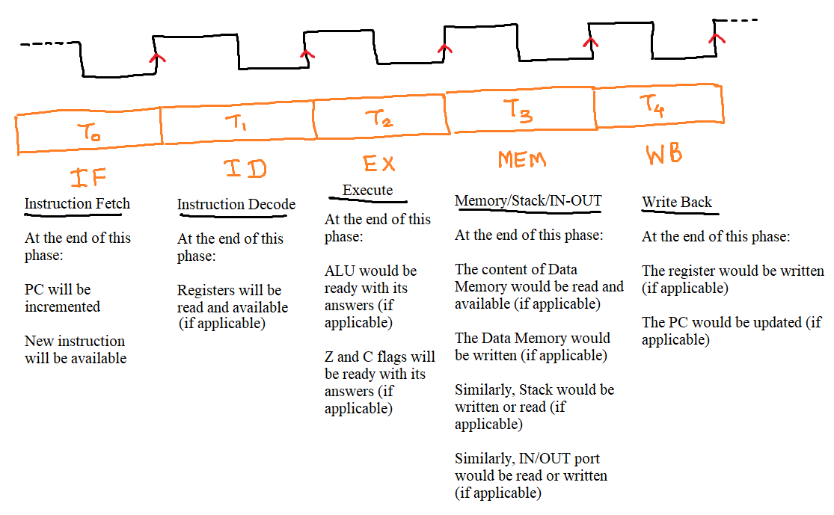
Acronyms:
- IMMDATA = IMM[7:0]
- ADDR = IMM[11:0]
- XP = X-Pointer (12-bits) = {R_{S1}[3:0], R_{S2}[7:0]}
- For finding R_{S3}, the Source-3 = IMM[3:0]
- ADDR4 = IMM[3:0]

OPCODE | Mnemonic | Flags affected
00H | NOP | None
01H | ADD R_{D} ← R_{S1} + R_{S2} | C, Z
02H | ADDI R_{D} ← R_{S1} + IMMDATA | C, Z
03H | ADDC R_{D} ← R_{S1} + R_{S2} + C | C, Z
04H | SUB R_{D} ← R_{S1} + 1’sComp(R_{S2}) + 1 | C, Z
05H | SUBI R_{D} ← R_{S1} + 1’sComp(IMMDATA) + 1 | C, Z
06H | SUBC R_{D} ← R_{S1} + 1’sComp(R_{S2}) + C | C, Z
07H | CMP R_{S1} + 1’sComp(R_{S2}) + 1 | C, Z
08H | CMPI R_{S1} + 1’sComp(IMMDATA) + 1 | C, Z
09H | AND R_{D} ← R_{S1} & R_{S2} | Z
0AH | ANDI R_{D} ← R_{S1} & IMMDATA | Z
0BH | OR R_{D} ← R_{S1} | R_{S2} | Z
0CH | ORI R_{D} ← R_{S1} | IMMDATA | Z
0DH | EXOR R_{D} ← R_{S1} ^ R_{S2} | Z
0EH | EXORI R_{D} ← R_{S1} ^ IMMDATA | Z
0FH | INC R_{D} ← R_{S1} + 01H | Z
10H | DEC R_{D} ← R_{S1} + 1’sComp(01H) + 1 | Z
11H | MOVI R_{D} ← IMMDATA
12H | MOV R_{D} ← R_{S1}
13H | MOVF R_{D} ← {C, 6’b00000, Z}
14H | LOAD R_{D} ← M[ADDR]
15H | LOADI R_{D} ← M[XP]
16H | STORE M[ADDR] ← R_{S1}
17H | STOREI M[XP] ← R_{S3}
18H | LRS R_{D}[7:0] ← {1’b0, R_{S1}[7:1]} (logical shift right by 1-bit) | C = R_{S1}[0], Z
19H | ARS R_{D}[7:0] ← {R_{S1}[7], R_{S1}[7:1]} (arithmetic shift right by 1-bit) | C = R_{S1}[0], Z
1AH | LLS R_{D}[7:0] ← {R_{S1}[6:0],1’b0} (logical shift left by 1-bit) | C = R_{S1}[7], Z
1BH | ROTR R_{D}[7:0] ← {R_{S1}[0], R_{S1}[7:1]} (rotate right by 1-bit) | C = R_{S1}[0], Z
1CH | ROTL R_{D}[7:0] ← {R_{S1}[6:0], R_{S1}[7]} (rotate left by 1-bit) | C = R_{S1}[7], Z
1DH | ROTRC {C, R_{D}[7:0]} ← {R_{S1}[0], C, R_{S1}[7:1]} (rotate right with C by 1-bit) | C = R_{S1}[0], Z
1EH | ROTLC {C, R_{D}[7:0]} ← {R_{S1}[7:0], C} (rotate left with C by 1-bit) | C = R_{S1}[7], Z
1FH | JMPZ ADDR
20H | JMPNZ ADDR
21H | JMPC ADDR
22H | JMPNC ADDR
23H | CALL ADDR
24H | RET
25H | PUSH Stack ← R_{S1}
26H | POP R_{D} ← Stack
27H | unsignedMULT {Stack, R_{D}}← R_{S1} x R_{S2}  (lower-order byte written in WB to RD)  (higher-order byte written to Stack in MEM)  The programmer may in subsequent instruction POP to a register the high-order byte of the answer
28H | IN R_{D} ← PORT[ADDR4]  Input ports have address 0H, 1H, 2H, 3H
29H | OUT PORT[ADDR4] ← R_{S1}  Output ports have address 8H, 9H, AH, BH
2AH | JMP ADDR (unconditional jump)

Notes:
- There are 16 registers, R₀ to R₁₅, each register is 8-bits
- ALU is 8-bits; There are two operands, and each operand is 8-bits
- Address bus for Instruction memory is 12-bits
- Address bus for Data memory is 12-bits
- The internal address bus (and mechanism of SP) of Stack is 8-bits
- The Address bus for I/O ports are 4-bits
- At many places, in your design you will need very large MUXs (because your Opcode is 8-bits) ☹, examples:
  - MUX256_to1_1bit for each control signal
  - MUX256_to1_8bit for operands selection MUXs, to the left of the ALU
  - MUX256_to1_8bit for answer selection MUX inside ALU
  - MUX256_to1_12bit for selecting the address for DataMemory (SRAM4096) or for the ProgramCounter
  - For your reference and understanding, the Verilog design of such large MUXs (including large 8to256 decoder) can be found on:
    - https://edaplayground.com/x/9evy
    - https://edaplayground.com/x/727U
    - https://edaplayground.com/x/abub

- Create processor.v file with the following module
Module Name | Inputs | Outputs | Comments
RISCprocessor | clk  Reset  [7:0] InpExtWorld1  [7:0] InpExtWorld2  [7:0] InpExtWorld3  [7:0] InpExtWorld4 | [7:0] OutExtWorld1  [7:0] OutExtWorld2  [7:0] OutExtWorld3  [7:0] OutExtWorld4 | (Overall Structural coding)  There will be several modules instantiated within this module;  Some important instances are mentioned below:  RegisterFile  InstMEM4096  SRAM4096  Stack256  ALU8  TimingGen  ProgCounter  INport  OUTport  ControlLogic  & some MUX32to1_8bit

- Create subcomponents.v file with the following modules [Any smaller modules not mention in the table below, will have to be created by you – that is implicit]
Module Name | Inputs | Outputs | Comments/Guidance
eightbitRegwithLoad | Clk  Reset  load  [7:0] Datain | [7:0] Dataout | Code already available with you in Lab5  Remember that, this module can also be converted to (or used as) an 8-bit FF by simply passing 1’b1 to load when instantiating it in another module
RegisterFile | Clk  Reset  RegFileRead  RegFileWrite  [7:0] Datain  [3:0] Source1  [3:0] Source2  [3:0] Source3  [3:0] Destin | [7:0] Dataout1  [7:0] Dataout2  [7:0] Dataout3 | Structural coding preferred, with some important instances:  16 instances of eightbitRegwithLoad  1 instance of Decoder4to16_withE  3 instances of MUX16to1_8bit  3 instances of eightbitRegwithLoad  Dataout3 used for STOREI instruction
InstMEM4096 | Clk  Reset  [11:0] Address  InstRead | [31:0] Dataout  [7:0] Opcode  [3:0] Destin  [3:0] Source1  [3:0] Source2  [3:0] Source3  [11:0] ADDR  [7:0] ImmData  [3:0] ADDR4 | (Behavioral coding)  The memory variable would be declared as:  reg [31:0] instmemory [0:4095]  Use initial block and $readmemb to load your assembly language program (instructions in binary format)
SRAM256 | Clk  Reset  [7:0] Address  SRAMRead  SRAMWrite  [7:0] Datain | [7:0] Dataout | (Behavioral coding)  The memory variable would be declared as:  reg [7:0] datamemsmall [0:255]
SRAM4096 | Clk  Reset  [11:0] Address  SRAMRead  SRAMWrite  [7:0] Datain | [7:0] Dataout | (Behavioral coding)  The memory variable would be declared as:  reg [7:0] datamemlarge [0:4095]
Stack256 | Clk  Reset  StackRead  StackWrite  [7:0] Datain | [7:0] Dataout | Partial structural coding, with the following important instances:  1 instance of SRAM256  2 instances of MUX4to1_8bit  And some more instances of relevant modules to create the stack pointer/counter logic
ALU8 | Clk  Reset  [7:0] Operand1  [7:0] Operand2  [7:0] Opcode  ALUSave  ZflagSave  CflagSave | Zflag  Cflag  [7:0] ALUout  [7:0] ALUout2 | Any style  ALUout2 used for storing the high-order byte during UMULT instruction
TimingGen | Clk  Reset | T0  T1  T2  T3  T4 | Any style
ProgCounter | Clk  Reset  PCenable  PCupdate  [11:0] Address | [11:0] PC | Any style
INport | Clk  Reset  INportRead  [7:0] InpExtWorld1  [7:0] InpExtWorld2  [7:0] InpExtWorld3  [7:0] InpExtWorld4  [3:0] Address | [7:0] Dataout | Any style
OUTport | Clk  Reset  [3:0] Address  [7:0] Datain  OUTportWrite | [7:0] OutExtWorld1  [7:0] OutExtWorld2  [7:0] OutExtWorld3  [7:0] OutExtWorld4 | Any style
ControlLogic | Clk  Reset  T1  T2  T3  T4  Zflag  Cflag  [7:0] Opcode | PCupdate  SRAMRead  SRAMWrite  StackRead  StackWrite  ALUSave  ZflagSave  CflagSave  INportRead  OUTportWrite  RegFileRead  RegFileWrite | Any style

- Each group will prepare one powerpoint based presentation (worth 10 minutes), and present their work using the projector in Lab, as per the slots (to be announced) on the dates (already in the list of lab sessions) in April 2026.
  - Each person of the group will have to speak.
  - It will be the responsibility of the group to check beforehand (1-2 days in advance) the appropriate connection (display settings and any adapters needed) of their laptop for the presentation.
- Each group will submit the following files by Monday 6-April-2026:
  - subcomponents.v
  - processor.v
  - The text file containing their assembly language code (in binary format)
    - (corresponding) hand-written assembly language code that was tested
  - Powerpoint presentation

The end

