A CASE-STUDY BASED REPORT
ON
Hospital Readmission Prediction Using Elastic Net Regularized Logistic Regression
submitted in partial fulfilment of the requirements for the Course
MACHINE LEARNING
BACHELOR OF TECHNOLOGY
in
A.Y.: 2026-27
by
Uppalapati Moksha Ratna 2500031613
Sinde Vedhanth 252003004
Vootla Hemanth 2520030025
Under the Esteemed guidance of
MR.GADDAM RAVINDRA BABU
Project Guide, CSE Department




INDEX
Abstract
Introduction
Background
Motivation for the Project
Overview of the Work Carried Out
Scope and Responsible-Use Statement
Problem Statement
Case-Study Scenario
Central Case-Study Question
Formal Problem Definition
Objectives that Guide the Study
Assumptions and Limitations
Dataset and Exploratory Data Analysis
About the Dataset
Purpose of EDA
Preparation Steps Actually Performed
EDA Exploration - Implementation
Summary of EDA Findings
Algorithm Selection and Implementation

Conclusion

Signature of the Team members

Abstract
Hospital readmission increases healthcare costs and places pressure on hospital resources. This case study investigates Elastic Net regularized Logistic Regression to predict whether a hospital encounter will be followed by readmission within 30 days. It uses the UCI Diabetes 130-US Hospitals dataset with 101,766 encounters. After cleaning, 43 columns were retained. The target is encoded as 1 for readmission within 30 days and 0 for readmission after 30 days or no readmission. The compact patient-facing model uses 12 features. Reported performance is 67.78% accuracy, 17.16% precision, 49.32% recall, 25.46% F1-score, and 64.25% ROC-AUC. The model is integrated into a React frontend, FastAPI backend, and SQLite database for academic demonstration. It is not intended for clinical decision-making.

1. Introduction

1.1 Background
Hospital readmission is an important healthcare analytics problem because repeated hospital stays can increase costs, consume hospital resources, and indicate a need for follow-up. Machine learning can identify patterns in historical encounter data and estimate the likelihood of readmission. This case study focuses on diabetes-related hospital encounters and readmission within 30 days.

1.2 Motivation for the Project
The project explores a regularized and relatively interpretable classification model and connects it to a hospital-style web application. Elastic Net combines L1 and L2 penalties, balancing sparse feature selection with coefficient stability when predictors are correlated.

1.3 Overview of the Work Carried Out
The work includes dataset inspection, missing-value treatment, removal of selected columns, binary target preparation, exploratory data analysis, model evaluation, and integration into a React/FastAPI/SQLite application. EDA plots include target distribution, readmission rate by age, boxplots, admission-type comparison, correlation heatmap, and scatter plot.

1.4 Scope and Responsible-Use Statement
This is an academic case study using historical data. It is not clinically validated and must not be used to diagnose, treat, discharge, or prioritize real patients. The compact model does not use blood group or symptoms as predictive inputs because they are not part of its trained feature set.

2. Problem Statement

2.1 Case-Study Scenario
A hospital analytics team wants to study whether information recorded during a hospital encounter can help identify encounters associated with readmission within 30 days. Historical data is used to build and evaluate a binary classifier and demonstrate the result through a web interface.

2.2 Central Case-Study Question
Can Elastic Net regularized Logistic Regression use a compact set of demographic, admission, medication, and prior-utilization features to distinguish encounters followed by readmission within 30 days?

2.3 Formal Problem Definition
Let each encounter be represented by feature vector x. The target y is 1 when the dataset label is '<30' and 0 when it is '>30' or 'NO'. The model estimates P(y=1|x). The dataset contains 11,357 positive encounters and 90,409 negative encounters, so the positive class is approximately 11.16%.

2.4 Objectives that Guide the Study
• Inspect and clean the UCI Diabetes 130-US Hospitals dataset.
• Prepare the binary readmission target and compact model features.
• Use EDA to examine class balance and relationships among selected variables.
• Train an Elastic Net regularized Logistic Regression classifier.
• Evaluate using accuracy, precision, recall, F1-score, ROC-AUC, and a confusion matrix.
• Integrate the model into an academic React/FastAPI/SQLite demonstration.

2.5 Assumptions and Limitations
The target is readmission within 30 days versus later/no readmission. The dataset may not represent current or other hospital populations. Class imbalance affects interpretation of accuracy and precision. The compact patient-facing feature set is smaller than the original dataset feature set. Results are for academic demonstration.

3. Dataset and Exploratory Data Analysis

3.1 About the Dataset
The UCI Diabetes 130-US Hospitals dataset contains 101,766 encounters. The cleaned workbook contains 43 retained columns. The target distribution is 90,409 class-0 encounters and 11,357 class-1 encounters, a positive rate of approximately 11.16%. Features cover demographics, admission, hospital stay, procedures, medications, diagnoses, and previous outpatient, emergency, and inpatient utilization.

3.2 Purpose of EDA
EDA examines target imbalance, compares numerical variables across readmission classes, explores admission-type differences, and assesses correlations among selected numerical features. These plots are descriptive and do not establish causal relationships.

3.3 Preparation Steps Actually Performed
• Converted '?' markers into missing values.
• Removed encounter_id and patient_nbr identifiers.
• Removed weight due to very high missingness and payer_code/medical_specialty due to high missingness.
• Removed examide and citoglipton because they had no useful variation.
• Filled categorical missing values with Unknown and median-imputed numerical missing values.
• Checked duplicates; the cleaned dataset has zero duplicate rows.
• Encoded <30 as 1 and >30/NO as 0.
• Retained 101,766 rows while reducing the original 50 CSV columns to 43 cleaned columns.

3.4 EDA Exploration – Implementation
The following figures were generated from the cleaned dataset. They summarize class balance, feature distributions, and relationships among selected variables.
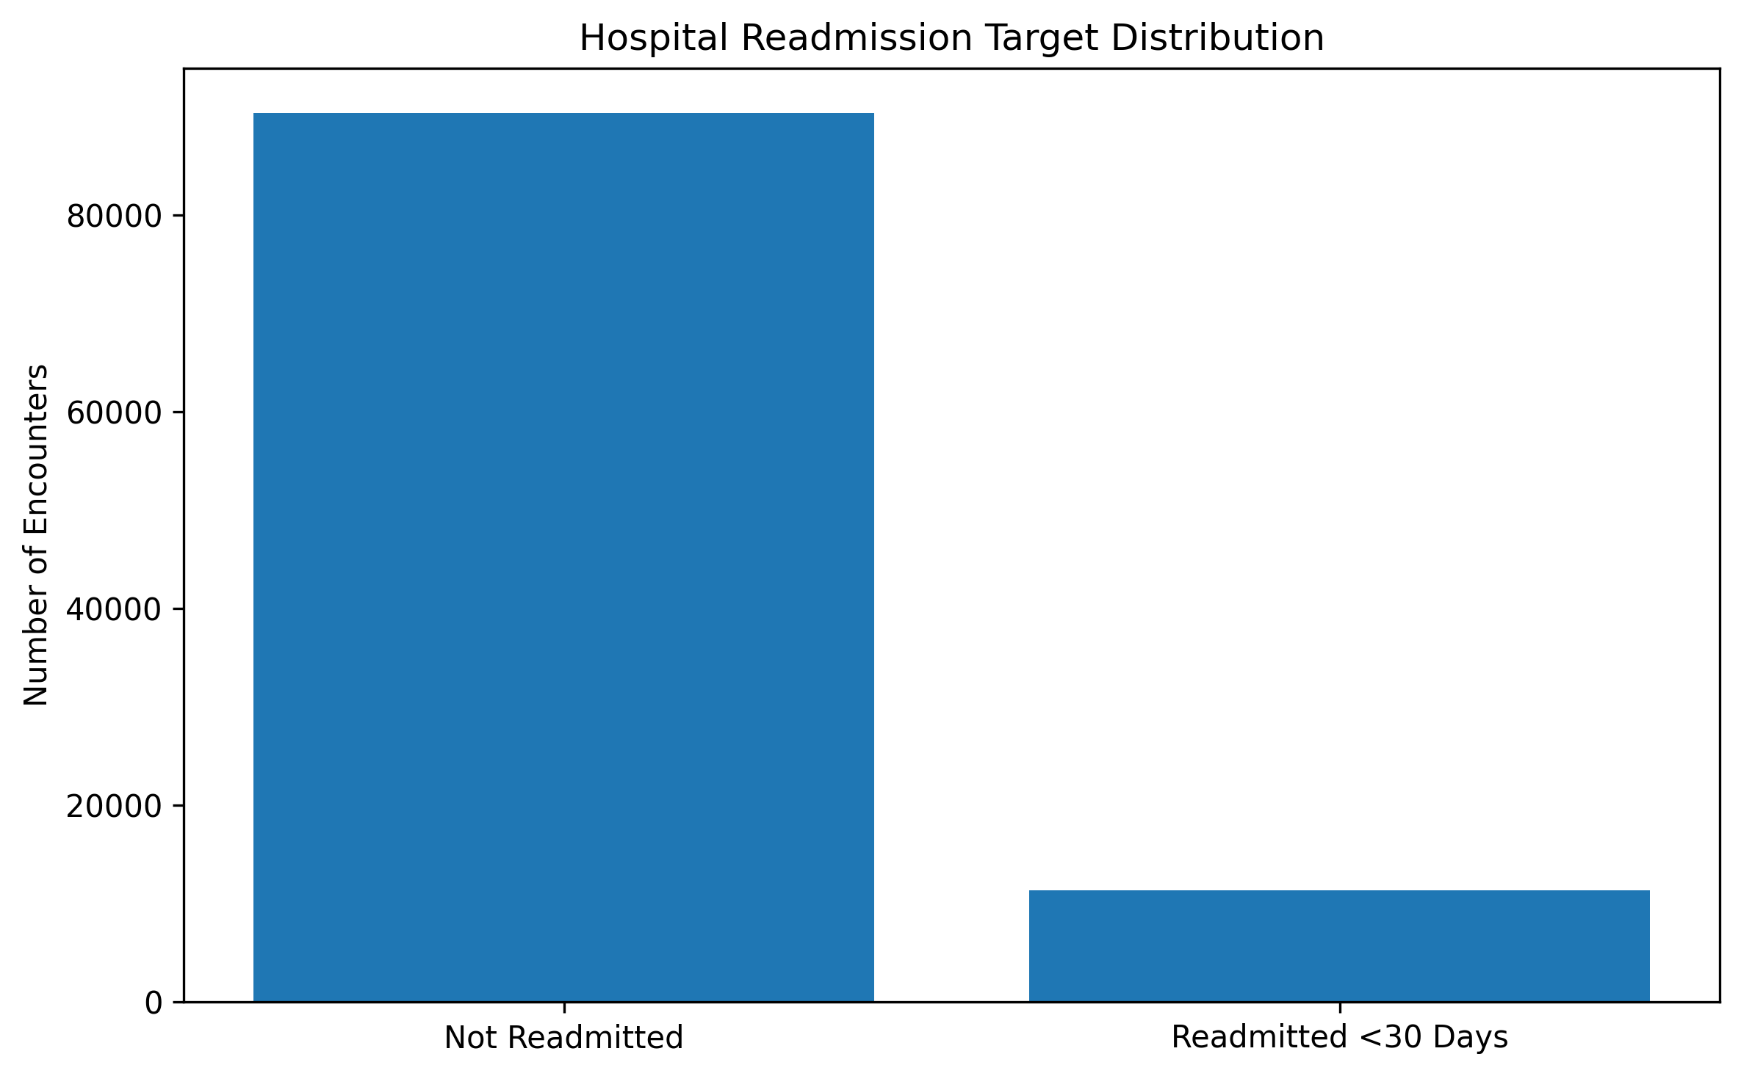
Figure 1. Target class distribution
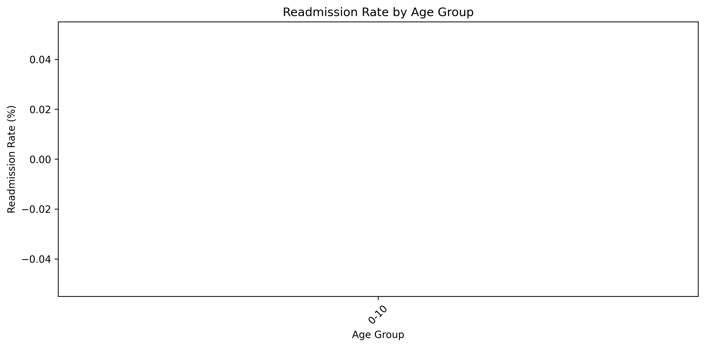
Figure 2. Readmission rate by age group
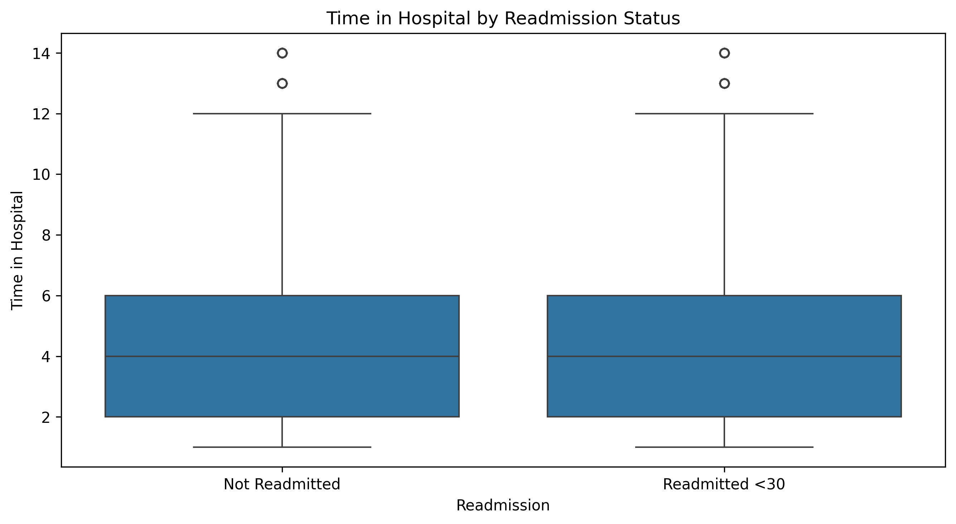
Figure 3. Time in hospital by readmission status
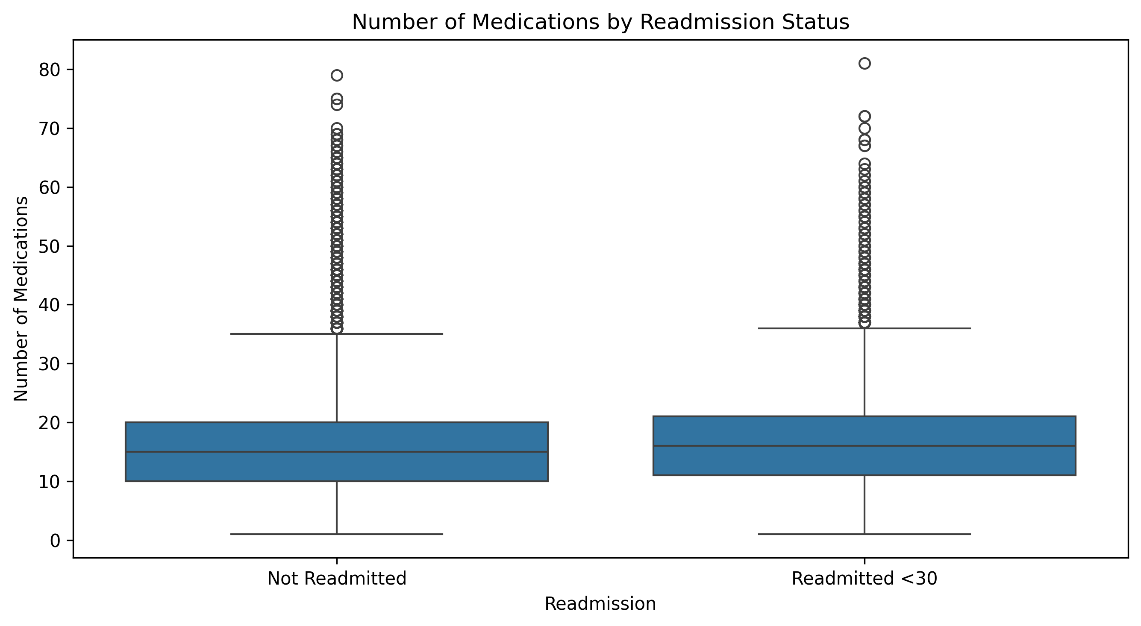
Figure 4. Number of medications by readmission status
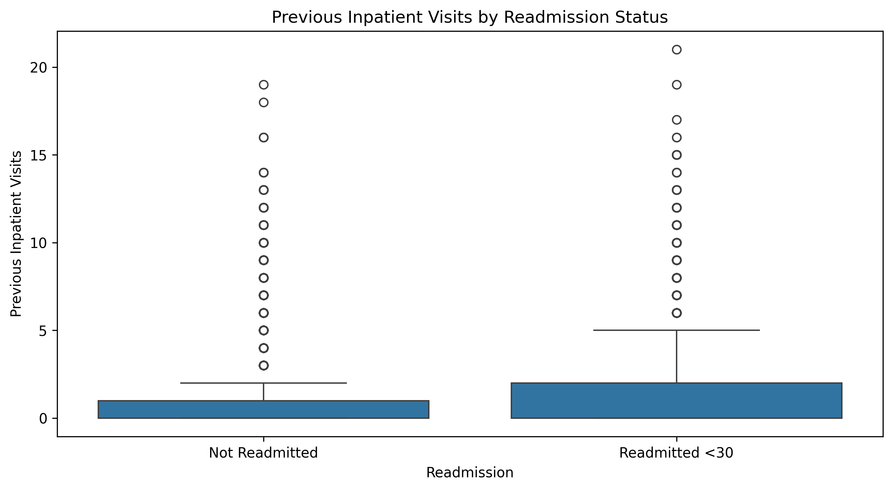
Figure 5. Previous inpatient visits by readmission status
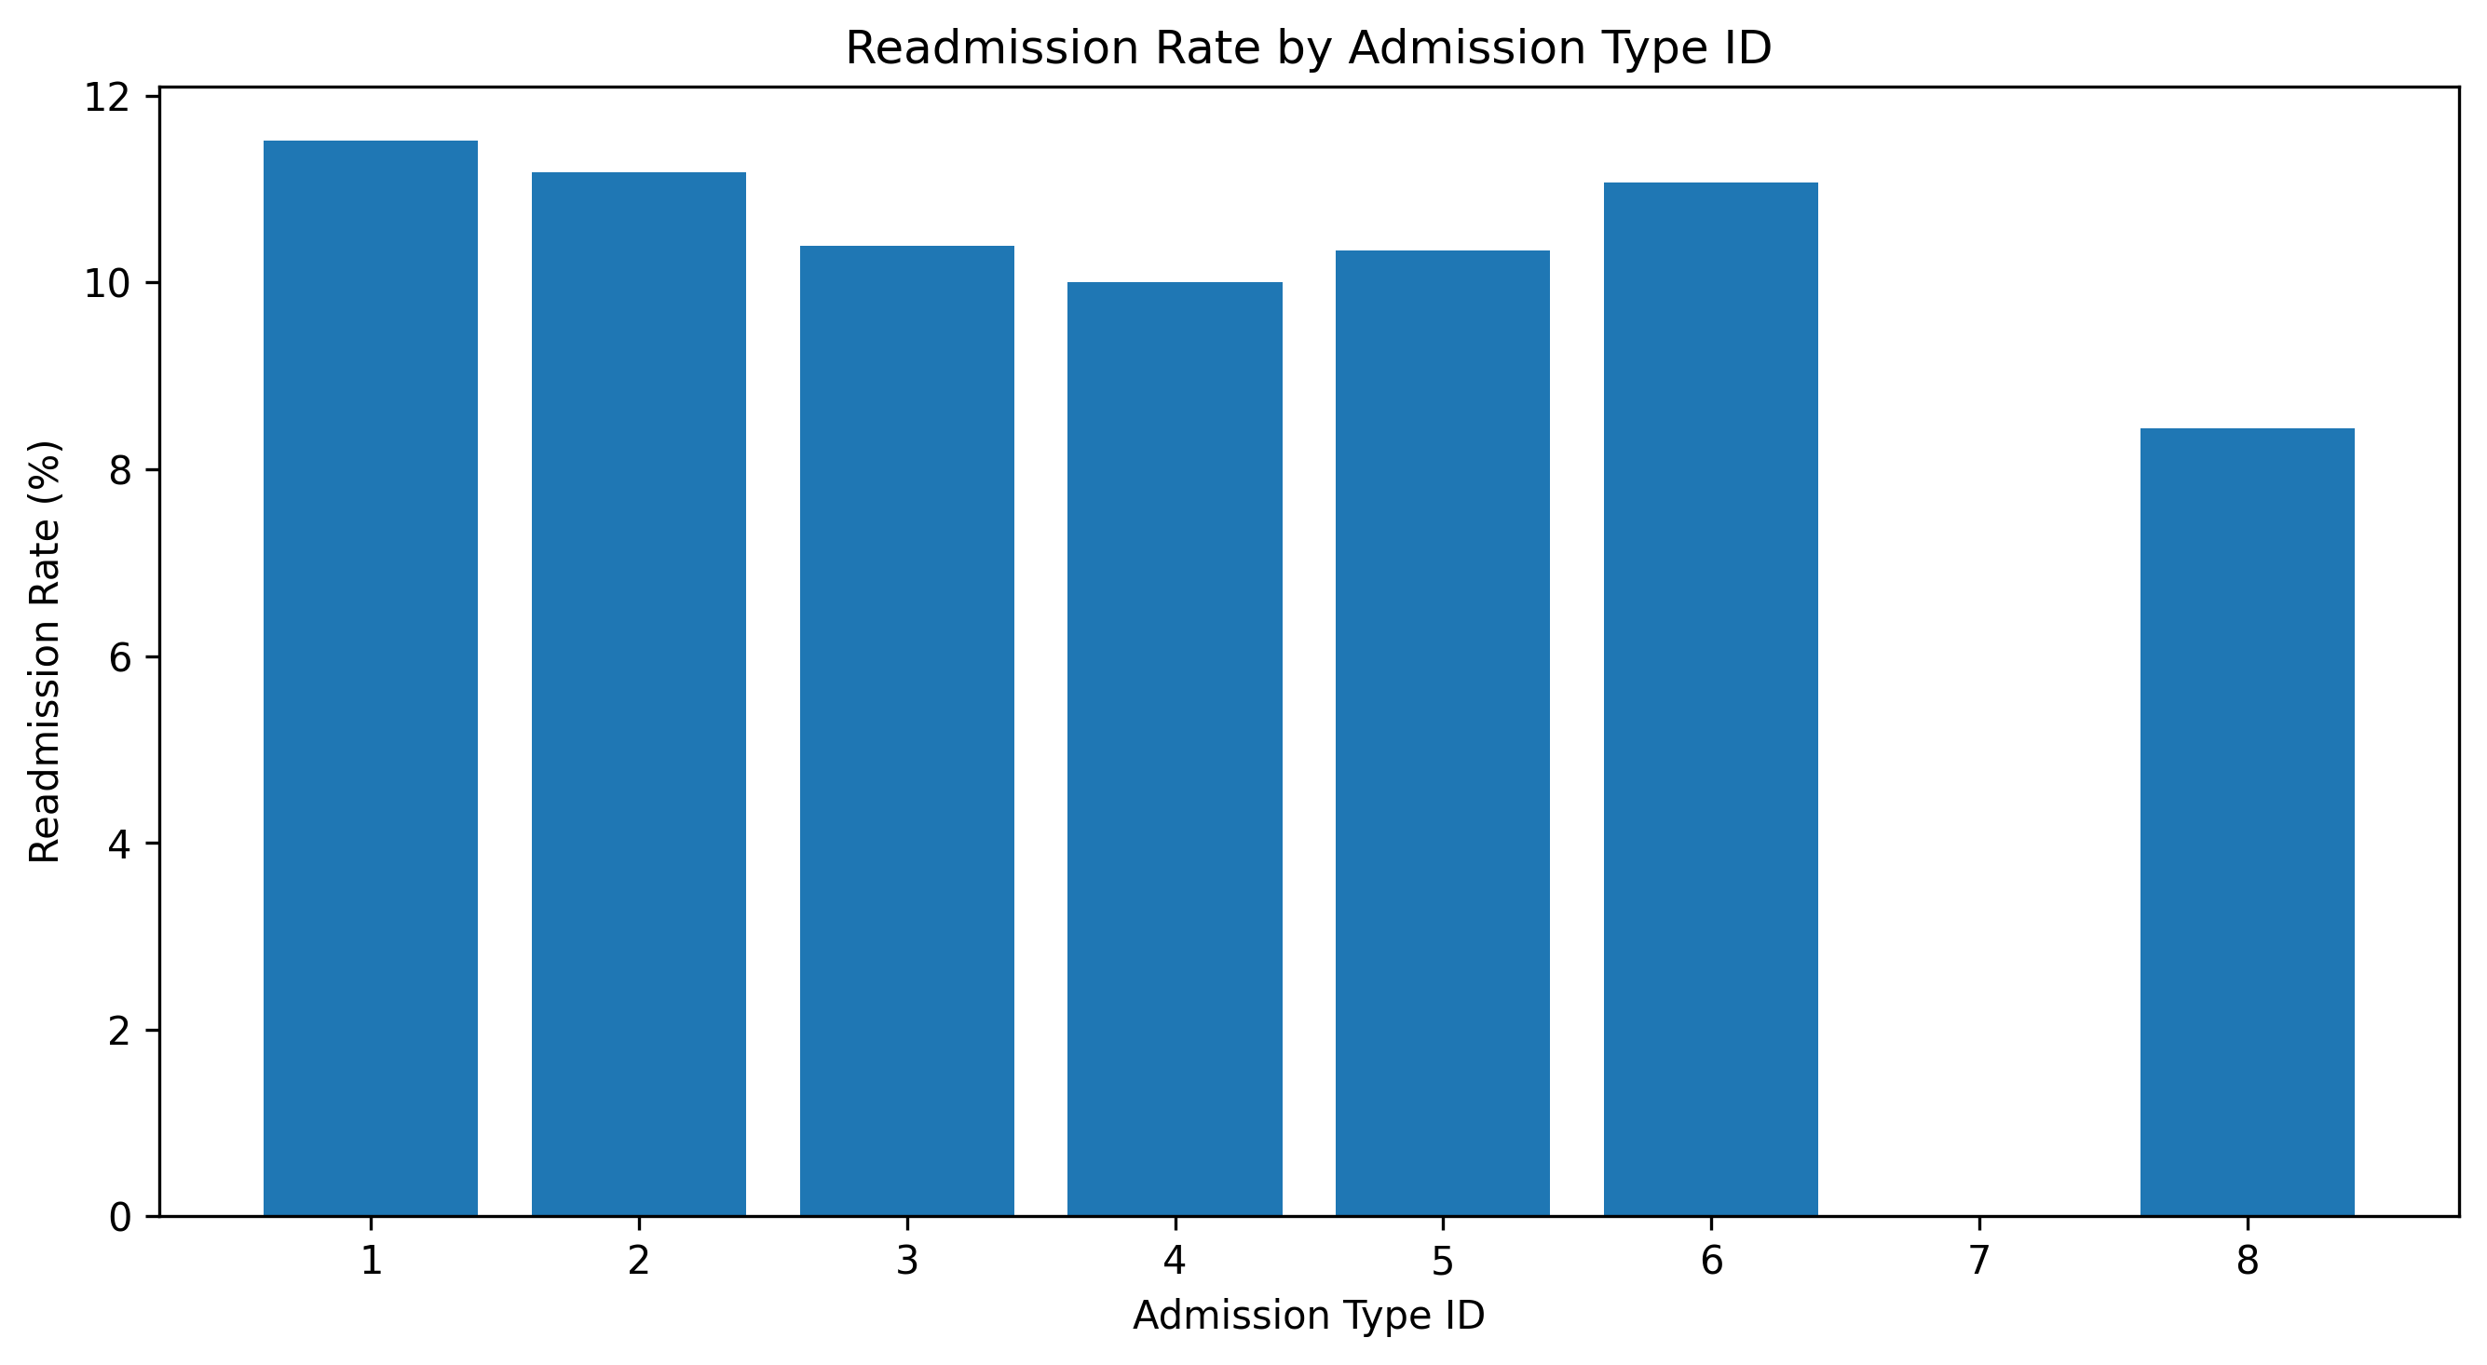
Figure 6. Readmission rate by admission type
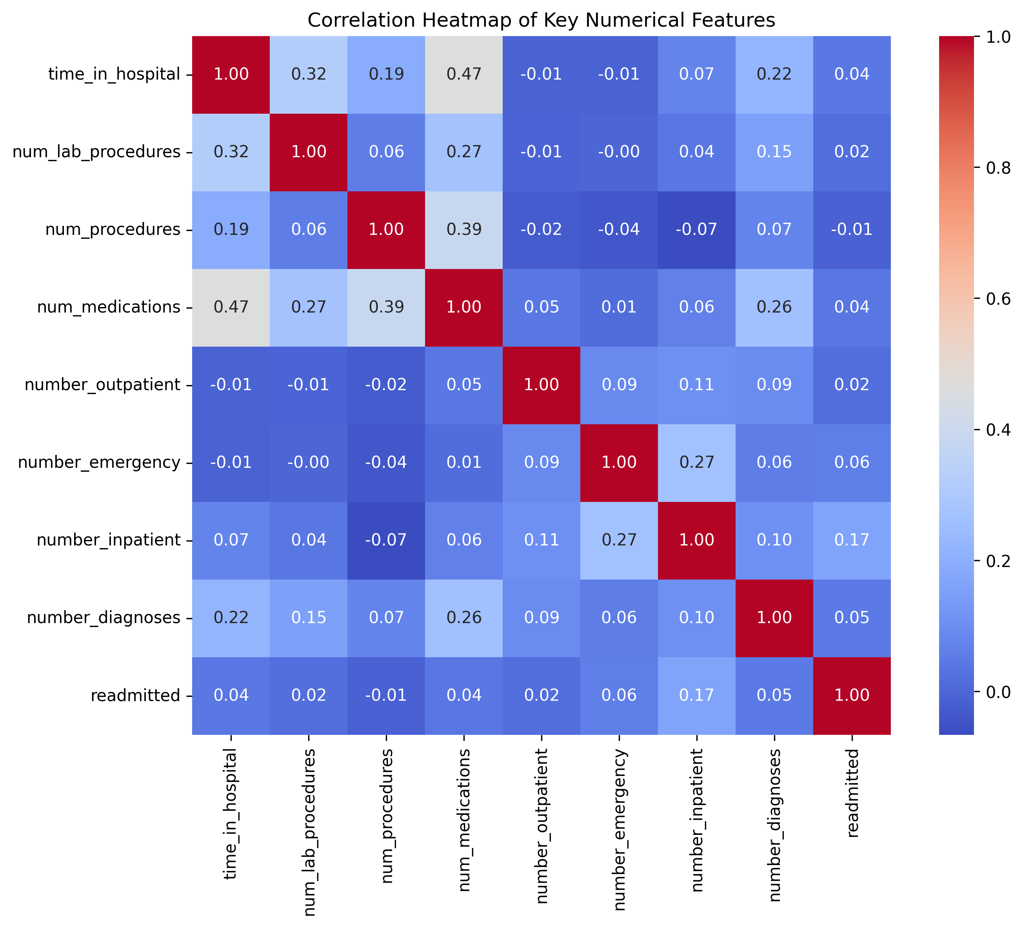
Figure 7. Correlation heatmap of key numerical features
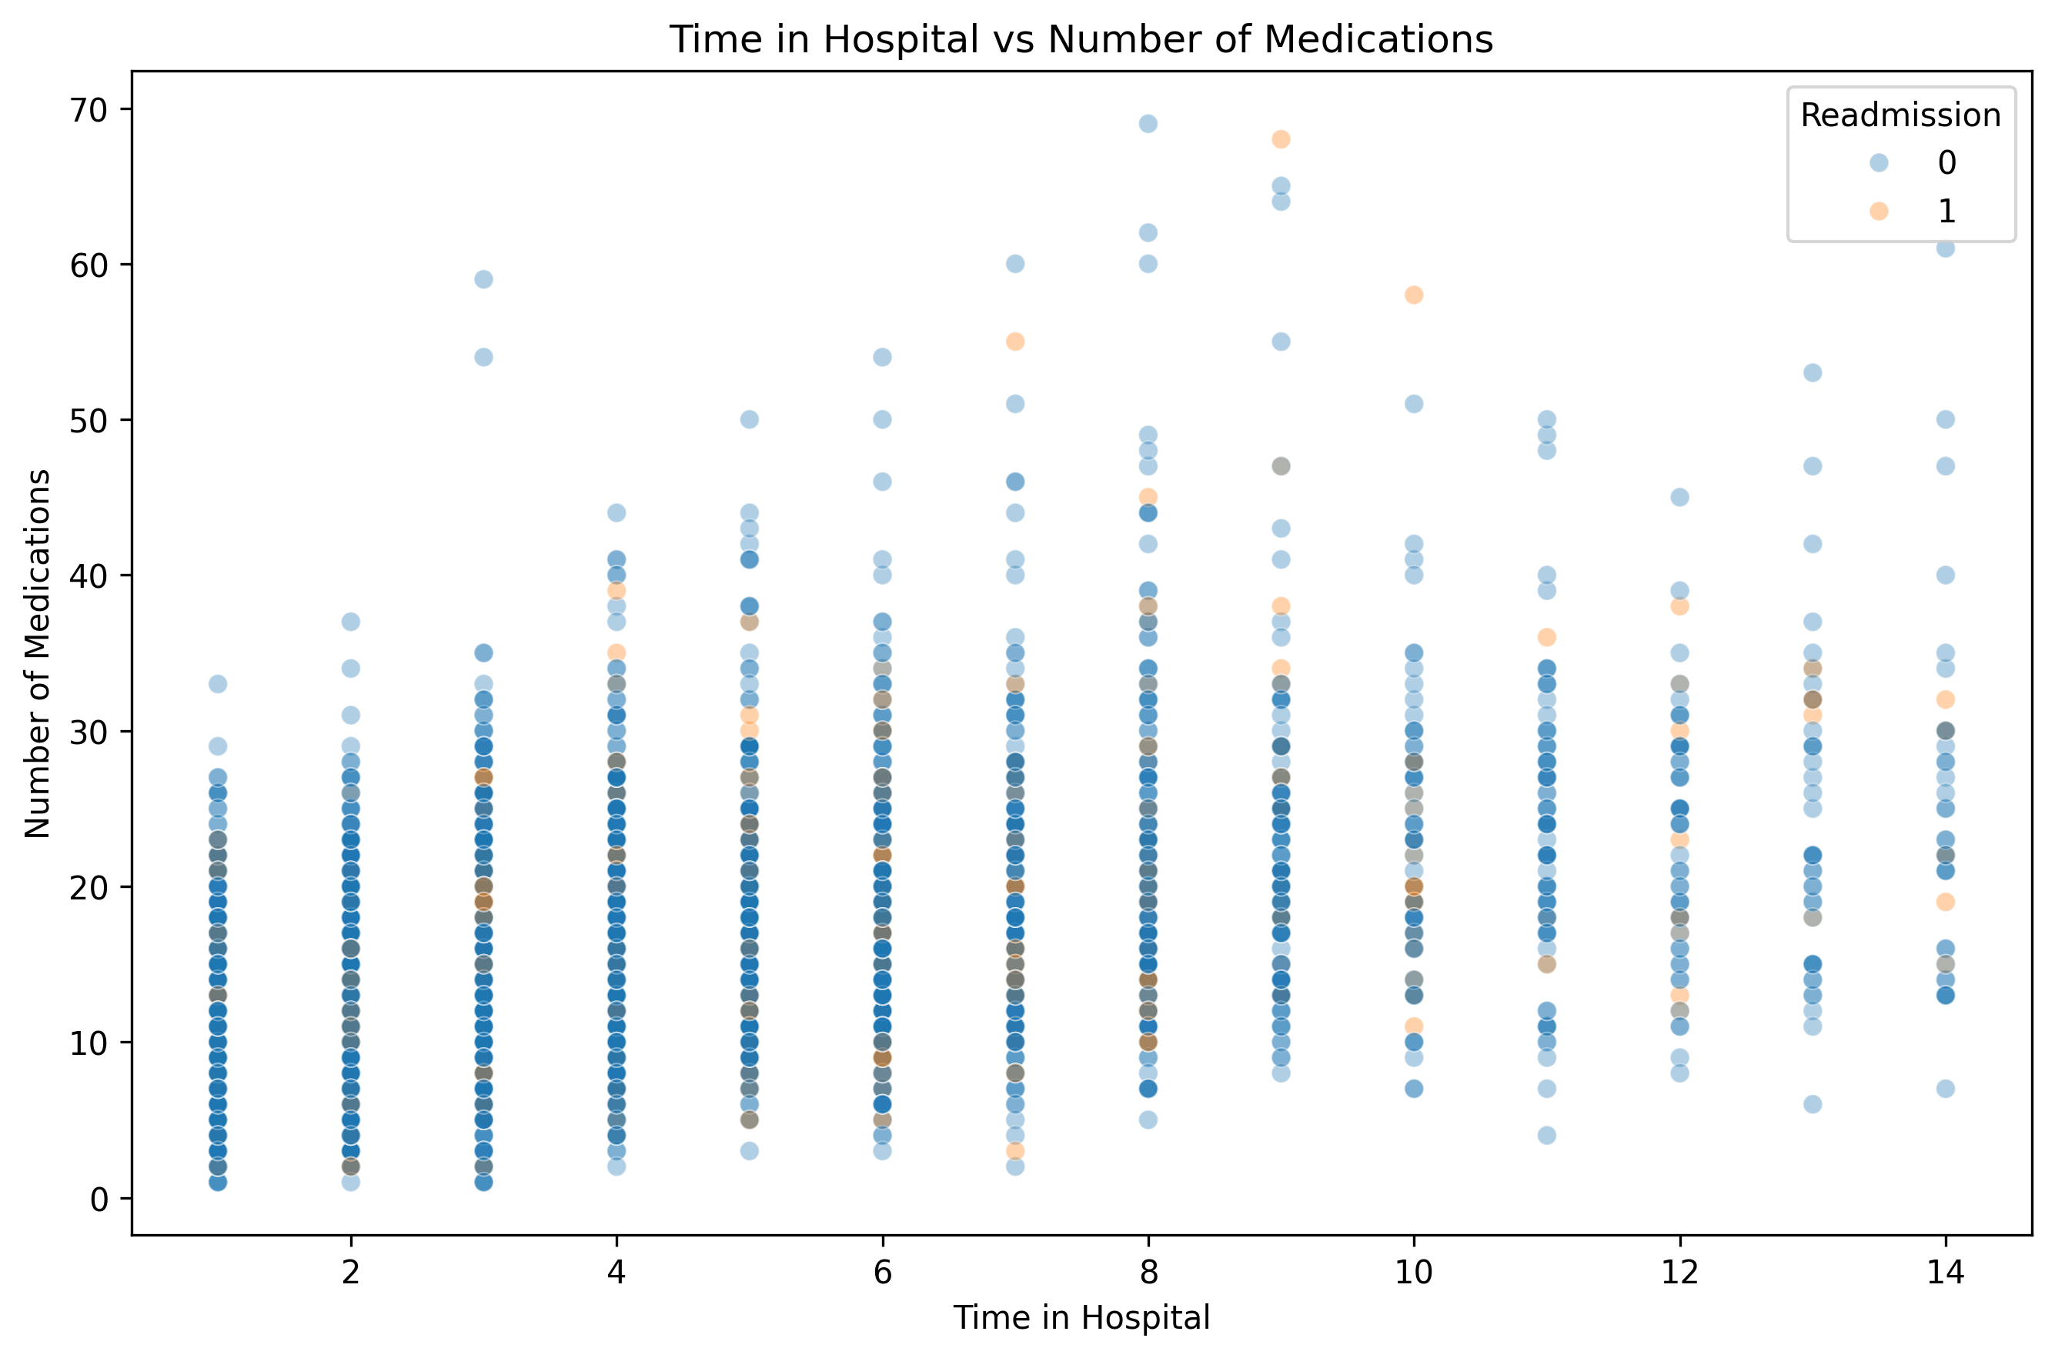
Figure 8. Time in hospital versus number of medications
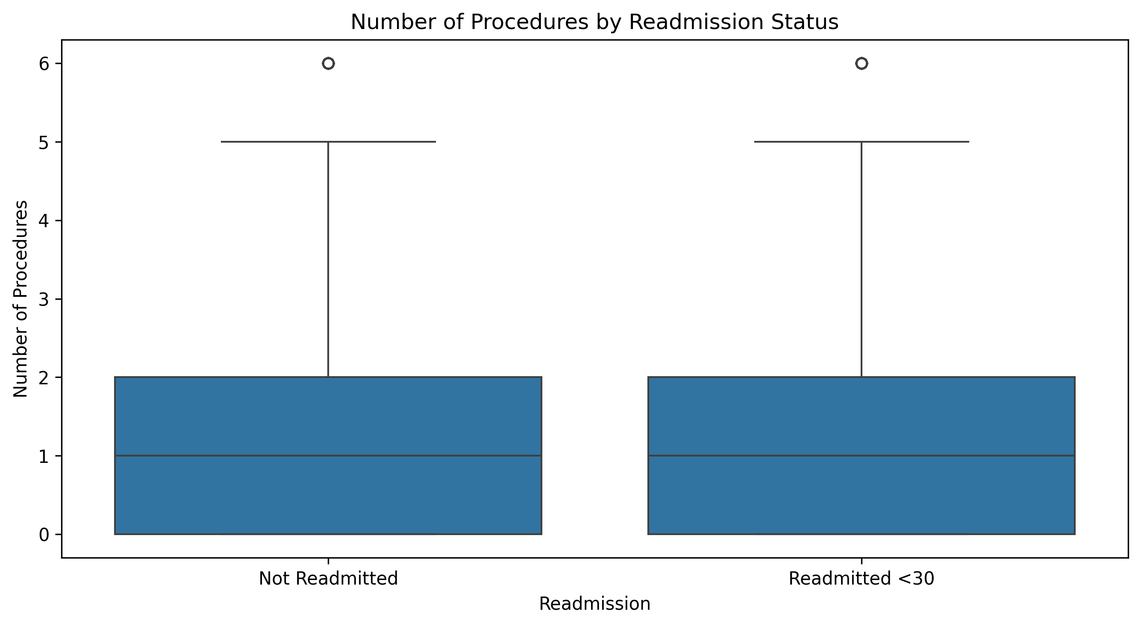
Figure 9. Number of procedures by readmission status
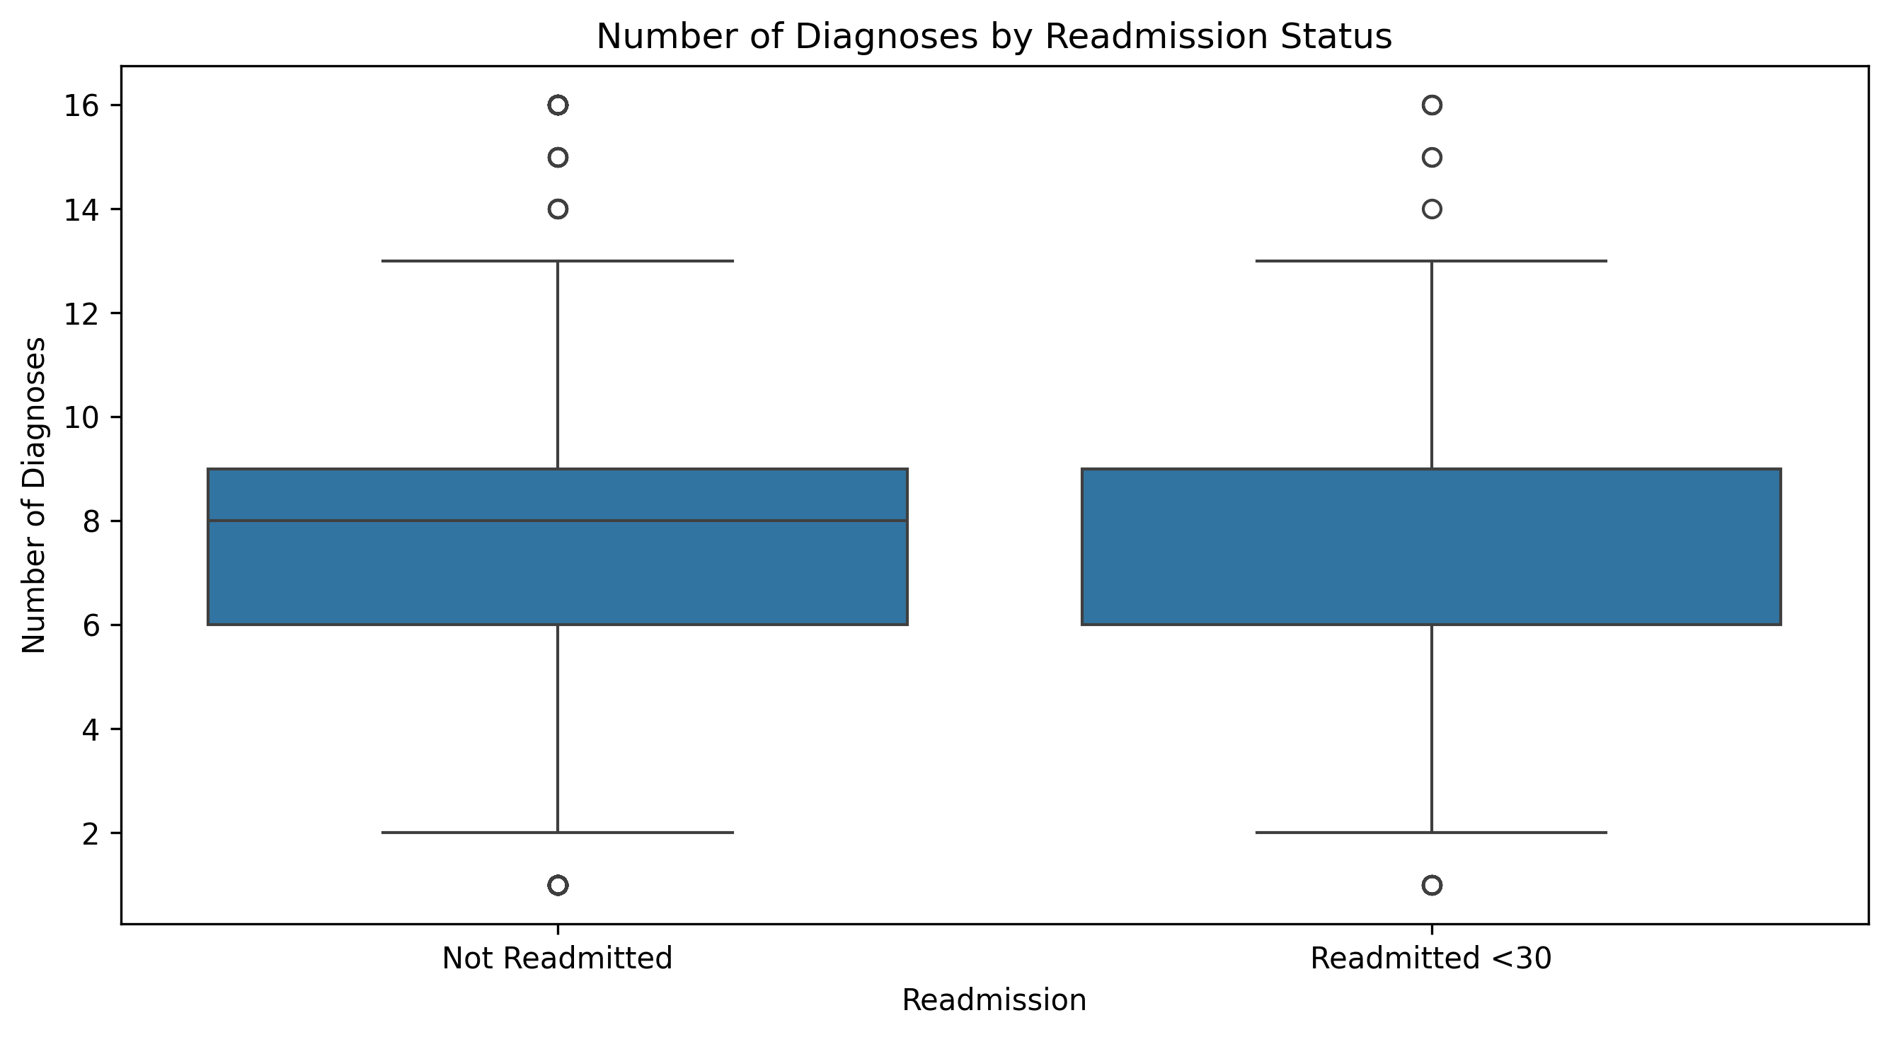
Figure 10. Number of diagnoses by readmission status

3.5 Summary of EDA Findings
The target is imbalanced: approximately 11.16% of encounters are readmitted within 30 days. Boxplots and the admission-type chart compare the distributions and rates of selected variables. The correlation heatmap summarizes linear relationships among numeric variables; correlation does not imply causation.

4. Algorithm Selection and Implementation

4.1 Why Elastic Net Logistic Regression
Logistic Regression is suitable for a binary target and estimates class probabilities. Elastic Net combines L1 and L2 penalties. L1 can shrink less useful coefficients toward zero, while L2 can improve coefficient stability when predictors are correlated. This provides a comparatively interpretable baseline.

4.2 Model Configuration and Features
The configuration uses C = 0.05, l1_ratio = 0.20, penalty = elasticnet, solver = saga, and class_weight = balanced. The 12 model features are age_group, gender, admission_type, diabetes_medication, insulin, time_in_hospital, num_diagnoses, num_medications, num_procedures, previous_visits, previous_emergency_visits, and previous_outpatient_visits.

4.3 Evaluation Results
The reported metrics are accuracy 67.78%, precision 17.16%, recall 49.32%, F1-score 25.46%, and ROC-AUC 64.25%. The confusion matrix contains TN = 12,676, FP = 5,407, FN = 1,151, and TP = 1,120. The relatively low precision indicates many predicted positives are false positives; recall indicates that the model identifies about half of positive cases at the evaluated threshold.

5. Conclusion
This case study demonstrates a workflow from data cleaning and EDA to Elastic Net Logistic Regression evaluation and web-application integration. The model achieved 64.25% ROC-AUC and 49.32% recall, while precision remained low at 17.16%. The results show that the task is challenging and further validation is required. The implementation is intended for academic use only.

References
1. UCI Machine Learning Repository. Diabetes 130-US Hospitals for Years 1999–2008.
2. Zou, H., & Hastie, T. (2005). Regularization and variable selection via the elastic net. Journal of the Royal Statistical Society: Series B, 67(2), 301–320.
3. Gao, X. et al. (2023). Interpretable machine learning models for hospital readmission prediction: a two-step extracted regression tree approach. BMC Medical Informatics and Decision Making, 23, 104. https://doi.org/10.1186/s12911-023-02193-5
4. Yu, M.-Y., & Son, Y.-J. (2024). Machine learning-based 30-day readmission prediction models for patients with heart failure: a systematic review. European Journal of Cardiovascular Nursing, 23(7), 711–719. https://doi.org/10.1093/eurjcn/zvae031

Team Members' Signatures
Uppalapati Moksha Ratna — 2500031613: ______________________________
Sinde Vedhanth — 252003004: ______________________________
Vootla Hemanth — 2520030025: ______________________________

