
Product Search and Recommendation System for Shopping
A Project Report Submitted in partial fulfillment of the requirements for the award of the degree of
BACHELOR OF TECHNOLOGY
in
DEPARTMENT OF COMPUTER SCIENCE ENGINEERING
Data Structures and Algorithms - 3 (25CS2103E)
by
K. Akshitha – 2520030233
T. Meghana – 2520030245
U. Moksha – 2500031613
Under the Guidance of
Dr. V. Sireesha
Professor, Department of Computer Science and Engineering
Koneru Lakshmaiah Education Foundation
Off-Campus: Bachupally-Gandimaisamma Road, Bowrampet, Hyderabad, Telangana – 500 043
2026-27
DEPARTMENT OF COMPUTER SCIENCE ENGINEERING
DECLARATION
We hereby declare that the project report entitled “Product Search and Recommendation System for Shopping” is a record of the bona fide work carried out by K. Akshitha – 2520030233, T. Meghana – 2520030245, and U. Moksha – 2500031613 in partial fulfillment of the requirements for the award of the degree of Bachelor of Technology in Computer Science Engineering during the academic year 2026-27.
The work presented in this report focuses on the practical application of Data Structures and Algorithms to an e-commerce style product-search and recommendation problem. The implementation uses a file-based Java architecture and does not depend on a SQL database.
K. Akshitha – 2520030233
T. Meghana – 2520030245
U. Moksha – 2500031613

DEPARTMENT OF COMPUTER SCIENCE ENGINEERING
CERTIFICATE
This is to certify that the mini-project based report entitled “Product Search and Recommendation System for Shopping” is a bona fide work done and submitted by K. Akshitha – 2520030233, T. Meghana – 2520030245, and U. Moksha – 2500031613 in partial fulfillment of the requirements for the award of the degree of Bachelor of Technology in Computer Science Engineering during the academic year 2026-27.
The project demonstrates the use of Data Structures and Algorithms including KMP string matching, Edit Distance using Dynamic Programming, Randomized QuickSort, a bounded Top-K min-heap, and HashMap-based indexing and persistence.
Signature of the Guide
(Dr. V. Sireesha) Signature of the HOD

ACKNOWLEDGEMENT
We express our sincere gratitude to our project guide, Dr. V. Sireesha, Professor, Department of Computer Science and Engineering, for her guidance, encouragement, and valuable suggestions throughout the development of this project. Her feedback helped us connect the theoretical concepts of Data Structures and Algorithms with a practical software application.
We also thank Dr. P. Venkateswara Rao, Associate Professor and HOD, Department of Computer Science and Engineering, for providing the academic environment and support required to complete this work. We are grateful to the faculty members and our classmates who contributed suggestions during demonstrations and testing.
Finally, we thank our team members for their cooperation in design, implementation, testing, documentation, and presentation of the Product Search and Recommendation System.
K. Akshitha – 2520030233
T. Meghana – 2520030245
U. Moksha – 2500031613

ABSTRACT
The Product Search and Recommendation System for Shopping is a web-based application designed to help users locate products efficiently, compare seller offers, and receive relevant recommendations. The project applies Data Structures and Algorithms directly to common e-commerce operations rather than relying on a database search engine or an external recommendation service. The implementation uses Java for the server and algorithmic logic, HTML/CSS/JavaScript for the browser interface, and CSV files for catalog and user-related persistence.
The search module uses Knuth-Morris-Pratt (KMP) pattern matching to find query words in product name, category, brand, and keyword text. When an exact search produces no result, Levenshtein Edit Distance implemented with Dynamic Programming is used to identify a nearby vocabulary word and retry the search, allowing typo correction such as “erbuds” to “earbuds”. Randomized QuickSort is used for price and rating sorting, while a bounded Top-K min-heap is used to retain high-scoring recommendations, cheaper alternatives, top deals, and search results without sorting the complete catalog. HashMaps provide average O(1) indexing for products, seller offers, user data, carts, wishlists, and sessions.
The current project dataset contains 2,000 products and 5,752 seller offers. The implementation was tested using a Java algorithm demonstration that verified KMP matching, Edit Distance correction distance, seller sorting, recommendation ranking, and top-deal selection. The project demonstrates how core DSA concepts can be integrated into a functional e-commerce workflow.

TABLE OF CONTENTS
Declaration
Certificate
Acknowledgement
Abstract
Table of Contents
List of Figures
1. Introduction
2. System Requirements
3. System Design
4. Implementation
5. Results
6. Conclusion and Future Work
References
Note: The Table of Contents can be updated in Microsoft Word using References → Update Table after the document is opened. Chapter numbering and headings follow the supplied project-documentation guidelines.

LIST OF FIGURES
Fig. 1.1 System Architecture
Fig. 3.1 High-Level System Architecture
Fig. 3.2 Search and Typo-Correction Flow
Fig. 3.3 Recommendation Scoring and Top-K Flow
Fig. 5.1 Algorithm Demonstration Summary

1. INTRODUCTION

1.1 Overview
Online shopping platforms contain large product catalogs, multiple seller offers, ratings, and different prices. A conventional product-search interface can become less useful when the catalog grows or when users enter incomplete or misspelled keywords. This project addresses that problem by building a shopping-style web application in which the search, sorting, seller comparison, recommendation, and ranking functions are implemented using explicit Data Structures and Algorithms.
The application follows a client-server model. The browser interface is implemented with HTML, CSS, and JavaScript, while a lightweight Java HTTP server handles requests and applies the DSA logic. Product and seller information is stored in CSV files. The supplied project README explicitly describes the system as file-based and states that there is no SQL database. The project contains 2,000 products and 5,752 seller offers.
The system provides product browsing, category filtering, search with typo correction, sorting, seller comparison, cheaper alternatives, recommendations, wishlist, cart, checkout, order history, registration, login, and logout. The implementation therefore demonstrates DSA concepts in an application that resembles a small e-commerce platform.
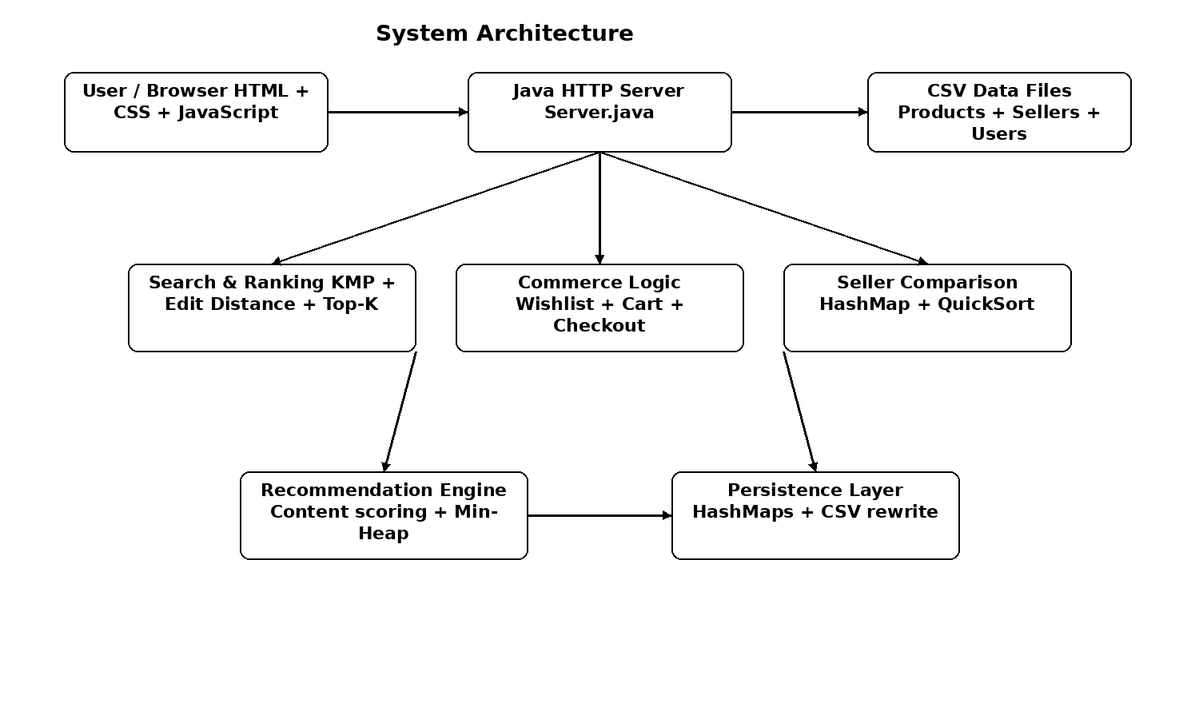
Fig. 1.1 System architecture of the Product Search and Recommendation System.

1.2 Problem Statement
Users searching a large shopping catalog need results that are relevant even when the query contains spelling errors or when several sellers offer the same product at different prices. Basic linear matching and complete sorting can become inefficient when repeated across a large catalog. The project therefore aims to design a product-search and recommendation system that uses appropriate DSA techniques for exact matching, typo correction, ranking, seller comparison, and recommendation generation.

1.3 Scope of the Project
- Search products by keywords across product name, category, brand, and keywords.
- Correct close spelling mistakes using Levenshtein Edit Distance and retry the search.
- Sort products by cheapest seller price, reverse price order, or product rating using Randomized QuickSort.
- Compare multiple sellers for the same product by price, rating, delivery time, stock, and descriptive tags.
- Generate content-based recommendations, cheaper alternatives, and top deals using scoring and a bounded Top-K min-heap.
- Provide user registration, login, wishlist, cart, checkout, simulated payment, and order-history functionality using CSV persistence.

1.4 Objectives
- Implement efficient pattern matching using KMP.
- Handle spelling mistakes using Dynamic Programming based Edit Distance.
- Use Randomized QuickSort for sorting product and seller offers.
- Use a Top-K min-heap to retain only the highest-scoring results.
- Use HashMaps for fast product, seller, user, session, cart, and wishlist access.
- Integrate the algorithms into a usable web-based shopping workflow.
- Evaluate the implementation with representative algorithm demonstrations and system-level functional checks.

2. SYSTEM REQUIREMENTS

2.1 Background and Existing Approaches
Existing product-search systems commonly use keyword matching, indexing, sorting, and recommendation methods to retrieve relevant products. For this academic project, the focus is not on reproducing a production search engine but on demonstrating how classical DSA algorithms can solve identifiable subproblems inside an e-commerce workflow. The project presentation identifies KMP, Z-Function, Rabin-Karp, Edit Distance, Suffix Arrays, and LCP as relevant string-processing techniques. The implemented code specifically uses KMP, Edit Distance, Randomized QuickSort, Top-K min-heap, and HashMap-based indexing.
The gap addressed by the project is therefore educational and practical: instead of treating product search as a black-box service, the application exposes the role of individual algorithms in search, correction, sorting, ranking, and recommendation. This provides a clear mapping between DSA theory and visible application behavior.

2.2 Functional Requirements
ID | Requirement | Description
FR1 | Product browsing | Display catalog products with category and pagination support.
FR2 | Keyword search | Find products using KMP across searchable product text.
FR3 | Typo correction | Use Edit Distance to correct close query words when exact search fails.
FR4 | Sorting | Sort by cheapest-seller price, descending price, or rating.
FR5 | Seller comparison | Display all seller offers for a product with price, rating, delivery and stock.
FR6 | Recommendations | Show similar products, cheaper alternatives, and top deals.
FR7 | User accounts | Register, login, logout, and maintain a session token.
FR8 | Wishlist and cart | Add/remove wishlist products and add/update seller-specific cart items.
FR9 | Checkout | Validate order information and support simulated UPI/card/COD flows.
FR10 | Orders | Persist and display order history.

2.3 Non-Functional Requirements
- Usability: the browser interface should make searching, comparison, recommendation, cart, and checkout understandable.
- Performance: search and ranking should use the intended DSA implementations rather than unnecessary full sorting.
- Maintainability: algorithmic logic is separated into Java classes such as KMP, EditDistance, RandomizedQuickSort, TopK, and RecommendationEngine.
- Portability: the project is designed for Java 8 or newer and can be started using the supplied Windows batch file, shell script, or direct javac/java commands.
- Data integrity: checkout prices are read from server-side seller data, and card numbers/CVV are not stored.
- Persistence: catalog, seller offers, users, wishlist, cart, and orders are represented through CSV files.

2.4 Hardware Requirements
Component | Minimum / Requirement
Computer/Laptop | Required
RAM | Minimum 4 GB
Internet connection | Required for normal web access/development environment

2.5 Software Requirements
Software | Use
Windows/Linux | Operating system
Java 8 or newer | Server and DSA implementation
HTML, CSS, JavaScript | Frontend
VS Code or similar IDE | Development
Web browser | User interface
Git/GitHub | Project version control

3. SYSTEM DESIGN

3.1 High-Level Architecture
The system is organized into a browser frontend, Java HTTP server, algorithmic modules, and CSV-backed persistence. The frontend sends HTTP requests to Java API routes. The server loads products and seller offers during startup and creates searchable text and a vocabulary for typo correction. User-specific state is held in HashMaps during execution and is rewritten to CSV files whenever it changes.
Fig. 3.1 High-Level System Architecture showing the browser, Java server, DSA modules, and CSV persistence.

3.2 Data Model and Files
File | Purpose | Important fields / content
data/products.csv | Product catalog | id, name, category, brand, price, rating, reviews, color, description, keywords, discount, image
data/sellers.csv | Seller offers | productId, seller, sellerRating, price, deliveryDays, stock
data/users.csv | User accounts | username, salt, password hash, display name
data/wishlist.csv | Wishlist state | username and product id
data/cart.csv | Cart state | username, product id, seller, quantity
data/orders.csv | Orders | order and item information in delimiter-separated form

3.3 DSA Components
Technique | Implementation | Purpose | Complexity
KMP | KMP.java / Server.runSearch | Exact pattern matching in product text | O(n + m) per text
Edit Distance DP | EditDistance.java / Server.correct | Typo correction and name similarity | O(nm) time, O(m) space
Randomized QuickSort | RandomizedQuickSort.java | Price/rating and seller-offer sorting | Expected O(n log n)
Top-K min-heap | TopK.java | Keep highest K scores without sorting all n | O(n log K)
HashMap | OfferStore.java / Store.java / Server.java | Fast indexing and user/session state | O(1) average lookup
Luhn checksum | Server.java | Card-number validation | O(d), d = digits

3.4 Search Design
At startup, the server builds a searchable string for each product by concatenating the product name, category, brand, and keywords in lowercase. The query is split into tokens. KMP checks whether each token occurs in the searchable text. A relevance score begins with the product rating and receives additional weight when a token appears in the product name or brand. A Top-K structure retains the best search results.
If an exact search produces no results, the system compares query tokens with the vocabulary using Edit Distance. A candidate correction is accepted only when its distance is sufficiently small relative to the token length. The corrected query is then searched again with KMP. If multiple tokens still fail to produce a complete match, a partial search can return products containing at least one token.
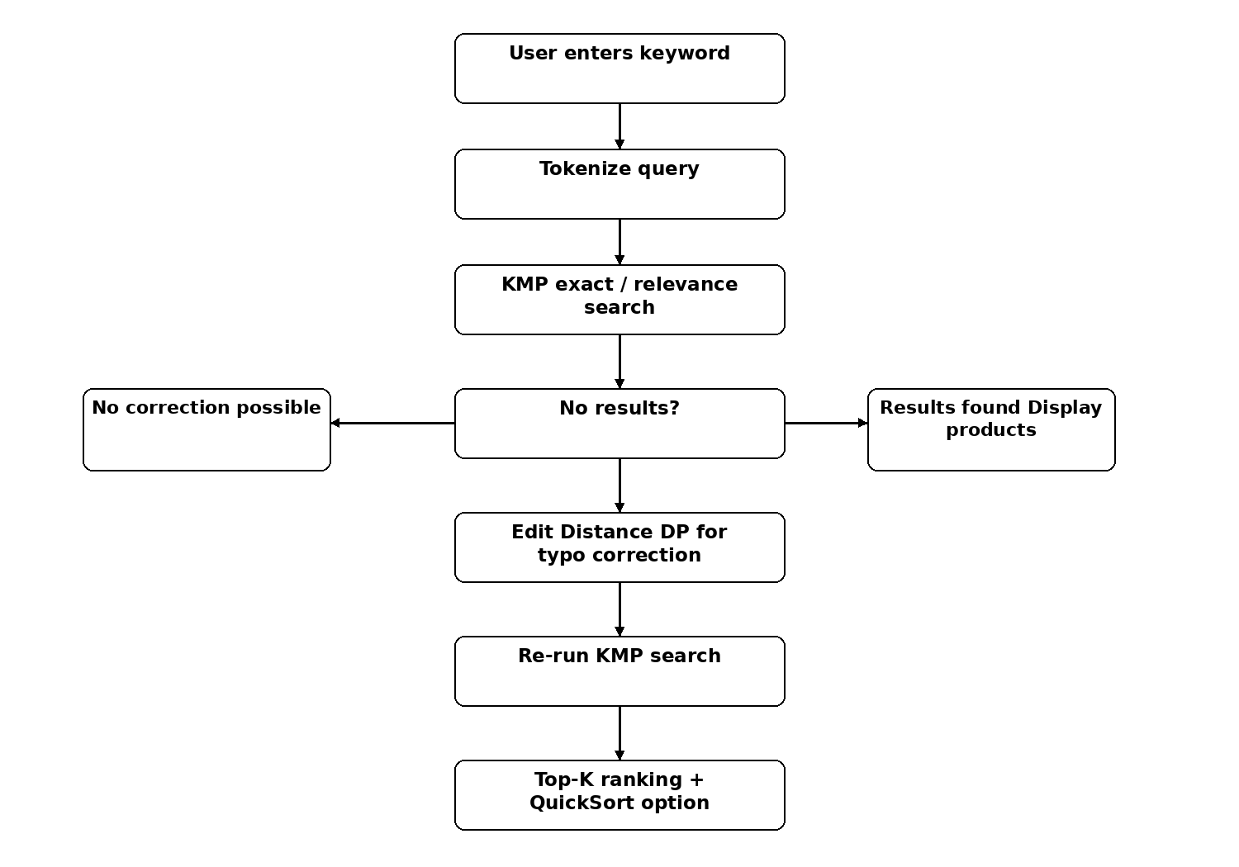
Fig. 3.2 Search and typo-correction flow using KMP and Edit Distance.

3.5 Recommendation Design
The recommendation engine uses a content-based scoring function. A candidate product receives 50 points for matching the target category, 12 for matching the brand, 5 for matching colour, a name-similarity contribution based on Edit Distance, and 8 additional points when the rating is at least 4.5. Candidates are inserted into a bounded min-heap and the best results are returned. Duplicate product names are filtered to improve variety.
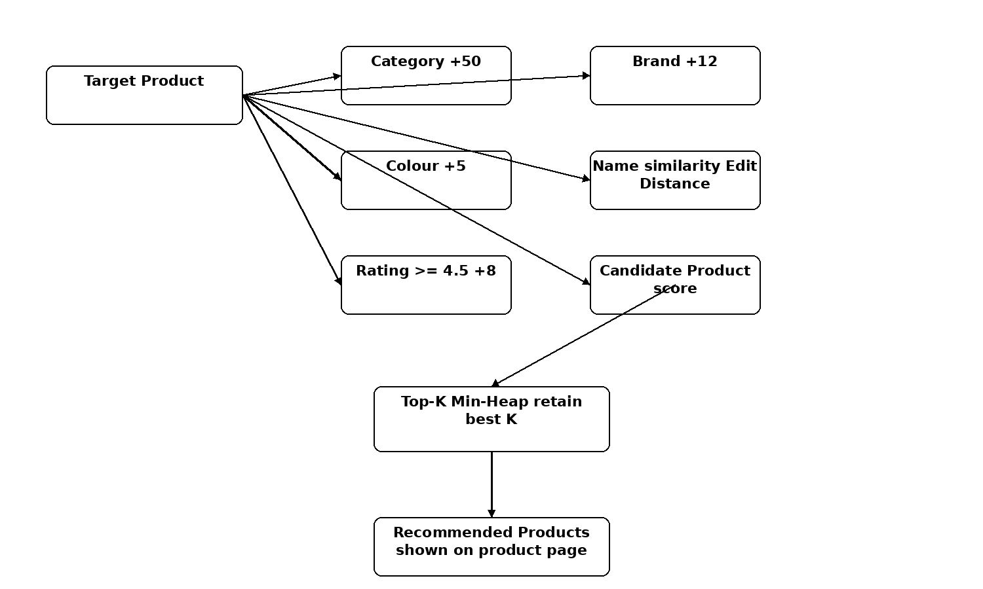
Fig. 3.3 Recommendation scoring and Top-K selection flow.

3.6 Seller Comparison Design
Seller offers are loaded into a HashMap keyed by productId. Each product’s seller array is sorted by price once at load time using Randomized QuickSort. Therefore, the first offer represents the cheapest seller. The product page can then identify the cheapest offer, top-rated seller, fastest delivery option, and the price difference between the minimum and maximum seller prices.

4. IMPLEMENTATION

4.1 Project Modules
Module/Class | Responsibility
Main.java | Loads catalog, seller offers, persistent state and starts the HTTP server.
ProductDataLoader.java | Reads product records from CSV.
OfferStore.java | Loads seller offers, indexes by productId and exposes min/max/find operations.
KMP.java | Builds the LPS array and performs KMP pattern matching.
EditDistance.java | Computes Levenshtein distance with rolling arrays.
RandomizedQuickSort.java | Sorts products and seller offers using randomized pivots.
TopK.java | Implements a bounded min-heap for top-K selection.
RecommendationEngine.java | Scores recommendations, cheaper alternatives and top deals.
Store.java | Handles users, sessions, wishlists, carts and orders with CSV persistence.
Server.java | Exposes HTTP APIs and connects frontend requests to DSA modules.

4.2 Pseudocode: KMP Search
Pseudocode:
- Build the LPS (Longest Prefix Suffix) array for the pattern.
- Set text index i = 0 and pattern index j = 0.
- While i is inside the text: compare text[i] and pattern[j].
- If equal, increment both indices; if j reaches pattern length, report a match.
- If unequal and j > 0, set j = LPS[j-1]; otherwise increment i.
- Return false if the text ends before a complete match.

4.3 Pseudocode: Edit Distance
- Initialize the previous row as 0,1,2,...,m.
- For every character of string A, create the current row.
- For each character of string B, compute insertion, deletion and substitution costs.
- Store the minimum of the three operations.
- Swap current and previous rows after each iteration.
- Return the final cell as the Levenshtein distance.

4.4 Pseudocode: Top-K Min-Heap
- Create a min-heap with capacity K.
- For each candidate product, compute its score.
- If the heap has fewer than K items, insert the candidate and sift up.
- Otherwise compare the candidate score with the heap minimum.
- If the candidate is better, replace the minimum and sift down.
- Drain the heap in reverse removal order to obtain best-first results.

4.5 Pseudocode: Recommendation Generation
- Select the product currently being viewed as the target.
- For every other product, calculate category, brand, colour, name-similarity and rating contributions.
- Insert the candidate into a Top-K min-heap.
- Drain candidates from best to worst.
- Remove the target product and repeated product names to increase variety.
- Return the requested number of recommendations.

4.6 Pseudocode: Search with Typo Correction
- Read the query and split it into lowercase tokens.
- Run KMP search requiring all tokens to occur.
- If no result exists, find a close vocabulary word for each unmatched token using Edit Distance.
- Run KMP again using the corrected tokens.
- If still unsuccessful and multiple tokens exist, perform partial matching where any token may match.
- Apply the requested QuickSort ordering and return the JSON response.

4.7 User and Commerce Flow
Registration creates a user record using a random salt and salted SHA-256 password hash. Login creates an in-memory session token. Wishlist and cart operations require a valid token. Cart items retain both product ID and seller so that users can choose among seller offers. During checkout, the server retrieves seller prices from its own data rather than trusting browser-provided prices. The payment interface is simulated and does not process real money.

4.8 HTTP API Interface
Method | Endpoint | Purpose
GET | /api/products?category=&page=&sort= | Browse and sort products
GET | /api/search?q=&sort= | Search and rank products
GET | /api/product?id= | Product details, seller offers and recommendations
GET | /api/deals | Top seller price-gap deals
POST | /api/register | Create user account
POST | /api/login | Authenticate user
POST | /api/logout | End session
GET | /api/wishlist | Read wishlist
POST | /api/wishlist/toggle | Add/remove wishlist item
GET | /api/cart | Read cart
POST | /api/cart/add | Add cart item
POST | /api/cart/update | Update quantity
POST | /api/checkout | Create order
GET | /api/orders | Read order history

4.9 Execution Procedure
- Compile with javac -d out src/*.java.
- Start the application with java -cp out Main, or use run.bat/run.sh.
- Open http://localhost:8080 in a browser.
- Browse categories or search for a product.
- Test a misspelled query to observe Edit Distance correction.
- Open a product and compare sellers, cheaper alternatives, and recommendations.
- Register/login to test wishlist, cart, checkout, and order history.
- Run AlgorithmDemo to demonstrate the individual DSA components in the terminal.

4.10 SOURCE CODE LISTINGS

Code Listing: Main.java
public class Main {
public static void main(String[] args) throws Exception {
Product[] products = ProductDataLoader.load("data/products.csv");
OfferStore.load("data/sellers.csv"); // seller offers (price/rating/delivery per seller)
Store.load(); // users, wishlists, carts, orders (data/*.csv)
Server.start(products);
System.out.println("Open the URL above in Chrome/Edge.");
System.out.println("Press Ctrl+C to stop.");
}
}
Listing 4.10.1: Source code from Main.java used in the implementation.

Code Listing: Product.java
public class Product {
public int id;
public String name, category, brand, color, description, keywords, image;
public double price, rating;
public int reviews, discount;
public Product(int id, String name, String category, String brand, double price,
double rating, int reviews, String color, String description,
String keywords, int discount, String image) {
this.id=id; this.name=name; this.category=category; this.brand=brand;
this.price=price; this.rating=rating; this.reviews=reviews; this.color=color;
this.description=description; this.keywords=keywords; this.discount=discount;
this.image=image;
}
}
Listing 4.10.2: Source code from Product.java used in the implementation.

Code Listing: Offer.java
/** One seller's listing of a product: the same product can be sold by several sellers at different prices. */
public class Offer {
public int productId;
public String seller;
public double sellerRating;
public double price;
public int deliveryDays;
public int stock;
public Offer(int productId, String seller, double sellerRating, double price, int deliveryDays, int stock) {
this.productId = productId; this.seller = seller; this.sellerRating = sellerRating;
this.price = price; this.deliveryDays = deliveryDays; this.stock = stock;
}
}
Listing 4.10.3: Source code from Offer.java used in the implementation.

Code Listing: ProductDataLoader.java
import java.io.*;
import java.util.*;
public class ProductDataLoader {
public static Product[] load(String file) throws Exception {
BufferedReader br = new BufferedReader(new FileReader(file));
String line = br.readLine();
ArrayList<Product> list = new ArrayList<Product>();
while ((line = br.readLine()) != null) {
String[] p = splitCsv(line);
if (p.length < 12) continue;
list.add(new Product(
Integer.parseInt(p[0]), p[1], p[2], p[3], Double.parseDouble(p[4]),
Double.parseDouble(p[5]), Integer.parseInt(p[6]), p[7], p[8], p[9],
Integer.parseInt(p[10]), p[11]
));
}
br.close();
return list.toArray(new Product[0]);
}
private static String[] splitCsv(String s) {
ArrayList<String> a = new ArrayList<String>();
StringBuilder cur = new StringBuilder();
boolean q=false;
for(int i=0;i<s.length();i++){
char c=s.charAt(i);
if(c=='"') { q=!q; }
else if(c==',' && !q) { a.add(cur.toString()); cur.setLength(0); }
else cur.append(c);
}
a.add(cur.toString());
return a.toArray(new String[0]);
}
}
Listing 4.10.4: Source code from ProductDataLoader.java used in the implementation.

Code Listing: KMP.java
public class KMP {
public static int[] buildLPS(String pattern) {
int[] lps = new int[pattern.length()];
int len = 0, i = 1;
while (i < pattern.length()) {
if (pattern.charAt(i) == pattern.charAt(len)) lps[i++] = ++len;
else if (len > 0) len = lps[len - 1];
else lps[i++] = 0;
}
return lps;
}
public static boolean contains(String text, String pattern) {
if(pattern == null || pattern.length()==0) return true;
text = text.toLowerCase();
pattern = pattern.toLowerCase();
int[] lps = buildLPS(pattern);
int i=0,j=0;
while(i<text.length()) {
if(text.charAt(i)==pattern.charAt(j)){i++;j++; if(j==pattern.length()) return true;}
else if(j>0) j=lps[j-1];
else i++;
}
return false;
}
}
Listing 4.10.5: Source code from KMP.java used in the implementation.

Code Listing: EditDistance.java
public class EditDistance {
public static int distance(String a, String b) {
a=a.toLowerCase(); b=b.toLowerCase();
int[] prev = new int[b.length()+1];
int[] cur = new int[b.length()+1];
for(int j=0;j<=b.length();j++) prev[j]=j;
for(int i=1;i<=a.length();i++){
cur[0]=i;
for(int j=1;j<=b.length();j++){
int cost = a.charAt(i-1)==b.charAt(j-1)?0:1;
int x=prev[j]+1, y=cur[j-1]+1, z=prev[j-1]+cost;
cur[j]=Math.min(x, Math.min(y,z));
}
int[] t=prev; prev=cur; cur=t;
}
return prev[b.length()];
}
}
Listing 4.10.6: Source code from EditDistance.java used in the implementation.

Code Listing: RandomizedQuickSort.java
import java.util.function.ToDoubleFunction;
/** Randomized QuickSort: a random pivot makes the expected running time O(n log n) on every input. */
public class RandomizedQuickSort {
private static long seed = 123456789L;
private static int rand(int n) {
seed = (seed * 6364136223846793005L + 1442695040888963407L);
long x = seed ^ (seed >>> 33);
if (x < 0) x = -x;
return (int)(x % n);
}
// ---- sorting products ---------------------------------------------------------------
/** Original version: sort by list price. */
public static void sort(Product[] a, int lo, int hi) { sort(a, lo, hi, p -> p.price); }
/** Sort products ascending by any numeric key (e.g. cheapest-seller price, rating). */
public static void sort(Product[] a, int lo, int hi, ToDoubleFunction<Product> key) {
if (lo >= hi) return;
int p = partition(a, lo, hi, key);
sort(a, lo, p - 1, key); sort(a, p + 1, hi, key);
}
private static int partition(Product[] a, int lo, int hi, ToDoubleFunction<Product> key) {
int r = lo + rand(hi - lo + 1);
Product tmp = a[r]; a[r] = a[hi]; a[hi] = tmp;
double pivot = key.applyAsDouble(a[hi]);
int i = lo;
for (int j = lo; j < hi; j++) if (key.applyAsDouble(a[j]) <= pivot) {
tmp = a[i]; a[i] = a[j]; a[j] = tmp; i++;
}
tmp = a[i]; a[i] = a[hi]; a[hi] = tmp;
return i;
}
/** Server-side sort modes used by the website's sort dropdown. */
public static void sortProducts(Product[] a, String mode) {
if ("priceAsc".equals(mode)) sort(a, 0, a.length - 1, p -> OfferStore.min(p.id, p.price));
else if ("priceDesc".equals(mode)) sort(a, 0, a.length - 1, p -> -OfferStore.min(p.id, p.price));
else if ("rating".equals(mode)) sort(a, 0, a.length - 1, p -> -p.rating);
}
// ---- sorting seller offers (same algorithm, applied to Offer objects) ------------------
public static void sortOffersByPrice(Offer[] a, int lo, int hi) {
if (lo >= hi) return;
int r = lo + rand(hi - lo + 1);
Offer tmp = a[r]; a[r] = a[hi]; a[hi] = tmp;
double pivot = a[hi].price;
int i = lo;
for (int j = lo; j < hi; j++) if (a[j].price <= pivot) { tmp = a[i]; a[i] = a[j]; a[j] = tmp; i++; }
tmp = a[i]; a[i] = a[hi]; a[hi] = tmp;
sortOffersByPrice(a, lo, i - 1); sortOffersByPrice(a, i + 1, hi);
}
}
Listing 4.10.7: Source code from RandomizedQuickSort.java used in the implementation.

Code Listing: TopK.java
/**
* Bounded MIN-HEAP that keeps only the K highest-scoring products seen so far.
* Adding one item costs O(log K), so scanning n products costs O(n log K) -- much cheaper than
* sorting all n products (O(n log n)) when we only need the best few (recommendations, top deals).
*/
public class TopK {
private final int k;
private final Product[] items;
private final double[] keys;
private int size = 0;
public TopK(int k) { this.k = Math.max(1, k); items = new Product[this.k]; keys = new double[this.k]; }
public void offer(Product p, double key) {
if (size < k) { items[size] = p; keys[size] = key; siftUp(size); size++; }
else if (key > keys[0]) { items[0] = p; keys[0] = key; siftDown(0); } // beat the weakest of the top K
}
/** Returns the kept products best-first. Empties the heap. */
public Product[] drainBestFirst() {
Product[] out = new Product[size];
for (int i = size - 1; i >= 0; i--) { // repeatedly remove the minimum -> fill from the back
out[i] = items[0];
size--; items[0] = items[size]; keys[0] = keys[size];
if (size > 0) siftDown(0);
}
return out;
}
private void siftUp(int i) {
while (i > 0) { int p = (i - 1) / 2; if (keys[i] >= keys[p]) break; swap(i, p); i = p; }
}
private void siftDown(int i) {
while (true) {
int l = 2 * i + 1, r = l + 1, m = i;
if (l < size && keys[l] < keys[m]) m = l;
if (r < size && keys[r] < keys[m]) m = r;
if (m == i) return;
swap(i, m); i = m;
}
}
private void swap(int a, int b) {
Product tp = items[a]; items[a] = items[b]; items[b] = tp;
double tk = keys[a]; keys[a] = keys[b]; keys[b] = tk;
}
}
Listing 4.10.8: Source code from TopK.java used in the implementation.

Code Listing: RecommendationEngine.java
/**
* Content-based recommendations. Every product is scored against the target product
* (same category / brand / colour, similar name via Edit Distance, good rating) and a bounded
* min-heap (TopK) keeps only the best few.
*/
public class RecommendationEngine {
static double score(Product p, Product target) {
double s = 0;
if (p.category.equalsIgnoreCase(target.category)) s += 50;
if (p.brand.equalsIgnoreCase(target.brand)) s += 12;
if (p.color.equalsIgnoreCase(target.color)) s += 5;
s += Math.max(0, 20 - EditDistance.distance(p.name, target.name));
if (p.rating >= 4.5) s += 8;
return s;
}
/**
* "You may also like": the most similar products, best first. The catalog repeats product names
* many times, so we keep a larger heap and then show only one listing per distinct name
* (and never the same name as the product being viewed) so the list has variety.
*/
public static Product[] recommend(Product[] products, Product target, int limit) {
TopK top = new TopK(limit * 12);
for (Product p : products) {
if (p.id == target.id) continue;
top.offer(p, score(p, target));
}
Product[] ranked = top.drainBestFirst();
java.util.ArrayList<Product> out = new java.util.ArrayList<Product>();
java.util.HashSet<String> seen = new java.util.HashSet<String>();
seen.add(target.name.toLowerCase());
for (Product p : ranked) {
if (out.size() == limit) break;
if (seen.add(p.name.toLowerCase())) out.add(p);
}
for (Product p : ranked) { // not enough variety -> fill with the best remaining
if (out.size() == limit) break;
if (!out.contains(p)) out.add(p);
}
return out.toArray(new Product[0]);
}
/** "Cheaper alternatives": similar products in the same category whose best price is lower. */
public static Product[] cheaperAlternatives(Product[] products, Product target, int limit) {
double base = OfferStore.min(target.id, target.price);
TopK top = new TopK(limit);
for (Product p : products) {
if (p.id == target.id || !p.category.equalsIgnoreCase(target.category)) continue;
double m = OfferStore.min(p.id, p.price);
if (m >= base) continue;
top.offer(p, score(p, target) + (base - m) / base * 30); // reward bigger savings
}
return top.drainBestFirst();
}
/** Home-page "Top deals": products where choosing the cheapest seller saves the most. */
public static Product[] topDeals(Product[] products, int limit) {
TopK top = new TopK(limit);
for (Product p : products) top.offer(p, OfferStore.savingsPercent(p.id));
return top.drainBestFirst();
}
}
Listing 4.10.9: Source code from RecommendationEngine.java used in the implementation.

Code Listing: OfferStore.java
import java.io.*;
import java.util.*;
/**
* Loads data/sellers.csv and keeps every product's offers in a HashMap (productId -> offers) so a
* product's sellers are found in O(1). Each product's offers are sorted by price ONCE at load time
* using Randomized QuickSort, so the cheapest seller is always offers[0].
*/
public class OfferStore {
private static final Map<Integer, Offer[]> byProduct = new HashMap<Integer, Offer[]>();
public static void load(String file) throws IOException {
Map<Integer, ArrayList<Offer>> tmp = new HashMap<Integer, ArrayList<Offer>>();
BufferedReader br = new BufferedReader(new FileReader(file));
br.readLine(); // header
String line;
while ((line = br.readLine()) != null) {
String[] p = line.trim().split(",");
if (p.length < 6) continue;
Offer o = new Offer(Integer.parseInt(p[0]), p[1], Double.parseDouble(p[2]),
Double.parseDouble(p[3]), Integer.parseInt(p[4]), Integer.parseInt(p[5]));
ArrayList<Offer> l = tmp.get(o.productId);
if (l == null) { l = new ArrayList<Offer>(); tmp.put(o.productId, l); }
l.add(o);
}
br.close();
for (Map.Entry<Integer, ArrayList<Offer>> en : tmp.entrySet()) {
Offer[] arr = en.getValue().toArray(new Offer[0]);
RandomizedQuickSort.sortOffersByPrice(arr, 0, arr.length - 1);
byProduct.put(en.getKey(), arr);
}
}
/** Offers of a product, cheapest first (empty array if none). */
public static Offer[] offers(int productId) {
Offer[] o = byProduct.get(productId);
return o == null ? new Offer[0] : o;
}
public static double min(int productId, double fallback) {
Offer[] o = offers(productId); return o.length == 0 ? fallback : o[0].price;
}
public static double max(int productId, double fallback) {
Offer[] o = offers(productId); return o.length == 0 ? fallback : o[o.length - 1].price;
}
public static Offer find(int productId, String seller) {
for (Offer o : offers(productId)) if (o.seller.equals(seller)) return o;
return null;
}
/** Percentage gap between the cheapest and the most expensive seller (0..100). */
public static double savingsPercent(int productId) {
Offer[] o = offers(productId);
if (o.length < 2) return 0;
return (o[o.length - 1].price - o[0].price) * 100.0 / o[o.length - 1].price;
}
}
Listing 4.10.10: Source code from OfferStore.java used in the implementation.

Code Listing: AlgorithmDemo.java
public class AlgorithmDemo {
public static void main(String[] args) throws Exception {
Product[] p = ProductDataLoader.load("data/products.csv");
OfferStore.load("data/sellers.csv");
System.out.println("\n=== DSA DEMONSTRATION ===");
System.out.println("Products loaded: " + p.length);
String text="wireless headphones with bluetooth";
String pattern="headphones";
System.out.println("\nKMP: searching '" + pattern + "'");
System.out.println("Match: " + KMP.contains(text, pattern));
System.out.println("Complexity: O(n + m)");
System.out.println("\nLevenshtein DP:");
System.out.println("Distance between 'hedphones' and 'headphones' = " +
EditDistance.distance("hedphones","headphones"));
System.out.println("Complexity: O(n*m), space O(m)");
Product[] sample=new Product[10];
for(int i=0;i<10;i++) sample[i]=p[i];
System.out.println("\nRandomized QuickSort by cheapest-seller price:");
RandomizedQuickSort.sortProducts(sample, "priceAsc");
for(Product x:sample) System.out.println(x.name+" -> from Rs."+OfferStore.min(x.id, x.price));
System.out.println("Expected complexity: O(n log n)");
Product t = p[1];
System.out.println("\nSeller offers for '" + t.name + "' (HashMap lookup O(1), sorted cheapest first):");
for(Offer o : OfferStore.offers(t.id))
System.out.println(" " + o.seller + " rating " + o.sellerRating + " Rs." + o.price + " delivery " + o.deliveryDays + "d");
System.out.println("\nTop-K min-heap -> 5 most similar products to '" + t.name + "':");
for(Product r : RecommendationEngine.recommend(p, t, 5)) System.out.println(" " + r.name + " (" + r.category + ")");
System.out.println("Complexity: O(n log K) for n products, K results");
System.out.println("\nTop-K min-heap -> 3 biggest seller price gaps:");
for(Product d : RecommendationEngine.topDeals(p, 3))
System.out.printf(" %s: Rs.%.0f - Rs.%.0f (%.1f%% saving)%n", d.name, OfferStore.min(d.id,d.price), OfferStore.max(d.id,d.price), OfferStore.savingsPercent(d.id));
}
}
Listing 4.10.11: Source code from AlgorithmDemo.java used in the implementation.

Code Listing: Store.java
import java.io.*;
import java.nio.charset.StandardCharsets;
import java.security.MessageDigest;
import java.security.SecureRandom;
import java.util.*;
/**
* File-based persistence for users, wishlists, carts and orders (no SQL database, like the catalog).
* Everything lives in memory in HashMaps for O(1) access and is re-written to data/*.csv on every change.
*/
public class Store {
static final String USERS = "data/users.csv", WISH = "data/wishlist.csv",
CART = "data/cart.csv", ORDERS = "data/orders.csv";
public static class OrderItem {
public int productId; public String seller; public int qty; public double unitPrice;
OrderItem(int p, String s, int q, double u) { productId = p; seller = s; qty = q; unitPrice = u; }
}
public static class Order {
public String id, user, name, phone, address, method, payRef, status;
public long time; public double delivery, total;
public ArrayList<OrderItem> items = new ArrayList<OrderItem>();
}
// username -> {salt, hash, displayName}
private static final Map<String, String[]> users = new HashMap<String, String[]>();
private static final Map<String, LinkedHashSet<Integer>> wishlist = new HashMap<String, LinkedHashSet<Integer>>();
// username -> ("productId|seller" -> quantity), insertion ordered
private static final Map<String, LinkedHashMap<String, Integer>> carts = new HashMap<String, LinkedHashMap<String, Integer>>();
private static final ArrayList<Order> orders = new ArrayList<Order>();
private static final Map<String, String> sessions = new HashMap<String, String>(); // token -> username
private static final SecureRandom rng = new SecureRandom();
// ------------------------------------------------------------------ loading
public static synchronized void load() {
for (String l : lines(USERS)) { String[] p = l.split(",", -1); if (p.length >= 4) users.put(p[0], new String[]{p[1], p[2], p[3]}); }
for (String l : lines(WISH)) { String[] p = l.split(",", -1); if (p.length >= 2) wishSet(p[0]).add(Integer.parseInt(p[1])); }
for (String l : lines(CART)) { String[] p = l.split(",", -1); if (p.length >= 4) cartMap(p[0]).put(p[1] + "|" + p[2], Integer.parseInt(p[3])); }
for (String l : lines(ORDERS)) {
String[] p = l.split("\\|", -1);
if (p.length < 11) continue;
Order o = new Order();
o.id = p[0]; o.user = p[1]; o.time = Long.parseLong(p[2]); o.name = p[3]; o.phone = p[4]; o.address = p[5];
o.method = p[6]; o.payRef = p[7]; o.status = p[8]; o.delivery = Double.parseDouble(p[9]);
double sub = 0;
for (String it : p[10].split(";")) {
String[] f = it.split(":");
if (f.length < 4) continue;
OrderItem oi = new OrderItem(Integer.parseInt(f[0]), f[1], Integer.parseInt(f[2]), Double.parseDouble(f[3]));
o.items.add(oi); sub += oi.qty * oi.unitPrice;
}
o.total = sub + o.delivery;
orders.add(o);
}
}
private static List<String> lines(String file) {
ArrayList<String> out = new ArrayList<String>();
File f = new File(file);
if (!f.exists()) return out;
try (BufferedReader br = new BufferedReader(new InputStreamReader(new FileInputStream(f), StandardCharsets.UTF_8))) {
String l; while ((l = br.readLine()) != null) if (l.trim().length() > 0) out.add(l);
} catch (IOException e) { e.printStackTrace(); }
return out;
}
private static void write(String file, List<String> rows) {
try (PrintWriter w = new PrintWriter(new OutputStreamWriter(new FileOutputStream(file), StandardCharsets.UTF_8))) {
for (String r : rows) w.println(r);
} catch (IOException e) { e.printStackTrace(); }
}
private static LinkedHashSet<Integer> wishSet(String u) {
LinkedHashSet<Integer> s = wishlist.get(u); if (s == null) { s = new LinkedHashSet<Integer>(); wishlist.put(u, s); } return s;
}
private static LinkedHashMap<String, Integer> cartMap(String u) {
LinkedHashMap<String, Integer> m = carts.get(u); if (m == null) { m = new LinkedHashMap<String, Integer>(); carts.put(u, m); } return m;
}
/** Free text is stored in delimiter-separated files, so strip the delimiters. */
public static String clean(String s) { return s == null ? "" : s.replaceAll("[|,\\r\\n]", " ").trim(); }
// ------------------------------------------------------------------ users + sessions
private static String sha256(String s) {
try {
byte[] d = MessageDigest.getInstance("SHA-256").digest(s.getBytes(StandardCharsets.UTF_8));
StringBuilder b = new StringBuilder(); for (byte x : d) b.append(String.format("%02x", x)); return b.toString();
} catch (Exception e) { throw new RuntimeException(e); }
}
public static synchronized String register(String user, String pass, String display) {
if (!user.matches("[A-Za-z0-9_.@-]{3,30}")) return "Username must be 3-30 characters: letters, digits, . _ - @";
if (pass.length() < 6) return "Password must be at least 6 characters";
if (users.containsKey(user.toLowerCase())) return "That username is already taken";
byte[] s = new byte[8]; rng.nextBytes(s);
StringBuilder salt = new StringBuilder(); for (byte x : s) salt.append(String.format("%02x", x));
String shown = clean(display).length() == 0 ? user : clean(display);
users.put(user.toLowerCase(), new String[]{salt.toString(), sha256(salt + pass), shown});
saveUsers();
return null; // null = success
}
/** @return a new session token, or null if the username/password is wrong */
public static synchronized String login(String user, String pass) {
String[] u = users.get(user.toLowerCase());
if (u == null || !u[1].equals(sha256(u[0] + pass))) return null;
byte[] t = new byte[16]; rng.nextBytes(t);
StringBuilder tok = new StringBuilder(); for (byte x : t) tok.append(String.format("%02x", x));
sessions.put(tok.toString(), user.toLowerCase());
return tok.toString();
}
public static synchronized void logout(String token) { sessions.remove(token); }
public static synchronized String userOf(String token) { return token == null ? null : sessions.get(token); }
public static synchronized String displayName(String user) { String[] u = users.get(user); return u == null ? user : u[2]; }
private static void saveUsers() {
ArrayList<String> r = new ArrayList<String>();
for (Map.Entry<String, String[]> e : users.entrySet()) r.add(e.getKey() + "," + e.getValue()[0] + "," + e.getValue()[1] + "," + e.getValue()[2]);
write(USERS, r);
}
// ------------------------------------------------------------------ wishlist
public static synchronized boolean toggleWish(String user, int productId) {
LinkedHashSet<Integer> s = wishSet(user);
boolean now = !s.remove(productId);
if (now) s.add(productId);
ArrayList<String> r = new ArrayList<String>();
for (Map.Entry<String, LinkedHashSet<Integer>> e : wishlist.entrySet()) for (int id : e.getValue()) r.add(e.getKey() + "," + id);
write(WISH, r);
return now;
}
public static synchronized List<Integer> wishIds(String user) { return new ArrayList<Integer>(wishSet(user)); }
// ------------------------------------------------------------------ cart
/** @return list of {productId, seller, qty} */
public static synchronized List<Object[]> cartItems(String user) {
ArrayList<Object[]> out = new ArrayList<Object[]>();
for (Map.Entry<String, Integer> e : cartMap(user).entrySet()) {
int bar = e.getKey().indexOf('|');
out.add(new Object[]{Integer.parseInt(e.getKey().substring(0, bar)), e.getKey().substring(bar + 1), e.getValue()});
}
return out;
}
public static synchronized void setCartQty(String user, int productId, String seller, int qty) {
LinkedHashMap<String, Integer> c = cartMap(user);
String key = productId + "|" + seller;
if (qty <= 0) c.remove(key); else c.put(key, qty);
saveCarts();
}
public static synchronized int cartQty(String user, int productId, String seller) {
Integer q = cartMap(user).get(productId + "|" + seller); return q == null ? 0 : q;
}
public static synchronized void clearCart(String user) { cartMap(user).clear(); saveCarts(); }
public static synchronized int cartCount(String user) { int n = 0; for (int q : cartMap(user).values()) n += q; return n; }
private static void saveCarts() {
ArrayList<String> r = new ArrayList<String>();
for (Map.Entry<String, LinkedHashMap<String, Integer>> e : carts.entrySet())
for (Map.Entry<String, Integer> c : e.getValue().entrySet()) {
int bar = c.getKey().indexOf('|');
r.add(e.getKey() + "," + c.getKey().substring(0, bar) + "," + c.getKey().substring(bar + 1) + "," + c.getValue());
}
write(CART, r);
}
// ------------------------------------------------------------------ orders
public static synchronized Order addOrder(Order o) {
o.id = "ORD" + (100000 + orders.size() + 1);
orders.add(o);
ArrayList<String> r = new ArrayList<String>();
for (Order x : orders) {
StringBuilder it = new StringBuilder();
for (OrderItem i : x.items) { if (it.length() > 0) it.append(';'); it.append(i.productId + ":" + i.seller + ":" + i.qty + ":" + i.unitPrice); }
r.add(x.id + "|" + x.user + "|" + x.time + "|" + x.name + "|" + x.phone + "|" + x.address + "|" + x.method + "|" + x.payRef + "|" + x.status + "|" + x.delivery + "|" + it);
}
write(ORDERS, r);
return o;
}
/** Newest first. */
public static synchronized List<Order> ordersOf(String user) {
ArrayList<Order> out = new ArrayList<Order>();
for (int i = orders.size() - 1; i >= 0; i--) if (orders.get(i).user.equals(user)) out.add(orders.get(i));
return out;
}
public static String newPayRef() { return "TXN" + (100000000L + (long) (rng.nextDouble() * 899999999L)); }
}
Listing 4.10.12: Source code from Store.java used in the implementation.

Code Listing: Server.java
import com.sun.net.httpserver.*;
import java.io.*;
import java.net.*;
import java.nio.charset.StandardCharsets;
import java.nio.file.Files;
import java.util.*;
import java.util.concurrent.Executors;
public class Server {
static Product[] products;
static final Map<Integer, Product> byId = new HashMap<Integer, Product>();
static String[] hay; // lower-case "name category brand keywords" per product
static final ArrayList<String> vocab = new ArrayList<String>(); // known words, used for typo correction
static final Map<String, String> realImages = new HashMap<String, String>(); // "product_0001" -> "product_0001.jpg"
static final int PAGE = 24;
static class ApiException extends RuntimeException {
int code;
ApiException(int code, String msg) { super(msg); this.code = code; }
}
// =================================================================== start-up
public static void start(Product[] p) throws Exception {
products = p;
hay = new String[p.length];
TreeSet<String> words = new TreeSet<String>();
for (int i = 0; i < p.length; i++) {
byId.put(p[i].id, p[i]);
hay[i] = (p[i].name + " " + p[i].category + " " + p[i].brand + " " + p[i].keywords).toLowerCase();
for (String w : hay[i].split("[^a-z0-9]+")) if (w.length() >= 3 && !w.matches("\\d+")) words.add(w);
}
vocab.addAll(words);
scanRealImages();
HttpServer server = HttpServer.create(new InetSocketAddress(8080), 0);
server.createContext("/", Server::staticFile);
server.createContext("/api/", Server::api);
server.setExecutor(Executors.newFixedThreadPool(8));
server.start();
System.out.println("==============================================");
System.out.println(" Product Search & Recommendation System");
System.out.println(" Frontend: http://localhost:8080");
System.out.println(" Products loaded: " + products.length + " | seller offers: " + countOffers());
System.out.println(" Real photos found in images/real: " + realImages.size());
System.out.println(" DSA: KMP + Edit Distance DP + Randomized QuickSort + Heap (Top-K) + HashMap");
System.out.println("==============================================");
}
static int countOffers() { int n = 0; for (Product x : products) n += OfferStore.offers(x.id).length; return n; }
static void scanRealImages() {
String[] names = new File("images/real").list();
if (names == null) return;
for (String n : names) {
int dot = n.lastIndexOf('.');
if (dot < 0) continue;
String ext = n.substring(dot + 1).toLowerCase();
if (ext.equals("jpg") || ext.equals("jpeg") || ext.equals("png") || ext.equals("webp"))
realImages.put(n.substring(0, dot).toLowerCase(), n);
}
}
static String imageUrl(Product p) {
String base = p.image.substring(0, p.image.lastIndexOf('.')).toLowerCase();
String real = realImages.get(base);
return real != null ? "/images/real/" + real : "/images/" + p.image;
}
// =================================================================== small helpers
static void send(HttpExchange e, int code, String body) throws IOException {
byte[] b = body.getBytes(StandardCharsets.UTF_8);
e.getResponseHeaders().set("Content-Type", "application/json; charset=UTF-8");
e.getResponseHeaders().set("Cache-Control", "no-store");
e.sendResponseHeaders(code, b.length);
e.getResponseBody().write(b); e.close();
}
static String dec(String s) {
try { return URLDecoder.decode(s, "UTF-8"); } catch (UnsupportedEncodingException ex) { return s; }
}
/** Query-string and form-body parameters merged into one map. */
static Map<String, String> params(HttpExchange e) throws IOException {
Map<String, String> m = new HashMap<String, String>();
parseInto(m, e.getRequestURI().getRawQuery());
if (e.getRequestMethod().equals("POST")) {
ByteArrayOutputStream bo = new ByteArrayOutputStream();
byte[] buf = new byte[4096]; int n;
InputStream in = e.getRequestBody();
while ((n = in.read(buf)) > 0 && bo.size() < 100000) bo.write(buf, 0, n);
parseInto(m, new String(bo.toByteArray(), StandardCharsets.UTF_8));
}
return m;
}
static void parseInto(Map<String, String> m, String s) {
if (s == null || s.length() == 0) return;
for (String x : s.split("&")) {
String[] a = x.split("=", 2);
m.put(dec(a[0]), a.length == 2 ? dec(a[1]) : "");
}
}
static String get(Map<String, String> p, String k) { String v = p.get(k); return v == null ? "" : v.trim(); }
static int geti(Map<String, String> p, String k, int def) {
try { return Integer.parseInt(get(p, k)); } catch (Exception x) { return def; }
}
static void needPost(HttpExchange e) { if (!e.getRequestMethod().equals("POST")) throw new ApiException(405, "Use POST"); }
static String needUser(HttpExchange e) {
String u = Store.userOf(e.getRequestHeaders().getFirst("X-Token"));
if (u == null) throw new ApiException(401, "Please log in first");
return u;
}
static String esc(String s) {
StringBuilder b = new StringBuilder();
for (char c : s.toCharArray()) {
if (c == '\\') b.append("\\\\"); else if (c == '"') b.append("\\\"");
else if (c == '\n' || c == '\r' || c == '\t') b.append(' ');
else if (c < 0x20) b.append(' '); else b.append(c);
}
return b.toString();
}
static String s(String v) { return "\"" + esc(v) + "\""; }
static Product product(int id) {
Product p = byId.get(id);
if (p == null) throw new ApiException(404, "Product not found");
return p;
}
// =================================================================== JSON builders
static String json(Product p) {
double min = OfferStore.min(p.id, p.price), max = OfferStore.max(p.id, p.price);
return "{\"id\":" + p.id + ",\"name\":" + s(p.name) + ",\"category\":" + s(p.category) + ",\"brand\":" + s(p.brand)
+ ",\"price\":" + p.price + ",\"minPrice\":" + min + ",\"maxPrice\":" + max + ",\"sellers\":" + OfferStore.offers(p.id).length
+ ",\"rating\":" + p.rating + ",\"reviews\":" + p.reviews + ",\"color\":" + s(p.color)
+ ",\"description\":" + s(p.description) + ",\"discount\":" + p.discount + ",\"image\":" + s(imageUrl(p))
+ ",\"realImage\":" + realImages.containsKey(p.image.substring(0, p.image.lastIndexOf('.')).toLowerCase()) + "}";
}
static String jsonList(Product[] list) {
StringBuilder b = new StringBuilder("[");
for (int i = 0; i < list.length; i++) { if (i > 0) b.append(","); b.append(json(list[i])); }
return b.append("]").toString();
}
static String offersJson(int productId) {
Offer[] o = OfferStore.offers(productId); // already cheapest-first
int topRated = 0, fastest = 0;
for (int i = 1; i < o.length; i++) {
if (o[i].sellerRating > o[topRated].sellerRating) topRated = i;
if (o[i].deliveryDays < o[fastest].deliveryDays) fastest = i;
}
StringBuilder b = new StringBuilder("[");
for (int i = 0; i < o.length; i++) {
if (i > 0) b.append(",");
b.append("{\"seller\":" + s(o[i].seller) + ",\"sellerRating\":" + o[i].sellerRating + ",\"price\":" + o[i].price
+ ",\"deliveryDays\":" + o[i].deliveryDays + ",\"stock\":" + o[i].stock + ",\"tags\":[");
ArrayList<String> tags = new ArrayList<String>();
if (i == 0) tags.add("Best price");
if (o.length > 1 && i == topRated) tags.add("Top rated seller");
if (o.length > 1 && i == fastest) tags.add("Fastest delivery");
for (int t = 0; t < tags.size(); t++) { if (t > 0) b.append(","); b.append(s(tags.get(t))); }
b.append("]}");
}
return b.append("]").toString();
}
// =================================================================== router
static void api(HttpExchange e) throws IOException {
try {
String path = e.getRequestURI().getPath();
Map<String, String> p = params(e);
String body;
switch (path) {
case "/api/products": body = productsApi(p); break;
case "/api/search": body = searchApi(p); break;
case "/api/product": body = productApi(p); break;
case "/api/deals": body = "{\"products\":" + jsonList(RecommendationEngine.topDeals(products, 12)) + "}"; break;
case "/api/register": needPost(e); body = registerApi(p); break;
case "/api/login": needPost(e); body = loginApi(p); break;
case "/api/logout": needPost(e); Store.logout(e.getRequestHeaders().getFirst("X-Token")); body = "{\"ok\":true}"; break;
case "/api/me": body = meApi(e); break;
case "/api/wishlist": body = wishlistApi(needUser(e)); break;
case "/api/wishlist/toggle": needPost(e); body = toggleWishApi(needUser(e), p); break;
case "/api/cart": body = cartJson(needUser(e)); break;
case "/api/cart/add": needPost(e); body = cartAddApi(needUser(e), p); break;
case "/api/cart/update": needPost(e); body = cartUpdateApi(needUser(e), p); break;
case "/api/checkout": needPost(e); body = checkoutApi(needUser(e), p); break;
case "/api/orders": body = ordersApi(needUser(e)); break;
default: throw new ApiException(404, "Unknown API");
}
send(e, 200, body);
} catch (ApiException ex) {
send(e, ex.code, "{\"error\":" + s(ex.getMessage()) + "}");
} catch (Exception ex) {
ex.printStackTrace();
send(e, 500, "{\"error\":\"Server error\"}");
}
}
// =================================================================== catalog
static String productsApi(Map<String, String> p) {
String cat = get(p, "category"), sort = get(p, "sort");
int page = Math.max(1, geti(p, "page", 1));
ArrayList<Product> f = new ArrayList<Product>();
for (Product x : products) if (cat.length() == 0 || x.category.equalsIgnoreCase(cat)) f.add(x);
Product[] arr = f.toArray(new Product[0]);
RandomizedQuickSort.sortProducts(arr, sort); // price / rating sorting done by the DSA engine
int start = Math.min((page - 1) * PAGE, arr.length), end = Math.min(start + PAGE, arr.length);
return "{\"total\":" + arr.length + ",\"page\":" + page + ",\"products\":" + jsonList(Arrays.copyOfRange(arr, start, end)) + "}";
}
static boolean anyContains(String token) {
for (int i = 0; i < hay.length; i++) if (KMP.contains(hay[i], token)) return true;
return false;
}
/** Nearest known word by Levenshtein distance (only accepted if it is "close enough"). */
static String correct(String token) {
String best = token; int bd = 99;
for (String w : vocab) {
int d = EditDistance.distance(token, w);
if (d < bd) { bd = d; best = w; }
}
return bd <= Math.max(1, Math.min(3, token.length() / 3)) ? best : token;
}
static String searchApi(Map<String, String> p) {
String term = get(p, "q"), sort = get(p, "sort");
String[] tokens = term.toLowerCase().split("\\s+");
if (term.length() == 0) tokens = new String[0];
String corrected = "";
boolean partial = false;
Product[] found = runSearch(tokens, true).drainBestFirst();
if (found.length == 0 && tokens.length > 0) { // nothing matched: try fixing typos with Edit Distance
String[] fixed = new String[tokens.length];
StringBuilder sb = new StringBuilder();
for (int i = 0; i < tokens.length; i++) {
fixed[i] = anyContains(tokens[i]) ? tokens[i] : correct(tokens[i]);
sb.append(i > 0 ? " " : "").append(fixed[i]);
}
found = runSearch(fixed, true).drainBestFirst();
if (found.length > 0) corrected = sb.toString();
else { tokens = fixed; }
}
if (found.length == 0 && tokens.length > 1) { // still nothing: show products matching SOME of the words
found = runSearch(tokens, false).drainBestFirst();
partial = found.length > 0;
}
RandomizedQuickSort.sortProducts(found, sort);
return "{\"query\":" + s(term) + ",\"corrected\":" + s(corrected) + ",\"partial\":" + partial + ",\"count\":" + found.length + ",\"products\":" + jsonList(found) + "}";
}
/**
* KMP search. requireAll=true: every word of the query must occur in the product text;
* false: at least one word must. The best 120 by relevance are kept in a heap.
*/
static TopK runSearch(String[] tokens, boolean requireAll) {
TopK top = new TopK(120);
for (int i = 0; i < products.length; i++) {
Product x = products[i];
double score = x.rating / 10.0; int hits = 0;
for (String t : tokens) {
if (!KMP.contains(hay[i], t)) continue;
hits++;
score += KMP.contains(x.name, t) ? 3 : KMP.contains(x.brand, t) ? 2 : 1;
}
if (requireAll ? hits == tokens.length : hits > 0) top.offer(x, score);
}
return top;
}
static String productApi(Map<String, String> p) {
Product x = product(geti(p, "id", -1));
double min = OfferStore.min(x.id, x.price), max = OfferStore.max(x.id, x.price);
return "{\"product\":" + json(x) + ",\"offers\":" + offersJson(x.id) + ",\"maxSaving\":" + (max - min)
+ ",\"recommended\":" + jsonList(RecommendationEngine.recommend(products, x, 8))
+ ",\"cheaper\":" + jsonList(RecommendationEngine.cheaperAlternatives(products, x, 4)) + "}";
}
// =================================================================== accounts, wishlist
static String registerApi(Map<String, String> p) {
String err = Store.register(get(p, "user"), p.containsKey("pass") ? p.get("pass") : "", get(p, "name"));
if (err != null) throw new ApiException(400, err);
return loginApi(p);
}
static String loginApi(Map<String, String> p) {
String tok = Store.login(get(p, "user"), p.containsKey("pass") ? p.get("pass") : "");
if (tok == null) throw new ApiException(401, "Wrong username or password");
String u = get(p, "user").toLowerCase();
return "{\"token\":" + s(tok) + ",\"user\":" + s(u) + ",\"name\":" + s(Store.displayName(u)) + "}";
}
static String meApi(HttpExchange e) {
String u = Store.userOf(e.getRequestHeaders().getFirst("X-Token"));
if (u == null) return "{\"loggedIn\":false}";
StringBuilder w = new StringBuilder("[");
List<Integer> ids = Store.wishIds(u);
for (int i = 0; i < ids.size(); i++) w.append(i > 0 ? "," : "").append(ids.get(i));
return "{\"loggedIn\":true,\"user\":" + s(u) + ",\"name\":" + s(Store.displayName(u)) + ",\"wishlist\":" + w + "],\"cartCount\":" + Store.cartCount(u) + "}";
}
static String wishlistApi(String u) {
ArrayList<Product> l = new ArrayList<Product>();
for (int id : Store.wishIds(u)) if (byId.containsKey(id)) l.add(byId.get(id));
return "{\"products\":" + jsonList(l.toArray(new Product[0])) + "}";
}
static String toggleWishApi(String u, Map<String, String> p) {
Product x = product(geti(p, "id", -1));
return "{\"wished\":" + Store.toggleWish(u, x.id) + "}";
}
// =================================================================== cart
static double deliveryFee(double subtotal) { return subtotal == 0 || subtotal >= 500 ? 0 : 40; }
static String cartJson(String u) {
StringBuilder b = new StringBuilder("{\"items\":[");
double sub = 0; int count = 0; boolean first = true;
for (Object[] it : Store.cartItems(u)) {
int id = (Integer) it[0]; String seller = (String) it[1]; int qty = (Integer) it[2];
Product x = byId.get(id); Offer o = OfferStore.find(id, seller);
if (x == null || o == null) { Store.setCartQty(u, id, seller, 0); continue; } // listing disappeared
if (!first) b.append(","); first = false;
sub += o.price * qty; count += qty;
b.append("{\"id\":" + id + ",\"name\":" + s(x.name) + ",\"brand\":" + s(x.brand) + ",\"image\":" + s(imageUrl(x))
+ ",\"seller\":" + s(seller) + ",\"sellerRating\":" + o.sellerRating + ",\"price\":" + o.price + ",\"qty\":" + qty
+ ",\"stock\":" + o.stock + ",\"deliveryDays\":" + o.deliveryDays + ",\"subtotal\":" + (o.price * qty) + "}");
}
double del = deliveryFee(sub);
return b.append("],\"count\":" + count + ",\"subtotal\":" + sub + ",\"delivery\":" + del + ",\"total\":" + (sub + del) + "}").toString();
}
static String cartAddApi(String u, Map<String, String> p) {
Product x = product(geti(p, "id", -1));
String seller = get(p, "seller");
Offer[] offers = OfferStore.offers(x.id);
if (offers.length == 0) throw new ApiException(400, "No seller has this product");
Offer o = seller.length() == 0 ? offers[0] : OfferStore.find(x.id, seller); // no seller given -> cheapest
if (o == null) throw new ApiException(400, "Seller not found");
int qty = Math.max(1, geti(p, "qty", 1));
int total = Store.cartQty(u, x.id, o.seller) + qty;
if (total > Math.min(10, o.stock)) throw new ApiException(400, "Only " + Math.min(10, o.stock) + " units available from this seller");
Store.setCartQty(u, x.id, o.seller, total);
return cartJson(u);
}
static String cartUpdateApi(String u, Map<String, String> p) {
Product x = product(geti(p, "id", -1));
String seller = get(p, "seller");
Offer o = OfferStore.find(x.id, seller);
if (o == null) throw new ApiException(400, "Seller not found");
int qty = geti(p, "qty", 1);
if (qty > Math.min(10, o.stock)) throw new ApiException(400, "Only " + Math.min(10, o.stock) + " units available from this seller");
Store.setCartQty(u, x.id, seller, qty); // qty <= 0 removes the item
return cartJson(u);
}
// =================================================================== checkout + payment (simulated)
static boolean luhn(String num) {
int sum = 0; boolean dbl = false;
for (int i = num.length() - 1; i >= 0; i--) {
int d = num.charAt(i) - '0';
if (dbl) { d *= 2; if (d > 9) d -= 9; }
sum += d; dbl = !dbl;
}
return sum % 10 == 0;
}
static String checkoutApi(String u, Map<String, String> p) {
List<Object[]> items = Store.cartItems(u);
if (items.isEmpty()) throw new ApiException(400, "Your cart is empty");
String name = Store.clean(get(p, "name")), phone = get(p, "phone").replaceAll("\\s", "");
String addr = Store.clean(get(p, "address")), pin = get(p, "pincode");
if (name.length() < 2) throw new ApiException(400, "Enter the receiver's name");
if (!phone.matches("[6-9]\\d{9}")) throw new ApiException(400, "Enter a valid 10-digit mobile number");
if (addr.length() < 10) throw new ApiException(400, "Enter a full delivery address");
if (!pin.matches("\\d{6}")) throw new ApiException(400, "Enter a 6-digit PIN code");
String method = get(p, "method"), label, status, ref;
if (method.equals("upi")) {
if (!get(p, "upi").matches("[A-Za-z0-9._-]{2,}@[A-Za-z]{2,}")) throw new ApiException(400, "Enter a valid UPI ID like name@bank");
label = "UPI"; status = "Paid - confirmed"; ref = Store.newPayRef();
} else if (method.equals("card")) {
String num = get(p, "cardNumber").replaceAll("[\\s-]", "");
if (!num.matches("\\d{13,19}") || !luhn(num)) throw new ApiException(400, "Card number is not valid");
if (get(p, "cardName").length() < 2) throw new ApiException(400, "Enter the name on the card");
java.util.regex.Matcher m = java.util.regex.Pattern.compile("(\\d{2})\\s*/\\s*(\\d{2})").matcher(get(p, "expiry"));
if (!m.matches()) throw new ApiException(400, "Expiry must be MM/YY");
int mm = Integer.parseInt(m.group(1)), yy = 2000 + Integer.parseInt(m.group(2));
Calendar now = Calendar.getInstance();
if (mm < 1 || mm > 12 || yy < now.get(Calendar.YEAR) || (yy == now.get(Calendar.YEAR) && mm < now.get(Calendar.MONTH) + 1))
throw new ApiException(400, "This card has expired");
if (!get(p, "cvv").matches("\\d{3,4}")) throw new ApiException(400, "Enter the 3-digit CVV");
// Only the last 4 digits are kept. The full number and CVV are never stored.
label = "Card ending " + num.substring(num.length() - 4); status = "Paid - confirmed"; ref = Store.newPayRef();
} else if (method.equals("cod")) {
label = "Cash on Delivery"; status = "Placed - pay on delivery"; ref = "PAY-ON-DELIVERY";
} else throw new ApiException(400, "Choose a payment method");
// Prices always come from the server's seller data, never from the browser.
Store.Order o = new Store.Order();
double sub = 0;
for (Object[] it : items) {
int id = (Integer) it[0]; String seller = (String) it[1]; int qty = (Integer) it[2];
Offer off = OfferStore.find(id, seller);
if (off == null || qty > off.stock) throw new ApiException(400, "An item in your cart is no longer available - please review your cart");
o.items.add(new Store.OrderItem(id, seller, qty, off.price)); sub += off.price * qty;
}
o.user = u; o.name = name; o.phone = phone; o.address = addr + " - " + pin; o.method = label; o.payRef = ref;
o.status = status; o.time = System.currentTimeMillis(); o.delivery = deliveryFee(sub); o.total = sub + o.delivery;
o = Store.addOrder(o);
Store.clearCart(u);
return "{\"order\":" + orderJson(o) + "}";
}
static String orderJson(Store.Order o) {
StringBuilder b = new StringBuilder("{\"id\":" + s(o.id) + ",\"time\":" + o.time + ",\"status\":" + s(o.status) + ",\"method\":" + s(o.method)
+ ",\"payRef\":" + s(o.payRef) + ",\"name\":" + s(o.name) + ",\"phone\":" + s(o.phone) + ",\"address\":" + s(o.address)
+ ",\"delivery\":" + o.delivery + ",\"total\":" + o.total + ",\"items\":[");
for (int i = 0; i < o.items.size(); i++) {
Store.OrderItem it = o.items.get(i); Product x = byId.get(it.productId);
if (i > 0) b.append(",");
b.append("{\"id\":" + it.productId + ",\"name\":" + s(x == null ? "Product #" + it.productId : x.name) + ",\"image\":"
+ s(x == null ? "" : imageUrl(x)) + ",\"seller\":" + s(it.seller) + ",\"qty\":" + it.qty + ",\"price\":" + it.unitPrice + "}");
}
return b.append("]}").toString();
}
static String ordersApi(String u) {
StringBuilder b = new StringBuilder("{\"orders\":[");
List<Store.Order> l = Store.ordersOf(u);
for (int i = 0; i < l.size(); i++) { if (i > 0) b.append(","); b.append(orderJson(l.get(i))); }
return b.append("]}").toString();
}
// =================================================================== static files
static void staticFile(HttpExchange e) throws IOException {
String path = e.getRequestURI().getPath();
if (path.equals("/")) path = "/index.html";
File base = new File(path.startsWith("/images/") ? "images" : "frontend").getCanonicalFile();
File f = new File(base, path.startsWith("/images/") ? path.substring("/images/".length()) : path.substring(1)).getCanonicalFile();
// refuse "../" tricks: the file must really be inside the folder we serve
if (!f.getPath().startsWith(base.getPath() + File.separator) || !f.isFile()) { e.sendResponseHeaders(404, -1); e.close(); return; }
String n = f.getName().toLowerCase(), type;
if (n.endsWith(".html")) type = "text/html; charset=UTF-8";
else if (n.endsWith(".css")) type = "text/css; charset=UTF-8";
else if (n.endsWith(".js")) type = "application/javascript; charset=UTF-8";
else if (n.endsWith(".svg")) type = "image/svg+xml";
else if (n.endsWith(".png")) type = "image/png";
else if (n.endsWith(".webp")) type = "image/webp";
else if (n.endsWith(".jpg") || n.endsWith(".jpeg")) type = "image/jpeg";
else type = "application/octet-stream";
byte[] data = Files.readAllBytes(f.toPath());
e.getResponseHeaders().set("Content-Type", type);
if (path.startsWith("/images/")) e.getResponseHeaders().set("Cache-Control", "max-age=3600");
e.sendResponseHeaders(200, data.length);
e.getResponseBody().write(data); e.close();
}
}
Listing 4.10.13: Source code from Server.java used in the implementation.

5. RESULTS
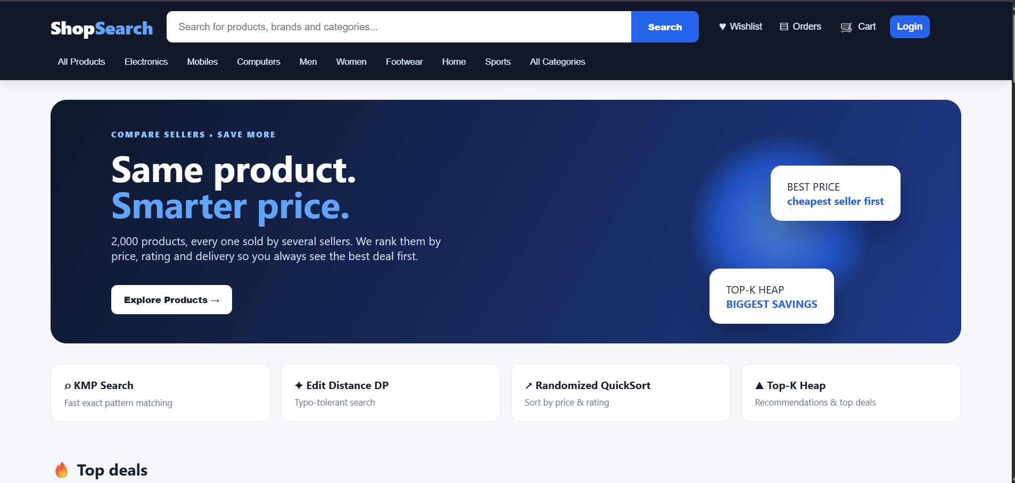
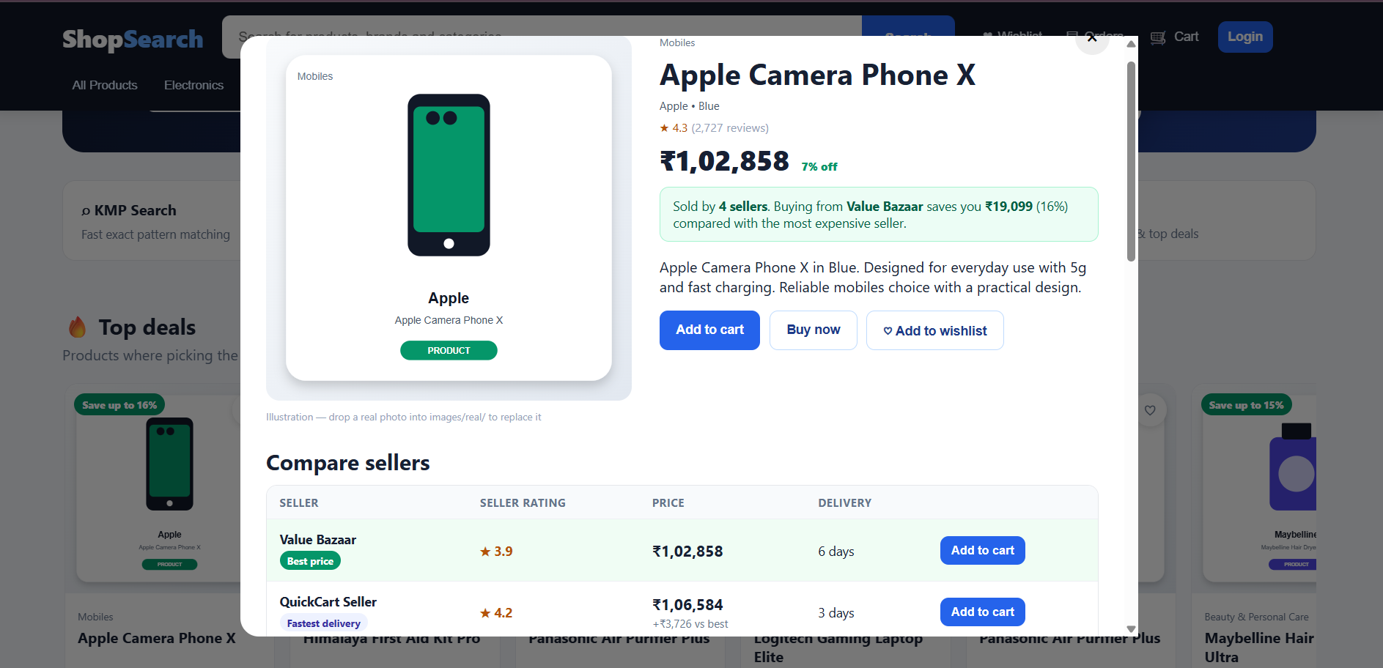
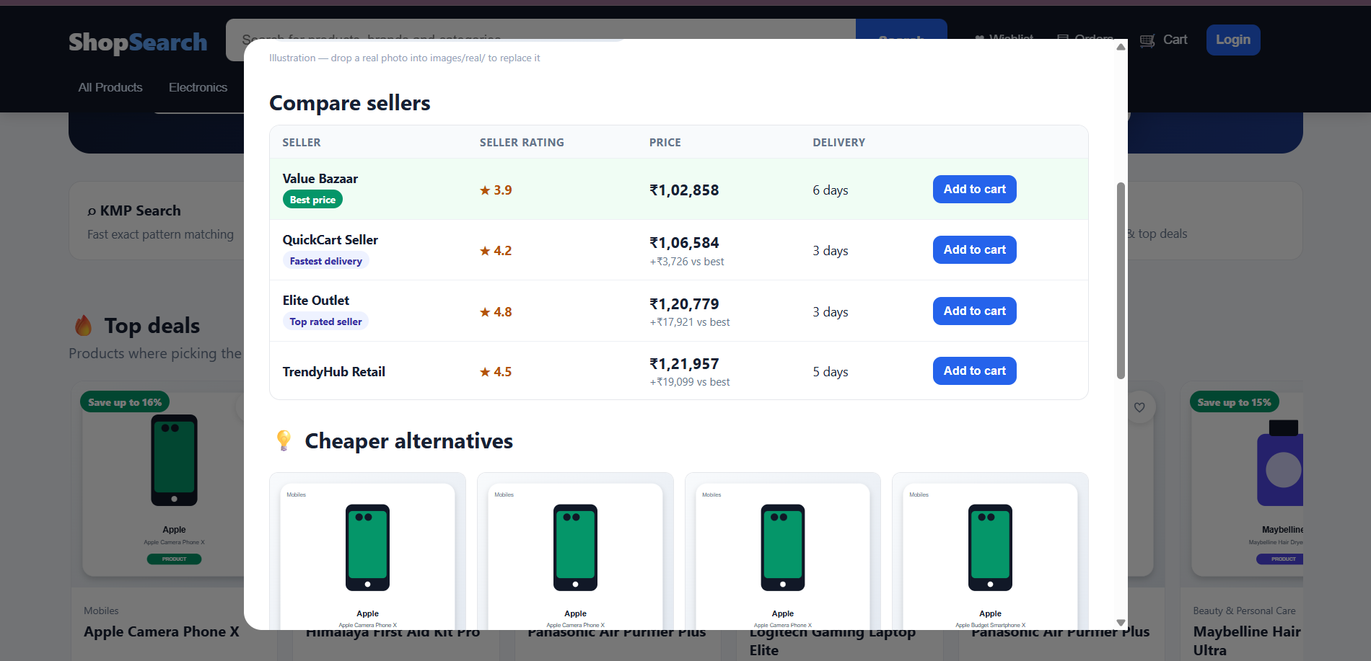
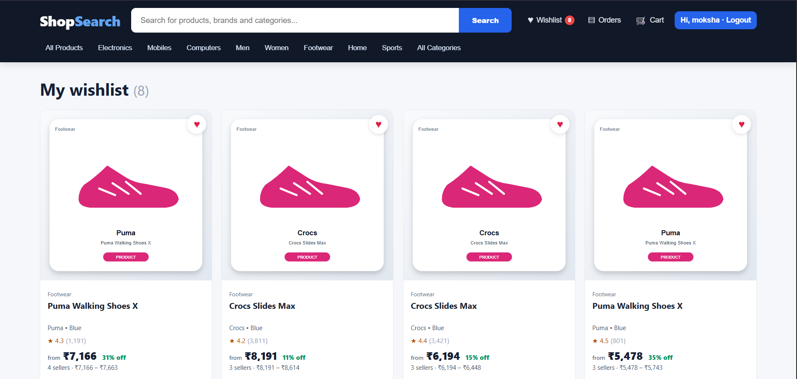
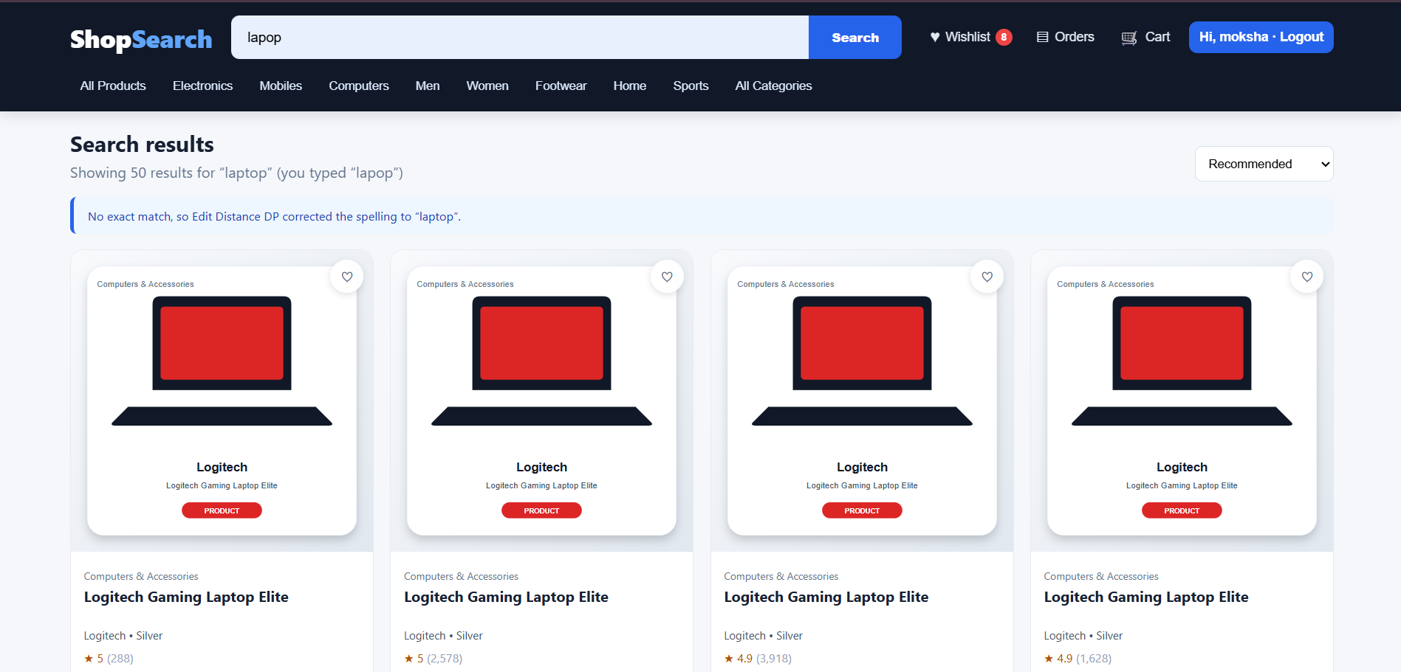

5.1 Dataset and Startup Validation
The supplied project dataset and Java demonstration were executed directly from the uploaded source archive. The algorithm demonstration reported 2,000 products loaded. The README identifies 5,752 seller offers in data/sellers.csv. The project therefore provides a sufficiently large catalog to demonstrate why bounded ranking, hashing, and efficient string matching are useful in the application.
Validation Item | Observed Result
Products loaded | 2,000
Seller offers | 5,752, as documented in README
KMP test | “headphones” found in “wireless headphones with bluetooth”
Edit Distance test | distance(“hedphones”, “headphones”) = 1
QuickSort test | 10 sample products sorted by cheapest seller price
Top-K recommendation test | 5 most similar products returned
Top-deals test | 3 largest seller price-gap products returned
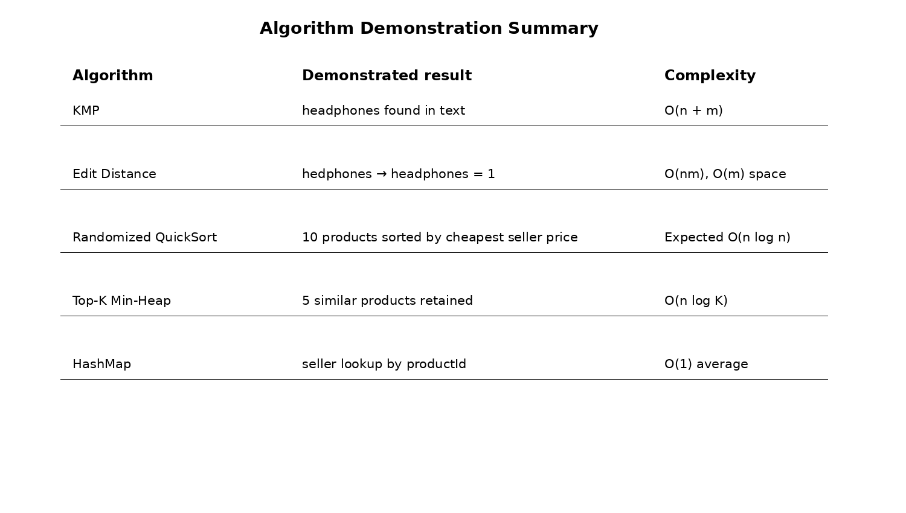
Fig. 5.1 Summary of the executed algorithm demonstration.

5.2 KMP Search Result
The executed AlgorithmDemo verifies that KMP identifies “headphones” inside the sample text “wireless headphones with bluetooth”. The implementation uses a precomputed LPS array so that mismatches do not restart the pattern from the beginning. In the web application, the same method is used against the combined name/category/brand/keywords text of each product.

5.3 Edit Distance Result
The executed demonstration reports a Levenshtein distance of 1 between “hedphones” and “headphones”, confirming that the typo can be treated as a one-edit difference. The server uses this distance to select a close vocabulary word when an exact KMP search returns no results.

5.4 Sorting and Seller Comparison Result
The Randomized QuickSort demonstration sorted a ten-product sample by cheapest seller price. The output began with Maybelline Hair Dryer Ultra at Rs. 3,436, followed by ONLY Co-ord Set Prime at Rs. 5,290 and Puma Walking Shoes X at Rs. 5,478. This confirms that the website sort operation can use seller-aware prices rather than only the product’s base list price.
For the sample product “Nothing Budget Smartphone Max”, the seller comparison output showed four offers. The cheapest was NovaMart at Rs. 23,270 with a 4.4 rating and two-day delivery; the other offers were QuickCart Seller at Rs. 24,379, MegaSave Retail at Rs. 25,889, and ShopEasy India at Rs. 26,972. This demonstrates the purpose of the seller HashMap and price sorting pipeline.

5.5 Recommendation and Top-Deal Result
The recommendation demonstration generated five similar products for “Nothing Budget Smartphone Max”, including Nothing 5G Smartphone Max, Nothing Camera Phone Max, Apple Budget Smartphone X, and Apple 5G Smartphone X. The top-deal demonstration identified Apple Camera Phone X, Himalaya First Aid Kit Pro, and Panasonic Air Purifier Plus as the three products with the largest seller price gaps in the tested catalog.

5.6 Complexity Analysis
Operation | Implemented Approach | Complexity
Exact product text matching | KMP | O(n+m) per text
Typo correction | Levenshtein DP | O(nm) time, O(m) space
Product/seller sorting | Randomized QuickSort | Expected O(n log n)
Top-K ranking | Bounded min-heap | O(n log K)
Product/seller indexing | HashMap | O(1) average lookup
Card validation | Luhn checksum | O(d)

5.7 Challenges and Limitations
- The current implementation uses CSV files instead of a relational or document database, so it is not designed for concurrent large-scale production workloads.
- The recommendation model is content-based and rule-scored; it does not learn from a large history of user interactions.
- Typo correction is vocabulary-based and uses a threshold, so unusual words may not be corrected.
- The payment system is explicitly simulated; it is not connected to a real payment gateway.
- The provided archive contains drawn SVG product images and supports optional real-photo fallback files; a complete production catalog would require a managed image service or CDN.
- The server stores active sessions in memory, so restarting the server requires users to log in again.

6. CONCLUSION AND FUTURE WORK

6.1 Conclusion
The Product Search and Recommendation System demonstrates how Data Structures and Algorithms can be embedded into a practical e-commerce application. KMP provides efficient exact pattern matching, Edit Distance with Dynamic Programming enables typo correction and name similarity, Randomized QuickSort supports seller-aware sorting, the Top-K min-heap avoids unnecessary full sorting when only a small set of best results is needed, and HashMaps provide fast indexing for products, seller offers, users, sessions, carts, and wishlists.
The executed demonstration confirms the core algorithmic behavior on the supplied catalog. The project also integrates the algorithms with a complete browser workflow containing product browsing, seller comparison, recommendations, authentication, wishlist, cart, checkout, and order history. This makes the system a useful demonstration of how DSA concepts can move beyond isolated classroom examples and become components of a working software system.

6.2 Future Work
- Add Aho-Corasick for efficient multi-pattern searching across large catalogs.
- Compare KMP, Z-Function, Rabin-Karp, and Aho-Corasick experimentally using the same dataset.
- Introduce database integration for scalable concurrent persistence.
- Improve recommendations using user browsing history, purchases, ratings, and collaborative filtering.
- Add an offline indexing phase such as an inverted index to reduce repeated scanning of the complete catalog.
- Add richer analytics, performance dashboards, and benchmark datasets.
- Integrate a secure production payment gateway and stronger account-management controls.
- Add real product-image ingestion and scalable image storage.

6.3 Skills Learned During Development
- Application of DSA concepts to a real software workflow.
- Java file handling, object-oriented design, and HTTP server development.
- Frontend integration through REST-like HTTP endpoints and JSON responses.
- Algorithmic complexity analysis and Top-K ranking.
- CSV data modelling and lightweight persistence.
- Testing, debugging, modularization, and project documentation.

REFERENCES
[1] Project source code and README: Product Search & Recommendation System for Shopping, uploaded project archive, 2026.
[2] T. H. Cormen, C. E. Leiserson, R. L. Rivest and C. Stein, Introduction to Algorithms, MIT Press.
[3] R. Sedgewick and K. Wayne, Algorithms, Addison-Wesley.
[4] Supplied DSA-3 project presentation, “Product Search and Recommendation System for Shopping”, 2026-27.
[5] Supplied “Guidelines for project document” and “Project Documentation format 2026-27” documents.

