TASK-1

CREATION OFF TERRAIN

Tried many times but, I didn’t know how to get rid of these pink colour error

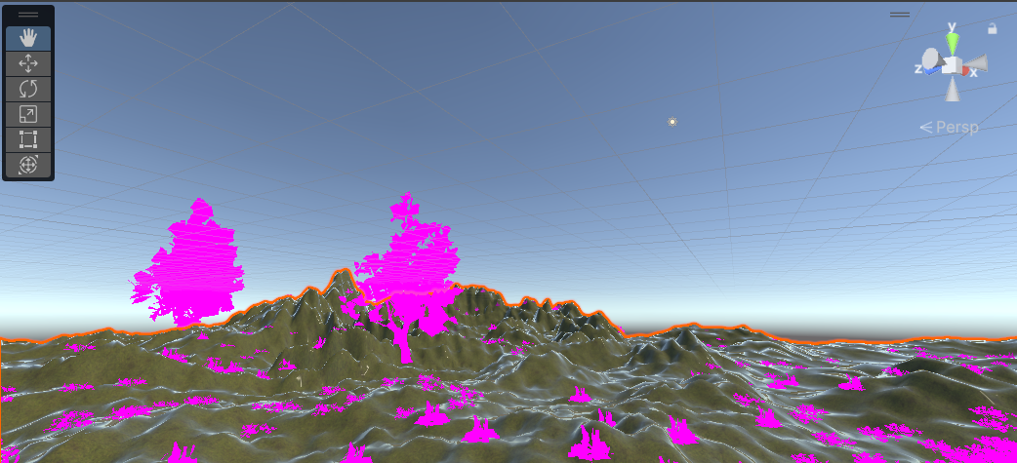

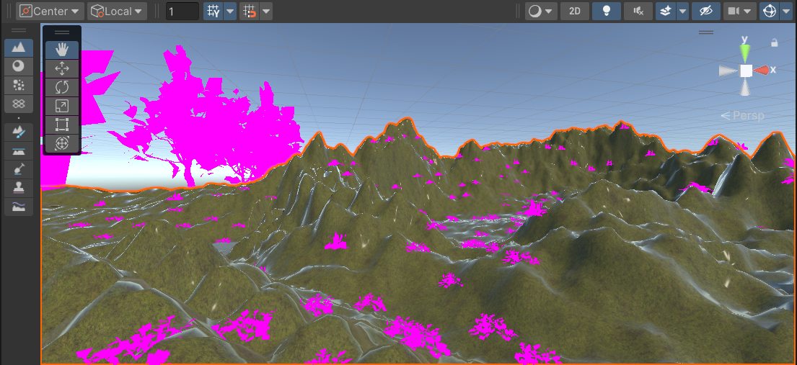

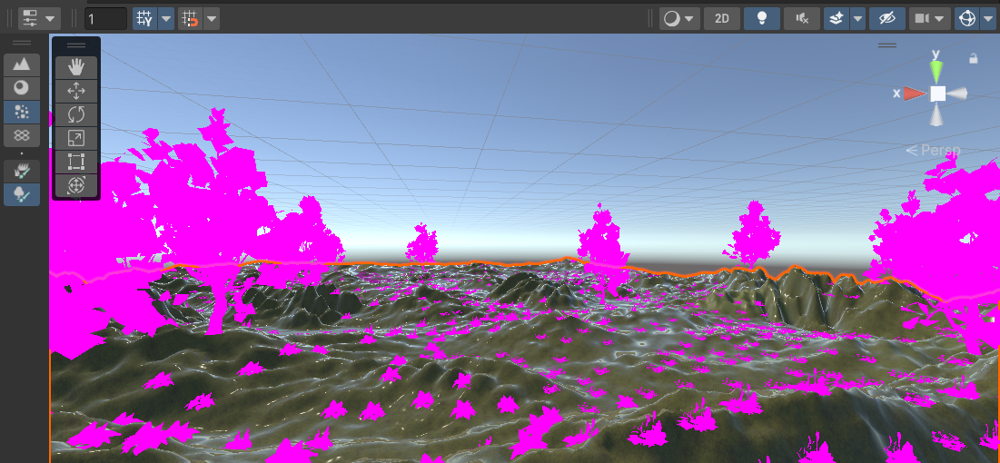



RESOURCES LINKS:

<https://assetstore.unity.com/packages/3d/vegetation/trees/realistic-tree-pack-vol-1-50418>

<https://assetstore.unity.com/packages/3d/environments/landscapes/mountain-terrain-rock-tree-97905>

<https://assetstore.unity.com/packages/3d/environments/unity-terrain-hdrp-demo-scene-213198>