PROJECT REPORT
CloudWatch
Server Resource Anomaly Predictor
A Web-Based Real-Time Server Monitoring and Anomaly Detection System

Contents
Part 1 — Project Case Study
Part 2 — Technology Case Study
Part 3 — Deliverables: Architecture, Workflow & Module Explanation

PART 1 — PROJECT CASE STUDY

1. Problem Statement
Modern IT infrastructure — whether on-premises servers, virtual machines, or cloud instances — generates a continuous stream of resource utilization data such as CPU load, memory consumption, disk I/O, and network throughput. When a server begins to behave abnormally, for example due to a memory leak, a runaway process, a denial-of-service attack, or hardware degradation, these symptoms usually appear first as unusual patterns in resource metrics. In most small and medium-scale environments, administrators rely on manual observation, static threshold alarms, or periodic log inspection to catch such problems. This reactive approach means that anomalies are often discovered only after they have already caused downtime, degraded performance, or service failures.
There is a clear need for a lightweight, web-based system that continuously monitors server resource metrics, automatically identifies abnormal patterns as they emerge, and presents this information to administrators through an intuitive real-time dashboard — rather than requiring administrators to manually watch raw numbers or wait for a service outage to investigate.

2. Existing System Analysis
Server monitoring today is typically handled in one of the following ways:
- Manual monitoring: Administrators periodically log into servers and check resource usage using commands or basic OS utilities.
- Static threshold-based tools: Traditional monitoring tools raise an alert only when a metric crosses a fixed, pre-configured threshold (for example, CPU usage above 90%).
- Heavyweight enterprise monitoring suites: Large-scale platforms offer comprehensive monitoring but are resource-intensive, complex to configure, and often unsuitable for smaller projects, academic environments, or single-server deployments.
These approaches form the baseline against which the proposed CloudWatch system is designed.

3. Drawbacks of Existing System
- Manual checks are time-consuming, inconsistent, and impossible to sustain around the clock.
- Static thresholds generate false positives (alerts during normal spikes) and false negatives (missed gradual or unusual anomalies that never cross the fixed limit).
- Fixed thresholds cannot adapt to a server's own historical usage pattern — a threshold suitable for one server may be meaningless for another.
- Existing enterprise tools are often complex, expensive, or overly heavy for small teams, students, or single-server use cases.
- Most basic tools lack a clean, real-time, easy-to-read visual dashboard for at-a-glance monitoring.
- Alerting is frequently delayed, disconnected from a central dashboard, or requires separate configuration.

4. Proposed Solution
CloudWatch is proposed as a lightweight, web-based Server Resource Anomaly Predictor built using the Flask framework. The system continuously collects key server resource metrics, analyzes them using statistical and pattern-based anomaly detection techniques, and displays real-time status through a responsive web dashboard built with HTML, CSS, and JavaScript. Instead of relying purely on fixed thresholds, CloudWatch studies the normal behavior pattern of a server over time and flags readings that deviate significantly from that pattern, enabling earlier and more meaningful detection of potential problems.
When an anomaly is detected, the system immediately raises a visible alert on the dashboard (and optionally via notification), allowing administrators to investigate and respond before the issue escalates into downtime.

5. Objectives of the Project
- To design a web-based system that continuously monitors key server resource metrics (CPU, memory, disk, and network).
- To implement an anomaly detection mechanism that identifies abnormal resource usage patterns rather than relying solely on fixed thresholds.
- To provide a real-time, easy-to-understand visual dashboard for administrators.
- To generate timely alerts when anomalies are detected.
- To maintain a historical log of metrics and detected anomalies for later analysis.
- To build the system using lightweight, open-source, and easily deployable technologies (Flask, HTML, CSS, JavaScript).
- To ensure the solution is simple to set up and scale for small to medium server environments.

6. Scope of the Project
The scope of CloudWatch covers the design and development of a functional prototype that:
- Collects server resource metrics at defined polling intervals.
- Stores metric history and detected anomalies in a database.
- Applies anomaly detection logic to incoming data.
- Presents metrics and alerts through a browser-based dashboard.
- Supports viewing of historical trends and past alerts.
The current scope is focused on single or small clusters of servers monitored from a central Flask application. Advanced distributed monitoring across large data centers, deep-learning-based prediction, and mobile app integration are considered future enhancements rather than part of the immediate build.

7. Features and Modules
Module | Description | Key Functionality
User Authentication Module | Handles administrator login and session management. | Login, logout, session-based access control
Metrics Collection Module | Gathers live CPU, memory, disk, and network statistics from the monitored server(s). | Uses psutil to sample system resources at intervals
Data Storage Module | Persists collected metrics and alert history. | Database read/write of time-series metrics
Anomaly Detection Engine | Analyzes incoming metrics against learned normal behavior to flag deviations. | Statistical baselining, threshold and pattern-based scoring
Alert & Notification Module | Raises and manages alerts when anomalies are found. | Dashboard alerts, alert history log
Dashboard & Visualization Module | Presents real-time and historical data to the user. | Live charts, tables, status indicators
Reporting Module | Summarizes system health over a selected period. | Historical trend view, exportable summaries

8. Workflow of the System
The diagram below illustrates the end-to-end operational flow of CloudWatch, from continuous metric collection through anomaly detection to dashboard visualization and alerting.
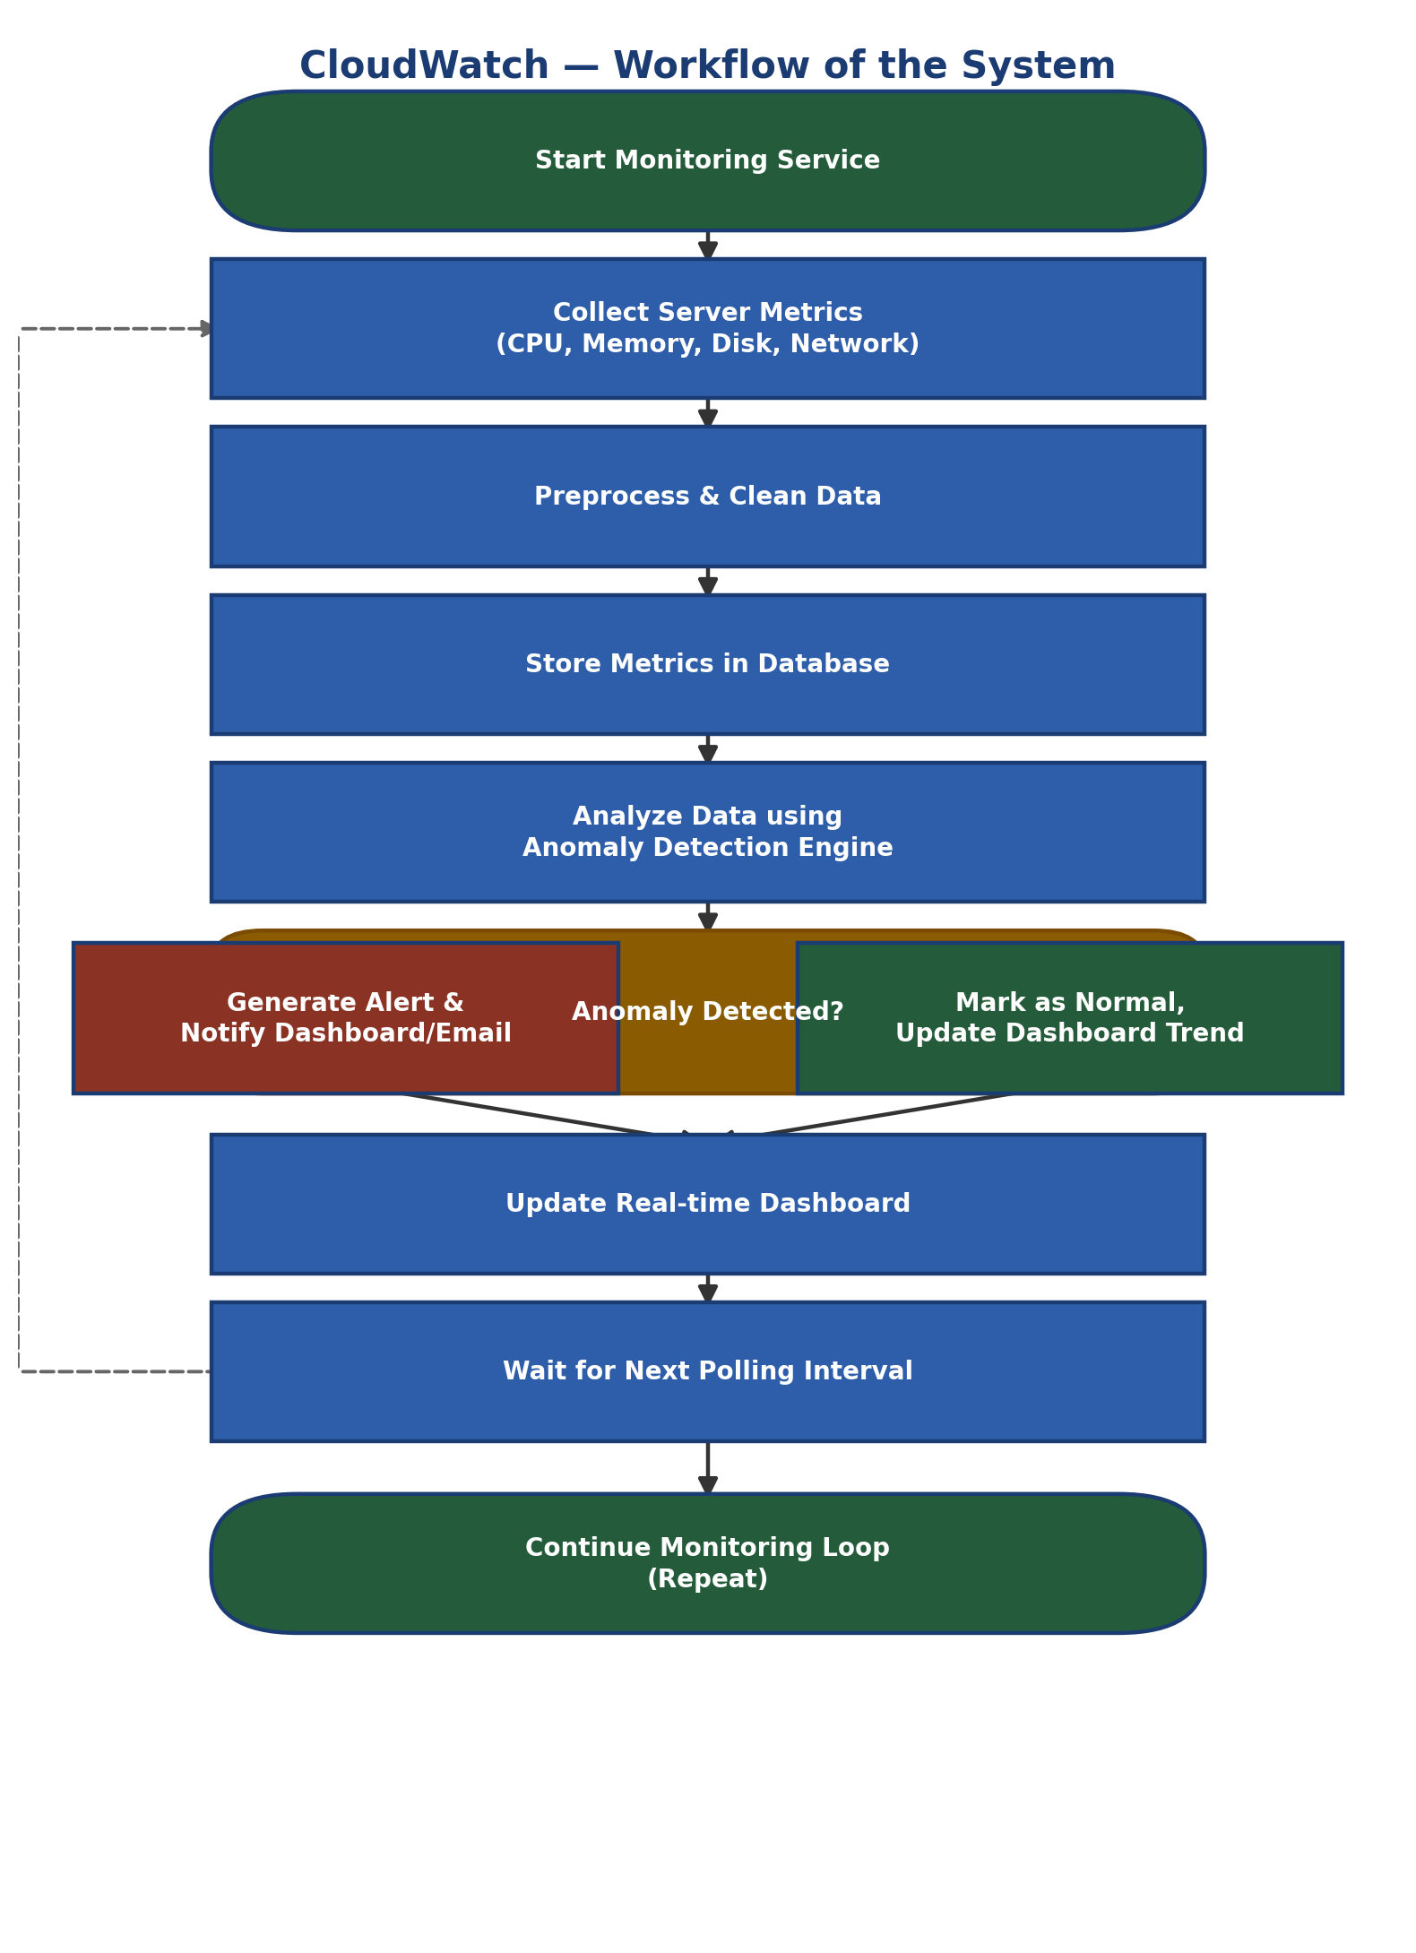
Figure 1: Workflow of the CloudWatch system
At a high level, the system continuously polls the monitored server for resource metrics, cleans and stores this data, evaluates it through the anomaly detection engine, and then either raises an alert (if an anomaly is found) or simply updates the dashboard trend (if the reading is normal), before repeating the cycle at the next polling interval.

9. Expected Outputs
- A real-time dashboard displaying live CPU, memory, disk, and network usage.
- Visual indicators (charts/status colors) distinguishing normal behavior from anomalous behavior.
- Instant on-dashboard alerts when an anomaly is detected, along with a timestamped alert log.
- Historical trend views allowing administrators to review past resource usage and past anomalies.
- A centralized, browser-accessible view of server health that removes the need for manual command-line checks.

10. Future Enhancements
- Integration of machine learning models (e.g., time-series forecasting) for more predictive, rather than purely reactive, anomaly detection.
- Support for monitoring multiple servers/clusters simultaneously from a single dashboard.
- Email/SMS/push notification integration for critical alerts.
- Role-based access control for multiple administrator accounts.
- Exportable PDF/Excel health reports on a scheduled basis.
- Containerized deployment (Docker) for easier scaling and installation.
- A mobile-friendly companion app for on-the-go monitoring.

11. Conclusion
CloudWatch addresses a genuine and common problem in server administration: the difficulty of catching abnormal resource behavior early using only manual checks or rigid, fixed-threshold tools. By combining a lightweight Flask backend, a responsive HTML/CSS/JavaScript dashboard, and a pattern-based anomaly detection engine, the project delivers a practical, easy-to-deploy monitoring solution suitable for small to medium server environments. The modular design also leaves clear room for future growth — from smarter ML-based prediction to multi-server and mobile support — making CloudWatch both a useful standalone tool and a solid foundation for more advanced monitoring platforms.

PART 2 — TECHNOLOGY CASE STUDY

1. Flask Framework

1.1 Introduction to Flask
Flask is a lightweight, open-source Python web framework classified as a 'micro-framework' because it provides only the core tools needed to build a web application — routing, request handling, and templating — without imposing a rigid project structure or bundling unnecessary components. It is built on top of the Werkzeug WSGI toolkit and the Jinja2 templating engine. Because of its minimalism and flexibility, Flask is widely used for building web dashboards, REST APIs, and small-to-medium web applications such as CloudWatch.

1.2 Features of Flask
- Lightweight and modular — only the essentials are included by default; additional capability is added through extensions.
- Built-in development server and debugger for rapid iteration.
- Integrated Jinja2 templating engine for dynamic HTML generation.
- Flexible URL routing using simple Python decorators (@app.route).
- RESTful request handling, supporting GET, POST, and other HTTP methods.
- Support for extensions such as Flask-SQLAlchemy (database ORM), Flask-Login (authentication), and Flask-WTF (forms).
- Werkzeug-based WSGI compliance, making it compatible with standard Python web servers.

1.3 Advantages of Flask
- Simple, readable syntax that speeds up development for small and medium projects.
- Minimal boilerplate — a working application can be started with only a few lines of code.
- High flexibility: developers choose their own project structure, database, and libraries.
- Large ecosystem of extensions and strong community support.
- Easy integration with front-end technologies (HTML, CSS, JavaScript) through template rendering.
- Well suited for building and exposing APIs consumed by dashboards or external systems.

1.4 Why Flask is Suitable for This Project
CloudWatch needs a backend that can periodically collect system metrics, run them through a lightweight analysis routine, persist the results, and serve both HTML pages and live data updates to a browser dashboard. Flask's minimal footprint keeps the monitoring service itself lightweight (important, since a monitoring tool should not itself become a resource burden on the server it watches). Its simple routing model makes it straightforward to expose endpoints for metrics collection, historical data retrieval, and alert management, while Jinja2 templating allows the dashboard pages to be rendered dynamically with live data. This combination of simplicity, flexibility, and low overhead makes Flask a natural fit for CloudWatch.

2. HTML

2.1 Purpose of HTML
HTML (HyperText Markup Language) defines the structure and content of web pages. In CloudWatch, HTML forms the skeleton of every dashboard page — organizing metric panels, navigation, alert tables, and forms so that CSS can style them and JavaScript can make them interactive.

2.2 Important Tags Used in the Project
Tag | Purpose in CloudWatch | Example Usage
<div> | Structural container for dashboard panels/sections | Wrapping each metric widget
<nav> | Top navigation bar for dashboard, alerts, reports | Sidebar/topbar navigation
<table> | Displaying tabular alert history and logs | Alert log listing
<form> | Login form and settings/threshold input forms | Admin login form
<canvas> | Rendering live resource usage charts via JavaScript | CPU/memory line charts
<section>/<header>/<footer> | Semantic page structuring | Page layout regions

2.3 Form Elements
Forms are used for the administrator login screen and for configuration inputs such as setting polling intervals or anomaly sensitivity. Key elements include:
- <input type="text"> and <input type="password"> for login credentials.
- <input type="number"> or <input type="range"> for threshold/sensitivity configuration.
- <select> dropdowns for choosing a server or a time range for historical reports.
- <button>/<input type="submit"> for form submission, paired with JavaScript validation.

2.4 Tables, Cards, Navigation Components
- Tables: used for the alert history log and historical metrics listing, with sortable columns for timestamp, metric, and severity.
- Cards: each resource metric (CPU, memory, disk, network) is displayed as a self-contained dashboard card showing a current value, a mini trend chart, and a status indicator.
- Navigation: a persistent sidebar/topbar allows quick movement between the Dashboard, Alerts, Reports, and Settings views.

3. CSS

3.1 Purpose of CSS
CSS (Cascading Style Sheets) controls the visual presentation of the HTML structure — colors, spacing, typography, and layout — giving the CloudWatch dashboard a clean, professional, and easily scannable appearance so administrators can interpret server health at a glance.

3.2 Responsive Design Concepts
Since administrators may check the dashboard from desktops, laptops, or tablets, CloudWatch uses responsive design principles: fluid layouts, relative sizing units (%, rem, vw/vh), and CSS media queries that rearrange metric cards from a multi-column grid on wide screens to a single column on narrow screens.

3.3 Flexbox and Grid Concepts
- Flexbox is used for one-dimensional layouts such as aligning items within the navigation bar, aligning icons with labels inside a metric card, and evenly spacing action buttons.
- CSS Grid is used for the two-dimensional dashboard layout — arranging the CPU, memory, disk, and network cards into a responsive grid that reflows based on available screen width.

3.4 UI/UX Design Principles
- Visual hierarchy: the most critical information (active alerts, abnormal metrics) is given the strongest visual weight (color, size, position).
- Consistency: a single color palette and spacing scale is used across all dashboard pages.
- Feedback: state changes (e.g., a metric turning anomalous) are reflected through clear color changes (e.g., green → amber → red).
- Minimal cognitive load: only the most relevant numbers and trends are shown by default, with details available on demand.

3.5 Professional Web Design Practices
- Use of a defined color system (status colors for normal, warning, and critical states).
- Consistent typography scale and spacing system across the interface.
- Accessible color contrast for readability of critical alerts.
- Separation of concerns: structure (HTML), presentation (CSS), and behavior (JavaScript) are kept in distinct files.

4. JavaScript

4.1 Purpose of JavaScript
JavaScript adds interactivity and live behavior to the CloudWatch dashboard — updating charts in real time, validating form input, and reacting to user actions without requiring a full page reload.

4.2 DOM Manipulation
JavaScript's Document Object Model (DOM) APIs are used to dynamically update metric values, redraw charts, and toggle alert banners as new data arrives from the Flask backend — for example, updating a card's displayed CPU percentage and its color state every polling cycle without refreshing the page.

4.3 Form Validation
Client-side validation checks login fields and configuration inputs (e.g., ensuring a threshold value is numeric and within an allowed range) before the form is submitted, giving administrators immediate feedback and reducing unnecessary server requests.

4.4 Dynamic Content Handling
JavaScript periodically requests fresh metric and alert data from the Flask backend (via fetch/AJAX calls) and updates the relevant sections of the dashboard dynamically, so the interface reflects near real-time server status.

4.5 Event Handling
- Click events for navigation between dashboard sections and for dismissing/acknowledging alerts.
- Change events for updating charts when a user selects a different time range or server.
- Interval-based events (timers) that trigger periodic refresh of metrics for real-time monitoring.

5. Flask Template Rendering

5.1 Project Structure
A typical Flask project structure used for CloudWatch separates application logic from presentation and static assets:
- app.py — main Flask application, route definitions, and startup logic.
- /templates — HTML template files rendered by Flask.
- /static — CSS, JavaScript, and image assets.
- /modules or /services — metrics collection and anomaly detection logic.
- /database or models.py — data models and database access.

5.2 Templates Folder
Flask looks for HTML templates inside a folder named 'templates' by default. Each dashboard page (login, main dashboard, alerts, reports) is stored here as a .html file using Jinja2 syntax, allowing the same template structure to be reused with different dynamic data.

5.3 Static Folder
The 'static' folder holds CSS stylesheets, JavaScript files, and images. Flask serves these files directly via a predictable URL path (e.g., /static/css/style.css), keeping presentation assets cleanly separated from application logic.

5.4 render_template() Method
The render_template() function is Flask's core mechanism for returning dynamic HTML. A route handler calls render_template('dashboard.html', metrics=current_metrics, alerts=recent_alerts) to combine an HTML template with live Python data, producing a fully rendered page sent back to the browser.

5.5 Jinja Templating Basics
- Variable output: {{ metric.value }} inserts a Python value into the HTML.
- Control structures: {% for alert in alerts %} ... {% endfor %} loops over data to build alert rows or metric cards.
- Conditionals: {% if metric.status == 'anomalous' %} ... {% endif %} changes styling or content based on data state.
- Template inheritance: {% extends 'base.html' %} allows a shared layout (navigation, header, footer) to be reused across all dashboard pages.

5.6 Passing Data from Flask to HTML
Data collected and analyzed in Python (current metric values, computed anomaly flags, alert history) is passed into render_template() as keyword arguments. Jinja2 then exposes these as variables inside the corresponding HTML template, enabling the page to display up-to-date server status every time it is rendered.

5.7 Dynamic Rendering Concepts
Beyond the initial page load, CloudWatch's dashboard also updates dynamically in the browser using JavaScript fetch calls to lightweight Flask API endpoints that return JSON metric data. This hybrid approach — server-side rendering for the initial page structure, combined with client-side dynamic updates for live values — keeps the dashboard responsive and close to real time without requiring full page reloads.

PART 3 — DELIVERABLES

1. Architecture Diagram
The architecture diagram below shows the layered structure of CloudWatch, from the monitored server(s) supplying raw resource data, through the Flask backend's collection and analysis layers, to the browser-based dashboard consumed by the administrator.
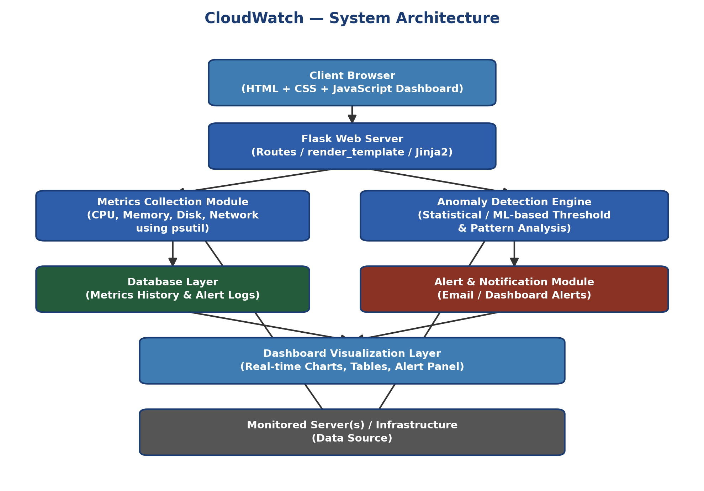
Figure 2: System Architecture of CloudWatch

2. Workflow Diagram
The workflow diagram (also shown earlier in Part 1, Section 8) traces the operational cycle of the system from metric collection through anomaly evaluation to alerting and dashboard refresh.

Figure 3: Workflow of the CloudWatch system

3. Module Explanation
The table below summarizes each core module of CloudWatch, its primary responsibility, and the main technology used to implement it.
Module | Responsibility | Primary Technology
Authentication Module | Secures dashboard access via administrator login and session control. | Flask, Flask-Login/session, HTML forms
Metrics Collection Module | Periodically samples CPU, memory, disk, and network usage from the server. | Python (psutil), background scheduler
Data Storage Module | Persists time-series metrics and alert records for later retrieval. | SQLite/SQL database, Flask-SQLAlchemy
Anomaly Detection Engine | Compares incoming readings against learned normal patterns to flag deviations. | Python statistical logic
Alert & Notification Module | Creates, stores, and surfaces alerts when anomalies are detected. | Flask routes, database, dashboard UI
Dashboard & Visualization Module | Renders real-time metric cards, charts, and alert panels. | HTML, CSS (Flexbox/Grid), JavaScript, Jinja2
Reporting Module | Provides historical trend views and summarized system health reports. | Flask routes, Jinja2 templates, JavaScript charts

Conclusion of Report
This report has presented the complete case study for CloudWatch — Server Resource Anomaly Predictor, covering the problem it addresses, the design of its proposed solution, the technologies chosen to build it, and the architecture and workflow that tie those technologies together. Flask, HTML, CSS, and JavaScript together provide a lightweight yet capable stack for building a real-time, web-based monitoring dashboard, while the modular design ensures the system can be extended with more advanced anomaly detection and multi-server support in the future.

