


\\\\\\\



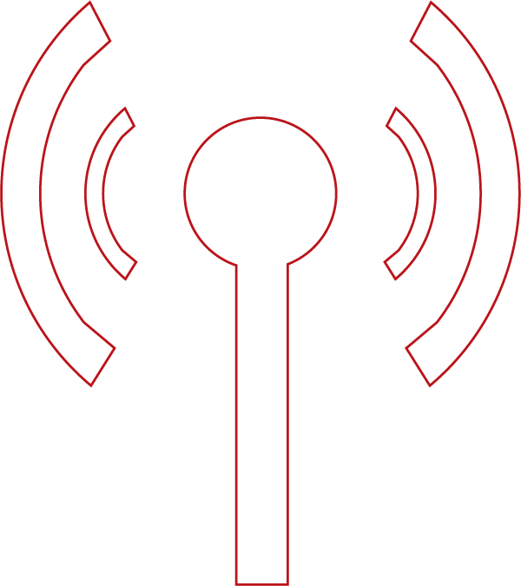

Coupons

Contents
About Coupons ………………………………………………………………………………………………..1
About Document ……………………………………………………………………………………………..2
Coupons …………………………………………………………………………………………………………..3
Manage Coupons 3
Manage Coupon Distribution 16
Coupon Redemption 19
Screenshot Examples 21
Event 26
Coupons Priority Order 27
Redeeming the Coupon 28
Manage Subscription 28
Sign-up 29
Event 32
Coupon related Tables 33
Time Zones in Coupons 34
Support …………………………………………………………………………………………………………..37
Copyright ……………………………………………………………………………………………………….38

About Coupons

As per the marketing definition, the Coupon is a ticket or document that can be redeemed for a financial discount or rebate when purchasing a product.
In the same way, in our system, the Coupon is treated as a promotional offering that is offered to the Customers in the form of discount percentages/amounts.
The Coupons are offered by the Service Provider to attract new customers, to retain the existing business customers, to sustain in the competitive market, to increase marketing sales, etc.
Mostly the Coupons are offered on some condition like eligibility criteria of the Customer or on his purchase made. Example: A discount of 10 % is offered to all the On-board customers who subscribe to the plan worth Rs.500/- or above, etc.
Here in this system, the User can use various criteria attributes while defining the Coupons. The available Eligibility criteria attributes are Customer type (E.g. VIP, Student, etc.), Applicable Processes (E.g. New Order, Renewal, Upgrade, Customer On-board, etc.), Geo Region (E.g. North Region, South Region, etc.), Operational Entity, Segments, and Applicable Products.
Generally, the Service Providers offer promotional discounts on Plans/Products for a certain duration of time to the Customers. Once the Coupon’s validity is elapsed, the same cannot be used to avail the offered discount.

About Document

This document offers knowledge on the Coupons feature and helps the User in defining various Coupons (Generic Coupons and Birthday Coupons) using the Manage Coupons screen.
It also helps the user in understanding the Coupons related screens and their usage along with the necessary pre-requisites etc.
After reading the document, the User should be able to define the Coupons for different eligibility criteria in the MQ System, and also should be able to understand how to redeem the defined Coupons.

Coupons

Manage Coupons
To define a Coupon in the System, the Manage Coupons screen is used.
Follow these Steps:
- On Settings, Click Order Management, click Product Catalogue, and then click Manage Coupons.
The Manage Coupons screen appears.
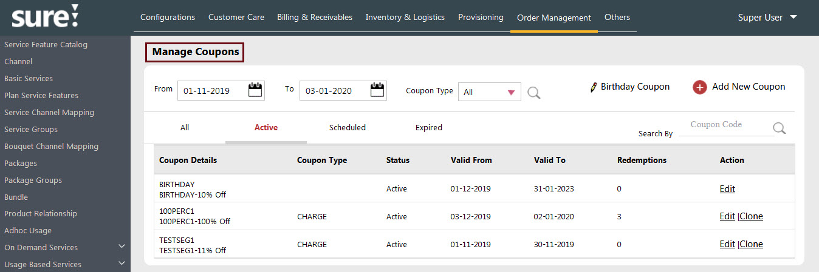
Screenshot showing Manage Coupons Screen
- To define a new Coupon, Click.
The New Coupon screen appears.
- In the Coupon Code box, define the name for the Coupon code.
- Click the Subscription option button and select the Coupon Type as Charge, Payment, Freebies, or Gift.
- Charge: This is used to apply the Coupon code on the Subscription Charges of the Customer.
Example: Let’s say the Subscription Charges of the Customer is Rs. 500/- (Minimum Order Value is Rs. 100/-). So, when the Charge is selected as a Coupon Type, the System considers and applies the defined coupon discount (discount of 5 % i.e. Rs. 25/- ) on the Customer’s Subscription Charge i.e. on Rs. 500/-
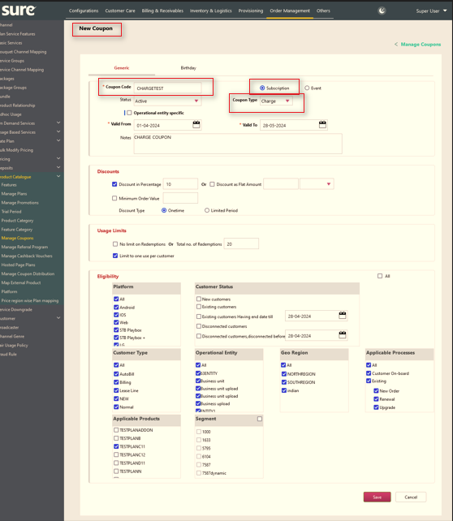
Screenshot showing New Coupon Screen for the Coupon Type Charge

- Payment: This is used to apply the Coupon code on the Customer’s Payment type/mode. I.e. on Debit Card, Credit Card, Net banking, etc.
Example: Let’s say, the Customer needs to pay Rs. 500/- as Subscription charges and the Discount Amount of AUD 50 is defined only for the Paymode Credit Card.
In this case, the Customers who pay the Subscription Charge with Credit Card only will get the discount of AUD 50. (As the Coupon Type is Payment and the Paymode is Credit Card).
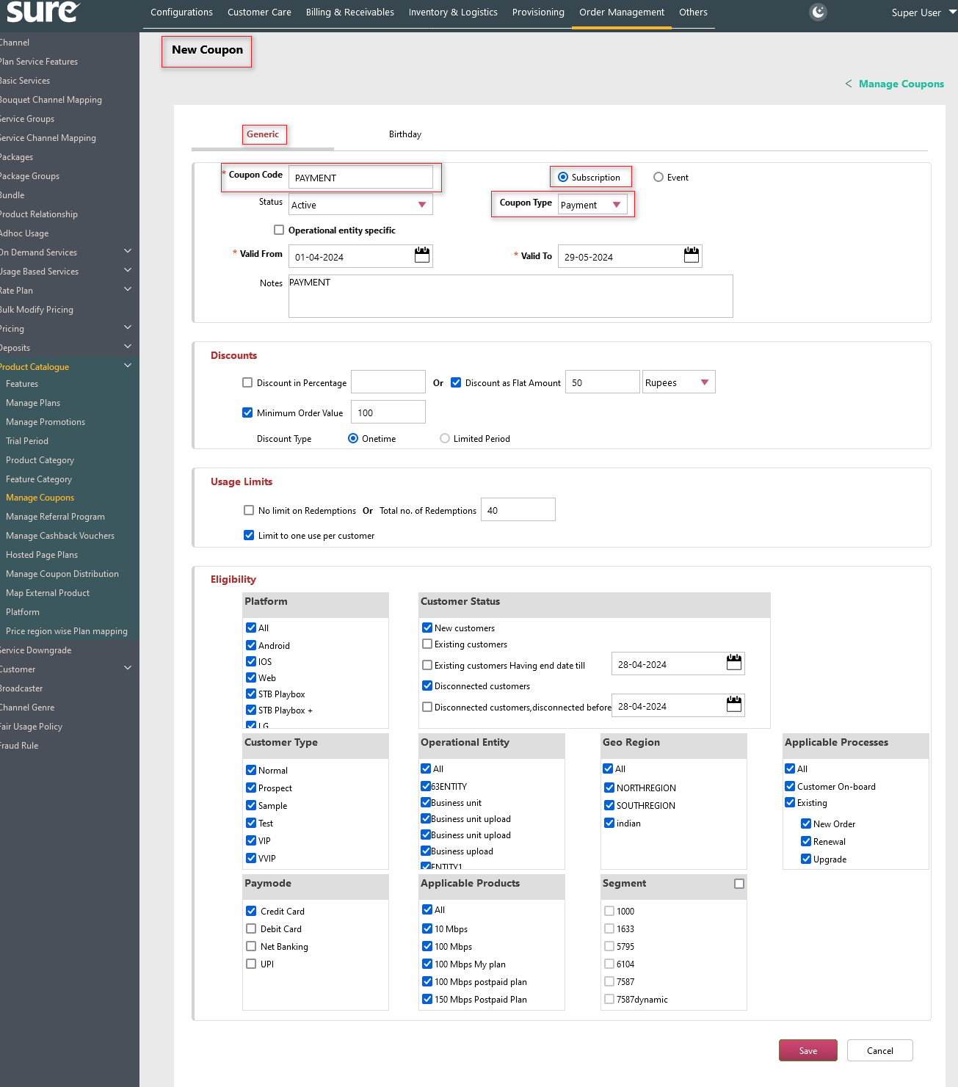
Screenshot showing New Coupon Screen for the Coupon Type Payment

Imp Note:
- In the case of Coupon Type Payment, the discounted amount is not deducted from the Grand Total Amount, but it will be offered to the Customers as a Cashback.
- For the Coupon Type Payment, the customer will have additional criteria i.e. Paymode (Payment Modes) in the Eligibility section. (See here in the Eligibility Section)
- Freebie: The term freebie implies the thing(s) that is offered free of charge (Basically the freebies are 100% discount offerings to the Customers).
This Coupon Type Freebies can be applied to the Subscription and Event types.

Note: All Freebies coupons are only valid for customers' prepaid plans.

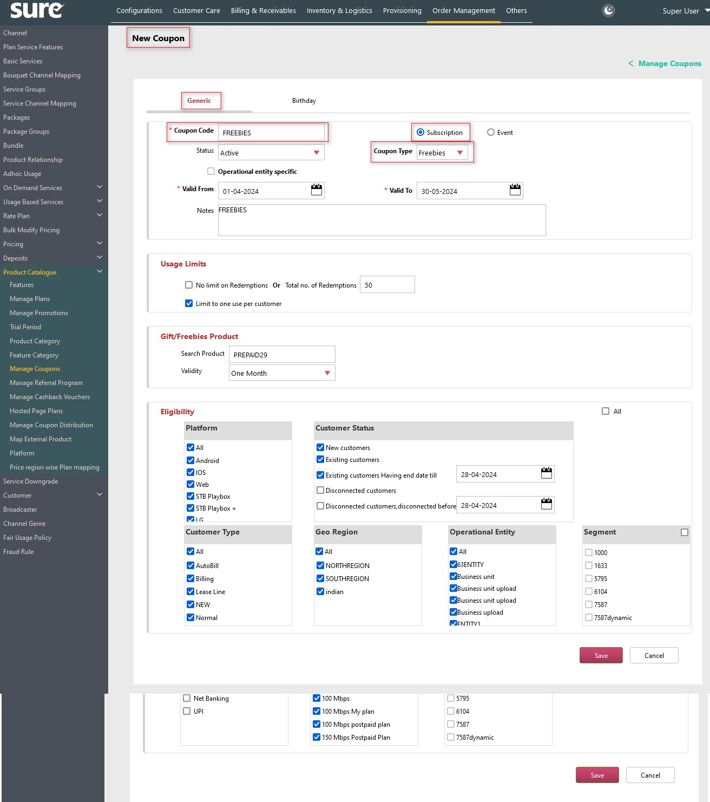
Screenshot showing New Coupon Screen for the Coupon Type Freebies
- Gift: This Coupon Type is used to gift the Subscription Product or an Event to their friends or family.

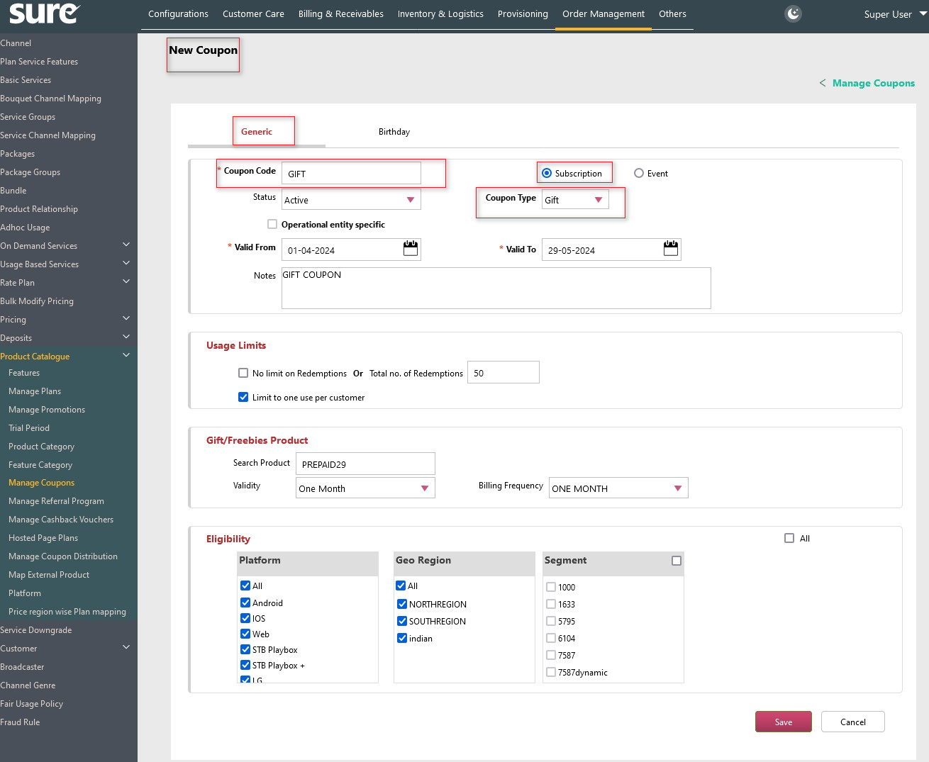
Screenshot showing a New Coupon Screen for the Coupon Type Gift.
Note: For Coupon Type Gift and Freebies, the Gift/Freebies section is replaced with the Discounts section and this coupon type is applied on only Single Plan.
Note: All Gift Coupons are only valid for customers' prepaid plans.
- From the Status list, select the status of the coupon as Active to enable the Coupon feature.
Note: Status Inactive disables the Coupon feature.
- In the Valid From and Valid To box, enter/select the valid from date and valid to date. The Valid From value is the starting date of the coupon and the Valid To value is the expiry date of the coupon.
- Enter the relevant notes for the Coupon in the Notes box if any.
- In the Discounts section, select the discount type as Discount Percentage or Discount Amount.
- Discount Percentage: The Discount Percentage offers a discount as Percentage on the defined Coupons.
For the Discount Percentage: In the Discount Value box, enter the discount percentage value. Example: 20. (Implies, 20% of discount).
- Discount Amount: The Discount Amount offers a discount as a Flat Amount on the defined Coupons.
For the Discount Amount: In the Discount Value box, enter the discount amount value and select the Currency type from the list.
Example: 50 (Discount Amount) and Rs (Currency Type).
- Select Minimum Order Value check box to set the minimum order value for the Customer in availing the Coupon Code.
Enter the minimum order amount value in the Minimum Order Value box.
Example: If the check box is selected, and if the value in the text box is 500, it implies the Coupon is applied to the Customer only if he does the minimum transaction of Rs. 500/-
- The Discount Type can be of Onetime or to a Limited Period. Select the required option.
For the Limited Period option, you have Beginning of the term and Specific term values in the Apply on list. Enter the number of months’ details in the Months(s) box.
- Beginning of the term: This implies, the discount is applied only for the number of months’ that is given in Months(s) box.
Example: If the Contract is for 12 Months, and if the Beginning of the term value is 3 Month(s), then the discount is applied only for the first 3 months.
- Specific Term: This implies, the discount is applicable only for the particular months’ value that is given in the Month(s) box.
Example: If the Contract is for 12 Months, and the Specific Term value is 1, 3, 5 Month(s), then the discount is applied in the 1st, 2nd, and 3rd Months.
Note: For Specific Term, you can give Month(s) value by comma-separated. E.g. 1, 3, 5.
- In the Usage Limits section, enter the value in the Limit number of redemptions to box to restrict the usage of the Coupon for the given value times.
Example: If the value given in the Limit number of redemption to box is 100, it implies the Coupon is used only for 100 times in total.
Note: Here, the System verifies the redemption count of the Coupon i.e. 100 times; irrespective of the Coupon being used only by one Customer or different Customers.
- Select Limit to one use per customer check box to limit the usage of the Coupon only for one Customer. In other words, this check box selection limits the Customer to avail the Coupon only once.
- Select the Operational entity specific check box to define the coupon as entity-specific. I.e. The Coupon defined with this check box can be distributed to particular Customer/Customers of an Operational Entity or to the selected Operational Entities.
Note: The distribution of these coupons can be made using the Manage Coupon Distribution screen.
- The Eligibility section is used to apply the eligibility criteria using the Coupon’s criteria attributes.
In other words, the selected attribute values from this section are eligible for availing the coupon facility.
The available attributes in the screen are Customer Type, Geo Region, Operational Entity, Applicable Processes, Segment, and Applicable Products.
Note: Clear the All check box in the Eligibility section to view the Coupon attributes.
By default, the All check box is selected, and it will not show attributes of the Eligibility section.
The following are the Coupon’s eligibility attributes:
- Customer Type: The Customer Type criteria hold the values of all Customer Types.
Example: Customer Types like VIP Customer, Student Customer, etc.
- Geo Region: The Geo Region criteria hold the values of different geographical locations.
- Operational Entity: The Operational Entity criteria hold the values of different Operational Entities.
Note: To enable the Operational Entity in the Eligibility section, you need to set the ENABLEOPENTITY value as TRUE in the web. config file.
- Applicable Processes: The Applicable Processes criteria hold the Customer’s Transaction Type values like whether the Customer is a new On-board Customer, or an existing Customer with New Order, Renewal, or Upgrade.

Note: For the Upgrade, the defined coupon will be applied to the Customer only in the case when the Customer upgrades his plan as part of the change order.
- Applicable Product: The Applicable Product criteria hold the values of the products i.e. actual plans existing in the System.
- Paymode: The Paymode criteria hold the values of different Payment modes/types. Example: Credit Card, Debit Card, Net Banking, etc.
Note: The Paymode criterion appears only for the Coupon Type Payment.
- Segment: The Segment criteria hold the values of different segments that are defined from the Segment screen.
Note: The Segments, which are defined in the Segments screen are the potential Customers identified for some business requirements.
- Select the required check boxes of the attributes from the Eligibility section to apply the eligibility criteria and click Save to save and define the Coupon.

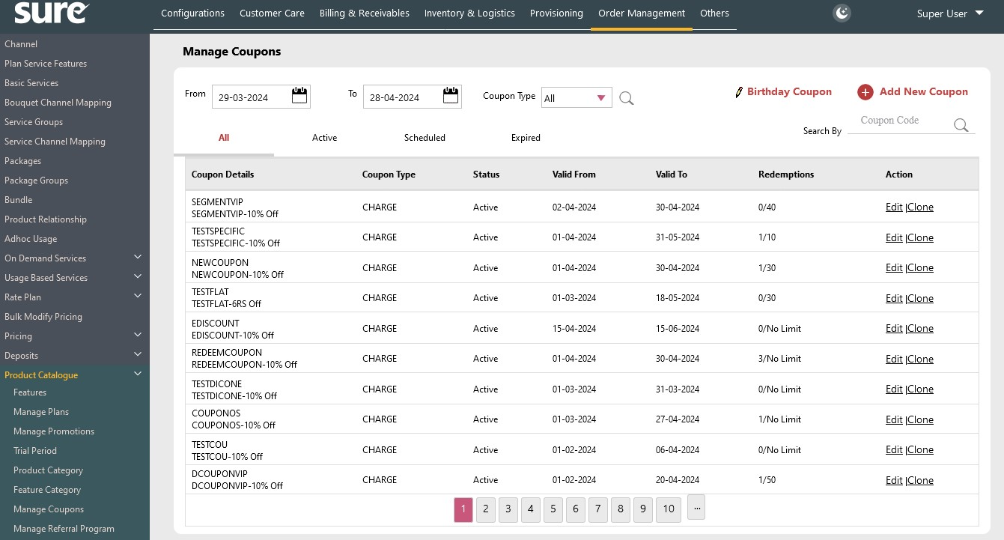 Screenshot showing the defined Coupons in the Manage Coupons screen.
To define a Birthday Coupon:
Imp Note: The Customer should have his birthday registered with the system to avail the Birthday Coupon.
- In the Manage Coupons screen, click link.
The New Coupon screen for birthday appears.

- Define the name for the birthday coupon in the Coupon Code box.
- Select the Status as Active to enable the Birthday Coupon Code.
Note: Status Inactive will disable _{the} Birthday Coupon Code.
- In the Valid From and Valid To boxes, select the Coupon Code’s Start date and End date.
- Enter the relevant notes for the Birthday Coupon in the Notes box if any.
- Follow Steps 8 and Step 9 as shown above for applying the Coupon’s discounts.

- In the Applicability section, enter the value for the number of days the Coupon is made available to the Customer before/after the Customer’s birthday.
Example: If the value given in the box is 5 then the Birthday Coupon is made available 5 days before and after the birthday of the Customer.
- After defining the birthday coupon, click Save to save the details.
To Apply the Birthday coupon using the Service Order Screen in Native Portal, FFA and LCO:
Imp Note: The Customer should have his/her birthday registered with the system to avail of the Birthday Coupon.
Follow these steps:
1. On Order Management menu item, click the Service Order screen.
2. In the Customer # box, enter the customer number to whom you want to distribute the coupon.
Note: Here, By default Create New Subscription button should be enabled to create a plan for the user.
3. From the Create New Subscription section, choose a plan from the given Basic Plan lists.
4. From the Select Product(s) section, enter/select Order Date (order start date), Effective Date (order end date) and Number of Rooms (value in number).
Note:
- Once the plan is successfully selected, a Coupon/Promotion Code box will appear. Here, the user can manually apply the coupon or use the search button to find the coupon code from the coupon list.
- When the Coupon Code is entered, the system generates a message containing the Coupon Code and the amount of the discount.
Example: Coupon 48154 is applied. Rs.61.50 discount applied.
5. Click on Save.
To Apply the Birthday Coupon in Manage Subscription screen for Selfcare Portal.
Manage Subscription:
The Manage Subscription screen is used to book a new Plan order or to renew the existing Plan.
Follow these steps:
- On the Self-Care Portal screen, click MANAGE SUBSCRIPTIONS.
The Order Booking screen appears.
- In the Order Booking screen, Renew and New Plan sections will appear.
- For the new plan selection, click the New Plan tab. The new plans appear in the Base, Bouquets, and Alacarte lists respectively.
- For the Renew selection, click the Renew tab. The existing plans lists will be displayed.
- Select the Plan from the list (E.g. Base Plan). The corresponding plan appears in the Cart section with the Plan’s Subscription Charge details. If the Coupon is defined and applicable for the Customer, the same (Coupon Code) is shown in the Coupon Code list.
- Click the Coupon Code list and click Apply to apply the Coupon.
Note: Once the Coupon is applied, the discount value is deducted from the Grand Total amount and the remaining Payable amount is shown below the Grand Total.
For the Customer’s readability, the Grand Total amount is shown strikethrough and the payable amount (Grant Total – Discount Amount) is shown along with the discount value description.
- Once the Payable amount is shown, click Confirm to book the order.

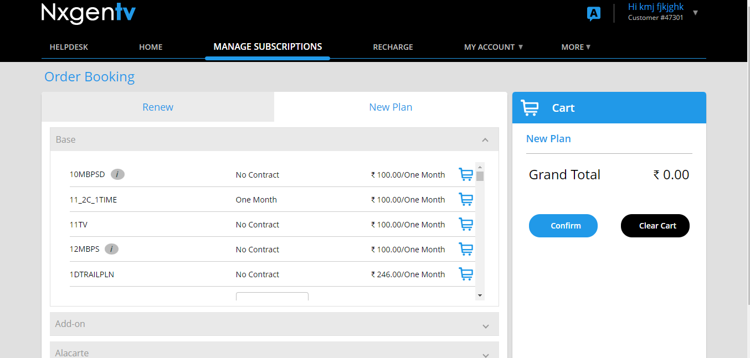
Screenshot showing the Manage Subscription screen for applying the Birthday Coupon to Renew and New Plans.
To Search / Edit / Clone the Coupons.
To Search:
- Enter the Coupon’s start date and end date in the From and To boxes respectively.
- Select the Coupon Type from the list and click. The search criteria result appears in the table below.

- To search the specific coupon, enter the Coupon Code in the Search By and click enter key or Search Icon. The search criteria result appears in the table below.
To Edit:
- To edit a Coupon, click Edit link against the required Coupon. The screen navigates to the Edit Coupon screen for modification.
Note: In the Edit Coupon screen, the Coupon Code, Eligibility Section, and Discount Type are not allowed for modification. For the Discount Type, the change of Percentage to Flat and vice versa is not allowed but its values (i.e. Percentage/Flat values) can be modified.
- Modify the applicable fields and click Save to save the same.
- To view the modify/edit history of the Coupon (if any), click View History.
Note: The View History button is available only when there is a history of Edit Coupon.
To Clone:
The Clone action creates the replica of the Coupon definition, where the User can make use of the same Coupon definition but with a different name.
Note: Here the User cannot change the Coupon definition except the Coupon Code name.
- To Clone the Coupon, Click Clone link against the required Coupon. The screen navigates to the Edit Coupon screen with only Coupon Code in editable mode.
- Once the Coupon Code is modified, Click Save to save the clone details.


Screenshot showing the Edit/Clone options under the Action column.
Note:
- The Birthday Coupon will not have the Clone Option.
- In the Manage Coupons screen, different tabs like All, Active, Scheduled, and Expired are provided to filter the existing Coupons
Example: If the Active tab is clicked, then all the Active Coupons are displayed, e

Manage Coupon Distribution
Earlier, the System was used to suggest the best applicable Coupons to the Customers at the time of transactions like Sign-up, New Order, Renew, or Upgrade. The Customers were not aware or have communication regarding the Coupons and their benefits. The Coupons defined were with respect to the selected plans. I.e. there is no personalization for the distribution of the Coupons to the particular Customers, Operational entities, etc.
Now, a new screen Manage Coupon Distribution screen is provided to handle these scenarios.
The Manage Coupon Distribution screen is used to define and manage the coupon distribution. I.e. the User can make his personalization against the defined Coupons and can distribute the Coupons to the Customers, Segments, Operational Entities, or for a Sign-Up (New Customers).
And also, the User can view the list of defined coupons in different tabs like All, Pending, Approved, Published, and Cancelled based on the Coupon status. The User can take action like Approve, Cancel, Edit, and Publish against the coupon based on its status.
Example: The actions like Approve, Cancel, or Edit can be made on the Pending coupons, like-wise the action Publish can be made for the Approved coupons.
Follow these Steps:
- On Settings, Click Order Management, click Product Catalogue, and then click Manage Coupon Distribution.
The Manage Coupon Distribution screen appears.
- Click to distribute the defined coupon.
The Coupon Distribution screen appears.
- In the Coupon section, select the required coupon from the Coupon list.
Note: The selection of Operational Entity Specific check box lists only the Operational Entity specific coupons in the Coupon list. I.e. the coupons which are defined with Operational Entity Specific check box in the New Coupon screen.
- The Approve check box approves the definition of the coupon distribution.
Note: The distribution of the coupon is possible only when the Approve check box is enabled.
- In the Distribute To section, select the required option to distribute the Coupon.
The following are the values under this section:
- Customer #: Enter the Customer number in the Customer # box to distribute the Coupon to the entered Customer.
- Segment: Select the required segment from the Segment list and enter the quantity value of the coupons in the Quantity box.
- Operational Entities: select the required operational entity from the Operational Entities list and enter the quantity value of the coupons in the Quantity box.
Select the Branch check box to list the Internal Operational Entities in the list.
- Sign Up: Select the Sign Up option when you want to distribute the coupon for the Sign-ups i.e. New Customer. Enter the quantity value of the coupons in the Quantity box.
- In the Distribute With section, enter the alias name or the unique Code for the configured distribution Coupon.
In other words, for the configured distribution coupon, you can give any alternative or alias name in the Coupon Alias box or you can define a Unique Code for the Coupon by giving the Prefix, Suffix, and its Length values in the respective boxes.
- In the Publish With section, select the Email Template and SMS Template from the respective lists and enter/select the publish date from the Date box.
Note: The configured email/SMS details are sent to the Customers regarding the Coupon.
- Enter the notes in the Notes box if required.
- Click Save to save the coupon distribution.

Points:
Following are the miscellaneous points with respect to the Coupon Distribution feature:
- Coupons that are distributed to the Operational Entities would be given by the Operators for their Customers from the Native Portal and these Coupons will not be displayed in the Self-Care portal.
- In case of a coupon that has to be published with a future date, a job Publish Coupons is provided for sending Email/SMS on the publish date.
- The coupon with the maximum discount will be displayed by the System even if more than one coupon is distributed to the Customer.
- The user can Approve or can do a Pending transaction.
- The user has the option to select coupons that are Entity-specific.
- Publish can be done only in the case of Segment and Customer distribution.
- Tagged Coupons (Customers of the Segment) will be displayed on the Home page of the Self-care portal if not published.
- An ART report will be provided to view the list of customers associated with coupons.
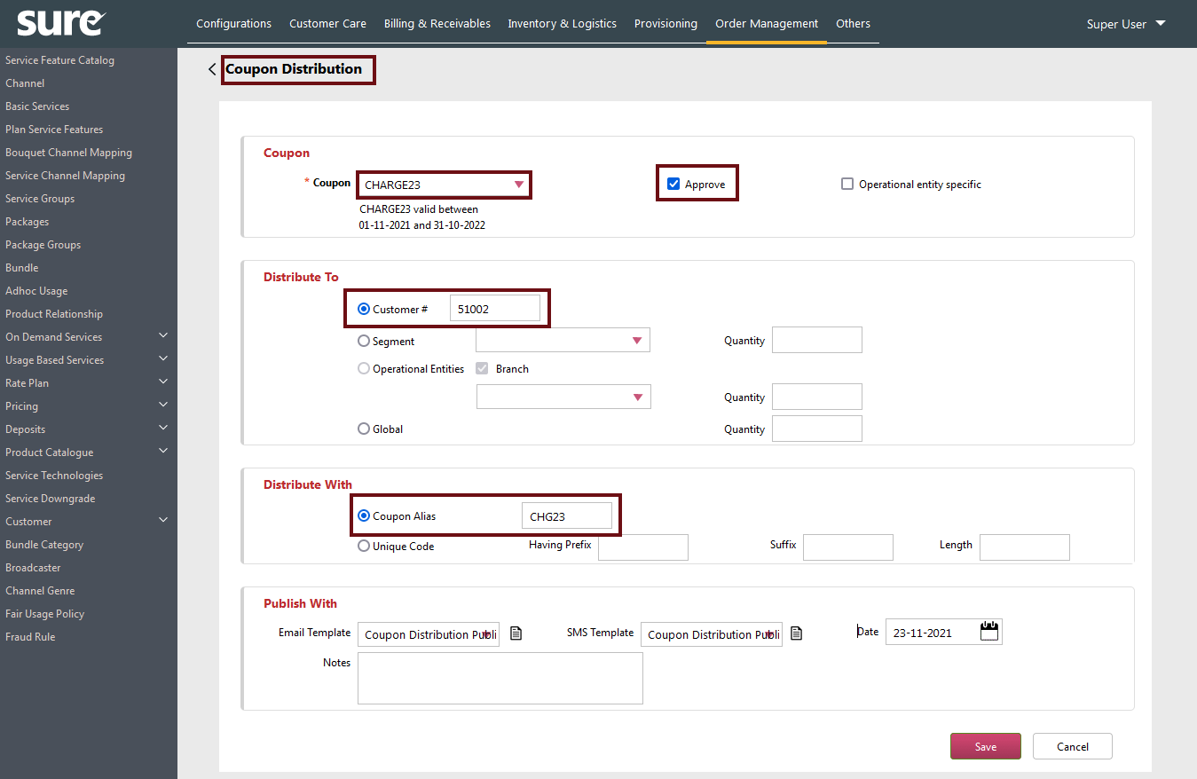
Screenshot showing Coupon Distribution screen

Coupon Redemption
This screen is used to redeem the distributed coupon. The coupons that are defined and distributed to Customer # and Segments in the Coupon Distribution screen can be redeemed from this screen.
Note:
- This screen is used to redeem only the charge coupons.
- In the New Coupon screen, the Applicable Product selection should be to a single plan for redeeming the coupon from the Coupon Redemption screen. In other words, From Coupon Redemption screen, only single plan is considered for redeeming the coupon.
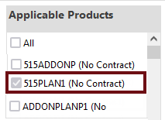
- The Entity Specific coupons will not be shown in the Coupon Redemption but will be showed in the Service Order screen.
- The base coupon must be defined with single plan.
- The plan should have single billing frequency mapped to it.
- For now while redeeming, the list of billing frequency will come only for plans defined from simple product screen.
Follow these Steps:
- On Order Management menu item, click Coupon Redemption.
- In the Customer # box, enter the customer number to whom you want to distribute the coupon.
Note: The coupon distribution mapping between the Coupon Code and Customer Number should already exist and is done in the Coupon Distribution screen.
- Enter the distributed coupon code in the Coupon Code box and click Enter key.
The coupon related details appear below in the Coupon Info section.
- Click Save to distribute the coupon to the Customer.

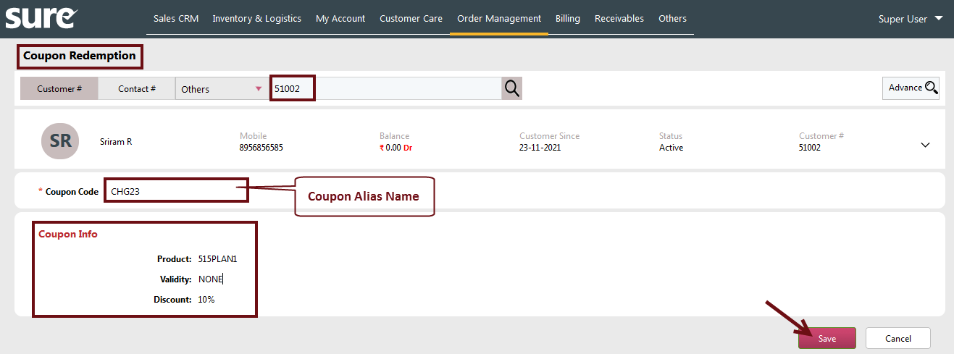
Screenshot showing Coupon Redemption screen

Screenshot Examples
Following screenshots shows the sequence of events for the Coupon definition, distribution, and redemption.
Screenshot 1: This screenshot shows a definition of a sample Plan (Plan ABC) in the Simple Product screen.
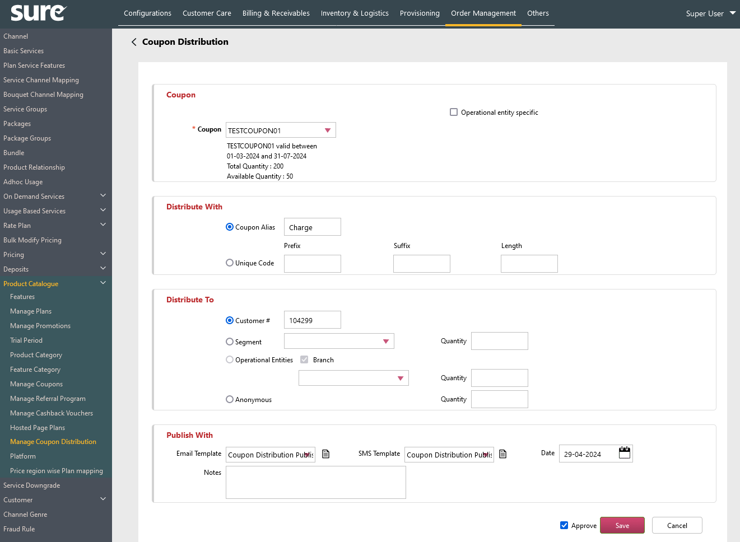
Screenshot 2: This screenshot shows the definition of a sample coupon (MONSOON) in the New Coupon screen. Here, Coupon (MONSOON) is mapped to the Plan (Plan ABC).
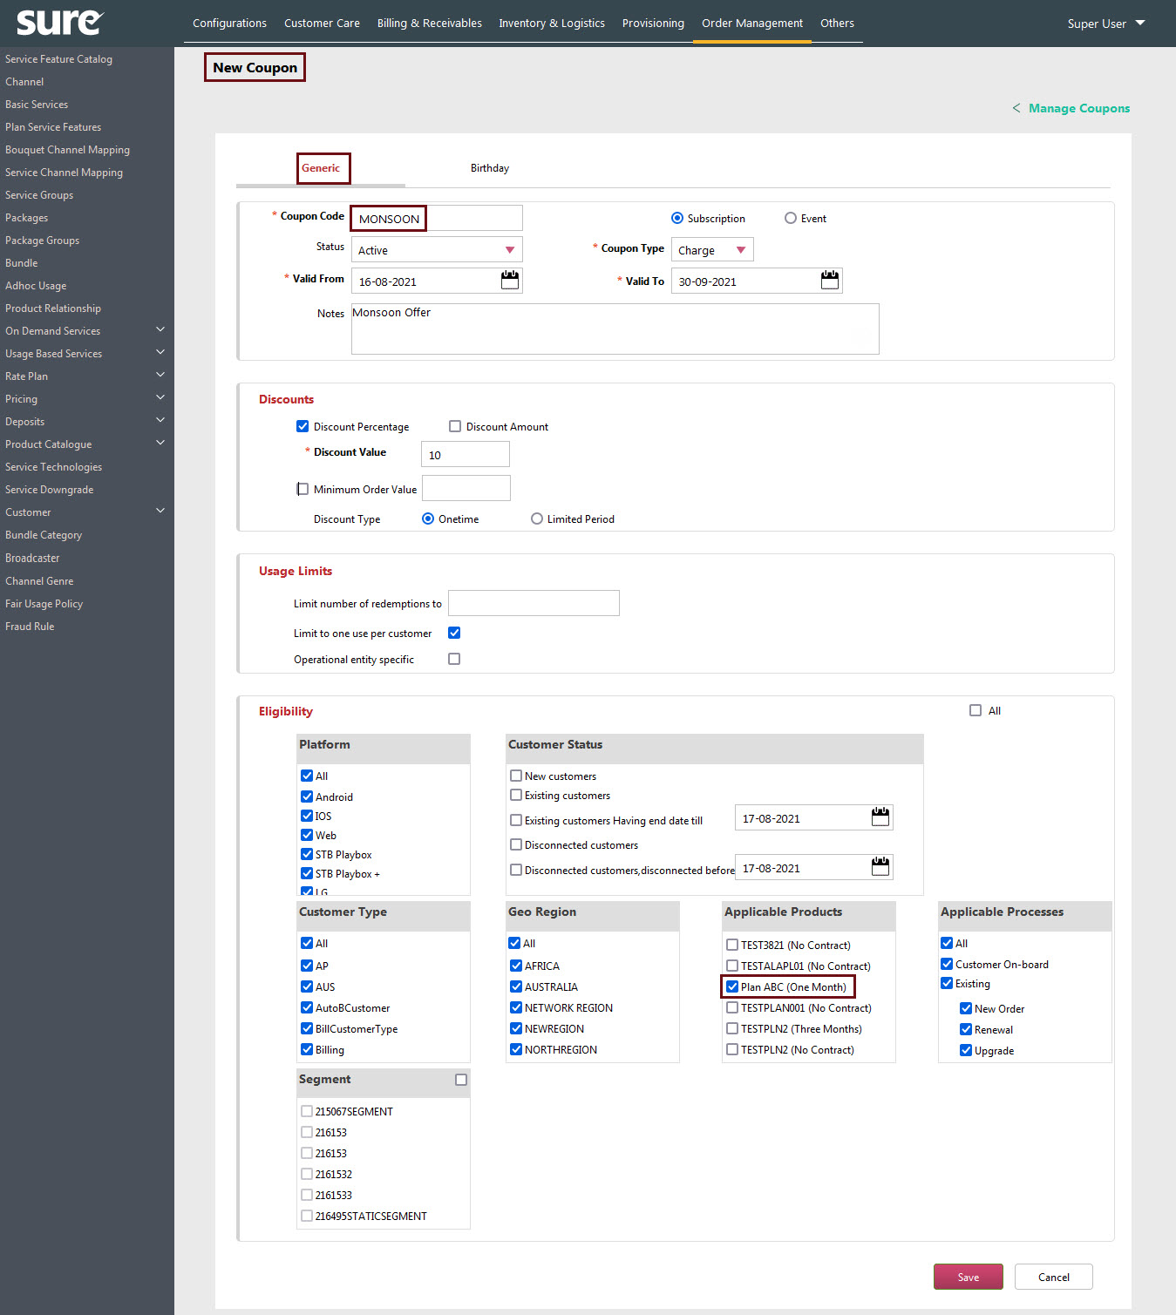

Screenshot 3: This screenshot shows the Coupon Distribution screen for the MONSOON coupon code.
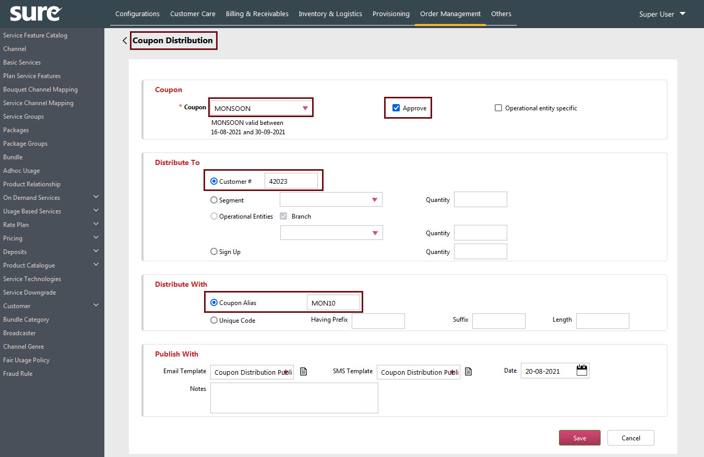
Screenshot 4: This screenshot shows the Coupon Redemption screen for redeeming the coupon code (Procedure 1).
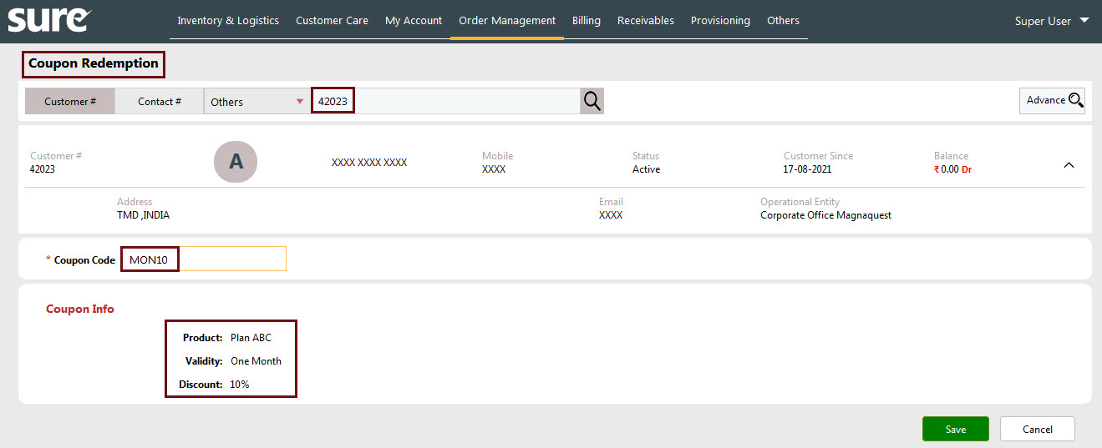
Screenshot 5: This screenshot shows the Service Order screen for redeeming the coupon code (Procedure 2):
Note: The distributed coupon can be redeemed from the Service Order screen. The list of distributed applicable coupons will appear in the Coupons List.
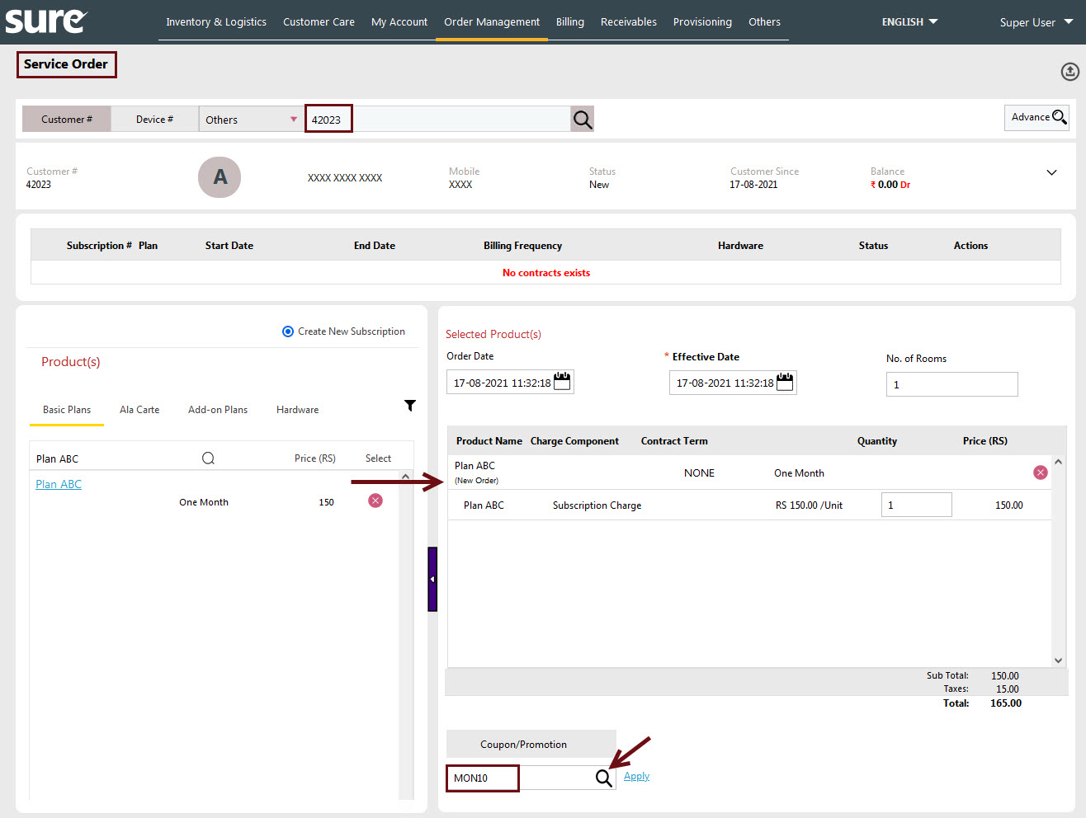

Screenshot 6: This screenshot shows the Coupons List dialog box after clicking the Icon
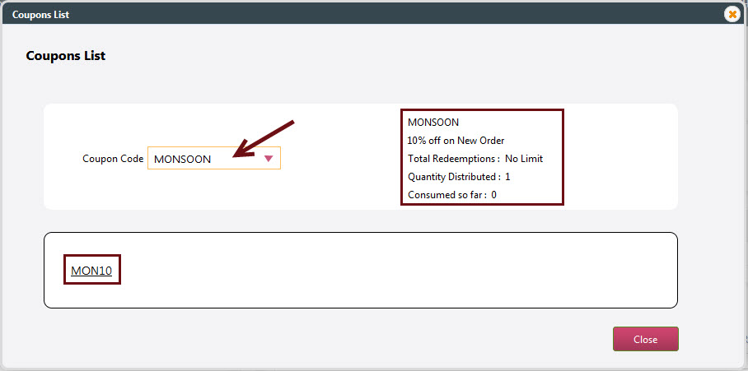
Screenshot 7: This screenshot shows the Service Order screen after the application of the distributed coupon i.e. MONSOON.
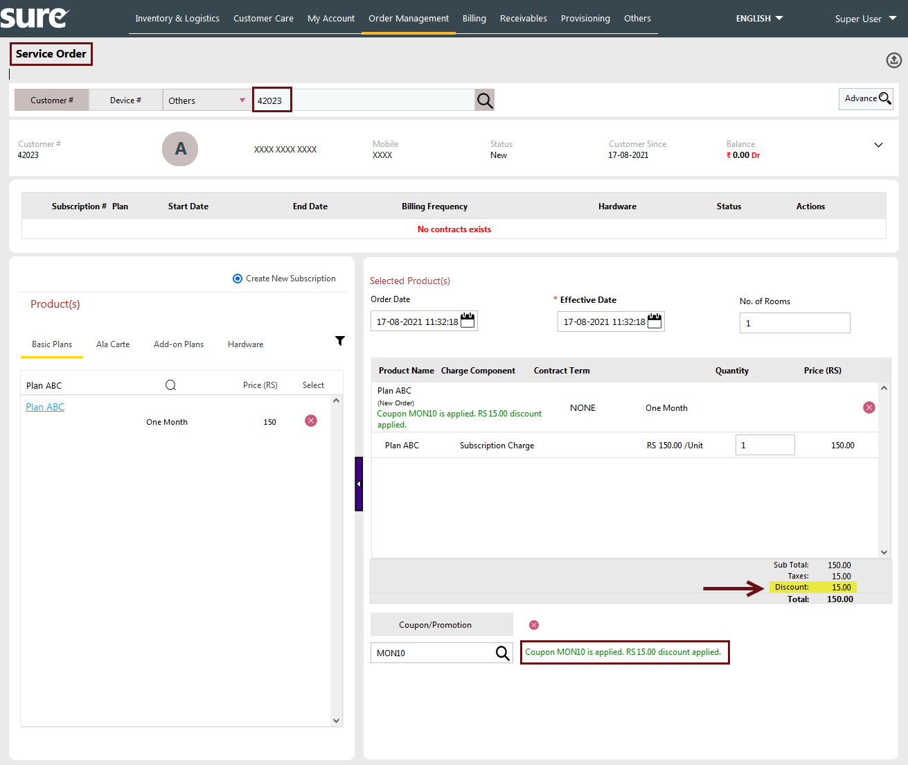

Event
The Coupon codes can be applied to the Events as well.
Events are broadcast items or video contents scheduled for broadcasting on a particular date and time for a particular time period. Valid events are the contents sold/provisioned as a single unit to the customer obtaining on demand services like Pay per View (PPV) or Video on Demand (VOD).
Example: Movies, Live program events, TV Reality shows, etc.
The definition of coupons for the Events is same as the Subscription (discussed above) but with an additional event-based section Gift/Freebies Product.
- In the Gift/Freebies Product section, enter the event name in the Search Product box to offer the product as Gift or a Freebie.
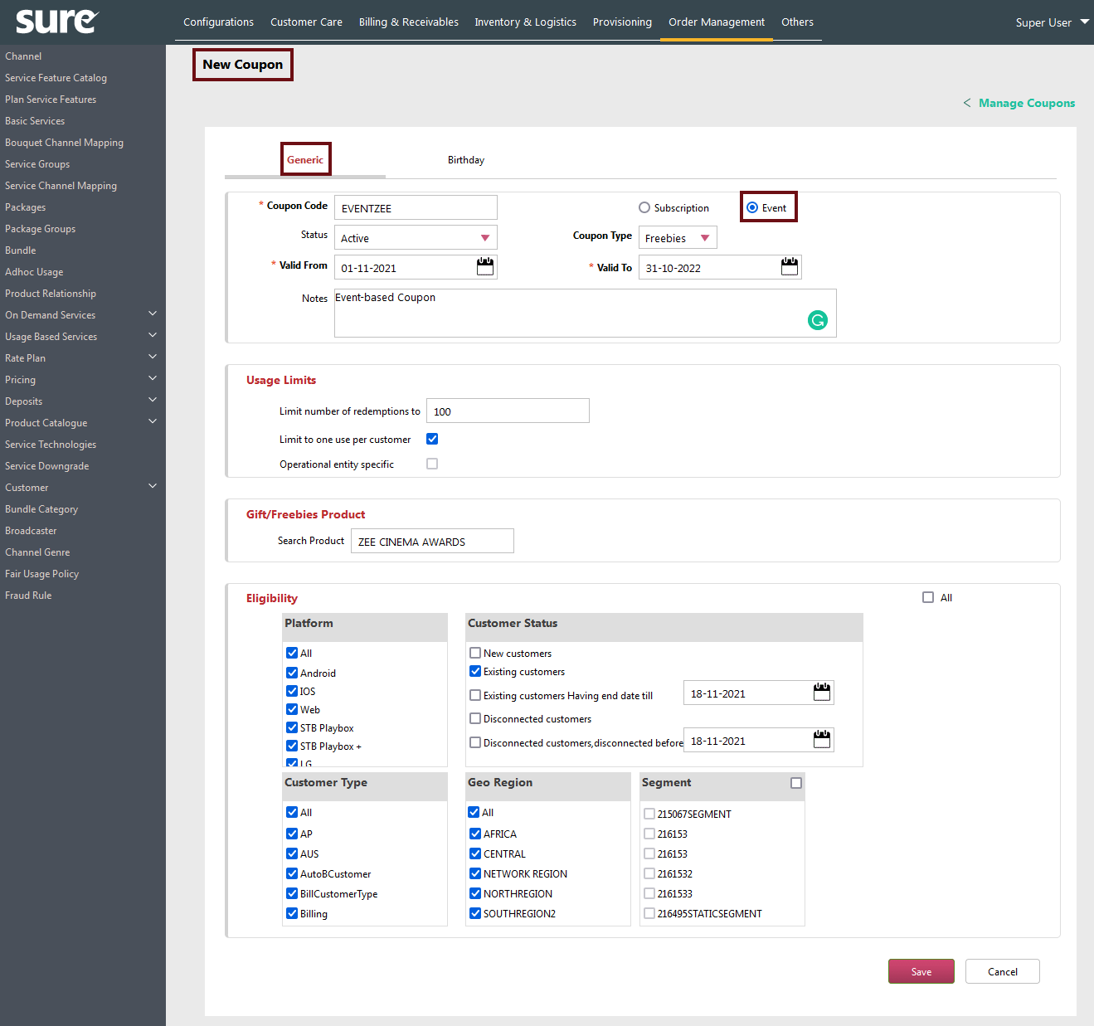
Screenshot showing the sample definition of the coupon (EVENTZEE) for the Event

Coupons Priority Order
In case, if there are multiple coupons defined for a particular period, and if the Customer is eligible for multiple coupons, then the system considers only one coupon to apply for the Customer.
The selection of the coupon is done based on the Coupons Priority Order.
Priority Order:

- Birthday
- Payment Coupon
- Charge Coupon (Discount Amount)
- Charge Coupon (Discount Percentage)

Inference:

- The Birthday Coupon is given the highest precedence over the rest of Coupons in the System. In other words, if the Customer has any Coupon Code (E.g. Payment Coupon Code) and also if his birthday falls in the same period of the transaction, then the Birthday Coupon Code will take the precedence over the Payment Coupon Code and only Birthday Coupon is applied.
- If there are multiple Charge Coupons in the System, then the System treats Discount Amount as a priority over the Discount Percentage.

Redeeming the Coupon
In order to redeem the defined Coupon, the Customer should follow the below steps. The Coupon is redeemed from the Self-Care Portal.
The Coupon can be redeemed by the Customer from two places in the Self-Care Portal.

- Manage Subscription Screen
- Sign-up Screen

Manage Subscription
The Manage Subscription screen is used to book a new Plan order or to renew the existing Plan.
Follow these steps:
- On the Self-Care Portal screen, click MANAGE SUBSCRIPTIONS.
The Order Booking screen appears.
- For the new plan selection, click the New Plan tab.
The new plans appear in the Base, Bouquets, and Alacarte lists respectively.
- Select the Plan from the list (E.g. Base Plan). The corresponding plan appears in the Cart section with the Plan’s Subscription Charge details.
If the Coupon is defined and applicable for the Customer, the same (Coupon Code) is shown in the Coupon Code list.
- Click the Coupon Code list and click Apply to apply the Coupon.
Once the Coupon is applied, the discount value is deducted from the Grand Total amount and the remaining Payable amount is shown below the Grand Total.
For the Customer’s readability, the Grand Total amount is shown strikethrough and the payable amount (Grant Total – Discount Amount) is shown along with the discount value description.
- Once the Payable amount is shown, click Confirm to book the order.
Screen navigates to the Price Details screen.
- In the Price Details screen, after verifying the details, click Pay Now to navigate to the Merchant’s Payment Gateway.
Note: The Pay Now button is driven by the Profile Option Online Payment on Selfcare Order.

If the Profile Option value is Yes, then the Pay Now button appears in the Price Details Screen to navigate to the Merchant’s Gateway.
If the value is No, then the Save button appears to save the Order Booking.
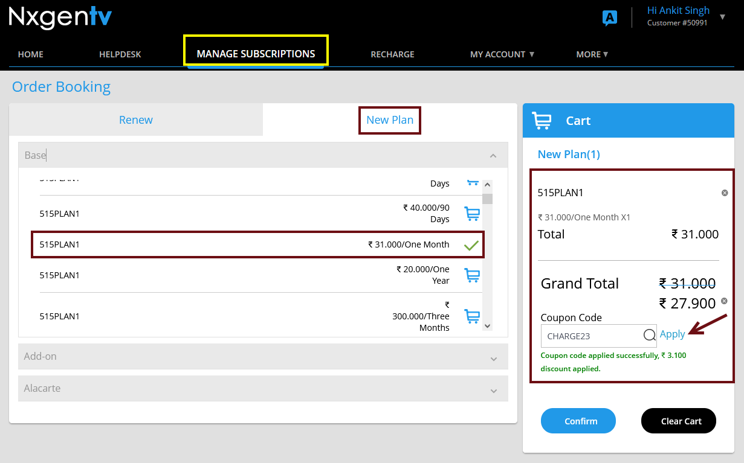
Screenshot showing Manage Subscriptions screen for Order Booking
(Coupon Code: NEWYEAR; Discount of Rs.30/- is applied against the coupon code.)

Note:

The above screenshot illustrates the example for the Manage Subscription New Plan.
In the case of Manage Subscription My Plans, if the coupon exists, the same procedure is followed for applying the coupon.

Sign-up
The Sign-up screen is used by the Customer to register his details with the Self-Care Portal.
From this screen, the Customer not only can register his details with the System but also can make an Order Booking of the Plans.
The following screenshots illustrates the usage of the Coupons in the Sign-up Screen.
Screenshot 1: Click the Register button for Self-Care Registration.
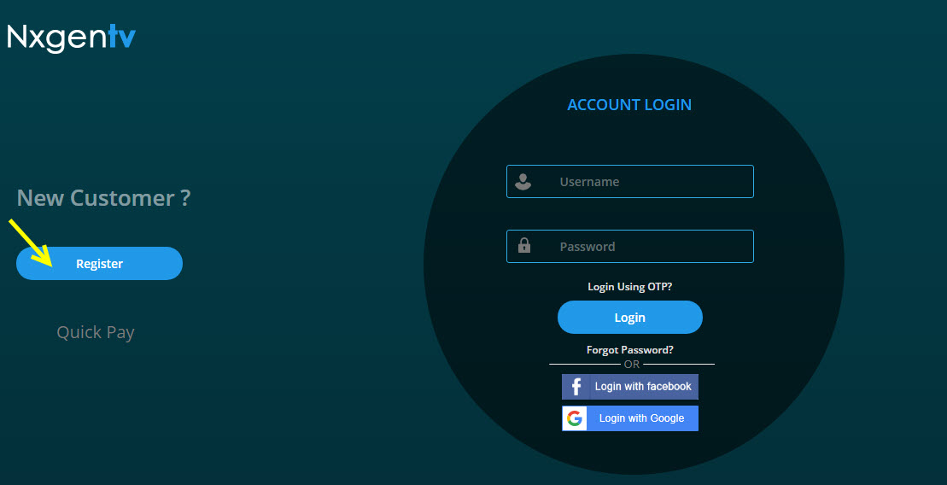
Screenshot 2: Select the required Plan.
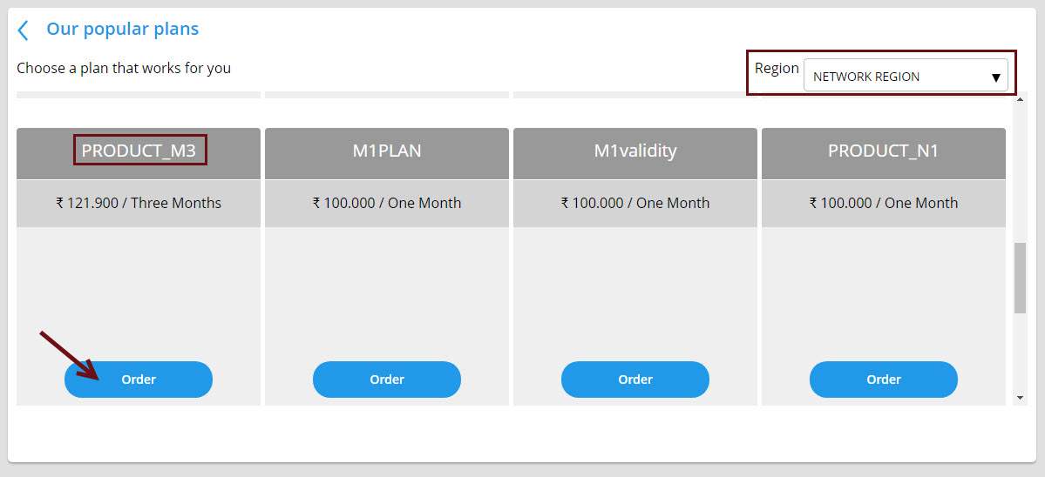
Screenshot 3: Enter the registration details like Name, Email, Mobile, Password, and Preferred Language. Select the Coupon Code and click Apply.
Example: Here, the Coupon Code NEWYEAR is applied for the discount of Rs.30

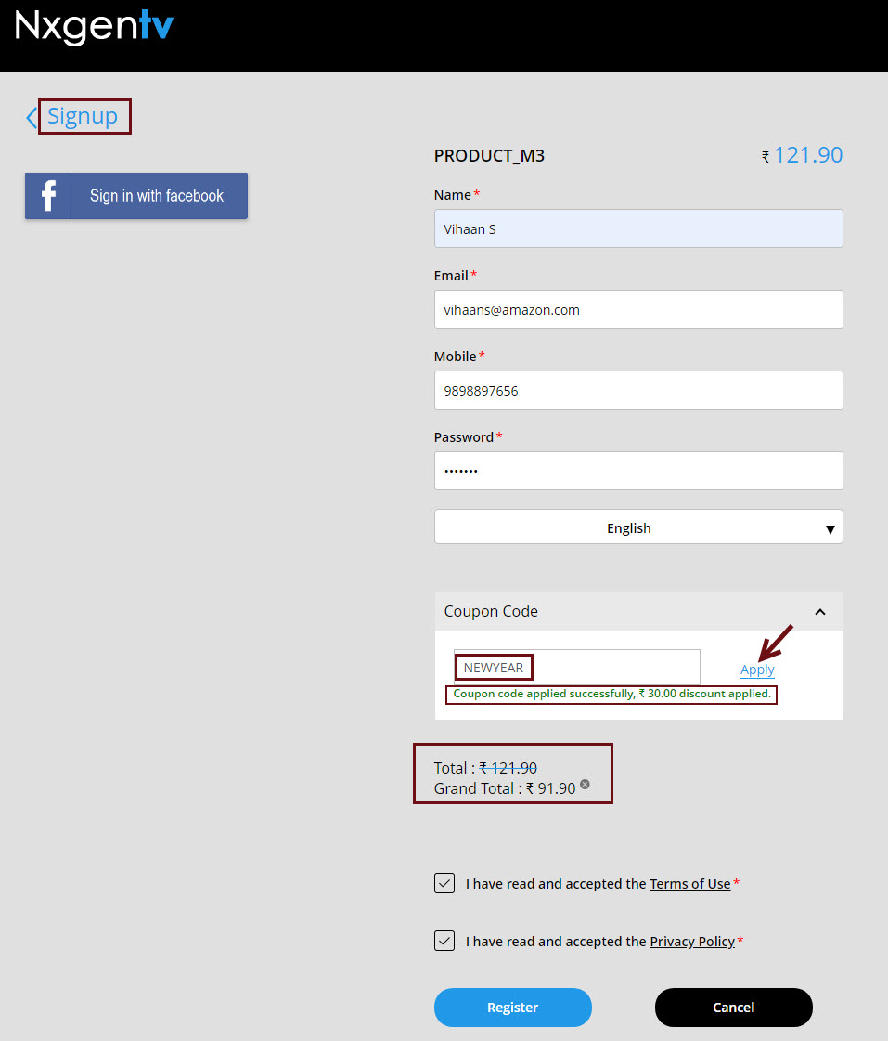

Event
The following screenshots demonstrate the coupon redemption for the Event in the Self-Care portal.
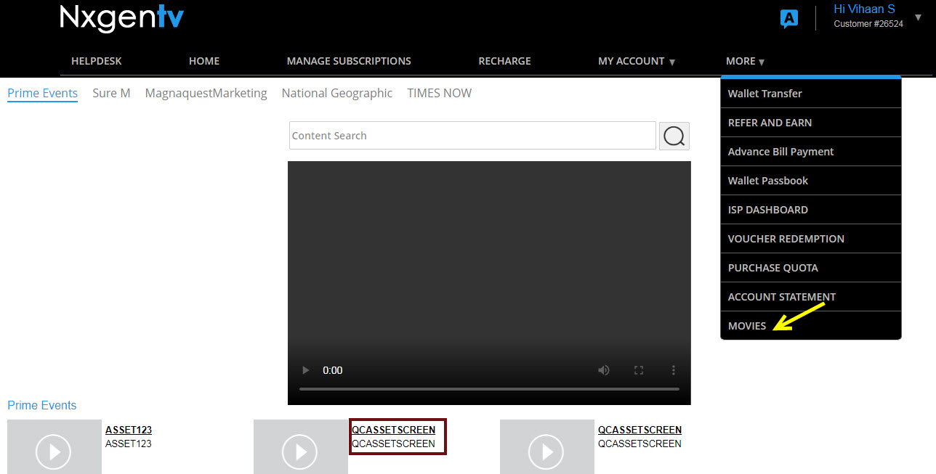
Screenshot showing the selection of Event (Movies) in the Sure Self-Care portal
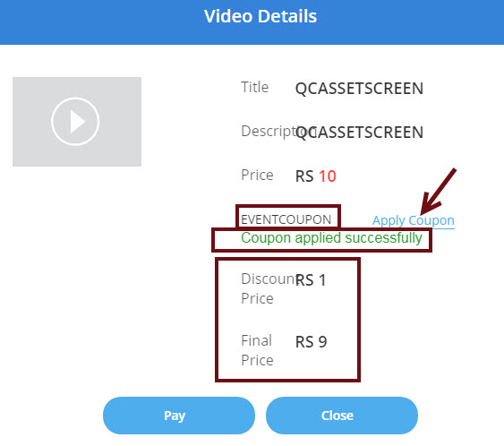
Screenshot showing the application of Coupon code (EVENTCOUPON) for the Even

Coupon related Tables
Following are the Database tables that are related to the Coupons.

- PROMOTION
- PROMOTION_QUALIFIER
- COUPON
- COUPON_RATE_PRICE
- COUPON_QUALIFIER
- CUSTOMER_ORDERS
- CUSTOMER_COUPON_REDEEM_DTL

Time Zones in Coupons
The Time Zone feature in Coupon enables the System to show the time with the timestamp. This feature is enabled with the Profile Option Enable time based subscription.
Once the time zone feature is enabled, the Date component of the Contract is appended with Time Stamp.
Example: The dates like Start Date, End Date, Effective Date, and Order Date of the Contract are appended with the Timestamp.
Following are the points with respect to Time Zone:
- With disable of the Time Zone feature (Profile Option Value No), the contract end date or any corresponding dates will be calculated on a daily basis but not on a timestamp basis.
Example: If a Contract Validity of a Plan ABC is 1 Month i.e. Plan Effective Date is 1 Jan 2021 then the Contract End Date would be 31 Jan 2021, as the time zone is disabled.
Similarly, in the case of Renewal of the Plan, the renewed plan would come into effect after one day after the Contract End date (I.e. Contract End date + 1).
Example: If the same plan ABC is renewed, then the effective date of that renewal plan would be from 01 February 2021.
- With enable of the Time Zone feature (i.e. Profile Option value Yes), the contract end date or any corresponding dates will be calculated on a timestamp basis.
Example: If a Contract Validity of a Plan XYZ is 1 Month i.e. Plan Effective Date is 1 Jan 2021, 00:00:00 (HH:MM:SS) then the Contract End Date would be 31 Jan 2021, 23:59:00) as the time zone is enabled.
Similarly, in the case of Renewal of the Plan, the renewed plan would come into effect after one Minute after the Contract End date (I.e. Contract End Minute + 1).
Example: If the same plan XYZ is renewed, then the effective date of that renewal plan would be from 01 February 2021, 00:00:00.

The following screenshot examples show the significance of the Time Zone feature:
Screenshot 1: The Profile Option Enable time based subscription with value No
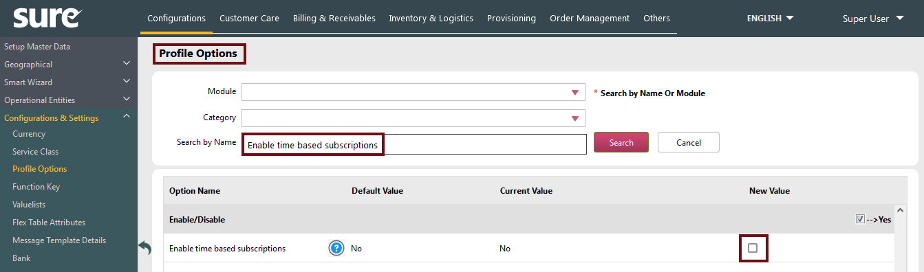
Screenshot 2: Sample screen (Service Order) showing the Order Date and Effective Date with No timestamp.
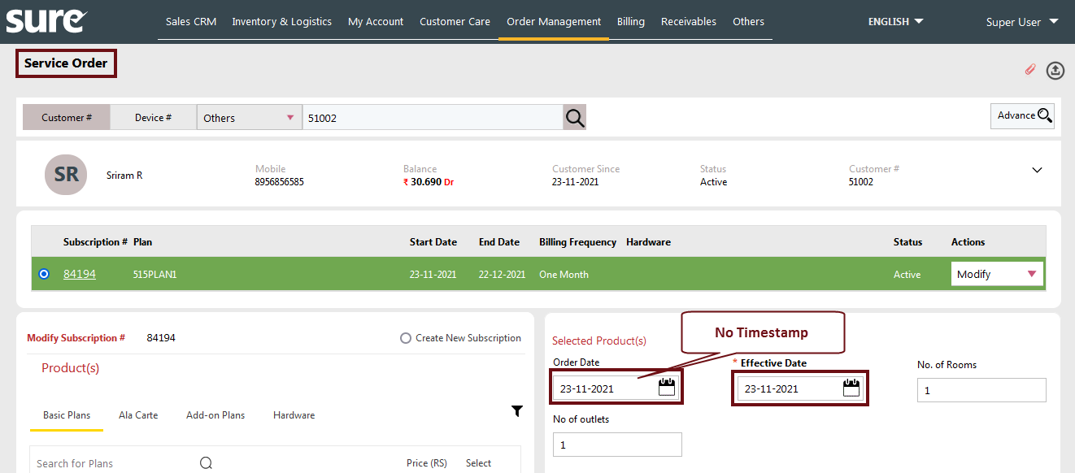

Screenshot 3: The Profile Option Enable time based subscription with value Yes

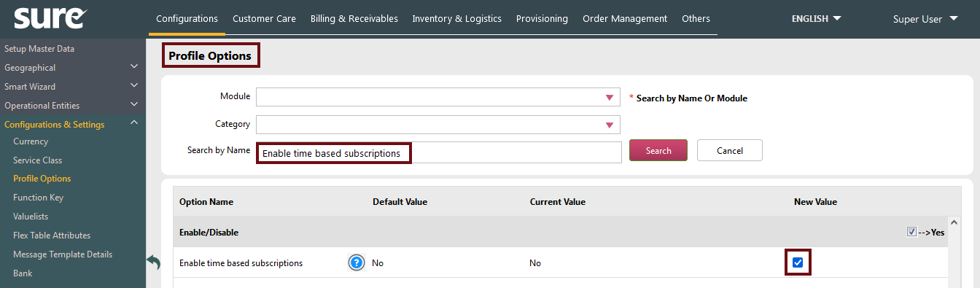
Screenshot 4: Sample screen (Service Order) showing the Order Date and Effective Date with timestamp.

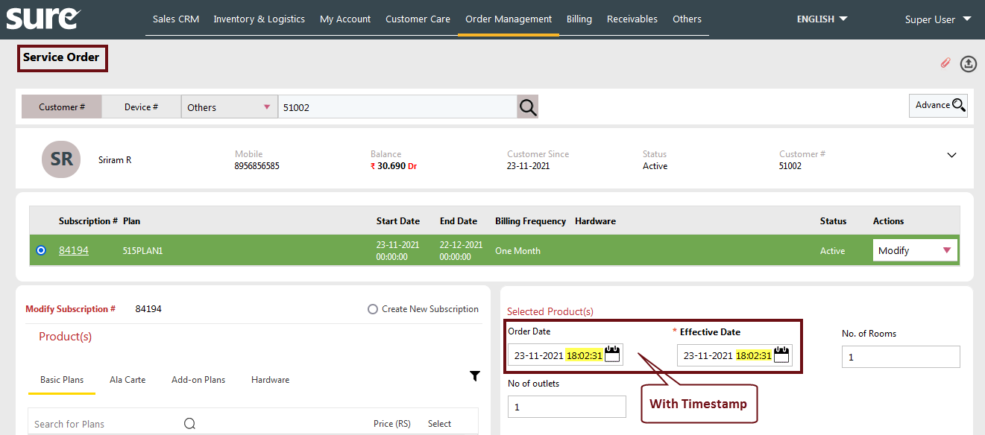

Support
For further information or any technical support, please contact:
E-mail: mqssupport@magnaquest.com, bcrm.support@magnaquest.com
Phone: +91 9866558383

Copyright
This document is the property of, and is proprietary to Magnaquest Technologies Limited (Magnaquest). It is not to be disclosed in whole or in part without the expressed written authorization of Magnaquest, and shall not be duplicated or used, in whole or in part, and shall be returned to Magnaquest upon request.
Copyright © 2024 Magnaquest Technologies Limited (Magnaquest). All rights reserved. All trademarks, trade names, service marks, and logos referenced herein belong to their respective companies.

