

\\\




MQ SURE! Referral Program

Contents
Referral Program ……………………………………………………………………………………………..1
Prerequisites 1
Manage Referral Program Screen 2
Referral Program Capabilities 4
Benefit Applicability Rules 4
Configuration and Processing 5
API and Workflow Integration 6
Plan Applicability Rules 7
Self-Care – Refer & Earn 8
Support ………………………………………………………………………………………………………….10
Copyright ……………………………………………………………………………………………………….11

Referral Program
The Manage Referral Program feature enables service providers to configure and manage a Refer-a-Friend scheme that benefits existing customers for referring new customers. When a referred customer successfully subscribes to a plan, the configured referral benefits are credited to the Referrer, the Referee, or both, based on the referral program definition.
Referral benefits can be defined as Flat Amount, Percentage Discount and Extension of Contract and are applied according to the rules configured in the program.

Prerequisites
- The Enable Referral Program profile option must be set to Yes.
- Scheduled actions or RabbitMQ must be active to generate and process referral codes after customer registration, and codes will be stored in the customer_referral_code table. The Self-Care portal must be enabled to display referral codes under Refer & Earn.
- Referrer should be the Prepayment customer.

Manage Referral Program Screen
The Manage Referral Program screen is used to define all parameters of a referral program, including benefits, currency, validity, usage limits, and activation status.
Follow these steps:
- On Settings, click Order Management, click Product Catalogue, and then click Manage Referral Program.
The Manage Referral Program screen appears.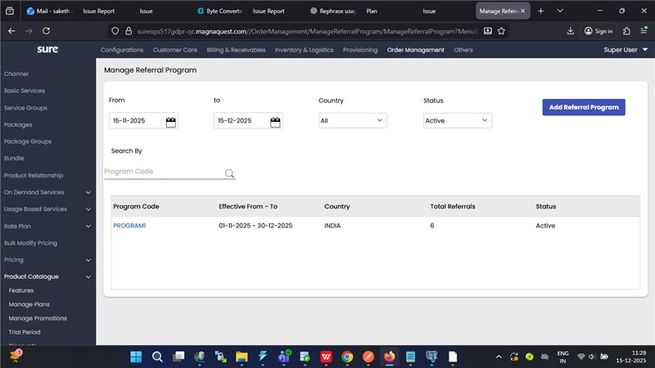This screenshot displays the Manage Referral Program screen.
- To define a new referral program, click Add (+).
The New Referral Program screen appears.
- Enter the referral program code and its description in the Referral Code and Description boxes, respectively.
- Select the Currency from the Currency list.
- Enter the Referrer Benefit Amount and Referee Benefit Amount in the respective fields.
Referrer: Existing customer who refers another person.
Referee: New customer who is referred and subscribes for the first time.

- Select the referral program validity period using the Valid From and Valid Till calendar fields.
- Enter the maximum number of people a customer can refer in Max. Referrals per Customer.
Example: If the value is 5, a customer can refer up to five people.
- Select Active from the Status list to enable the referral program.
If set to Inactive, the referral code is disabled and cannot be used.
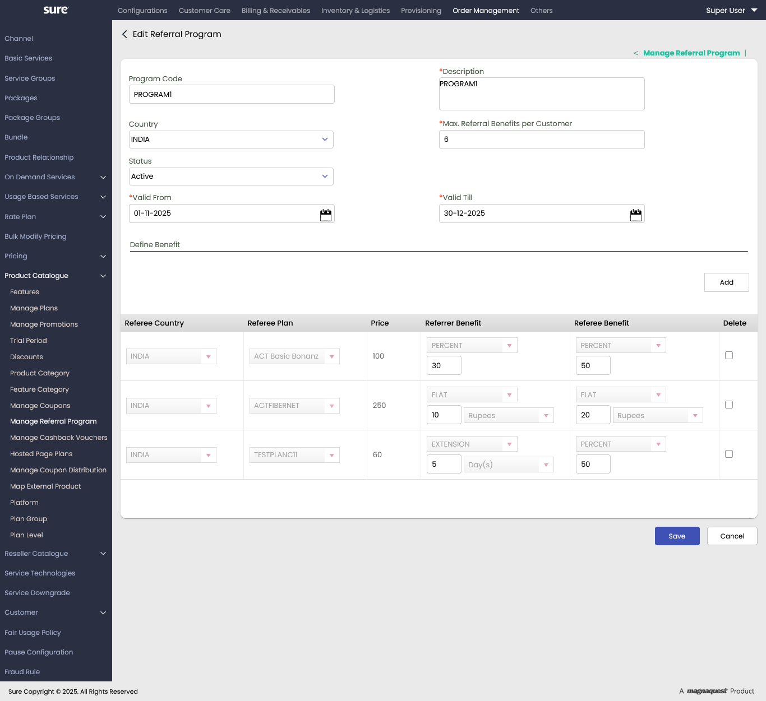
This screenshot displays the Edit Referral Program screen.

Referral Program Capabilities
The application supports an advanced referral framework with the following capabilities:
- Service providers can define country-specific referral programs.
- Separate benefits can be configured for:
- Referrer
- Referee
- Benefit types include:
- Discounts - Flat & Percentage
- Validity Extension (applicable only to the Referrer)
- No Benefit (applicable only to the Referee)
- Automatic generation of a unique referral code for every customer after successful customer registration.
- Referral codes can be shared and used during the first subscription payment of the referee.
- Referee benefits are applied immediately during their first payment.

Benefit Applicability Rules
- Referrer Benefits: Referrer benefits are applied only after the successful referee’s benefits.
- Validity Extension: Applied immediately after a successful referral.
- Discounts: Applied during the next renewal cycle and change order.
The referrer is required to apply the coupon code in a subsequent transaction to avail the referral benefit. Once the referral benefit is successfully generated, the coupon code is displayed in the Single View screen, and the coupon details are also sent to the referrer via email for reference and future use.
- Provide Referrer Code in Add Multiple API.
- The APPLYREFERRALBENEFIT workflow must be enabled to process referrer benefits.
- If the referral subscription is on auto-renewal, the discount amount will not be applied automatically and must be redeemed manually using the coupon code.
- Referee Benefits: Applied immediately during the first successful subscription payment.

Configuration and Processing
- The profile option Enable Referral Program must be set to Yes to generate referral codes.

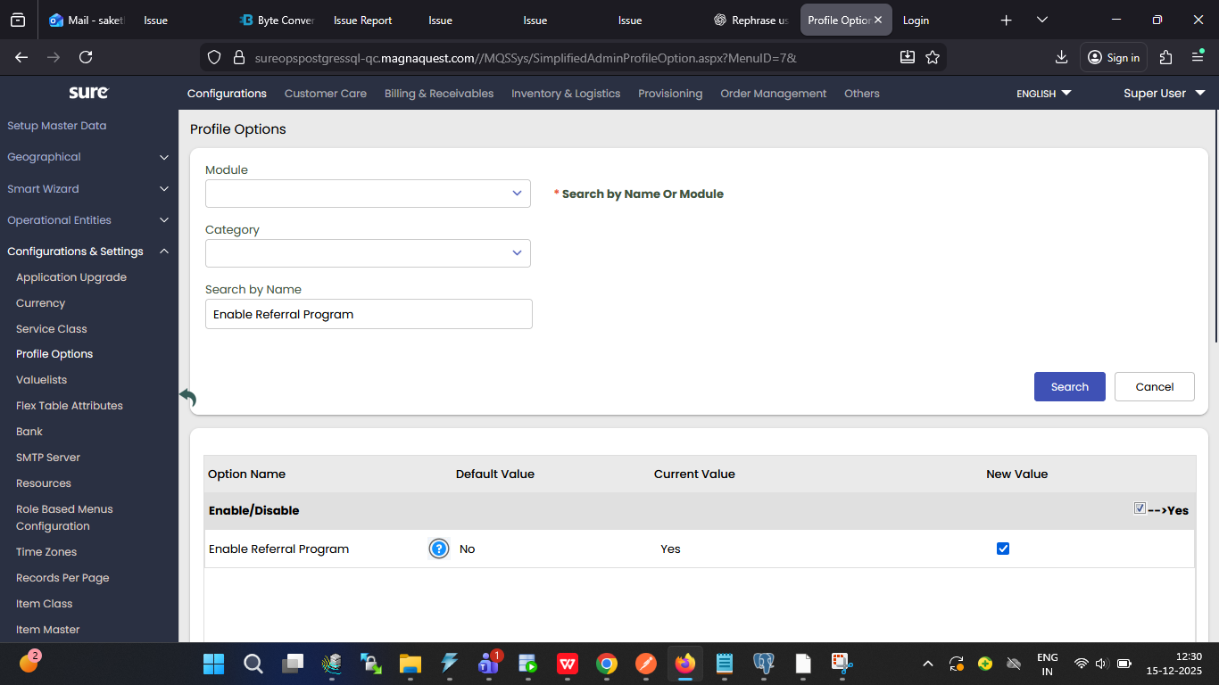
This screenshot displays the Enable Referral Program profile option.
2. After customer registration:
- Schedule Actions job must be processed or.
- RabbitMQ must be processed.
- Generated referral codes are stored in the customer_referral_code table.
- Referral codes are displayed in Self-Care → Refer & Earn.
Note: Custom Referral Code generation, this profile option will be yes, and the respective DLL will be in the deploy.

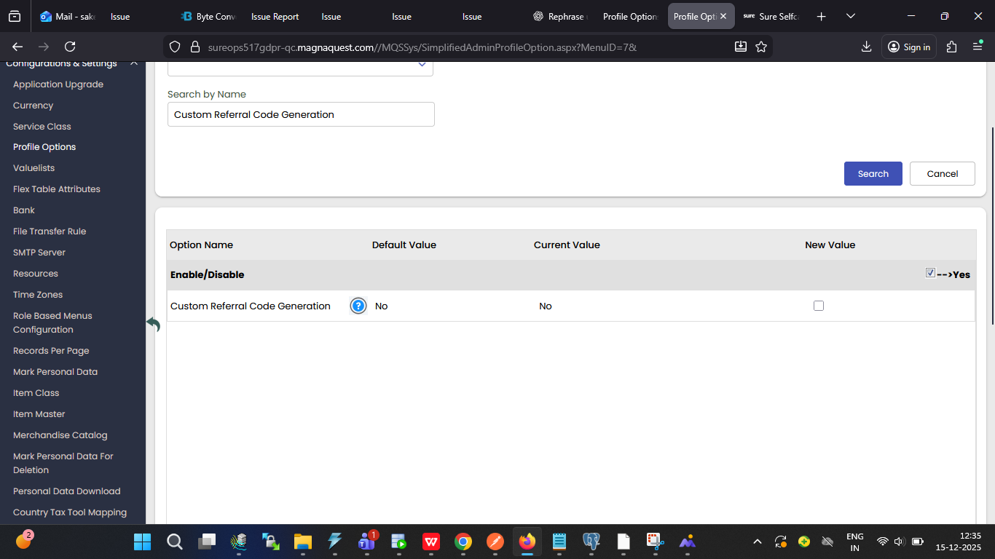
This screenshot displays the Customer Referral Code Generation profile option.

API and Workflow Integration
Referee Benefit
- Benefits are applied through the Add Multiple Products API.
- The Referrer Code must be passed in the API request to get the Referee Benefit.
Referrer Benefit
- The workflow APPLYREFERRALBENEFIT must be enabled.
- Referrer benefits are applied only when the workflow is active.
Upon successful application of the referee’s benefit, a coupon code is generated and displayed to the referrer in the Single View screen under Referral Benefits, and the same coupon code, along with its details, is emailed to the customer.

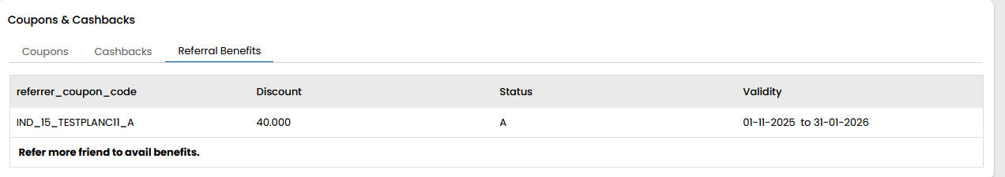
This screenshot displays the Referral Benefits Section in the Single View screen.

Plan Applicability Rules
Referral benefits are applicable only to the plans defined in the Referral Program. If the benefits should be applicable to all plans, the Referee Plan must be selected as ALL in the New Referral Program screen.
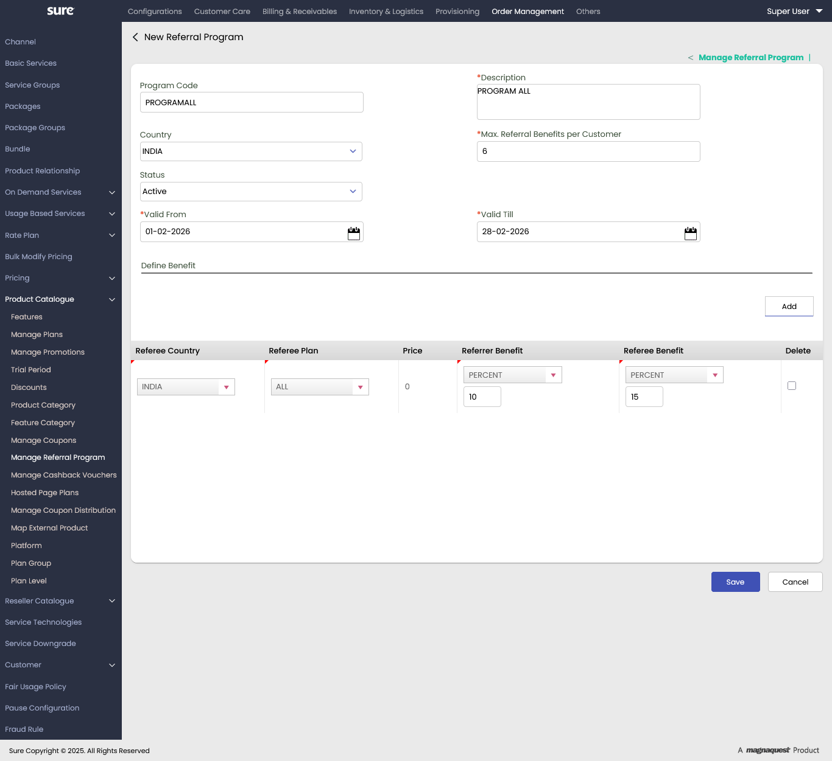 This screenshot displays the Referee Plan (ALL) in the New Referral Program screen.
Note: Referral benefits are supported only through the Add Multiple Products API and are not applicable via application-level flows (Native and Self-Care portals).

Self-Care – Refer & Earn
In the Self-Care portal, a dedicated Refer and Earn screen is provided to allow customers to participate in the referral program. This screen displays the Referral Program description along with the Referral Code generated for the customer.
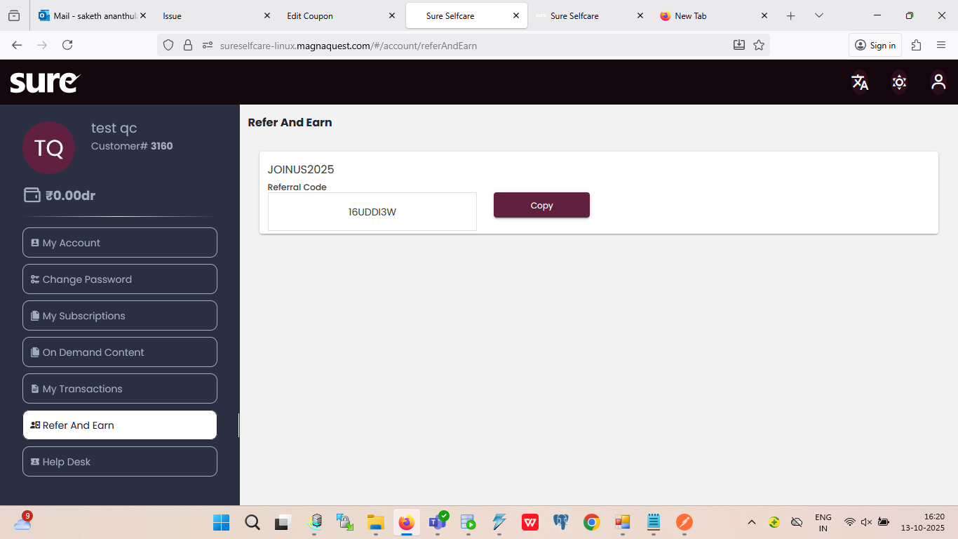
This screenshot displays the Refer And Earn screen in the Selfcare.

For Displaying Referral Code:
- Profile Option Enable Referral Program is set to YES.
- The Schedule Actions job or RabbitMQ should be processed to ensure that referral data is generated.

Signup Flow
To display the Referral Code field during the signup process, a configuration change is required in the web configuration file.
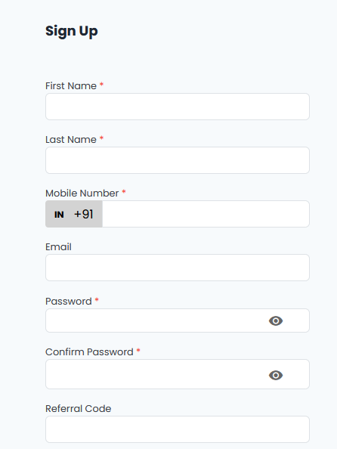
This screenshot displays the Referral Code field in the Sign Up screen.
Configuration Rules
- Set visible: true for the ReferralCode label to display the referral code field.
- Set visible: false to hide the referral code field during signup.
Configuration Format
"referralCode": {
"visible": true,
"label": "ReferralCode" }
Note: The system captures all referrals; however, the service provider will decide if, when, and what benefits are to be granted.

Support
For further information or any technical support, please contact:
E-mail: mqssupport@magnaquest.com, bcrm.support@magnaquest.com
Phone: +91 9866558383

Copyright
This document is the property of and is proprietary to Magnaquest Technologies Limited (Magnaquest). It is not to be disclosed in whole or in part without the expressed written authorization of Magnaquest, and shall not be duplicated or used, in whole or in part, and shall be returned to Magnaquest upon request.
Copyright © 2025 Magnaquest Technologies Limited (Magnaquest). All rights reserved. All trademarks, trade names, service marks, and logos referenced herein belong to their respective companies.

