ASSIGNMENT
Catalogue Upload, Product Cart & Grade-wise Ratio

Objective
Build a simple application using the sample Catalogue Excel file. The application should allow the user to upload the catalogue, select products and add them to a Cart, and set a size-wise Ratio separately for products with different Grades such as A, B and C.

1. Upload Sample Catalogue File
Upload the sample Catalogue Excel file provided with this assignment.
- Provide an option to upload the Excel (.xlsx) file.
- Read the catalogue data after upload.
- Display the products from the uploaded file.
- Use the uploaded catalogue as the source of product, Grade and size data.

2. Add Products to Cart
Allow the user to select a few products from the catalogue and add them to the Cart.
- Products added to the Cart can have different Grades.
- For the test, use products with Grade A, Grade B and Grade C.
- The Cart should clearly show the selected products.
- The Cart should show the Grade and sizes for each selected product.

Reference – Cart
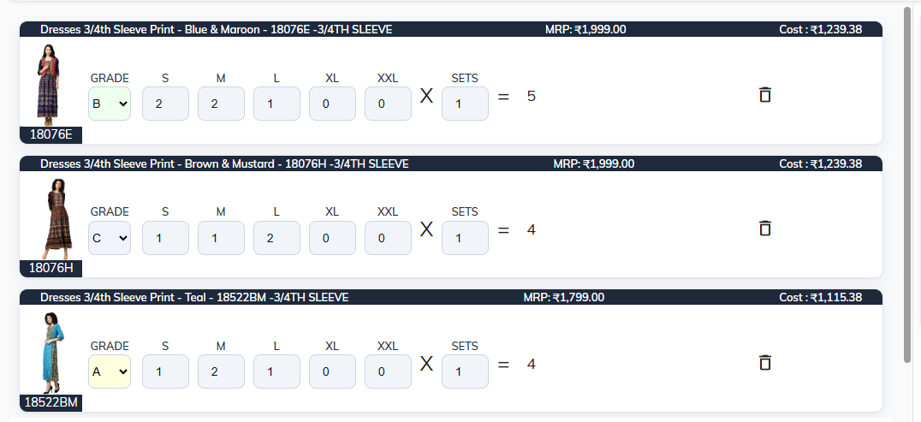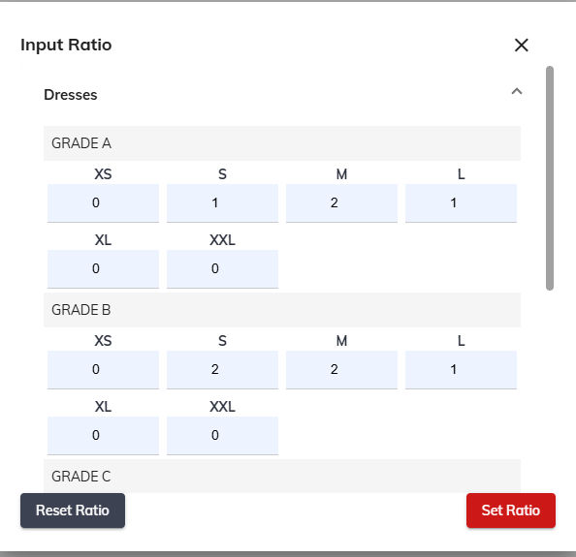

3. Set Ratio Based on Grade
After adding products with Grade A, B and C to the Cart, the user should be able to set a separate size-wise ratio for each Grade.
Example:
Grade | S | M | L
A | 1 | 2 | 1
B | 2 | 2 | 1
C | 1 | 1 | 2
Meaning: The ratio is maintained separately for each Grade.
- Grade A → S : M : L = 1 : 2 : 1
- Grade B → S : M : L = 2 : 2 : 1
- Grade C → S : M : L = 1 : 1 : 2

Reference – Input Ratio

4. Ratio Level
The ratio should be capable of being set at different catalogue attribute levels:
- Brick
- Category
- Brick + Neck
- Brick + Sleeve
- Other attribute combinations, where applicable
The selected attribute level should group the relevant products, and the Grade-wise size ratio can then be entered for that group.

5. Expected Flow
1. Upload the sample Catalogue Excel file.
2. Display the catalogue products.
3. Select a few products.
4. Add the selected products to the Cart.
5. Cart should contain products with Grade A, Grade B and Grade C.
6. Set the ratio separately for Grade A, Grade B and Grade C.
7. Example: A = S:1, M:2, L:1; B = S:2, M:2, L:1; C = S:1, M:1, L:2.
8. Save / Set Ratio.

6. Simple Example
Suppose the Cart contains the following products:
Product | Grade | Sizes
Product 1 | A | S, M, L
Product 2 | A | S, M, L
Product 3 | B | S, M, L
Product 4 | B | S, M, L
Product 5 | C | S, M, L
The user can then configure the ratio separately for each Grade:
Grade | S | M | L
A | 1 | 2 | 1
B | 2 | 2 | 1
C | 1 | 1 | 2

7. Candidate Deliverables
- Working application
- Source code
- Brief setup / run instructions
- Short explanation of the approach used for Grade-wise ratio

8. Important Note
The sample Catalogue Excel file and screenshots are provided as functional references. The candidate does not need to reproduce the screenshots exactly. The focus is on implementing the requested functionality in a simple and reusable way.
The size list should come from the uploaded catalogue wherever possible. Different product types may have different sizes, so the solution should not depend only on S, M and L.

