1. Download the file [web_scraper.sh](https://hs2solutions-my.sharepoint.com/:u:/g/personal/sharath_ram_bounteous_com/EVjtybZVxKRHjRNAwDkxVIYB_IKgcXaEGaAEjgcYAnTC1Q?e=MwOOxC) . Make the file executable. The file takes any wikipedia webpage as an argument. Run the process on multiple sites like [Wikipedia:Stub - Wikipedia](https://en.wikipedia.org/wiki/Wikipedia:Stub) , [India - Wikipedia](https://en.wikipedia.org/wiki/India) at the same time and
   1. Find all the processes running on the system.
   2. Find the first 5 processes with the highest memory usage.

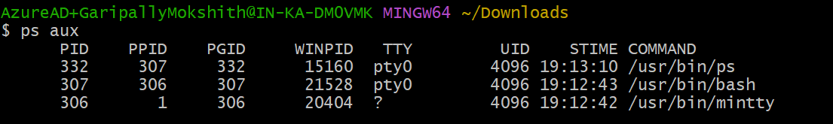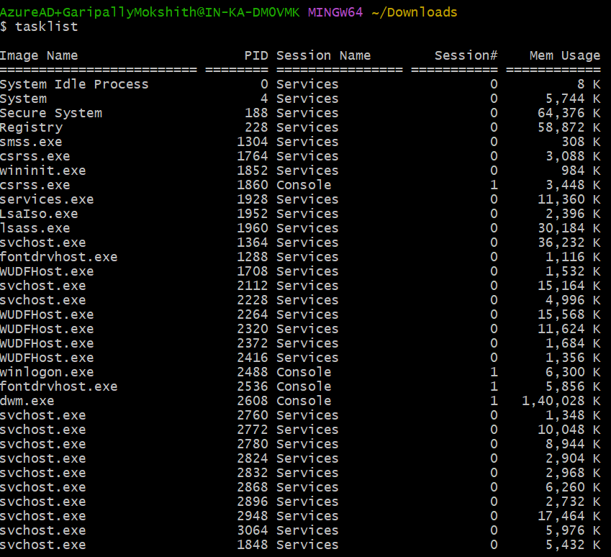

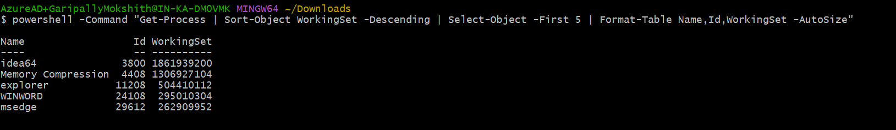

-Print the HTTP response code obtained from google.com.

-Find the top 3 running processes which consume the most processing power.

-Write a script that finds all files larger than 100MB in a directory and lists them.

-Find which version of Python is installed on the system.

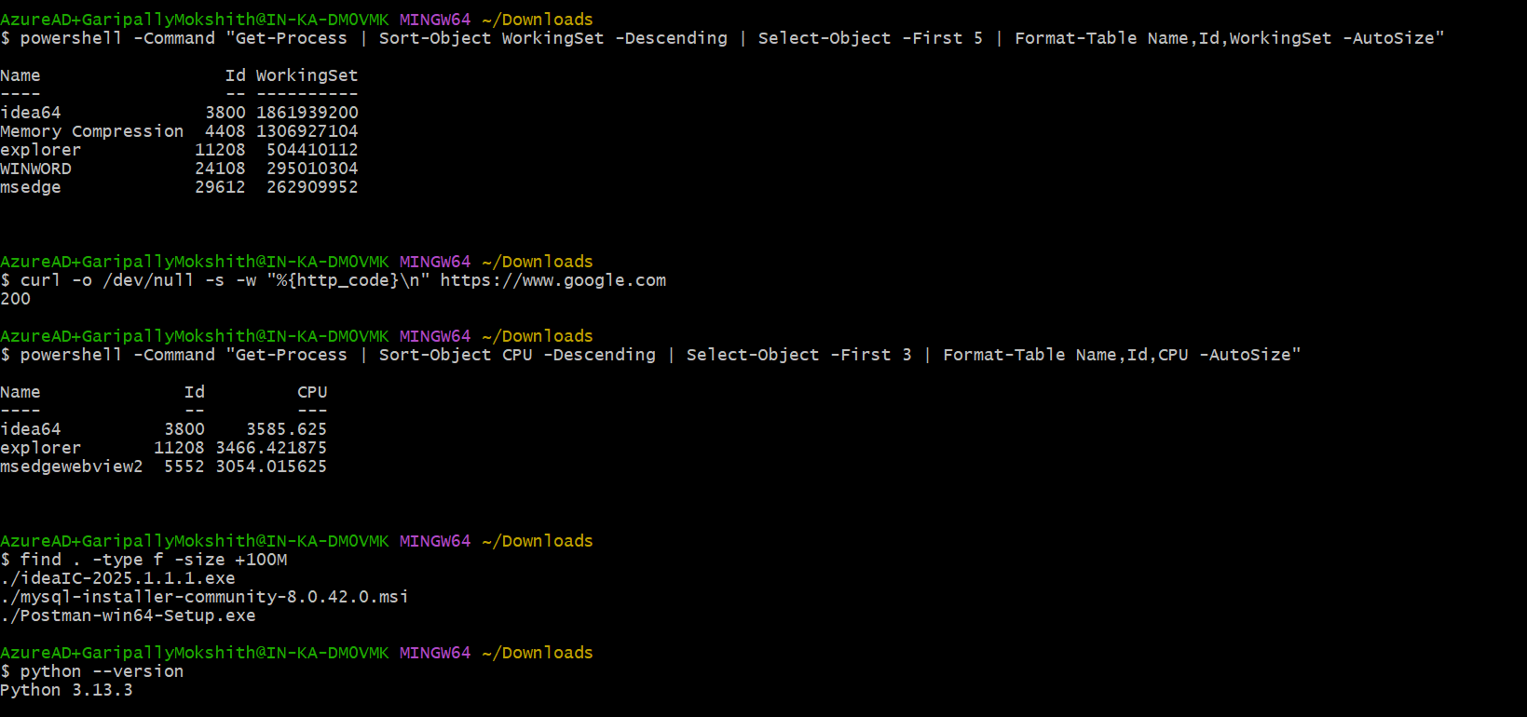

-Get the current time zone of your system.

-Get the current time in New York, London, and Sydney.

-Check for how long the system is up. 

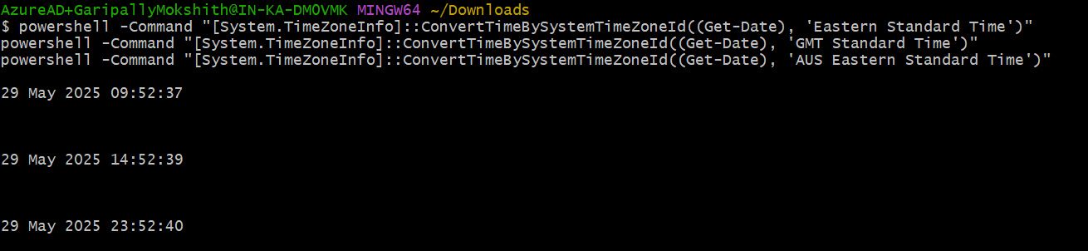

1. Given a log file:
   1. Find all the errors in the log and dump them to a new file.
   2. What events occurred between 09:10 and 09:19?
   3. How many INFO messages are in the log file?
   4. Print the first 5 lines of the file.
   5. Print the last 5 lines of the file.
   6. Print lines if the lines contain error, fail, or warning.
   7. Rename the file to new_log.txt.
   8. Edit the log file and add the string "hello, world!" at the beginning of the file.
   9. Delete the old log file.
   10. Filter entries containing the "INFO" string for a particular date for a given log file, you can use the sample log file given below.

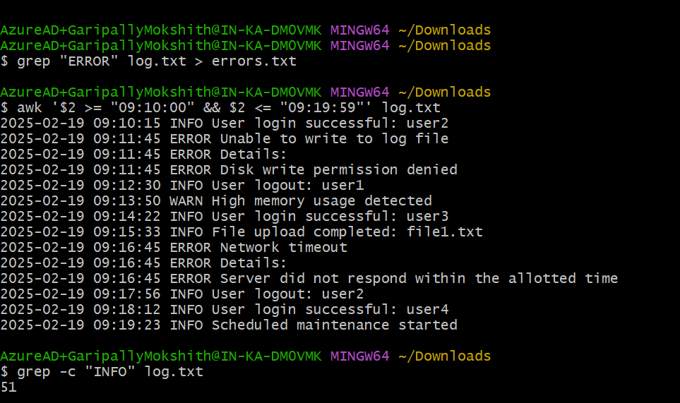

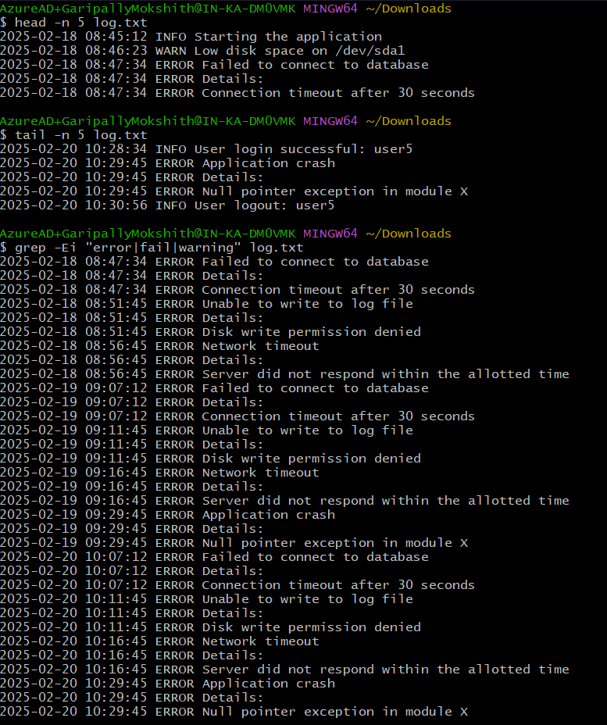

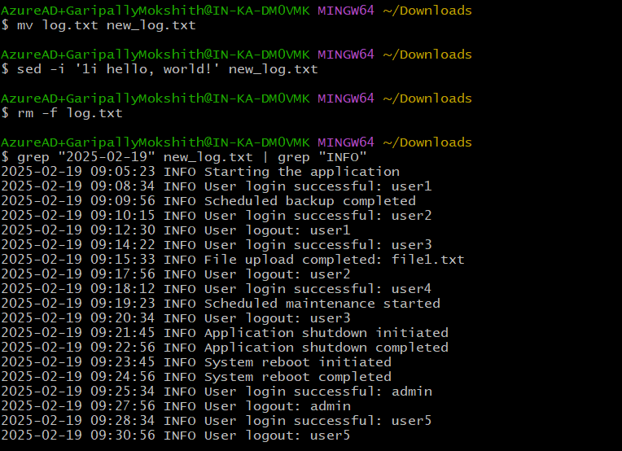

1. Write a command to continuously monitor what is being appended to the file and output if you find the string "Error".
2. Connect to google.com and copy the output to a text file.
3. Create a file called example.txt. Write a script to make it read-only for all users.
4. Write a script that changes the permissions of a script named myscript.sh to make it executable by the owner, group, and others.
5. Recursively make all the files readable in a directory.
6. List out all the files that end with ".log" in a directory.
7. Write a command to get the kernel version.
8. Find the IP address of the system.
9. Write a script to list all files and directories in the current directory, sorted by size.
10. List all files and directories in the current directory with sizes in human-readable format.
11. Print the hostname a computer.
12. Command to Kill a particular process running in your system.
13. Create two files test1.txt and test2.txt with some content and merge it to a single file test.text
14. Create a shell script test.sh with the content given at the bottom and execute it.
15. Tes.sh creates mutiple process , wrtie command to kill some specific process with given pid.
16. Write a shell script which take your name as input and it will dispaly Hello your name.
17. Write a command to download file.zip from <https://github.com/github/gitignore/archive/refs/heads/main.zip>
18. Write a command to zip test.txt to test.zip and unzip it.

