# email, ph, name,address,password
def login(user,passwrd):
username = input("Enter your username")
password = input("Enter your password")
if username == user and password == passwrd:
print("Login succesful")
else:
print("Please try again")

def validation(name, email, phone, address, password):
if name.isalpha():
if email.islower() and email.endswith(".com") or email.endswith(".in") and email.count("@") == 1:
if phone.isdigit():
print(f"Your username is {email.split("@")[0]}")
login(email.split("@")[0],password)
else:
print("Enter only digits for phone number")
else:
print("Enter a valid email ID")
else:
print("Name should have only alphabets")

def registration():
name = input("Enter your name:")
email = input("Enter your email:")
ph = input("Enter your phone no:")
address = input("Enter your address")
password = input("Enter your password:")
retype = input("Enter your password again:")
if password == retype:
validation(name,email,ph,address,password)

registration()

Python Function Arguments and Parameters Assignment –
Today’s task will be to polish the above login application by implementing proper validation along with login feature.
Understand how validations are working in the above code using string inbuilt methods and Add below validations –
Password - Length should be >=8, atleast one lowercase character, and one uppercase character and allow only _#@ inside your password.
Hint : Use a for loop for password validation where inside for loop you can use counters for uppercase, lowercase and length.
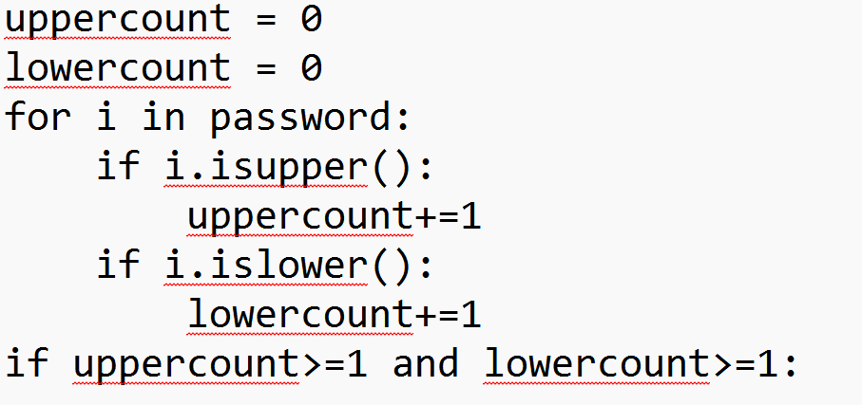

Login - Give user 3 chances only for login. If user is not able to login in those 3 chances no login. But if user is logging in successfully then show success message.
Hint : Use a while loop with break to break if login successfull

Bonus - Try to make a dictionary from user inputs in registration function and pass that dictionary in validation function so that you don't have to deal with multiple arguments and parameters.

