Weight Loss Data

Mokshitha

2023-04-02

**WEIGHT LOSS DATA**

# Description

Contrived data on weight loss and self esteem over three months, for three groups of individuals: Control, Diet and Diet + Exercise. The data constitute a double-multivariate design.

## Usage

Weightloss

### Format

A data frame with 34 observations on the following 7 variables.

group:a factor with levels Control Diet DietEx.

wl1:Weight loss at 1 month

wl2:Weight loss at 2 months

wl3:Weight loss at 3 months

se1:Self esteem at 1 month

se2:Self esteem at 2 months

se3:Self esteem at 3 months

#### Details

Helmert contrasts are assigned to group, comparing Control vs. (Diet DietEx) and Diet vs. DietEx.

WeightLoss <- read.csv("C:/Users/moksh/Downloads/WeightLoss.csv")  
summary(WeightLoss)

## X group wl1 wl2   
## Min. : 1.00 Length:34 Min. :3.000 Min. :2.000   
## 1st Qu.: 9.25 Class :character 1st Qu.:4.000 1st Qu.:3.000   
## Median :17.50 Mode :character Median :5.000 Median :4.000   
## Mean :17.50 Mean :5.294 Mean :4.353   
## 3rd Qu.:25.75 3rd Qu.:6.000 3rd Qu.:5.000   
## Max. :34.00 Max. :9.000 Max. :9.000   
## wl3 se1 se2 se3   
## Min. :1.000 Min. :11.00 Min. :11.00 Min. :11.00   
## 1st Qu.:1.000 1st Qu.:13.00 1st Qu.:12.00 1st Qu.:15.00   
## Median :2.000 Median :15.00 Median :14.00 Median :17.00   
## Mean :2.176 Mean :14.91 Mean :13.82 Mean :16.21   
## 3rd Qu.:3.000 3rd Qu.:16.00 3rd Qu.:15.00 3rd Qu.:18.00   
## Max. :4.000 Max. :19.00 Max. :19.00 Max. :19.00

hist(WeightLoss$wl3,col = 'blue')  
library(psych)

## Warning: package 'psych' was built under R version 4.2.3

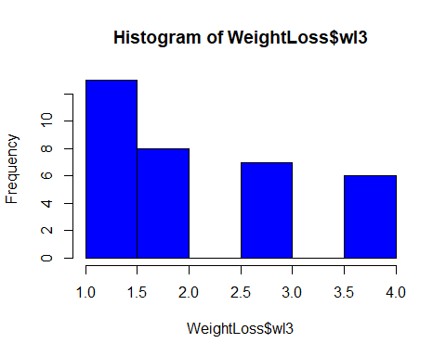

pairs.panels(WeightLoss[2:7],gap=0)

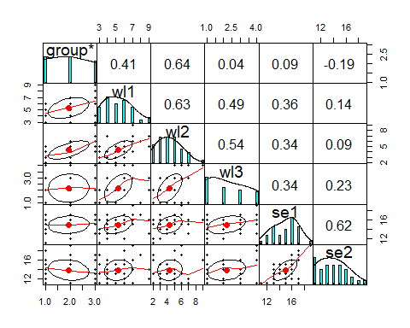

Comments : Each individual plot shows the relationship between the variable in the horizontal vs the vertical of the grid.