SIMATS ENGINEERING
ASSESSMENT TOOL 2 – APPLICATION-BASED QUESTIONS

Course: ETHICAL HACKING | Code: ITA1407 | CO: CO5
Duration: 1Hr | Total Marks: 100 | Reg No / Name :  Mokshitha Kilari  192525413

COURSE OUTCOME COVERED
CO5: Analyze vulnerabilities in Windows and Linux systems and evaluate security weaknesses in messaging, web, and mobile applications using appropriate exploitation techniques and hacking tools. (BT5)
Instructions: Answer all questions. Each question carries 20 marks.
___________________________________________________________________
1. A mid-sized financial organization operates several legacy Windows servers where multiple RPC services remain exposed due to delayed patching cycles caused by operational constraints. Recently, abnormal traffic patterns and unauthorized connection attempts have been observed within the internal network. As a security analyst, evaluate how attackers could exploit these RPC vulnerabilities to gain unauthorized access and escalate privileges. Assess the level of risk associated with delaying patches in such environments and justify whether immediate patch deployment or controlled maintenance scheduling is more appropriate. Recommend suitable mitigation strategies to reduce exposure without affecting business continuity.
2. A web application used for online transactions suffers from multiple vulnerabilities, including cross-site scripting (XSS), cross-site request forgery (CSRF), and weak session management practices. Users report unauthorized transactions and session hijacking incidents. Evaluate how attackers could combine these vulnerabilities to execute complex attacks affecting user accounts. Assess the risks associated with poor session handling and lack of input validation. Justify the need for a layered security approach and recommend comprehensive mitigation strategies to secure the application.
3. An enterprise uses an outdated IIS server to host multiple internal and external applications, and recent vulnerability scans indicate several unpatched critical flaws. Despite warnings, the organization delays updates due to fear of downtime and service disruption. Assess how attackers could exploit these vulnerabilities to gain unauthorized access or execute remote code. Evaluate the risks associated with delaying security updates in such environments and justify whether immediate patching or temporary isolation is more appropriate. Recommend strategies to ensure both security and service availability.
4. A mobile application used by customers stores sensitive information such as login credentials and personal data in plaintext within the device storage. Additionally, the application communicates with backend servers over unsecured channels. Evaluate how attackers could exploit these weaknesses through device compromise or network interception. Assess the potential impact on user privacy and organizational reputation. Justify the need for encryption and recommend secure storage and communication techniques.
5. A system administrator disables the Windows firewall temporarily to troubleshoot connectivity issues but forgets to re-enable it. Within a short period, multiple unauthorized access attempts are detected. Evaluate how attackers could exploit this temporary exposure to gain access to critical services. Assess the risks associated with mismanagement of security controls and justify the importance of enforcing automated policies. Recommend administrative safeguards to prevent such incidents.
Code of Conduct:
I Mokshitha Kilari(192525413) (Name / Reg No) certify that this submission is my original work and that I have adhered to the guidelines specified for this assessment. I understand that any violation of academic integrity rules will result in disciplinary action.
Signature of the student: MOKSHITHAKILARI

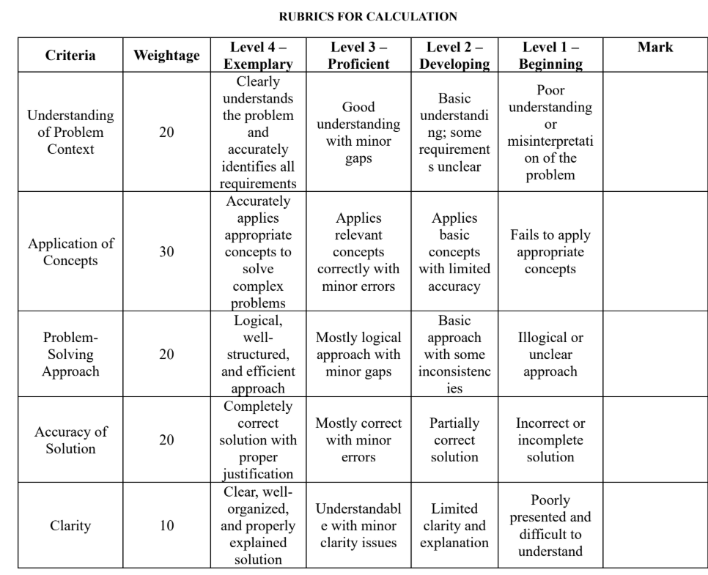
Question 1
Scenario: A mid-sized financial organization operates several legacy Windows servers where multiple RPC services remain exposed due to delayed patching cycles. Abnormal traffic and unauthorized connection attempts have been observed internally.
1. Understanding the Problem Context
The core issue is a combination of two weaknesses acting together: outdated, unpatched Remote Procedure Call (RPC) services on legacy Windows servers, and an organizational patching process that is slow due to operational/change-management constraints. RPC endpoints (e.g., the RPC endpoint mapper on TCP 135, and named-pipe/SMB-based RPC over 445) are historically associated with critical remote code execution flaws (such as the class of vulnerabilities exploited by worms like Blaster and WannaCry/EternalBlue-style SMB issues). When these services are internet- or network-reachable and unpatched, they present a high-value target. The abnormal traffic and unauthorized connection attempts described are strong indicators that reconnaissance or active exploitation attempts are already under way, which elevates this from a theoretical risk to an active incident requiring urgent triage.
2. Exploitation / Attack Path Analysis
An attacker would typically follow a staged path:
- Reconnaissance & Service Discovery: Port scanning (e.g., Nmap) to identify open RPC-related ports (135, 445, dynamic high ports used by RPC), followed by service/version fingerprinting to identify unpatched software versions.
- Vulnerability Identification: Mapping discovered versions against known CVEs for RPC/SMB services to find an unpatched, exploitable endpoint.
- Initial Access: Sending a crafted RPC request that triggers a buffer overflow or logic flaw in the vulnerable service, yielding remote code execution or an authentication bypass without valid credentials.
- Privilege Escalation: Because many legacy RPC services run under SYSTEM or highly privileged service accounts, a successful exploit can hand the attacker SYSTEM-level control immediately, or the attacker escalates further via token impersonation, credential dumping (e.g., LSASS memory), or exploiting weak service permissions.
- Lateral Movement & Persistence: Using the compromised host as a pivot to reach other internal systems (especially dangerous in a flat internal network), and installing persistence mechanisms (scheduled tasks, new services, registry run keys).
This matches the pattern captured in the lab analysis below: service discovery leads to identification of a vulnerable RPC endpoint, which enables initial access and then privilege escalation.
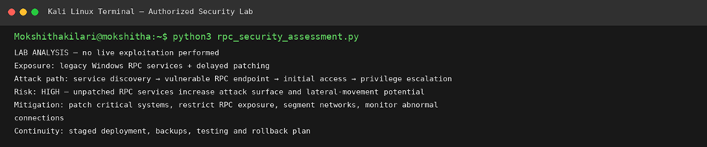
Figure 1: Authorized lab analysis output (rpc_security_assessment.py) — reconnaissance/attack-path modelling only; no live exploitation performed.
3. Risk Assessment
The risk level here is HIGH to CRITICAL. Impact is severe because these are financial-sector servers, meaning a successful compromise could expose customer financial data, enable fraud, and trigger regulatory/compliance breaches (e.g., PCI-DSS, RBI/financial-sector cyber guidelines). Likelihood is also elevated given the observed abnormal traffic, meaning threat actors may already be probing the environment. Using a simple Risk = Likelihood × Impact model, both factors are elevated, so the overall residual risk of continued exposure is unacceptably high for a financial organization, which typically has strict uptime/regulatory obligations but even stricter data-protection obligations.
4. Justification: Immediate Patching vs. Controlled Maintenance Scheduling
Given that unauthorized connection attempts are already being observed, this scenario has moved from 'preventive maintenance' to 'active risk mitigation under attack conditions.' Immediate patch deployment is justified over normal controlled maintenance scheduling for the specific vulnerable RPC services, because the cost of a breach (financial loss, regulatory penalties, reputational damage, and potential systemic fraud) far outweighs the short-term cost of an emergency change window. However, a fully unplanned, untested emergency patch across all legacy servers risks operational disruption. The recommended approach is therefore a hybrid: apply emergency compensating controls immediately (see below) to stop active exploitation attempts, while running the actual patch deployment through an accelerated but still tested emergency-change process (a compressed maintenance window with rollback plans), rather than either reckless immediate patching of production with no testing, or business-as-usual scheduled patching that leaves the organization exposed for weeks.
5. Recommended Mitigation Strategies
- Patch critical/unpatched RPC and SMB-related vulnerabilities on priority servers first, using an accelerated (not reckless) emergency-change process with pre-tested rollback plans.
- Restrict RPC exposure: block/limit ports 135, 445 and dynamic RPC ports at the network perimeter and between internal segments using firewalls/ACLs so only authorized hosts can reach them.
- Network segmentation: isolate legacy servers into a dedicated VLAN with strict east-west traffic controls to limit lateral movement.
- Continuous monitoring: deploy IDS/IPS and SIEM alerting tuned to detect RPC/SMB exploitation signatures and the abnormal connection patterns already observed.
- Compensating controls where patching must be delayed: virtual patching via IPS signatures, disabling unused RPC-dependent services, and enforcing the principle of least privilege on service accounts.
- Maintain business continuity through staged deployment, full backups before patching, pre-production testing, and a documented rollback plan (as reflected in the lab evidence above).

Question 2
Scenario: A web application used for online transactions suffers from XSS, CSRF, and weak session management. Users report unauthorized transactions and session hijacking.
1. Understanding the Problem Context
This scenario involves three distinct but interrelated web application weaknesses. Cross-Site Scripting (XSS) allows an attacker to inject malicious client-side scripts into pages viewed by other users, typically because of insufficient input validation and output encoding. Cross-Site Request Forgery (CSRF) allows an attacker to trick an authenticated user's browser into submitting unintended requests to the application, exploiting the trust the server places in the user's session. Weak session management (e.g., predictable session tokens, missing timeouts, tokens exposed in URLs, lack of secure cookie flags) undermines the integrity of the authentication mechanism itself. Individually each is serious; combined, they create a compounding attack surface where one flaw amplifies the impact of another, which explains the reported unauthorized transactions and session hijacking.
2. Exploitation / Attack Chain Analysis
- Step 1 – Injection: The attacker identifies an input field lacking sanitization (e.g., a comment box, search field, or profile field) and injects a malicious script.
- Step 2 – Script Execution & Session Theft: When a victim views the affected page, the script executes in their browser context. If session cookies lack the HttpOnly flag, the script can read and exfiltrate the session token to an attacker-controlled server, enabling session hijacking.
- Step 3 – CSRF Abuse: In parallel, or independently, the attacker crafts a hidden form/auto-submitting request (e.g., a fund-transfer request) hosted on a malicious page. If the victim is logged in and the application does not validate CSRF tokens or the SameSite cookie attribute, the browser automatically attaches the valid session cookie, and the forged request is processed as if the victim intentionally submitted it — this directly explains the unauthorized transactions.
- Step 4 – Persistence via Weak Sessions: Because sessions lack rotation and proper timeouts, a stolen token can remain valid long after the interaction, letting the attacker continue to act as the victim across multiple sessions.
In effect, XSS provides the delivery mechanism for token theft, CSRF provides the mechanism for forcing unauthorized authenticated actions, and weak session management removes the safety nets (short lifetimes, secure flags, rotation) that would otherwise limit the damage.
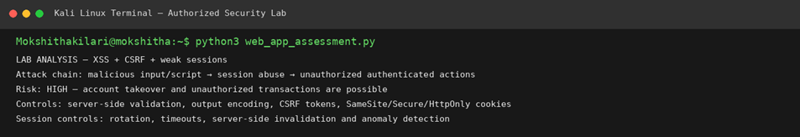
Figure 2: Authorized lab analysis output (web_app_assessment.py) modelling the XSS + CSRF + weak-session attack chain.
3. Risk Assessment
The risk is HIGH. This is a financial/transactional application, so impact includes direct monetary loss to users, unauthorized fund transfers, loss of customer trust, and potential regulatory action for failing to protect payment-related data (e.g., under PCI-DSS or similar frameworks). Likelihood is high because XSS and CSRF are well-understood, commonly automated attack classes (tools such as Burp Suite and OWASP ZAP can identify and exploit them quickly), and the fact that incidents are already being reported confirms active exploitation.
4. Justification for a Layered (Defense-in-Depth) Security Approach
No single control fully closes this gap: fixing XSS alone does not stop CSRF, and fixing CSRF alone does not stop session hijacking via other vectors (e.g., network sniffing on non-HTTPS channels or XSS elsewhere). Because the three weaknesses are independent root causes that happen to combine into one attack chain, mitigation must be layered — addressing input handling, output handling, request-origin verification, and session lifecycle management as separate but complementary controls. This layered approach also provides defense-in-depth: if one control fails or a new bypass is discovered, other layers still constrain the attacker's ability to cause harm.
5. Recommended Mitigation Strategies
- Input validation and output encoding/escaping on all user-supplied data (contextual encoding for HTML, JS, and URL contexts) to neutralize XSS payloads.
- Content Security Policy (CSP) headers to restrict script execution sources as a secondary defense against XSS.
- Anti-CSRF tokens (synchronizer token pattern) on all state-changing requests, combined with SameSite=Strict/Lax cookie attributes.
- Secure session management: HttpOnly and Secure cookie flags, short session timeouts, session ID rotation after login/privilege changes, and server-side session invalidation on logout.
- Continuous monitoring for anomalous session behavior (e.g., same session used from multiple geographies/IPs in a short window) and rate-limiting on transaction endpoints.
- Regular security testing (SAST/DAST and penetration testing) to catch regressions in input validation and session handling before release.

Question 3
Scenario: An enterprise uses an outdated IIS server hosting multiple applications; vulnerability scans show unpatched critical flaws, but updates are delayed due to fear of downtime.
1. Understanding the Problem Context
The organization is knowingly running outdated Internet Information Services (IIS) software with confirmed critical vulnerabilities, but is prioritizing perceived operational stability (avoiding downtime) over addressing known security flaws. Because IIS hosts both internal and external applications, a single vulnerable instance can serve as a gateway into multiple business systems at once, magnifying the blast radius of any successful attack. This is a classic risk-acceptance-versus-risk-transfer dilemma, except that the 'acceptance' here is implicit and undocumented rather than a deliberate, informed business decision.
2. Exploitation / Attack Path Analysis
- Reconnaissance: Attackers fingerprint the IIS version and installed modules/extensions (e.g., via HTTP response headers, banner grabbing, or tools like Nikto/Nmap NSE scripts) to identify the exact build and known CVEs.
- Exploitation of Unpatched Flaws: Depending on the specific CVE, this can range from directory traversal and information disclosure to authentication bypass or full remote code execution (RCE) via vulnerable ISAPI extensions, WebDAV, or request-parsing flaws.
- Unauthorized Access / RCE: A successful RCE exploit gives the attacker a foothold with the privileges of the IIS application pool identity, which can then be escalated further (e.g., via local privilege escalation flaws or misconfigured service accounts) to gain full server control.
- Multi-application impact: Because the server hosts multiple internal and external applications, compromise of the underlying IIS instance can expose or compromise every application on that host, not just one.
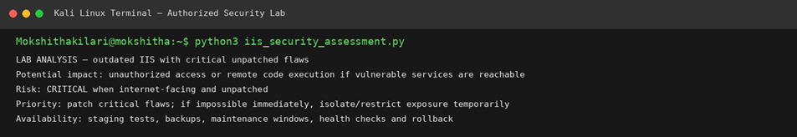
Figure 3: Authorized lab analysis output (iis_security_assessment.py) — outdated IIS with unpatched critical flaws.
3. Risk Assessment
Risk is CRITICAL, especially for the externally-facing applications, since any internet-reachable vulnerable service is exposed to the entire internet's threat population, not just internal actors. Impact is severe due to the multi-tenant nature of the server (one compromise affects many applications), and likelihood is high given that vulnerability scanners have already flagged the flaws — meaning automated attacker tools and scanners are very likely to find the same weaknesses.
4. Justification: Immediate Patching vs. Temporary Isolation
The right approach depends on exposure and exploit availability. For flaws with public exploits and internet-facing exposure, immediate patching (or, if patching cannot be completed instantly, immediate temporary isolation of the affected applications from the internet) is justified, because the potential cost of a breach across multiple hosted applications vastly exceeds the cost of a short, well-communicated outage. For internal-only applications with lower exploit availability, a short, controlled maintenance window with pre-patch backups and rollback testing is reasonable, since the exposure is more limited. In no case is indefinite delay justified: the fear of downtime must be weighed against the near-certainty of a scanner-confirmed vulnerability eventually being exploited, and downtime from a planned patch window is virtually always shorter and cheaper than downtime from an actual incident (which includes forensics, remediation, and reputational recovery).
5. Recommended Strategies for Security and Availability
- Patch the critical, actively-exploitable flaws first, prioritized by CVSS score and internet exposure, using a risk-ranked patch schedule rather than an all-or-nothing approach.
- Where immediate patching is not feasible, temporarily isolate or restrict access to the affected applications (e.g., placing them behind a WAF, VPN-only access, or taking external-facing endpoints offline) until they can be patched.
- Use staging environments to test patches for compatibility before production rollout, minimizing the chance of patch-induced downtime.
- Maintain full backups and a documented rollback plan before every patch cycle, plus health checks immediately after deployment to confirm stability.
- Deploy a Web Application Firewall (WAF) as a compensating control to filter known exploit patterns while patches are being finalized.
- Establish a formal patch-management policy with defined SLAs based on severity, so 'fear of downtime' can no longer become an indefinite excuse for inaction.

Question 4
Scenario: A mobile application stores sensitive information (login credentials, personal data) in plaintext on the device and communicates with backend servers over unsecured channels.
1. Understanding the Problem Context
This scenario reflects two of the most common mobile application security failures identified in frameworks such as the OWASP Mobile Top 10: insecure data storage and insecure communication. Storing credentials and personal data in plaintext (e.g., in shared preferences, local SQLite databases, or flat files without encryption) means that anyone with access to the device's filesystem — whether through physical theft, malware, or a rooted/jailbroken device — can read this data directly. Simultaneously, communicating over unsecured channels (plain HTTP instead of TLS, or TLS without proper certificate validation) exposes data in transit to interception.
2. Exploitation / Attack Path Analysis
- Device-based compromise: An attacker who gains physical access to a lost/stolen device, or who tricks the user into installing malware, can access the app's local storage directly (via file-system access, backup extraction, or a rooted device) and read plaintext credentials and personal data without needing to bypass any encryption.
- Network interception: On an unsecured or improperly secured channel, an attacker on the same network (e.g., public Wi-Fi) can perform a man-in-the-middle (MITM) attack — intercepting, reading, and potentially modifying data in transit, including login credentials sent during authentication.
- Combined impact: An attacker could harvest stored credentials from a compromised device and separately harvest live session data via network interception, giving multiple independent paths to full account takeover.
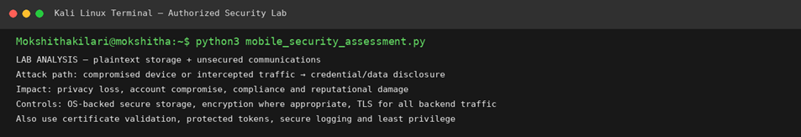
Figure 4: Authorized lab analysis output (mobile_security_assessment.py) — plaintext storage and unsecured communications.
3. Risk Assessment — Impact on Privacy and Reputation
The impact on user privacy is severe: exposure of login credentials and personal data can lead to identity theft, unauthorized account access, and financial fraud, and once such data is exposed it cannot be 'taken back.' The impact on organizational reputation is equally significant — a publicized breach involving plaintext credential storage is often viewed as a basic, avoidable failure of due diligence, which can trigger regulatory scrutiny (e.g., under data protection regulations), loss of customer trust, and potential legal liability. Given the sensitivity of the data and the simplicity of the attack paths (no advanced exploit is required, just device or network access), the overall risk is HIGH.
4. Justification for Encryption
Encryption is essential at both rest and in transit because it changes the economics of the attack: even if an attacker gains access to the device storage or intercepts network traffic, properly encrypted data remains unusable without the corresponding keys. Encryption does not eliminate the need for other controls, but it is the foundational control that ensures a single point of compromise (lost device, network sniffing) does not automatically translate into full data disclosure.
5. Recommended Secure Storage and Communication Techniques
- Use OS-provided secure storage mechanisms for credentials and sensitive data — Android Keystore/EncryptedSharedPreferences and iOS Keychain — rather than plain files or shared preferences.
- Encrypt sensitive data at rest using strong, vetted algorithms (e.g., AES-256) when secure storage APIs alone are insufficient for the data type.
- Enforce TLS (HTTPS) for all client-server communication, with certificate/public-key pinning to prevent MITM attacks even if a rogue certificate authority is trusted by the device.
- Avoid storing long-lived credentials on the device at all where possible — use short-lived, revocable tokens (e.g., OAuth access/refresh tokens) instead of persistent passwords.
- Implement secure logging practices (never log credentials or personal data in plaintext) and apply least-privilege access to any local data the app does store.
- Conduct regular mobile application security testing (static and dynamic analysis, e.g., using MobSF) to catch insecure storage or communication patterns before release.

Question 5
Scenario: A system administrator disables the Windows firewall temporarily for troubleshooting and forgets to re-enable it. Multiple unauthorized access attempts are detected shortly after.
1. Understanding the Problem Context
This scenario is fundamentally a security-control mismanagement problem rather than a software vulnerability. The Windows firewall is a host-based control that restricts inbound/outbound traffic to only explicitly permitted services. Temporarily disabling it for troubleshooting is a legitimate and common administrative action, but the failure here is procedural: there was no safeguard to ensure the control was automatically restored, no time-boxing of the change, and apparently no monitoring to flag that a critical control had been left off. This turned a short, intended exception into a persistent, unintended exposure.
2. Exploitation / Attack Path Analysis
- Exposure window: With the firewall disabled, any service listening on the host (including ones normally blocked by default firewall rules, such as file sharing, RPC, or management interfaces) becomes reachable from the network without the usual filtering.
- Discovery: Attackers or automated scanners on the same network segment (or, if the host is reachable externally, from the internet) can quickly detect the newly-open ports via routine scanning, since such scans are often continuously running in the background on many networks.
- Unauthorized access attempts: Once open services are found, attackers attempt direct connections, brute-force login attempts, or exploitation of any service-level vulnerabilities that the firewall would normally have blocked, which matches the multiple unauthorized access attempts described in the scenario.
- Escalation risk: If any exposed service has weak authentication or a known vulnerability, the initial exposure can lead directly to unauthorized access to critical services and, from there, to broader compromise.
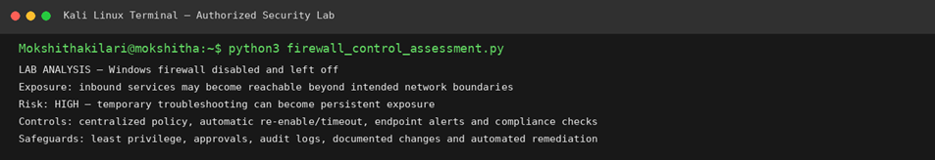
Figure 5: Authorized lab analysis output (firewall_control_assessment.py) — Windows firewall left disabled after troubleshooting.
3. Risk Assessment
The risk is HIGH. While the firewall being off does not by itself compromise the system, it removes a key layer of defense-in-depth, meaning any underlying weak service or weak credential set is now directly reachable. Likelihood rises sharply the longer the control remains off (as shown by the multiple attempts detected 'within a short period'), and impact depends on what services are exposed — potentially including administrative or file-sharing services that would give an attacker a direct path to critical systems.
4. Justification: Importance of Enforcing Automated Policies
This incident illustrates why security controls should not depend solely on human memory or manual follow-up. A single missed step (forgetting to re-enable the firewall) converted a controlled, time-limited exception into an ongoing vulnerability. Enforcing automated policies — such as scheduled/timed re-enablement, centrally managed firewall policy (e.g., via Group Policy) that periodically reasserts the desired state, and automated compliance checks — removes reliance on individual memory and ensures that deviations from baseline security posture are detected and corrected quickly, regardless of human error.
5. Recommended Administrative Safeguards
- Use centrally managed firewall policy (e.g., Group Policy Objects) so firewall state is enforced and automatically reasserted rather than left to local, manual configuration.
- Implement automatic re-enable/timeout mechanisms for any troubleshooting exception, so the firewall (or any disabled control) reverts to its secure default after a defined period even if the administrator forgets.
- Deploy endpoint compliance monitoring/alerts that immediately flag when a critical control such as the firewall is disabled, notifying security operations in real time.
- Require change-approval and logging for any temporary disabling of security controls, including a mandatory documented reason, expected duration, and a named owner responsible for re-enabling it.
- Apply least-privilege administrative access so that only authorized personnel can disable host-based security controls, reducing the chance of unreviewed changes.
- Conduct periodic security configuration audits to catch any drift from baseline (such as a disabled firewall) that automated alerting may have missed.

