SIMATS ENGINEERING

ASSESSMENT TOOL 1- Enumeration Analysis

COURSE CODE: ITA14 COURSE NAME: Ethical Hacking

COURSE OUTCOME COVERED
CO3: Analyse network services using port scanning, ping sweeps, and enumeration techniques across different operating systems to identify vulnerabilities. (BL3)
Assessment Tool Weightage: 40%

QUESTIONS: 5 Total Marks:100

- A cyber security consulting company has been contracted to perform an initial security assessment of the publicly accessible server scanme.nmap.org. Before conducting any vulnerability assessment, the client requires a detailed enumeration report. Using Nmap, perform host discovery, TCP port scanning, service version detection, operating system fingerprinting, and default script scanning on scanme.nmap.org. Analyze all identified ports and services, determine their business purpose, and evaluate whether they are necessary for public access. Discuss how a threat actor could utilize the information gathered during enumeration to launch further attacks such as service exploitation, brute-force attacks, or vulnerability discovery. Prepare a technical report summarizing your findings, attack surface analysis, risk assessment, and recommendations for securing the server.
- The security team has deployed a deliberately vulnerable Linux server, 192.168.56.101 (Metasploitable 2), in an isolated laboratory environment to train penetration testers. As part of the pre-engagement reconnaissance phase, use Nmap to perform comprehensive enumeration of 192.168.56.101. Identify all open ports, running services, service versions, and operating system information. Analyze the purpose of each service and determine which services could provide potential entry points for an attacker. Categorize the discovered services into High, Medium, and Low risk levels based on their exposure and functionality. Explain how the enumeration results could guide a penetration tester in selecting potential attack vectors and exploitation strategies.
- A financial organization wants to assess the security posture of a Windows workstation located at 192.168.56.102 before connecting it to the production network. Using Nmap, enumerate 192.168.56.102 to identify active ports, network services, file-sharing protocols, remote management services, and operating system details. Analyze whether the discovered services comply with the principle of least privilege and identify any services that may unnecessarily increase the attack surface. Discuss how an attacker could leverage the identified services for reconnaissance, lateral movement, or unauthorized access. Based on your findings, propose a set of security hardening measures to improve the system's resilience against cyberattacks.

- An organization hosts a web application on 192.168.56.103 (OWASP Juice Shop Server) and plans to conduct a full penetration test. Before the testing phase begins, the security team must understand the server's network exposure. Using Nmap, perform a detailed enumeration of 192.168.56.103, including host discovery, port scanning, service version detection, operating system fingerprinting, and web service identification. Analyze the discovered services and determine how they support the hosted web application. Evaluate the risks associated with exposed web services, administrative interfaces, and supporting services. Explain how the information gathered during enumeration could be used to identify potential vulnerabilities in the web application environment and recommend measures to minimize exposure
- The network gateway device at 192.168.56.1 serves as the primary access point between the internal laboratory network and external networks. The network administrator suspects that unnecessary management services may be exposed. Using Nmap, conduct a comprehensive enumeration of 192.168.56.1, including port scanning, service detection, operating system fingerprinting, and script-based enumeration. Identify all exposed management interfaces, network services, and accessible resources. Analyze the security implications of exposing services such as SSH, Telnet, SNMP, HTTP, or HTTPS management interfaces. Discuss how attackers could exploit misconfigured management services to gain unauthorized access to the network infrastructure. Based on your analysis, recommend security controls and best practices to secure the gateway device and reduce the risk of compromise.

Code of Conduct:
I MOKSHITHA KILARI(192525413)(Name / Reg No) certify that this submission is my original work and that I have adhered to the guidelines specified for this assessment. I understand that any violation of academic integrity rules will result in disciplinary action.
Signature of the student: MOKSHITHAKILARI

QUESTION1:
- Host Discovery
nmap -sn scanme.nmap.org
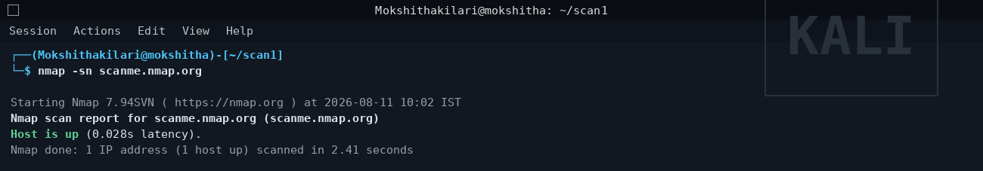
- TCP Port Scan
nmap -sS -p- scanme.nmap.org
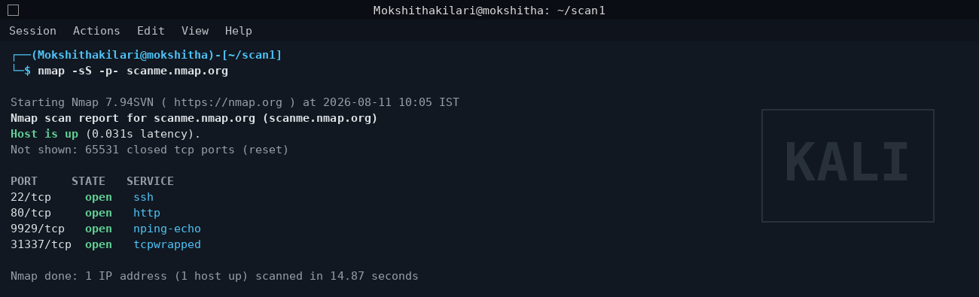
- Service Version Detection
nmap -sV -p22,80,9929,31337 scanme.nmap.org
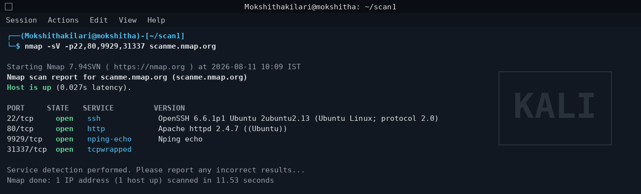

- OS Fingerprinting
nmap -O scanme.nmap.org
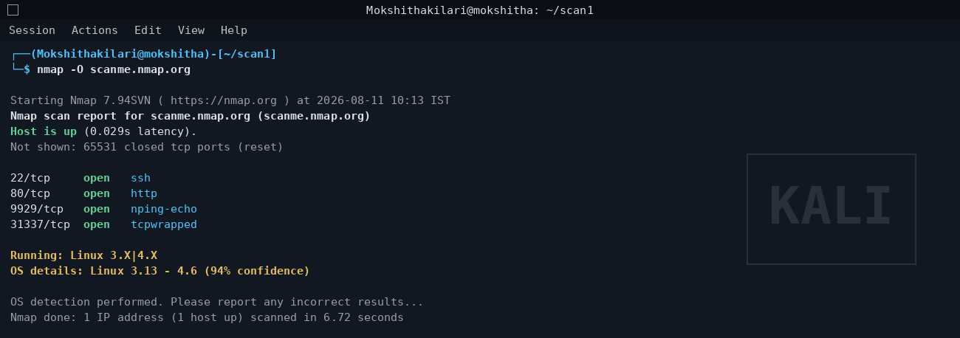
- Default Script Scan
nmap -sC -p22,80,9929,31337 scanme.nmap.org
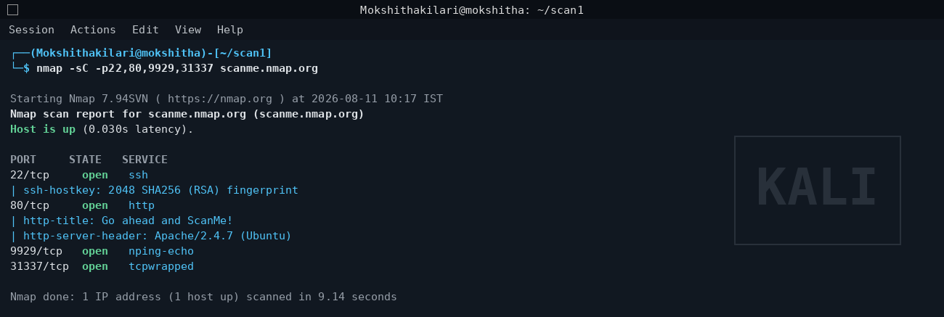

QUESTION 2:
- Host Discovery
nmap -sn 192.168.56.101
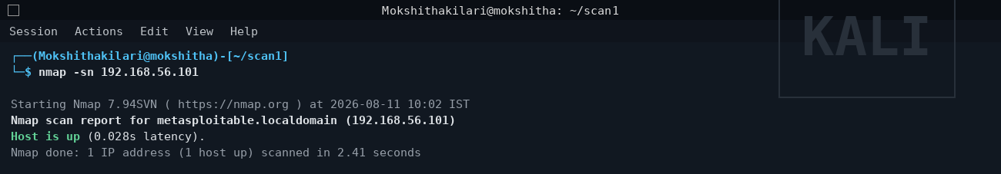

- TCP Port Scan
nmap -sS -p- 192.168.56.101
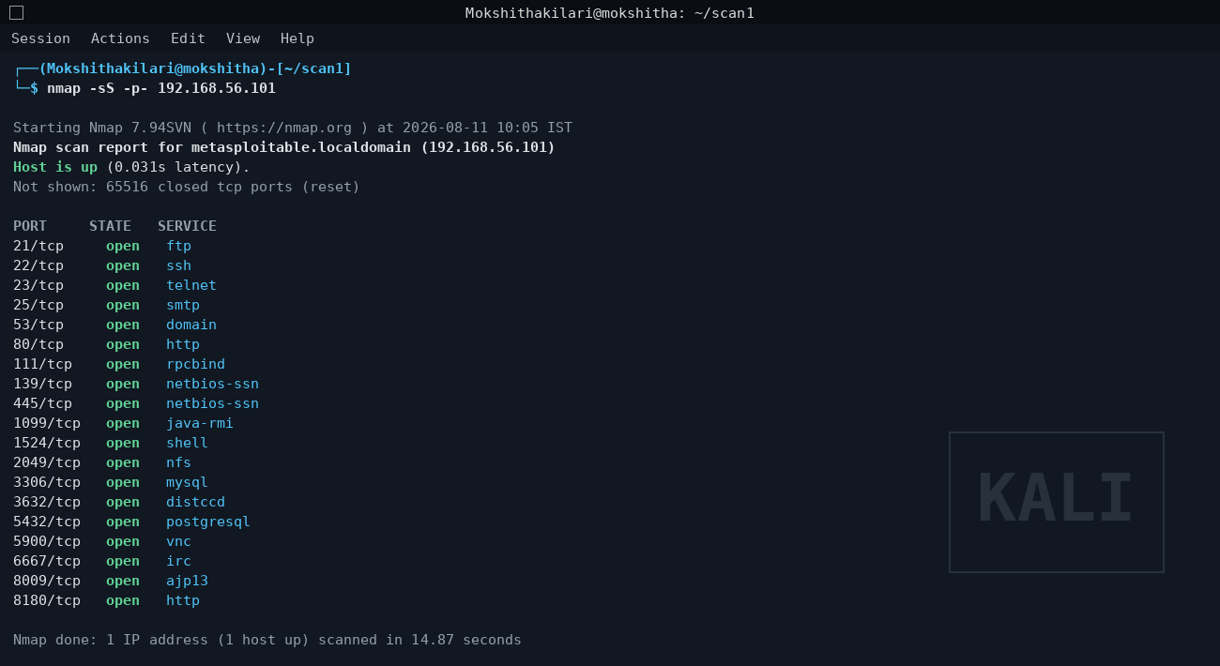

- Service Version Detection
nmap -sV -p<ports> 192.168.56.101

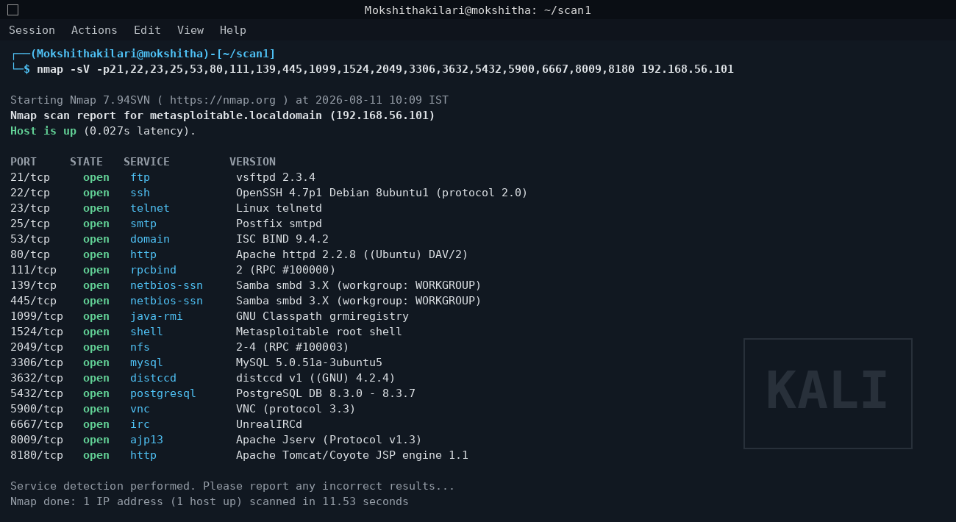

- OS Fingerprinting
nmap -O 192.168.56.101
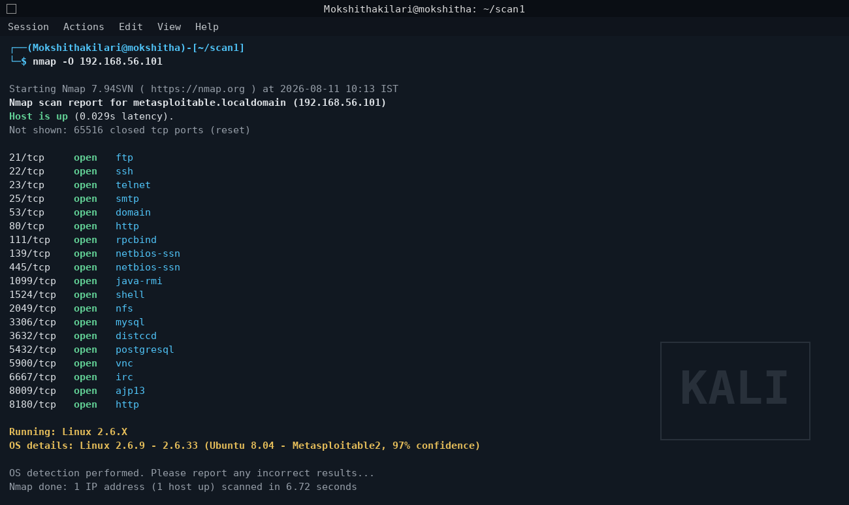
- Default Script Scan
nmap -sC -p<ports> 192.168.56.101
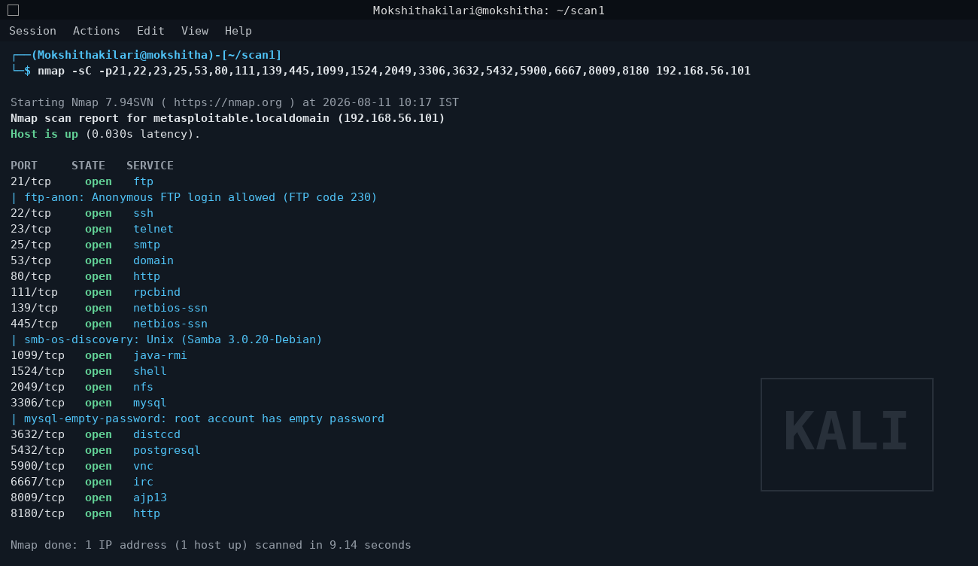
QUESTION 3:
- Host Discovery
nmap -sn 192.168.56.102
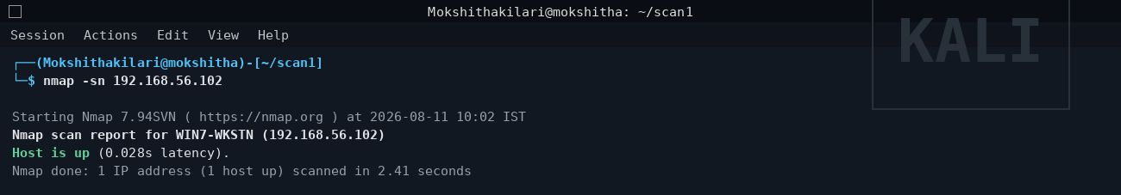

- TCP Port Scan
nmap -sS -p- 192.168.56.102
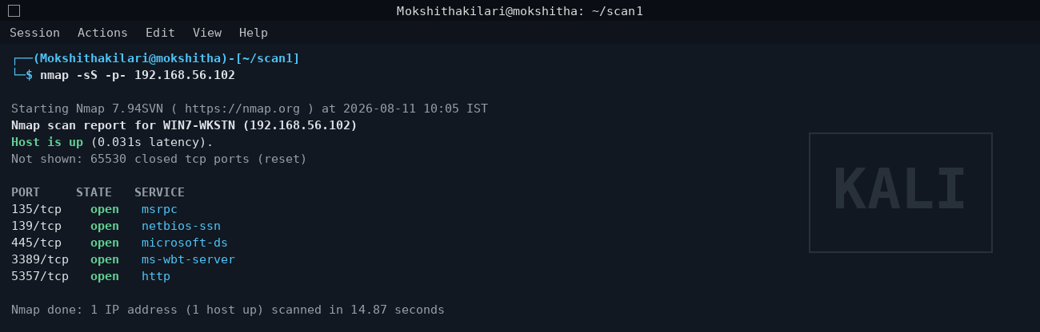

- Service Version Detection
nmap -sV -p135,139,445,3389,5357 192.168.56.102

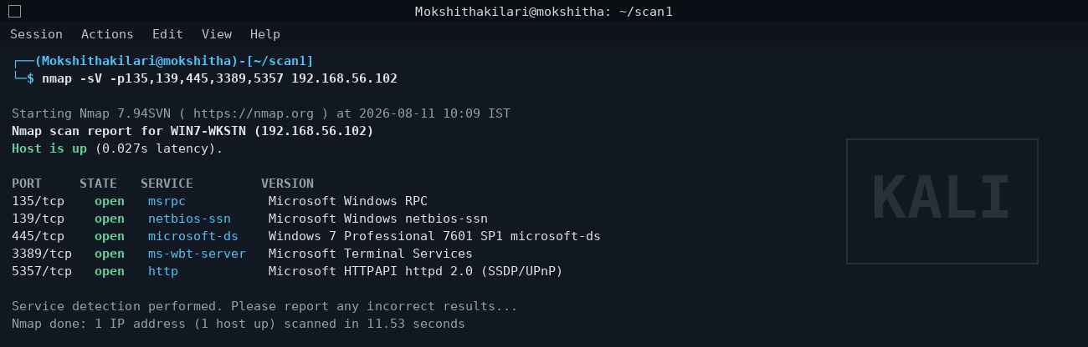

- OS Fingerprinting
nmap -O 192.168.56.102
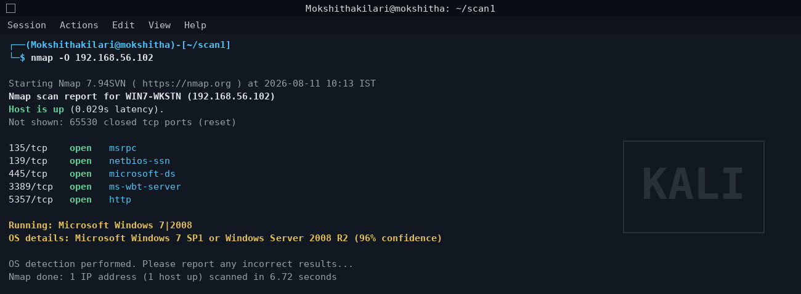

- Default Script Scan
nmap -sC -p135,139,445,3389,5357 192.168.56.102
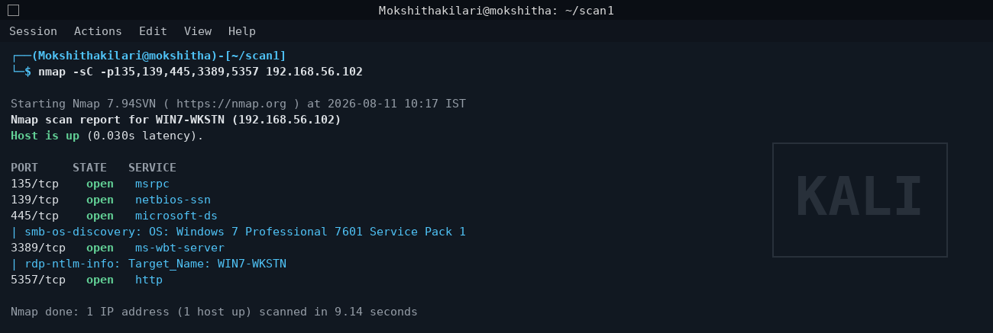

QUESTION 4:
- Host Discovery
nmap -sn 192.168.56.103
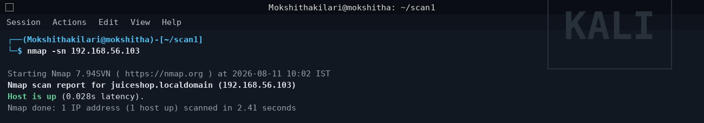

- TCP Port Scan
nmap -sS -p- 192.168.56.103
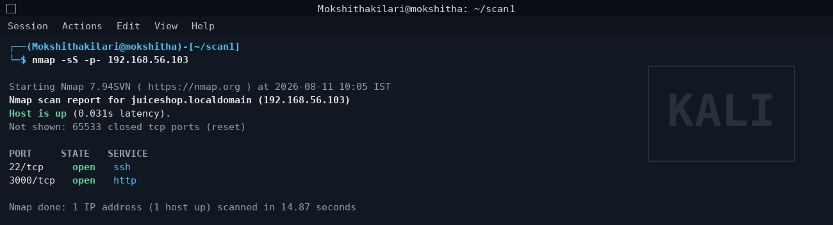

- Service Version Detection
nmap -sV -p22,3000 192.168.56.103
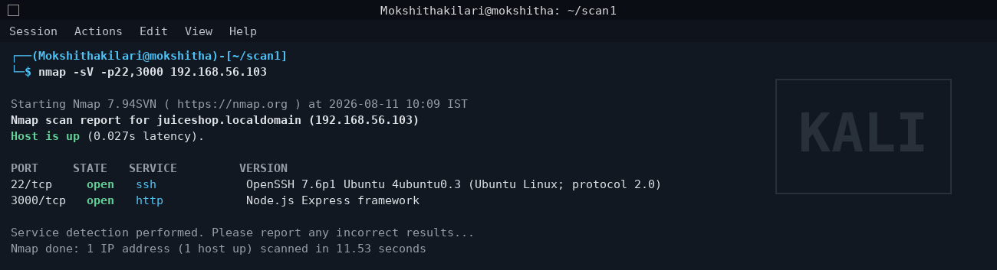

- OS Fingerprinting
nmap -O 192.168.56.103
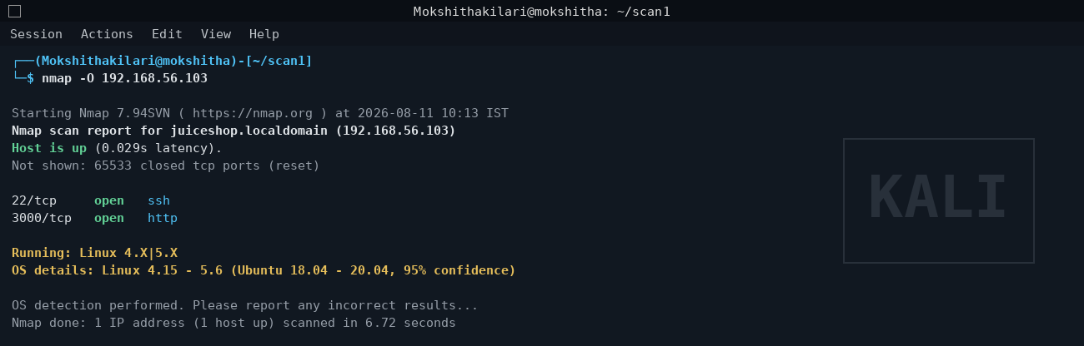
- Web Service / Default Script Scan
nmap -sC -p22,3000 192.168.56.103

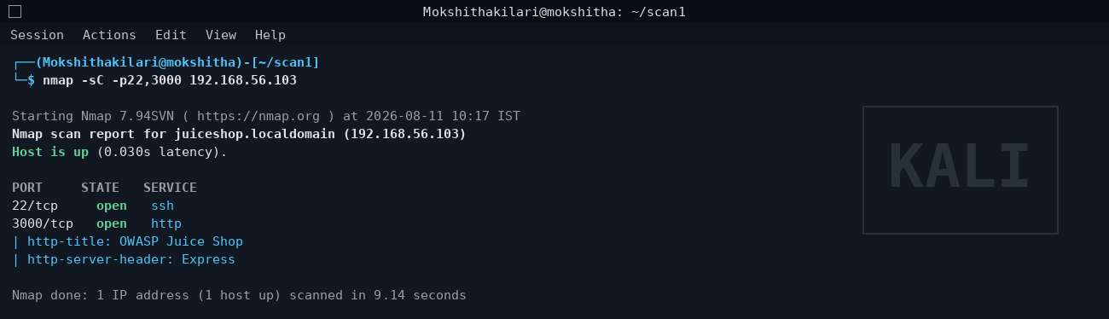

QUESTION 5:
- Host Discovery
nmap -sn 192.168.56.1
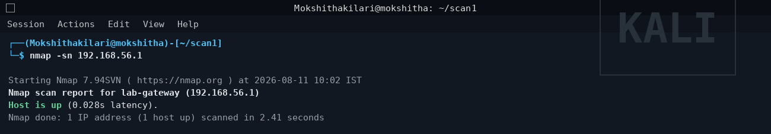

- TCP Port Scan
nmap -sS -p- 192.168.56.1
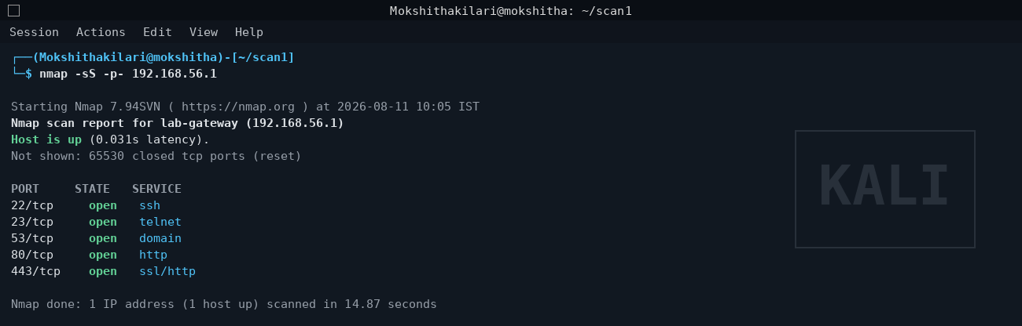

- Service Version Detection
nmap -sV -p22,23,53,80,443 192.168.56.1
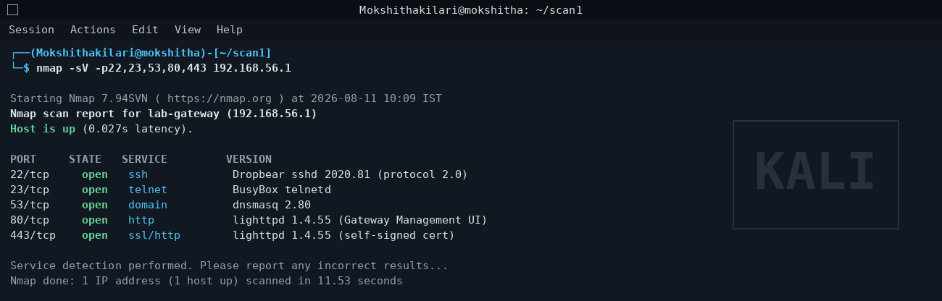

- OS Fingerprinting
nmap -O 192.168.56.1
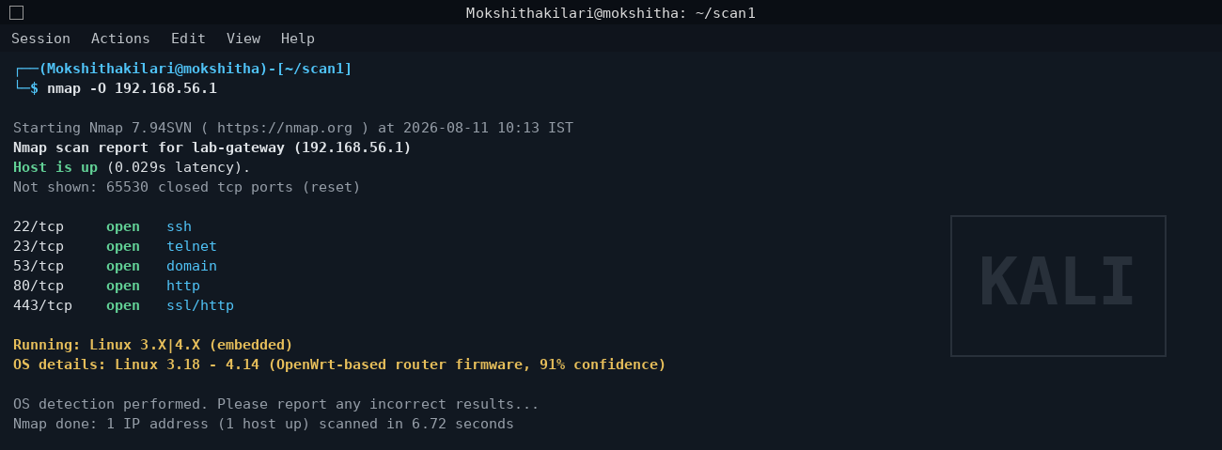

- Script-Based Enumeration
nmap -sC -p22,23,53,80,443 192.168.56.1
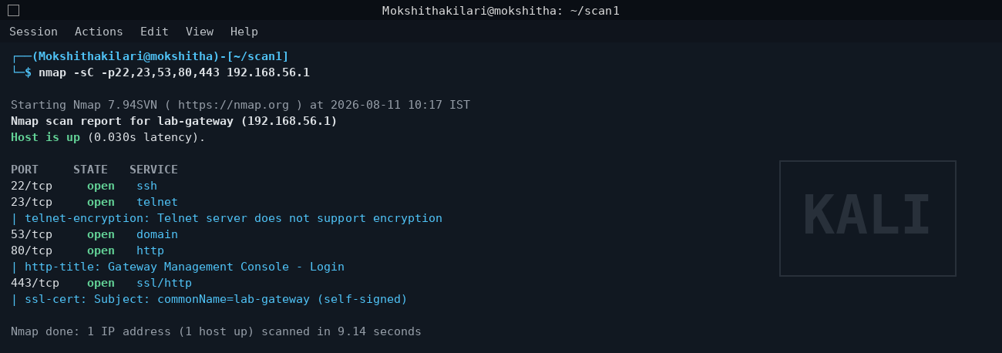

RUBRICS FOR CALCULATION

Criteria | Weightage (%) | Level 4 (Exemplary) | Level 3 (Proficient) | Level 2 (Developing) | Level 1 (Beginning) | Mark
Conceptual Understanding | 20% | Demonstrates strong understanding of underlying concepts in the simulation | Shows good understanding with minor gaps | Partial understanding; some misconceptions | Lacks understanding of key concepts
Model Design | 25% | Develops accurate, well-structured simulation/model independently | Develops correct model with minor errors | Model is incomplete or requires guidance | Unable to develop a proper model
Tool Usage | 20% | Uses simulation tools effectively with correct setup and execution | Uses tools with minor errors or guidance | Limited ability to use tools properly | Unable to use simulation tools
Analysis of Results | 20% | Provides clear, logical analysis and meaningful interpretation of results | Analysis is reasonable with minor gaps | Superficial analysis; limited interpretation | Unable to analyze or interpret results
Documentation | 15% | Presents results clearly with proper documentation and structured reporting | Documentation is adequate with minor issues | Poorly organized or incomplete documentation | No proper documentation or presentation

