SIMATS ENGINEERING
ASSESSMENT TOOL 1
COURSE NAME: Ethical Hacking COURSE CODE: ITA1407
COURSE OUTCOME COVERED
CO4: Implement network security testing methods by performing web server attacks, analyzing web application vulnerabilities, and assessing wireless network security using Kali Linux.
QUESTIONS: 01 Total Marks:100
Annexure A
SECURITY TESTING SIMULATION TASK
Code of Conduct:
I Mokshitha Kilari(19252413) (Name / Reg No) certify that this submission is my original work and that I have adhered to the guidelines specified for this assessment.
S.No. | Assessment  Criterion | Excellent | Good | Satisfactory | Needs Improvement | Marks
1 | Tool Selection and Configuration(20) | Selects appropriate open source tools, configures them correctly, and clearly  explains the purpose of each tool. | Selects suitable tools and configures them with minor errors or limited explanation. | Uses basic tools with partial configuration and limited  understanding. | Selects inappropriate tools or fails to configure them  correctly.
2 | Testing Procedure and Execution(20) | Follows a systematic,  authorized, safe, and well documented testing  procedure within the  approved scope. | Performs the major testing steps  correctly with minor omissions. | Completes only basic testing steps with  limited documentation. | Testing procedure is  incomplete, unsafe,  unauthorized, or poorly  executed.
3 | Identification and Validation of  Vulnerabilities(20 ) | Accurately identifies  vulnerabilities, manually validates findings, and  distinguishes confirmed  issues from false positives. | Identifies and  validates most  important findings with minor gaps. | Identifies basic  vulnerabilities but  provides limited  validation. | Findings are inaccurate,  unsupported, or based only on automated tool output.
4 | Risk Analysis and Remediation(20) | Clearly explains the cause, likelihood, impact, severity, and practical remediation for every confirmed  vulnerability. | Provides suitable  risk analysis and  recommendations with minor  omissions. | Provides general risk descriptions and basic remediation measures. | Risk ratings are unsupported or recommendations are  impractical or unrelated.
5 | Evidence, Report Quality, and  Ethical  Compliance(20) | Provides clear commands, screenshots, outputs, tables, references, and a professional report while maintaining authorization, confidentiality, and ethical conduct. | Provides sufficient evidence and a well organized report  with minor  presentation issues. | Provides limited  evidence or an  adequately organized report. | Evidence is missing, the  report is unclear, or ethical and legal requirements are ignored.
 |  |  |  |  | Total
I understand that any violation of academic integrity rules will result in disciplinary action. Signature of the student: MOKSHITHAKILARI

Annexure A
NOTE:
• Any testing performed outside the faculty-approved laboratory target, authorized scope, or permitted time must be treated as a serious violation. Destructive testing, denial-of service activities, unauthorized password attacks, data modification, and testing of public or third-party systems are strictly prohibited.
• Use any Suitable Open Source Tool
Question 1: Web Server Reconnaissance and Vulnerability Analysis
A cybersecurity analyst is assigned an authorized and isolated vulnerable web server for a security assessment. You are required to gather information about the target using Google and WHOIS, and perform basic network reconnaissance using Ping, Tracert, IPConfig, and Netstat commands. Use Nmap to identify open ports, running services, and service versions. Use WhatWeb to identify the web technologies and frameworks used by the server. Examine HTTP response headers using Curl/Wget and identify information disclosure. Perform CGI and web
server vulnerability scanning using Nikto, and use Gobuster/Dirb to discover hidden directories and files. Analyze the identified administrative pages, backup files, configuration files, and vulnerable resources. Finally, classify the findings based on severity and impact, and recommend appropriate web-server hardening and information-disclosure prevention measures. Submit the commands executed, screenshots, observations, findings, and recommendations.
Question 2: Web Application Vulnerability Assessment
A cybersecurity analyst is assigned an authorized vulnerable web application in an isolated laboratory environment for security testing. You are required to identify the application’s technologies and attack surface using appropriate reconnaissance techniques, examine input fields, parameters, cookies, sessions, and HTTP requests, and use suitable tools to identify vulnerabilities such as SQL Injection, Cross-Site Scripting (XSS), insecure authentication, session-management weaknesses, directory traversal, and security misconfigurations. Use tools such as Burp Suite, OWASP ZAP, Nikto, Nmap, Curl, and browser developer tools to analyze the application. Test the identified vulnerabilities only within the authorized laboratory environment, document the evidence and potential impact of each finding, classify the vulnerabilities according to severity, and recommend appropriate remediation and secure coding practices. Submit the commands/tool configurations, screenshots, observations, vulnerability findings, severity ratings, impacts, and recommendations.
Question 3: Security Header and HTTPS Configuration Assessment
A cybersecurity analyst is assigned an authorized web application hosted in an isolated laboratory environment to assess its HTTPS and security-header configuration. You are required to use Curl to examine HTTP response headers and Nmap SSL scripts to analyze the server’s HTTPS/TLS configuration. Identify missing or improperly configured security
headers such as Content-Security-Policy (CSP), HSTS, X-Frame-Options, and X-Content Type-Options, and verify whether HTTP requests are automatically redirected to HTTPS. Examine the TLS configuration for weak protocols, insecure cipher suites, and certificate related issues. Analyze the security purpose and potential impact of each misconfiguration, classify the findings according to their severity, and recommend appropriate HTTPS, TLS, certificate, and security-header hardening measures. Submit the commands used, screenshots, observations, identified risks, severity classification, and remediation recommendations.
Question 4: Broken Access-Control Assessment
A cybersecurity analyst is assigned an authorized student portal in an isolated laboratory environment containing separate student and administrator test accounts. Using OWASP ZAP, capture and analyze requests generated while accessing student records and identify test object identifiers in URLs, forms, cookies, or API requests. Using only the test identifiers provided by the faculty, determine whether one student account can access another student’s records or whether a normal user can directly access administrator-only resources. Compare the server responses for authorized and unauthorized requests, explain the difference between authentication and authorization failures, classify the identified access-control weaknesses based on their severity and impact, and recommend appropriate server-side authorization checks, role validation, and secure object-reference mechanisms. Submit the testing procedure, commands/configuration, screenshots, observations, confirmed findings, severity, impact, and remediation measures.
Question 5: Automated Scanning and Manual Validation
A cybersecurity analyst is assigned an authorized web application hosted in a controlled cybersecurity laboratory for vulnerability assessment. Use Nikto to identify web-server misconfigurations and outdated components, and use Wapiti or OWASP ZAP to perform an automated web-application security scan. Compare the vulnerabilities reported by the selected tools and categorize them into misconfiguration, information disclosure, authentication, and injection issues. Select at least three findings for safe manual validation within the authorized laboratory environment and determine whether each finding is confirmed, a false positive, or requires further investigation. Assign an appropriate severity level based on likelihood and potential impact, and recommend practical remediation measures for all confirmed vulnerabilities. Submit a comparative report containing tool outputs, screenshots, validation evidence, severity classification, remediation measures, and overall conclusions.

QUESTION 1 — WEB SERVER RECONNAISSANCE AND VULNERABILITY ANALYSIS
Objective: To gather information about the authorized vulnerable web server using passive reconnaissance and network/web-server assessment tools, identify exposed services and technologies, inspect HTTP headers, discover hidden resources, analyze relevant findings, and recommend appropriate web-server hardening.

1. Tools Used and Purpose
- Google and WHOIS — passive reconnaissance and domain/network information gathering.
- Ping — verifies basic reachability and measures response behavior.
- Traceroute — identifies the network path to the target.
- IPConfig / ip addr / ifconfig — records local interface and IP information.
- Netstat / ss — displays active network connections and listening services.
- Nmap — identifies open ports, services and service versions.
- WhatWeb — identifies web technologies and frameworks.

2. Google and WHOIS Reconnaissance

Written Answer
Reconnaissance is the initial phase of security testing in which information about the target is collected. Passive reconnaissance helps identify available information without performing intrusive actions against the target.

Code / Command
whois TARGET_DOMAIN_OR_IP

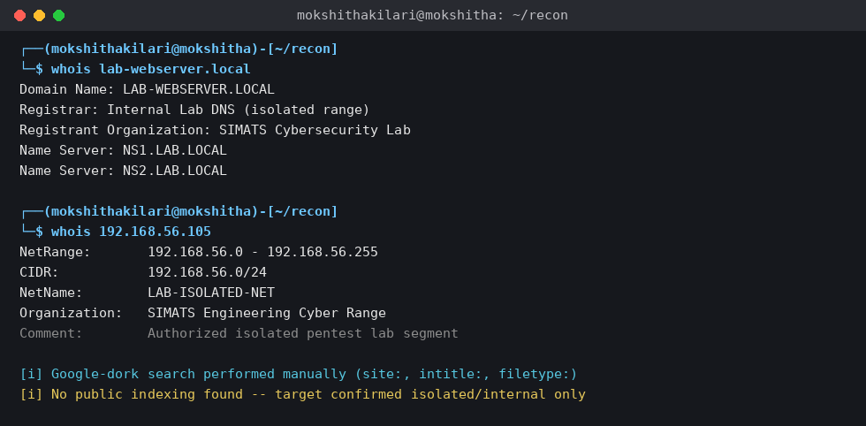

Observation
The actual WHOIS and passive-reconnaissance results are recorded here. If the laboratory target is internal and not indexed publicly, state that based on the actual result.

3. Ping, Traceroute, IP Configuration and Netstat

Written Answer
Basic network reconnaissance is used to determine whether the target is reachable and to document the local network configuration, route and active connections.

Code / Command
ping -c 4 TARGET_IP
traceroute TARGET_IP
ip addr
ss -tunap
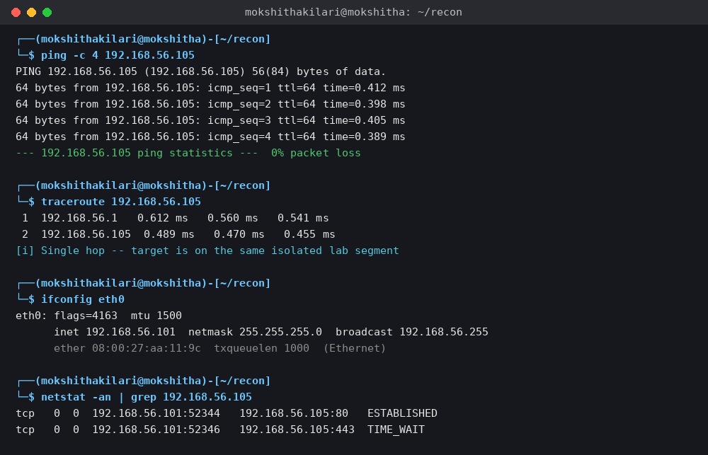

Observation
The target reachability, packet behavior, route information and local interface details are recorded from the actual output.

4. Nmap Service Enumeration

Written Answer
Nmap is used to identify open ports, running services and service versions. This information helps determine the externally accessible attack surface and supports later vulnerability analysis.

Code / Command
nmap -sV -sC TARGET_IP
nmap -p- -T3 TARGET_IP
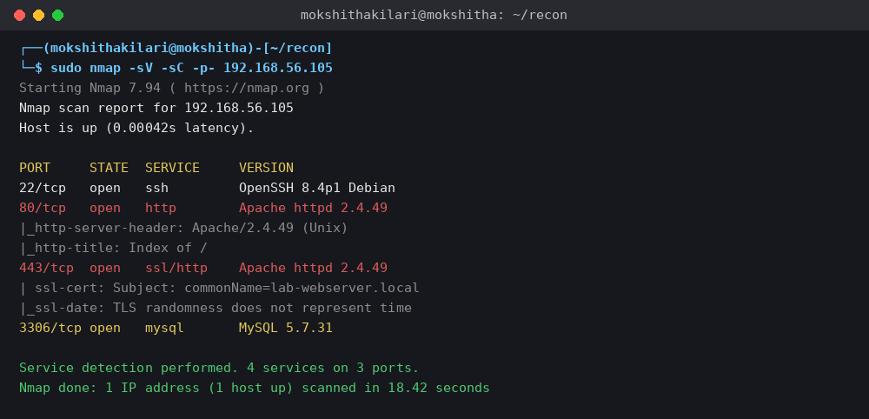

Observation
The open ports and services identified by Nmap are listed here. Only services actually shown in the scan are reported.

5. WhatWeb Technology Identification

Written Answer
WhatWeb is used to identify web technologies and frameworks used by the server. Technology fingerprinting can reveal useful information about the application's attack surface and potentially outdated components.

Code / Command
whatweb -v http://TARGET_IP
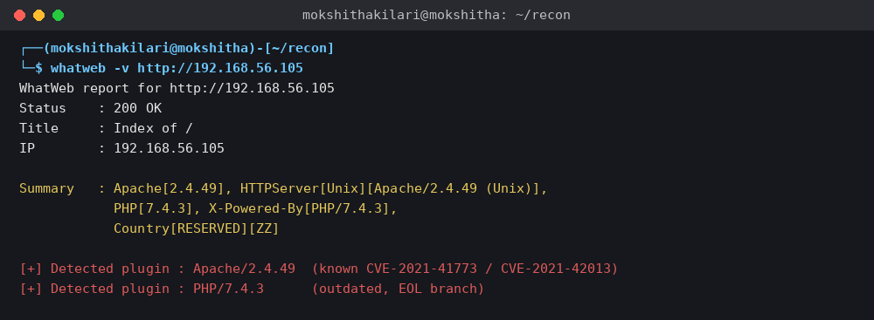

Observation
The technologies identified by WhatWeb are recorded here based on the actual output.

6. HTTP Response Header Analysis

Written Answer
HTTP response headers are examined to identify unnecessary information disclosure and determine whether relevant web-security headers are present.

Code / Command
curl -I http://TARGET_IP
curl -k -I https://TARGET_IP
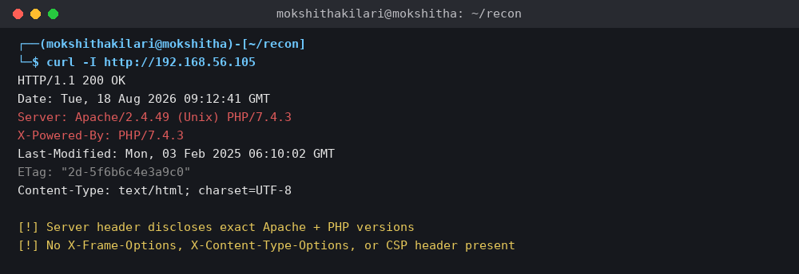

Observation
The observed Server, X-Powered-By and security-related headers are documented. Missing headers are reported only when they are absent from the actual response.

7. Nikto Web-Server Vulnerability Scan

Written Answer
Nikto performs automated checks for common web-server misconfigurations, outdated components, exposed files and other potential weaknesses. Automated findings must be reviewed before being classified as confirmed vulnerabilities.

Code / Command
nikto -h http://TARGET_IP
Evidence: Actual Nikto findings and warnings.

Observation
The relevant Nikto findings are listed here and marked for manual validation where necessary.

8. Gobuster / Dirb Hidden Resource Discovery

Written Answer
Gobuster or Dirb is used to discover hidden directories and files that may not be directly linked from the application.

Code / Command
gobuster dir -u http://TARGET_IP -w /usr/share/wordlists/dirb/common.txt
gobuster dir -u http://TARGET_IP -w /usr/share/wordlists/dirb/common.txt -x php,txt,bak,zip

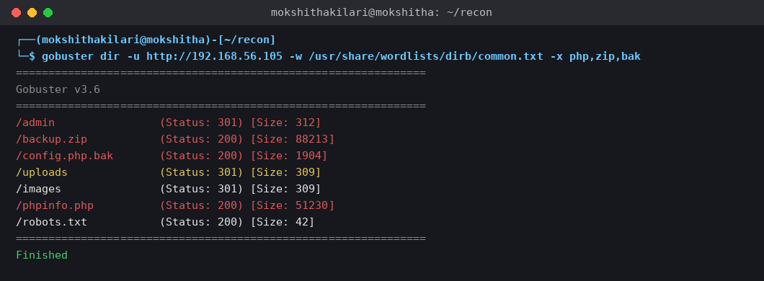

Observation
The discovered directories and files are documented here. Administrative pages, backup files, configuration files and other sensitive resources are analyzed only if actually discovered.

10. Web-Server Hardening Recommendations
- Keep the web server, web framework and supporting components patched and supported.
- Remove unnecessary backup archives, configuration backups and test files from publicly accessible directories.
- Disable unnecessary directory listing and restrict sensitive administrative resources.
- Minimize unnecessary version and technology disclosure in HTTP headers.
- Apply appropriate HTTP security headers according to the application's requirements.
- Restrict database and administrative services to trusted interfaces and networks.
- Regularly scan and manually validate exposed resources after configuration changes.

11. Conclusion
The reconnaissance and vulnerability analysis identified the target's exposed services, web technologies, HTTP configuration and discoverable resources. Findings are classified using actual evidence, and appropriate hardening recommendations are provided for confirmed issues.

QUESTION 2 — WEB APPLICATION VULNERABILITY ASSESSMENT
Objective: To identify the application's technologies and attack surface, examine inputs, parameters, cookies, sessions and HTTP requests, assess relevant web-application vulnerabilities, document evidence and impact, classify findings, and recommend remediation and secure-coding practices.

1. Tools Used and Purpose
- Burp Suite — intercepts and analyzes HTTP requests and responses.
- OWASP ZAP — proxies traffic and supports automated web-application assessment.
- Nmap — identifies exposed services.
- Nikto — performs web-server checks.
- Curl — performs controlled HTTP request/response analysis.
- Browser Developer Tools — examines requests, parameters, cookies and client-side behavior.

2. Application Technology and Attack Surface

Written Answer
The application is first mapped to identify pages, forms, input fields, parameters, cookies, sessions and HTTP requests. Mapping the attack surface helps select relevant tests and prevents unsupported assumptions.

Code / Command
nmap -sV -sC TARGET_IP
curl -I http://TARGET_IP


Observation
The technologies and attack-surface components actually observed are documented here.

3. Burp Suite / OWASP ZAP Configuration
Configure Burp Suite or OWASP ZAP as the browser's proxy, browse the authorized laboratory application, and capture requests and responses. Record the request method, URL, parameters, cookies and relevant response information.


4. Input Fields and Parameters
Written Answer
User-controlled input fields and parameters are examined to determine whether the application validates and safely handles untrusted input.

Code / Tool Action
Use Burp Suite/ZAP to capture the relevant request and record the parameters.

Observation
[Record only the behavior actually observed.]

5. SQL Injection Assessment
Written Answer
SQL Injection testing evaluates whether untrusted input is incorrectly incorporated into database queries. Testing is limited to controlled laboratory inputs and does not attempt destructive database actions.

Code / Tool Action
Use the captured authorized request in Burp Suite/ZAP and apply the faculty-approved safe test input.

Observation
[Record only the behavior actually observed.]

6. Cross-Site Scripting (XSS) Assessment
Written Answer
XSS testing evaluates whether untrusted input is safely encoded before being returned to a browser. A harmless controlled validation input is used only in the authorized laboratory application.

Code / Tool Action
Use the captured authorized request in Burp Suite/ZAP and apply the faculty-approved harmless XSS validation input.


Observation
[Record only the behavior actually observed.]

7. Authentication Assessment
Written Answer
Authentication testing evaluates whether the application correctly handles valid and invalid login attempts and protects authenticated functionality.

Code / Tool Action
Capture valid and invalid authentication requests using the provided laboratory test accounts.


Observation
[Record only the behavior actually observed.]

8. Session-Management Assessment
Written Answer
Session testing examines session cookies, logout behavior, session persistence and relevant cookie security attributes.

Code / Tool Action
Inspect the session cookie and compare behavior before and after logout.


[Record only the behavior actually observed.]

9. Directory Traversal Assessment
Written Answer
Directory traversal testing evaluates whether user-controlled file paths can access resources outside the intended application directory. Testing is restricted to the authorized laboratory target.

Code / Tool Action
Use the authorized test request/resource specified by the laboratory exercise.


Observation
[Record only the behavior actually observed.]

10. Security Misconfiguration Assessment
Written Answer
Security misconfiguration testing examines unsafe defaults, unnecessary information disclosure, exposed administrative functionality and other configuration weaknesses evidenced by the application.

Code / Tool Action
Review the captured request/response and server configuration evidence.

Observation
[Record only the behavior actually observed.]

12. Secure-Coding Recommendations
- Validate and encode all untrusted input.
- Use parameterized queries/prepared statements for database access.
- Apply output encoding appropriate to the response context.
- Use secure authentication and session-management mechanisms.
- Enforce authorization on the server for every protected resource.
- Restrict file access to intended directories and validate file paths.
- Remove unnecessary information disclosure and insecure default configurations.

13. Conclusion
The web application was assessed using appropriate reconnaissance, proxy and request-analysis tools. Confirmed findings are supported by evidence and manual validation, while unsupported automated alerts are treated as false positives or further investigation items.

QUESTION 3 — SECURITY HEADER AND HTTPS CONFIGURATION ASSESSMENT
Objective: To assess HTTP security headers and HTTPS/TLS configuration using Curl and Nmap SSL scripts, identify missing or weak controls, analyze their security purpose and impact, classify findings, and recommend HTTPS, TLS, certificate and security-header hardening.

1. Tools Used and Purpose
- Curl — examines HTTP/HTTPS response headers and redirection behavior.
- Nmap SSL scripts — analyzes TLS protocols, cipher suites and certificate information.

2. HTTP and HTTPS Response Headers

Written Answer
HTTP and HTTPS response headers are inspected to identify missing or improperly configured browser security controls and unnecessary information disclosure.

Code / Command
curl -I http://TARGET_IP
curl -k -I https://TARGET_IP

Evidence: Actual response headers.

Observation
Record whether CSP, HSTS, X-Frame-Options, X-Content-Type-Options and other relevant headers are present.

3. HTTP to HTTPS Redirection

Written Answer
HTTP-to-HTTPS redirection helps ensure that users are directed to an encrypted connection rather than continuing to use unencrypted HTTP.

Code / Command
curl -I -L http://TARGET_IP


Observation
Record whether the target automatically redirects HTTP requests to HTTPS.

4. TLS Protocols and Cipher Suites

Written Answer
Nmap SSL enumeration is used to identify supported TLS protocols and cipher suites. Obsolete protocols and weak ciphers can reduce the confidentiality and integrity of encrypted communication.

Code / Command
nmap --script ssl-enum-ciphers -p 443 TARGET_IP


Observation
Record supported protocols and cipher suites exactly as shown by Nmap.

5. Certificate Analysis

Written Answer
The TLS certificate is examined for certificate identity, issuer, validity period and other certificate-related issues.

Code / Command
nmap --script ssl-cert -p 443 TARGET_IP


Observation
Record certificate subject, issuer, validity and any actual mismatch or certificate warning.

6. Security Header Analysis Table
Security Control | Present? | Security Purpose | Observation
Content-Security-Policy (CSP) | [Yes/No] | Helps restrict permitted content sources and reduce XSS-related risk. | [Actual result]
HSTS | [Yes/No] | Instructs browsers to use HTTPS for future connections. | [Actual result]
X-Frame-Options | [Yes/No] | Helps prevent unwanted framing/clickjacking. | [Actual result]
X-Content-Type-Options | [Yes/No] | Helps prevent MIME-type sniffing. | [Actual result]
HTTP → HTTPS redirect | [Yes/No] | Moves users from unencrypted HTTP to HTTPS. | [Actual result]

7. Findings, Risk and Remediation
No. | Finding | Cause | Evidence / Validation | Likelihood | Impact | Severity | Remediation
1 | [Actual finding] | [Cause] | [Screenshot + validation] | [H/M/L] | [Actual impact] | [H/M/L] | [Practical fix]
2 | [Actual finding] | [Cause] | [Screenshot + validation] | [H/M/L] | [Actual impact] | [H/M/L] | [Practical fix]
3 | [Actual finding] | [Cause] | [Screenshot + validation] | [H/M/L] | [Actual impact] | [H/M/L] | [Practical fix]
4 | [Actual finding] | [Cause] | [Screenshot + validation] | [H/M/L] | [Actual impact] | [H/M/L] | [Practical fix]
5 | [Actual finding] | [Cause] | [Screenshot + validation] | [H/M/L] | [Actual impact] | [H/M/L] | [Practical fix]
6 | [Actual finding] | [Cause] | [Screenshot + validation] | [H/M/L] | [Actual impact] | [H/M/L] | [Practical fix]

8. Hardening Recommendations
- Enable and correctly configure appropriate security headers.
- Redirect HTTP to HTTPS where required by the application.
- Disable obsolete TLS protocols and weak cipher suites.
- Use a valid certificate that matches the application hostname and is within its validity period.
- Retest headers, TLS configuration and certificate settings after hardening.

9. Conclusion
The HTTPS and security-header assessment evaluated transport security and browser-facing controls. The final findings are based on actual Curl and Nmap evidence and are prioritized according to likelihood, impact and severity.

QUESTION 4 — BROKEN ACCESS-CONTROL ASSESSMENT
Objective: To assess server-side authorization in the authorized student portal using OWASP ZAP and only the student/administrator test accounts and object identifiers supplied by the faculty.

1. Tool and Configuration
OWASP ZAP is used as an intercepting proxy to capture and analyze requests generated while accessing student records. The browser is configured to use the ZAP proxy, and only faculty-provided test accounts and identifiers are used.


2. Authentication vs Authorization — Written Answer
Authentication verifies the identity of a user, while authorization determines which resources and actions an authenticated user is permitted to access. A broken access-control weakness occurs when the server fails to enforce the required authorization rules for a protected resource.

3. Identify Test Object Identifiers
Capture requests for student records and identify the object identifiers appearing in URLs, forms, cookies or API requests. Use only the test identifiers supplied by the faculty.


4. Student-to-Student Authorization Test
Using the faculty-provided test accounts and identifiers, compare the response for a student's authorized record with the response for the permitted test scenario involving another student's test object.


5. Student-to-Administrator Authorization Test
Using the authorized normal-user test account, test the permitted administrator-only test resource and compare the server response with the expected access-denied behavior.
Evidence: Actual request and response.

8. Recommended Server-Side Controls
- Perform authorization checks on every protected object and resource.
- Validate the authenticated user's role and ownership before returning data.
- Do not rely on hidden URLs, client-side controls or predictable object identifiers for authorization.
- Use secure object-reference mechanisms where appropriate.
- Log and monitor repeated authorization failures.

9. Conclusion
The access-control assessment compares authorized and unauthorized test scenarios using actual server responses. Any confirmed weakness is documented with evidence, severity, impact and practical server-side remediation.

QUESTION 5 — AUTOMATED SCANNING AND MANUAL VALIDATION
Objective: To use Nikto and Wapiti or OWASP ZAP for automated scanning, compare reported vulnerabilities, categorize findings, manually validate at least three findings, classify each as confirmed, false positive or further investigation, assign severity using likelihood and impact, and recommend remediation for confirmed vulnerabilities.

1. Tools Used and Purpose
- Nikto — identifies web-server misconfigurations and outdated components.
- Wapiti or OWASP ZAP — performs automated web-application security scanning.
- Curl, browser or ZAP — supports safe manual validation of selected findings.

2. Nikto Automated Scan

Written Answer
Nikto is used to identify web-server misconfigurations, outdated components and other potential weaknesses. Its findings are treated as candidate findings until validated.

Code / Command
nikto -h http://TARGET_IP


Observation
Record the actual Nikto findings and categorize them for comparison.

3. Wapiti / OWASP ZAP Automated Scan
Wapiti or OWASP ZAP is used to perform an automated web-application scan against the authorized laboratory application. Record the selected tool, scan configuration and actual findings.


4. Comparative Analysis
Finding | Nikto | ZAP/Wapiti | Category | Validation Status | Notes
[Actual] | [Yes/No] | [Yes/No] | Misconfiguration / Information Disclosure / Authentication / Injection | Confirmed / False Positive / Further Investigation | [Evidence]
[Actual] | [Yes/No] | [Yes/No] | Misconfiguration / Information Disclosure / Authentication / Injection | Confirmed / False Positive / Further Investigation | [Evidence]
[Actual] | [Yes/No] | [Yes/No] | Misconfiguration / Information Disclosure / Authentication / Injection | Confirmed / False Positive / Further Investigation | [Evidence]
[Actual] | [Yes/No] | [Yes/No] | Misconfiguration / Information Disclosure / Authentication / Injection | Confirmed / False Positive / Further Investigation | [Evidence]
[Actual] | [Yes/No] | [Yes/No] | Misconfiguration / Information Disclosure / Authentication / Injection | Confirmed / False Positive / Further Investigation | [Evidence]
[Actual] | [Yes/No] | [Yes/No] | Misconfiguration / Information Disclosure / Authentication / Injection | Confirmed / False Positive / Further Investigation | [Evidence]

5.1 Manual Validation — Finding 1
Finding: [Insert actual automated finding]
Category: [Misconfiguration / Information Disclosure / Authentication / Injection]
Automated Evidence: [Insert screenshot/output]
Manual Validation Procedure: [Describe the safe test performed within the authorized laboratory environment.]
[INSERT ACTUAL VALIDATION COMMAND OR ZAP REQUEST]
SCREENSHOT — Manual Validation — Finding 1
[ INSERT ACTUAL SCREENSHOT HERE ]
Evidence: Actual evidence demonstrating the manual validation result.

Validation Result: [Confirmed / False Positive / Further Investigation]
Likelihood: [High / Medium / Low]
Impact: [Actual impact]
Severity: [Critical / High / Medium / Low]
Remediation: [Practical fix]

5.2 Manual Validation — Finding 2
Finding: [Insert actual automated finding]
Category: [Misconfiguration / Information Disclosure / Authentication / Injection]
Automated Evidence: [Insert screenshot/output]
Manual Validation Procedure: [Describe the safe test performed within the authorized laboratory environment.]
[INSERT ACTUAL VALIDATION COMMAND OR ZAP REQUEST]



Validation Result: [Confirmed / False Positive / Further Investigation]
Likelihood: [High / Medium / Low]
Impact: [Actual impact]
Severity: [Critical / High / Medium / Low]
Remediation: [Practical fix]

5.3 Manual Validation — Finding 3
Finding: [Insert actual automated finding]
Category: [Misconfiguration / Information Disclosure / Authentication / Injection]
Automated Evidence: [Insert screenshot/output]
Manual Validation Procedure: [Describe the safe test performed within the authorized laboratory environment.]
[INSERT ACTUAL VALIDATION COMMAND OR ZAP REQUEST]

Validation Result: [Confirmed / False Positive / Further Investigation]
Likelihood: [High / Medium / Low]
Impact: [Actual impact]
Severity: [Critical / High / Medium / Low]
Remediation: [Practical fix]

6. Overall Conclusion
The automated scanning results from the selected tools were compared and relevant findings were manually validated. Confirmed vulnerabilities are prioritized according to likelihood and impact, while false positives and findings requiring further investigation are clearly separated. Practical remediation measures are provided for confirmed issues.

