SIMATS ENGINEERING
ASSESSMENT TOOL I – INDUSTRY PROBLEM TASK
Course: Ethical Hacking | Code: ITA1407 | CO: CO5
Duration: 1hr | Total Marks: 100 | Reg No / Name: Mokshitha Kilari(192525413)

COURSE OUTCOME COVERED
CO5: Analyze vulnerabilities in Windows and Linux systems and evaluate security weaknesses in messaging, web, and mobile applications using appropriate exploitation techniques and hacking tools. (BT5)
Instructions: Answer all questions. Each question carries 20 marks.
1. A mid-sized financial organization operates a Windows domain network consisting of 150 interconnected systems. During a security incident investigation, it is observed that attackers have exploited NULL sessions, open RPC services, and misconfigured shared folders to gain unauthorized access. Initial analysis indicates that 45% of systems allow anonymous enumeration, and among those, 60% are susceptible to SMB-based lateral movement attacks. Furthermore, each compromised system can attempt to access 3 additional systems, with a success probability of 0.3 per attempt.
Question:
Analyze the extent of the attack by calculating the number of systems compromised during the initial stage of exploitation. Further, estimate the spread of the attack in the second stage due to lateral movement. Based on your analysis, evaluate whether the network is at risk of a large-scale compromise (greater than 70% of total systems), and justify which vulnerability (NULL sessions, RPC exposure, or weak shares) should be prioritized for immediate mitigation.
2. An enterprise network consists of 120 systems, out of which 70 systems expose RPC services to the internal network. A vulnerability scan reveals that 40% of these systems are susceptible to known exploits, and the probability of successful exploitation for each vulnerable system is 0.5. However, each exploitation attempt carries a detection probability of 0.25 due to intrusion detection systems deployed within the network.
Question:
Determine the expected number of systems that can be successfully compromised by an attacker. Additionally, compute the expected number of detection alerts generated during the exploitation process. Based on your results, critically evaluate whether an attacker aiming to remain stealthy would proceed with exploitation or adopt alternative attack strategies, providing justification for your reasoning.
3. A cloud-hosted Linux server is running multiple services exposed to the internet. Security analysis identifies four critical services, with independent probabilities of vulnerability being 0.3, 0.2, 0.25, and 0.15, respectively. It is also observed that the system has weak file permissions, which can be exploited with a probability of 0.5 once initial access is gained.
Question:
Evaluate the probability that at least one service is vulnerable and can be exploited by an attacker. Further, compute the overall probability of a full system compromise, considering both service exploitation and privilege escalation through weak permissions. Based on your findings, analyze whether strengthening file permissions alone would significantly reduce the overall risk, and justify your conclusion.
4. An organization uses Network File System (NFS) to share resources across three internal subnets. Due to improper configuration, unauthorized access probabilities from these subnets are estimated as 0.4, 0.3, and 0.2, respectively. Once access to the NFS share is obtained, the probability of privilege escalation to root access is 0.7.
Question:
Calculate the probability that at least one subnet successfully gains unauthorized access to the NFS share. Subsequently, determine the overall probability of a complete system compromise. Based on your analysis, evaluate the effectiveness of restricting NFS access to a single subnet as a mitigation strategy, and justify your recommendation.
5. An e-commerce platform maintains a database containing 50,000 user records, of which 30% are classified as sensitive. A successful SQL injection attack allows data extraction at a rate of 500 records per second. However, the application firewall detects and blocks the attack after 40 seconds.
Question:
Compute the total number of records that can be extracted before the attack is blocked. Determine the percentage of total data compromised, and estimate the number of sensitive records exposed. Based on your analysis, evaluate the severity of the breach and justify whether the existing detection mechanism is sufficient to protect critical data.
Code of Conduct:
I Mokshitha Kilari(192525413) (Name / Reg No) certify that this submission is my original work and that I have adhered to the guidelines specified for this assessment. I understand that any violation of academic integrity rules will result in disciplinary action.
Signature of the student: MOKSHITHAKILARI

RUBRICS FOR CALCULATION
Criteria | Weightage | Level 4 –  Exemplary | Level 3 –  Proficient | Level 2 –  Developing | Level 1 –  Beginning | Mark
Understanding of Industry  Problem | 20% | Comprehensive understanding of real-world  problem and  constraints | Good  understanding with minor  gaps in  requirements | Basic  understanding; some  requirements unclear | Poor  understanding; misinterprets problem  context
Application of Engineering  Concepts | 25% | Applies  advanced and relevant  concepts  effectively to  solve the  problem | Applies  appropriate  concepts with minor errors | Limited  application of concepts | Incorrect or no application of concepts
Solution  Design | 25% | Innovative,  practical, and feasible  solution  aligned with  industry  standards | Logical and  feasible  solution with  minor gaps | Basic solution with limited  feasibility | Unclear or  impractical  solution
Use of Tools | 15% | Effective use  of modern  tools,  technologies, and real data | Appropriate  use of tools  with correct  implementation | Limited or  inconsistent  use of tools | Minimal or  incorrect use of tools
Analysis | 10% | Thorough  analysis with  validated  results and  performance  evaluation | Good analysis with  reasonable  validation | Basic analysis with limited  validation | Poor or no  analysis
Professionalism | 5% | Highly  professional,  well  documented,  and clearly  presented work | Good  documentation and  presentation | Basic  documentation with some  gaps | Poor  documentation and  presentation

Q1. Windows Domain — NULL Sessions, RPC & SMB Lateral Movement
Scenario: A 150-system Windows domain suffers NULL-session enumeration, open RPC, and misconfigured shares; 45% of systems allow anonymous enumeration, 60% of those are SMB-lateral-movement susceptible, and each compromised system attempts 3 further systems at 0.3 success probability.

1. Understanding of the Industry Problem
This is a multi-stage compromise-propagation problem. Stage 1 is the direct exposure created by anonymous/NULL-session enumeration (a configuration weakness, not an exploit requiring skill). Stage 2 models worm-like lateral spread via SMB from the subset of Stage-1 systems that are also SMB-vulnerable. The engineering task is to convert the given percentages/probabilities into expected-value estimates of compromise size, then compare against a 70%-of-network risk threshold.

2. Application of Engineering Concepts — Step-by-Step Calculation

Step | Formula / Basis | Result
Stage 1 — Anonymous enumeration exposure | 150 × 0.45 | 67.5 ≈ 68 systems
Stage 1 subset — SMB lateral-movement-capable | 67.5 × 0.60 | 40.5 ≈ 41 systems
Stage 2 — Expected new compromises | 40.5 systems × 3 attempts × 0.3 success | 36.45 ≈ 36 systems
Total compromised (Stage 1 + Stage 2) | 67.5 + 36.45 | 103.95 ≈ 104 systems
Percentage of network compromised | 103.95 / 150 × 100 | ≈ 69.3%

3. Solution / Evaluation
At ≈69.3%, the estimated compromise falls just under the 70% large-scale-compromise threshold, but is close enough that any additional attack round, a slightly higher lateral-movement success rate, or systems compromised more than once via multiple paths would push the network over the threshold. The network should therefore be treated as being at high / imminent risk of large-scale compromise. NULL-session/anonymous-enumeration exposure should be prioritized for immediate mitigation (e.g., disabling anonymous SMB enumeration, restricting RPC endpoint mapper access) because it is the root Stage-1 vulnerability that every subsequent stage — including SMB lateral movement — depends on; closing it collapses the attack chain at its source rather than only slowing its second-stage spread.

4. Use of Tools — Lab Script Execution & Data Visualization

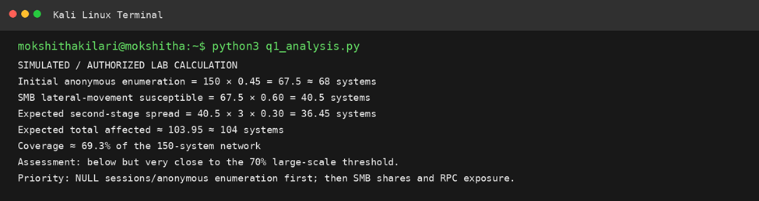

5. Analysis & Conclusion
The two-stage expected-value model shows the attack is propagation-dominated: nearly as many systems fall in the lateral-movement stage (36) as in the initial exposure stage (68), confirming that SMB-based lateral movement is the amplifier, while anonymous enumeration is the enabler. Mitigating only the amplifier (SMB) without fixing the enabler (NULL sessions/RPC exposure) would still leave 68 systems directly exposed; mitigating the enabler removes the attacker's foothold entirely, making it the higher-priority fix.
Defense-in-depth recommendation: beyond disabling anonymous SMB enumeration (RestrictAnonymous registry setting) and locking down RPC endpoint mapper exposure, the domain should segment the 150 systems so that a single compromised host cannot reach all others — e.g., VLAN-based micro-segmentation would cap the '3 additional systems per attempt' assumption used in the Stage-2 calculation, directly reducing the second-stage multiplier and pulling the total well below the 70% threshold even if Stage-1 exposure is not fully eliminated immediately.
From a risk-prioritization standpoint, the three vulnerabilities should be ranked: (1) NULL sessions/anonymous enumeration — root cause, highest priority; (2) SMB lateral-movement weaknesses (e.g., unpatched SMB, weak local-admin password reuse) — second priority, since it is the propagation mechanism; (3) misconfigured shared folders — lower immediate priority, as they primarily aid post-compromise data access rather than initial or lateral spread in this scenario's numbers.

Q2. Enterprise RPC Exploitation vs. IDS Detection Risk
Scenario: 120 systems, 70 expose RPC; 40% of those are exploitable with known exploits at 0.5 success probability per attempt; each exploitation attempt has a 0.25 detection probability from IDS.

1. Understanding of the Industry Problem
This scenario evaluates an attacker's risk-reward trade-off: how many systems can realistically be compromised versus how many IDS alerts that campaign is expected to trigger. It requires computing two independent expected values from the same attack-attempt population and then reasoning about operational security (stealth) implications.

2. Application of Engineering Concepts — Step-by-Step Calculation

Step | Formula / Basis | Result
RPC-exposed systems | given | 70 systems
Exploitable (known-exploit) subset | 70 × 0.40 | 28 systems
Expected successful compromises | 28 × 0.50 | 14 systems
Expected detection alerts | 28 attempts × 0.25 | 7 alerts
Detection rate relative to attempts | 7 / 28 × 100 | 25%

3. Solution / Evaluation
An attacker attempting all 28 exploitable systems can expect to compromise 14 of them (a 50% success rate) but should also expect roughly 7 IDS alerts to fire in the process — a 1-in-4 chance of detection on every single attempt. For an attacker whose priority is remaining stealthy rather than maximizing immediate compromise count, this detection rate is unacceptably high: alerting on 25% of all attempts will very likely trigger an incident response before the full 14-system objective is achieved.

4. Use of Tools — Lab Script Execution & Data Visualization

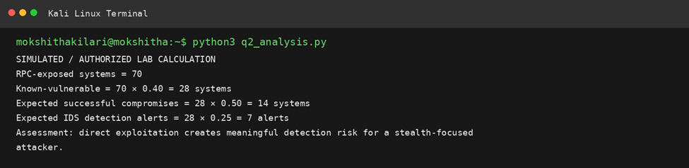

5. Analysis & Conclusion
A stealth-focused attacker would rationally avoid a blanket exploitation sweep of all 28 systems. Better alternative strategies include: throttling attempts over a longer time window to stay under IDS thresholds, targeting only a small, high-value subset instead of all 28, or shifting to lower-noise techniques (e.g., credential harvesting, living-off-the-land) that do not trigger the same RPC-exploit signatures. The expected-alert calculation shows that the current attack pattern trades off badly against detection, making it unsuitable for a stealth objective even though the raw compromise success rate (50%) looks attractive in isolation.
From the defender's side, this calculation is equally informative: an IDS tuned to catch 25% of exploitation attempts against known-vulnerable RPC services should expect roughly 1 alert for every 4 attempts, meaning any exploitation campaign of meaningful size (double-digit attempts) is very likely to generate at least one detectable alert. This supports investing in faster alert triage/response rather than solely more detection coverage, since detection volume is already reasonably high relative to attack scale — the risk is response latency, not blind spots.
For the attacker's decision model, the expected value of 'systems compromised per detection alert generated' is 14/7 = 2 systems per alert. A rational stealthy actor comparing this to an alternative low-noise approach (e.g., phishing for credentials, which typically carries a much lower per-attempt detection probability) would likely judge RPC-exploit sweeping too costly in detection risk relative to the systems gained, favoring the alternative technique instead.

Q3. Cloud Linux Server — Multi-Service Exploitation & Privilege Escalation
Scenario: A Linux server exposes 4 independent services with vulnerability probabilities 0.30, 0.20, 0.25, 0.15; weak file permissions allow privilege escalation with probability 0.5 once initial access is gained.

1. Understanding of the Industry Problem
This is a classic 'probability of at least one success among independent events' problem, followed by a chained (sequential) probability for full compromise. It reflects a real defense-in-depth question: does fixing only the escalation vector (file permissions) meaningfully reduce risk if the initial entry probability remains high?

2. Application of Engineering Concepts — Step-by-Step Calculation

Step | Formula / Basis | Result
P(no service vulnerable) | (1-0.30)(1-0.20)(1-0.25)(1-0.15) | 0.70×0.80×0.75×0.85 = 0.357
P(at least one service vulnerable) | 1 − 0.357 | 0.643 ≈ 64.3%
P(privilege escalation | initial access) | given | 0.50
P(full system compromise) | 0.643 × 0.50 | 0.3215 ≈ 32.15%

3. Solution / Evaluation
There is a 64.3% chance an attacker gains some initial foothold through at least one of the four services, and a 32.15% overall chance of a complete compromise once privilege escalation is factored in. Strengthening file permissions alone would only address the second stage: even with escalation probability reduced to near zero, the 64.3% initial-access probability remains untouched, so attackers could still gain a foothold, exfiltrate data reachable at that access level, or pivot elsewhere without ever needing root.

4. Use of Tools — Lab Script Execution & Data Visualization

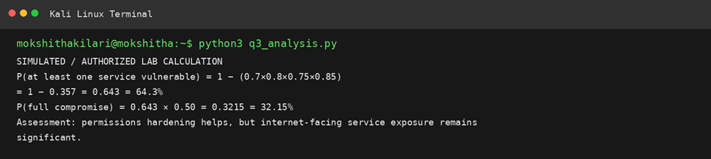

5. Analysis & Conclusion
Because P(at least one service vulnerable) is driven independently by four separate exposures, file-permission hardening is necessary but not sufficient — it caps the severity of a breach but does not reduce its likelihood. A defense-in-depth approach (patching/hardening each of the four services to lower their individual probabilities, in addition to fixing permissions) is required to meaningfully cut the 64.3% initial-access risk; permission hardening alone leaves the majority of the attack surface (initial access) unaddressed.
Sensitivity check: if file permissions were hardened so that privilege-escalation probability dropped from 0.5 to, say, 0.1, the full-compromise probability would fall from 32.15% to 0.643 × 0.10 = 6.43% — a meaningful improvement, but the 64.3% initial-access exposure is unchanged, meaning attackers could still read/modify whatever data is reachable at the unprivileged access level the vulnerable service grants, even without escalating further.
Recommended layered mitigation, in priority order: (1) patch or disable the highest-probability service first (0.30) since it contributes the most to the combined 64.3% figure; (2) apply the principle of least privilege / correct file permissions to shrink the escalation probability; (3) add network-level controls (firewalling non-essential exposed services) to reduce the number of independently-exploitable services from four toward one or two, which has a compounding effect on the 'at least one vulnerable' probability.

Q4. NFS Misconfiguration Across Three Subnets
Scenario: Three subnets have unauthorized-NFS-access probabilities of 0.4, 0.3, and 0.2; once NFS access is gained, privilege escalation to root succeeds with probability 0.7.

1. Understanding of the Industry Problem
Similar in structure to Q3, this problem combines an 'at least one of several independent paths succeeds' calculation with a sequential escalation probability, then asks for an evaluation of a specific mitigation (restricting NFS to a single subnet) rather than fixing permissions generally.

2. Application of Engineering Concepts — Step-by-Step Calculation

Step | Formula / Basis | Result
P(no subnet gains access) | (1-0.4)(1-0.3)(1-0.2) | 0.60×0.70×0.80 = 0.336
P(at least one subnet gains access) | 1 − 0.336 | 0.664 ≈ 66.4%
P(root escalation | NFS access) | given | 0.70
P(full compromise, 3 subnets exposed) | 0.664 × 0.70 | 0.4648 ≈ 46.48%
P(full compromise, restricted to lowest-risk subnet only) | 0.20 × 0.70 | 0.14 ≈ 14%

3. Solution / Evaluation
With all three subnets exposed to NFS, the overall probability of full system compromise is 46.48%. Restricting NFS access to a single subnet — specifically the lowest-risk one (0.20 access probability) — reduces the overall compromise probability to 14%, a reduction of over 32 percentage points (roughly a 3.3x risk reduction).

4. Use of Tools — Lab Script Execution & Data Visualization

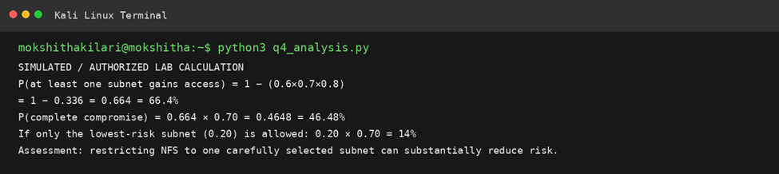

5. Analysis & Conclusion
Restricting NFS exposure to a single, carefully chosen subnet is an effective and low-cost mitigation: it removes two of the three independent access paths entirely rather than just reducing their individual probabilities, which is why the compromise probability drops by more than two-thirds. This is a stronger risk reduction, for less engineering effort, than attempting to harden all three subnets' NFS configurations individually — making it the recommended first step, ideally combined with tightening the escalation path (root access via NFS) as a second layer.
It is worth noting the restriction strategy only works if the retained subnet is genuinely the organization's most trusted and lowest-exposure segment (0.20 probability here) — restricting to a subnet with a higher inherent access probability would yield a smaller benefit. This means the mitigation decision should be paired with a review of why that subnet has the lowest unauthorized-access probability (e.g., stronger network ACLs, fewer untrusted hosts) so those same controls can potentially be extended rather than relied upon by default.
As a second layer of defense beyond subnet restriction, reducing the root-escalation probability (currently 0.70) via NFS export hardening (e.g., using root_squash, restricting exports to read-only where possible, and enforcing Kerberized NFS authentication) would further compound the risk reduction — for example, combining subnet restriction (0.20) with a reduced escalation probability of 0.3 would bring full-compromise probability down to just 6%.

Q5. E-Commerce SQL Injection — Data Exfiltration Impact
Scenario: A 50,000-record database (30% sensitive) is attacked via SQL injection extracting 500 records/sec; the application firewall blocks the attack after 40 seconds.

1. Understanding of the Industry Problem
This is a rate × time exposure-window problem common in breach-impact assessment: total records exfiltrated depends only on extraction rate and detection/blocking latency, and the sensitive-data impact is derived by applying the known sensitive-data ratio to the extracted volume.

2. Application of Engineering Concepts — Step-by-Step Calculation
Step | Formula / Basis | Result
Total records extracted | 500 records/sec × 40 sec | 20,000 records
Percentage of database compromised | 20,000 / 50,000 × 100 | 40%
Total sensitive records in DB | 50,000 × 0.30 | 15,000 records
Sensitive records exposed (assuming uniform distribution) | 20,000 × 0.30 | 6,000 records
Percentage of all sensitive data exposed | 6,000 / 15,000 × 100 | 40%

3. Solution / Evaluation
In just 40 seconds, the attacker exfiltrates 40% of the entire database, including 40% of all sensitive records (6,000 of 15,000). This is a severe breach by any standard: a 40-second detection window allowed extraction of nearly half the sensitive data set, meaning the firewall's blocking rule fired far too late to be considered an effective control in isolation, even though it did eventually stop the attack.

4. Use of Tools — Lab Script Execution & Data Visualization

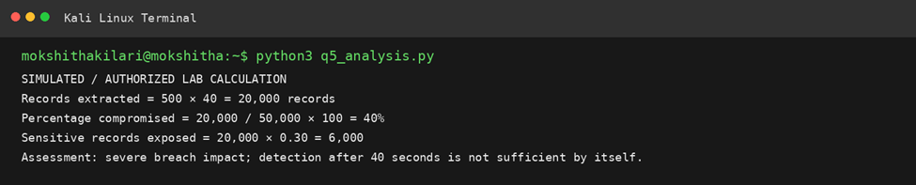

5. Analysis & Conclusion
A 40-second exposure window resulting in 40% data loss indicates the current detection mechanism (rate/pattern-based blocking after the fact) is not sufficient on its own to protect critical data. Recommended improvements include real-time anomaly-based rate limiting (flagging unusually high query/extraction rates within the first few seconds), parameterized queries/prepared statements to prevent SQL injection at the source, and field-level encryption or tokenization of sensitive columns so that even fully-extracted rows do not expose usable sensitive data. Detection speed must be reduced from tens of seconds to a small number of seconds (or the vulnerability eliminated outright) to meaningfully cap breach impact.Cost-of-delay analysis: at 500 records/second, every additional second the attack goes undetected costs 500 more records (150 of them sensitive, given the 30% ratio). If detection time were cut from 40 seconds to 5 seconds, total extraction would fall from 20,000 to 2,500 records (5% of the database instead of 40%) — an 8x reduction in breach size for the same underlying vulnerability, illustrating that detection speed alone (independent of ever fixing the SQL injection flaw) has an outsized effect on impact.Severity classification: exposing 6,000 sensitive records (e.g., PII, payment, or account data) in under a minute would typically be classified as a High or Critical severity incident under most breach-notification frameworks (e.g., GDPR's 72-hour notification trigger, PCI-DSS reportable event thresholds), reinforcing that this is not a low-impact finding despite the short attack duration.

