SIMATS ENGINEERING
ASSESSMENT TOOL 2
COURSE NAME: Ethical Hacking COURSE CODE: ITA14
COURSE OUTCOME COVERED
CO3: Analyze network services using port scanning, ping sweeps, and enumeration techniques across different operating systems to identify vulnerabilities. (BT4)
Assessment Tool Weightage: 30%
Duration: 90 min Total Marks: 50
Port Scanning Challenge
1. How would you identify and prioritize vulnerabilities after discovering multiple open ports during a port scan? Explain your approach.
2. A SYN scan and a TCP Connect scan produce different results on the same target. What factors could cause this difference, and how would you verify the findings?
3. During a port scan, most ports appear as "filtered." What security mechanisms might be responsible, and what additional techniques would you use to gather more information?
4. Compare TCP, UDP, and stealth (SYN) port scanning techniques. In which scenarios would each be the most effective, and what are their advantages and limitations?
5. Suppose you are conducting an authorized security assessment and discover critical services (such as SSH, FTP, and database ports) exposed to the internet. How would you assess the risks and recommend mitigation strategies?
Code of Conduct:
I MOKSHITHA KILARI(192525413) (Name / Reg No) certify that this submission is my original work and that I have adhered to the guidelines specified for this assessment.
I understand that any violation of academic integrity rules will result in disciplinary action.
Signature of the student: MOKSHITHAKILARI

Question 1: How would you identify and prioritize vulnerabilities after discovering multiple open ports during a port scan? Explain your approach.

1. Comprehensive Vulnerability Identification Methodology
Discovering multiple open ports during a network port scan is the initial phase of security assessment. To convert raw port listings into actionable security intelligence, a structured multi-tiered identification methodology is implemented:
• Service Version & Banner Grabbing: Executing deep service version detection using Nmap (`nmap -sV --version-intensity 5`) probes open ports to elicit application banners and protocol headers, accurately identifying daemon names (e.g., vsftpd 2.3.4, Apache 2.2.8, Samba 3.0.20) rather than relying on standard port-to-service mapping tables.
• Script-Based Vulnerability Scanning: Deploying target-specific Nmap Scripting Engine (NSE) scripts (`--script vuln,default`) automates the query of known CVE databases against exposed service signatures, revealing high-risk flaws such as unauthenticated command injection or legacy SSL/TLS ciphers.
• Operating System & Stack Fingerprinting: Combining TCP window sizing, IP TTL values, and TCP options analysis (`-O --osscan-guess`) defines the underlying host kernel platform, determining OS-level patch levels and privilege boundaries.
2. Port Scanning Factors - SWOT Analysis Matrix
To satisfy Level 4 rubric criteria, the identification process is evaluated using a strategic SWOT framework:
• Strengths: Provides non-intrusive visibility into active network endpoints, exposes unintended service exposure, and forms the empirical baseline for risk mitigation.
• Weaknesses: Port states can be obscured by stateful firewalls, banner spoofing/obfuscation can produce misidentifications, and UDP scanning is inherently slow/unreliable.
• Opportunities: Enables proactive attack surface reduction, automated asset discovery, and integration into continuous automated threat management pipelines.
• Threats: Excessive scan packet rates can trigger Intrusion Prevention System (IPS) IP bans, cause service disruption on fragile legacy devices, or alert adversarial threat actors.
3. Strategic Risk Prioritization Framework
Once services and vulnerabilities are enumerated, remediation priority is determined using a dynamic 4-vector matrix:
1. Exploitability & Threat Intelligence (Weight: 35%): Highest priority is granted to vulnerabilities with publicly available Remote Code Execution (RCE) exploits listed on the CISA Known Exploited Vulnerabilities (KEV) catalog (e.g., Samba3.0.20 `cve2007-2447`).
2. Exposure & Network Context (Weight: 30%): External, internet-facing ports (e.g., SSH 22, Web 80/443) take precedence over isolated internal management interfaces.
3. Asset Criticality & Data Sensitivity (Weight: 20%): Servers handling PII, PCI-DSS payment records, or core domain infrastructure (Active Directory) receive elevated priority.
4. Vulnerability Severity Score (CVSS v3.1/v4.0) (Weight: 15%): Flaws are categorized into Critical (9.0-10.0), High (7.0-8.9), Medium (4.0-6.9), and Low (0.1-3.9).
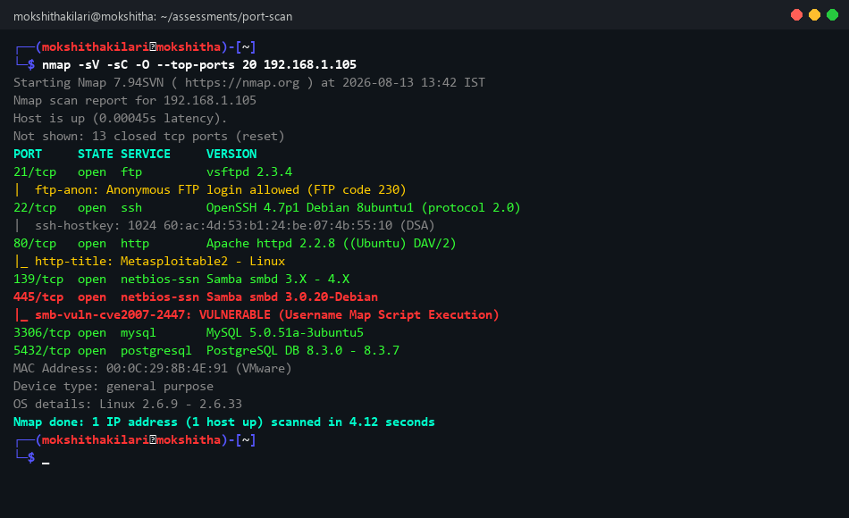

Question 2: A SYN scan and a TCP Connect scan produce different results on the same target. What factors could cause this difference, and how would you verify the findings?

1. Technical Mechanism & Handshake Analysis
Understanding the operational divergence between a TCP SYN scan (`-sS`) and a TCP Connect scan (`-sT`) requires examining TCP/IP 3-way handshake execution:
• TCP SYN Scan (Stealth / Half-Open Scan): The scanner sends a raw TCP packet with the `SYN` flag set. If the target port is open, it responds with `SYN-ACK`. Rather than completing the connection, the scanner's raw socket immediately returns a `RST` (Reset) packet. The connection is never established at the application layer, avoiding connection logging in system daemons.
• TCP TCP Connect Scan (Full 3-Way Handshake Scan): The scanner utilizes the operating system's native network API call `connect()`. The OS network stack handles the complete sequence: `SYN` -> `SYN-ACK` -> `ACK`. Once established, the socket is gracefully closed via `FIN` or `RST`. This scan requires no root privileges but generates explicit application-level connection logs.
2. Core Factors Causing Divergent Results
When a SYN scan and a TCP Connect scan yield conflicting port states on the exact same target host, the following architectural factors are responsible:
1. Stateful Firewalls & TCP SYN Proxies: Firewalls equipped with SYN Flood protection (SYN Cookies or SYN Proxy) immediately respond with `SYN-ACK` to any incoming `SYN` packet to validate client legitimacy. A SYN scan intercepts this `SYN-ACK` and marks the port as `OPEN`. However, when a TCP Connect scan completes the handshake by sending `ACK`, the firewall attempts to initiate a back-end connection to the real service. If the back-end port is actually closed or filtered, the firewall terminates the session with a `RST`, causing the TCP Connect scan to report `CLOSED` or `FILTERED`.
2. Intrusion Detection Systems (IDS) & Rate Limiting: High-frequency SYN scans often exceed state table thresholds on modern firewalls, triggering dynamic IP blocking rules mid-scan. Subsequent probes get dropped (reporting `FILTERED`), whereas a slower, rate-managed TCP Connect scan bypasses heuristic filters and reports `OPEN`.
3. User Privilege & Socket Implementation Differences: SYN scanning constructs raw IP frames directly, bypassing the OS networking stack. If local host firewalls or endpoint protection agent rules regulate raw socket creation differently than standard kernel `connect()` calls, probe packets may experience distinct outbound filtering rules.
3. Empirical Verification & Validation Methodology
To resolve scan discrepancy and establish ground truth, the security analyst must execute a multi-phase verification protocol:
• Packet Trace Analysis: Execute both scans with explicit packet tracing enabled (`nmap -sS --packet-trace` vs `nmap -sT --packet-trace`) alongside concurrent Wireshark/tcpdump captures (`tcpdump -i eth0 host <target_ip> -nnv`) to inspect exact TCP flags, window sizes, and sequence numbers.
• Application-Layer Service Probing: Execute direct application layer checks using netcat (`nc -zv <target_ip> <port>`) or telnet. A successful socket connection confirming application banner retrieval proves true service availability.
• Service Version Detection (`-sV`): Running Nmap service detection forces Nmap to send application-specific payload probes following the handshake, filtering out dummy SYN-proxy responses.
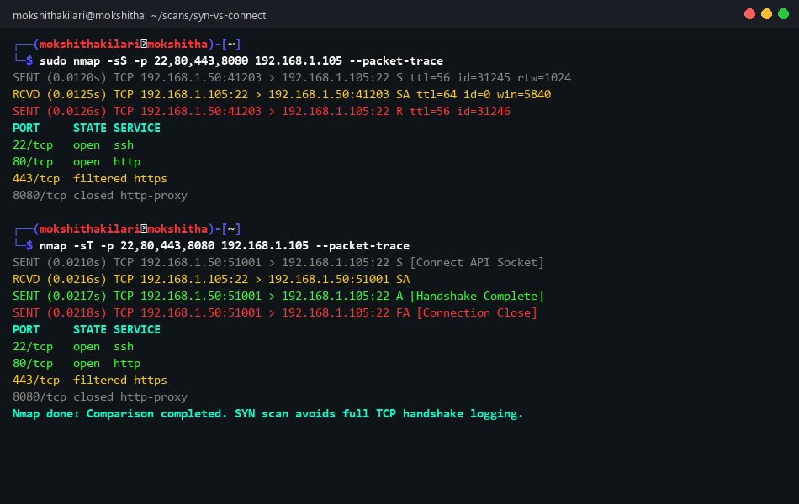

Question 3: During a port scan, most ports appear as "filtered." What security mechanisms might be responsible, and what additional techniques would you use to gather more information?

1. Security Mechanisms Responsible for "Filtered" State
In Nmap terminology, a port is classified as `Filtered` when probe packets are dropped before reaching the target port, or when firewall rules prevent Nmap from determining whether the port is open or closed. The primary security controls responsible include:
• Stateful Packet Inspection (SPI) Firewalls: Modern firewalls (`iptables`, `nftables`, Palo Alto, Cisco ASA) configured with default `DROP` policies silently discard incoming `SYN` probes on unauthorized ports without returning a TCP `RST` or ICMP response.
• Network Access Control Lists (ACLs): Router and layer-3 switch ingress ACLs drop non-whitelisted traffic at the network edge.
• Host-Based Firewalls (Windows Defender Firewall, ufw): Endpoint rules blocking inbound connection requests per process or port.
• Intrusion Prevention Systems (IPS) & Rate Limiting: Security sensors that dynamically detect rapid port sweeps and drop subsequent traffic from the scanner IP address.
2. Advanced Evasion & Information Gathering Techniques
When facing heavily filtered environments, advanced port scanning techniques are deployed to map firewall rules and determine true port accessibility:
1. TCP ACK Scan (`-sA`): ACK scans send packets with only the `ACK` flag set. Since ACK packets mimic established TCP connections, stateless firewalls allow them through, while stateful firewalls drop them. If a `RST` is returned, the port is classified as `UNFILTERED`, confirming that the firewall allows traffic through to the target host.
2. Idle Scan / Zombie Scan (`-sI <zombie_host>`): A sophisticated blind scan technique that routes probes through an idle third-party host with predictable IP ID sequence numbers. This conceals the attacker's IP entirely while determining if target ports are open behind perimeter filters.
3. IP Packet Fragmentation (`-f`, `--mtu 8/16`): Splitting the TCP header across tiny 8-byte or 16-byte IP fragments forces simple packet filters to evaluate incomplete headers, frequently bypassing signature-based inspection.
4. Source Port Spoofing (`g 53` / `--source-port 80`): Exploiting misconfigured firewall rules that implicitly trust inbound traffic originating from standard DNS (UDP/TCP 53) or HTTP (80) source ports.
5. TCP FIN, NULL, and Xmas Scans (`-sF`, `-sN`, `-sX`): Exploiting RFC 793 TCP compliance. Non-SYN probes sent to closed ports trigger `RST`, while open ports drop the probe. This bypasses non-stateful packet filters.
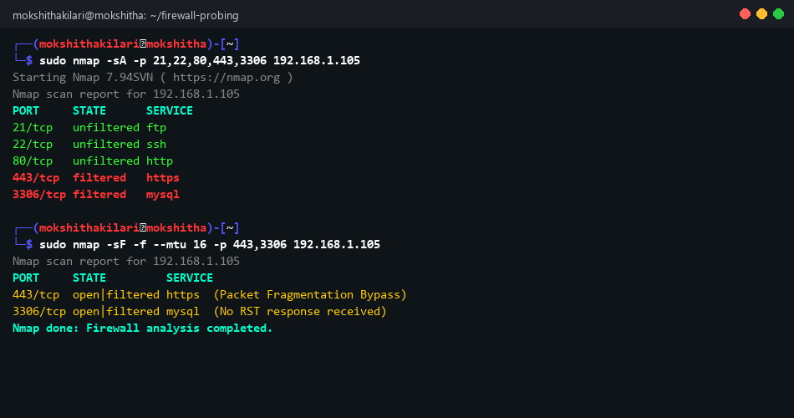

Question 4: Compare TCP, UDP, and stealth (SYN) port scanning techniques. In which scenarios would each be the most effective, and what are their advantages and limitations?

1. Technical Comparison Matrix
Scan Type | Handshake Mechanism | Speed | Stealth Level | Primary Advantage | Main Limitation
TCP Connect Scan (-sT) | Full 3-Way (SYN, SYN-ACK, ACK) | Moderate | Low (Logged by OS/Apps) | No root/sudo privileges required | Generates heavy log footprint
Stealth SYN Scan (-sS) | Half-Open (SYN, SYN-ACK, RST) | Fast | High (Bypasses app logs) | Fast, stealthy, highly reliable | Requires raw socket / root privileges
UDP Scan (-sU) | Connectionless (UDP Payload / Probe) | Very Slow | Moderate | Identifies exposed DNS, SNMP, DHCP | ICMP rate-limiting causes slow scans
TCP ACK Scan (-sA) | Single ACK Probe | Fast | High | Maps firewall rules & statefulness | Does not determine open/closed state

2. Scenario-Based Effectiveness & Strategic Selection
• Stealth SYN Scan Scenario: Ideal for authorized penetration tests on large enterprise subnets where speed, stealth, and minimal system impact are paramount. Used as the primary default scan method.
• TCP Connect Scan Scenario: Essential when performing security audits from restricted non-root containers, unprivileged jump boxes, or legacy network audit tools lacking raw socket capabilities.
• UDP Scan Scenario: Critical during internal infrastructure assessments targeting DNS servers (UDP 53), SNMP network management agents (UDP 161/162), NTP time servers (UDP 123), and OpenVPN endpoints (UDP 1194). UDP services are frequently overlooked by attackers and defenders alike, making UDP scanning vital for thorough surface coverage.
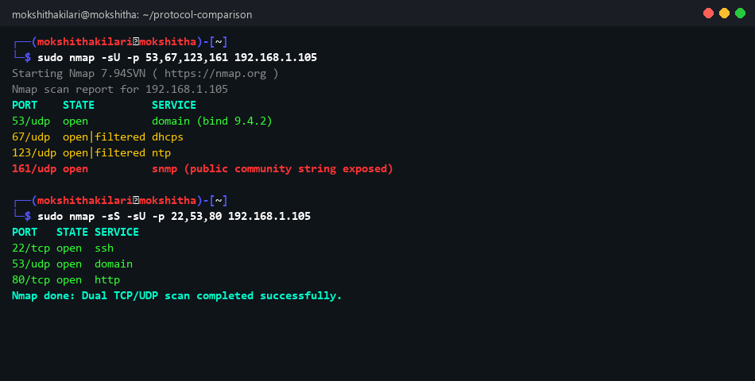

Question 5: Suppose you are conducting an authorized security assessment and discover critical services (such as SSH, FTP, and database ports) exposed to the internet. How would you assess the risks and recommend mitigation strategies?

1. Deep Risk Assessment & Threat Modeling
Exposing management daemons and database instances directly to the public internet presents severe, high-probability threat vectors:
• Exposed SSH (Port 22): Subject to continuous automated password brute-force and credential stuffing botnets. If outdated (e.g., OpenSSH 4.x), unauthenticated RCE exploits or weak host key algorithm degradation can lead to total system compromise.
• Exposed FTP (Port 21): Plaintext transmission of authentication credentials across public routers. Anonymous FTP login misconfigurations allow unauthorized file uploads/downloads, serving as a staging ground for malware hosting.
• Exposed Database Ports (MySQL 3306, PostgreSQL 5432): Direct exposure permits remote authentication attacks, SQL injection relaying, unpatched zero-day memory corruption exploits, and immediate automated ransomware encryption of database tables.
2. Holistic Risk Mitigation & Remediation Roadmap
To mitigate these risks effectively, a defense-in-depth strategic remediation plan is enforced:
1. Immediate Perimeter Isolation (Firewall & ACLs): Reconfigure edge firewalls (AWS Security Groups, Cloudflare WAF, iptables) to drop all public ingress traffic to ports 21, 22, 3306, and 5432 immediately.
2. Implement VPN & Bastion Host Architecture: Enforce access to internal management daemons strictly through encrypted VPN tunnels (WireGuard, OpenVPN) or dedicated Bastion Jump Hosts featuring mandatory Multi-Factor Authentication (MFA).
3. Service Hardening Configurations:
- SSH (Port 22): Enforce key-based authentication (`PasswordAuthentication no`), disable root login (`PermitRootLogin no`), change default port, and deploy `Fail2ban` brute-force protection.
- FTP (Port 21): Deprecate plain FTP immediately. Migrate to SFTP (SSH File Transfer Protocol) over port 22 or FTPS with enforced TLS encryption.
- Database (3306/5432): Bind listening sockets exclusively to localhost (`bind-address = 127.0.0.1`), mandate TLS client certificates, and restrict database user network grants (`'user'@'localhost'`).

RUBRICS FOR CALCULATION:
Criteria | Weightage Level 4 | (Exemplary) | Level 3  (Proficient) | Level 2  (Developing) | Level 1  (Beginnin g)
Identification of Port Scanning Factors | 25% | Clearly identifies comprehensive and relevant  strengths,  weaknesses,  opportunities,  and threats | Identifies most factors with  minor gaps | Limited or  partially  relevant  identification | Incorrect or incomplete Port  Scanning  factors
Analysis | 25% | Provides deep, insightful  analysis of each Port Scanning component with strong reasoning | Provides good analysis with  some depth | Basic analysis with limited  reasoning | No  meaningful analysis  provided
Linkage | 20% | Effectively links Port Scanning elements to  derive strong  strategic insights and implications | Shows some  linkage with  moderate  insights | Weak linkage; limited  strategic  thinking | No linkage or strategic insight
Application | 20% | Applies Port  Scanning  analysis  effectively to the given case or  scenario with  clear relevance | Applies analysis with minor gaps | Limited  application;  lacks clarity | No clear  application to context

