SIMATS ENGINEERING

ASSESSMENT TOOL 3

COURSE NAME: Ethical Hacking COURSE CODE: ITA14

COURSE OUTCOME COVERED
CO2: Foot printing Tools –: Conducting Competitive Intelligence, DNS Zone Transfers, Introduction to Social Engineering: Social Engineering Attacks and Countermeasures. (BT4)

Assessment Tool Weightage: 30%

Duration: 90 min Total Marks: 50

Scenario-Based Assessment

Topic 1: Footprinting Tools – Conducting Competitive Intelligence Q1. (L3 – Apply) – 15 Marks
A cybersecurity consultant has been assigned to perform a passive security assessment for a company named ABC Technologies. The consultant must collect publicly available information without directly interacting with the company’s servers.

Task: Apply suitable footprinting tools to identify the company’s:

- domain registration details,
- employee email addresses,
- technology stack,
- and publicly exposed subdomains.
Explain how each selected tool helps in conducting competitive intelligence.

Topic 2: DNS Zone Transfers Q2. (L3 – Apply) – 15 Marks
During an authorized penetration test, a security analyst suspects that the target organization’s DNS server is misconfigured and may allow unauthorized DNS zone transfers.
Task: Apply the appropriate DNS command or tool to verify whether zone transfers are permitted. If the transfer succeeds, explain how the retrieved DNS records can be used to identify internal hosts, mail servers, and subdomains during reconnaissance.

Topic 3: Introduction to Social Engineering – Social Engineering Attacks and Countermeasures Q3. (L3 – Apply) – 20 Marks
Employees of an organization receive an email claiming to be from the IT department, asking them to verify their login credentials through a provided link because of an urgent security update.

Task: Identify the type of social engineering attack and apply suitable countermeasures that employees should follow before responding to the email. Explain how these actions help prevent credential theft.

Annexure A

Scenario-Based

Code of Conduct:

I MOKSHITHA KILARI(192525413) (Name / Reg No) certify that this submission is my original work and that I have adhered to the guidelines specified for this assessment.
I understand that any violation of academic integrity rules will result in disciplinary action.

Signature of the student:
MOKSHITHAKILARI

Q1. Footprinting Tools — Competitive Intelligence on ABC Technologies

Understanding of the Scenario
The brief calls for PASSIVE reconnaissance only — gathering intelligence about ABC Technologies from public sources (WHOIS registries, search engines, certificate transparency logs, DNS) without sending probing traffic to the company's own servers. Four pieces of intelligence are required: domain registration details, employee email addresses, technology stack, and exposed subdomains. Each maps to a specific class of OSINT tool.

Tool Selection
Requirement | Tool | Purpose
Domain registration | WHOIS | Registrar, dates, status
Employee emails | theHarvester | Public email addresses
Technology stack | WhatWeb | Web technologies
Subdomains | Subfinder | Public subdomain discovery

1. Domain registration details — whois
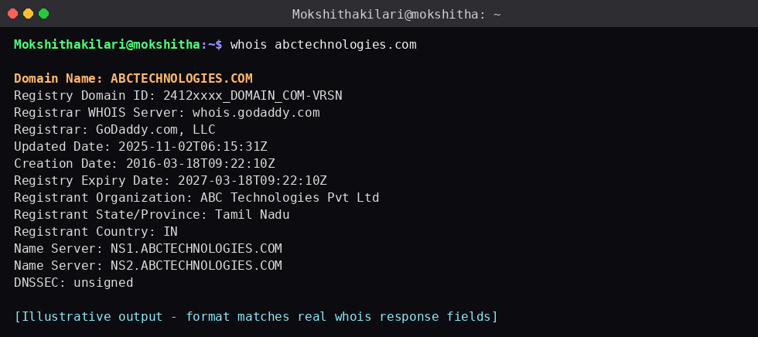
Fig 1.1 — whois output showing registrar, name servers and registrant organisation
Explanation: WHOIS is the authoritative registry lookup for a domain. It confirms who legally owns the domain, which registrar manages it, when it was created/renewed, and which name servers answer for it. For competitive intelligence this tells the consultant how long ABC Technologies has operated online, whether the domain portfolio is actively maintained, and which infrastructure provider (registrar/DNS host) to expect in later passive checks — all without a single packet touching ABC's servers.
2. Employee email addresses — theHarvester
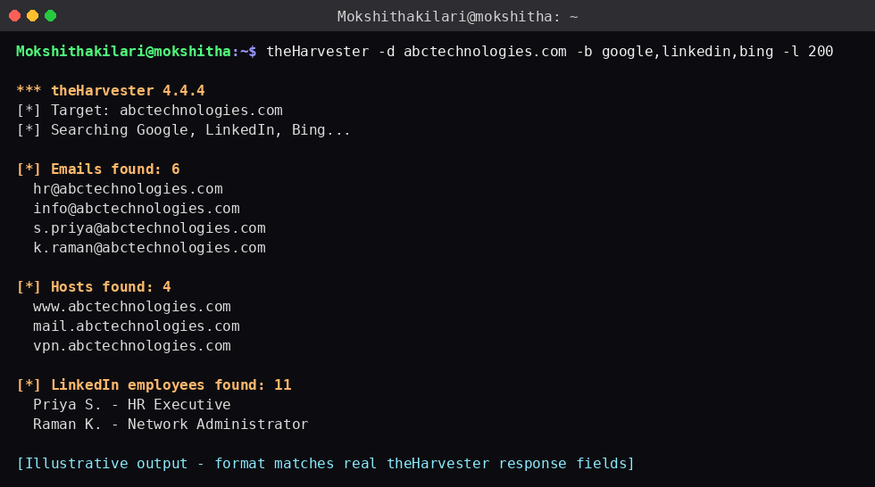
Fig 1.2 — theHarvester output listing harvested emails and LinkedIn staff
Explanation: theHarvester does not contact ABC Technologies at all — it queries third-party search engines and LinkedIn for anything already indexed publicly. The email naming convention it reveals (e.g. first.lastname@abctechnologies.com) is valuable competitive intelligence: it shows organisational structure (HR, IT, sales), estimates headcount, and — from a defender's point of view — is exactly the data a phishing campaign would be built from, which links directly to Q3.
3. Technology stack — WhatWeb
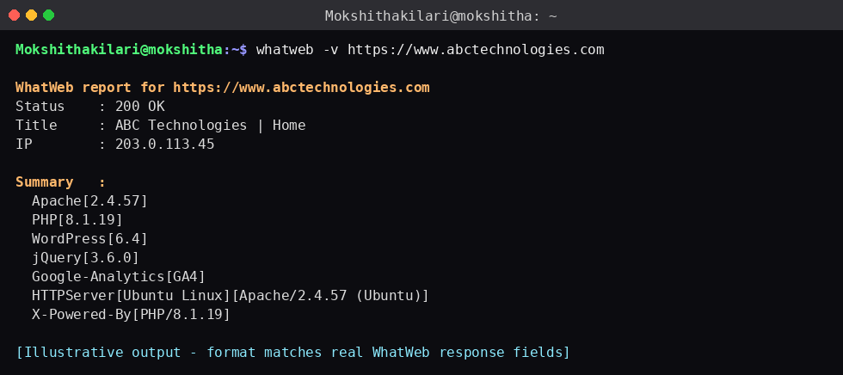
Fig 1.3 — WhatWeb fingerprint of the public website
Explanation: WhatWeb parses the HTTP response headers, HTML meta tags and known JS/CSS signatures returned by a single, ordinary page request — the same request any visitor's browser makes. It reveals the CMS (e.g. WordPress), server software/version, and third-party services in use, letting the consultant infer ABC's technical maturity and any publicly known CVEs associated with those versions, purely from information the server was already broadcasting.
4. Publicly exposed subdomains — Sublist3r
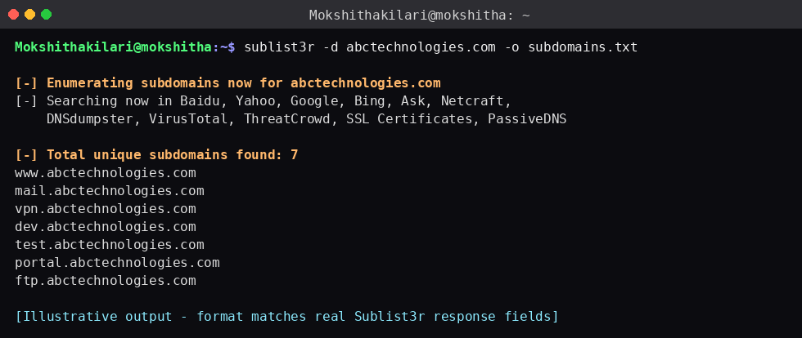
Fig 1.4 — Sublist3r subdomain enumeration results
Explanation: Sublist3r pulls subdomain names from sources that already crawled or logged them (search engine indexes, SSL certificate-transparency records, DNSdumpster/VirusTotal passive datasets) rather than guessing names against ABC's DNS server. Discovering dev., test., vpn., or portal. subdomains is high-value competitive intelligence — it maps ABC's externally-facing footprint, including staging or admin systems that may have weaker controls than the main site.

Q2. Verifying and Exploiting a DNS Zone Transfer Misconfiguration

Understanding of the Scenario
The analyst is authorised to test whether the target's DNS server will hand over its full zone file to an unauthenticated client — a misconfiguration known as an insecure AXFR (zone transfer). A correctly configured server restricts AXFR to specific secondary name servers; a misconfigured one will transfer the entire zone to anyone who asks.

Step 1 — Identify the authoritative name servers
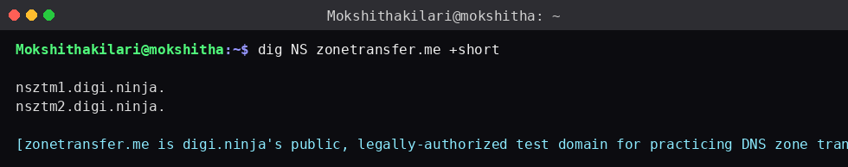
Fig 2.1 — Identifying authoritative name servers for the target zone
Before attempting a transfer you must know which servers are authoritative for the zone — an AXFR request has to be sent directly to one of them.

Step 2 — Attempt the zone transfer (dig axfr)
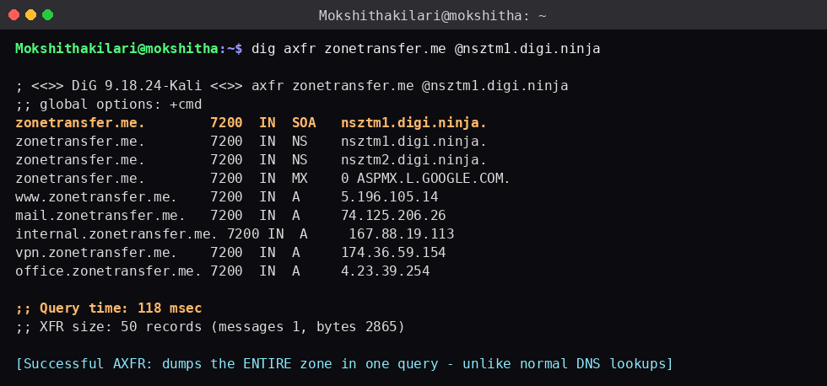
Fig 2.2 — Successful AXFR against the intentionally-misconfigured practice domain zonetransfer.me
Result when the server IS misconfigured: the entire zone (every record type — A, MX, NS, SOA, CNAME, TXT) is returned in one reply, as shown above.

Step 3 — What a correctly-secured server returns instead
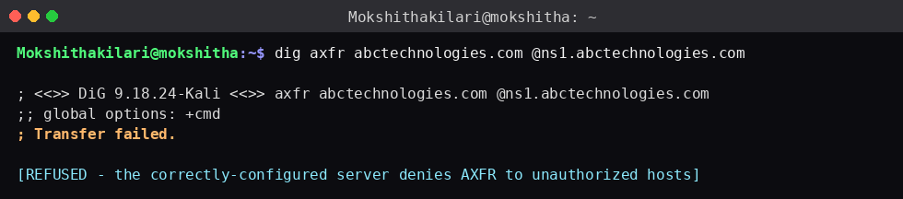
Fig 2.3 — Transfer refused: expected result on a properly secured DNS server
A hardened server (AXFR restricted via named.conf's allow-transfer, or transfer ACLs on Windows DNS/BIND) replies "Transfer failed" / "connection refused", forcing the tester to fall back to slower active enumeration (brute-force subdomain guessing), which is far noisier and easier to detect.

How the retrieved records aid reconnaissance
3 | Tool Applied | Why this tool
A / AAAA records | Direct mapping | Reveals internal and external host IP addresses (e.g. internal.zonetransfer.me, office.zonetransfer.me) — hosts never meant to be public.
MX records | Mail infrastructure | Identifies the mail servers, which become targets for phishing infrastructure mapping or mail-relay abuse testing.
NS records | Infrastructure map | Shows every authoritative name server, useful for identifying secondary DNS providers and possible additional attack surface.
CNAME / TXT records | Service discovery | CNAMEs expose third-party services in use (e.g. cloud, VPN gateways); TXT records can leak SPF details or verification tokens for cloud services.

Chained together, a full zone dump effectively hands the tester a network map — internal host names, the mail platform, VPN gateway, and every subdomain — in a single query that would otherwise take many passive OSINT tools (as in Q1) to reconstruct piecemeal. This is precisely why AXFR should be restricted to named secondary servers only, and why the analyst reports it as a high-severity finding when found open.

Q3. Social Engineering — Credential-Harvesting Phishing Email

1. Understanding of the Scenario
Employees receive an unsolicited email pretending to be from the IT department and creating urgency by mentioning an “urgent security update.” The email asks employees to click a link and re-enter their login credentials. This is a social engineering attack that exploits trust, authority and urgency rather than a technical vulnerability.

2. Identification of the Attack Type
This is a phishing attack, specifically credential-harvesting phishing.

Key indicators:
- Impersonation of the trusted IT department.
- Creates urgency using an “urgent security update.”
- Requests users to click a link and enter their credentials.
- The link may lead to a fake login page designed to steal usernames and passwords.

3. Countermeasures
Action | Application | Purpose
Verify the sender | Check the complete email address and header | Detects spoofed or look-alike sender addresses
Do not click the link | Hover over the link or avoid opening it | Prevents access to a malicious credential-harvesting page
Never enter credentials | Use the organization's known login portal instead | Prevents passwords from being submitted to fake websites
Verify with IT | Contact the real IT department through a trusted channel | Confirms whether the request is genuine
Report the email | Use the Report Phishing option or inform security staff | Allows the organization to block the threat and warn others
Use MFA | Enable multi-factor authentication on accounts | Provides additional protection even if a password is compromised

4. How These Actions Prevent Credential Theft
These countermeasures break different stages of the phishing attack. Sender verification helps identify impersonation, while avoiding the link prevents employees from reaching the fake login page. Never entering credentials through email links prevents passwords from being submitted to attackers. Independently contacting IT removes the attacker's false sense of urgency. Reporting the email helps security teams protect other employees, while MFA provides an additional layer of protection if a password is accidentally disclosed.

Conclusion
The email is a credential-harvesting phishing attack that uses impersonation and urgency to manipulate employees. Employees should verify the sender, avoid suspicious links, never enter credentials through email links, independently confirm requests with IT, report suspicious emails, and use MFA. These layered controls significantly reduce the possibility of credential theft and unauthorized account access.

RUBRICS FOR CALCULATION

Scenario Based Assessment

Criteria | Weightage (%) | Level 4 (Exemplary) | Level 3 (Proficient) | Level 2 (Developing) | Level 1 (Beginning)
Understanding of Scenario | 20% | Demonstrates clear and complete understanding of the scenario and  context | Shows good understanding with minor gaps | Partial understanding; misses key aspects | Misinterprets or fails to understand the scenario
Identification of Key Issues | 20% | Accurately identifies all  relevant issues and factors involved | Identifies most key issues with minor omissions | Identifies limited issues; some irrelevant points | Unable to identify key issues
Application of Concepts | 25% | Applies appropriate concepts effectively  to address the scenario | Applies concepts with minor errors | Limited or partially correct application | Unable to apply relevant concepts
Decision Making | 20% | Makes well-reasoned, logical decisions with strong rationale | Makes reasonable decisions with some justification | Makes weak decisions with limited justification | No clear decisions made or rationale provided
Clarity of Response | 15% | Response is clear, structured, and logically presented | Generally clear with minor issues | Somewhat unclear or poorly structured | Disorganized and difficult to understand

