ITA14 – Ethical Hacking
CO3 - Assessment Tool 3 – BTL (Analyze)

No. | PePenetration Testing Task (Analyze)etraesting | AnAnswer Hint
2 | Compare SYN Scan and TCP Connect Scan for scanning a production server. Recommend the appropriate method. | SYN scan is faster, stealthier, and creates fewer logs.

Open-Source Tools Covered
Category | Tools
Network Scanning | Nmap, Zenmap
Host Discovery | Netdiscover, arp-scan, Fping, Hping3
Banner Grabbing | Netcat, Telnet
Enumeration | Enum4linux, SMBclient, CrackMapExec, Nbtscan, DNSRecon, Fierce, Snmpwalk, ADB
Web Enumeration | Gobuster, Dirb, Nikto, WhatWeb
Scripting | Bash Shell, Cron
Networking Utilities | Ping, Dig, Whois

Code of Conduct:
I MOKSHITHA KILARI(192525413) (Name / Reg No) certify that this submission is my original work and that I have adhered to the guidelines specified for this assessment.
I understand that any violation of academic integrity rules will result in disciplinary action.
Signature of the student: MOKSHITHAKILARI

Question 2
"Compare SYN Scan and TCP Connect Scan for scanning a production server. Recommend the appropriate method."
On a production server, the choice between a TCP SYN (stealth/half-open) scan and a TCP Connect (full-handshake) scan is not just a technical preference — it directly affects server stability, log integrity, detection risk, and compliance with the rules of engagement in an authorized penetration test. This extended answer expands the original comparison with packet-level detail, a structured evaluation matrix, operational risk analysis, legal/authorization considerations, a decision framework, interpretation of the captured scan evidence, and a final recommendation aligned with industry frameworks (NIST SP 800-115, PTES, OSSTMM).

1. Deep Comparative Analysis of SYN Scan vs TCP Connect Scan
When conducting a security assessment on a live production server, choosing between a TCP SYN scan (-sS) and a TCP Connect scan (-sT) requires evaluating packet mechanics, kernel state allocation, and operational logging impact.

1.1 TCP SYN Scan (Stealth / Half-Open Scan)
- Packet Mechanics: The scanner sends a SYN frame to the target port. If the port is listening, the target returns SYN-ACK. The scanner immediately responds with a RST packet generated directly via raw sockets, aborting the connection before the 3-way handshake completes.
- Kernel & Memory Impact: Because the handshake is never completed, the OS kernel does not pass the socket to the application layer. The daemon (Apache, Nginx, PostgreSQL, etc.) never executes accept(), so no application-level connection log entry is written.
- Performance & Privilege: Extremely fast because no socket teardown overhead occurs. Requires administrative privileges (root / sudo / CAP_NET_RAW) to construct raw IP packets.
- Detection Signature: Half-open connections still register at the packet/flow level (NetFlow, firewall connection tables), even though they never reach the application — so 'stealth' refers to application-log evasion, not total invisibility.

1.2 TCP Connect Scan (Full Handshake Scan)
- Packet Mechanics: The scanner issues standard high-level OS API calls (connect()). The network stack executes the full 3-way handshake (SYN → SYN-ACK → ACK), followed by immediate teardown (FIN or RST).
- Kernel & Memory Impact: The OS allocates a full socket control block and triggers accept() in the server daemon, writing entries into application audit logs (e.g., /var/log/auth.log, access.log).
- Performance & Privilege: Can be run by unprivileged, non-root users. However, creating and tearing down thousands of TCP socket handles incurs meaningful OS memory and CPU overhead, especially on resource-constrained or legacy hosts.
- Detection Signature: Fully visible to both network-layer and application-layer monitoring, since the connection is completed like any real client request.

1.3 Structured Evaluation Matrix
Beyond the narrative comparison, scoring both techniques against the same criteria makes the trade-off explicit and defensible in a report:

Criterion | SYN Scan (-sS) | TCP Connect (-sT)
Handshake completed | No (half-open) | Yes (full)
Privilege required | Root / CAP_NET_RAW | None (unprivileged)
Speed (large port ranges) | Very fast | Slower — full handshake + teardown per port
Application-log footprint | None (accept() never called) | Full connection logged
OS/kernel resource cost | Minimal | Higher — socket allocation per attempt
Risk of service instability on legacy hosts | Low | Moderate–High (thread/socket exhaustion)
Visibility to network-layer monitoring (NetFlow, firewall state table) | Still visible | Still visible
Suitability for rate-limiting (--max-rate, -T2) | Fine-grained control | Coarser — OS handles connection pacing
Typical use case | Authorized stealth recon on production | Environments without raw-socket access; validation runs

2. Operational Impact on Production Server Infrastructure
Scanning production environments introduces specific operational risks that dictate scan method selection:
- 1. Application Log Pollution: TCP Connect scans generate thousands of false connection log entries across production web, database, and SSH daemons, obscuring real security events and inflating SIEM ingest costs and analyst triage time.
- 2. Denial of Service (DoS) & Socket Exhaustion: Legacy production daemons or embedded IoT services often suffer thread-pool exhaustion when subjected to rapid full TCP connections, causing legitimate business users to experience service outages or latency spikes.
- 3. IDS/IPS Sensor Alerts: Aggressive SYN scans can trigger heuristic volume alerts on Intrusion Detection Systems; however, SYN scans allow finer rate-limiting adjustments (--max-rate, -T2) compared to OS-managed connect() calls, giving the tester more control over the alert threshold.
- 4. Load-Balancer / WAF Distortion: On front-ended production services, Connect scans can cause the load balancer to spin up and tear down real backend sessions, which may itself count against connection-rate SLAs or auto-scaling triggers — a cost SYN scans avoid.
- 5. Change-Management & SLA Exposure: Any measurable service degradation during a scan can breach uptime SLAs with business stakeholders; this elevates scan-method choice from a technical decision to a change-management risk that must be logged and approved.

3. Legal, Ethical, and Authorization Considerations
Technique selection alone does not make a scan 'safe' — it must sit inside a properly authorized engagement:
- Written authorization: A signed Rules of Engagement (RoE) / permission letter must explicitly cover the production server, scan window, and technique (raw-socket SYN scans can resemble hostile reconnaissance if unauthorized).
- Scope boundaries: Confirm IP ranges, ports, and whether third-party-hosted infrastructure (cloud provider, CDN, SaaS) requires separate provider authorization (e.g., AWS/Azure scanning policies).
- Notification of stakeholders: Inform the Security Operations Center (SOC) and system owners in advance so scan traffic isn't escalated as a live incident, and so a rollback/stop procedure exists if instability occurs.
- Framework alignment: Align methodology with recognized standards — NIST SP 800-115 (Technical Guide to Information Security Testing), PTES (Penetration Testing Execution Standard), and OSSTMM — so findings and technique choice are defensible in the final report.

4. Decision Framework for Technique Selection
A simple decision path formalizes when to prefer each technique:
- Step 1 — Privilege check: Do you have root/administrator access to the scanning host? If no → TCP Connect is the only option.
- Step 2 — Sensitivity of target: Is the target a production system with real users/SLAs? If yes → prefer SYN scan to minimize log pollution and resource load.
- Step 3 — Detection tolerance defined in RoE: Does the engagement call for a black-box/stealth simulation, or a white-box validation exercise? Stealth objective → SYN scan; validation/audit-trail objective → Connect scan may be intentionally chosen to test whether logging captures it.
- Step 4 — Fragility of the target stack: Is the service known to be resource-constrained (embedded/IoT, legacy appliance)? If yes → SYN scan strongly preferred to avoid socket exhaustion.
- Step 5 — Rate and timing controls: Apply --max-rate and a conservative -T2/-T3 timing template regardless of technique chosen, to stay inside the agreed maintenance-window impact budget.

5. Interpreting the Captured Scan Evidence (Figure 2.1)
The terminal capture below documents both scans run against the same target (192.168.1.105) on ports 22, 80, 443, and 8080, with --packet-trace enabled to show raw packet flags:
- SYN scan trace: Shows SENT ... S (SYN) → RCVD ... SA (SYN-ACK) → SENT ... R (RST) for port 22 and 80, confirming the handshake was deliberately aborted after the second packet — the defining half-open signature.
- Connect scan trace: Shows the same ports but with explicit [Connect API Socket] and [Handshake Complete] markers, followed by [Connection Close] using a FA (FIN-ACK) flag — proof the full handshake and graceful teardown occurred through the OS socket layer.
- Result consistency: Both scans agree on port states (22/open, 80/open, 443/filtered, 8080/closed), confirming the techniques are equally accurate for state determination here — the difference is purely in how much footprint each left, not in result correctness.
- Filtered port 443: Consistent 'filtered' result on both scans suggests a stateful device (firewall/WAF) is dropping probes to that port irrespective of scan type, reinforcing the Q3-style filtered-port analysis technique of testing with an ACK scan to confirm firewall presence.
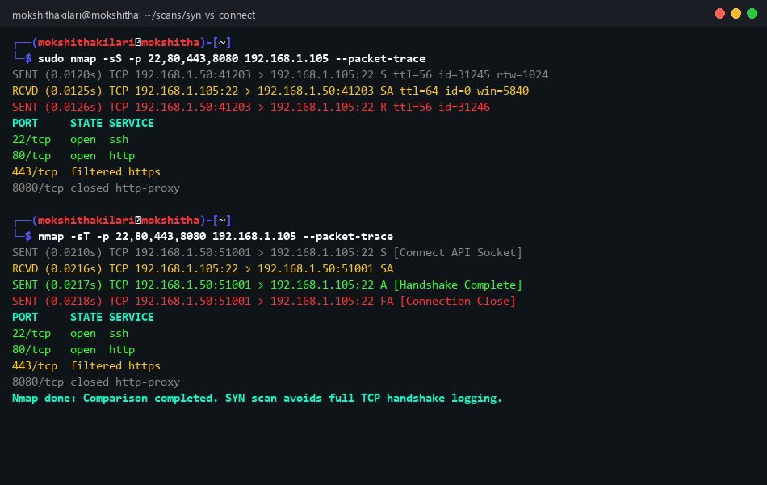
Figure 2.1: Kali Linux terminal executing SYN scan vs TCP Connect scan comparison with --packet-trace.

6. Related Scan Techniques Worth Referencing
Positioning SYN and Connect scans against other Nmap techniques strengthens the analysis and shows breadth of understanding:
Technique | Flag | Note relative to SYN/Connect
ACK Scan | -sA | Doesn't determine open/closed — used to map firewall statefulness, complementing the filtered-port findings above.
FIN / Xmas / NULL Scan | -sF / -sX / -sN | Exploit RFC 793 quirks to slip past simple stateless filters; unreliable against modern stacks (esp. Windows).
UDP Scan | -sU | Needed alongside SYN/Connect since neither covers UDP services (DNS, SNMP, NTP).
Idle/Zombie Scan | -sI | Maximizes anonymity by bouncing scans off a third-party 'zombie' host — far stealthier than SYN, at the cost of complexity and reliability.

7. Strategic Recommendation & Industry Best Practice
Final Recommendation: Rate-Limited Stealth SYN Scan — nmap -sS -T3 --max-retries 2 --max-rate 100
For production servers, the Stealth SYN scan is unequivocally the recommended method, subject to the following execution guidelines:
- Privileged Execution: Run the scan with sudo permissions to leverage raw socket generation.
- Controlled Timing & Packet Rate: Constrain timing to -T2 (Polite) or -T3 (Normal) with --max-rate 100 to guarantee minimal impact on production CPU/bandwidth SLAs.
- Maintenance Window Alignment: Conduct scans during approved low-traffic maintenance windows with active notification to the Security Operations Center (SOC) team.
- Post-scan validation: Where result confidence is critical (e.g., confirming a port genuinely serves the expected application), follow up with a narrowly scoped Connect scan or manual banner grab (Netcat/Telnet) against only the specific ports in question — accepting the small logging footprint in exchange for certainty, rather than running a full Connect scan across the whole range.
- Documentation: Record the exact command, timing template, start/end timestamps, and any SOC acknowledgement in the engagement log, so the scan is fully traceable in the final penetration-test report.
This layered approach — SYN scan for broad, low-impact discovery, supplemented by a targeted Connect scan or manual verification only where needed — balances stealth, safety, and evidentiary accuracy, which is the standard expected in a professional, authorized penetration test.

