

SIMATS ENGINEERING

Saveetha Institute of Medical and Technical Sciences Chennai- 602105

Student Name: Mokshitha Kilari Reg. No:192525413 Course Code: MLA0101 Slot: A
Course Name: Artificial Intelligence and Expert Systems

Course Faculty: Dr. P. Subramanian

Project Title: AI-Enhanced Voice Recognition System for Arduino LED Control
Module Photographs:
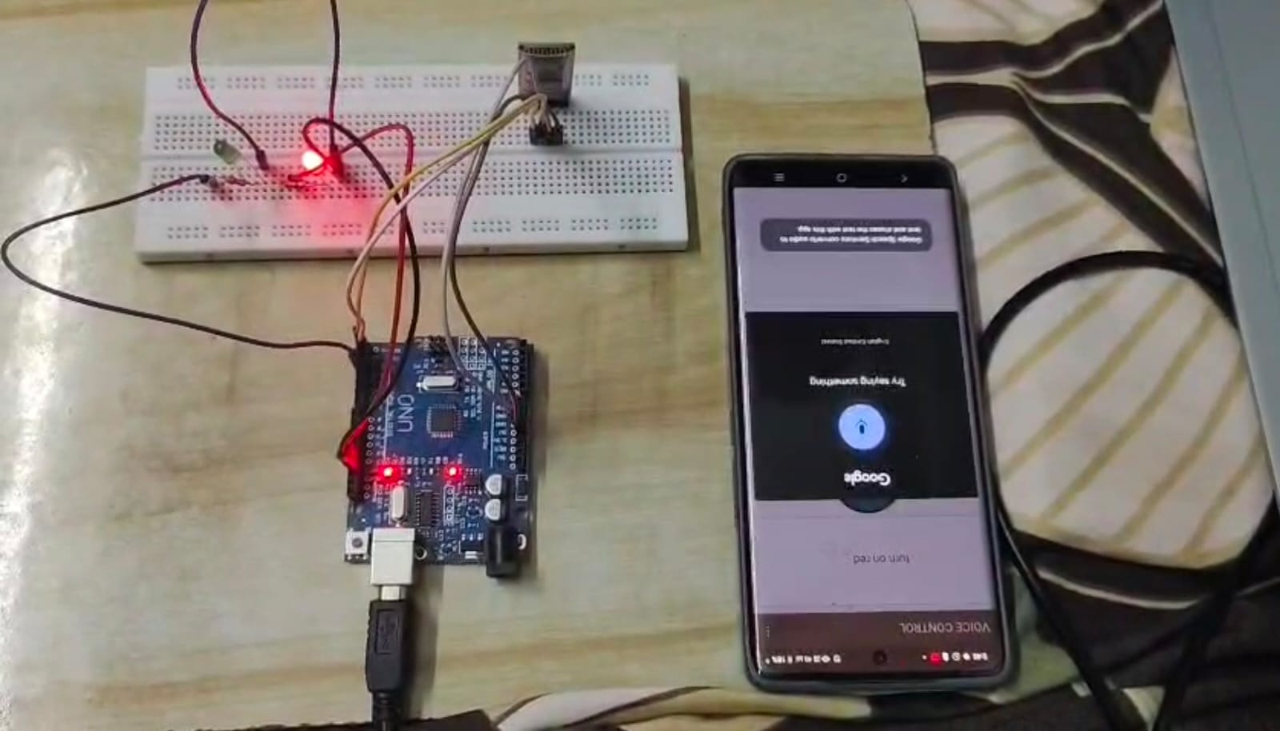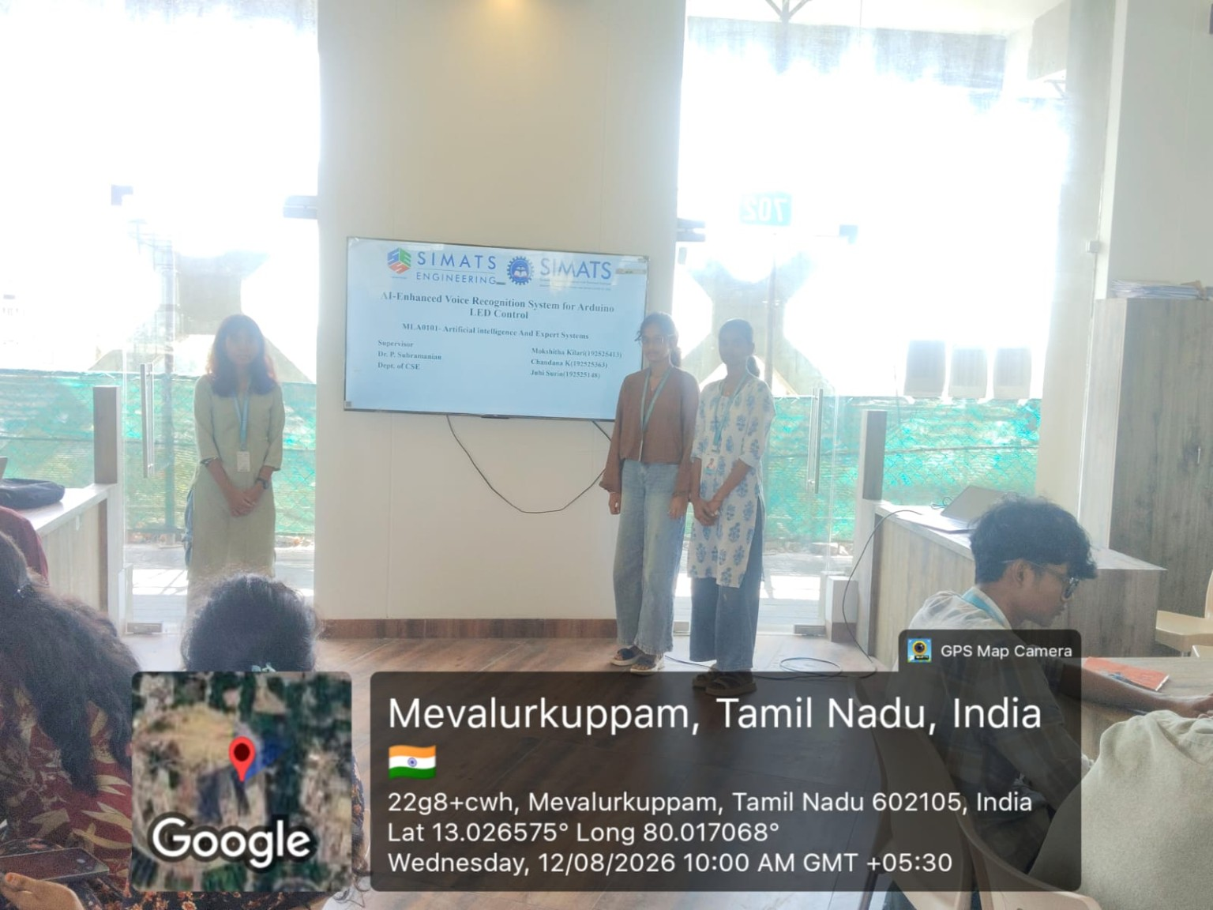
Project Description:
The AI-Enhanced Voice Recognition System for Arduino LED Control is a voice-controlled automation project that combines Artificial Intelligence, voice recognition, Bluetooth and Arduino Uno. The system captures a spoken command through a microphone or smartphone, recognizes the intended command using AI-based speech recognition, and transmits it wirelessly through the Bluetooth HC-05 module. Arduino receives the command and controls the Red, Green and Blue LEDs in real time. The project includes three modules: Voice Recognition & AI Processing, Wireless Command Transmission, and Arduino LED Control. The system supports commands such as Turn ON LED, Turn OFF LED, Red LED ON, Green LED ON and Blue LED ON, providing a simple, hands-free and affordable approach to smart-home automation.

Student Signature Guide Signature

