Tutorial of Virtual Screening of MolGridCal

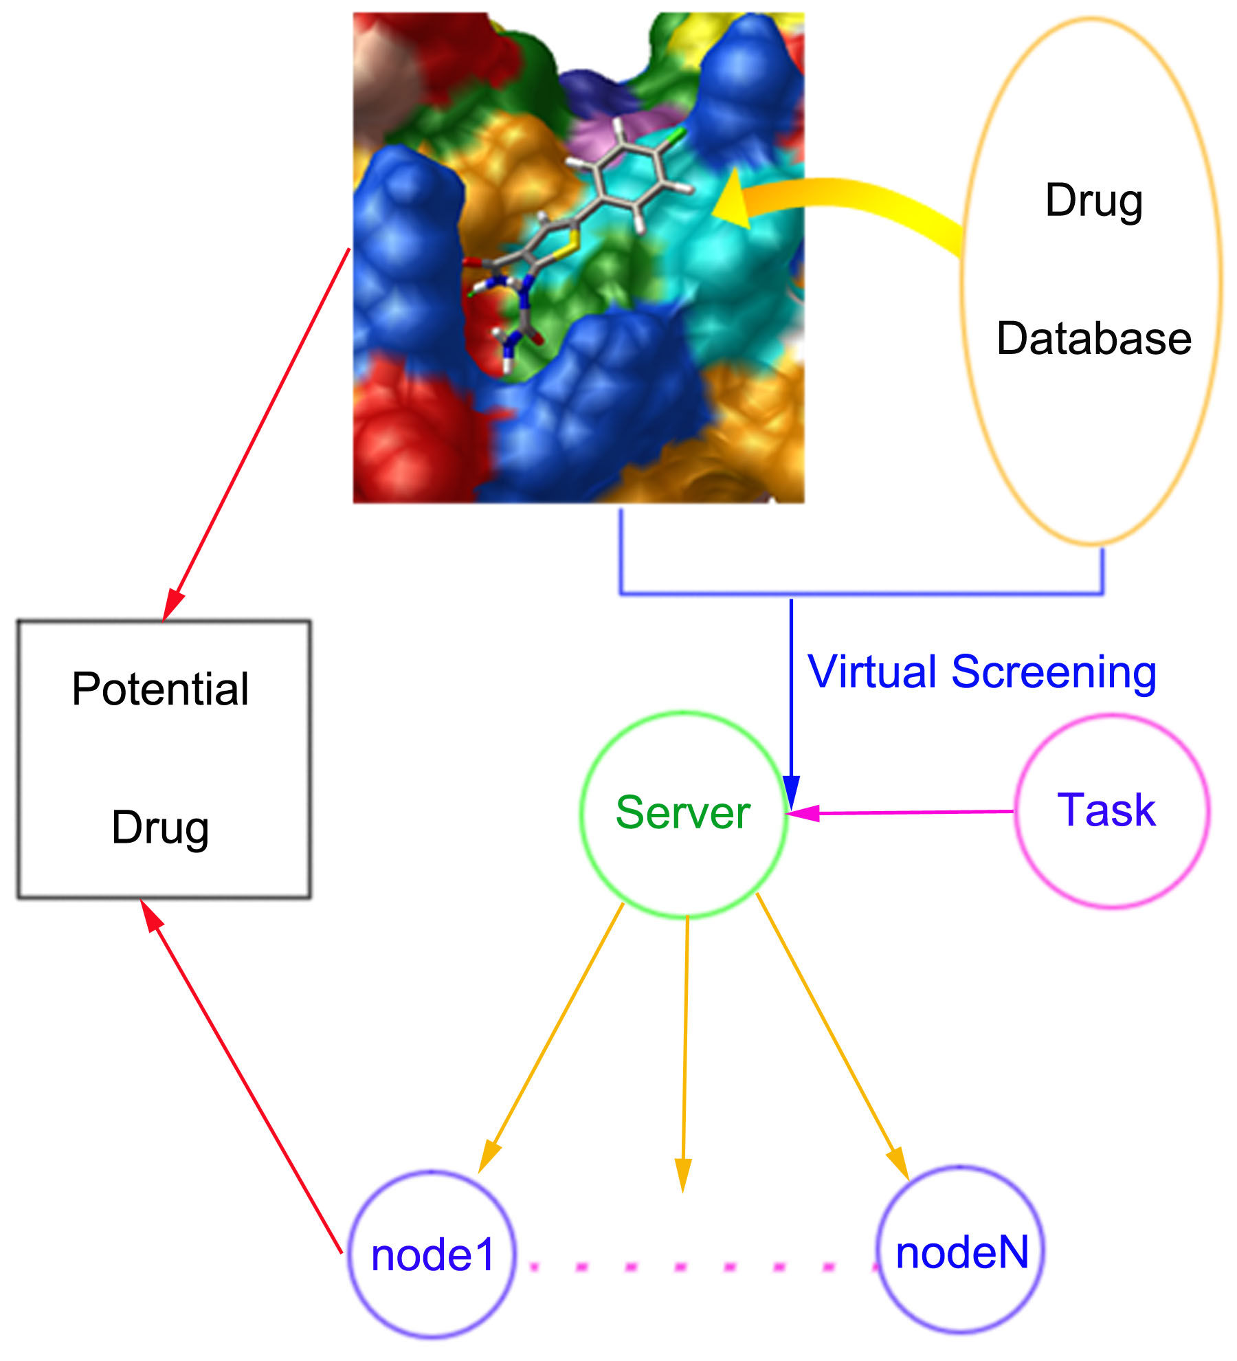
Update by Qifeng Bai
2017-11
Contents
Introduction 3
Required Software 4
Installation 5
JDK and ANT environment 5
MGLTools and VINA install 7
MolGridCal setup 7
Getting started 8
Protein preparation 8
Ligand preparation 8
Split database into the single files 8
Covert MOL2 to the PDBQT 9
Build the FTP server 9
Generate the certificate SSL 12
Distinct driver trust stores for nodes and clients 15
Configure JPPF-5.2.8-driver 16
Configure JPPF-5.2.8-node 17
Idle system 17
Start MolGridCal 17
Rank the docking results 19
Reference: 21

Introduction
Grid computing could utilize the idle computer resource to realize the common goals. It can be applied to the different many different fields, such as Hadron Collider¹, nuclear magnetic resonance (NMR)², image analysis³ and so on. Especially, if the grid computing is used to discovery drugs, it will save money and time. About 3.5 billion target proteins, one of which possibly contained more than one active site, resulted in a large and complicated virtual screening work. The screensaver project of grid computing could supply enough computing resource to solve these problems⁴. JPPF (www.jppf.org) supplies a powerful framework for grid computing. A useful and detail example will supply a good demonstration to further apply the grid computing in drug discovery. Here, I wrote the grid computing program called MolGridCal for virtual screening of ligand database, such as ZINC database which contained over 35 million purchasable compounds⁵. The related useful links as below:
JPPF: http://www.jppf.org
Globus: http://www.globus.org
Hadoop: http://hadoop.apache.org
Openstack: http://www.openstack.org/

Now we started our tutorial!

Required Software
- MolGridCal program (https://molgridcal.codeplex.com/).
- Java SE 6 or later:
(http://www.oracle.com/technetwork/java/javase/downloads/index.html), we recommend Java SE 7. JPPF and MolGridCal were wrote by pure JAVA language, so the Java compiled environment was needed.
- Apache Ant program (http://ant.apache.org). The ANT 1.8.x or later were needed. In this study, the ANT (version 1.9.2) was chosen for compiling the source code.
- The JPPF-4.2.1-driver and JPPF-4.2.1-node were needed (http://www.jppf.org) or (http://sourceforge.net/projects/jppf-project). Caution: Because some libraries exists the difference between different versions of JPPF, the version 4.2.1 is chosen for this tutorial. If you want to use the higher version of JPPF, just copy the library files of new version JPPF into the library path of MolGridCal.
- The FTP server is required. You can pick up Serv-U FTP, FileZilla, Apache FtpServer, Wing FTP Server, etc. Here, we used the Apache FtpServer for file transferring (http://mina.apache.org/ftpserver-project/)
- Autodock VINA (http://vina.scripps.edu) and MGLTools (http://mgltools.scripps.edu/) are required.

Installation

JDK and ANT environment
1. Decompressing files
In windows:
JDK: just double click and follow install instruction step by step.
ANT: just decompressing files.
In Linux:
%> tar -xzvf jdk-7u17-linux-x64.tar.gz
%> tar -xzvf apache-ant-1.9.2-bin.tar.gz
2. set the environment path:
In windows:
1. From the Desktop, right-click My Computer and click Properties.
In the System Properties window, click on the Advanced tab (Figure 1).
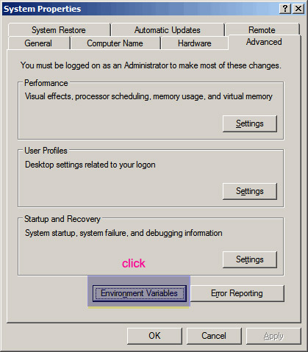
Figure 1: The Properties of system.
Then click the Environment Variables button (Figure 2):
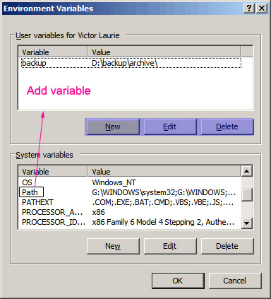
Figure 2: path of variables.
Finally, the Environment Variables in every entry is like as below:
C:\Program Files;C:\Winnt;C:\Winnt\System32

The different variables are separated by semicolon “;”. I supply an instance for setting environment of JDK and ANT:
Double click the “Path” of Environment Variables and add
;C:\Program Files\Java\jdk1.7.0_02\bin
;C:\Program Files\Java\jre7\bin;D:\Program Files\ant\bin

Create or double click CLASSPATH
;C:\Program Files\Java\jdk1.7.0_02\lib;C:\Program Files\Java\jre7\lib;D:\Program Files\ant\lib
Create the variable JAVA_HOME
;C:\Program Files\Java\jdk1.7.0_02
Caution: this is just an example, please modify it according to your real environment. JAVA_HOME is needed because the running of ant is required.
In Linux:
Open the root directory of current user. Edit the .bashrc and set the pathway of JDK and ANT. I just give an example, please modify it according to your real path of program.
export JAVA_HOME=/home/tim/bai/soft/jdk7 ###(Your own directory of JDK)
export ANT=/home/tim/bai/soft/ant192 ###(Your own directory of ANT)
export PATH=$ANT/bin:$JAVA_HOME/bin:$JAVA_HOME/jre/bin:$PATH
export LD_LIBRARY_PATH=$ANT/lib:$JAVA_HOME/lib:$JAVA_HOME/jre/lib:$JAVA_HOME/jre/lib/amd64:$LD_LIBRARY_PATH

MGLTools and VINA install
MGLTools: In windows operation system, just double click and install it followed by the instruction.
In Linux operation system, using chmod command like below:
%> chmod +x mgltools_Linux-x86_64_1.5.6_Install
Then double click and install it followed by instruction.
The VINA has a similar install way with MGLTools.

MolGridCal setup
It is very easy to install MolGridCal. Just decompress the MolGridCal and use it directly.

Getting started

Protein preparation
Here, the agonist binding sites of β₂AR is chosen as the target of virtual screening. The dealing protocol of β₂AR is omitted. The PDBQT is provided directly. More about dealt method of receptor, please refer: http://vina.scripps.edu/tutorial.html

Ligand preparation
Open VStutorial/01-vsligands, you would found the file “ligands.mol2” which contain 45 mol2 from the ZINC database. we will used it for our quick start tutorial.
All the ligands were prepared on the Linux operation system using batch shell.

Split database into the single files
split.csh---spilt the database into the single files.
#!/bin/csh
mkdir ligtmp
cd ligtmp
cat ../ligands.mol2 | csplit -ftmp -n4 -ks - '%^@.TRIPOS.MOLECULE%' '/^@.TRIPOS.
MOLECULE/'
foreach f (tmp*)
echo $f
set zid = `grep ZINC $f`
if !(-e "$zid".mol2) then
set filename = "$zid".mol2
else foreach n (`seq -w 1 99`)
if !(-e "$zid"_"$n".mol2) then
set filename = "$zid"_"$n".mol2
break
endif
end
endif
mv -v $f $filename
end

%> csh split.csh
It will split the database into the single files.

Covert MOL2 to the PDBQT
convertPDBQT.csh---convert Mol2 to PQBQT
#!/bin/csh
cd ligtmp
foreach f (`ls *`)
echo $f
pythonsh ../prepare_ligand4.py -l $f -d ../ligand_dict.py
end

set nonomatch=1 //if foreach no mathch
%> csh convertPDBQT.csh
It will convert the Mol2 to PDBQT format.
Caution: the pythonsh is part of MGLTools, so the full path should be gave if the variable environment is not set.
extract.csh---extract the PDBQT file
#!/bin/csh
mkdir ligands
cd ligtmp
mv *.pdbqt ../ligands

%> csh extract.csh
It will extract the PDBQT file into the pointed folder.

Please refer the “Using AutoDock 4 for Virtual Screening” if you want to get more information:
(http://autodock.scripps.edu/faqs-help/tutorial/using-autodock4-for-virtual-screening)

Build the FTP server
Here, we build the FTP server on Linux operation system.
1. %> tar -xzvf ftpserver-1.0.6.tar.gz
2. Because there will be a lot of connects of nodes when the virtual grid computing start, so the ftp server should be set the enough number of max login at the same time. To make sure the transferring security of FPT server, the new user name and password should be set firstly. Open ”ftpserver/res/conf” folder and edit the file of “users.properties” for user name and password (see Figure 3). In this tutorial, the MD 5 was used for encrypting. You can convert your password to MD 5 (http://www.miraclesalad.com/webtools/md5.php).
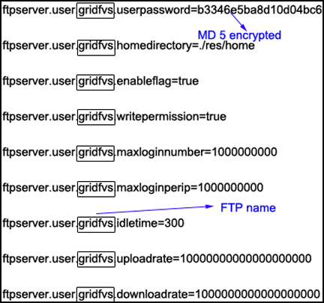
Figure 3: setting the username and password
“ftpd-typical.xml” was set as below:

If you want to start quickly, copy VStutorial/02-soft/ftpserver to overwrite the FTPserver. In this situation, the username and password of FTP server was gridfvs and molgridcal, respectively.

<server xmlns="http://mina.apache.org/ftpserver/spring/v1"
xmlns:xsi="http://www.w3.org/2001/XMLSchema-instance"
xsi:schemaLocation="
http://mina.apache.org/ftpserver/spring/v1 http://mina.apache.org/ftpserver/ftpserver-1.0.xsd
"
id="myServer"
max-logins="50000"
max-threads="999999"
anon-enabled="false"
max-anon-logins="56000"
max-login-failures="124"
login-failure-delay="125">
<listeners>
<nio-listener name="default" port="2121">
<ssl>
<keystore file="./res/ftpserver.jks" password="password" />
</ssl>
</nio-listener>
</listeners>
<file-user-manager file="./res/conf/users.properties" />
</server>

3. When the configure was setting, the ftp could be started using command in Linux as below easily:
%> bin/ftpd.sh res/conf/ftpd-typical.xml
In Windows operation system:
%> bin/ftpd.bat res/conf/ftpd-typical.xml
If you want to run the FTP server in background, run command:
bin/ftpd.sh res/conf/ftpd-typical.xml >& ftp.log &
4. This is just optional according to your tasks required. If you want to kill your background work, just use:
%> ps -ux
You find the ID of ftp server, and use command: kill “ID”, for example: kill 25691
The port of this ftp server was set to 2121 above.
More information about the configure of apache java FTP server could be found at http://mina.apache.org/ftpserver-project/documentation.html

Generate the certificate SSL
Because the nodes can search the server and connect to the server automatically, the Secure Socket Layer (SSL) was needed to authorized the certificate for connecting to server. If you want to start the MolGridCal quickly, you can skip this step using the default setting. The keytool was used to generate the certificate for servers, nodes and clients.
Please refer information of keytool:
JDK6 reference:
http://docs.oracle.com/javase/6/docs/technotes/guides/security/jsse/JSSERefGuide.html
JDK7 reference:
http://docs.oracle.com/javase/7/docs/technotes/tools/windows/keytool.html
http://docs.oracle.com/javase/7/docs/technotes/guides/security/jsse/JSSERefGuide.html

%> keytool -genkeypair -alias QFB -keyalg RSA -validity 7 -keystore keystore.ks
Enter keystore password:
Re-enter new password:
What is your first and last name?
[Unknown]: QFB
What is the name of your organizational unit?
[Unknown]: lzu
What is the name of your organization?
[Unknown]: lzu
What is the name of your City or Locality?
[Unknown]: lanzhou
What is the name of your State or Province?
[Unknown]: gansu
What is the two-letter country code for this unit?
[Unknown]: cn
Is CN=QFB, OU=lzu, O=lzu, L=lanzhou, ST=gansu, C=cn correct?
[no]: yes

Enter key password for <QFB>
(RETURN if same as keystore password):
Re-enter new password:

%> keytool -list -v -keystore keystore.ks
Enter keystore password:

Keystore type: JKS
Keystore provider: SUN

Your keystore contains 1 entry

Alias name: duke
Creation date: Aug 24, 2013
Entry type: PrivateKeyEntry
Certificate chain length: 1
Certificate[1]:
Owner: CN=QFB, OU=lzu, O=lzu, L=lanzhou, ST=gansu, C=cn
Issuer: CN=QFB, OU=lzu, O=lzu, L=lanzhou, ST=gansu, C=cn
Serial number: 5de6f703
Valid from: Sat Aug 24 00:12:01 CST 2013 until: Sat Aug 31 00:12:01 CST 2013
Certificate fingerprints:
MD5: D2:42:A5:E2:F0:42:C0:87:77:5C:E6:BB:03:72:2D:D1
SHA1: B8:CE:D0:1F:BF:03:46:B2:0B:E5:0C:46:8B:5D:35:5D:92:39:07:C9
SHA256: 0C:86:FA:CB:31:3C:4C:C7:28:37:27:F0:14:3B:A4:90:B2:BD:87:ED:C2:74:AB:A7:E9:1B:11:BD:97:DE:4E:F6
Signature algorithm name: SHA256withRSA
Version: 3

Extensions:

#1: ObjectId: 2.5.29.14 Criticality=false
SubjectKeyIdentifier [
KeyIdentifier [
0000: 33 65 DC 54 63 E5 D2 59 53 96 0B 19 AB DD 66 77 3e.Tc..YS.....fw
0010: 0B F2 5D 27 ..]'
]
]

*******************************************
*******************************************

%> keytool -export -alias QFB -keystore keystore -rfc -file QFB.cer
%> keytool -import -alias dukecert -file QFB.cer -keystore truststore.ks
Enter keystore password:
Re-enter new password:
Owner: CN=QFB, OU=lzu, O=lzu, L=lanzhou, ST=gansu, C=cn
Issuer: CN=QFB, OU=lzu, O=lzu, L=lanzhou, ST=gansu, C=cn
Serial number: 4ed4f509
Valid from: Sat Aug 24 00:19:16 CST 2013 until: Sat Aug 31 00:19:16 CST 2013
Certificate fingerprints:
MD5: 7A:E6:F9:1F:EE:86:B5:EC:06:08:FF:93:D8:CF:32:F5
SHA1: 16:8B:0E:58:EC:C1:75:F9:70:23:66:46:34:B2:FC:23:34:D6:15:0B
SHA256: 08:96:81:8E:6D:FD:24:95:33:2D:D7:C4:DF:08:C6:B1:D4:50:73:6E:77:3D:D1:DE:B0:30:36:4B:77:6F:00:AF
Signature algorithm name: SHA256withRSA
Version: 3

Extensions:

#1: ObjectId: 2.5.29.14 Criticality=false
SubjectKeyIdentifier [
KeyIdentifier [
0000: 6A 3C C8 82 B8 16 44 B8 2E 4C 8B 90 2E F4 4F D3 j<....D..L....O.
0010: EB C3 C2 EC ....
]
]

Trust this certificate? [no]: yes
Certificate was added to keystore

%> keytool -list -v -keystore truststore.ks
You will generated the “keystore.ks” and “truststore.ks”, and add them into the ssl folder of servers, nodes and clients. For example, the ssl folder is in “node31/config/ssl”.
Open ”config/ssl” folder of servers, nodes and clients. Edit their ssl.properties and modify all passwords corresponding to your passwords of “keystore.ks” and “truststore.ks”. The below is just an example for reference.
jppf.ssl.keystore.password = Your password when generate keystore.ks
jppf.ssl.truststore.file = config/ssl/truststore.ks
jppf.ssl.truststore.password = Your password when generate truststore.ks
jppf.ssl.truststore.password.source = org.jppf.ssl.PlainTextPassword Your password

Now the SSL setting is finished. Anyone who wants to connect to your server will need your password and certificate.

Distinct driver trust stores for nodes and clients
The above part gives the example for the generation of “keystore.ks” and “truststore.ks”. However, these certificates cannot distinguish connection between server-clients and server-nodes. In other words, if you obtain the node key, you can put it into the client key-folder, in this case, you can submit your job arbitrarily. It is not safe for the grid computing networking management. Different kinds of “keystore.ks” and “truststore.ks” can be generated to distinguish the node and client. The detail examples are introduced in the JPPF demo part:
http://svn.code.sf.net/p/jppf-project/code/branches/b_3_3/demo/config/ssl3/ and
http://www.jppf.org/doc/v3/index.php?title=Configuring_SSL/TLS_communications#Trust_store_and_associated_password
Now I give an instance to generate different kinds of certificates using command as below in the Linux environments:
export DNAME="CN=MolGridCal $1, OU=MolGridCal, O=MolGridCal, L=LZU, S=LZU, C=Gansu"
keytool -genkey -dname "$DNAME" -alias node -keypass password -keyalg RSA -validity 3650 -keystore node_keystore.ks -storepass password
keytool -genkey -dname "$DNAME" -alias client -keypass password -keyalg RSA -validity 3650 -keystore client_keystore.ks -storepass password
keytool -genkey -dname "$DNAME" -alias driver -keypass password -keyalg RSA -validity 3650 -keystore driver_keystore.ks -storepass password
keytool -genkey -dname "$DNAME" -alias client -keypass password -keyalg RSA -validity 3650 -keystore client_keystore.ks -storepass password
keytool -export -alias driver -keypass password -keystore driver_keystore.ks -storepass password -rfc -file driver.cer
keytool -export -alias node -keypass password -keystore node_keystore.ks -storepass password -rfc -file node.cer
keytool -export -alias client -keypass password -keystore client_keystore.ks -storepass password -rfc -file client.cer
keytool -import -alias driver -keypass password -file driver.cer -keystore node_truststore.ks -storepass password -noprompt

keytool -import -alias driver -keypass password -file driver.cer -keystore client_truststore.ks -storepass password -noprompt
keytool -import -alias node -keypass password -file node.cer -keystore driver_truststore.ks -storepass password -noprompt
keytool -import -alias client -keypass password -file client.cer -keystore driver_client_truststore.ks -storepass password -noprompt

Configure JPPF-5.2.8-driver
- Customize your own IP address, you should point out your server IP address as below:
jppf.server.host = Your ip adress

- Make sure the SSL was uncommented in the config/jppf-driver.properties:
jppf.peer.ssl.enabled = true
jppf.ssl.configuration.file = config/ssl/ssl-server.properties

To avoid the unauthorized nodes to connect to server, close the ordinary port
#jppf.server.port = 11111
jppf.server.port = -1

- You must write the right port for SSL connection, for example, the default node listens to the connection at port 11143, you should set the SSL port in server part as below:
jppf.ssl.server.port = 11143

More information is available at:
http://www.jppf.org/doc/v4/index.php?title=Configuring_SSL/TLS_communications
- The algorithm of distributed tasks is as below:
jppf.load.balancing.algorithm = manual
strategy.manual.size = 1

If you want to start quickly, copy VStutorial/02-soft/driver31 to overwrite the JPPF-3.1-driver.

Configure JPPF-5.2.8-node
Make sure the SSL in “config/jppf-node.properties” is open:
jppf.ssl.enabled = true

Idle system
Option: if you want to use the screensaver function using the idle resource of computer, you can change the parameters of “config/jppf-node.properties” as below.
jppf.idle.mode.enabled = true
jppf.idle.detector.factory = org.jppf.example.idlesystem.IdleTimeDetectorFactoryImpl
jppf.idle.timeout = 6000
jppf.idle.poll.interval = 1000

If you want to start quickly, copy VStutorial/02-soft/node31 to overwrite the JPPF-3.1-node. And copy the vina program into the 02-soft/node31.

Start MolGridCal
Until now, all configures are finished. Let us start the work of MolGridCal
1. If you generate your certificate, please replace “keystore.ks” and “truststore.ks” into “config/ssl”. The detailed method has been introduced above.
2. Copy the file of β₂AR, “executed program VINA”, “conf.txt” into the directory of nodes directly. In this version of MolGridCal, the name of “conf.txt” is absolute. Please do not modify it to other name, or it will be wrong.
3. Create the file “parameter.mgc” in the directory of MolGridCal:
parameter.mgc

Ipaddress 2001:da8:c000:201:f66d:4ff:fe21:10e7
IpPort 2121
User gridfvs
Password molgridcal
Downloaddir /VS1/ligands
UploadDir /VS1/result
MaxNodes 10000

# The line show program run as below
Token ZINC
Program Autodock_Vina
Command vina

Ipaddress: Your IP address of FTP server. Now it supports IPv6 address (see above).
IpPort: The port of FTP server
User: the login name of FTP server
Password: the login password of FTP server
Downloaddir: The directory of ligands for virtual screening
UploadDir: The gathered directory of docking results
MaxNodes: The maximum number of loading files in memory at one time.
Token: To delete the molecules easily
Program: choose program for virtual screening
Command: choose command for executing the virtual screening
The parameters are introduced above, now run the ant command orderly:
- Start the server, change into the directory of server: “cd driver421”
%> ant
- Start the nodes, change into the directory of nodes: “cd node421”
%> ant
3) Run MolGridCal, change into the directory of MolGridCal: “cd MolGridCal”
%> chmod +x vina autodock4
%> ant
All the ant command can run in the background of linux if you do not want to display them in the console:
ant >& ant.log &
But you must remember the run ID (see the id:18118 of Figure 4), if you do not want to use it, just kill it. Or use command: “ps -ux”, and find the running ID. Then input: “kill ID”. In this example, input command: kill 18118
Now the work of nodes started as shown in the below figure:
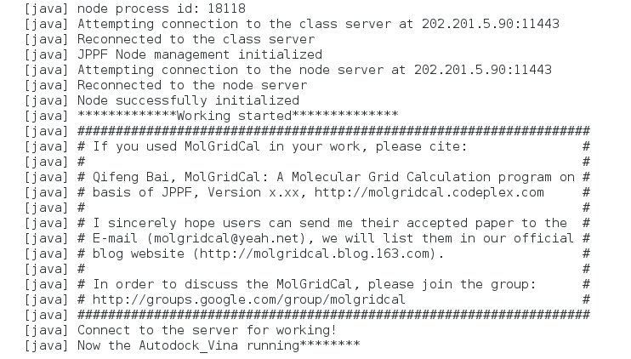
Figure 4. The screening output of MolGridCal in the nodes.
Now all the works are finished. You could have a coffee for a rest.

Rank the docking results
When all the results were collected, it need get the good score of ligands. It was easy to rank the docking results using scripts or program language. Here, we refer the rank program of PYTHON which refers in the http://vina.scripps.edu/manual.html
vina_screen_get_top.py

#! /usr/bin/env python

import sys
import glob

def doit(n):
file_names = glob.glob('*/*.pdbqt')
everything = []
failures = []
print 'Found', len(file_names), 'pdbqt files'
for file_name in file_names:
file = open(file_name)
lines = file.readlines()
file.close()
try:
line = lines[1]
result = float(line.split(':')[1].split()[0])
everything.append([result, file_name])
except:
failures.append(file_name)
everything.sort(lambda x,y: cmp(x[0], y[0]))
part = everything[:n]
for p in part:
print p[1]
print
if len(failures) > 0:
print 'WARNING:', len(failures), 'pdbqt files could not be processed'

if __name__ == '__main__':
doit(int(sys.argv[1]))

Usage: ./vina_screen_get_top.py “num”
num is the number waht you want to rank
For example, get the top 600 of docking results:
%> chmod +x vina_screen_get_top.py
%> ./vina_screen_get_top.py 600 > rank600.log

Reference:
1. Geddes, N., The Large Hadron Collider and Grid computing. Philos Trans A Math Phys Eng Sci 2012, 370, 965-77.
2. Mareuil, F.; Blanchet, C.; Malliavin, T. E.; Nilges, M., Grid computing for improving conformational sampling in NMR structure calculation. Bioinformatics 2011, 27, 1713-4.
3. Kayser, K.; Gortler, J.; Borkenfeld, S.; Kayser, G., Grid computing in image analysis. Diagn Pathol 2011, 6 Suppl 1, S12.
4. Yim, W. W.; Chien, S.; Kusumoto, Y.; Date, S.; Haga, J., Grid heterogeneity in in-silico experiments: an exploration of drug screening using DOCK on cloud environments. Stud Health Technol Inform 2010, 159, 181-90.
5. Irwin, J. J.; Sterling, T.; Mysinger, M. M.; Bolstad, E. S.; Coleman, R. G., ZINC: A Free Tool to Discover Chemistry for Biology. J Chem Inf Model 2012.

