**Activity: Building a force field file**

**Overview**

In this exercise we will examine a simple fixed-charge force field (GAFF2) for a simple molecule (ethane) and see how it is “coded” into an XML file for OpenMM. You will then create an analogous XML file for simulating butane with OpenMM.

**A brief recap of force fields**

As we discussed, a great many fixed-charge force fields have used the following functional form to describe intra- and intermolecular interactions:

$$U=U_{bond}+U_{angle}+U_{torsion}+U_{elec}+U_{vdw}$$

where for individual bonds (between two atoms), angles (between atoms separated by two bonds), torsions (between atoms separated by three bonds), or atom pairs separated by three bonds/nonbonded atom pairs:

$U_{bond}=\frac{1}{2}k_{l}(l-l_{eq})^{2}$, $U_{angle}=\frac{1}{2}k_{θ}(θ-θ_{eq})^{2}$, $U_{torsion}=\sum_{n=1}^{n_{max}}{}U_{n}[1+cos(nϕ-γ_{n})]$

$U_{elec}=k_{e}q_{i}q_{j}/r_{ij}$, $U_{vdw}=4ϵ_{ij}[(σ_{ij}/r_{ij})^{12}-{(σ}_{ij}/r_{ij})^{6}]$

**Worked application: ethane**

To help make sense of these equations let’s examine ethane (C2H6), which is perhaps the simplest molecule that requires all of these terms for accurate modeling.

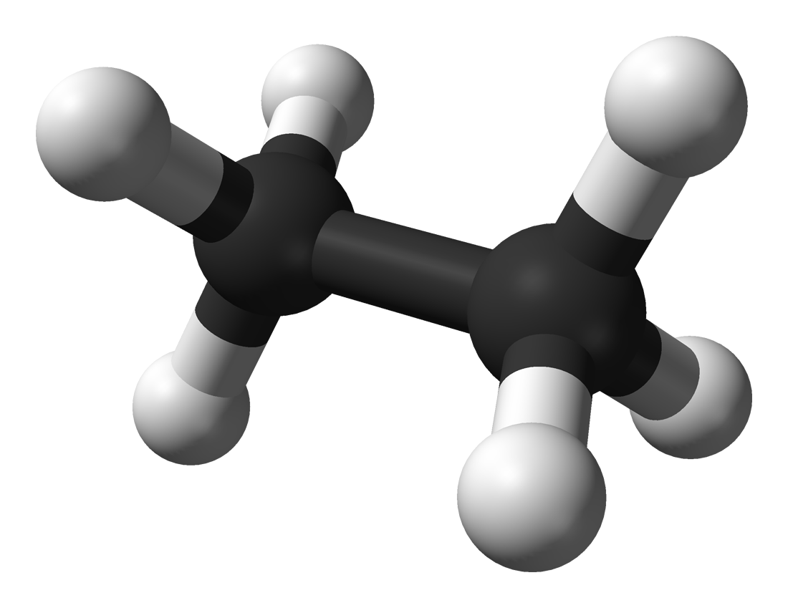

From the 3D structure above (see also *ethane.pdb*) we can reason that in ethane there are two types of bonds (C-C and C-H), two types of angles (H-C-H and H-C-C), and one torsion (H-C-C-H). By examining the symmetry of this molecule, it is reasonable to assume that the partial atomic charges ($q_{i}$) and van der Waals parameters ( $ϵ_{i}$ and $σ_{i}$) will be the same for both carbon atoms and likewise for all six hydrogen atoms. The GAFF2 force field assigns the following SI parameters for all of these interactions:

|  |  |
| --- | --- |
| **Interaction** | **Parameters** |
| C-C bond | $l_{eq}$ = 0.1538 nm, $k_{l}$ = 1.946 x 106 kJ/mol⋅nm2 |
| C-H bond | = 0.1097 nm, = 3.146 x 106 kJ/mol⋅nm2 |
| H-C-H angle | = 1.878 rad, $k_{θ}$ = 326.0 kJ/mol⋅rad2 |
| H-C-C angle | = 1.916 rad, $k_{θ}$ = 391.8 kJ/mol⋅rad2 |
| H-C-C-H torsion | $γ_{3}$ = 0 rad, $U_{3}$ = 0.5021 kJ/mol |
| C atom (nonbonded) | $q_{C}$ = –0.0951*e*, $σ_{C}$ = 0.3398 nm, $ϵ_{C}$ = 0.4510 kJ/mol |
| H atom (nonbonded) | $q_{H}$ = 0.0317*e*, $σ_{H}$ = 0.2600 nm, $ϵ_{H}$ = 0.0870 kJ/mol |

If you examine the file *ethane.gaff2.xml*, you will first see that we define two types of atoms (0 for the C atoms and 1 for the H atoms). The next section describes which types apply to the atoms in ethane. In addition, much like a PDB file, this XML file conveys connectivity/topology information by describing which atoms are bonded to each other. Finally, you should see multiple sections that convey the force field information given above.

**Your turn: butane**

Now consider the slightly more complex molecule butane (C4H10; see also *butane.pdb*):

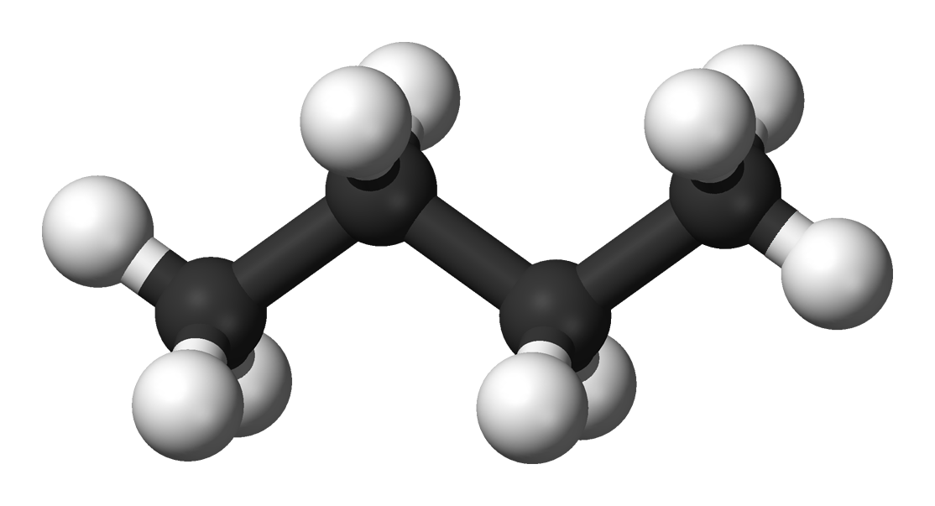

From the 3D structure we can immediately see that the same types of bonds that are present in ethane (i.e., C-C and C-H) are also present in butane. Likewise, the same types of angles are also present, but in butane there is also a C-C-C angle. For torsions there are two new possibilities: H-C-C-C and C-C-C-C. Finally, we will assume (using chemical intuition) that the van der Waals parameters for the C and H atoms are the same as in ethane. However, the partial atomic charges of the two “outer” carbon atoms probably can’t be the same as the two “inner” C atoms. The same is also true for the partial atomic charges of the six “outer” H atoms vs. those of the four “inner” H atoms. (Why?)

With all this in mind, use the parameters from *ethane.gaff2.xml*, the connectivity and atom names in *butane.pdb*, and the following information to complete the OpenMM force field file *butane.gaff2.xml*:

|  |  |
| --- | --- |
| **Interaction** | **Parameters** |
| C-C-C angle | $θ_{eq}$ = 1.946 rad, $k_{θ}$ = 543.0 kJ/mol⋅rad2 |
| H-C-C-C torsion | $γ_{3}$ = 0 rad, $U_{3}$ = 0.3347 kJ/mol |
| C-C-C-C torsion | $γ_{1}$ = 0 rad, $U_{1}$ = 0.4602 kJ/mol $γ_{2}$ = 3.1416 rad, $U_{2}$ = 1.2134 kJ/mol $γ_{3}$ = 0 rad, $U_{3}$ = 0.5439 kJ/mol |
| “Outer” C atom (nonbonded) | $q_{C}$ = –0.0932*e*, $σ_{C}$ and $ϵ_{C}$ same as ethane |
| “Inner” C atom (nonbonded) | $q_{C}$ = –0.0814*e*, $σ_{C}$ and $ϵ_{C}$ same as ethane |
| “Outer” H atom (nonbonded) | $q_{H}$ = 0.0324*e*, $σ_{H}$ and $ϵ_{H}$ same as ethane |
| “Inner” H atom (nonbonded) | $q_{H}$ = 0.0387*e*, $σ_{H}$ and $ϵ_{H}$ same as ethane |