Rotary Experiment Setup Notes

Computer username: .\Administrator
Password: ECE2o17b00m (also written on sticky note – be careful, the o in 2o17 is a letter!)

The current Quarc install should be working: Quarc 2.6.1 on Windows 10 + MATLAB 2017 using the Microsoft Visual C++ 2017 Family compiler. If the compiler has not been configured on MATLAB, the simulation should not be able to build:

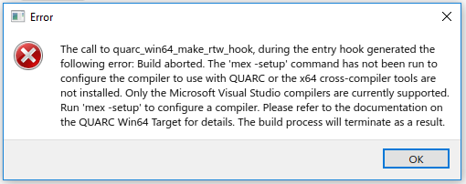

Make sure the target has been set to Win64 (quarc_win64.tlc) in the configuration parameters
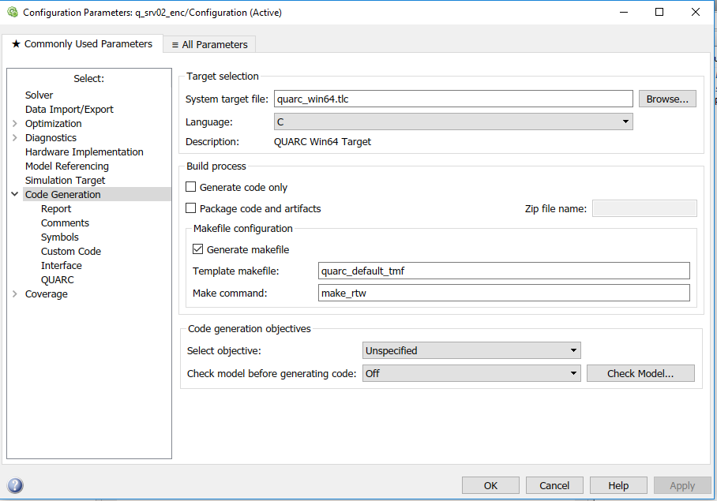
Running a Simulink File

- Build the Simulink file, under QUARC>Build. This can take a few moments, you can see when it is finished in the MATLAB command window. If this fails, there is probably something wrong with the QUARC install. Hopefully, this won’t be happening anymore.
- Connect to Target (the icon that looks like two circles with triangles point to each other in them). If this fails, check over the target in the configuration parameters (check under Tools or QUARC)
- Run - make sure the duration is not inf if you don’t want it to run indefinitely

In Users\Administrator\MATLAB\QUARC, there should be example Simulink files. I was working with the quarc_test.slx file, which includes basic I/O. I was able to get encoder input working with Rollen, but when I tried again at the end of the term, I wasn’t able to get any responses (only a 0 flatline), although the Simulink file appeared to build and run on the target as expected. There may have been some block variables that have changed? It’s also possible that something is wrong with the cables or encoders. You can try a short circuit test on the DIN cable, or switch the cables around?

Make sure that the cables are connected to the appropriate DAQ inputs: the encoders have their own block. (I connected the base encoder to 0, the arm encoder to 1, and the encoder at the tip of the pendulum to 2). The DAQ is the squarish kind of board with all the I/O ports on it. The motor should be connected to the amplifier output rather than directly to the analog output. Make sure the amplifier is at 1x.

In C:\Documents\Quarc, there is supporting documentation, including a setup manual, and some lab exercise manuals for linearization and more advanced controls. These can also be found online. There should already be a linearized A matrix with the system variables in these manuals/workbooks, which can be used to define transfer functions for a simulated pendulum block in Simulink. (you can use ss2tf for this)

