DOCUMENTATION

ASSIGNMENT 1

STUDENT NAME: Moldovan Raul Alexandru
GROUP: 30422

CONTENTS

1. Assignment Objective 3
2. Problem Analysis, Modeling, Scenarios, Use Cases 3
3. Design 5
4. Implementation 6
5. Results 10
6. Conclusions 11
7. Bibliography 11

Assignment Objective

The main objective of this assignment is to implement a polynomial calculator that performs mathematical operations on polynomials, such as addition, subtraction, multiplication, differentiation and integration. The calculator takes input in the form of one or two polynomials and allows the user to perform one of the five operations on them, with the result displayed in the output field.

Sub-objectives | Description
Input formatting | Takes the input String and makes it a Polynomial
Polynomial addition | Add two polynomials together
Polynomial subtraction | Subtract one polynomial from another
Polynomial multiplication | Multiply two polynomials together
Polynomial differentiation | Calculate the derivative of a polynomial
Polynomial integration | Calculate the integral of a polynomial
Output formatting | Display the results as a String from polynomial
User interface | Provide a user-friendly interface for input and output of polynomials

Problem Analysis, Modeling, Scenarios, Use Cases

Problem analysis

The problem being solved by this project is to perform polynomial arithmetic. The program takes one or two polynomial inputs from the user and performs the requested operation, displaying the result in a third field.

Modeling

The program uses the Polynomial class to model polynomial objects and the Operations class to perform the arithmetic operations on these objects.

Scenarios

The user can enter one or two, depending on the operation, polynomial inputs in text fields, and select one of the five arithmetic operations to perform using buttons. The program will then display the result of the operation in a third text field.

Use cases

- User enters two polynomial inputs and selects the addition operation. The program adds the polynomials and displays the result.

- User enters two polynomial inputs and selects the subtraction operation. The program subtracts the polynomials and displays the result.

- User enters two polynomial inputs and selects the multiplication operation. The program multiplies the polynomials and displays the result.

- User enters one polynomial input and selects the differentiation operation. The program differentiates the polynomial and displays the result.

- User enters one polynomial input and selects the integration operation. The program integrates the polynomial and displays the result.

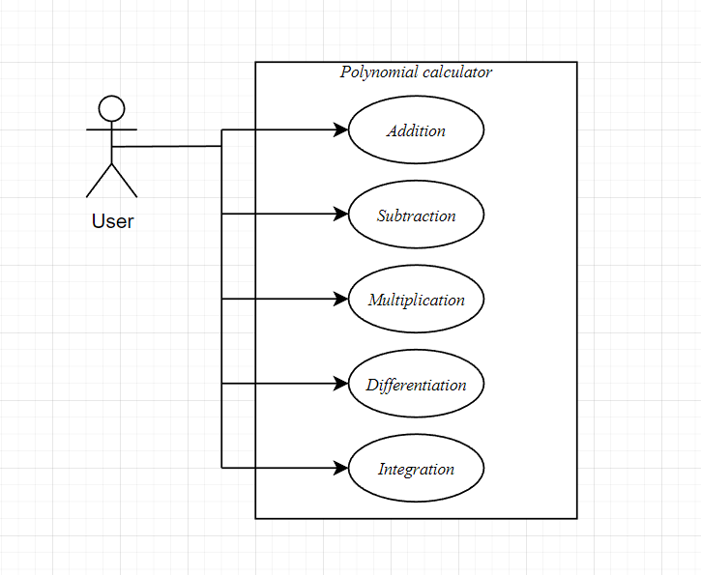

Design
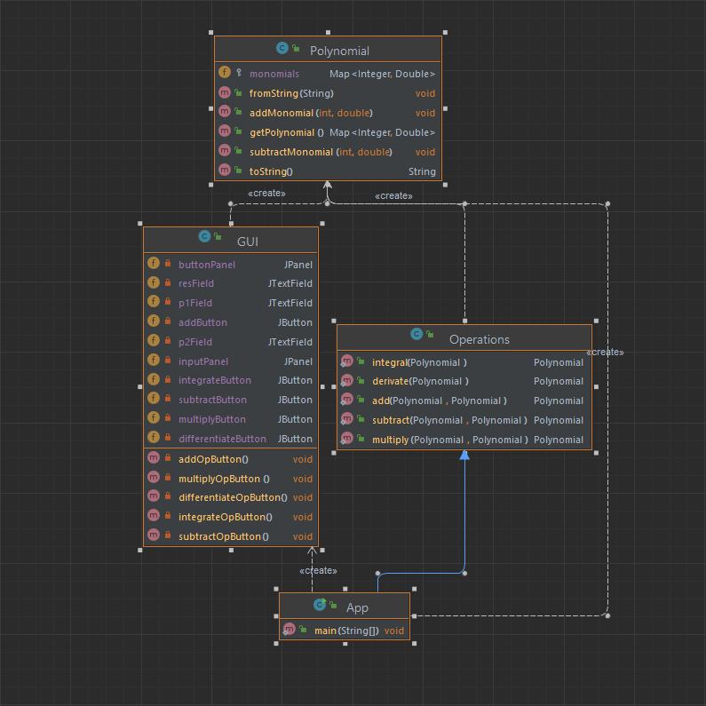

The image above shows the design of my project through a UML diagram from which we can clearly see the distribution on classes and methods.

In terms of architecture, the project follows the Model-View-Controller pattern. The Model is the Polynomial class, which encapsulates the logic for parsing and manipulating polynomials. The View is the Display class, which creates and manages the graphical user interface. The Controller is the Operations class, which contains the implementation of the polynomial operations.

The Display class is designed using Swing. It creates a JFrame with two panels, one for the input fields and another for the buttons. The input panel contains two text fields for entering the polynomials and a read-only text field for displaying the result. The button panel contains buttons for the five polynomial operations. Each button is associated with a listener that performs the corresponding operation and updates the result text field.

Overall, the design of the project aims to provide a simple and intuitive interface for performing polynomial operations, while also adhering to best practices in software architecture and design patterns.

Implementation
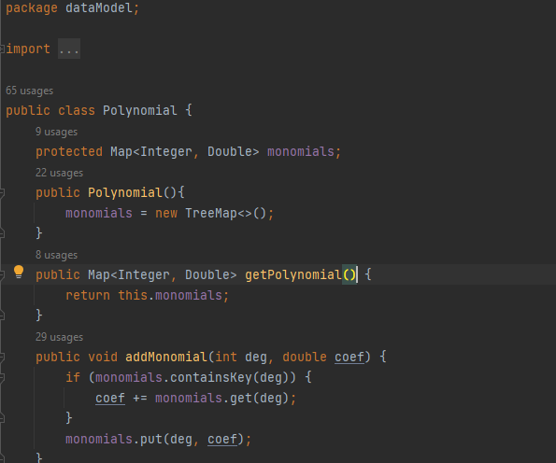

For this polynomial calculator I implemented a Polynomial class that has a Map<int,double> that stores the degree and the coefficient and an Operation class that has the addition, subtraction, multiplication, differentiation and integration methods for the polynomial described before.

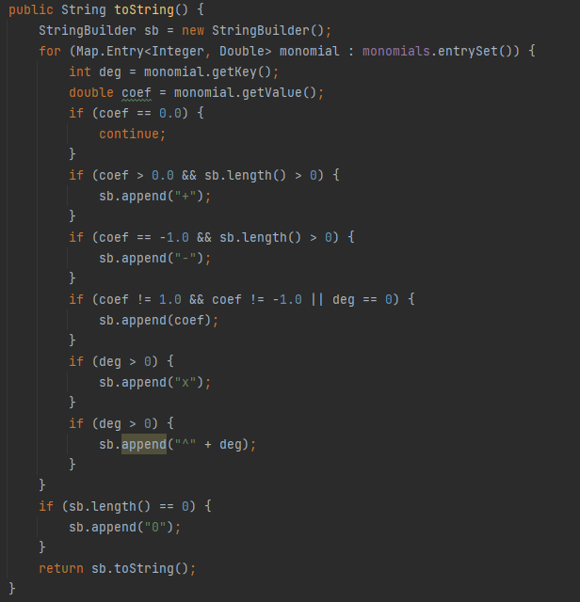
The method above converts a polynomial into string using a StringBuilder. It iterates through the monomials getting the degree and the coefficient of each one appending them to the string, following the rules of mathematical notation. If the coefficient is 0, the monomial is skipped since it doesn't contribute to the polynomial's value. If the coefficient is positive and the string is not empty, a plus sign is added before the monomial. If the coefficient is -1 and the string is not empty, a minus sign is added before the monomial. If the coefficient is not 1 or -1, or if the monomial has degree 0, the coefficient is appended to the string. If the monomial has degree greater than 0, the variable x is appended to the string, followed by the exponent. Overall, this method is used to provide a readable and standardized representation of a polynomial object, making it easier to display and work with.

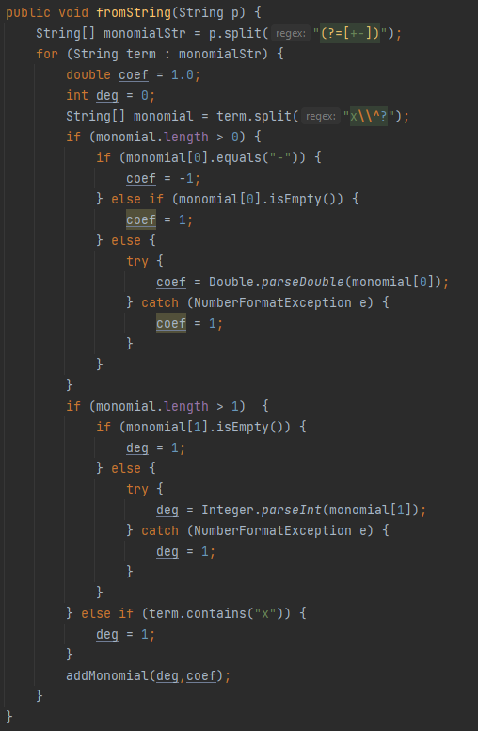

The fromString method takes a string input representing a polynomial and parses it into a Polynomial object. It first splits the input string into an array of substrings representing individual terms using a regular expression. Then, for each term, it further splits it into an array of substrings representing the degree and coefficcient. The method checks the length of the monomial array to determine whether the term has a coefficient or not. If it has no coefficient (e.g. the term is "x^2"), the coefficient is set to 1. If the coefficient is "-", it is set to -1. Otherwise, it is parsed as a double using Double.parseDouble(). Similar for the degree.

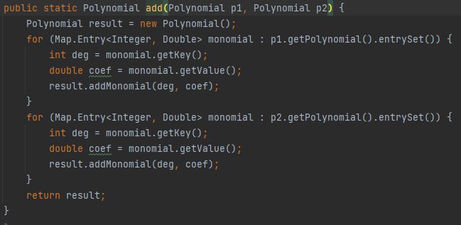

This method takes two Polynomial objects as input, p1 and p2. The method first creates a new empty Polynomial object called result. It then iterates over each monomial in p1 and adds it to the result polynomial using the addMonomial() method. The same is done for each monomial in p2. Once both polynomials have been added together, the method returns the resulting Polynomial object.

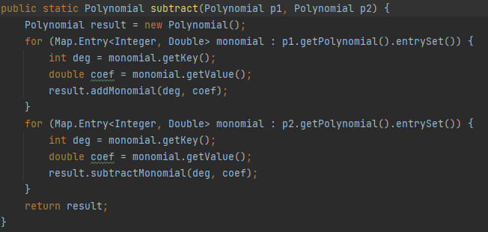

This method subtracts the polynomial p2 from polynomial p1 and returns the resulting polynomial. The method first creates an empty Polynomial object called result. Then, it iterates through the monomials in p1 and adds each monomial to the result using the addMonomial() method. After that, it iterates through the monomials in p2 and subtracts each monomial from the result using the subtractMonomial() method. Finally, the resulting polynomial is returned.

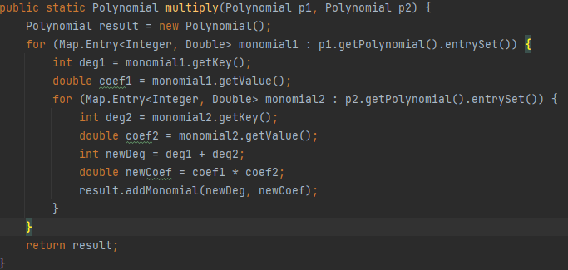
This method is used to multiply two polynomial objects and return the resulting polynomial object. It initializes an empty Polynomial object named result that will hold the resulting polynomial. It then loops through each monomial in p1 and multiplies it with each monomial in p2. For each monomial in p1, the method retrieves the degree and coefficient of the monomial. It then loops through each monomial in p2 and retrieves its degree and coefficient. The degree of the resulting monomial is the sum of the degrees of the two monomials being multiplied, and the coefficient of the resulting monomial is the product of the coefficients of the two monomials being multiplied.

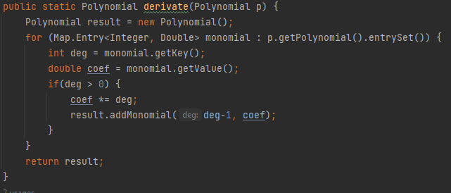

The derivate method computes the derivative of a polynomial by iterating through each monomial of the polynomial, multiplying the coefficient of the monomial by its degree, and creating a new monomial with the degree decremented by one and the new coefficient. This new monomial is added to the result polynomial. The resulting polynomial is the derivative of the input polynomial.

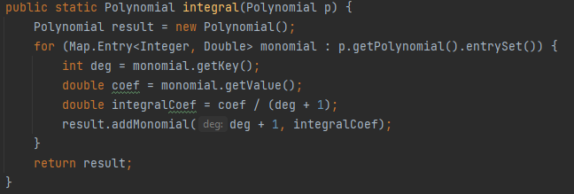

The method creates a new Polynomial object called result and iterates over each monomial in the input polynomial p. For each monomial, the method calculates the integral coefficient by dividing the coefficient of the monomial by the degree of the monomial plus one. Then, the method adds a new monomial to the result polynomial with a degree that is one greater than the degree of the current monomial and the calculated integral coefficient as its coefficient. Finally, the method returns the resulting Polynomial object, which represents the integral of the input polynomial p.

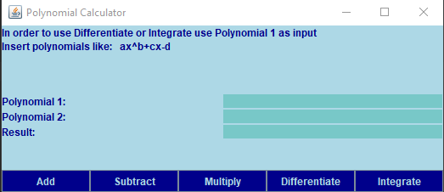

Using Swing I implemented a graphical user interface that is very intuitive and easy to use. In order to make an operation you first need to insert one or two polynomials in the coresonging text boxes as mentioned in the GUI.. After that the user selects the desired operation and the calculator computes the result and displays it. In the class GUI I implemented all the interface.

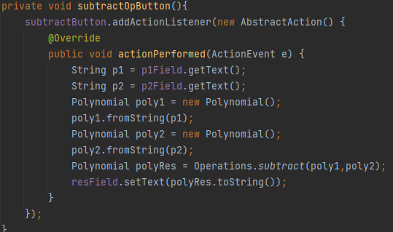

This is the implementation of a button more specifically the subtract button, but the implementation is similar for all of the operations.

Results
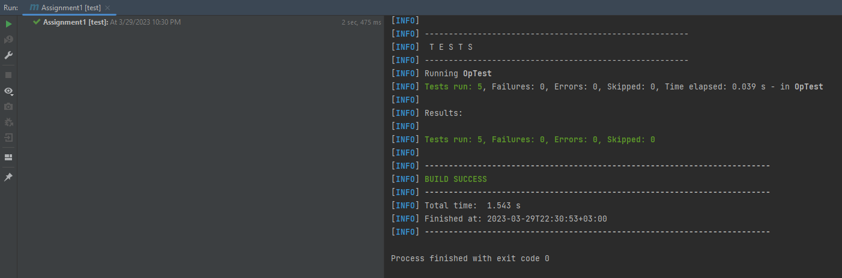
After running some tests with Jupiter we can clearly see that the polynomial calculator works as intended.
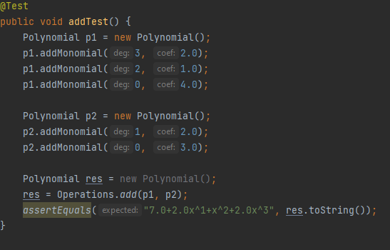

Conclusions

In conclusion, designing and implementing this project helped me learn more about Java and Object Oriented Programing and also learn about making a simple Graphical User Interface

Future developments
- This calculator does not have all the possible operations for example the division can also be implemented
- It might be able to make a more efficient solution in terms of the memory used
- Adding a history feature to remember past operations
- An update to the graphical user interface

Bibliography

https://www.w3schools.com/
https://linuxhint.com/parse-string-in-java/
https://stackoverflow.com/
https://www.emathhelp.net/calculators/algebra-1/polynomial-calculator/

