Analysis&Design for Muscle-Based Gym-App

Continut:
- General Presentation

- Theoretical Fundamentals

- IT Technology (which will be implemented)

- Functionalities

- Actors and related access rights

- Use Case Diagrams

- System Architecture

- Design (UML Diagrams)

- Operation Mode (Operation Guide, including screen-shots)

- Portability

1. Introduction
The project presented in this document is meant to help people all around the world in order to achieve their fitness goal. The goal of the application is to help the user understand which kind of exercises he must be doing in order to target a specific group of muscles. When discussing about physical work at the gym we can distinguish two major type of exercises: the one based on compound movements and the one based on isolated movements. What is the difference between these two you may ask. Well the first type, the compound based movements are the ones which engage not just a single group of muscles but plenty of them. These kind of exercises are very useful when trying to grow testosterone level so ultimately they help you grow your overall strength and size as well. Usually this kind of exercises require way more strength in order to execute them so that’s why they should be put at the beginning of your workout. Some popular examples would be deadlifts, squats and benchpress. Among the powerlifters these are the most popular type of exercises. On the other side we can find the isolation movements which, in contrast to the compound ones, target just a specific muscle, not a bunch of them. These exercises are more popular among bodybuilders because when focusing only on specific muscles while exercising, the user can develop each part of his body however he wants and he can be the own “sculptor” of his body. While the other type of exercises help you increase your strength and size, this ones exist in order to help the user achieve a more aesthetic look because isolated movements makes your muscle look more shredded and in the end they result to a lower body-fat percentage. Another use of this kind of exercises is to help the user fix muscle imbalances. Let’s say for example that you have an inferior group of muscle, like chest for example. In order to fix this problem the compound movements won’t be of big help because they won’t target only your chest, as desired, but other muscles as well, so the isolated movements would be the right choice here. The desire of this app is to provide the user with compound-based but also isolated-based exercises and explanations, for the most important muscles of his body in order to help the user in his fitness journey.

2. General Presentation

The project presented in this document is meant to help people all around the world in order to achieve their fitness goal. The goal of the application is to help the user understand which kind of exercises he must be doing in order to target a specific group of muscles. When discussing about physical work at the gym we can distinguish two major type of exercises: the one based on compound movements and the one based on isolated movements. What is the difference between these two you may ask. Well the first type, the compound based movements are the ones which engage not just a single group of muscles but plenty of them. These kind of exercises are very useful when trying to grow testosterone level so ultimately they help you grow your overall strength and size as well. Usually this kind of exercises require way more strength in order to execute them so that’s why they should be put at the beginning of your workout. Some popular examples would be deadlifts, squats and benchpress. Among the powerlifters these are the most popular type of exercises. On the other side we can find the isolation movements which, in contrast to the compound ones, target just a specific muscle, not a bunch of them. These exercises are more popular among bodybuilders because when focusing only on specific muscles while exercising, the user can develop each part of his body however he wants and he can be the own “sculptor” of his body. While the other type of exercises help you increase your strength and size, this ones exist in order to help the user achieve a more aesthetic look because isolated movements makes your muscle look more shredded and in the end they result to a lower body-fat percentage. Another use of this kind of exercises is to help the user fix muscle imbalances. Let’s say for example that you have an inferior group of muscle, like chest for example. In order to fix this problem the compound movements won’t be of big help because they won’t target only your chest, as desired, but other muscles as well, so the isolated movements would be the right choice here. The desire of this app is to provide the user with compound-based but also isolated-based exercises and explanations, for the most important muscles of his body in order to help the user in his fitness journey.
Roughly speaking the Muscle-Based GYM Application is a web app and as its name suggests, it contains different lists of exercises, grouped on muscle categories. The exercises are organized in such a manner so that the user can find the desired exercise/exercises as fast as possible. So we can say that simplicity and effectiveness are two of the main attributes this app tries to combine.
.

- Theoretical Fundamentals

The Application was made in such a way so that literally anyone who is medically allowed to do physical activities can make use of it. Each exercise comes with its own difficulty level so the user will be able to choose among all exercises based on his own current physical status. That’s possible because exercises starting from beginner up to advanced level will be provided.
No before experience is needed in order to use this app because all you need to know will be presented and explained in the application. It may also contain a starting tutorial in order for the user to fully understand the proper use of the application.

- IT Technology
In order to achieve the desired functionality of the application, SpringToolSuite IDE and MySql Database will be used. One of the most important tasks will be to carefully combine the java programming language with html and css, in order for the app to work and look in the way we want. We will start by creating a maven project in the SpringToolSuite IDE where we include all the dependencies we want, for example Mysql Database and Web-App dependencies. This way we can connect our Spring application to the database where all the data concerning the app will be stored. Furthermore by using the Tomcat open source web server we can build the connection between our application and an internet page where a “pure java” HTTP web server environment for java code to be run in will be created. This way we could create .jsp files on our project application where the http code will be written and a Controller class will be properly manage that http code.

- Functionalities
The main purpose of this app is to free the user of the task of individually searching among different sources exercises for his workout. Why bother to spend time by doing such things when you have all you want under an easy accessible compact form.
Besides that, not only you can find predefined lists of different interesting workouts, consisting of exercises inspired from the workout routine of bodybuilders which had an impact on the fitness industry, but you can also create your own exercise lists.
As said above, the main purpose is to maintain a compact and easy to understand design where the user will be able to easily find all the information he wants in the minimum possible time.
The Application was made in such a way so that literally anyone who is medically allowed to do physical activities can make use of it. Each exercise comes with its own difficulty level so the user will be able to choose among all exercises based on his own current physical status. That’s possible because exercises starting from beginner up to advanced level will be provided.
In addition to the things already presented, all the exercises come with an explanation which describes things like how the exercises should be correctfully performed, with what other kind of exercises may be combined, the suggested amount of sets, reps and time of rest or even minor execution variations of the chosen exercise, which are meant to have a slightly different impact on the muscle.

- Actors and related access rights
Let us focus on a single user who will play the role of the actor. The very first thing the user needs to do is to create an account by registering into the database. An username and a password will be required from him in order to complete the registration. After creating an account the next step will be to use the same username and password in order to login into the application. If introduced correctly, he will successfully reach the main page of the application. From here depends on what the user desires to do. He will be provided with a table containing all of the existent exercises with a specific name, a difficulty, the corresponding muscle group and their unique id. By entering the id in the Search By Id text case, the user will be shown a detailed description among with explanations, suggestions, pictures and videos of the exercise he has chosen. Each exercise will have an “add to list” option which will help the user to create his own working plan. He can check anytime the lists he has created or some other predefined lists. Besides searching an exercises by his id, the user will be able to also select a muscle group and he will be provided with a list of exercises which are targeting the muscle group he has chosen. After finishing using the application the user has the option to log out of the app or to remain logged in.

- Use Case Diagrams

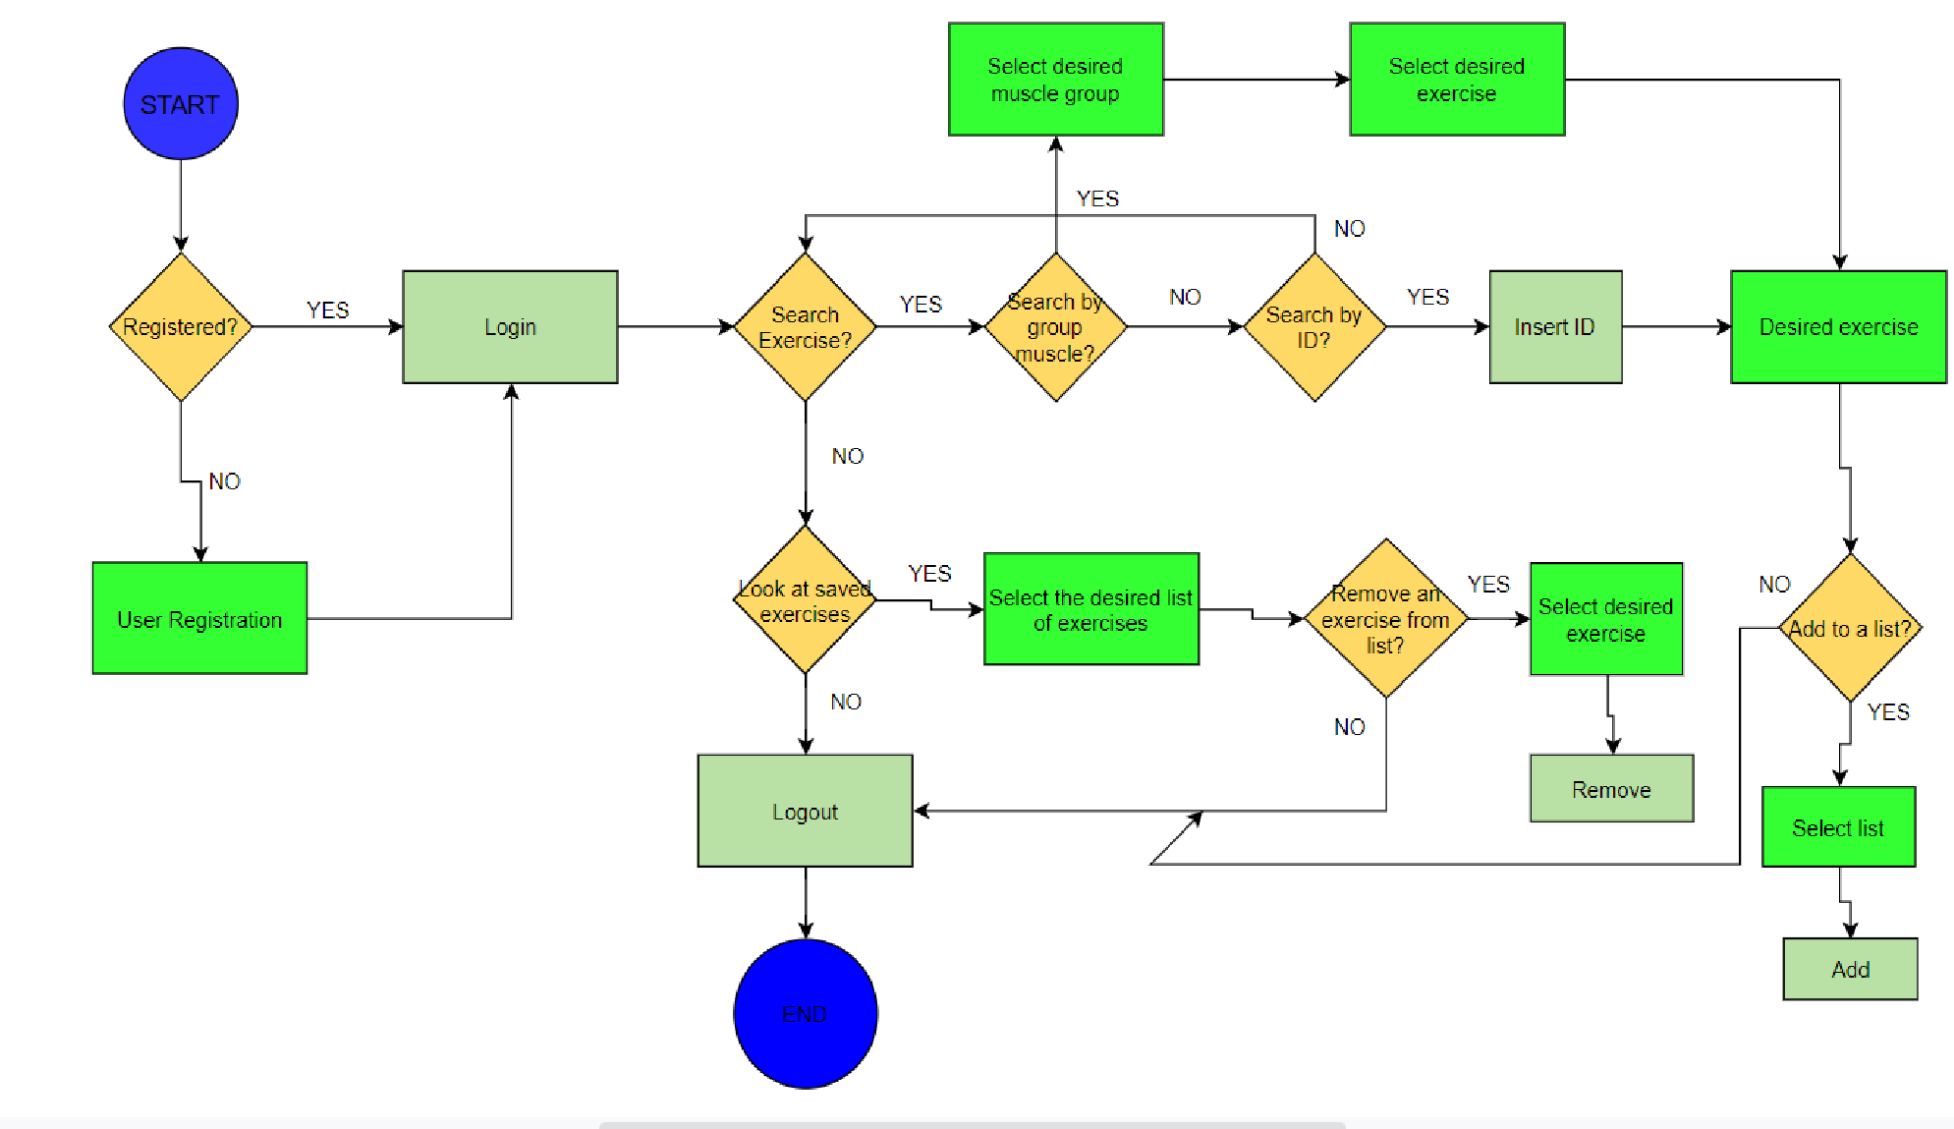

- System Architecture
The architecture of the application will be designed in such a way that allows us to take care of the user requests by understanding what kind of information is requested and carefully search it through the database, in order to be able to send back to the user the desired output.
A connection between the database and the web page has to be done in order for us to be able to store all the information. In order for this to be possible we need to make use the Spring java feature. By using it we can easily link all the pieces together through java code. Tomcat will be used in order to create the web connection. The communication between the database will be done through the application layer through http requests and responses.
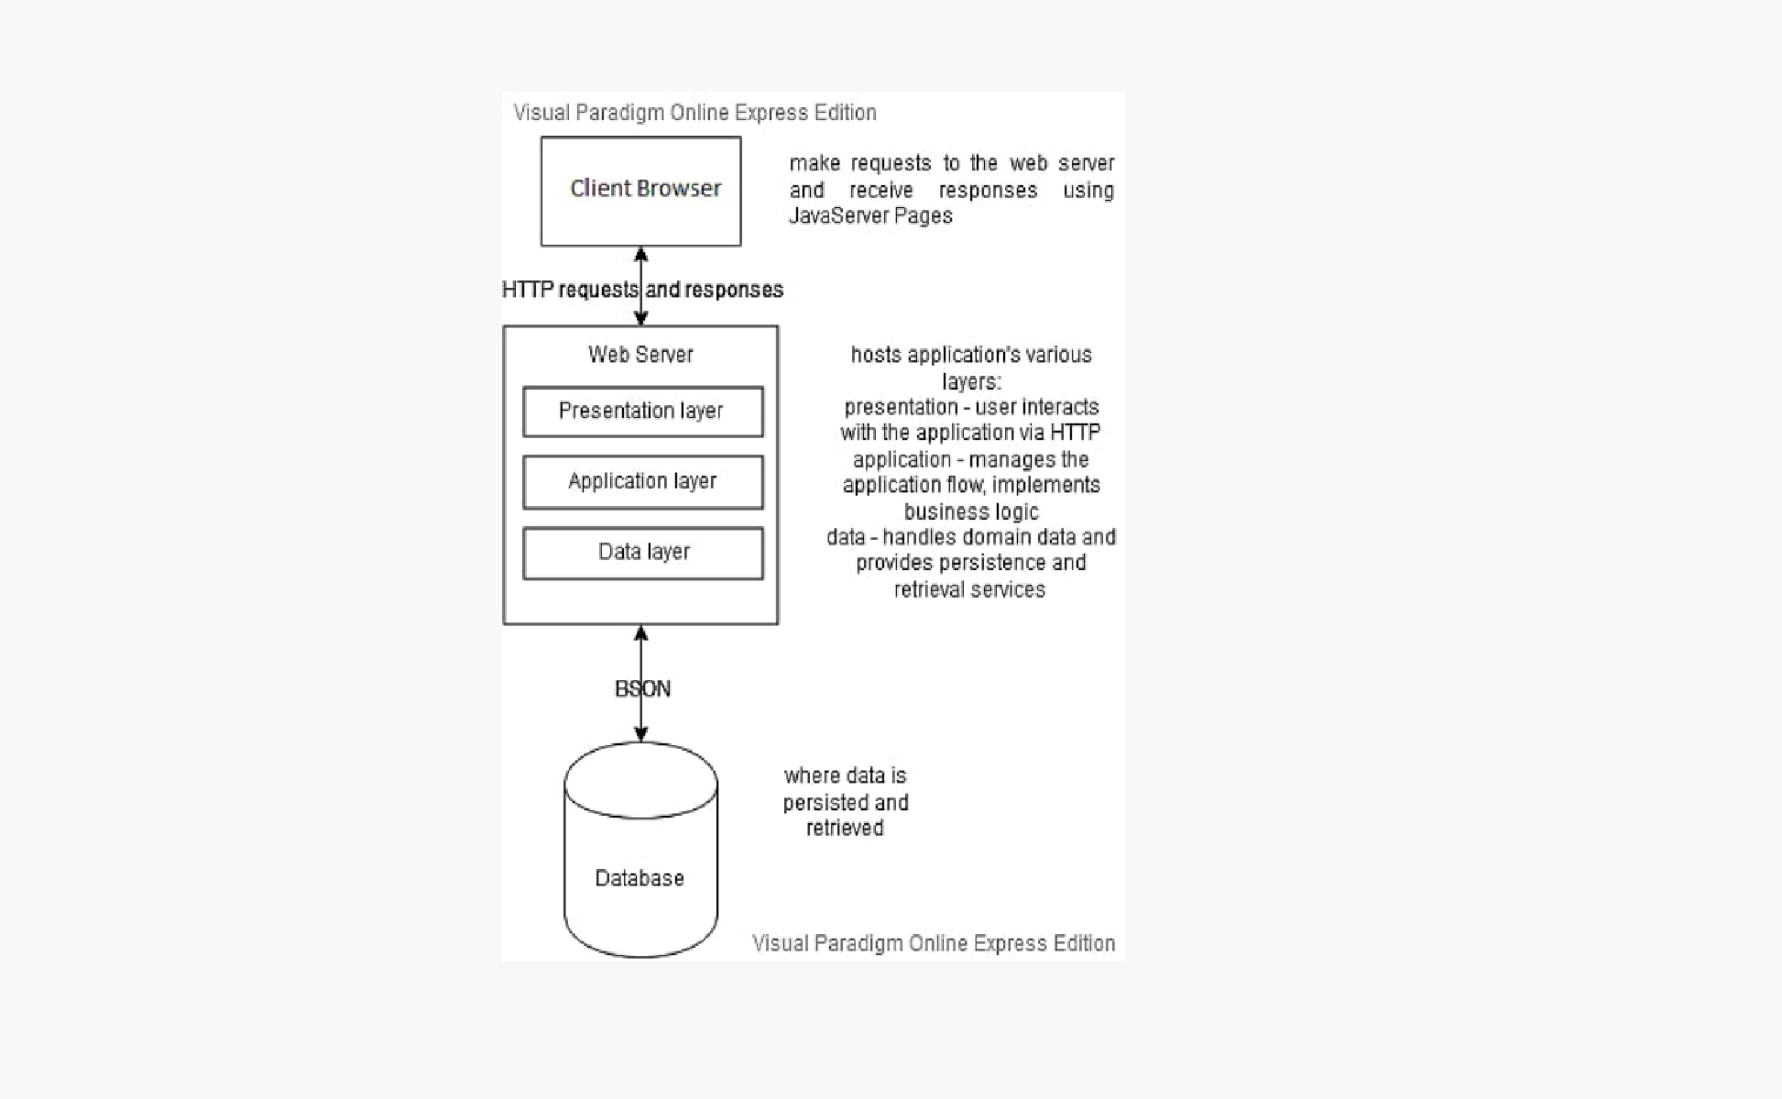

- Design
Package diagram:
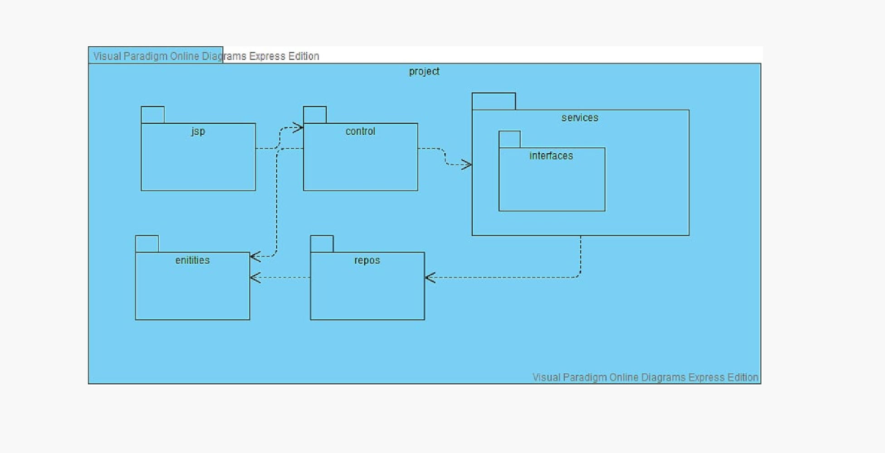

Database Diagram:

Communication Diagram:
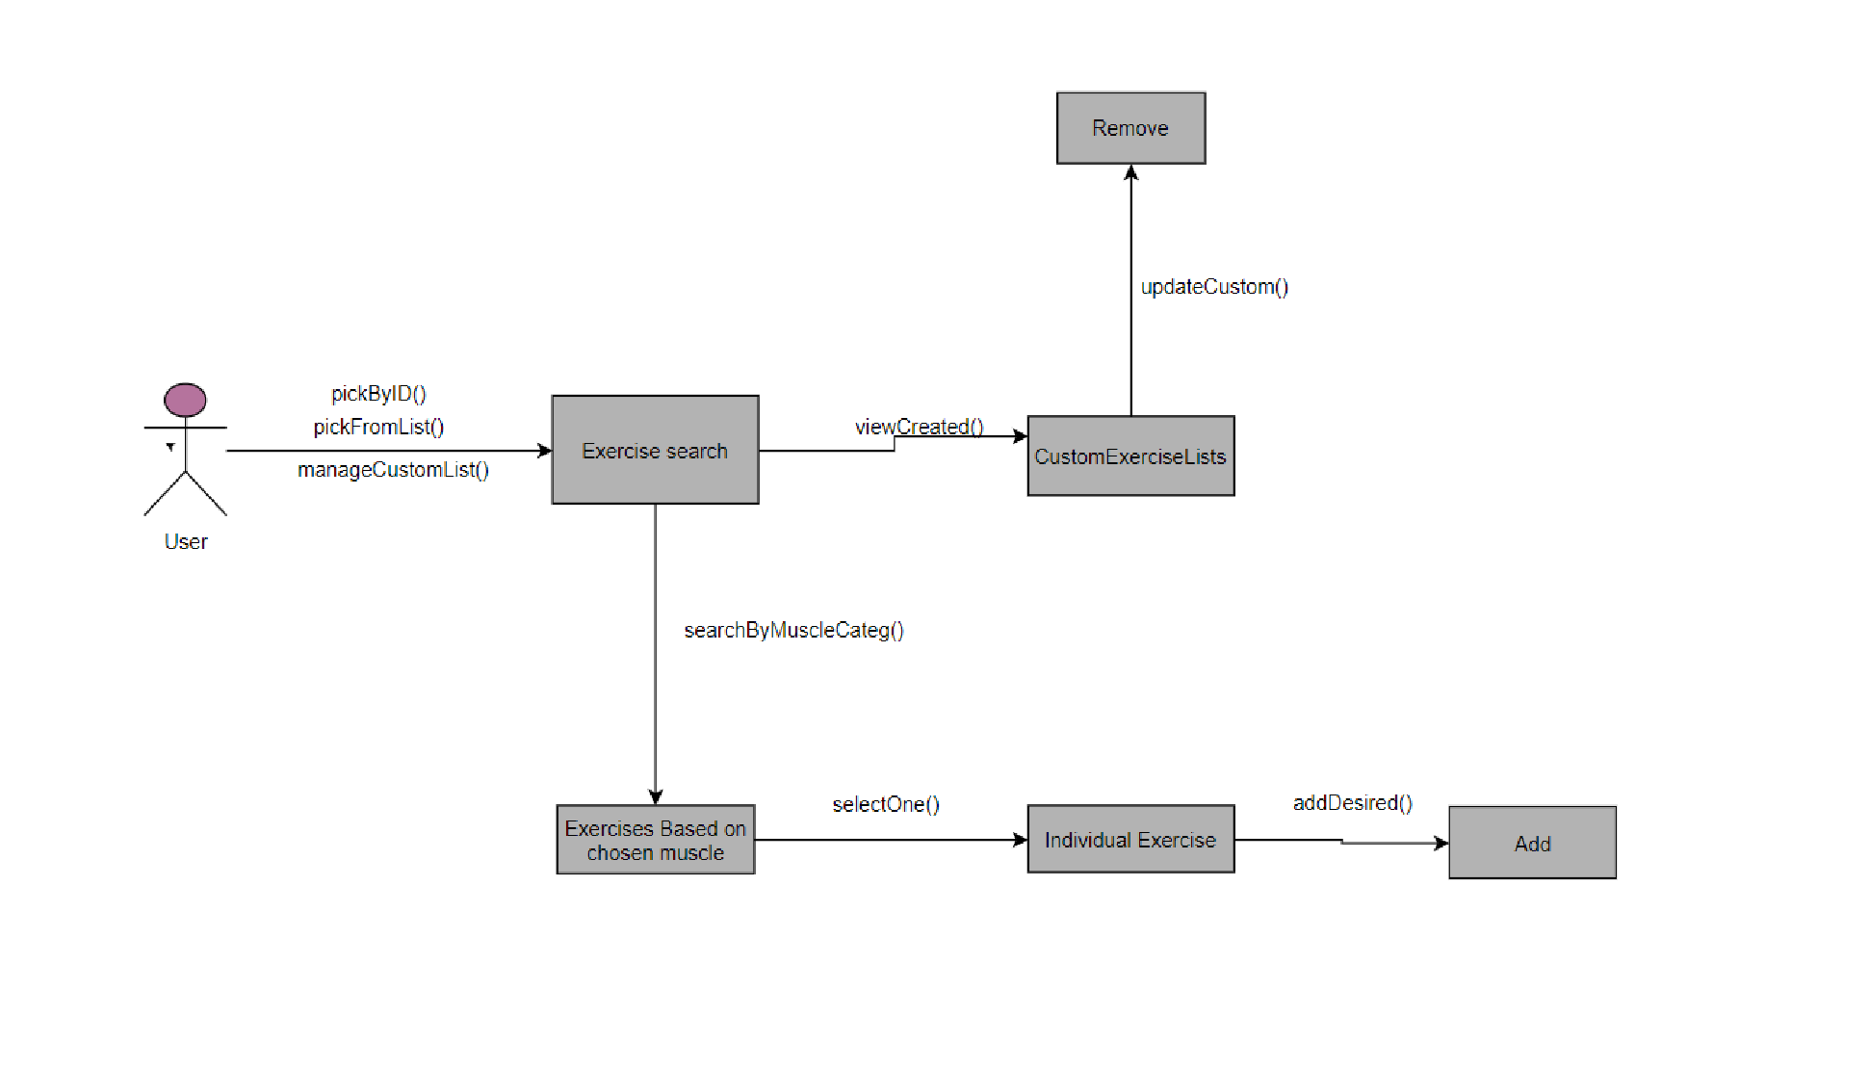

Database Diagram:
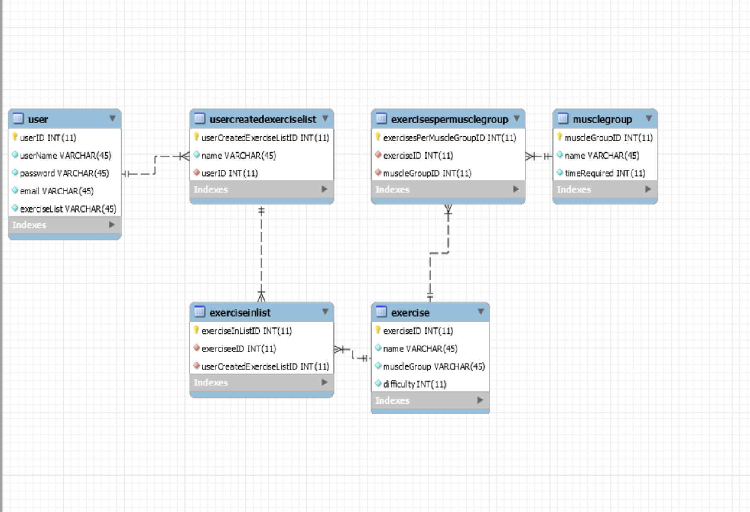

State Diagram:
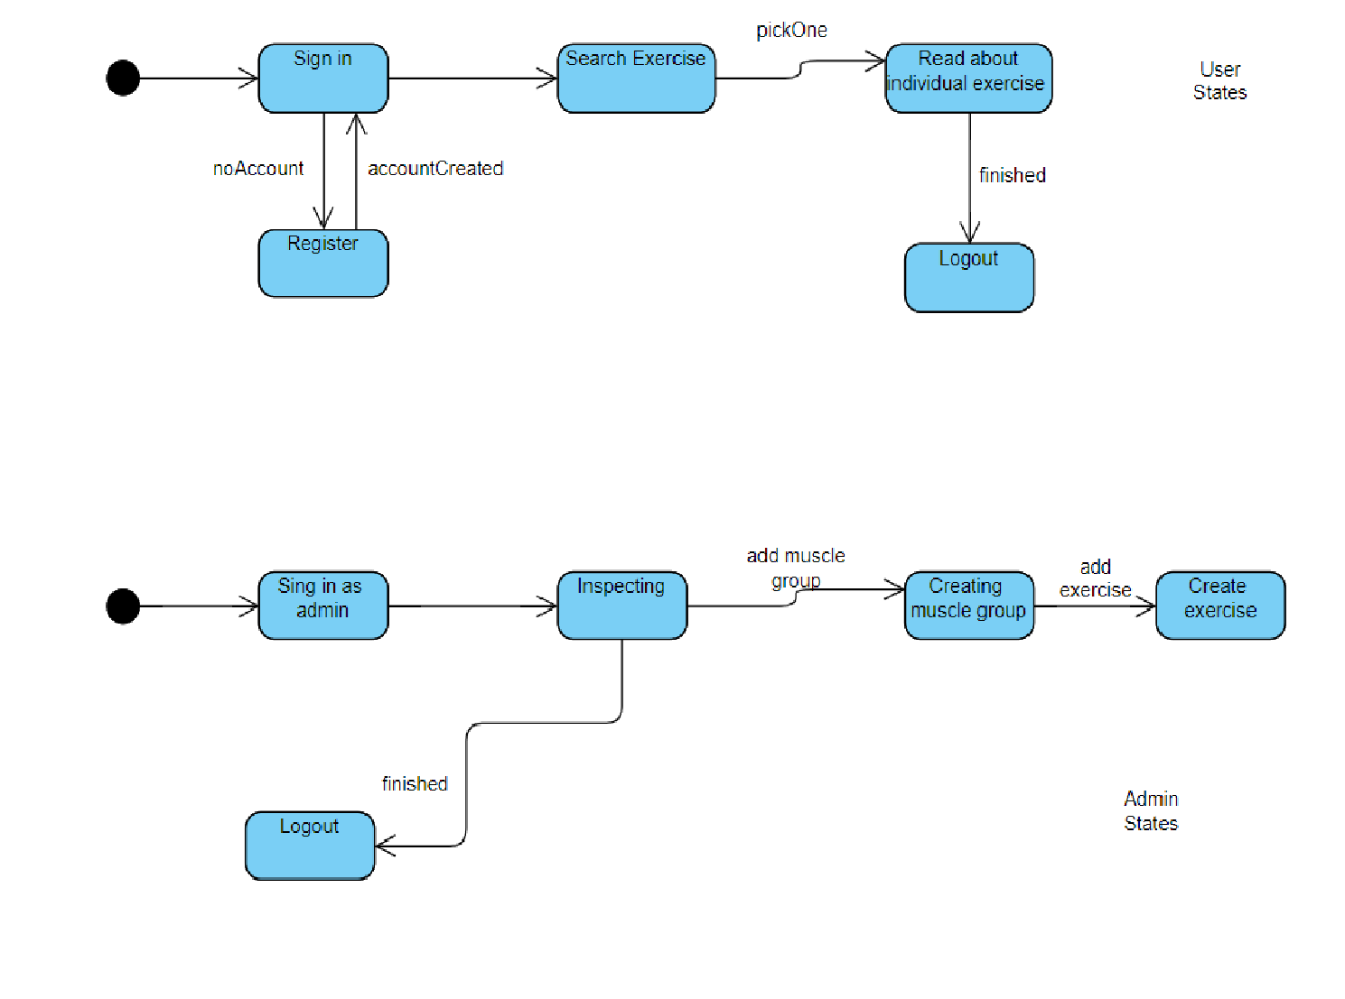

Sequence Diagram

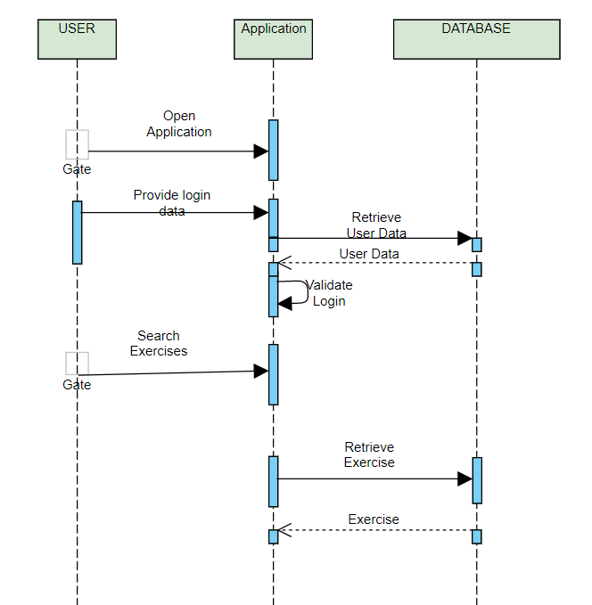

Class Diagram:
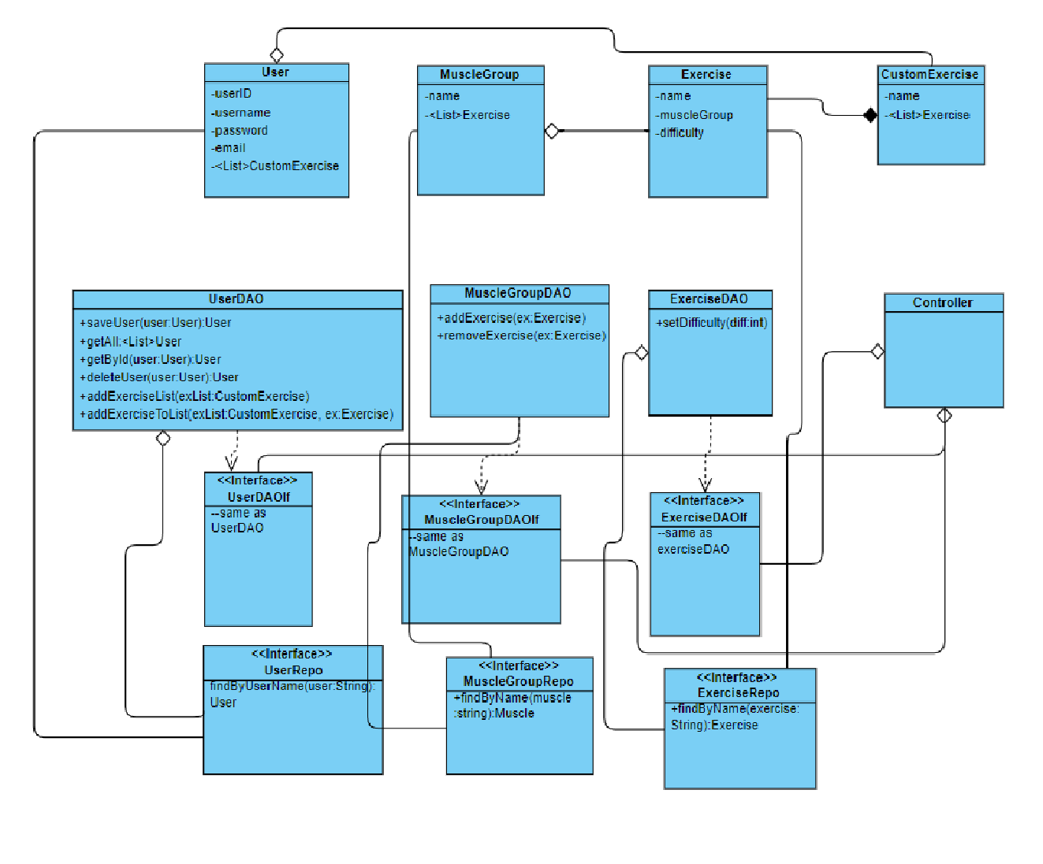

- Bugs

This section is designed with the purpose of presenting the bugs which had appeared throughout the presentation. And there were plenty of them. We will focus though only on the most important ones.
One of the most persistent bugs were caused by the absence of maven dependencies. The maven dependencies are contained in a so called pom file with the .xml extension (extensible markup language). Here is the place where a lot of dependencies had to be added throughout the design of the application in order to make some functionalities available. For example, in order to make possible the connection to the database or to the website, some specific html code must be included in the pom.xml file. If not included, the corresponding functionalities will not work at all, and the compiler doesn’t know what is missing so the error message isn’t helping at all in this type of cases.
Another bug was the fact that the main application was not able to see some classes so the run method was either not working or the program had some missing functionalities, like the missing data from the database. This error was caused because the classes were nice organized throughout different packages and for some reason the main app was not able to recognize some classes or the function of specific classes. That’s why in the main app some specifications have been added, like in what package to look for what kind of information.
Interface bugs were also present, where the outcome for some lines of html code was not the desired one. This bugs were resolved by either trial and error until the desired output was achieved, or by changing the output with something similar and doable.
Another interesting bug appeared when trying to add data in the SQL tables. Normally you want the ID column to increment automatically when adding a new value and the numbers must as well be unique. Well this was not the case in my previously implementation. In order to fix it an annotation has been added, namely @GeneratedValue(strategy=GenerationType.AUTO)
Talking about annotations, this another type of subject which caused a lot of bugs because without the right annotations in the right places the program will simply not work. For example if you want to perform an action which sends you to another path in the URL bar, so to show another webpage when something is done, without the @RequestMapping(“/path”) annotation above the specific method, the user will be redirected on whitelabel error page. This is just one of the many cases where annotations are needed.
A lot of other coding bugs were also present. For example, when pressing on a group muscle, the desired output should have been a table with all the exercises corresponding to that specific muscle group, but instead all exercises were displayed. Bugs similar to this which consist only of coding problems were resolved by either using the debug mode or by searching help on the internet.
Finally, all of the bugs were removed in order to present a flowless working application.

- Code description

If talking about the written java or html code I tried my best to write as organized as possible in order to make my code as easy as possible to be understood. Furthermore I will try to explain as clear as possible the coding part.

MyApplication.java
This is the main application where the run method is used. This is the class which starts the whole program.

ApplicationController.java
Here were described all the methods which need to be done in order to create an interactive application for the user. All the actions presented in the functioning of the application are running on those methods. You can think of this methods like action listeners. Each one of them has an annotation which specifies the path to which the app will switch and if necessarily, methods defined in the Service classes are called.

Exercise.java, MuscleGroup.java, User.java

This are all classes which describe a table in the associated database. Each one of them contains the fields of the header file of the table, a constructor for initiating a row with those fields and getters and setters for setting and retrieving the data.

ExerciseRepository.java, UserRepository.java

This are the interfaces where the definition of the methods needed for working with the tables are found. Besides the created methods, a lot of other basic but essential methods can be found here because of the CrudRepository, which is a spring made repository for working with databases, the interface extended by the repository classes.

ExerciseService.java, UserService.java

Here is the implementation of all the needed methods for working with the database. This methods are used in the controller for setting, changing or retrieving specific data from the database.

- Operation Mode (Interactivity presentation) + screen shots (UI design)

The application will look something like this:

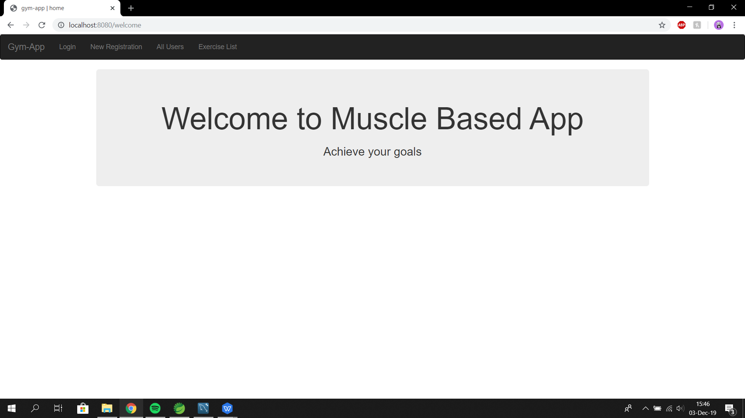

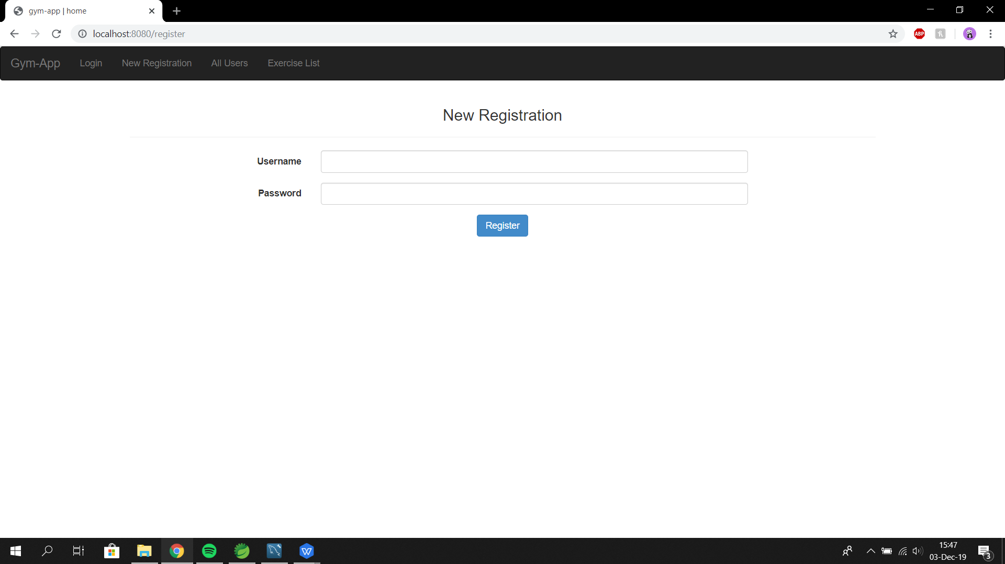

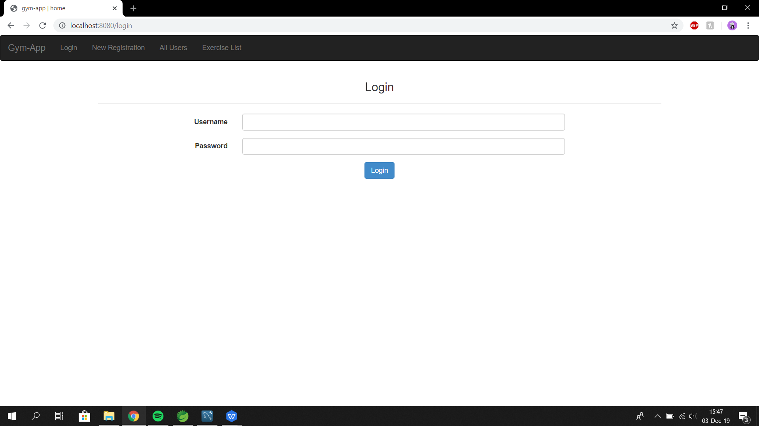

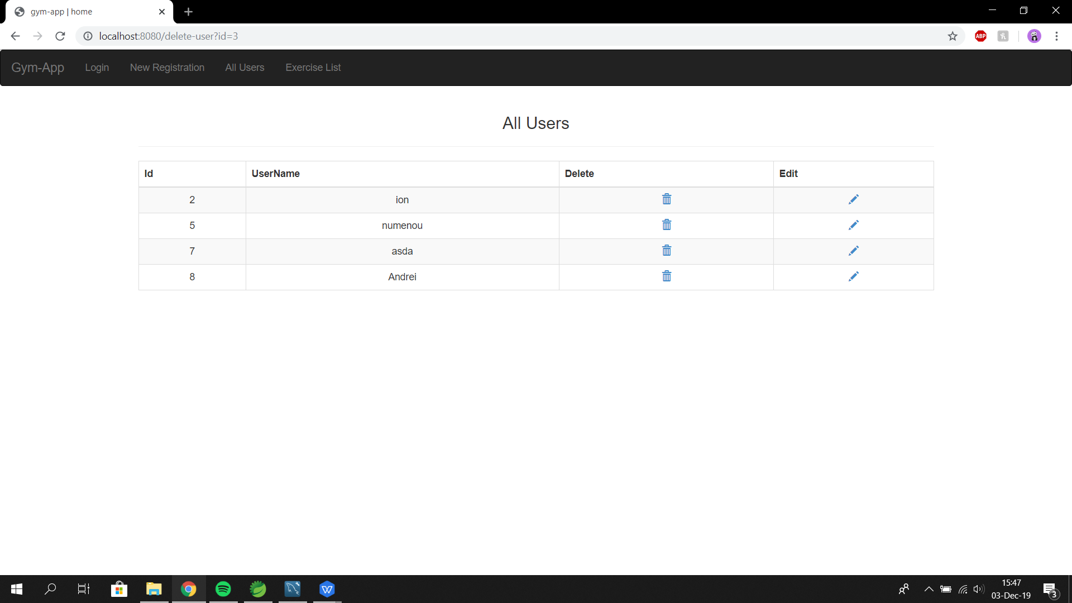

- Portability

The application will be accessible from any kind of browser the user wants to use. It will be reachable from windows but linux as well. In the future a mobile adaptation might also be created so that the users can access their favourite exercises more easily.

