SUMMARY

of the License Thesis entitled:

FITNESS TRACKING APPLICATION

|  |  |
| --- | --- |
| Author: | **Horia-Andrei MOLDOVAN** |
| Advisor: | **Lecturer Dr. Eng. Marcel ANTAL** |

1. Requirements:

Study, design and implement a fitness tracking application capable of helping the users increase their overall performance and achieve specific goals. Provide functionalities which can present the road to becoming a better self as something which anyone can achieve. Create features which are able to track not only the physical activities but also the diet status on a daily basis.

1. Related work:

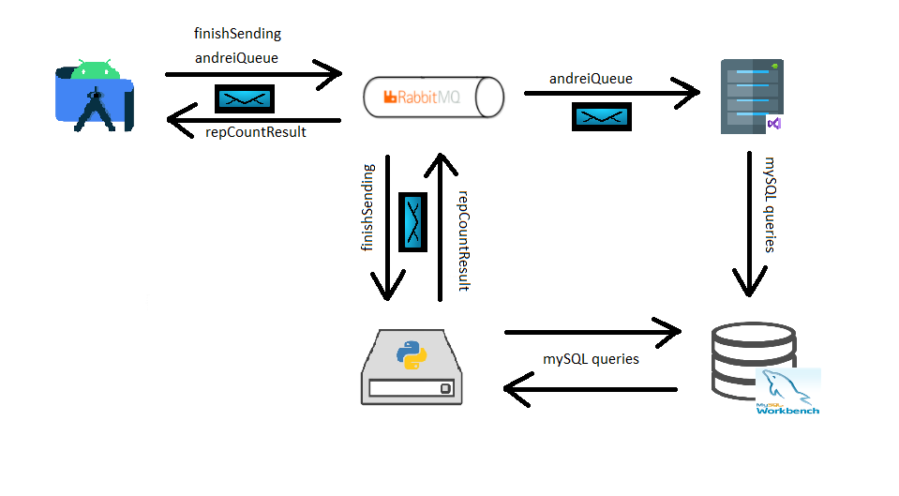Regarding the problem of tracking physical activities, a lot of studies have already been made in this domain because the need of physical exercise has been constantly increasing in the last years. For the problem of repetition counting, [1] comes with an idea which simplifies the computations a lot, namely supervised data gathering. Furthermore, regarding data gathering, articles like [2] propose a solution based on sensors like accelerometers or gyroscopes, incorporated in smart devices. Furthermore, in [3] the author describes the most optimal way where to place the used sensors and what kind of errors can be caused by a misplaced sensor. Following, [4] provided all the necessary information for calculating the daily calorie and macronutrient intake based on user specific attributes with the scope of reaching a certain target.

1. Proposed solution:

An application meaning to help the user track his daily fitness activities should be simple to use and accessible for any type of person. Because there are various people with different targets and goals, multiple features have been designed in order to cover all the requirements. The application supports a various range of exercises, each of them coming with a short description and a video demonstrating the correct execution. The app proves to be useful not only during the workout but also throughout the entire day. While exercising, the user can use the application for repetition counting. This functionality is achieved by analyzing the signals produced by the accelerometer incorporated in the device on which the application is running, namely a smartwatch placed around the wrist. Because the method of supervised data gathering was adopted, the user still has to specify the start and end of the execution in order to help the system differentiate the significant signals from the background noise, namely the resting time. Each and every exercise performed by the user is saved along with the number of repetitions, the used weight, the time took to perform it and the number of burned calories. Because of that, detailed information about specific workouts can be requested at any time, providing a summary of the individual performed exercises along with some information regarding the whole workout, which the user can choose to save to the external storage of his device. Moreover, the heaviest execution of every exercise throughout a workout is recorded, such that the user can visualize the growth in strength, in a graph containing all his personal records over a specified period of time.

Figure 1: Architectural Diagram

Because fitness is not only about physical activity but depends a lot on the consumed food as well, a diet tracking functionality has been added, which permits the user to analyze the number of consumed calories and macronutrients, compared to the total amount of calories and macros he should be consuming, based on his personal characteristics and on the desired goal, being it gaining muscle, loosing fat or just maintaining the current weight. The latter one was calculated with the help of Miffin St. Jeor Formula (Figure 2), which calculates the minimum amount of calories required for the human body to function normally at rest. When combined with the user activity level, this number becomes the total daily energy expenditure, representing the total amount of calories burned throughout Graphical user interface, text
a day. Switching back to physical exercise, in order to calculate the total number of calories burned throughout a workout, the Metabolic Equivalent of Task formula, presented in figure 3, has been used. Beside the weight of the user, the execution time and the MET value (representing the difficulty level) of the exercise are required. The MET value for most of the gym exercises lays somewhere around 6.

Figure 2: Miffin St. Jeor Formula

Figure 3: Calories burned through exercise

As presented in figure 1, three different applications are communicating through a message broker along with a database server in order to achieve the described functionalities. Each application uses specific queues in order to publish and consume messages on the RabbitMq server. The whole system works on a request-response principle, meaning that one application issues the request of the user while another one computes the requested result and sends it back to the application which displays it back to the user. Android Studio along with the Kotlin programming language was used for creating the graphical interface and managing the user requests, Visual Studio with .Net Core programming language in order to store real time data to the MySQL Workbench database and PyCharm with python programming language in order to perform more complex computations.

1. Experimental Results:

Regarding the functionality of repetition counting, a 3-axis accelerometer has been used in order to capture the signal generated by performing physical exercises. The main idea is that each repetition represents an acute change in velocity which can be identified as the peaks or maximum of the signal. Hence, each signal peak can be considered as one repetition. Figure 5 represents the accelerometer signal generated by executing the bench press exercise. One important mention would be that different exercise types generate signals which must be treated differently (as presented in figure 4) in order to calculate the number of repetitions. As we can see, there are three different signals, but in order to calculate the repetitions, only the peaks of the X signal (marked with red) are of interest. This is because while executing this specific exercise, the user constantly moves his wrist up and down in a vertical manner, so in an ideal case, only the X axis should encounter changes in acceleration. After successfully identifying the main axis of an exercise, the problem of counting the repetitions simply reduces to counting the number of maxima points from that signal.

Figure 5: 3-Axial Accelerometer Bench Press Signal

1. Personal contributions:

Figure 4: Differentiating variables among exercises

The main contributions of this thesis are the following:

* Implement an application which helps the user track his physical activity as well as his daily diet.
* Analyze various signals generated by smartwatch sensors in order to come with the best solution for repetition counting.
* Provide accurate graphics and suggestive feedbacks which help the user monitor his improvements.

1. Documentation sources:

[1] Andrea Soro, Gino Brunner, Simon Tanner. Recognition and repetition counting for complex physical exercises with deep learning. Sensors, 19:714, 02 2019.

[2] Bobak Mortazavi, Mohammad Pourhomayoun, Gabriel Alsheikh, Nabil Alshurafa, Sunghoon Lee, and Majid Sarrafzadeh. Determining the single best axis for exercise repetition recognition and counting on smartwatches. pages 33–38, 06 2014

[3] Oresti Banos, M´at´e T´oth, Miguel Damas, Hector Pomares, and Ignacio Rojas. Dealing with the effects of sensor displacement in wearable activity recognition. Sensors (Basel, Switzerland), 14:9995–10023, 06 2014.

[4] Suzuki I, Kawakami N, Shimizu H. Accuracy of Calorie Counter method to assess daily energy expenditure and physical activities in athletes and nonathletes. J Sports Med Phys Fitness. 1997 Jun;37(2) 131-136. PMID: 9239991.

|  |  |  |
| --- | --- | --- |
| Date: ________________ | Author | _____________________________ |
|  |  |  |
|  | Coordinator | _____________________________ |