AUTOMATED NEONATE PNEUMOTACHOGRAPH AND ERROR REPORTING MANUAL

Startup check list:
- Power on the rigs
- Power on the water baths
- Check to make sure gas tank valves are open (down position for yellow knob)
- Make sure the vacuum is on (Flowmeter: silver ball at 10 and black ball at 20)
- Make sure all air bubbles are removed from the water baths
- Each rig has its own set of calibration mask and face mask
- ECG box is on and switch is on AC
- Validyne box is on
- Arduino is on
- Git_PCC is running
- And Finish Startup process is completed without issues

Materials List:
- Impregum base pate + Catalyst Paste
- Facemask – each rig should have its own set (pup and calibration facemask)
- Swabs
- Conductive Paste
- ECG Leads – will need to be made so refer to wiki on instructions
- Super glue

Important notes before starting:
- Heed the advice given in the order of operations section below as it will streamline your operations.
- Facemask tips
  - DO NOT remove the facemasks from the respective rig.
  - IT IS IMPORTANT to avoid getting any paste on the pups mouth or nose as it will impact the breathing and the run.
- ECG tips
  - IT IS IMPORTANT that none of the conductive paste spots of the leads overlap with each other; this will result in a noisy signal.
  - It is best to place the red and black leads on with just the conductive paste first and verify a good signal being recorded in the GUI. This allows you to make adjustments without needing to rip off superglue, re-strip the wires, and reapply the conductive paste and glue every time.
  - If you experience noise on the ECG channels, but have a decent signal, try gently pulling on the wires from behind to apply tension. Sometimes this helps the signal and resolves noise nicely.
- Pay attention to the rigs during the startup process. This will be your best opportunity to find out if you will experience errors during your run that will prevent you from being able to use that recording.
- Be sure to record all of the following metadata surrounding your experiments. These data are essential to record as they cannot be retroactively collected. Other data may be included in a datasheet you use during collection, but these data are the most essential.
  - CUID
  - RUID
  - Sex
  - Weight
  - DOB
  - Age
  - Rig
  - Number of run on that rig that day
  - Gas tank ID (GUID)
- Make notes on components that are not working or if you notice something out of the ordinary during the run. See reporting errors section below.

Order of operations QuickStart:
- Turn on water heater and water pump.
- Generate RUIDs for each mouse you intend to run on the Derived Resources database and enter just the CUID for each of those mice. Make 5 entries at a time (or however many rigs are currently functional).
- Turn on each rig:
  - Ensure you have a PM folder for your project on that rig.
  - Run git_PCC and adjust all window sizes and settings.
  - Push through the protocol until you get to Signal Preview 2 and save the file in the format RUID_date.
- Go downstairs and get your mice.
- By the time you get back upstairs, 45 minutes will have passed so you can immediately begin mounting mice.
- Prior to preparing each mouse for the run, put a small dab of both the Impregum base paste with a small line of the catalyst next to each dab on the prep tray prior to mounting any pups.
  - This saves a lot of time because for each rig as you go along you can immediately start mixing and placing the facemask without having to open and close the Impregum tubes each time. This also makes it easier to use smaller amounts of the pastes, which results in less waste.
- Weigh your mice and get set up on each rig, one at time. Record the aforementioned variables using your preferred paper or electronic documentation method.
  - Eventually all of this data will be input into the derived resources or autoresuscitation plethysmography database. Recording at this stage is really only temporary until it is transferred.
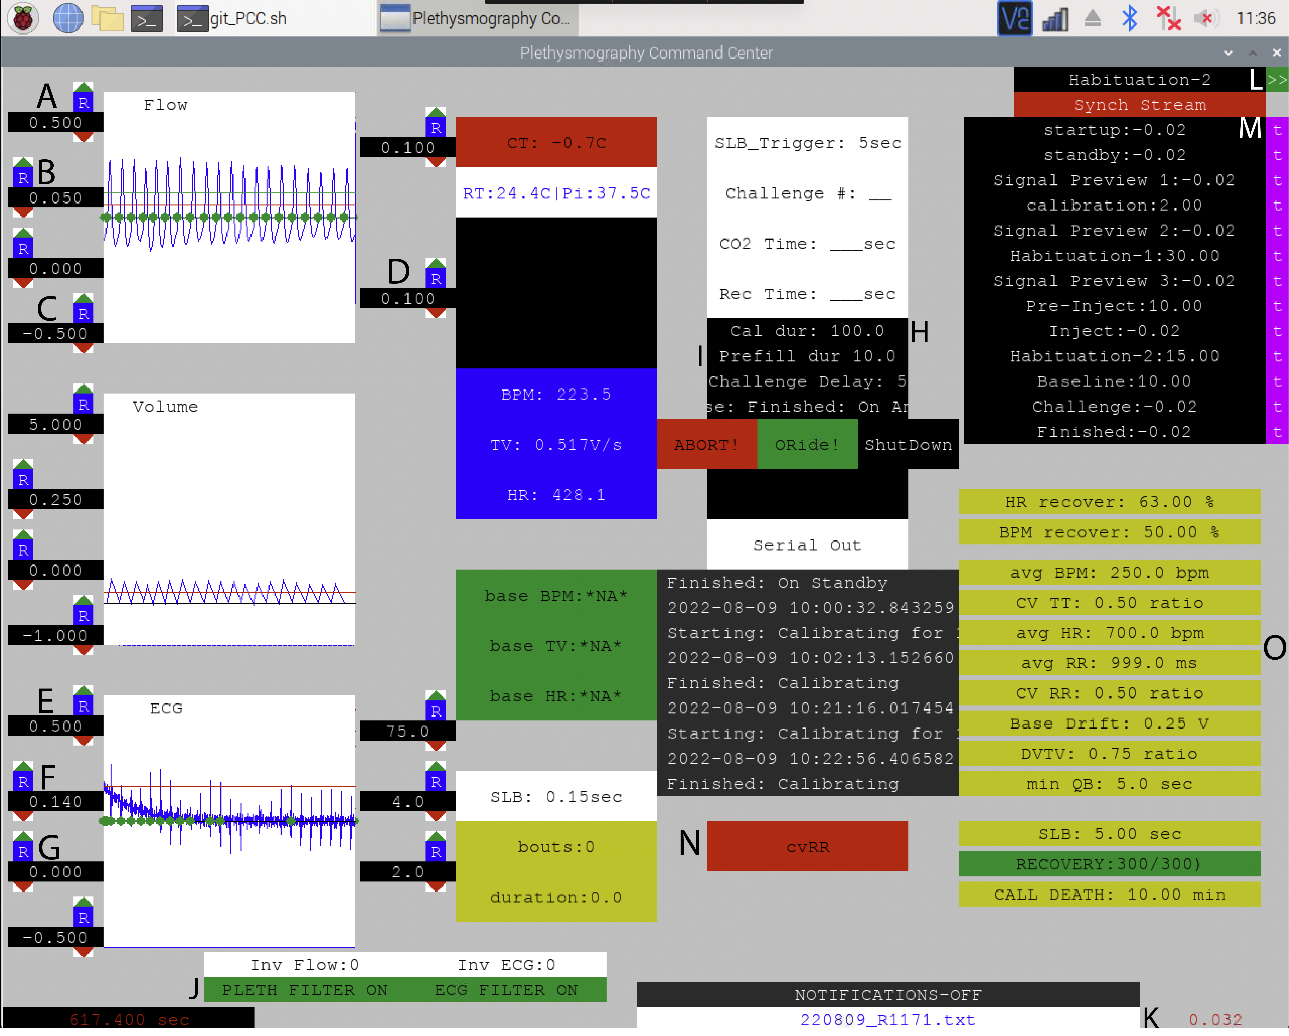

Detailed operations outline:
- Ensure the water bath is on and is set to 35 °C.
  - Ensure no leaks coming from the water baths.
  - Ensure all bubbles are removed from each water bath.
  - Ensure ECG leads of sufficient length are pulled through the water bath and not directly in a drip line of water. They must be dry at the time of application.
- Open git_PCC.
- Click Finish Startup.
  - Pay attention to the startup, especially if this is the first time that rig has been run that day. Check for:
    - Motor function
    - Pipette calibration
    - Calibration waveform on GUI
    - Gas valves operational and audible gas exiting when challenge gas valve opened.
  - While Startup is running, you can get all the way through window size adjustment and saving the file as you get faster and more familiar with the program. Just be sure that you see the calibration waveform appear in the GUI before proceeding.
    - Adjust the window sizes and thresholds as follows:
      - Windows:
        - 0.5: Upper window size for Flow
        - -0.5: Lower window size for Flow
        - 0.5: Upper window size for ECG
        - -0.5: Lower window size for ECG
      - Thresholds:
        - 0.05: Red line in the Flow to indicate a breath
        - 0.1: Green line in the flow to indicate breath during challenge
        - 0.14: Red line for ECG window to indicate HR
      - Other settings
        - 100 sec.: Calibration duration
        - 10 sec.: Prefill duration for challenge chamber
        - Change from pleth filter off (red) to on (green)
          - **Verify that the respiratory trace is at 0 before turning on the filter. You can adjust this using the knob on the Validyne box.
- Once startup is completed, or during startup if you get fast enough, save the file (K).
  - Make sure to save it to the external SSD
    - Go all the way back in the window prompt
    - Media/Pi/PNY SSD/Your_PM_Folder
    - Save your file with file name: RUID_date (ex. R1156_9-15-2022)
- Click the green button (L) to move onto standby phase.
- Once the hangar read “Finished Standby”, click (L) again to move onto Signal Preview 1.
  - It is at this point that you can change settings for the challenge and timing throughout the experiment.
    - Click (M) to change the times for the respective step.
    - DO NOT hit the step directly otherwise it will transition to that step.
- Do a quick check at this point to make sure your file is saved as you want, and all window, threshold, timing, and challenge settings are correct.
- Click the green button (L) to move onto calibration.
  - Complete up to this point on all rigs BEFORE retrieving pups.
- Place the prep tray on the first rig you intend to place a mouse on an put a small dab of Impregum base paste with a small line of Impregum catalyst next to each dab for the number of mice you plan to run.
  - For example, if you plan to run 5 mice, then prepare 5 Impregum dabs with catalyst lines on the prep tray before going downstairs.
- Go get pups from downstairs.
- Immediately begin, one-by-one, weighing and preparing the pups on the rigs.
  - Preparing the pup:
    - Mix one of the Impregum paste mounds until you get a purple color paste.
    - Apply the paste around the face starting from one eye and going in a full circle to the other eye and the top of the head.
    - Push the facemask onto the pup and hold it there for about 30 seconds
    - Load the mouse onto the rig, which should be in Signal Preview 2.
- Attach the ECG leads to the back of the pup in the following order: Red, white, black
  - You will need to put a small amount of ECG paste onto the pup for each lead.
  - Trim off the end of the lead to remove the exposed wire from the last use..
  - Strip the end of the wire to reveal fresh wire approximately 1-2 cm long.
  - Press the freshly stripped leads into the conductive paste applied to the back of the pup.
    - It is not a bad idea to have a tiny bit of conductive paste on the wooden tip while you press these in so you can ensure a good connection with the leads.
  - The best position for the red lead is between the ears.
    - The higher the better if you are doing intrascapular injections.
  - The white lead should be in the middle of the back.
  - The black lead should go a little bit above the tail.
  - Once the leads are providing sufficient ECG traces, apply superglue to hold them in place.
    - It might be easier to just apply the red and black leads first, superglue those in place, then attach the white lead last.
- Slide the water bath over the pup, ensure the ECG still looks clean, and hit the green button (L).
- At this point the assay will run by itself and you can monitor via VNC.
  - Additional steps will be required if doing an injection experiment. See injection protocol to pick up from this point with the protocol for injections.
- Towards the end of Habituation (before starting baseline) it is important to double check to make sure the box (N) is green for a majority of the time.
  - If it is red, you will need to go back to Signal Preview 2 and adjust the requirements (most likely avg BPM and avg HR) where the yellow boxes are (O).
- When the run is completed, write down the number of episodes and click Shutdown.
- Close the GUI.
- At the end of the day when all runs are completed, set up a transfer of the data you’ve collected from the external hard drive onto the brains server into a PM folder that matches the PM you’re saving under on the Pi.
Injection protocol:
- The protocol for injections includes 2 baselines. As default the second baseline (after drug administration) is used for injections. Therefore, no real requirements or restrictions are set on the first baseline.
  - Thus, it is imperative that you check periodically during the initial habituation and baseline to make sure that you are getting quality breathing enough to perform calculations on baseline, pre-drug levels.
- Once the animal has gone through baseline, the protocol will stop on Inject. It will not advance without input from this point.
  - Prep your injections in your syringe prior to proceeding.
  - Pull back the water bath to reveal the animal.
  - Using flat tweezers, lift the skin between the shoulder blades directly up away from the animal.
  - Into this teepee of skin you’ve created, insert your needle.
    - Keep your head directly above the animal as you insert the needle to make sure you do not push it through the other side.
    - Also make sure to not have the needle going into the head of the animal.
    - Basically, only insert the tip of the needle in as far as you need for the injection to dispense under the skin.
  - Very slowly inject your drug or placebo.
    - Do not do this step quickly, because their skin is very thin and flimsy and the injected bolus will simply exit the entry hole where you put the needle in.
  - You should see the skin balloon out as you inject. This is a GOOD sign.
  - Remove the needle.
  - Replace the water bath.
  - Ensure the ECG and respiratory traces are of equal quality to those before the injection.
- Advance the program from Inject to the next phase of habituation (L).
- From here, the program will run without need for human intervention. You should remain in the room, however, as many errors will require you hearing them and intervening, otherwise you will loose the run.
- When the run is completed, write down the number of episodes and click Shutdown.
- Close the GUI.
- At the end of the day when all runs are completed, set up a transfer of the data you’ve collected from the external hard drive onto the brains server into a PM folder that matches the PM you’re saving under on the Pi.

Error reporting:
For reporting issues and errors with the rigs there are a few things to keep in mind. Depending on the error, different people with different backgrounds that may be required to fix the problem. So, it is important that you record all the information that each of these kinds of people may need so that sufficient information is available for troubleshooting and repair.

Standard troubleshooting first step for all kinds of problems: can you reproduce the error with the eMouse? If so, what are the steps to reproduce this error?

Below I’ve outlined the various documents and/ or documentation for each branch of the development team. For every error, it is best practice to collect ALL of the below items regardless of where you think the error is derived.

For GitHub migration, tags will be utilized to keep track of engineering vs. software issues.
- Engineers
  - Error tracking and reporting back on fixes will be migrated to GitHub.
  - Complete an error reporting checklist, which can be found on the adjustment clipboards for each rig.
    - Include checkboxes for common errors (I.e., missing waveform, shaky rig/ fast movement)
  - Take notes on the following:
    - Describe the particular piece of the rig involved in the failure
    - Describe the failure with as much detail as you can (including when during the run the error occurred)
    - A picture of the portion of the rig that failed
    - A video of the failure, if possible
    - What, if anything, have you done to attempt to fix this error?
    - Is the rig no longer functional because of this error? (this helps with determining urgency)
- Software
  - Error tracking and reporting back on fixing errors on GitHub for software.
  - The .txt and .log files for the run with clear naming
    - When you give these to Chris, be sure to include a ReadMe document in the folder you choose to share with him that outlines what the name of the file is and which error that file demonstrates.
    - If you use the above convention, as you run in to new or more errors, you can simply continue adding files to the same shared folder on Box, Dropbox etc. and just update the ReadMe file.
  - A picture of the GUI screen during or just after the error
  - A text file that contains the contents of the command terminal (copy and paste the contents into a text file and save with naming convention RUID_date_terminaloutput)
  - Description of the failure (including when during the run the error occurred)
- General
  - Has the error occurred previously?
  - Who else has experienced this error?
  - Have you noticed anything about the circumstances that stick out?
    - For example, does it seem to only happen at the end of the day, or after another run has occurred prior to this run.

